Supplementary Note
Table of Contents
1 List of Supplementary 3
1.1 List of supplementary tables 3
1.2 List of supplementary files 3
2 Code and data availability 4
3 Structural variation detection with SVision 4
3.1 Encoder 5
3.1.1 Variant feature sequence selection 5
3.1.2 Variant feature sequence realignment 5
3.1.3 Variant feature sequence scaling 6
3.1.4 Coding sequence to three-channel image 7
3.1.5 Creation of denoised images via subtraction 9
3.2 Targeted multi-object recognition 10
3.2.1 Image segmentation 10
3.2.2 CNN training 12
3.3 Illustrator 15
3.4 Filtering and output 17
3.5 Example SVs detected by SVision 19
3.6 CSV graphs 21
4. Performance evaluation 21
4.1 Evaluation of simple SV detection on NA12878 21
4.2 Impact of supporting read for simulated CSV detection 22
4.3 Evaluation of CSV detection on NA12878 23
4.3.1 Misinterpreted deletion at chr9:71,895338-71,896,537 24
4.3.2 Unclassified CSV at chr17:5,594,699-5,595,567 25
5. Analysis and validation of CSVs detected from HG00733 25
5.1 Variant reconstructed from phased assemblies 25
5.2 Graph-based validation 26
5.3 Experimental validation 26
5.4 Comparison with Illumina calls 27
5.5 RNA-Seq analysis of one CSV at CNTN5 27
5.6 Analysis of one insertion-inversion-insertion event 28
6. Simulating complex structural variants 28
6.1 General workflow for the simulation 28
6.2 Simulated CSV types 29
6.2 Major steps 30
6.2.1 Creating simple SVs with VISOR 30
6.2.2 Adding simple SVs to flanking regions 30
6.2.3 Creating the CSV genome 30
7 Software version and parameters 31
7.1 Sniffles (V1.0.11) 31
7.2 SVIM (V1.3.1) 31
7.3 CuteSV (V1.3.8) 31
7.4 pbsv (V2.3.0) 31

1 List of Supplementary

1.1 List of supplementary tables
Supplementary Table S1: Performance evaluation on HG002
Supplementary Table S2: Simulated complex structural variants types and events
Supplementary Table S3: Performance of detecting simulated complex structural variants with different numbers of supporting reads
Supplementary Table S4: Performance evaluation of region match and subcomponent detection for simulated complex structural variants
Supplementary Table S5: Complex and simple structural variants manually curated from published complex calls on NA12878
Supplementary Table S6: Performance of SVision detecting manually curated complex structural variants in NA12878
Supplementary Table S7: 80 high-quality complex structural variants detected by SVision in HG00733
Supplementary Table S8: Validation of 80 high-quality complex structural variants in HG00733
Supplementary Table S9: 80 high-quality complex structural variants supported by short-read calls
Supplementary Table S10: The frequency of the complex structure variant event overlapping with CNTN5 in 35 HGSVC samples
Supplementary Table S11: List of RNA-Seq data used to analyze CNTN5 duplicated exon signature
Supplementary Table S12: Selected complex structural variants for experimental validation

1.2 List of supplementary files
Supplementary File 1: Manually curated CSV loci in NA12878 initially reported by 1000 Genomes Project
Supplementary File 2: Contig reconstruction of CSVs detected by SVision
Supplementary File 3: Haplotype contig reconstruction of CSV locus overlapping CNTN5
Supplementary File 4: One-variant images of CSVs detected by SVision in HG00733 Supplementary File 5: RNA-Seq analysis of one CSV at CNTN5

2 Code and data availability
The SVision source code and its user manual are available at https://github.com/xjtu-omics/SVision. Both the HiFi and Oxford Nanopore sequencing data for HG002 are available at GIAB FTP site (ftp://ftp.ncbi.nlm.nih.gov/giab/ftp/data/AshkenazimTrio/HG002_NA24385_son/). The PacBio HiFi sequencing data for NA12878 is available at http://ftp.1000genomes.ebi.ac.uk/vol1/ftp/data_collections/HGSVC2/release/v1.0/assemblies/20200628_HHU_assembly-results_CCS_v12/haploid_reads/. Primary raw PacBio HiFi sequencing data for HG00733 is available at http://ftp.1000genomes.ebi.ac.uk/vol1/ftp/data_collections/HGSVC2/working/20190925_PUR_PacBio_HiFi/, and the high-quality phased assemblies are available at http://ftp.1000genomes.ebi.ac.uk/vol1/ftp/data_collections/HGSVC2/working/20200417_Marschall-Eichler_NBT_hap-assm/. The Oxford Nanopore sequencing data used for graph-based validation is at http://ftp.1000genomes.ebi.ac.uk/vol1/ftp/data_collections/hgsv_sv_discovery/working/20181210_ONT_rebasecalled/. The latest HG00733 PAV (v1.1.2) call is at http://ftp.1000genomes.ebi.ac.uk/vol1/ftp/data_collections/HGSVC2/working/20210806_PAV_VCF/, and the latest release of PAV calls for 35 samples is at http://ftp.1000genomes.ebi.ac.uk/vol1/ftp/data_collections/HGSVC2/release/v2.0/integrated_callset/. The assemblies for 35 samples are available at http://ftp.1000genomes.ebi.ac.uk/vol1/ftp/data_collections/HGSVC2. The RNA-Seq data of precuneus and primary visual cortex could be accessed in SRA with PRJNA720779.

3 Structural variation detection with SVision
SVision is a long-read based structural variant (SV) detection and characterization tool that applies the targeted multi-object deep-learning-based framework, to detect complex and simple SVs larger than 50bp. It also provides a graph representation and computational approach to define and compare CSVs. Here, we give a detailed description how SVision works and the implemented novel algorithms that lead to much improved sensitivity and precision for both simple and complex SV detection. SVision contains three core components, i.e., encoder, tMOR and illustrator, which are all automatically executed sequentially. For the encoder, it consists feature sequence selection and feature sequence coding. The tMOR contains a two-step image segmentation process and a convolutional neural network (CNN) for object recognition. Finally, the illustrator gives a graph-based representation of detected CSVs.

3.1 Encoder

3.1.1 Variant feature sequence selection
Like existing state-of-the-art callers, SVision collects the abnormal aligned reads containing SV signatures from inter-read and intra-read alignments. For signatures obtained from intra-read alignments, SVision uses CIGAR operations, including ‘D’, ‘I’ and unmatched segments, that are longer than 50bp (minimum SV detection size). For inter-read alignment, one of the alignments (usually the longest mapping) is marked as primary alignment, while all others are called supplementary alignments. Note that CIGAR strings are parsed for both primary and supplementary alignments before we assessed the signatures from inter-read alignments, and CIGAR string for supplementary alignment could be obtained from SA tag. SVision only parses supplementary alignments of quality higher than 20 and filtered the primary alignment with more than 7 supplementary. For the SVision contig mode, it is easy to observe contigs with more than 7 supplementary alignments. This parameter is changed to 1 when the contig mode is activated. These collected aberrant alignment containing variant signatures are referred as variant feature sequence.

3.1.2 Variant feature sequence realignment
In the feature sequence selection step, we have recorded the matched and unmatched sequence according to the CIGAR string as well as gaps between pairs of primary and supplementary alignments. The variant feature sequence is termed as VAR and its counterpart segment on reference genome is termed as REF. Then, the unmatched sequence of VAR is locally realigned to REF via k-mer (k=10). This local realignment consists two major steps. It first matches the VAR k-mers to the REF k-mers, producing the initial matched segment, such as segments I and J (Supplementary Fig. S1). Secondly, SVision combines segments I and J to a longer segment. The details are explained as below:
- K-mer Matching: We separate VAR to a set of k-mers, and build a hash table for REF with its k-mers. Then, we visit the hash table to find a match of k-mer from VAR. If there is match, we keep extending the current match until no more matched sequence, where the extension stops if there are no matched bases or meet the sequence end. We record this extended match as a segment if it is longer than the parameter min_sv_size (default=50bp).
- Chaining and extension: Given a set of longest segments obtained from k-mer match, we further chain these segments by measuring the linearity of two adjacent segments. For example, segment $I$ and $J$ obtained from k-mer match could be chained and extended to a longer segment when the following equations are satisfied.
$$I.read_{end}-J.read_{start}<\left(I.length+J.length\right)*1.5$$
$$I.ref_{end}-J.ref_{start}<\left(I.length+J.length\right)*1.5$$
$$0.8<\left|\frac{I.ref_{start}-J.ref_{start}}{I.read_{start}-J.read_{start}}\right|<1.2$$
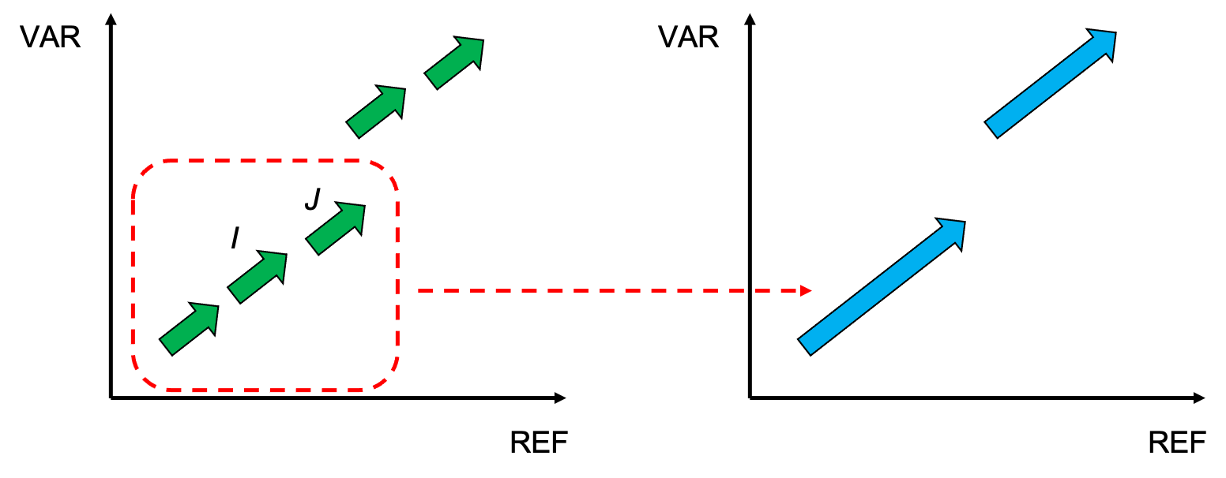
Supplementary Fig. S1 Schematic of segment extension in k-mer realignment
Note that unmapped sequences are obtained from ‘I’s in CIGAR string or gaps between pairs of primary and supplementary alignments. Specifically, for inter-read alignment, its primary alignment (defined as longest match across alignments of a read) is paired with each of its supplementary alignments to obtain gap sequences. SVision keeps start and end alignment position of segments with respect to REF and VAR.

3.1.3 Variant feature sequence scaling
We notice that the start and end position on read only covers sequence harboring variant, which lacks enough length of sequence spanning breakpoint junctions. Thus, sequence at the flanking region of variant is required to characterize each breakpoint junctions of CSVs. The flanking region essentially contains concordant sequence between read and its counterpart on reference genome. Thus, SVision implements a two-step approach to obtain enough length of sequence at the breakpoint junctions, referring as sequence scaling.
- Extension. Assuming the length of a segment signature $s$ is $l$, we calculated appropriate left boundary as $left_most = s.start_pos – l×2$, where $s.start_pos$ is the left most position of segment signature $s$. Similarly, the right boundary is calculated as $right_most = s.end_pos + l * 2$, where $s.end_pos$ is the right most position of segment signature $s$.
- Trimming. We ignore the segment signatures that outside the interval $[left_most, right_most]$. For segments that partially spanned the interval, we trimmed the extra sequences to ensure the trimmed segments start from $left_most$ or end with $right_most$.
The sequence scaling step produces a set of scaled segments that are used in further image coding.

3.1.4 Coding sequence to three-channel image
SVision uses a three-channel RGB image (Supplementary Fig. S2) to encode the difference and similarity between variant feature sequence and its corresponding REF, where the x-axis and y-axis indicate REF and VAR sequence, respectively. The three channels are described as follows:
- First channel. Encode all matched segments in this channel (255, 0, 0. Blue).
- Second channel. Duplicated segments are found by traversing the first channel’s x-axis. For a position on x-axis, if there are more than one pixel in vertical direction, we mark this position as a duplicate position. Segments that span duplicated positions will be encode again in the second channel. Since duplicated segments are encoded in both matched and duplicated channel, they will finally become cyan (255, 255, 0).
- Third channel. Reversed segments are marked by ‘reverse’ flag. We encode reverse segments in the third channel. Since reversed segments are encoded in both normal and reversed channel, then reversed segments will final become purple (255, 0, 255). If a reversed segment is duplicated with others, then is will show white (255, 255, 255).
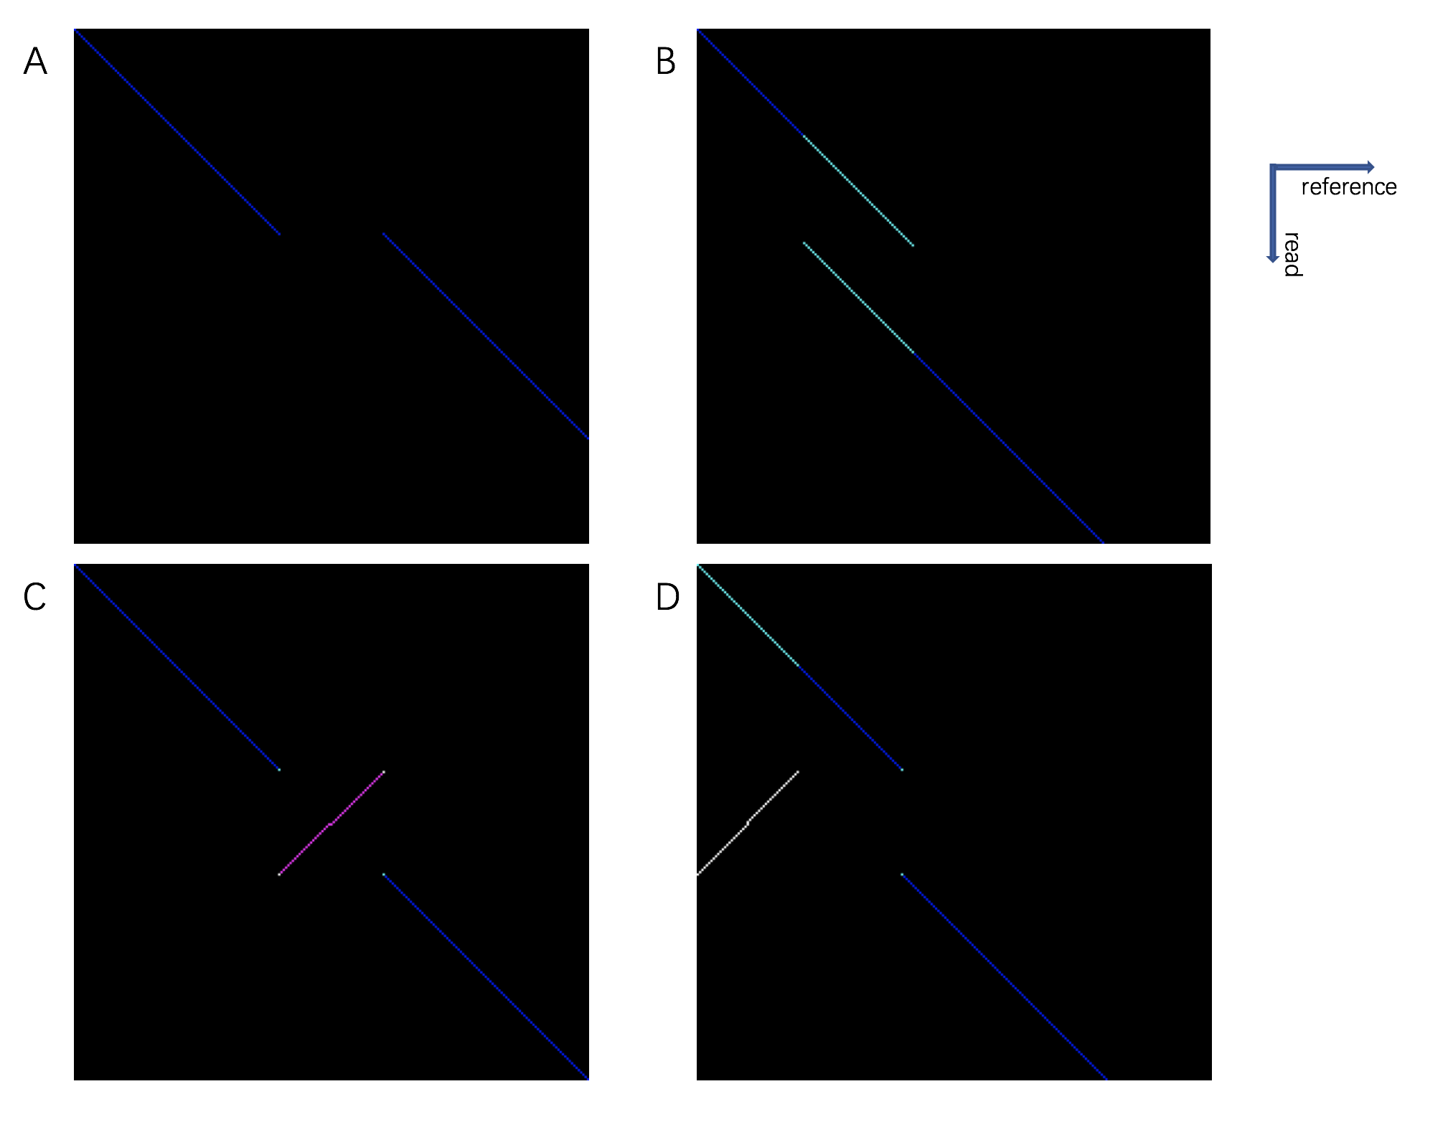
Supplementary Fig. S2 Examples of three-channel image
SVision uses the segments that are large than 50bp (3.1.2) and scaled segments (3.1.3) to create the VAR-to-REF image. These segments are kept with its position on REF and VAR, respectively, and SVision code these segments into image according to their order on read. Note that SVision keeps checking the linearity of two adjacent matched segment as described in section 3.1.3. If the newly added segment is collinear with existing segment, the existing segment will be expanded and the ratio is updated for further usage. The REF-to-REF is only created from k-mer alignment, which is consisted of two major steps, i.e., segments finding and image creation. The details are listed as follows:
- Segment finding
  - For two sequences, the default k-mer size is 10, which slides by 1bp at each step.
  - Build hash-table for the reference sequence.
  - Searching and extending the matched k-mer from alternative sequence. A segment will be recorded until no more matches.
- Image creation
  - The image is resized to 224*224*3 to satisfy the input of the CNN.
  - The first channel (255, 0, 0) coded all segments found in step 1.
  - The second and third channel will check if the matched segment is repeated or reversed.

3.1.5 Creation of denoised images via subtraction
SVision introduce a subtraction approach to remove reference sequence context, avoiding the impact of repetitive sequence for SV calling. In principle, SVs are originated from extra and different sequence in VAR with respect to REF, whereas the context of reference itself might affect detection due to repeats. Therefore, SVision implements this by subtracting the REF-to-REF image from VAR-to-REF image. However, the direct subtraction of two matrices (i.e., matrix for REF-to-REF and VAR-to-REF image) is greatly affected by the dimensions, where REF-to-REF is a square matrix. To solve the problem of dimension discordance, we first observe that the difference between these two matrices is originated from the reference dimension, and thus we only need to do the subtraction at the reference dimension (Supplementary Fig. S3). Specifically, SVision first maps the matrix to the reference dimension, referring as one dimension mapping, and then looks for the segment overlaps on the reference dimension. Note that two segments might map to the same location through one dimension mapping, SVision labels each segment separately according to their length. If the length of two segments is identical, they are duplications, and should be subtracted. For the subtraction on reference dimension, SVision first looks for the overlapped segment and calculate the length of non-overlapping part. Then, non-overlapping part smaller than minimum SV detection size (default=50bp) is ignored and filtered. Moreover, the adjacent subtracted segments are combined according to their ratio difference (described in 3.1.2), leading to denoised image.
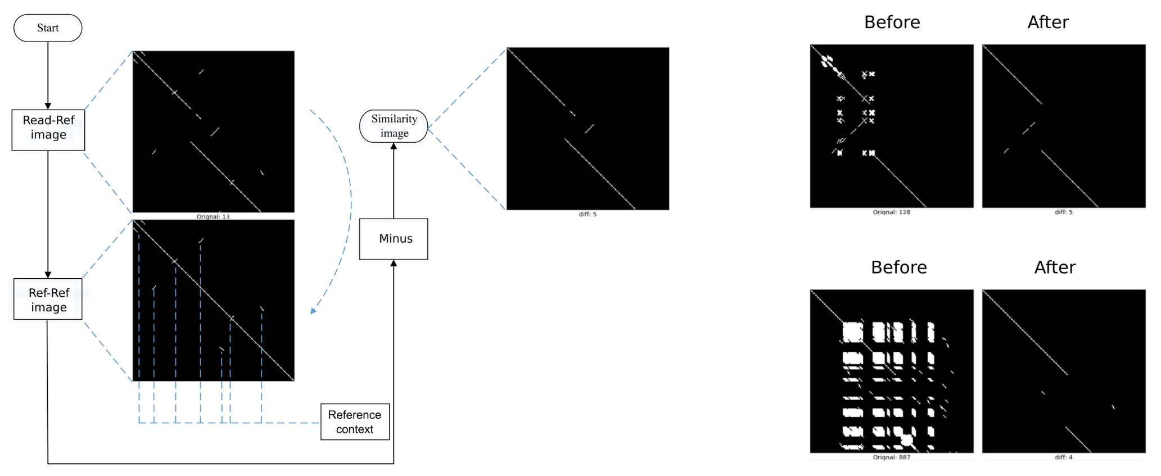
Supplementary Fig. S3 Workflow and examples of image subtraction

3.2 Targeted multi-object recognition

3.2.1 Image segmentation
The image segmentation step is the major component for the targeted multi-object recognition framework, especially for future longer and high-quality single molecule sequencing technologies. Thus, the segmentation contains two steps: 1) separating one-variant image and 2) dissecting one-variant image to Segment of Interests (SOI).
In the first step, we observe that two longest matched segments in the denoised image contribute to one-variant, where these two segments are like ‘anchors’ for SV identified visually from Dotplot. Accordingly, SVision sequentially combine the major segments and the minor segments in between to create the so-called one-variant image (Supplementary Fig. S4). Then, SVision clusters similar one-variant images according to the similarities of segments in different one-variant images, and the size of a cluster is used as the number of SV supporting one-variant images. Assuming segments ${[A}_{start}, A_{end}]$ and ${[B}_{start}, B_{end}]$ obtained from two one-variant images created by two variant sequences, the following distance measure Dist is used in hierarchical clustering:
$$A_{span}=\left|A_{end}-A_{start}\right|,B_{span}=\left|B_{end}-B_{start}\right|$$
$$A_{center}=\frac{\left|A_{end}-A_{start}\right|}{2}, B_{center}=\frac{\left|A_{end}-A_{start}\right|}{2}$$
$${Pos}_{A-B}=\frac{\min\left(\left|A_{start}-B_{start}\right|,\left|A_{end}-B_{end}\right|,\left|A_{center}-B_{center}\right|\right)}{scaler}$$
$${Span}_{A-B}=\left|A_{span}-B_{span}\right|/max⁡(A_{span}, B_{span})$$
$$Dist=Pos_{A-B}+Span_{A-B}$$
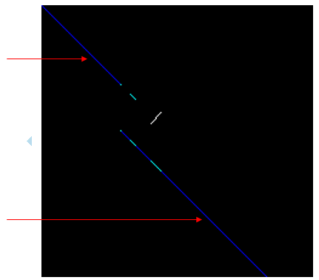
Supplementary Fig. S4 The three-channel image with two major segments
Secondly, SVision implements a targeted object segmentation process to identify SOIs from one-variant images (Supplementary Fig. S5). Multi-object recognition has been widely used in the field of computer vision, where complicated algorithms are proposed to efficiently locate the so-called Region of Interest. The region selection is usually based on unsupervised method, e.g., selective search and EdgeBoxes, which depends on image color, texture and etc. The sequence similarity image is lack of colors or textures compare with real world visions, but only segments represented as lines in the image. Thus, SVision incorporates the characters of SV breakpoints to dissect denoised image to SOIs, where breakpoints surrounding by segments are identified as SOI in denoised images. Accordingly, given the one-variant image, SVision sequentially combine all minor and major segments to create SOIs, whereas SOIs consist of two minor segments or two linear segments will be filtered out. Finally, these SOIs are used as input for the CNN.
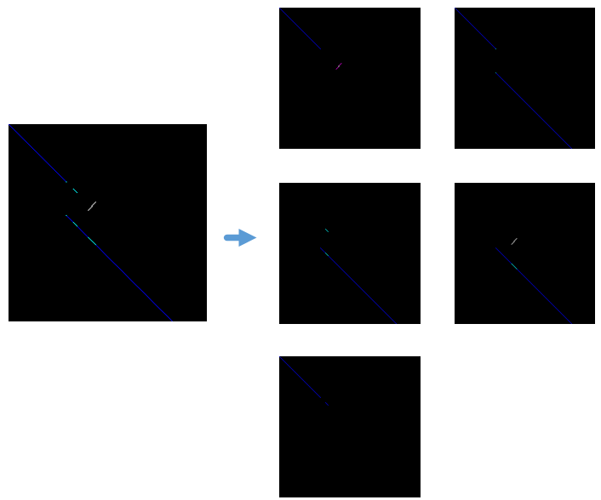
Supplementary Fig. S5 Dissected SOIs from the three-channel image

3.2.2 CNN training
We use the network architecture proposed as AlexNet, which is designed by Alex Krizhevsky and win the ImageNet challenge at 2012. The AlexNet architecture consists of five convolutional layers and three fully-connected layers. The most important features of AlexNet are as listed as below:
- ReLU Nonlinearity: AlexNet uses Rectified Linear Units (ReLU) instead of the tanh function to reduce the training time.
- Data Augmentation: The original paper used the label-preserving transformation to make their data more varied, including image translocations and horizontal reflection, which increased the training set by a factor of 2048.
- Dropout: This technique consists of ‘turning off’ neurons with a predetermined probability. As explained in the original paper, this forces each neuron to have more robust features that can be used with other random neurons.
The size of image input is 224*224*3 for AlexNet, and it uses the cross-entropy as optimizer. For the training, we shuffle the 75,000 SOIs obtained from training SVs of real samples (i.e., NA19240, HG00514, Supplementary Fig. S6) and apply the ten-fold cross validation for model training (Supplementary Fig. S7). The cross validation contains the following details:
- Half of the 75,000 SOIs is created from the simulated SVs.
- The batch size during training is 64, e.g., each training batch contains 64 SOIs.
- 5,000 training iterations.
- Ten-fold cross-validation: the training SOIs is divided into 10 groups, each containing 7,500 SOIs. One of the groups is selected as validation set during model training, leading to 10 models (ID from 0 to 9).
- Every trained model is applied on the validation set, from which, the loss and accuracy is calculated.
- The training time for one CNN model is approximately 35min, including the backpropagation time.
Meanwhile, we create another test set of 7,500 SOIs to assess the model accuracy (Supplementary Fig. S8).
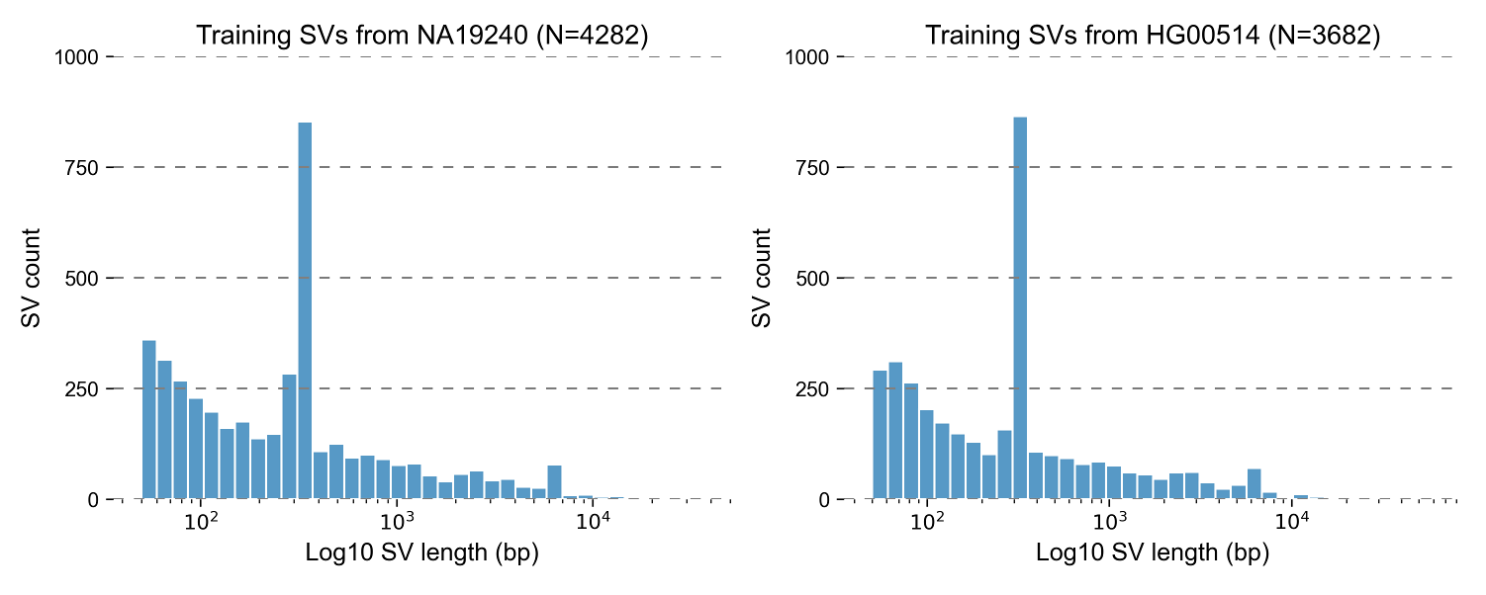
Supplementary Fig. S6 Size distribution of training structural variants obtained from two real samples.
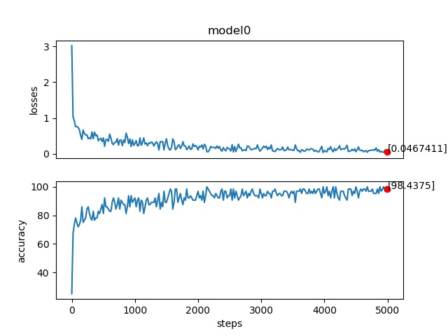
Supplementary Fig. S7 Results of the ten-fold cross validation of model 0.
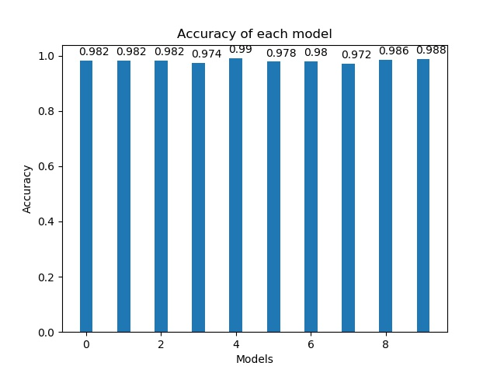
Supplementary Fig. S8 The performance of applying one model on the independent test set
Finally, the mode of the best performance is used in this study and provided for users. The trained model can be downloaded from https://drive.google.com/drive/folders/1j74IN6kPKEx9hy3aENx3zHYPUnyYWGvj?usp=sharing. In SVision, we use the tensorflow package to implement the AlexNet for CSV recognition.

3.3 Illustrator
Based on previous CSV publications, we observed that the CSV type definition is given by the abbreviation of the internal subcomponents, e.g., DelInv for deletion with inversion. This approach requires detailed description of the names, and it is also difficult to generalize between different studies. Here, we aim to propose a computational framework to define and compare different types of CSVs among various studies. Given segments coded in one-variant images, they indeed represent the differences and similarities between VAR and REF sequence. Thus, we would easily understand how these segments are rearranged in the sample genome respect to the reference one. Accordingly, SVision uses the graph data structure to describe the ‘jumping’ of rearranged segments in two steps. First of all, segment signatures contributing to SOI are extracted, which are matches between VAR and REF sequence. Meanwhile, gaps or unmatched sequence between VAR and REF could be extracted in two adjacent segment signatures. Segments representing discordant sequence between VAR and REF are collected and ordered according to their position on REF dimension. For instance (Supplementary Fig. S9A), nodes a, b, and c are collected from a simple deletion event, from which, the graph could be created by connecting a and c. Secondly, SVision connects the nodes according to their adjacencies on VAR dimension, and these edges are referred as adjacent edges ($E_{ad}$). Most importantly, adjacent edges should be added according to the orientation information coded in the third channel, such that inversions could be read from the graph representation (Supplementary Fig. S9B). Meanwhile, since the image also coded the duplicated sequence at the second channel, SVision adds duplication edges ($E_{dp}$) to connect insertion segments with known origin.
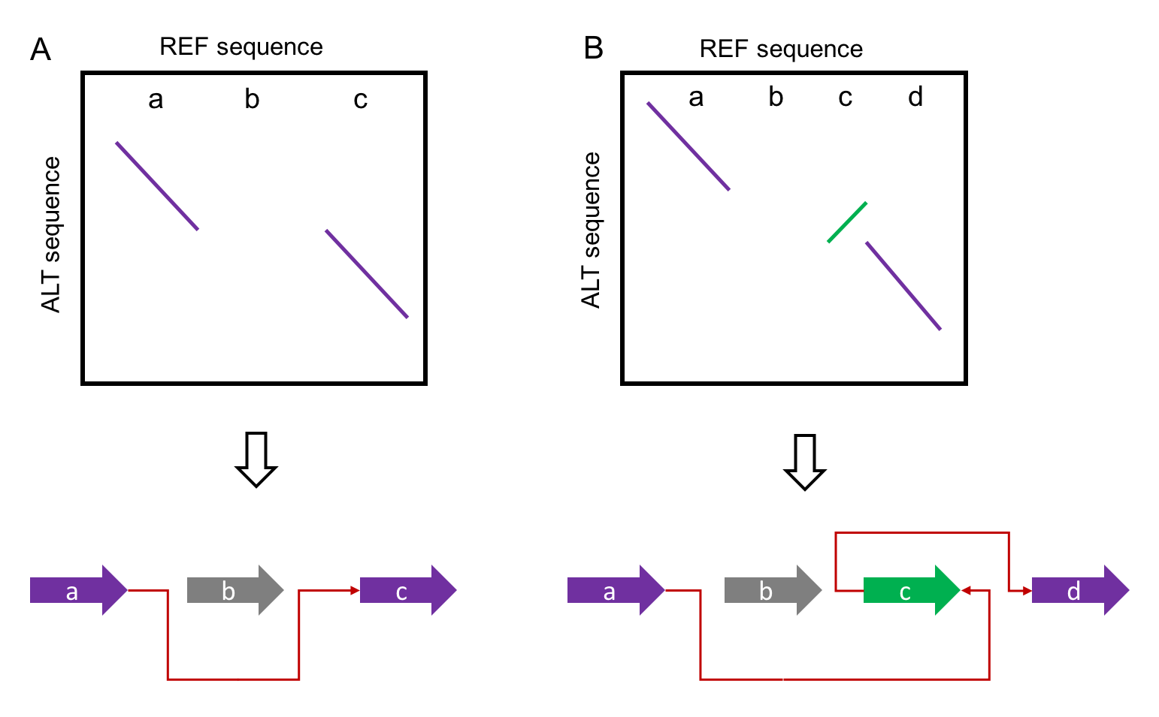
Supplementary Fig. S9 Examples of creating graph from similarity image
Next, SVision compares the graph topology similarities through a heuristic method. Note that the graph similarity is a NP-hard problem, while the ordered nodes simplifies this problem to a linear one. The comparison is mainly focus on the symmetric measure (Supplementary Fig. S10), where different node number leads to different graph structures. For the ‘Turn Over’ step in the comparison, the name of node is changed according to their order from another direction, e.g., S3 in the original path changes to S2 from the reverse direction. In the output, SVision assigns an ID to graphs of the same topology, and cluster events belong to the same topology. The ID might change if more calls are involved in the comparison. Besides ID, SVision also uses the path derived from the graph to differentiate different graph structures. The path read out is inspired by the breakpoint graph, where each interval has head and tail node. This implementation is straightforward to depict inversions involved in the graph. For example, a node visited in forward direction is denoted with the node name, such as S1, along with the ‘+’ sign, e.g., ‘S1+S1+’. The reverse direction is denoted as ‘S1-S1-’. Accordingly, if the graph contains three nodes, S1, S2, and S3, where S2 is visited in reverse direction. The path would be ‘S1+S1+S2-S2-S3+S3+’, which is simplified to ‘S1+S2-S2-S3+’ by removing part of the start (S1) and end (S3) node notations.
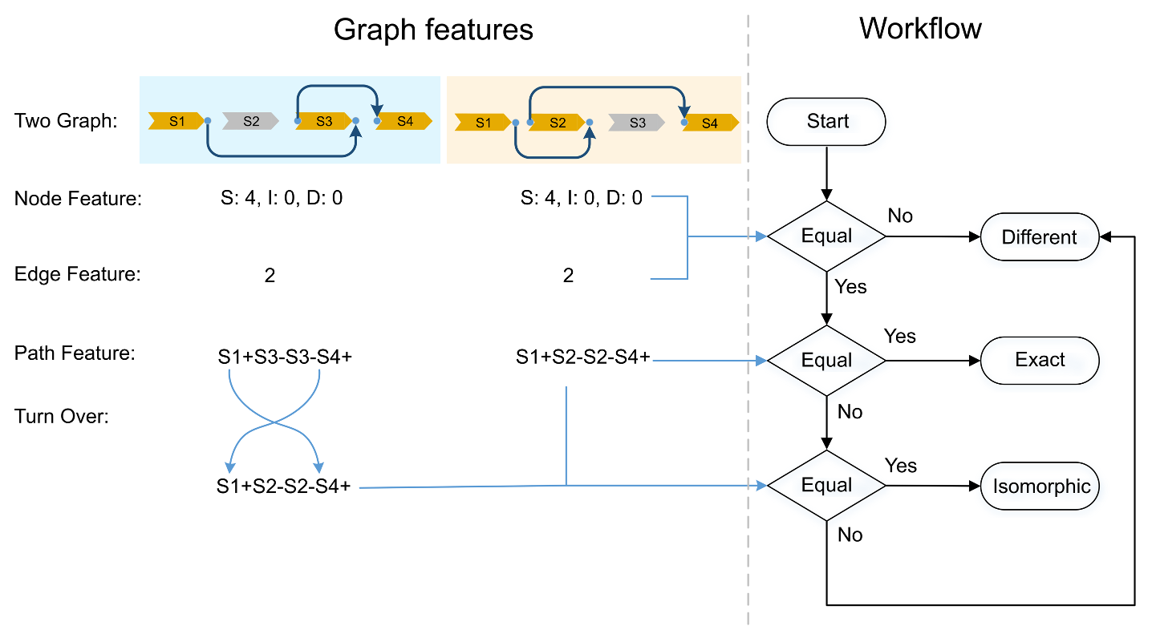
Supplementary Fig. S10 Workflow of identifying isomorphic graphs

3.4 Filtering and output
All translocation like events are reported according to split alignment at different chromosomes or intra-chromosomes of larger distance (default 100Kbp). For each SV, SVision combines the CNN output with the supporting evidence to measure the quality of a discovery, which scales from 0 to 100. Meanwhile, SVision counts the number of supporting reads and compares this to the user defined threshold (default: 5). The regions that used to filter SVision output was available at https://github.com/xjtu-omics/SVision/blob/master/supports/grch38.exclude_regions_cen.bed. In addition, we found two complex structure (Supplementary Fig. S11): 1) graphs contain nodes ‘S:2, I:2, D:1’, indicating the insertion is flanked by two duplicates; 2) graphs contain nodes ‘S:2, I:1, D:1’, indicating the insertion sequence is the direct repeat of local sequence. Events identified as these two complex structures (‘GraphID=0’ and ‘GraphID=3’) were filtered from the output based on the graph nodes and path information, leading to 261 CSVs (Supplementary Fig. S12). Moreover, the RepeatMasker and Tandem Repeat Masker annotated files were obtained from UCSC Genome Browser and used to annotate repeat element associated with each CSV loci. We used BEDtools intersect option to find overlaps between CSV loci and repeat elements. The repeat type was further assigned if the CSV region overlaps with the repeat element, while the size or percentage of overlaps was not required. For CSVs with multiple repeat types, the one with the largest overlapping region with the CSV was chosen. Meanwhile, CSV was annotated as STR if the repeat unit length < 7bp, otherwise, it was annotated as VNTR. The above filtering and annotation process were achieved by the customized scripts at https://github.com/jiadong324/SVisionUtils.
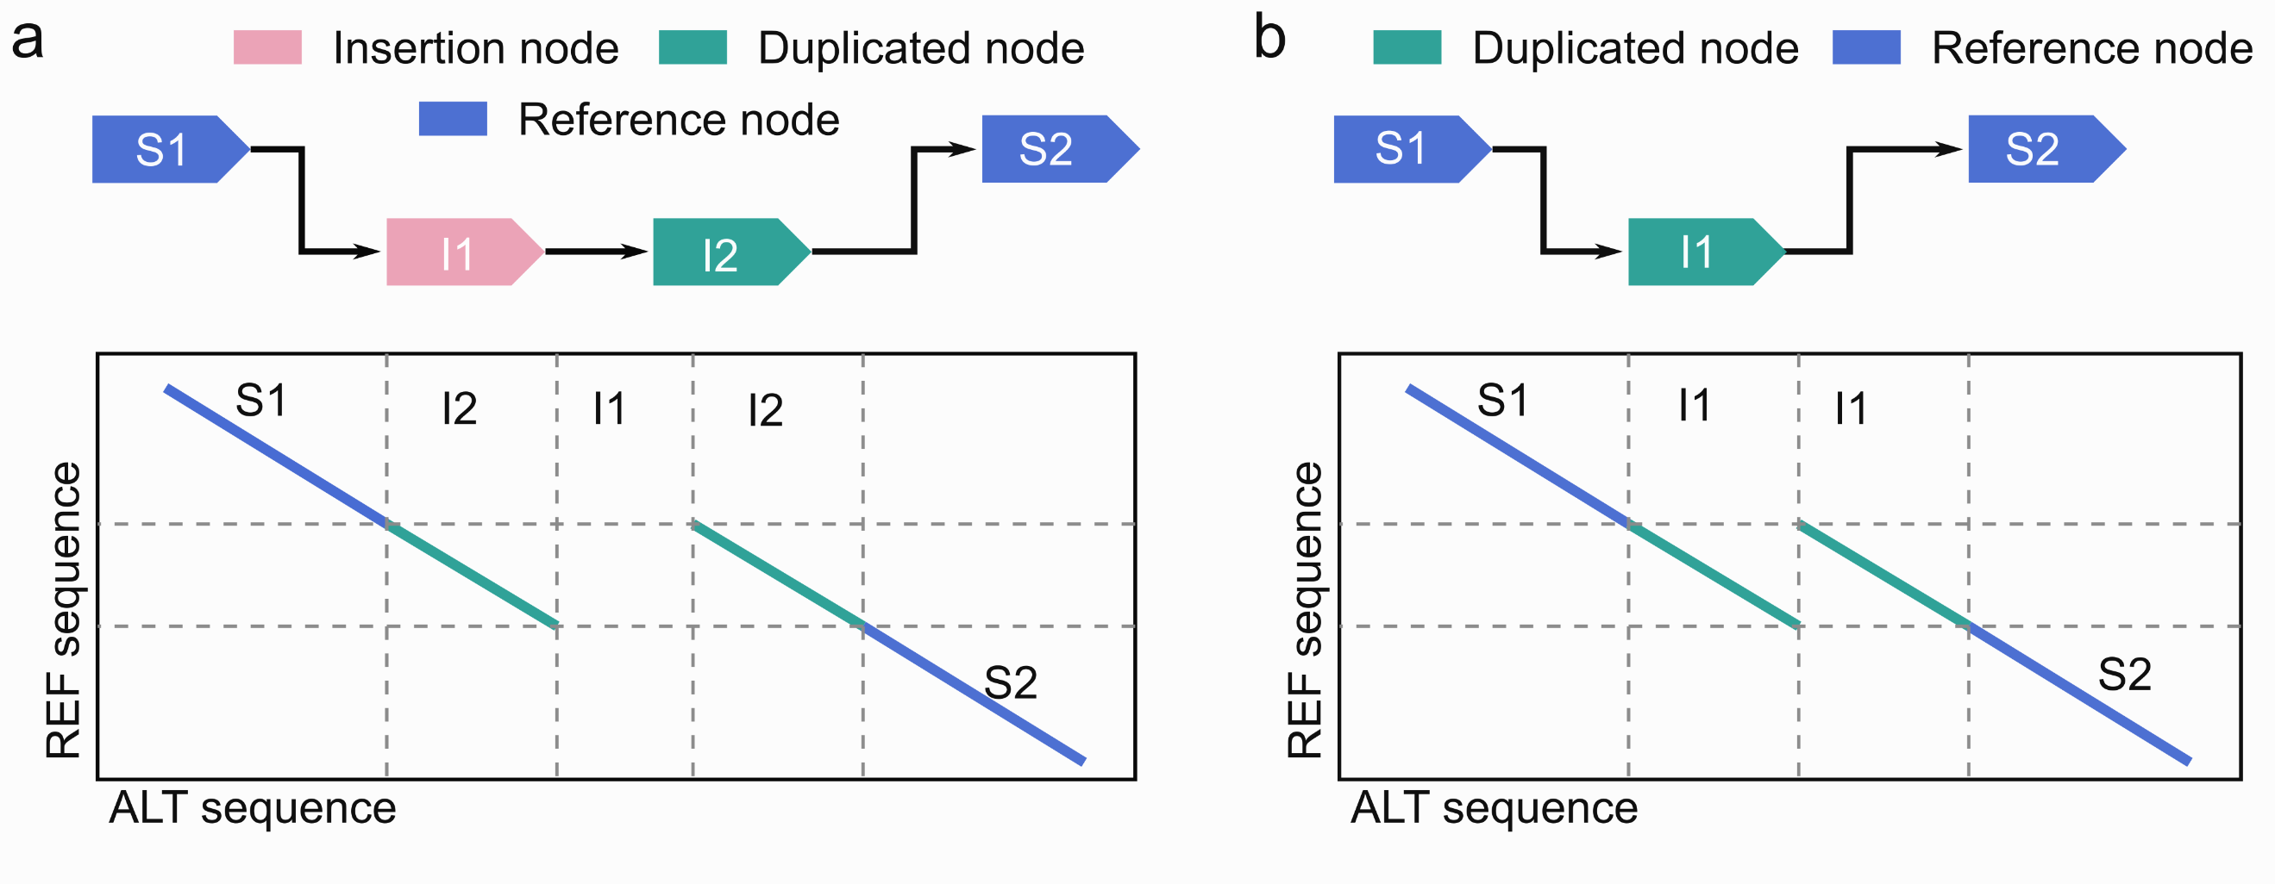
Supplementary Fig. S11 Simple structural variant type consisting of duplication and insertion breakpoints.
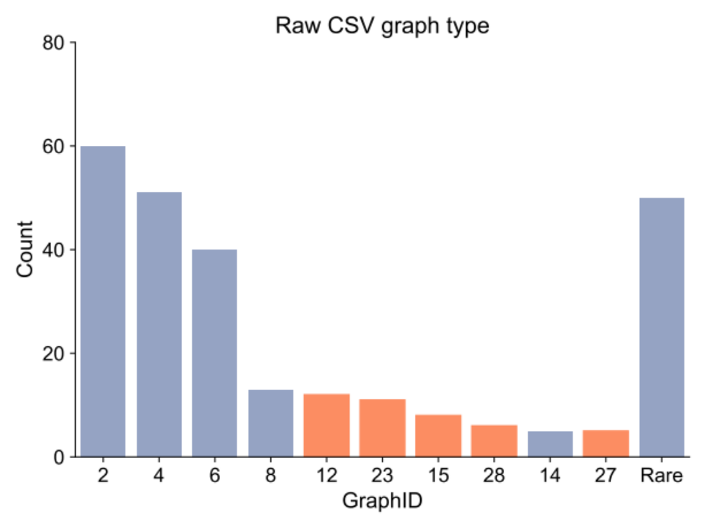
Supplementary Fig. S12 Classified graph type of 261 raw CSVs detected from HG00733 The orange bar indicated reported CSV types by previous publications.

3.5 Example SVs detected by SVision
For the CSV on gene CNTN5, SVision reports the high-quality supporting reads for this CSV (Supplementary Fig. S13). Similar event of the same alignment pattern (Supplementary Fig. S14) has also been detected at chr8:130,897,680-130,898,405 on gene ADCY8.
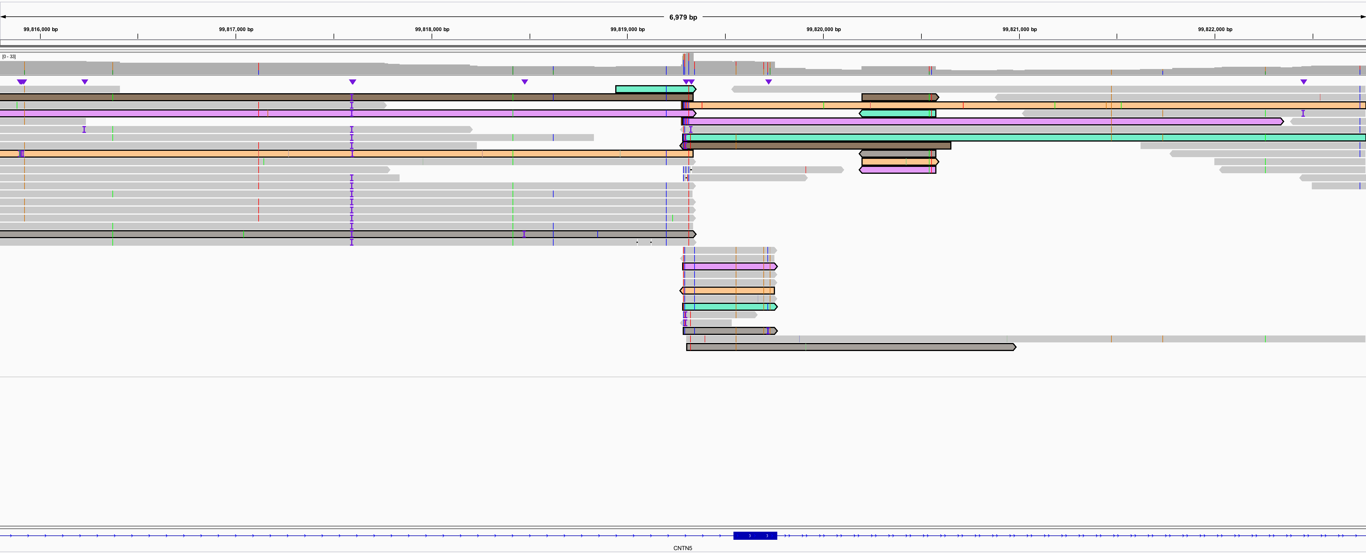
Supplementary Fig. S13 IGV view of CSV at chr11:99,819,283-99,820,576
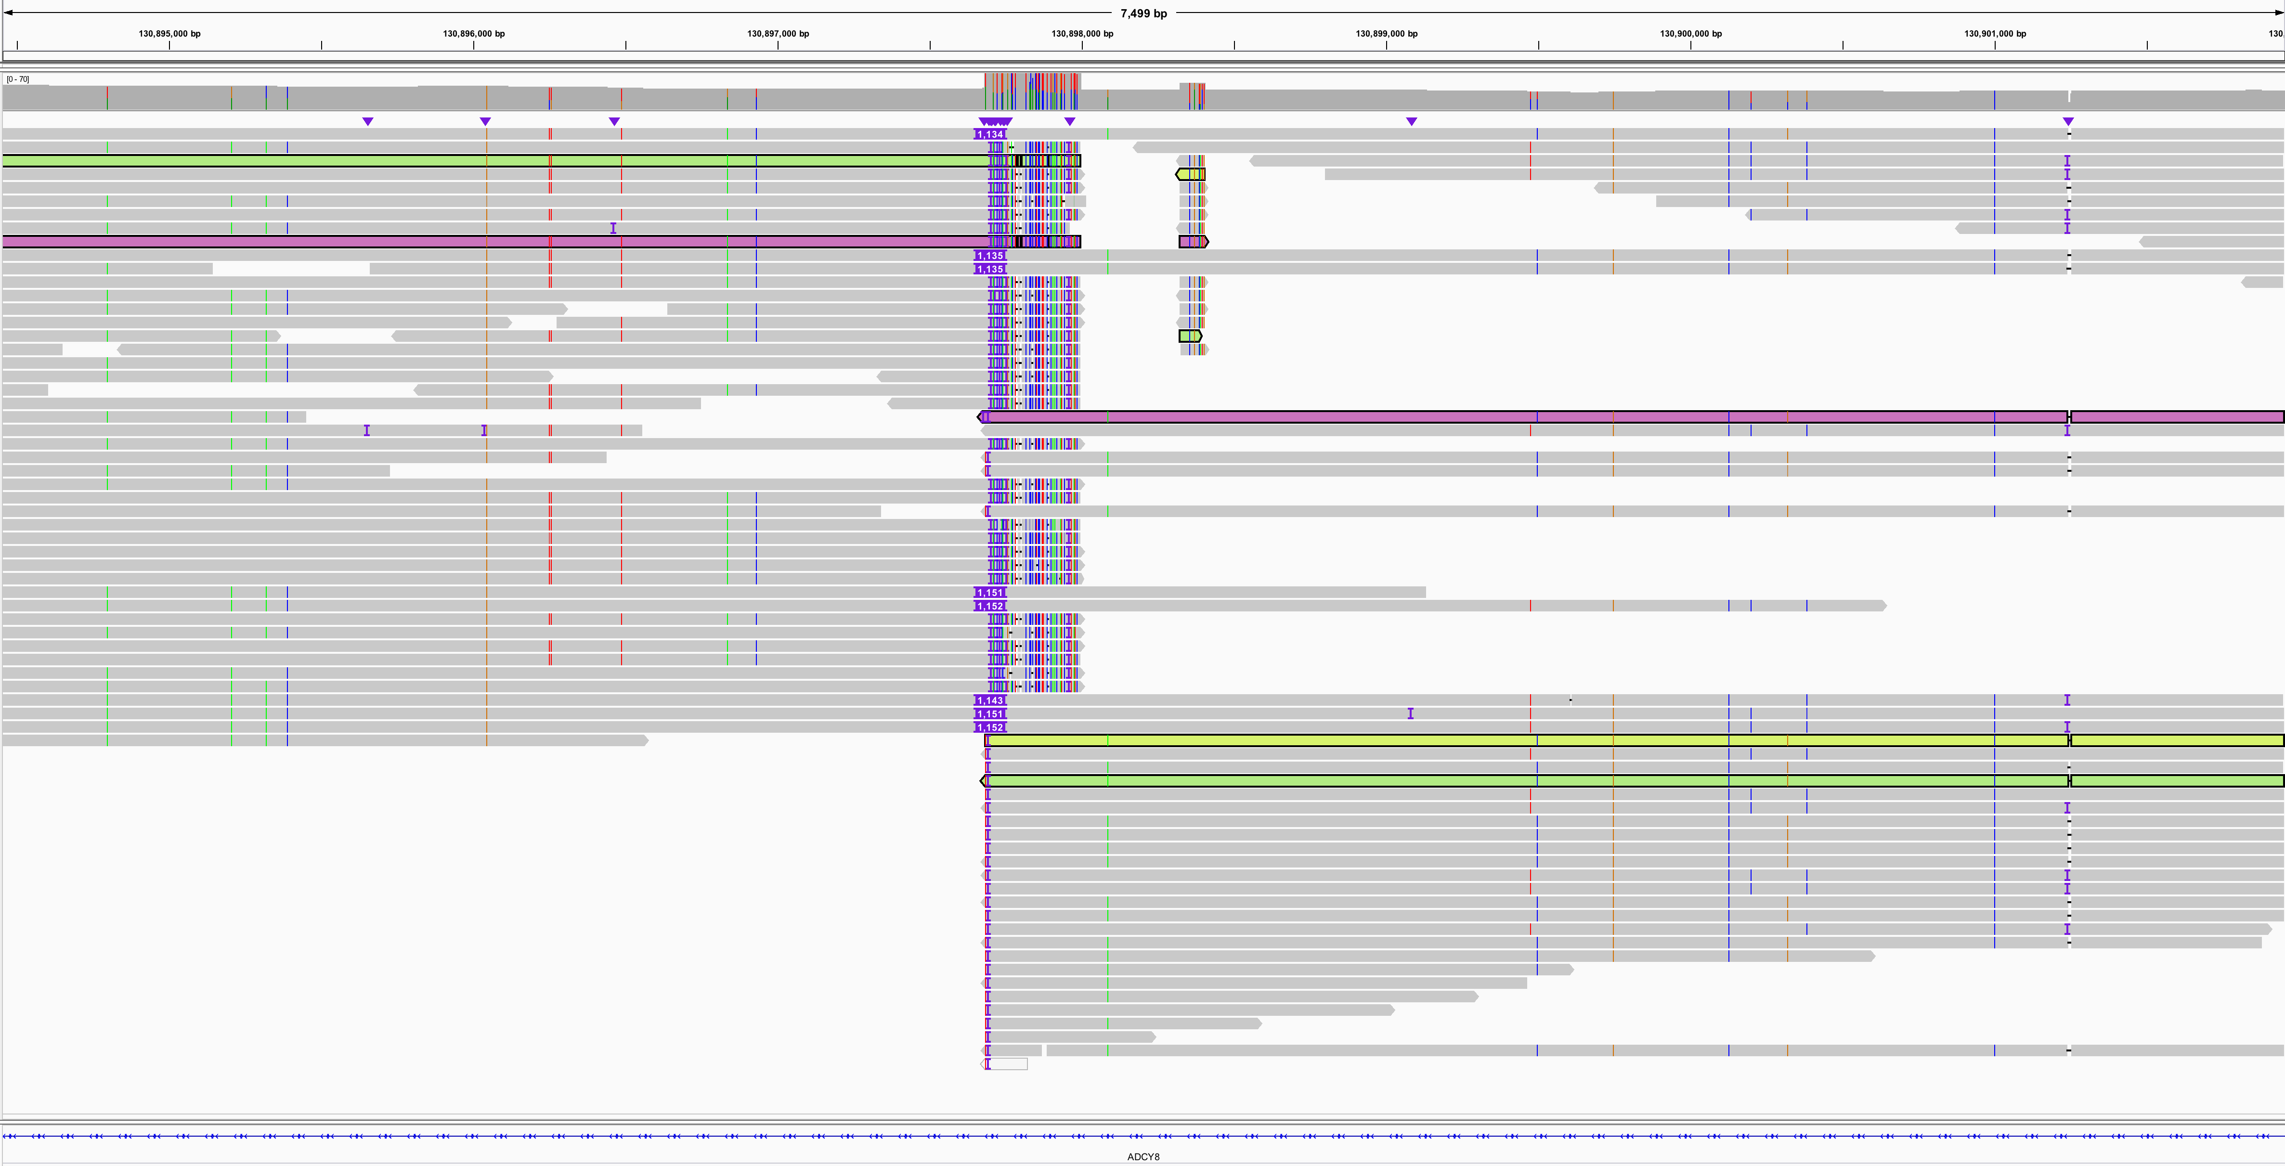
Supplementary Fig. S14 IGV view of CSV at chr8:130,897,680-130,898,405
Besides this novel CSV type, the most well characterized type deletion-inversion (e.g., event at chr9:74,283,222-74,283,473) could also be detected by SVision, while missed by Sniffles (Supplementary Fig. S15A). The alignment pattern of supporting reads is the same to that built by Sniffles. Another CSV type (e.g., event at chr2:61,473,618-61,476,320, Supplementary Fig. S15B), inverted duplication, was missed by all callers expect pbsv, but misinterpreted as canonical SV.
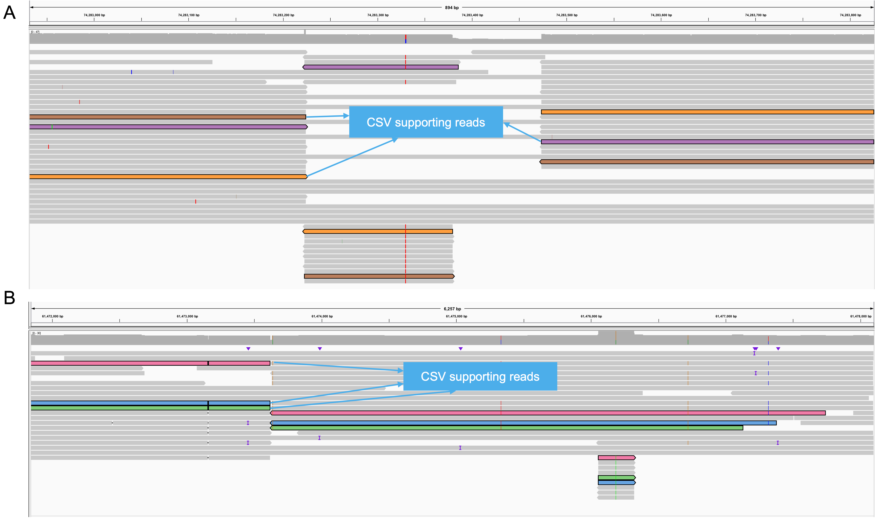
Supplementary Fig. S15 Examples of detecting deletion-inversion and inverted duplication
Moreover, SVision recognizes SVs from each variant feature sequence, thus it is able to distinguish regions with multiple SVs, referring as multi-allelic SV regions. For instance, human genome contains two haplotypes, it might contain two SVs (e.g., an insertion and a deletion) from each haplotype at chr11:26,529,116-26,529,291 on ANO3 (Supplementary Fig. S16). These two events are correctly detected and clustered to indicate potential multi-allelic SVs.
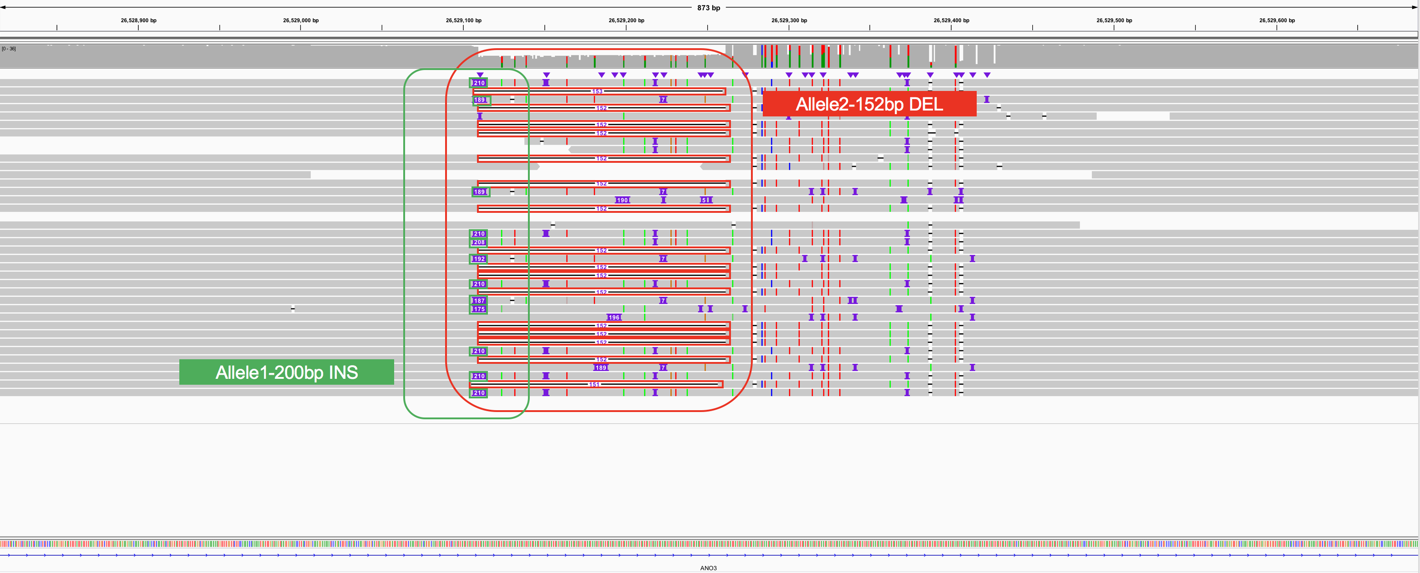
Supplementary Fig. S16 Example of multi-allelic SV region
Another advantage of detecting directly from sequence is that it could better characterize complex events involved multi-allelic SV regions, especially for those could not be resolved from CIGAR directly. For instance, site at chr11:68,956,045-68,956,288 contains an insertion and a tandem duplication (tDUP) were missed all missed by CuteSV, while the insertion was detected by Sniffles and pbsv (Supplementary Fig. S17).
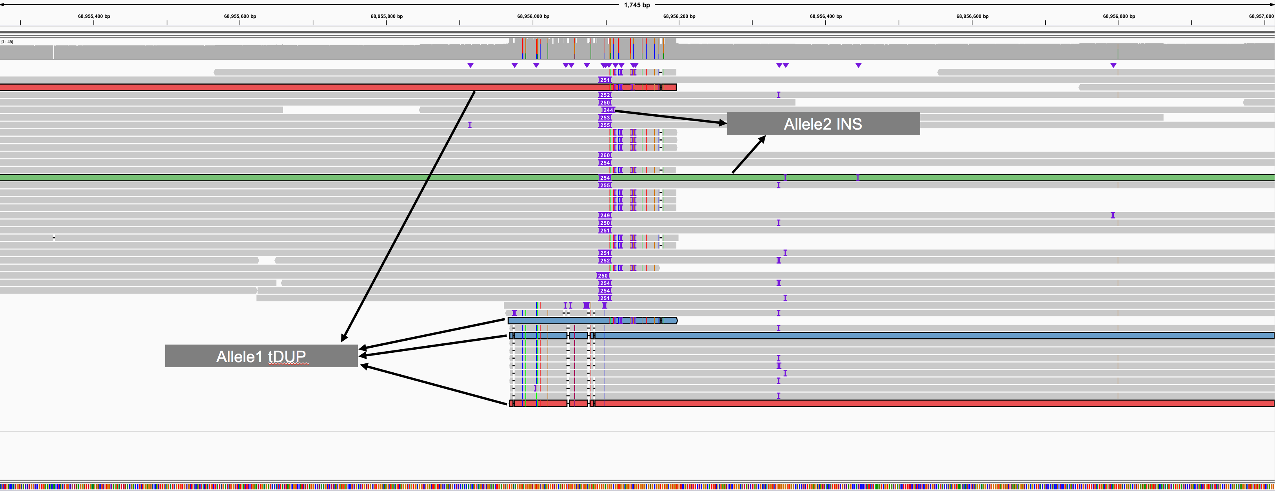
Supplementary Fig. S17 Example of multi-allelic SV region

3.6 CSV graphs
The graph comparison method names each CSV graph with a certain ID, which does not have specific meanings. On the contrary, if more CSV graphs are involved in the analysis, the graph ID might change correspondingly even for graph of the same topological structure.

4. Performance evaluation

4.1 Evaluation of simple SV detection on NA12878
Besides HG002 evaluation, we also examined simple SV detection with the NA12878 PAV calls. The support read is five of a valid call for each caller, where PAV identified more SVs of length around 50bp and 300bp (Supplementary Fig. S18). The PAV calls at chr1 to chrX and SVs larger than 50bp are used as benchmark set to assess the recall and precision of each caller. We considered a correct detection had 50% reciprocal overlap with a PAV call, where the ‘-c’ option is activated for BEDtools intersect to avoid redundancies. Detections of each caller that failed the reciprocal test are considered as false discoveries. SVision outperformed other callers for SVs across different size range (Supplementary Fig. S19).
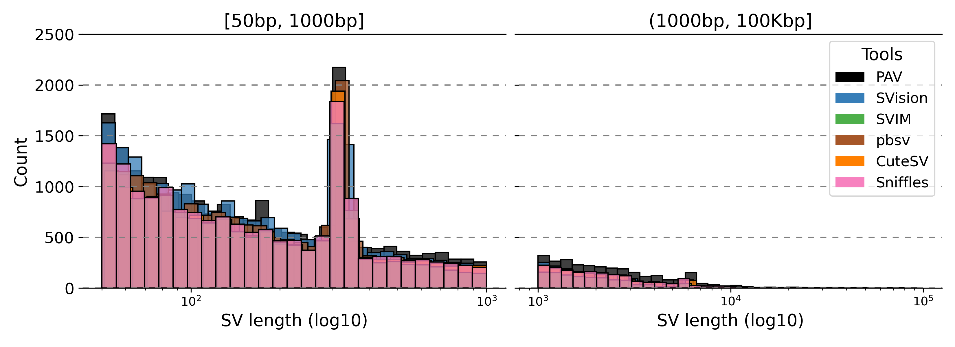
Supplementary Fig. S18 Size distribution of PAV calls and SVs detected by other callers
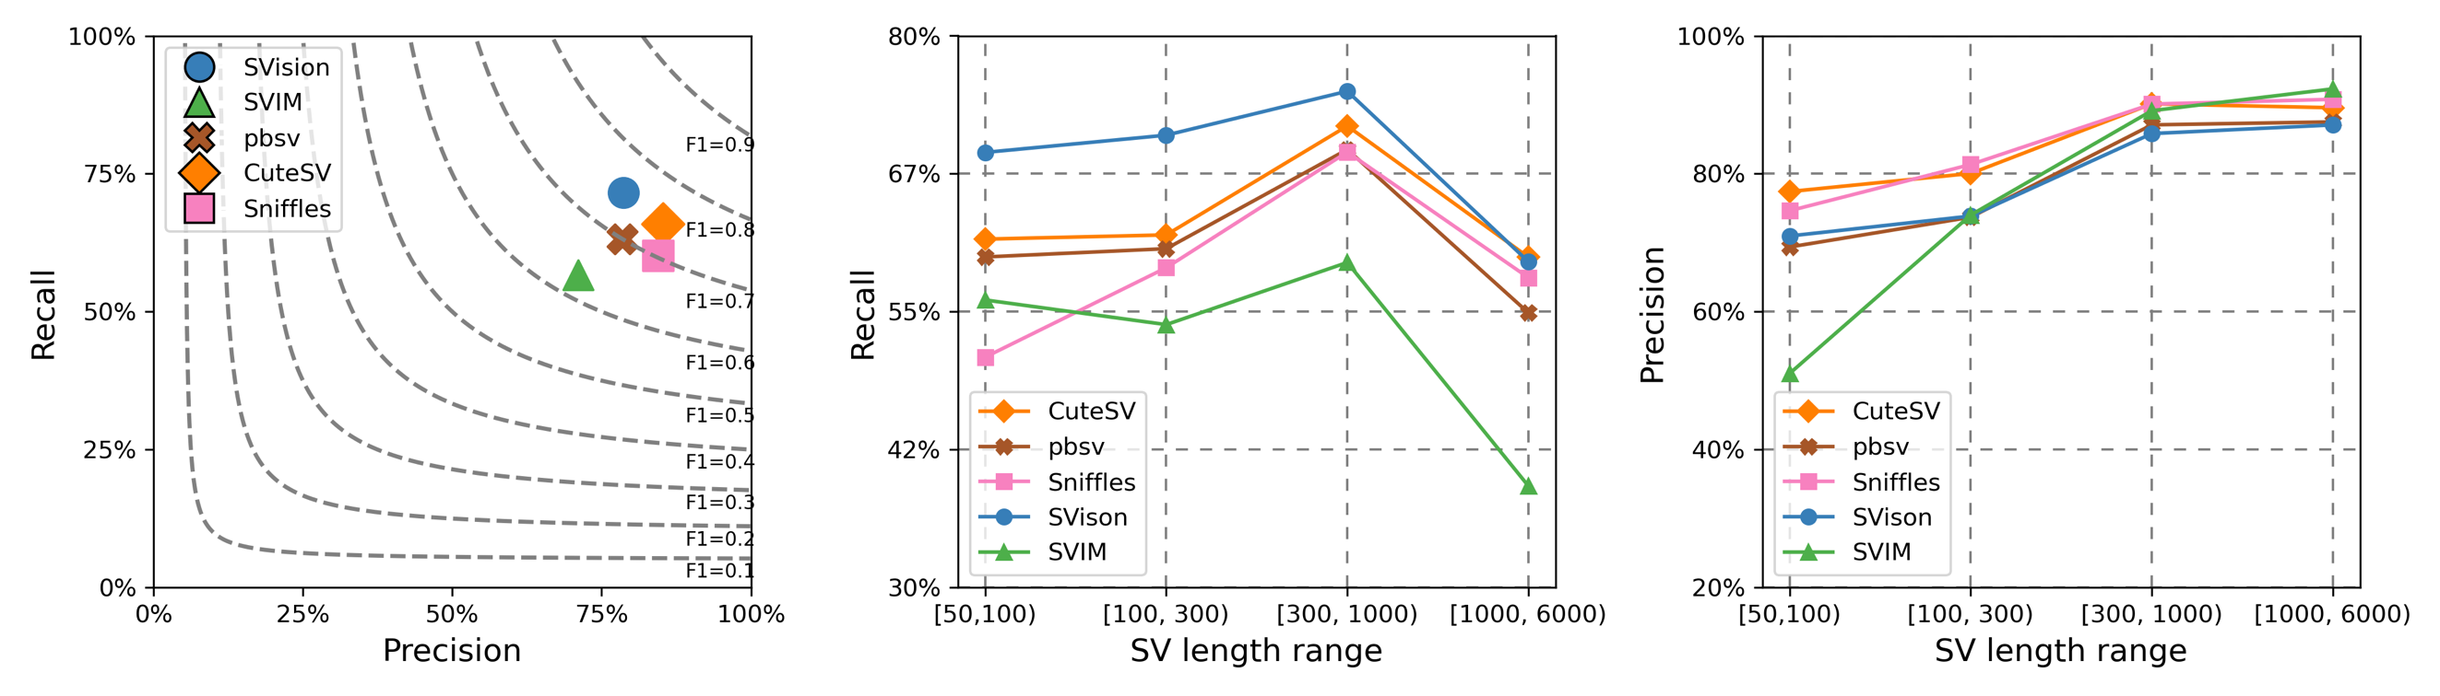Supplementary Fig. S19 Recall and precision of each caller evaluated with PAV calls

4.2 Impact of supporting read for simulated CSV detection
We run each caller with different supporting read (i.e., 1, 3, 5, and 10), and the performance of correctly detecting simulated CSVs are examined correspondingly. SVision outperforms other callers evaluated by region-match and exact-match, and its precision increases as the number supporting reads increase (Supplementary Fig. S20).
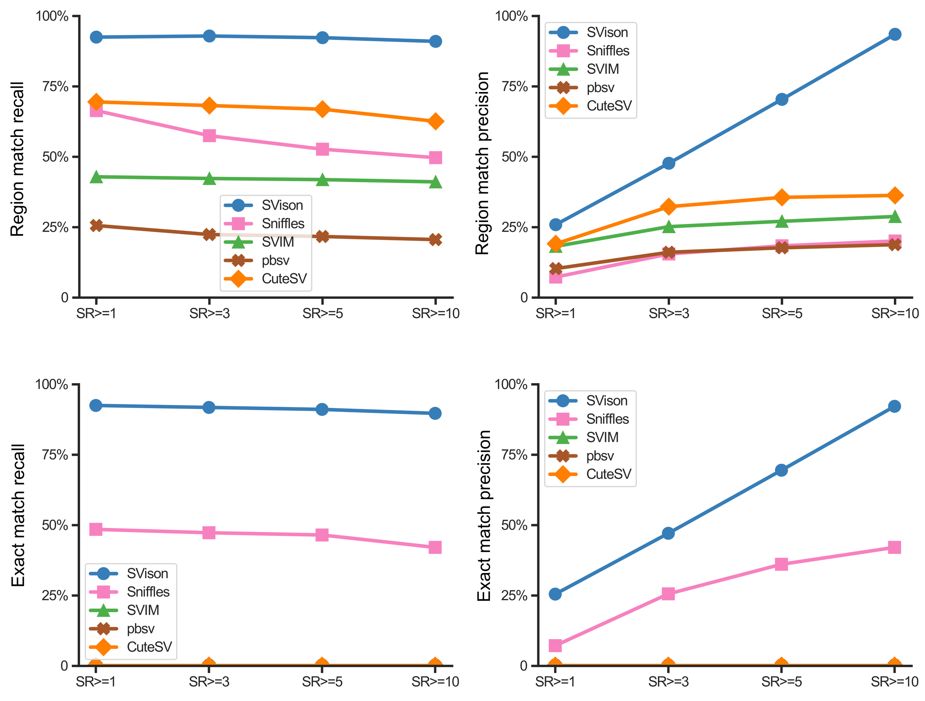
Supplementary Fig. S20 Performance of detecting simulated complex structure variants with different number of supporting reads.

4.3 Evaluation of CSV detection on NA12878
The CSV set of NA12878 was obtained from the 1000 Genomes Project publication [1], including events from the supplementary table 12 and 15 in the original publication, containing 62 and 251 CSV sites in hg19 coordinates, respectively. Based on the latest HiFi sequencing of NA12878 released by Human Genome Structural Variants Consortium (HGSVC) [2], we aligned HiFi reads with ngmlr (v0.2.7) default settings and manually inspected the Dotplot of every read that overlaps with the CSV site. Briefly, SAMtools and Gepard were used to extract HiFi reads and generate Dotplot, respectively, from which 18 CSVs and 64 simple SVs were visually confirmed (Supplementary File 1). Afterwards, SVision was applied to the ngmlr (v0.2.7) alignment for CSV discovery with default setting. We then compared the SVision detected CSV with the 18 CSVs by examining whether SVision is able to fully interpret the full CSV structure. For example, for a delINV event that contains deletion and inversion as subcomponents, a correct SVision detection should reveal both the inversion and deletion breakpoint.

4.3.1 Misinterpreted deletion at chr9:71,895338-71,896,537
The reference sequence of segment A, B, C, A’ and B (Fig. 1e) were extract from human reference hg19, and discordant orientation and insert-size alignments were identified from IGV (Supplementary Fig. S21). The reference sequence at this locus is mapped to clone RP11-16N10 with Blast. RP11 is one of the original Human Genome Project clones and still makes up 70% of hg38. The accession for this clone sequence, AL358113.21, matches hg38 at chr9:69,164,283-69,294,001. All 129,719 bases of the clone are stitched into the reference at that location, suggesting the same pattern of local sequence content, i.e., inverted duplication and dispersed duplication. Afterwards, we investigated the alignment of NA12878 on hg38 at chr9:69,164,283-69,294,001 (Supplementary Fig. S22), from which the same signal was observed in hg19 alignments (Supplementary Fig. S21).
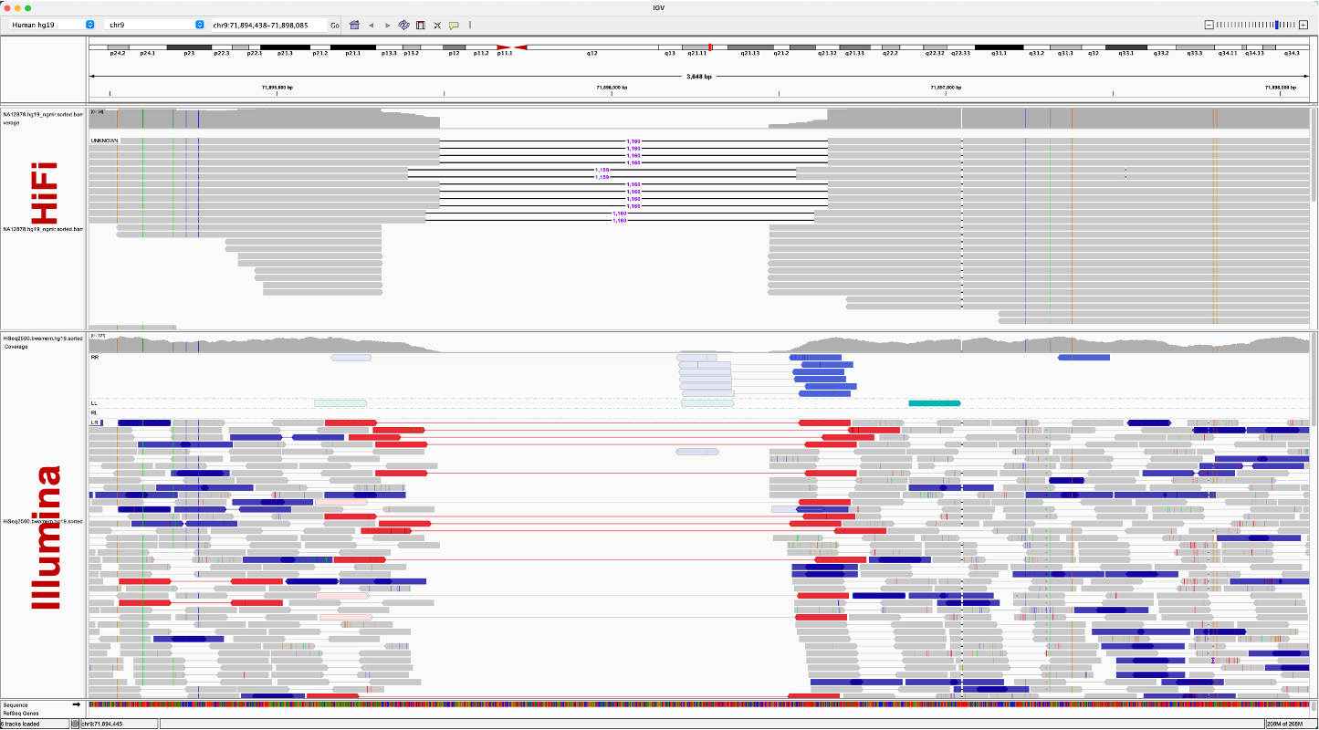
Supplementary Fig. S21 The discordant alignment of HiFi and Illumina reads at the complex genomic region on hg19 at chr9:71,894,438-71,898,085
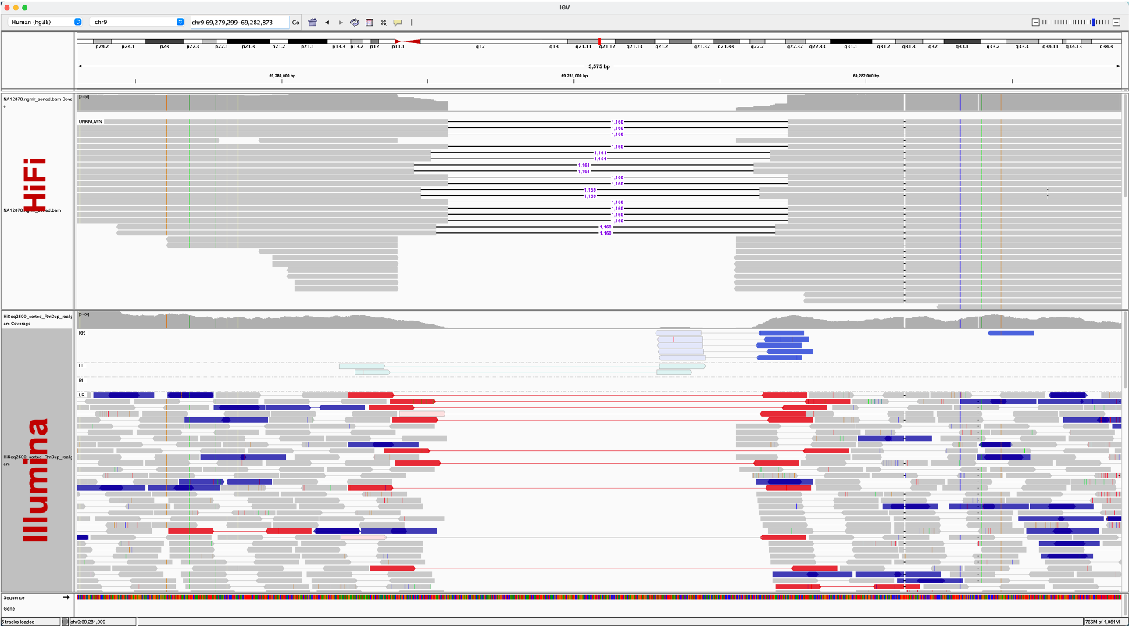
Supplementary Fig. S22 The discordant alignment of HiFi and Illumina reads at the complex genomic region on hg38 at chr9:69,279,299-69,282,873

4.3.2 Unclassified CSV at chr17:5,594,699-5,595,567
The short-read unclassified CSV event could be interpreted as deleted sequence replaced by complex insertion. To find the origins of the inserted sequence, we Blast the inserted sequence consisting of inverted and tandem duplications (Extended Data Fig. 4a), which was mapped to clone ABC13_947722_D4 of sequence ID AC270019.1. This sequence matches hg38 patch release 13 (GRCh38.p13) but absent from hg19, indicating a templated insertion sequence replaced the hg19 reference sequence in NA12878 at this locus. Though this complex event is originated from reference defect, it shows that SVision is able to characterize complex events of such structure.

5. Analysis and validation of CSVs detected from HG00733

5.1 Variant reconstructed from phased assemblies
The PAV calls are recently published by HGSVC, which is detected from high-quality haplotype-aware assembly of human genomes. Given this near comprehensive SV calls, we aim to understand whether the detected CSV loci contain variants, i.e., region match. Therefore, we test the overlap between PAV calls and SVision detected CSVs by using command ‘bedtools intersect -wo –a svision_csv.bed –b pav.bed’. As a result, those non-overlapped are considered as SVision novel discoveries and others are further examined manually via Dotplot. We first manually inspected the overlaps between PAV and CSV, from which, CSV loci matched multiple PAV calls were identified (Supplementary Table S8). Secondly, PAV call support contig (TIG_REGION column) was used to extract the sequence harboring variant according to the haplotypes (GT column). For example, the sequence was extracted from the h1 assembled genome for ‘1|1’ and ‘1|0’ genotype, while h2 assembled genome was used for ‘0|1’. Note that we extended 2Kbp both upstream and downstream to extract the variant sequence, while reference sequence was extracted by extending 5Kbp of SVision detected CSV loci. Specifically, both variant sequence and reference sequences are extracted via BEDtools getfasta option.

5.2 Graph-based validation
The graph-based validation was achieved via GraphAligner, and we counted the number of alignments that support the VAR path derived from CSV graph rGFA file. Specifically, some CSV graph path could be covered by a read in one alignment record, while some of them were kept in two records. Therefore, a CSV is verified by an ONT read if the CSV path is covered by one or more alignments originated from this ONT read, and this ONT read is defined as CSV supporting reads. We then count the total number of supporting reads for each CSV. In addition, we found one case that could be verified with two alignments originated from two different reads, considering as invalidated event (Supplementary Fig. S23).
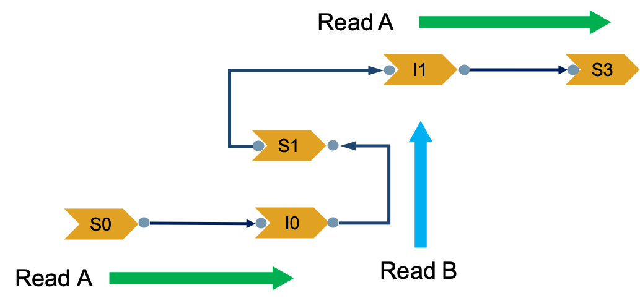
Supplementary Fig. S23 Complex structural variant supported by two different reads.

5.3 Experimental validation
(Contributors: by Christine Beck, Peter A Audano)
To validate the structures and sequences of the CSVs determined by SVision, we first determined that half of the 80 CSVs (39/80) were intractable for PCR due to their location within segmental duplications, the size of the amplicon needed to validate the rearrangement, or the simple repeat nature of the rearrangement. We then randomly selected 20 of the remaining rearrangements, and performed BLAT on the local region from the HG0733 assembly data. This resulted in concordant SV types for the SVision calls and our manual curation of the assembly data in 20/20 instances. We next attempted to PCR each of the 20 CSVs. Briefly, we designed primers flanking the CSV or flanking breakpoints within the CSV for each of the 20 events (Supplemental Table S12). Next, we attempted to amplify each region using Takara LA taq. We obtained the predicted band size for 12 of the 20 variant loci; the remaining 8 regions did not amplify in 3 separate attempts with alterations of the PCR conditions and template amounts. Each of the PCR products were sent to Sanger sequencing, were validated as on target, and contained the correct amplicon with the breakpoint from the assembly and SVision call.

5.4 Comparison with Illumina calls
The Illumina calls (V1.34) of the used samples were published by HGSVC [2]. The latest version (V3) was used to compare with the CSV detected by SVision from HG00733, which was available at http://ftp.1000genomes.ebi.ac.uk/vol1/ftp/data_collections/1000G_2504_high_coverage/working/20210124.SV_Illumina_Integration/. The complex calls (CPX) for HG00733 were selected from the merged VCF file based on the genotype ‘0/1’, ‘1/1’ and ‘1/0’. Similar to the evaluation metric used in the simulation CSV comparison, from which, the region match and exact match were obtained. Note that for the exact match, the Illumina calls should report identical breakpoint type as SVision did, and the breakpoint position should within 500bp of SVision’s breakpoints.

5.5 RNA-Seq analysis of one CSV at CNTN5
CNTN5 is a member of the immunoglobulin superfamily and contactin family, which mediate cell surface interactions during nervous system development. Based on the data from The Human Protein Atlas, we found this gene is specifically expressed in brain related tissues, such as cerebral cortex. We used the data from the study ‘Defining early changes in Alzheimer's disease from RNA sequencing of brain regions deferentially affected by pathology’, where the RNA-Seq data could be accessed in SRA with PRJNA720779. Briefly, this study sequenced 9 precuneus and 10 primary visual cortex samples from healthy and Alzheimer disease. The RNA-Seq data was aligned with hisat2 and duplicated exon signatures could be identified from the discordant read-pair alignments, i.e., abnormal aligned read-pair in reverse and forward direction. We also observed read depth change on exon 4, suggesting potential duplication. Due to the limited read length, we were not able to examine the status of alternative splicing.

5.6 Analysis of one insertion-inversion-insertion event
(Contributors: by Peter A Audano)
The CSV at chr9:74,283,222-74,283,473 was seen by PAV-minimap2, PAV-LRA, independent LRA call set (generated by Mark Chaisson), DeBreak (generated by Zechen Chong), Inspector (generated by Zechen Chong), breakpoint k-mers support across the 1KG cohort (generated by Tobias Rausch). This variant was not detected in previous long-read callsets (Chaisson 2019 or Audano 2019) and it was missed by PBSV (called a small simple inversion). As expected, it also missed by BioNano and DeepVariant (not in their size range). The variant was in 92% of haplotypes by discovery over the 64 long-read haplotypes. PanGenie could confidently re-genotype, and it found 80% allele frequency among the 2,504 1KG cohort (frequency calculation done after removing parents). Among the superpopulations, the inserted (ancestral) state ranges from 99% (EAS) to 75% (EUR) with others falling in the middle (88% in AFR, AMR, and SAS; 86% in AMR), which is consistent with the derived (reference) state arising in Europeans.
The insertional sequence of CSV at chr9:74,283,222-74,283,473 was extracted from HiFi assembly and Blast against several primate genomes. As a result, the insertional sequence was found in pan troglodytes (sequence ID: SSBP03006069.1) and gorilla (sequence ID: SRLZ01004541.1) with 99% sequence identity. Moreover, it was also found in pongo abelii (97% sequence identity, sequence ID: ABGA01408009.1) and Hylobates moloch (96% sequence identity, sequence ID: WKKJ03000010.1). To further validate the insertion in primate genomes, the assembly of chimpanzee and gorilla were mapped to GRCh38 with minimap2 and called variant with PAV, from which the same insertion event was identified.

6. Simulating complex structural variants

6.1 General workflow for the simulation
We developed a pipeline to simulate complex structural variants (CSV), which are also termed as nested variants (Supplementary Fig. S24). This pipeline has been used in our previous study, where we used VISOR (https://github.com/davidebolo1993/VISOR) and followed the idea of creating nested events used in Sniffles. In the simulation, we treated each type of structural variants as basic operation, which were used to create all CSVs. First of all, we prepared all operations that used in the simulation, including simple events and two duplication events (Tandup and TanInvdup) directly created by VISOR. Another two basic opertaions, dispered inverted duplication (DisInvdup) and dispersed duplication (Disdup) were generated with new functions, which were also included in our pipeline. Secondly, we randomly added basic operations to the existing events implanted on the genome. Specifically, a CSV was simulated by adding events to the flanking regions of existing events. For example, Tandup+DEL is created by adding deletion to a Tandup event created by VISOR. Moreover, Tandup+DEL+INV is created by adding two additional events at each side of a deletion.
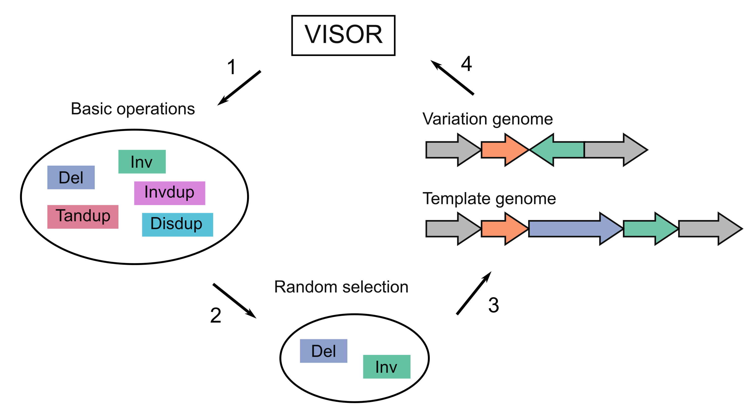
Supplementary Fig. S24 The workflow of simulating complex structural variants.

6.2 Simulated CSV types
The CSV structures reported by 1KGP included ‘Ins and Del’, ‘Ins with Dup and Del’, ‘Ins with MultiDup and Del’, ‘MultiDel with Inverted or non-inverted spacer’, ‘Inv and Del’ and ‘Inverted Dup’. Specifically, ‘Inverted Dup’ was simulated as CSV structure of ID1 and ID2. ‘MultiDel with Inverted or non-inverted spacer’ and ‘Inv and Del’ were simulated as ID4. Moreover, we considered ‘Ins and Del’ as the super-class of ‘Ins with Dup and Del’ and ‘Ins with MultiDup and Del’, and ‘Ins and Del’ were simulated as ID5, ID6, ID7 and ID8 with different insertion configurations. Secondly, we expanded the simulated CSV structures introduced by ASD study, where ‘cpdCNV’, ‘codINS’, ‘cpdINSdel’ and ‘CCR’ were excluded due to lack of precise structure schematic. In the ASD study, we noticed that the reported CSV structures ‘delINV’, ‘INVdel’ and ‘delINVdel’ were equal to ‘ Inv and Del’ and ‘MultiDel with Inverted or non-inverted spacer’ that reported by 1KGP, and ‘dupINV’, ‘INVdup’, ‘dupINVdup’ and ‘IR’ were of the same structure as ‘Inverted Dup’ that classified by 1KGP. Moreover, ‘Ins and Del’ and its two subclasses were reported as ‘INSdel’, ‘dupINVdel’, ‘delINVdup’ and ‘dDUPdel’ by the ASD cohort. Thirdly, we simulated ‘dDUP’ (dispersed duplication) as ID3, and it was used to create two highly complex CSV structures of ID9 and ID10. Specifically, ID9 and ID10 were simulated by adding direct and inverted repeats to the deletion associated with inversion event, respectively.

6.2 Major steps

6.2.1 Creating simple SVs with VISOR
In this step, we simulated 5 events genome-wide on non-N regions with VISOR.
Rscript randomregion.r -d chrom.dim.tsv -n num -l 500 -s 150 -v 'insertion,deletion,inversion,tandem duplication,inverted tandem duplication,dispersed duplication,dispersed inverted duplication' -r 20:20:20:20:20' -x exclude_regions.bed | sortBed > random.bed

6.2.2 Adding simple SVs to flanking regions
We developed a pipeline add_flank.py to randomly add events to existing SVs on the genome. Finally, we simulated 10 subtypes of CSVs for performance benchmarking.
Python add_flank.py -i randem.bed -w /path/to/ouput -c chromosome -p /path/to/chromosome.fa

6.2.3 Creating the CSV genome
We use the function in VISOR to implant the CSVs created in step2.
VISOR HACk -g grch38.fa -bed randem.nested.bed -o /path/to/output
6.2.4 Simulating HiFi reads and alignment
Simulating HiFi reads in 30X with VISOR LASeR function.
VISOR LASeR -g reference.fa -s CSV_genome.fa -bed purity.bed -o /path/to/output -c 30
Aligning HiFi reads to reference genome GRCh38 with NGMLR
ngmlr -r reference.fa -q *.fastq -o /path/to/output

7 Software version and parameters

7.1 Sniffles (V1.0.11)
Sniffles calls with different read support were filtered according to the SUPPORT in the INFO column.
sniffles -m /path/to/sample.sorted.bam -v /path/to/sniffles.vcf -l 50 -s 1 –cluster

7.2 SVIM (V1.3.1)
SVIM calls with different read support were filtered according to the SUPPORT in the INFO column.
svim alignment --cluster_max_distance 1.4 /path/to/output /path/to/sample.sorted.bam /path/to/reference.fa

7.3 CuteSV (V1.3.8)
CuteSV calls with different read support were filtered according to the RE in the INFO column.
cuteSV /path/to/sample.sorted.bam /path/to/reference.fa /path/to/cutesv.vcf /path/to/work_dir --max_cluster_bias_INS 1000 --diff_ratio_merging_INS 0.9 --max_cluster_bias_DEL 1000 --diff_ratio_merging_DEL 0.5 --min_support 1

7.4 pbsv (V2.3.0)
Pbsv calls with different read support (SR) were selected by setting –A, -O, -S, and –P parameters.
# SR>=1
pbsv call -A 1 -O 1 -S 0 -P 1 /path/to/reference.fa /path/to/sample.svsig.gz /path/to/pbsv.s1.vcf -m 50
# SR>=2
pbsv call -A 2 -O 2 -S 0 -P 1 /path/to/reference.fa /path/to/sample.svsig.gz /path/to/pbsv.s2.vcf -m 50
# SR>=3
pbsv call -A 3 -O 3 -S 0 -P 1 /path/to/reference.fa /path/to/sample.svsig.gz /path/to/pbsv.s3.vcf -m 50
# SR>=5
pbsv call -A 5 -O 5 -S 0 -P 1 /path/to/reference.fa /path/to/sample.svsig.gz /path/to/pbsv.s5.vcf -m 50
# SR>=8
pbsv call -A 8 -O 8 -S 0 -P 1 /path/to/reference.fa /path/to/sample.svsig.gz /path/to/pbsv.s8.vcf -m 50

References

1. Sudmant PH, Rausch T, Gardner EJ, Handsaker RE, Abyzov A, Huddleston J, Zhang Y, Ye K, Jun G, Fritz MH, et al: An integrated map of structural variation in 2,504 human genomes. Nature 2015, 526:75-81.
2. Ebert P, Audano PA, Zhu Q, Rodriguez-Martin B, Porubsky D, Bonder MJ, Sulovari A, Ebler J, Zhou W, Serra Mari R, et al: Haplotype-resolved diverse human genomes and integrated analysis of structural variation. Science 2021, 372.

