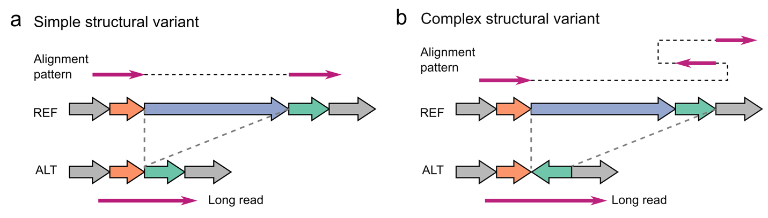
Extended Data Fig. 1 | Diagram of example simple and complex structural variants and their aberrant alignment patterns. a, The diagram and alignment pattern of a simple deletion. b, The diagram and alignment pattern of a deletion associated with inversion, where the inverted segment occurred at the 3’ flank region of the deletion.

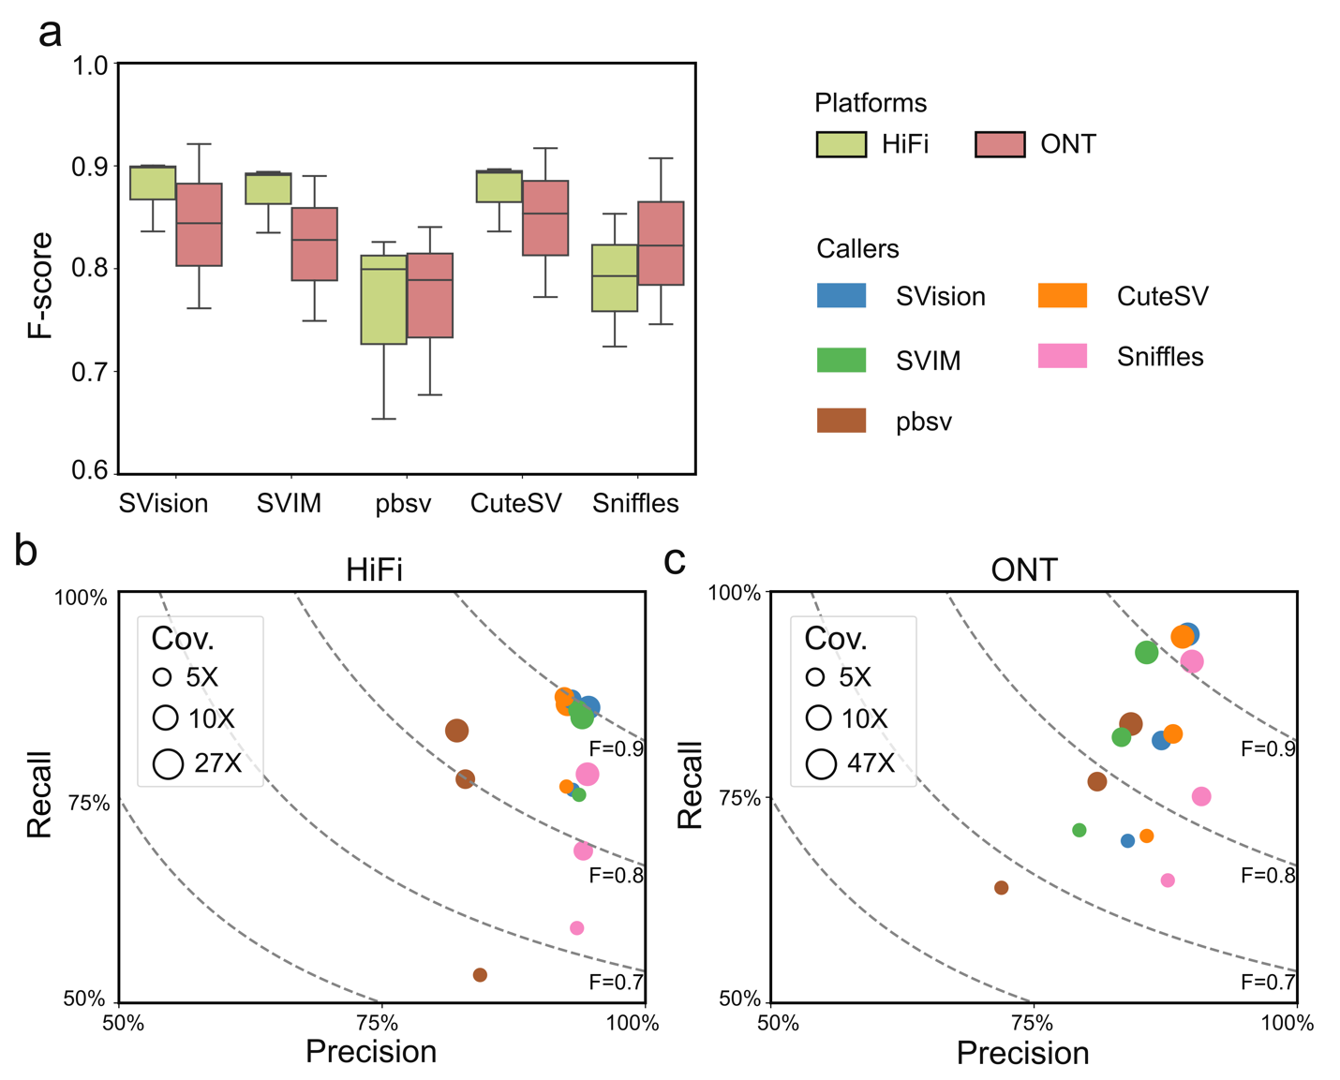
Extended Data Fig. 2 | Performance evaluation of callers with HG002 truthset at different coverages and platforms. a, F-score of callers on different platforms evaluated with Truvari. b, The precision (x-axis), recall (y-axis) and F-score (F, dotted line) measurements of detecting SVs from HiFi data at different coverages. c, The precision and recall measurements of detecting SVs from ONT data at different coverages.

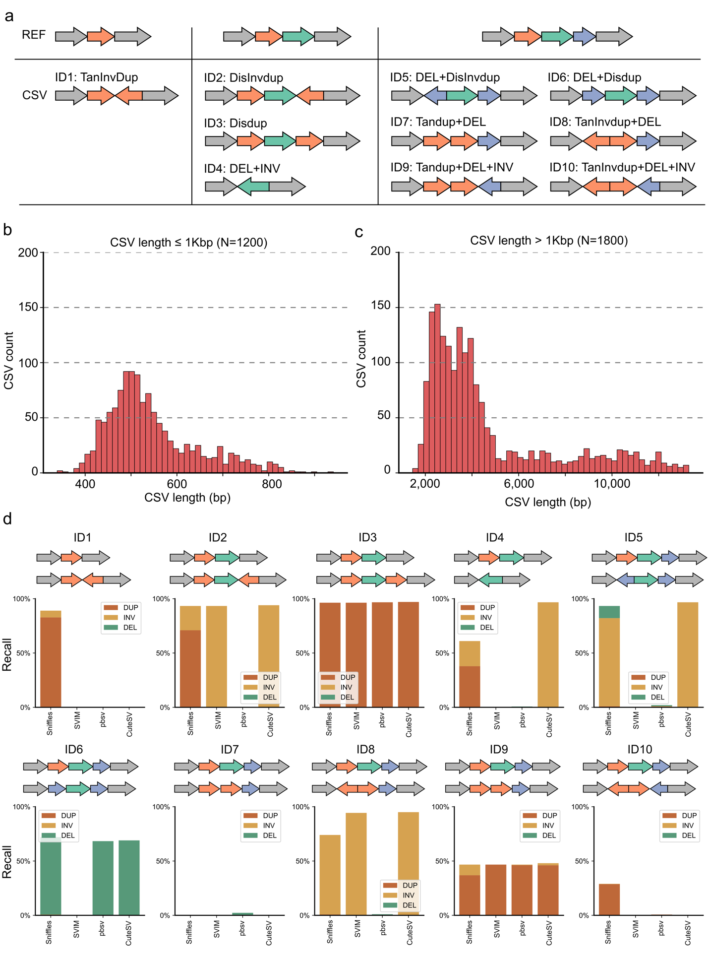
Extended Data Fig. 3 | Simulated complex structural variant types and performance of detecting complex structural variant subcomponents. a, The diagrams of simulated complex structural variants (CSV). Each type has a unique ID and a type definition. b, The size distribution of simulated CSVs smaller than 1Kbp (1,200 events). c, The size distribution of simulated CSVs larger than 1Kbp (1,800 events). d, The region-match recall rates of model-based callers for detecting subcomponents (i.e., DUP-duplication, DEL-deletion, INV-inversion) of CSVs.

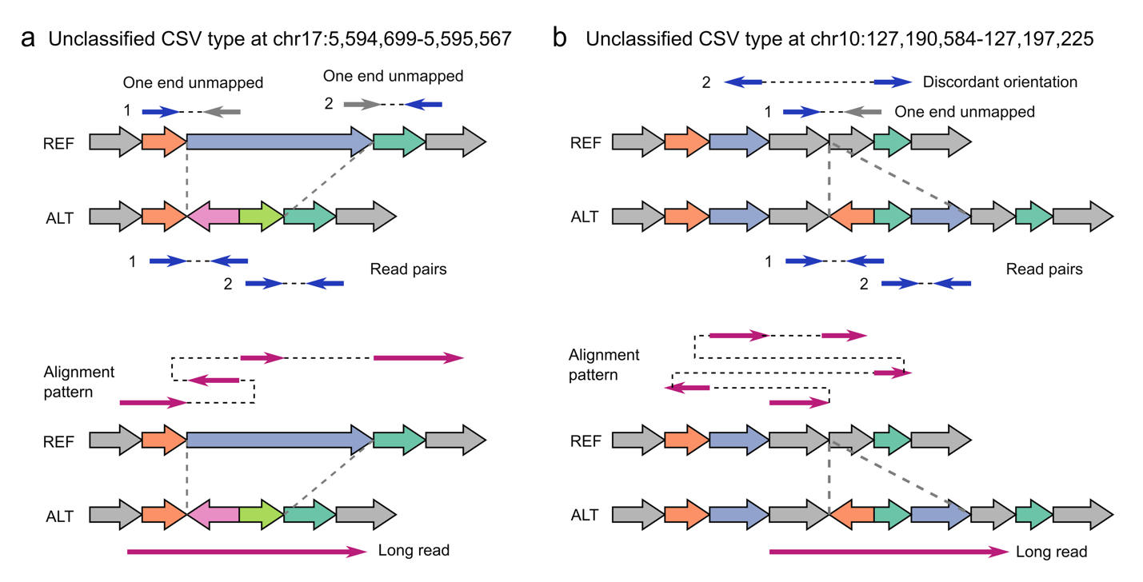
Extended Data Fig. 4 | The diagrams and alignment patterns of two unclassified complex structural variants. a, SVision correctly detected a deleted sequence replaced with dispersed duplication and inverted duplication. b, SVision characterized a complex insertion, consisting of two dispersed duplications and one inverted duplication. Both types of (a) and (b) are labeled as unclassified (NA) in the 1KGP call set. The top panel of (a) and (b) are the discordant alignments derived from short-read sequencing (i.e., one end unmapped and discordant alignment). The bottom panels of (a) and (b) describe the abnormal alignments from long-read alignment.

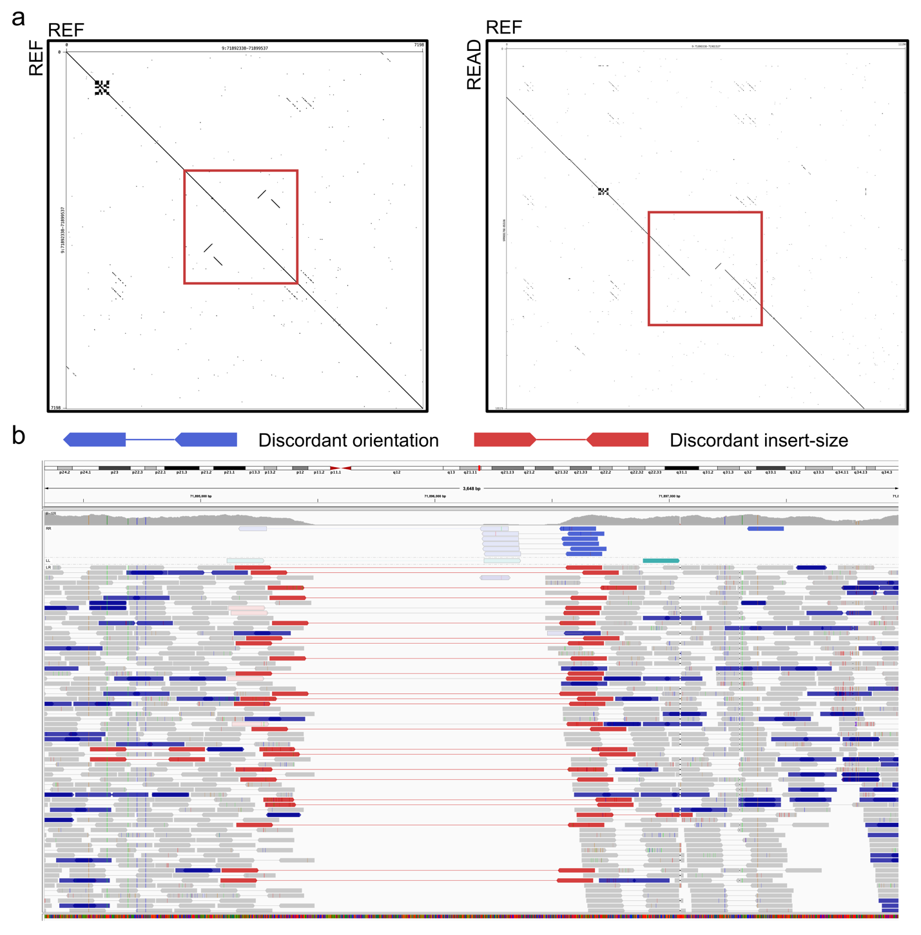
Extended Data Fig. 5 | One example of simple deletion misinterpreted as complex event by short-read data due to local repeats. a, Two Dotplots are created with Gepard to illustrate the local repeats at the variant locus on the reference genome (left) and the breakpoints comparing HiFi read (READ, y-axis) and the reference genome (REF, x-axis). b, The IGV view at this locus with reads grouped by pair orientation and colored by insert-size and pair orientation.

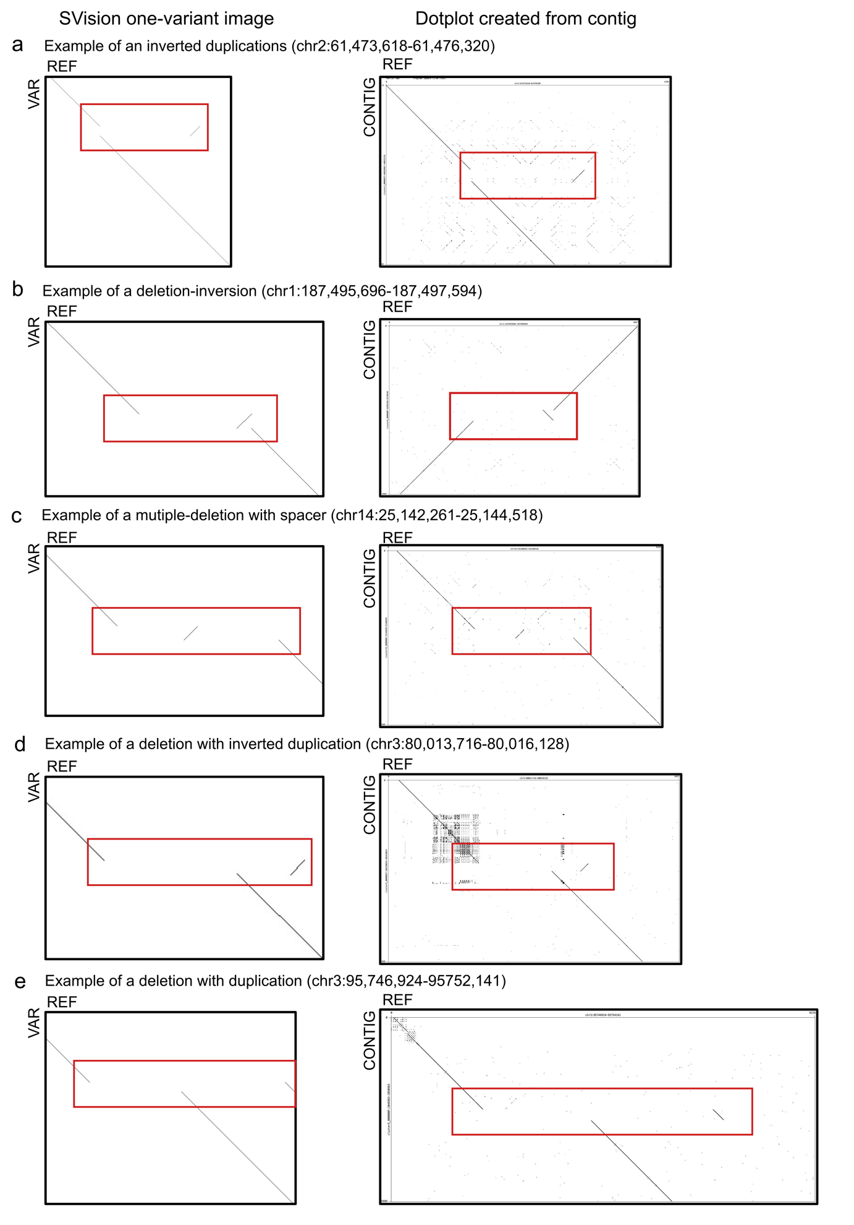
Extended Data Fig. 6 | Examples of reported complex structural variant types identified by SVision. a, One of the 12 inverted duplication events detected by SVision and classified as CSV graph structure ‘12’, b, One of the eight deletion associated with inversion events detected by SVison and classified as CSV graph structure ‘15’. c, One of the five multiple-deletion with spacer events detected by SVision and classified as CSV graph structure ‘27’. d, One of ten deletion with inverted duplication events detected by SVision and classified as CSV graph structure ‘23’. e, One of the five deletion with duplication events detected by SVision and classified as CSV graph structure ‘28’. From figure (a) to (e), the Dotplots on the left column are SVision one-variant images created with variant feature sequence (VAR, y-axis) and reference sequence (REF, x-axis) at the variant loci, while the Dotplots on right column are created with variant spanning HiFi assemblies (CONTIG, y-axis) and the reference sequence (REF, x-axis) at the variant loci.

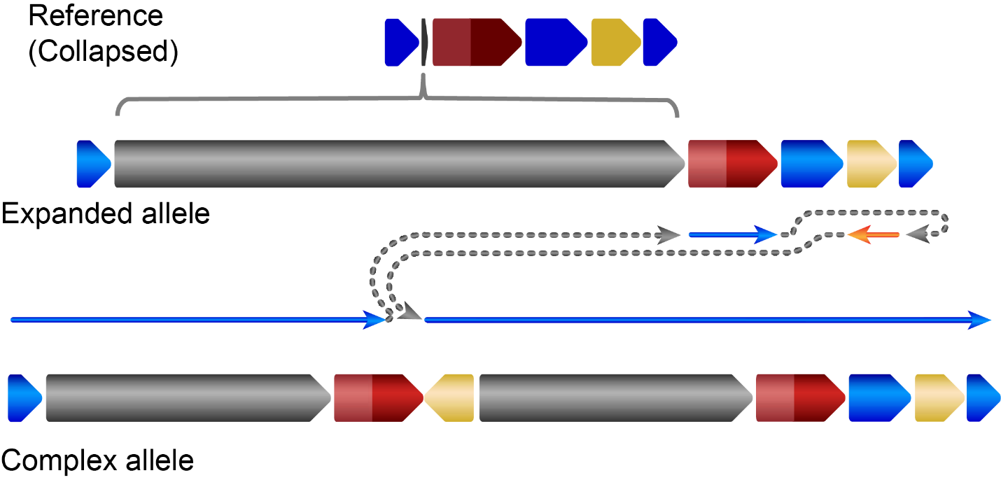
Extended Data Fig. 7 | The HiFi assembly reconstruction of the expanded allele and complex structural variant allele affecting CNTN5. The grey region indicates the repeat expansion. The dark red region indicates exon 4 of CNTN5, while the light red region is the 5’ flanking region of the exon.

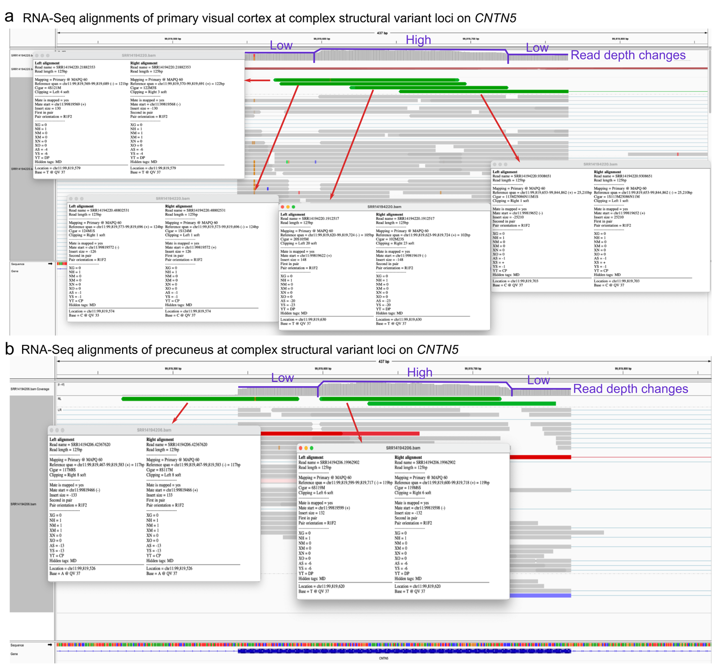
Extended Data Fig. 8 | The IGV screenshot of duplicated CNTN5 exon signature observed in RNA-Seq data. a, The RNA-Seq data of the primary visual cortex from an Alzheimer disease female. b, The RNA-Seq data of a control male precuneus. In (a) and (b), the green bars pointed by red arrows are duplication like read-pair signatures, i.e., there are 4 supporting discordant read-pairs in (a), and 2 in (b). Moreover, read depth change (fitted by purple line) on exon is observed in both (a) and (b). The RNA-Seq data for (a) and (b) are obtained from Sequence Read Archive (SRA) with accession number SRR14194220 and SRR14194206, respectively.

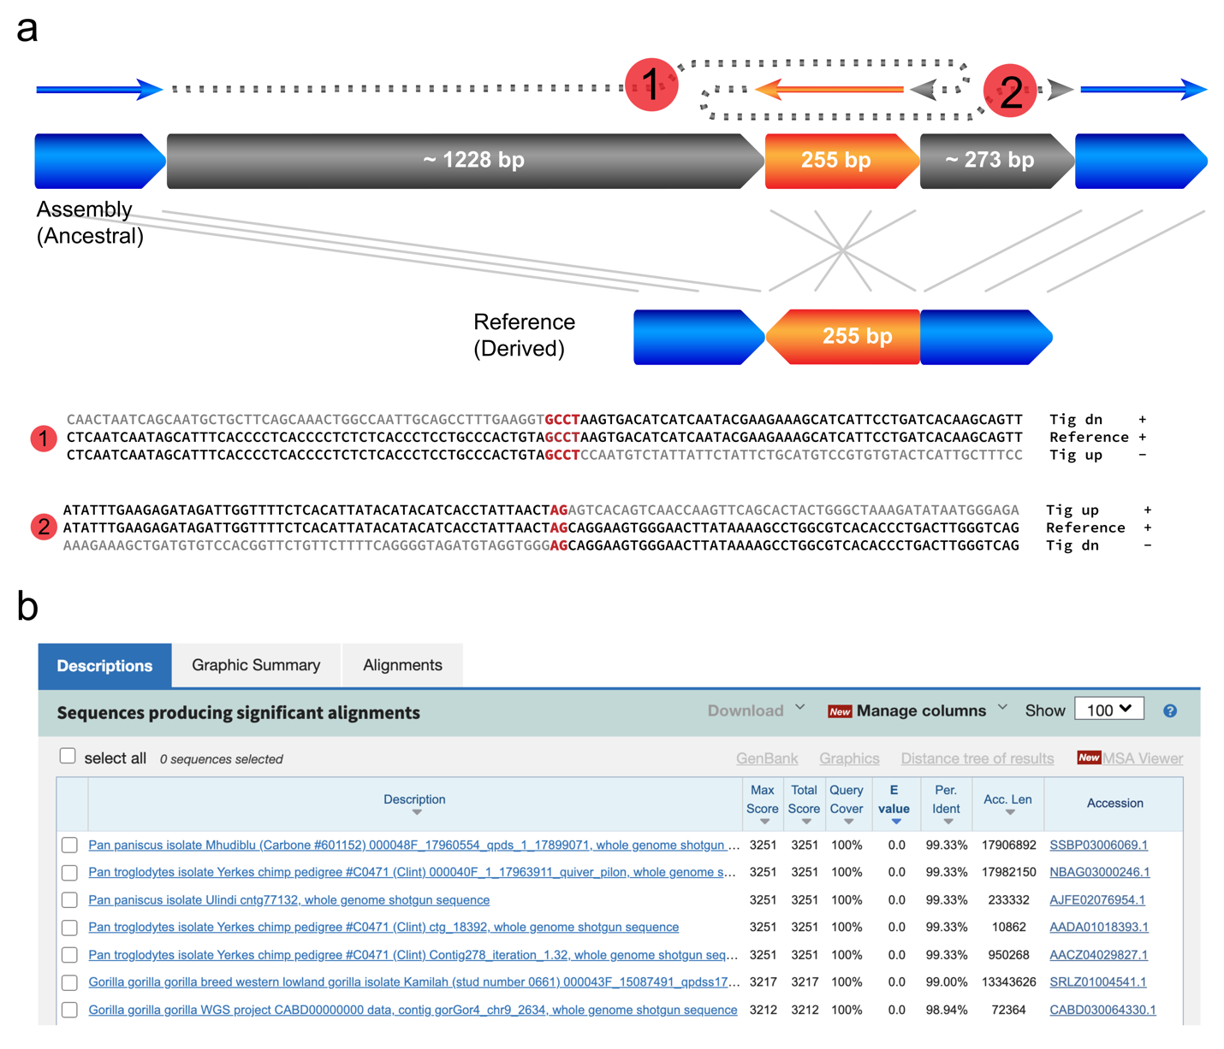
Extended Data Fig. 9 | The ancestral state of one genome segment revealed by a complex structural variant. a, The structure and breakpoint junction sequence of the variant derived from HiFi assembly. b, Blastn results of the inserted sequence mapping to primate genomes, and the top hits include pan troglodytes and gorilla.

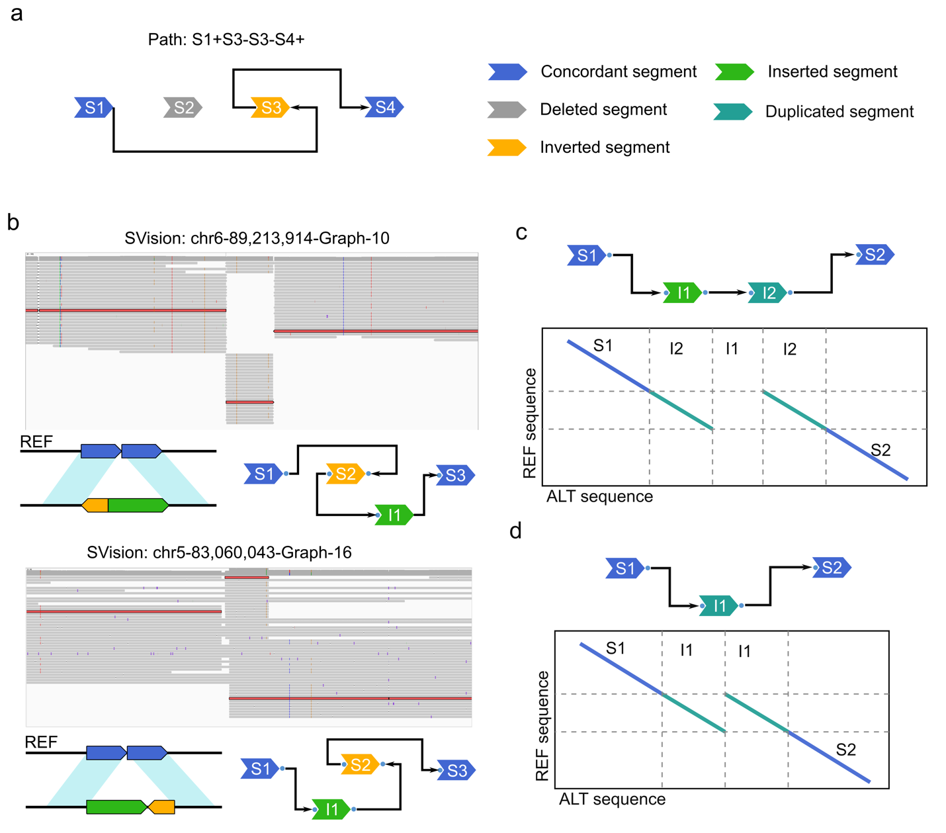
Extended Data Fig. 10 | Examples of graph and symmetric graphs as well as two special complex events identified by SVision. a, An example of a complex structural variant (CSV) graph where its graph path is interpreted as S1+S3-S3-S4+. b, Examples of isomorphic graphs representing two different CSV events. c, SVision detected CSV classified as local target site duplication. d, SVision detected CSV classified as tandem duplication. Though events of structure depicted by (c) and (d) were computed as complex events, they were considered as simple events from the biological perspective.

