SUPPLEMENTARY FIGURES

supplementary figure 1 summary statistics on person ability for coping strategies
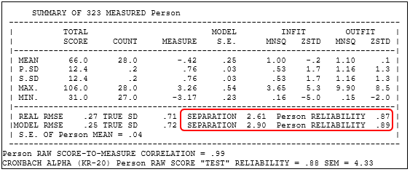

supplementary figure 2 Summary Statistics on item difficulty for coping strategies
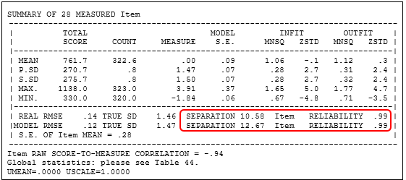

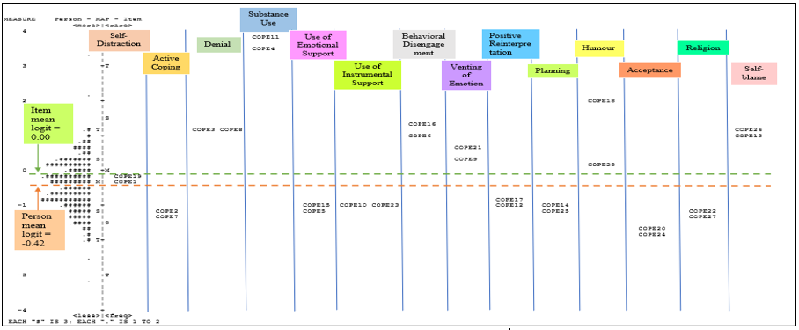
Supplementary Figure 3 Person-Item Distribution Map (PIDM) for Coping Strategies

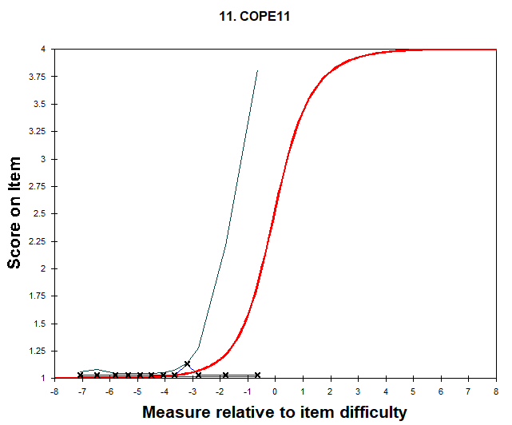

Supplementary Figure 4 The Expected Empirical ICC and Frequency Table for COPE11
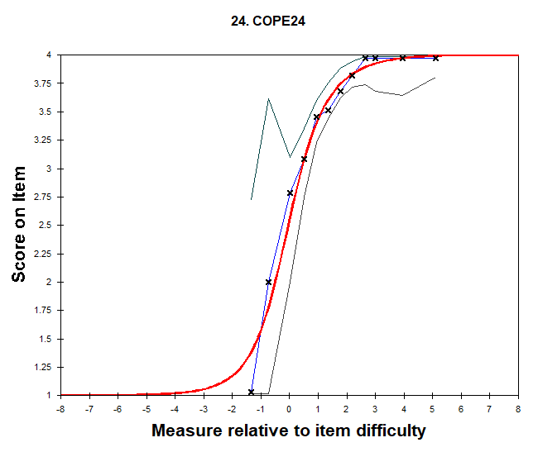

Supplementary Figure 5 The Expected Empirical ICC and Frequency Table for COPE24

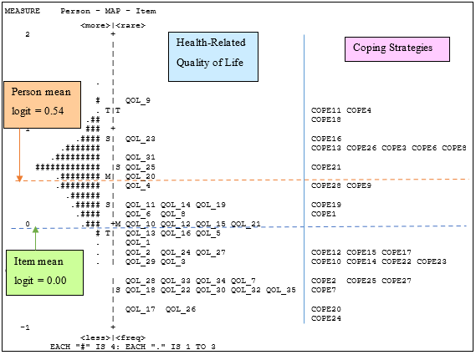
Supplementary Figure 6 Person-Item Distribution Map (PIDM) between HRQOL and Coping Strategies of GI Cancer Caregivers

