Supplementary materials
Efficient nitrogen and phosphorus removal from wastewater by screening and constructing a novel Chlorella sp.-Bacillus taeanensis SD148BN12 consortium

Liping Liu¹, Mengyu Zhang¹, Yun Li¹*, Luqing Pan¹, Le Dou¹, Zhaopeng Su¹

¹ The key Laboratory of Mariculture (Ocean University of China), Ministry of Education, Qingdao, Shandong 266003, China

*Corresponding author: Yun Li, Fisheries College, Ocean University of China, Yushan Road 5, Qingdao 266003, China.
Tel: +86-532-82032649, Fax: +86-532-82032649, E-mail: 15318790309@163.com

Present address: Fisheries College, Ocean University of China, Yushan Road 5, Qingdao 266003, China.

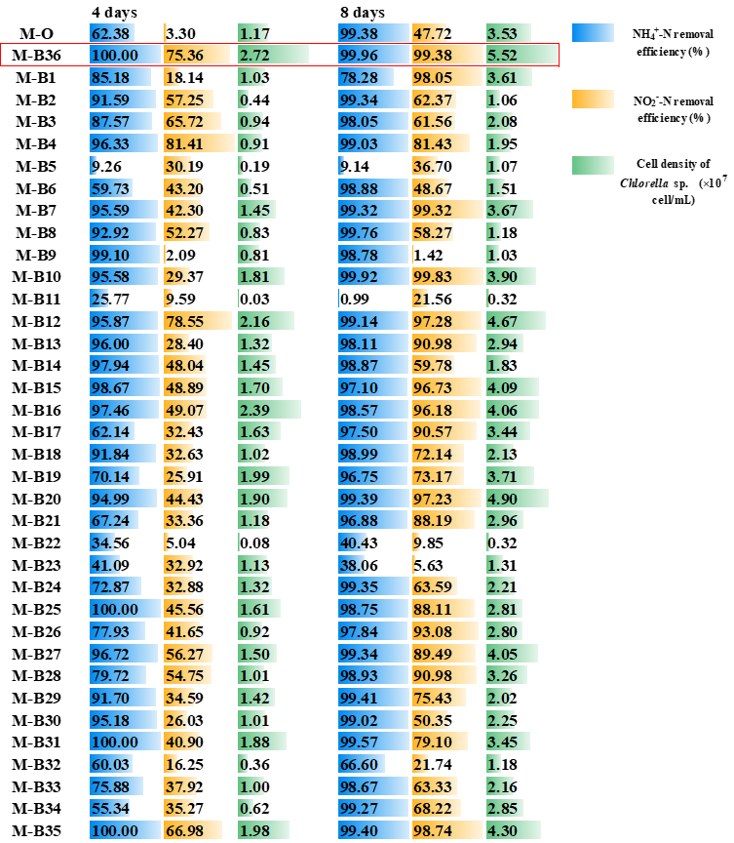

Fig. S1 The NH₄⁺-N, NO₂⁻-N removal efficiency and microalgal cell density of microalgae-bacteria consortiums of Chlorella sp.(M)-36 strains (B1 to B36) on the 4th and 8th day of culture.
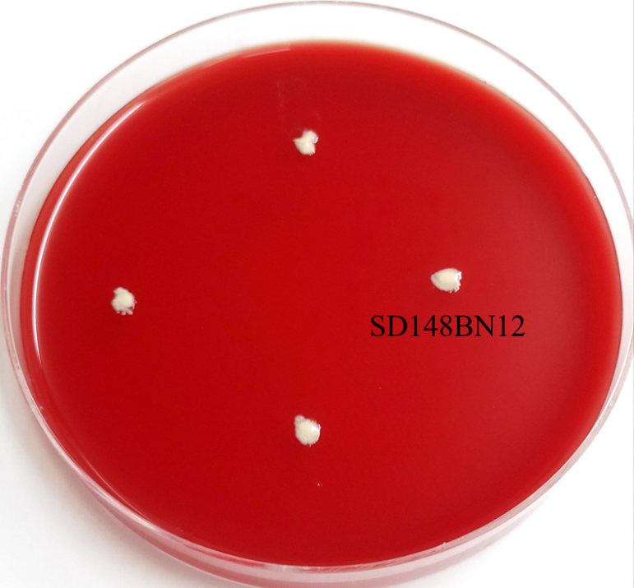

Fig. S2 Hemolysis activity of Bacillus taeanensis SD148BN12.

Environmental factors | Levels | TN removal efficiency (%)
Environmental factors | Levels | M-O | B-O | M-B
Temperature (℃) | 15 | 34.64 ± 1.65^{d} | 13.53 ± 0.29e | 53.50 ± 1.39^{f}
Temperature (℃) | 20 | 41.01 ± 2.44^{c} | 17.60 ± 0.67^{d} | 78.59 ± 1.41^{c}
Temperature (℃) | 25 | 48.56 ± 0.96ª | 26.81 ± 0.93^{c} | 86.1 ± 0.70^{b}
Temperature (℃) | 30 | 52.42 ± 1.05^{b} | 32.67 ± 0.51ª | 89.08 ± 1.12ª
Temperature (℃) | 35 | 40.82 ± 2.05^{c} | 30.15 ± 1.28^{b} | 74.49 ± 0.94^{d}
Temperature (℃) | 40 | 32.27 ± 1.37^{d} | 28.54 ± 1.39^{b} | 69.00 ± 1.19e
Salinity (‰) | 0 | 11.17 ± 0.50e | 3.19 ± 0.02^{d} | 13.39 ± 1.18^{f}
Salinity (‰) | 5 | 13.22 ± 1.06e | 25.01 ± 0.83^{c} | 45.59 ± 1.00e
Salinity (‰) | 10 | 26.31 ± 0.86^{d} | 30.17 ± 1.40ª | 63.06 ± 2.01^{d}
Salinity (‰) | 20 | 45.48 ± 0.26^{b} | 28.70 ± 1.38^{ab} | 82.47 ± 1.16^{b}
Salinity (‰) | 30 | 48.44 ± 0.64ª | 28.25 ± 1.03^{b} | 87.39 ± 1.18ª
Salinity (‰) | 40 | 37.21 ± 2.51^{c} | 27.23 ± 0.07^{b} | 74.85 ± 0.73^{c}
pH | 6 | 42.62 ± 1.37^{b} | 17.28 ± 0.81^{b} | 80.73 ± 0.30^{c}
pH | 7 | 45.16 ± 2.08^{b} | 25.64 ± 0.82ª | 87.81 ± 0.69^{ab}
pH | 7.5 | 49.52 ± 1.00ª | 26.66 ± 0.96ª | 87.1 ± 1.10^{b}
pH | 8 | 49.36 ± 2.07ª | 26.97 ± 0.89ª | 89.02 ± 0.49ª
pH | 8.5 | 50.59 ± 0.94ª | 24.50 ± 2.31ª | 87.19 ± 1.01^{b}
pH | 9 | 48.03 ± 1.19ª | 20.02 ± 2.48^{b} | 87.82 ± 0.99^{ab}
Light intensity (μmol photons m⁻² s⁻¹) | 12.5 | 18.26 ± 0.94^{f} | 25.53 ± 0.64ª | 51.49 ± 1.02^{c}
Light intensity (μmol photons m⁻² s⁻¹) | 25 | 31.98 ± 1.28e | 25.98 ± 0.35ª | 71.03 ± 1.24^{b}
Light intensity (μmol photons m⁻² s⁻¹) | 50 | 47.47 ± 1.92^{d} | 26.68 ± 1.87ª | 86.35 ± 1.23ª
Light intensity (μmol photons m⁻² s⁻¹) | 100 | 69.21 ± 1.33^{c} | 26.67 ± 0.51ª | 86.43 ± 0.86ª
Light intensity (μmol photons m⁻² s⁻¹) | 150 | 75.95 ± 0.55^{b} | 25.56 ± 0.88ª | 87.33 ± 1.23ª
Light intensity (μmol photons m⁻² s⁻¹) | 200 | 80.42 ± 0.86ª | 25.54 ± 1.05ª | 88.38 ± 1.24ª
C/N ratio | 0 | 60.07 ± 1.61ª | 0.73 ± 0.03e | 71.19 ± 1.31^{c}
C/N ratio | 1 | 57.54 ± 2.58ª | 1.70 ± 0.09e | 77.31 ± 0.65^{b}
C/N ratio | 2.5 | 54.23 ± 1.93^{b} | 11.50 ± 0.05^{d} | 86.75 ± 0.77ª
C/N ratio | 5 | 48.26 ± 1.88^{cd} | 25.95 ± 1.14^{c} | 87.44 ± 1.06ª
C/N ratio | 10 | 45.24 ± 0.65^{d} | 57.63 ± 1.55^{b} | 86.34 ± 0.71ª
C/N ratio | 15 | 49.50 ± 1.04^{c} | 65.43 ± 1.25ª | 72.65 ± 0.46^{c}
N/P ratio | 4 | 23.43 ± 0.98e | 35.26 ± 1.06ª | 80.68 ± 1.07^{d}
N/P ratio | 5 | 28.09 ± 2.23^{d} | 32.63 ± 1.59^{b} | 84.49 ± 1.20^{c}
N/P ratio | 7 | 32.92 ± 1.59^{c} | 30.30 ± 1.85^{bc} | 91.93 ± 1.42ª
N/P ratio | 10 | 50.49 ± 0.78ª | 26.51 ± 2.19^{d} | 87.75 ± 0.75^{b}
N/P ratio | 20 | 45.09 ± 1.04^{b} | 27.83 ± 0.67^{cd} | 82.10 ± 1.09^{d}
N/P ratio | 40 | 31.49 ± 2.12^{c} | 26.51 ± 0.81^{d} | 40.53 ± 0.53e
Nitrogen concentration (mg/L) | 1 | 89.82 ± 0.21^{b} | 29.43 ± 0.92^{b} | 94.13 ± 1.19ª
Nitrogen concentration (mg/L) | 2.5 | 92.46 ± 0.08ª | 31.79 ± 0.82ª | 92.64 ± 1.95ª
Nitrogen concentration (mg/L) | 5 | 91.78 ± 0.08^{ab} | 28.88 ± 0.79^{b} | 94.40 ± 2.37ª
Nitrogen concentration (mg/L) | 10 | 90.36 ± 2.71^{ab} | 25.88 ± 0.76^{c} | 94.46 ± 2.41ª
Nitrogen concentration (mg/L) | 20 | 48.26 ± 0.86^{c} | 26.18 ± 0.50^{c} | 86.43 ± 1.08^{b}
Nitrogen concentration (mg/L) | 50 | 36.55 ± 1.57^{d} | 24.17 ± 0.76^{d} | 75.33 ± 1.39^{c}

Table S1
TN removal efficiency of the Chlorella sp.-only (M-O), the Bacillus taeanensis SD148BN12-only (B-O), the Chlorella sp.-Bacillus taeanensis SD148BN12 consortium (M-B) under different environmental conditions after 8 days of cultivation.

