Article type: Original Research

Title: Sodium lignosulfonate improves shoot growth of Oryza sativa via enhancement of photosynthetic activity and reduction of stress response

Andrew De-Xian Kok¹, Ngai-Paing Tan², Wan Muhamad Asrul Nizam Wan Abdullah¹, Chu-Nie Tang¹, Lee-Yoon Low¹, Mohd Hafis Yuswan³, Janna Ong-Abdullah¹ & Kok-Song Lai⁴*

¹Department of Cell and Molecular Biology, Faculty of Biotechnology and Biomolecular Sciences, Universiti Putra Malaysia, 43400 UPM Serdang, Selangor, Malaysia
²Department of Land Management, Faculty of Agriculture, Universiti Putra Malaysia, 43400 UPM Serdang, Selangor, Malaysia
³Laboratory of Halal Services, Halal Products Research Institute, Universiti Putra Malaysia, 43400 UPM Serdang, Selangor, Malaysia
⁴Health Sciences Division, Abu Dhabi Women’s College, Higher Colleges of Technology, 41012 Abu Dhabi, United Arab Emirates

*Corresponding author: lkoksong@hct.ac.ae

Supplementary Figure Legends

Supplementary Figure S1. Exploratory analysis output of NaLS-treated rice via Perseus v1.6.0.7. (a) Score plot of Principal Component Analysis (PCA) attributes drastic variation between control (□) and NaLS-treated (□). (b) Loading plot of PCA. (c) Multi-scatter plot together with the Pearson correlation value reveals positive correlation between control and NaLS-treated rice.

Supplementary Figure S2. Normalised relative gene expression analysis of selected genes (PSAC, PSBC, CHT5, and CHT1) in control and NaLS-treated rice for proteomic validation. Data show the mean of three biological replicates. The selected genes were normalized with OsEF1 and OsUBQ5. Asterisk indicates statistically significant difference at p<0.05 when compared to control. Error bars represent standard deviation.

Supplementary Table Legends

Supplementary Table S1. Proteins showing significant abundance difference (together with their accession numbers) in NaLS-treated rice. The list is sorted according to descending increased and decreased fold change of each protein.

Supplementary Table S2 Primers used in RT-qPCR.

(a) | (b)
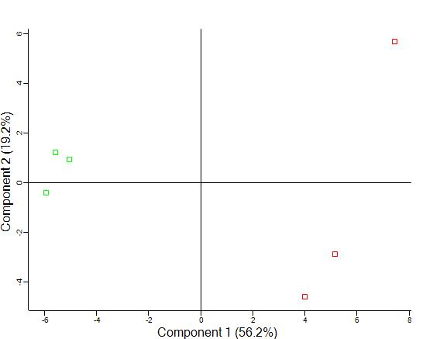 | 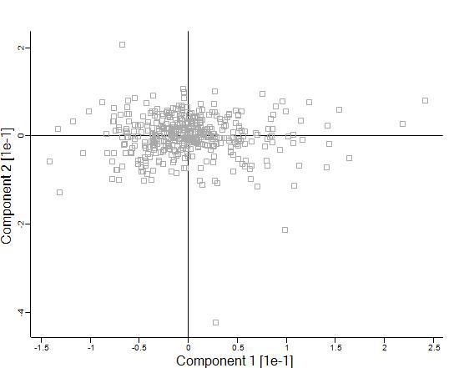
(c)
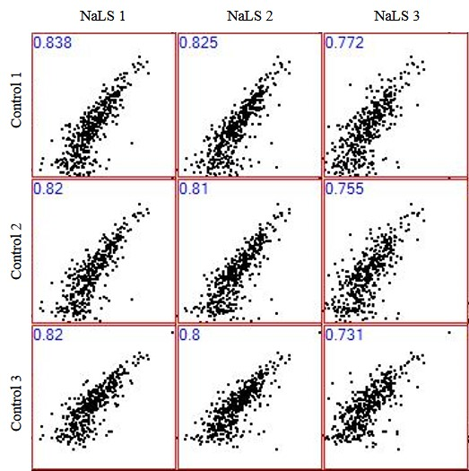

Supplementary Figure S1. Exploratory analysis output of NaLS-treated rice via Perseus v1.6.0.7. (a) Score plot of Principal Component Analysis (PCA) attributes drastic variation between control (□) and NaLS-treated (□). (b) Loading plot of PCA. (c) Multi-scatter plot together with the Pearson correlation value reveals positive correlation between control and NaLS-treated rice.

*
*
Supplementary Figure S2. Normalized relative gene expression analysis of selected genes (PSAC, PSBC, CHT5, and CHT1) in control and NaLS-treated rice for proteomic validation. Data show the mean of three biological replicates. The selected genes were normalized with OsEF1 and OsUBQ5. Asterisk indicates statistically significant difference at p<0.05 when compared to control. Error bars represent standard deviation.

Supplementary Table S1. Proteins showing significant abundance difference (together with their accession numbers) in NaLS-treated rice. The list is sorted according to descending increased and decreased fold change of each protein.
No | Proteins |  | Uniprot Accession No. | General Function | Fold Change
Upregulated proteins
1 | Photosystem II CP43 protein |  | P0C367 | Photosynthesis | 1.1811
2 | Photosystem I iron-sulfur center |  | P0C359 | Photosynthesis | 1.07513
3 | Photosystem II CP47 protein |  | P0C362 | Photosynthesis | 0.962446
4 | Photosystem II D1 protein |  | P0C433 | Photosynthesis | 0.937846
5 | Clathrin heavy chain 2 |  | Q2QYW2 | Translational Modification | 0.927112
6 | Chlorophyll a-b binding protein, chloroplastic |  | A2XJ35 | Photosynthesis | 0.922371
7 | Photosystem II D2 protein |  | P0C436 | Photosynthesis | 0.874711
8 | Ribulose bisphosphate carboxylase small chain A, chloroplastic |  | P18566 | Photosynthesis | 0.66129
9 | Chaperone protein ClpC2, chloroplastic |  | Q2QVG9 | N/A | 0.634115
10 | Probable aldo-keto reductase 3 |  | A2XRZ6 | N/A | 0.585803
11 | Elongation factor 1-delta 2 |  | Q40682 | Protein Biosynthesis | 0.584471
12 | Elongation factor 1-alpha |  | O64937 | Protein Biosynthesis | 0.524749
13 | Chaperone protein ClpC1, chloroplastic |  | Q7F9I1 | Translational Modification | 0.504763
14 | Glyceraldehyde-3-phosphate dehydrogenase 3, cytosolic |  | Q6K5G8 | Carbohydrate Metabolism | 0.440004
15 | Fructose-bisphosphate aldolase, chloroplastic |  | Q40677 | Carbohydrate Metabolism | 0.322455
Proteins exclusive to NaLS-treated rice
1 | ATP synthase subunit 9, mitochondrial |  | P0C519 | Energy Metabolism | NaLS-treated rice
2 | ATP-dependent zinc metalloprotease FTSH 1, chloroplastic |  | Q5Z974 | Translational Modification | NaLS-treated rice
3 | ATP-dependent zinc metalloprotease FTSH 2, chloroplastic |  | Q655S1 | Translational Modification | NaLS-treated rice
4 | Carbamoyl-phosphate synthase small chain, chloroplastic |  | Q6YV23 | Amino Acid Metabolism | NaLS-treated rice
5 | Chlorophyll a-b binding protein 1, chloroplastic |  | P12330 | Photosynthesis | NaLS-treated rice
6 | Chlorophyll a-b binding protein 2, chloroplastic |  | P12331 | Photosynthesis | NaLS-treated rice
7 | Cytochrome b6 |  | P0C315 | Photosynthesis | NaLS-treated rice
8 | Delta-1-pyrroline-5-carboxylate synthase 1 |  | O04226 | Stress Response | NaLS-treated rice
9 | Dolichyl-diphosphooligosaccharide--protein glycosyltransferase 48 kDa subunit |  | Q6ZLK0 | Translational Modification | NaLS-treated rice
10 | Eukaryotic translation initiation factor isoform 4G-1 |  | Q84PB3 | Protein Biosynthesis | NaLS-treated rice
11 | Glucose-1-phosphate adenylyltransferase large subunit 3, chloroplastic/amyloplastic |  | Q688T8 | Starch Biosynthesis | NaLS-treated rice
12 | Glutamyl-tRNA(Gln) amidotransferase subunit B, chloroplastic/mitochondrial |  | Q2R2Z0 | Protein Biosynthesis | NaLS-treated rice
13 | Leukotriene A-4 hydrolase homolog |  | Q84TA3 | Lipid Metabolism | NaLS-treated rice
14 | Peptide methionine sulfoxide reductase A4, chloroplastic |  | Q336R9 | Stress Response | NaLS-treated rice
15 | Photosystem I reaction center subunit VI, chloroplastic |  | Q0DG05 | Stress Response | NaLS-treated rice
Downregulated proteins
1 | Chitinase 5 |  | Q7Y1Z0 | N/A | -1.50325
2 | Chitinase 1 |  | Q42993 | N/A | -1.48961
3 | ATP synthase epsilon chain, chloroplastic |  | P0C2Z1 | N/A | -1.34773
4 | Thioredoxin reductase NTRB |  | Q6ZFU6 | Amino Acid Biosynthesis | -0.93522
5 | Acyl transferase 9 |  | Q9LGQ6 | N/A | -0.904535
6 | Probable UDP-arabinopyranose mutase 2 |  | Q7FAY6 | Amino Acid Metabolism | -0.885329
7 | Ribose-phosphate pyrophosphokinase 4 |  | Q6ZFT5 | Carbohydrate Metabolism | -0.873207
8 | Pyruvate kinase 1, cytosolic |  | B8BJ39 | Glycolysis | -0.842546
9 | 40S ribosomal protein S7 |  | Q8LJU5 | Translational Modification | -0.808968
10 | Glucosidase 2 subunit beta |  | A2WNF5 | Signalling and Cellular Process | -0.803812
11 | Cytochrome c |  | A2Y4S9 | N/A | -0.750532
12 | Proteasome subunit alpha type-3 |  | Q9LSU0 | Protein folding | -0.731038
13 | Probable NADPH:quinone oxidoreductase 1 |  | Q941Z0 | N/A | -0.723101
14 | Glutaredoxin-C8 |  | Q0DAE4 | Protein folding | -0.69478
15 | Glutamine synthetase cytosolic isozyme 1-1 |  | P14656 | Amino Acid Biosynthesis | -0.640245
Proteins exclusive to control
1 | 24.1 kDa heat shock protein, mitochondrial |  | Q6Z7V2 | Stress Response | Control
2 | 2-C-methyl-D-erythritol 4-phosphate cytidylyltransferase, chloroplastic |  | Q5N8G1 | Secondary Metabolite Biosynthesis | Control
3 | 40S ribosomal protein S13-1 |  | Q69UI2 | Translation | Control
4 | 4-diphosphocytidyl-2-C-methyl-D-erythritol kinase, chloroplastic |  | Q8S2G0 | Secondary Metabolite Biosynthesis | Control
5 | 60S acidic ribosomal protein P3 |  | P56724 | Translation | Control
6 | Actin-3 |  | Q10AZ4 | Signalling and Cellular Process | Control
7 | Actin-7 |  | P0C540 | Signalling and Cellular Process | Control
8 | Aspartate carbamoyltransferase, chloroplastic |  | Q9LD61 | Amino Acid Biosynthesis | Control
9 | Calcium-dependent protein kinase 28 |  | Q2QX45 | Plant Pathogen Interaction | Control
10 | Serine/threonine-protein kinase SAPK5 |  | Q7XKA8 | Signalling and Cellular Process | Control
11 | Small ubiquitin-related modifier 1 |  | P55857 | Signalling and Cellular Process | Control
12 | Thioredoxin M2, chloroplastic |  | Q7X8R5 | Transporter Protein | Control
13 | Two-component response regulator ORR11 |  | Q6H468 | Signalling and Cellular Process | Control
14 | U2 small nuclear ribonucleoprotein B |  | Q6ETX3 | Translational Modification | Control
15 | UDP-arabinopyranose mutase 3 |  | Q6Z4G3 | Nucleotide Metabolism | Control
N/A, not available

Supplementary Table S2 Primers used in RT-qPCR.
Target genes | Primer Sequence 5`–3`
PSAC | Forward | ATGCTGCGGGTTGTCTCAGGTC
PSAC | Reverse | ACCGAAGATTGTGTGGGTTGTAAG
PSBC | Forward | AGCTCACGTAGCCCATGCAG
PSBC | Reverse | ATAAATGCCACCGAAGCCTAAGAC
CHT1 | Forward | GTTCTGGTTCTGGATGACGC
CHT1 | Reverse | TGTAGAACCCAATCCGGTCG
CHT5 | Forward | CAAGGACTACTGCGGAGATGG
CHT5 | Reverse | GACCACGCTCTCTACAGACAC
Housekeeping genes | Primer Sequence 5`–3`
EF1 | Forward | ACCAGATCAACGAGCCCAAG
EF1 | Reverse | CTCCAGTCTCAACACGACCC
UBQ5 | Forward | TAGGCGTAGGCTCCTGTTCT
 | Reverse | ACAGAGGTGATGCTAAGGTGT

