An NADPH-auxotrophic Corynebacterium glutamicum recombinant strain and used it to construct L-leucine high-yielding strain

Sheng-Ling Chen ª, Bao-Yue Liu ª, Zhi-Ming Rao ^{b}, Wei-Guo Zhang ª, Jian-Zhong Xu ^{a, *}

ª The Key Laboratory of Industrial Biotechnology, Ministry of Education, Ministry of Education, School of Biotechnology, Jiangnan University, 1800# Lihu Road, WuXi 214122, People’s Republic of China
^{b} National Engineering Laboratory for Cereal Fermentation Technology (NELCF), Jiangnan University, 1800# Lihu Road, Wuxi, 214122, People’s Republic of China

* Corresponding author: Jianzhong Xu, Tel: +86-510-85329312; Fax: +86-510-85329312; E-mail: xujianzhong@jiangnan.edu.cn

Table S1 The oligonucleotides used in this study ª
Primer | Sequence (5’-3’) | Cleavage  sites | Purposes
P_{zwf}-F | cgggatccccaccggcgtgaagaaccctg | BamHI | Obtaining the promoter of zwf from C. glutamicum
P_{zwf}-R | cccaagcttgatggtagtgtcacgatc | HindIII | Obtaining the promoter of zwf from C. glutamicum
P_{gnd}-F | cgggatcccaggggcggaaatcatgc | BamHI | Obtaining the promoter of gnd from C. glutamicum
P_{gnd}-R | cccaagcttagcccggtgtcagca | HindIII | Obtaining the promoter of gnd from C. glutamicum
P_{gapA}-F | cgggatccttaatttgtggattcacg | BamHI | Obtaining the promoter of gapA from C. glutamicum
P_{gapA}-R | cccaagcttgttgtgtctcctctaaag | HindIII | Obtaining the promoter of gapA from C. glutamicum
P_{malE}-F | cgggatcccagcccaaattcagc | BamHI | Obtaining the promoter of malE from C. glutamicum
P_{malE}-R | cccaagcttatcatttagccttgt | HindIII | Obtaining the promoter of malE from C. glutamicum
P_{icd}-F | cgggatccccatcgatgtgaaatggctg | BamHI | Obtaining the promoter of icd from C. glutamicum
P_{icd}-R | cccaagcttgagtctccttggttgatg | HindIII | Obtaining the promoter of icd from C. glutamicum
pK18-F | cccgggtaccgagctcg | - | Obtaining the linear fragment of pK18mobsacB
pK18-R | ggcactggccgtcgttttac | - | Obtaining the linear fragment of pK18mobsacB
P_{zwf}-L-F | cgagctcggtacccgggtcgagtcctccaacggctac | - | Obtaining the left homologous arm of promoter P_{zwf}
P_{zwf}-L-R | cccaagcttgcgggatccctacttcaggcgagcttc | - | Obtaining the left homologous arm of promoter P_{zwf}
P_{zwf}-R-F | gcgggatcccccaagcttgtgagcacaaacacgac | - | Obtaining the right homologous arm of promoter P_{zwf}
P_{zwf}-R-R | gtaaaacgacggccagtgccttctggatgacgtcgcgggc | - | Obtaining the right homologous arm of promoter P_{zwf}
P_{malE}-L-F | cgagctcggtacccgggcagcgcgtatgtccccag | - | Obtaining the left homologous arm of promoter P_{malE}
P_{malE}-L-R | cccaagcttgcgggatccctacttcagtagcgggcg | - | Obtaining the left homologous arm of promoter P_{malE}
P_{malE}-R-F | gcgggatcccccaagcttatgaccatcgacctgcagc | - | Obtaining the right homologous arm of promoter P_{malE}
P_{malE}-R-R | gtaaaacgacggccagtgccccaatgaacaggtccgc | - | Obtaining the right homologous arm of promoter P_{malE}
P_{icd}-L-F | cgagctcggtacccggggcgacacaccgctttacg | - | Obtaining the left homologous arm of promoter P_{icd}
P_{icd}-L-R | cccaagcttgcgggatcctcagccccgcatggaaac | - | Obtaining the left homologous arm of promoter P_{icd}
P_{icd}-R-F | gcgggatcccccaagcttatggcagaaaaggtgtccttcg | - | Obtaining the right homologous arm of promoter P_{icd}
P_{icd}-R-R | gtaaaacgacggccagtgcccacttgtgctgccgtgc | - | Obtaining the right homologous arm of promoter P_{icd}
icd_{Cg}-L-F | cccgggtaccgagctcggactctggtacgaagaatgggc | - | Obtaining the left homologous arm of gene icd
icd_{Cg}-L-R | ggtatatctcctttcgagtctccttggttgatgggc | - | Obtaining the left homologous arm of gene icd
icd_{Cg}-R-F | gtgctgctgacctacctgagtctcttcacaaaaagcgc | - | Obtaining the right homologous arm of gene icd
icd_{Cg}-R-R | cccgggtaccgagctcggcttggcgtattactggctg | - | Obtaining the right homologous arm of gene icd
icd_{Sm}-F | ctcgaaaggagatataccatggcagaaaaggtgtccttcg | - | Obtaining the ORF of icd from Streptococcus mutans
icd_{Sm}-R | caggtaggtcagcagcac | - | Obtaining the ORF of icd from Streptococcus mutans
gapA_{Cg}-L-F | cccgggtaccgagctcgcaacttcgacgatgccaatc | - | Obtaining the left homologous arm of gene gapA
gapA_{Cg}-L-R | ggtatatctcctttcgttgtgtctcctctaaagattgtag | - | Obtaining the left homologous arm of gene gapA
gapA_{Cg}-R-F | gtccatcgtgctgaacctggattctgcgatcttttccag | - | Obtaining the right homologous arm of gene gapA
gapA_{Cg}-R-R | cccgggtaccgagctcgttagttcacatcgctaacgtg | - | Obtaining the right homologous arm of gene gapA
gapC_{Ca}-F | aacgaaaggagatataccatgttcgaaaacatctcctc | - | Obtaining the ORF of gapC from Clostridium acetobutylicum
gapC_{Ca}-R | caggttcagcacgatggac | - | Obtaining the ORF of gapC from Clostridium acetobutylicum
ª The letters with underline represent cleavage sites, the italic letters represent the homologous sequence of the target genes and the bold letters represent the SD sequence of C. glutamicum; -: No cleavage sites.
Figure S1. Strategy used for the construction of the integrative plasmids used for promoter deletion (a) and gene replacement (b). The symbols X, P, ORF and MCS represent gene, promoter, open reading frame and multiple cloning sites, respectively. The lines indicated in same color represent homologous sequences.

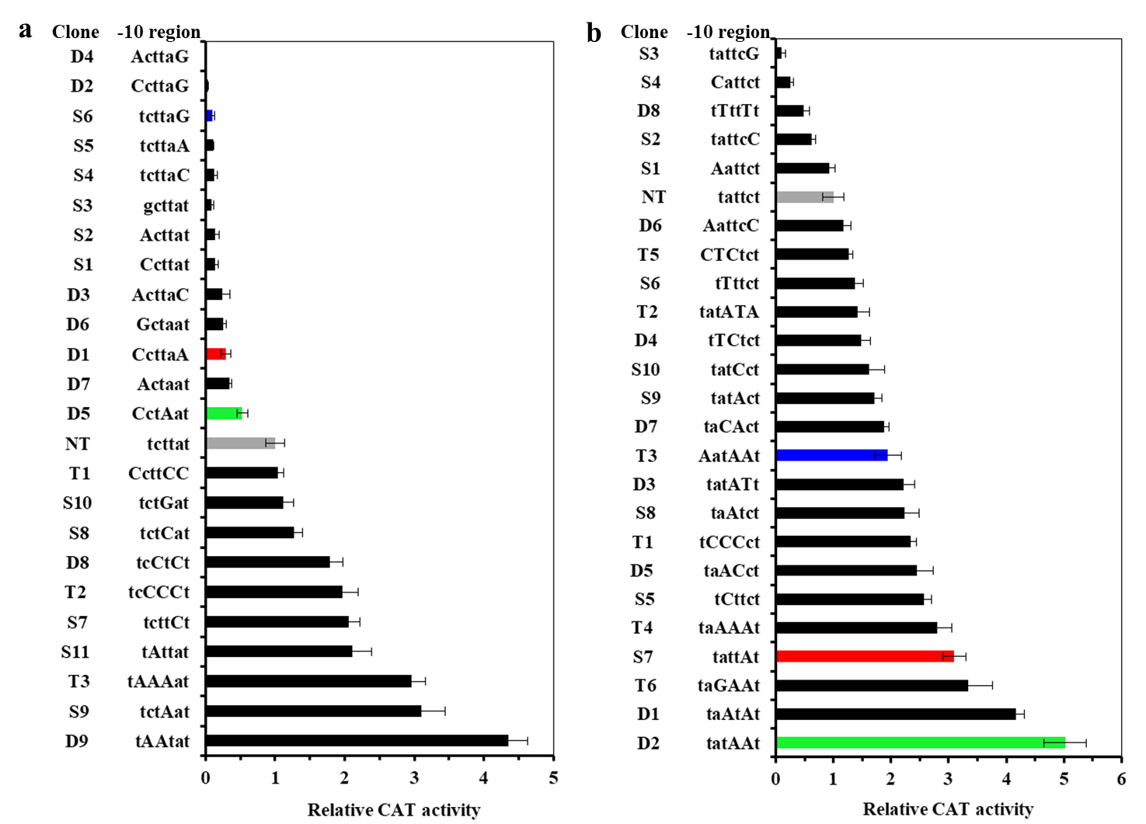
Figure S2. Effects of mutations in the -10 region of P_{zwf} (a) and P_{icd} (b) on promoter activity. Replacement bases are indicated in capital letters. CAT activity was measured by using the transcriptional fusion to the cat reporter gene in the multicopy vector pDXW-11. CAT activity is expressed relative to that measured with the Native-type (NT) promoter. Standard deviations (SD) from three independent measurements are indicated with error bar.

