MOL ID |  | Molecule Name | OB% | DL | Structure
MOL001040 | (2R)-5,7-dihydroxy-2-(4-hydroxyphenyl)chroman-4-one |  | 42.36 | 0.21 | 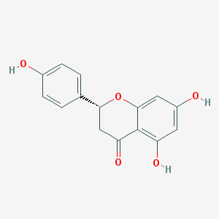
MOL001484 | Inermine |  | 75.18 | 0.54 | 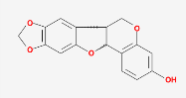
MOL003542 | 8-Isopentenyl-kaempferol |  | 38.04 | 0.39 | 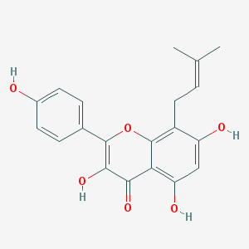
MOL003627 | sophocarpine |  | 64.26 | 0.25 | 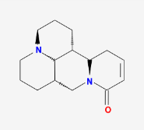
MOL003648 | Inermin |  | 65.83 | 0.54 | 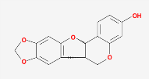
MOL003673 | Wighteone |  | 42.8 | 0.36 | 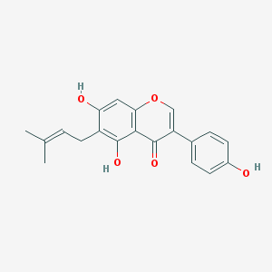
MOL003676 | Sophoramine |  | 42.16 | 0.25 | 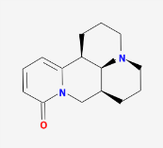
MOL003680 | sophoridine |  | 60.07 | 0.25 | 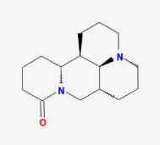
MOL000392 | formononetin |  | 69.67 | 0.21 | 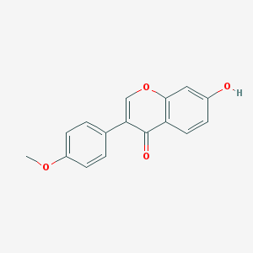
MOL004580 | cis-Dihydroquercetin |  | 66.44 | 0.27 | 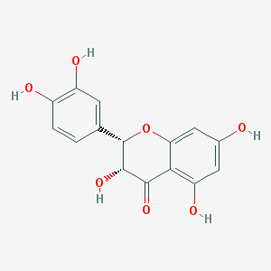
MOL004941 | (2R)-7-hydroxy-2-(4-hydroxyphenyl)chroman-4-one |  | 71.12 | 0.18 | 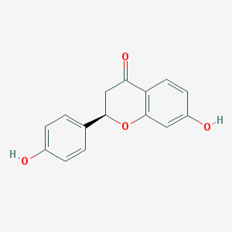
MOL005100 | 5,7-dihydroxy-2-(3-hydroxy-4-methoxyphenyl)chroman-4-one |  | 47.74 | 0.27 | 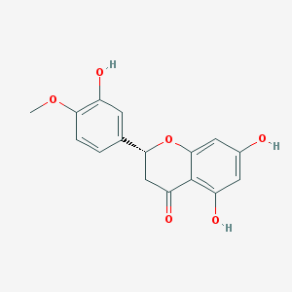
MOL005944 | matrine |  | 63.77 | 0.25 | 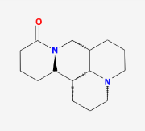
MOL000006 | luteolin |  | 36.16 | 0.25 | 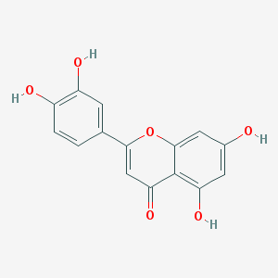
MOL006561 | (+)-14alpha-hydroxymatrine |  | 35.73 | 0.29 | 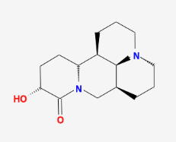
MOL006562 | (+)-7,11-dehydromatrine,(leontalbinine) |  | 62.08 | 0.25 | 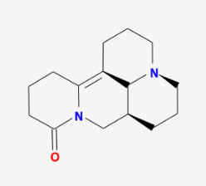
MOL006563 | (+)-9alpha-hydroxymatrine |  | 32.04 | 0.29 | 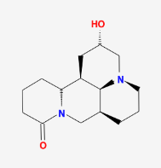
MOL006564 | (+)-allomatrine |  | 58.87 | 0.25 | 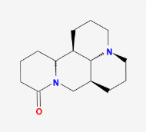
MOL006565 | AIDS211310 |  | 68.68 | 0.25 | 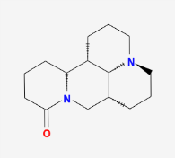
MOL006566 | (+)-lehmannine |  | 58.34 | 0.25 | 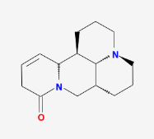
MOL006568 | isosophocarpine |  | 61.57 | 0.25 | 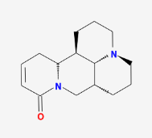
MOL006569 | (-)-14beta-hydroxymatrine |  | 37.26 | 0.29 | 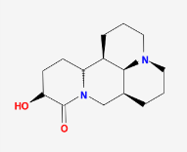
MOL006570 | (-)-9alpha-hydroxysophoramine |  | 35.23 | 0.29 | 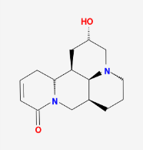
MOL006571 | anagyrine |  | 62.01 | 0.24 | 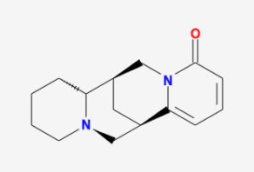
MOL006572 | 1,4-diazaindan-type,alkaloid,flavascensine |  | 34.64 | 0.24 | 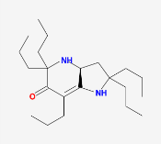
MOL006573 | 13,14-dehydrosophoridine |  | 65.34 | 0.25 | 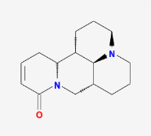
MOL006582 | 5α,9α-dihydroxymatrine |  | 40.93 | 0.32 | 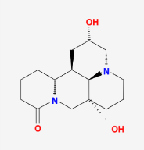
MOL006583 | 7,11-dehydromatrine |  | 44.43 | 0.25 | 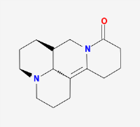
MOL006596 | Glyceollin |  | 97.27 | 0.76 | 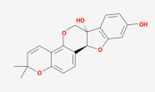
MOL003347 | hyperforin |  | 44.03 | 0.6 | 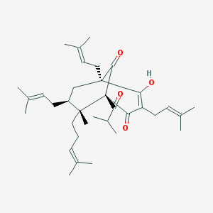
MOL006604 | (2S)-7-hydroxy-2-(4-hydroxyphenyl)-5-methoxy-8-(3-methylbut-2-enyl)chroman-4-one |  | 48.09 | 0.39 | 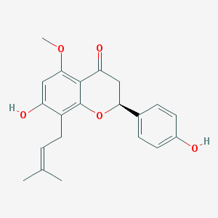
MOL006613 | kushenin |  | 47.62 | 0.38 | 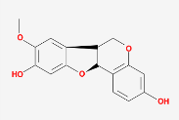
MOL006619 | kushenol J |  | 51.39 | 0.74 | 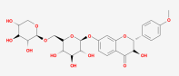
MOL006620 | kushenol J_qt |  | 50.86 | 0.24 | 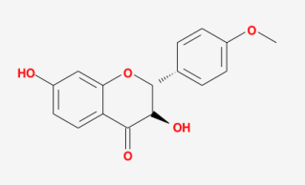
MOL006622 | kushenol O |  | 42.41 | 0.76 | 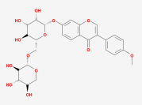
MOL006623 | kushenol,t |  | 51.28 | 0.64 | 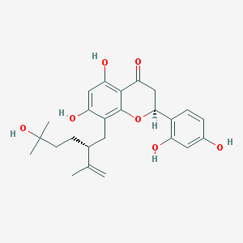
MOL006626 | leachianone,g |  | 60.97 | 0.4 | 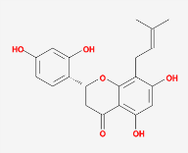
MOL006627 | Lehmanine |  | 62.23 | 0.25 | 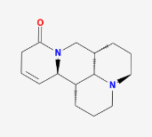
MOL006628 | (+)-Lupanine |  | 52.71 | 0.24 | 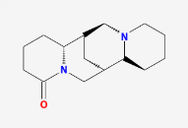
MOL006630 | Norartocarpetin |  | 54.93 | 0.24 | 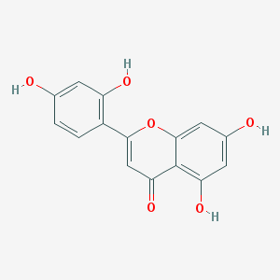
MOL000456 | Phaseolin |  | 78.2 | 0.73 | 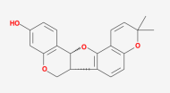
MOL006649 | sophranol |  | 55.42 | 0.28 | 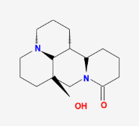
MOL006650 | (-)-Maackiain-3-O-glucosyl-6'-O-malonate |  | 48.69 | 0.52 | 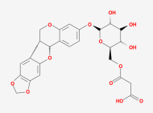
MOL006652 | trifolrhizin |  | 48.53 | 0.74 | 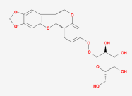
MOL000098 | quercetin |  | 46.43 | 0.28 | 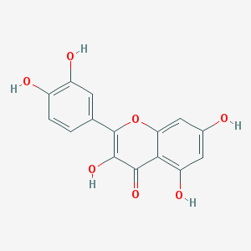
Table 1. The information of the bioactive compounds of Sophorae Flavescentis Radix.

