Title: Circadian rhythm and circulating cell-free DNA release on healthy subjects
Supplementary file

Authors: Geoffroy Poulet^{1,2}, Jean-Sébastien Hulot³, Anne Blanchard³, Damien Bergerot³, Wenjin Xiao^{1,} Frederic Ginot⁴, Audrey Boutonnet-Rodat⁴, Guillaume Beinse¹, Vanna Geromel², Laurence Pellegrina², Michel Azizi³, Pierre Laurent-Puig^{1,6}, Leonor Benhaim^{1,5*}, Valerie Taly^{1*}

Supplementary Table 1 : Basic clinical characteristics of healthy subjects included in this study referring main biological parameters: weight, creatinine, age, origin.

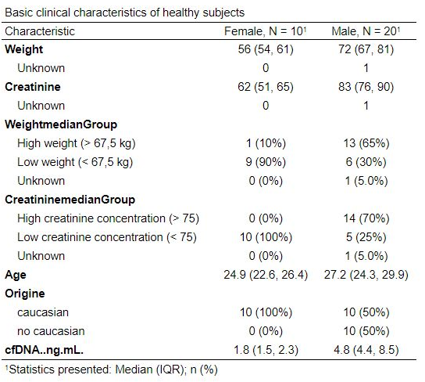


Supplementary Table 2 : Primers and probes sequences for the different digital PCR assays
Targeted sequences | Reporter dye | Probe Sequence (5’>3’) | Forward Primer sequence (5’>3’) | Reverse Primer sequence (5’>3’)
KRAS exon 2, codon 13 (WT sequence) | VIC | AGGGTTTTTATAATTTA
KRAS, exon 2, fragment 69 bp | - | No adding probe | GAAAATGACTGAATATAAACTTGTGGTA | TGTATCGTCAAGGCACTC
KRAS, exon 2, Fragment 243 bp | FAM | AAGGTACTGGTGGAGTAT | GCAGTCAACTGGAATTTTCA | TGTATCGTCAAGGCACTC

Supplementary Table 3 : PCR Programs
PCR Step | Temp (°C) | 69 bp | 243 bp | Cycle | Ramp rate (°C/min)
Enzyme activation | 50 | 2’ |  | 1
DNA denaturation | 95 | 10’ |  | 1 | 2
Primers & Probe hybridization and elongation | 95  60 | 15’’  30’’ | 15’’  1’15’’ | 45 | 2  2
Signal Stabilization | 98  12 | 10’  10’ |  | 1 | 2

Supplementary Figure 1 : Monitoring of the repeatability of the pre-analytical and analytical process applied on plasma samples in the clinical. The repeatability of the method has been evaluated on 39 plasma from healthy subjects (n = 13). For each patient, 3 mL of prepared plasma has been split into 3 cryotubes (aliquoted in a final volume of 1 mL / cryotube). Then, circulating DNA has been extracted using the Maxwell@ RSC ccfDNA Plasma Kit and quantified using digital droplet-based PCR 69 bp assay.
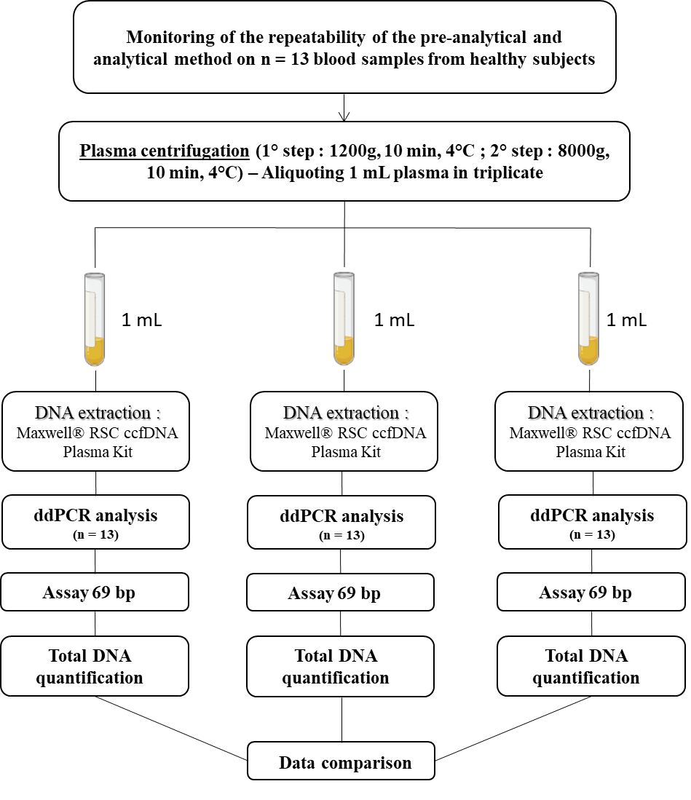

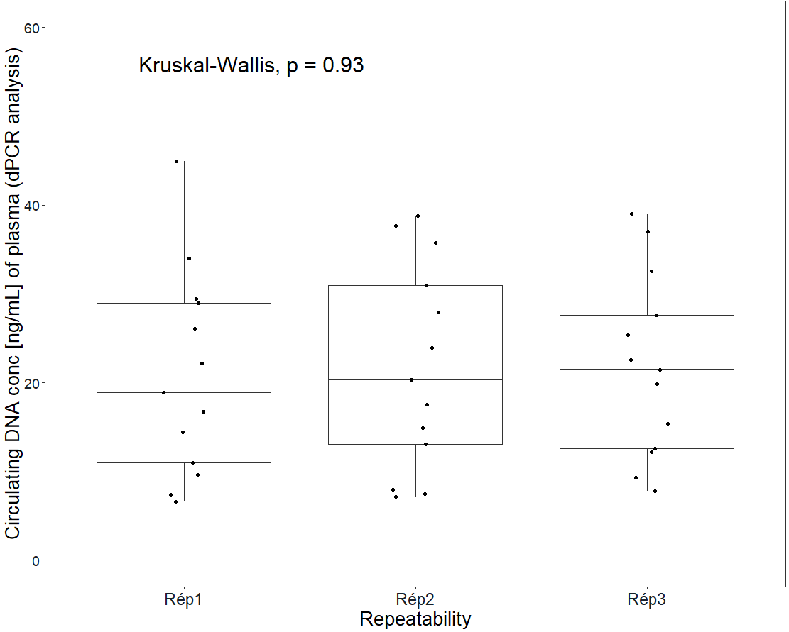
mmmmmm
Supplementary Figure 2 : Evaluation of the repeatability of the pre-analytical and analytical process based on n = 39 plasmas from N = 13 healthy subjects. The study workflow to evaluate the repeatability of the method is mentioned in Supplementary Figure 1. Overall, 3 x 1 mL of plasma from everyone have been separately prepared, extracted and analyzed by ddPCR. No significant differences are observed in terms of DNA quantification by ddPCR 69 bp assay between each repeated measure (Kruskal-Wallis test, p-value = 0.93).

Supplementary Figure 3 : Comparison of circulating DNA quantified by fluorimetry Qubit and by digital droplet-based PCR 69 bp assays (Pearson correlation has been performed and shows a good correlation R2 = 0.75 between the 2 techniques).
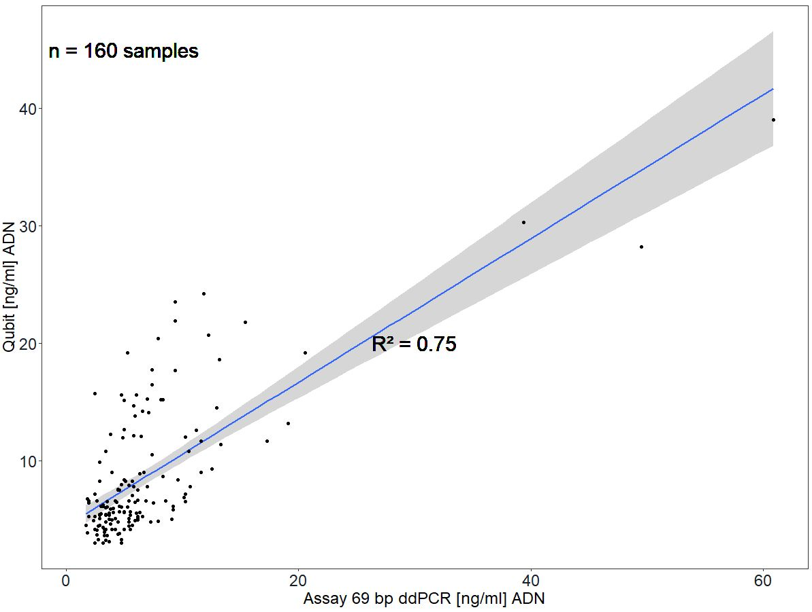

Supplementary Figure 4 : Comparison of circulating DNA quantified by fluorimetry Qubit and by digital droplet-based PCR 69 bp assays. Bland-Altman representation shows a correlation between the 2 techniques used with an average difference of – 1.85 ng/mL in favor of the fluorimetry Qubit quantification probably explained by the non-quantification of DNA fragments < 69 bp by the digital-droplet based PCR assay.
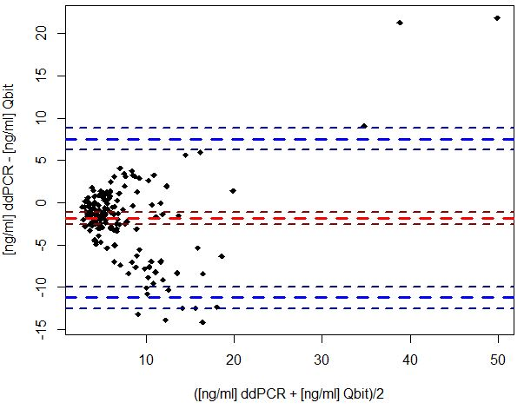

Supplementary Figure 5 : Variation of cortisol concentration (nmol / l) in blood during the 24h inclusion period for the 20 healthy males included in the study.
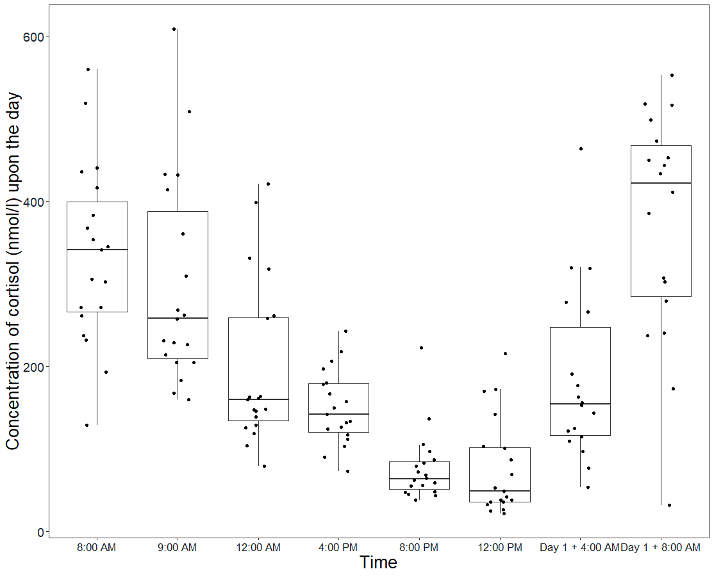
Supplementary Figure 6 : Comparison of the circulating DNA proportion between the first blood collection time (at 8:00 AM) and the last sampling time (at 8:00 AM of the next following day). Average DNA quantity are respectively 7.97 & 6.56 ng/mL for time 8:00 AM and 8:00 AM + Day 1.

