Supplementary Information
Supplementary figure S2A – Original records representing respiratory function of animals from CG, OG, AG, OAG and OADEXAG, on days 0, 12 and 21.

CG
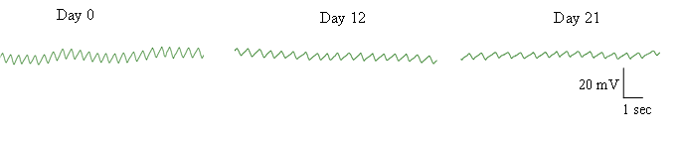

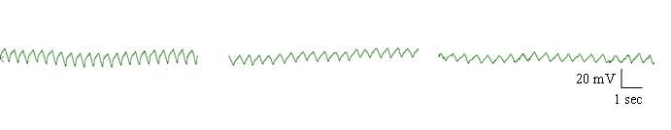
OG

AG

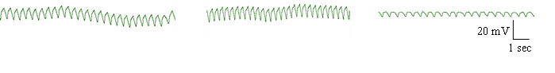

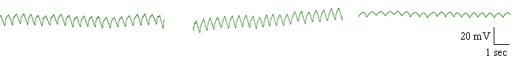
OAG

OADEXAG
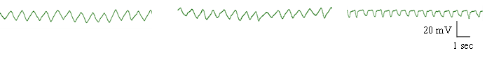

Supplementary figure S3 – Original records representative of tracheal reactivity induced with 100 µg/mL of OVA in rats from CG, OG, AG, OAG and OADEXAG.

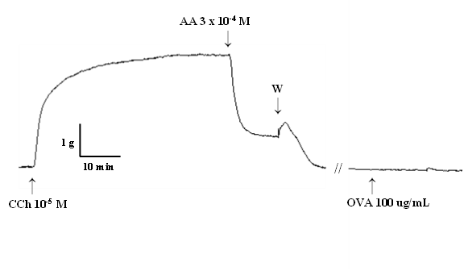
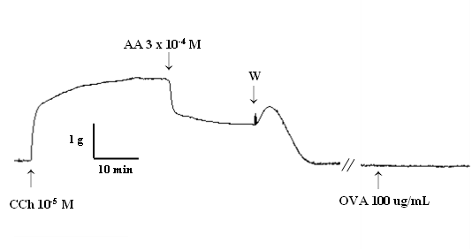

CG OG

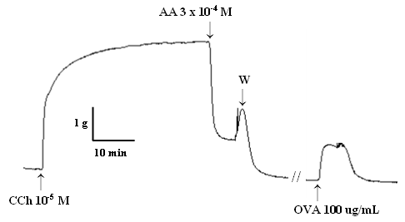
AG OAG

OADEXAG
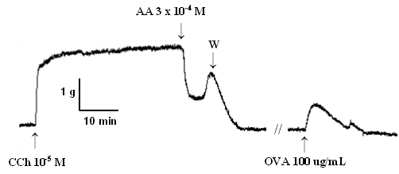

CCh: carbachol; AA: arachidonic acid; W: washing; OVA: ovalbumin.

Supplementary figure S4 – Original records representative of contractile reactivity to KCl in the trachea of animals from CG, OG, AG and OAG.

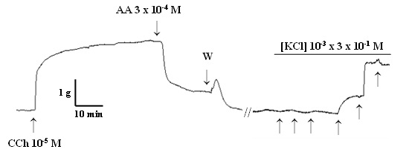
CG

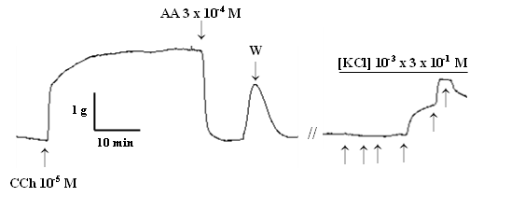
OG

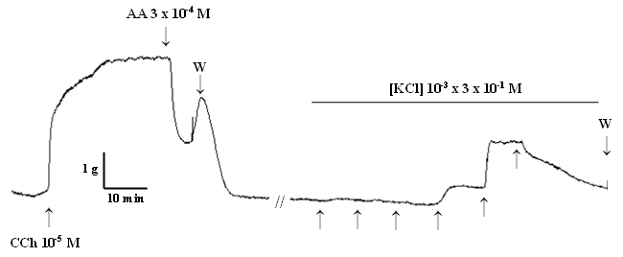
AG

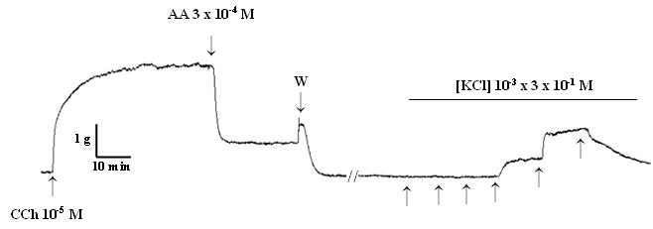
OAG

CCh: carbachol; AA: arachidonic acid; W: washing; KCl: potassium chloride.

Supplementary figure S5 – Original records representative of contractile reactivity to CCh in the trachea of animals from CG, OG, AG, OAG and OADEXAG.
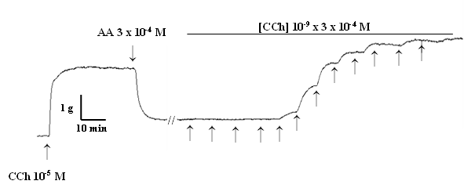
CG

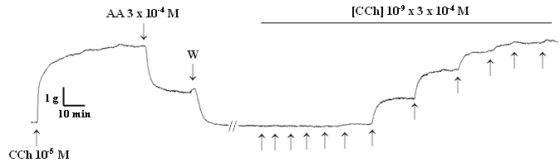
OG

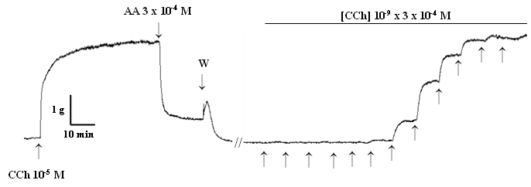
AG

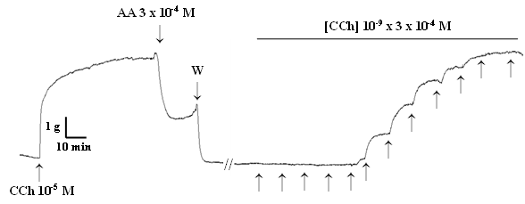
OAG

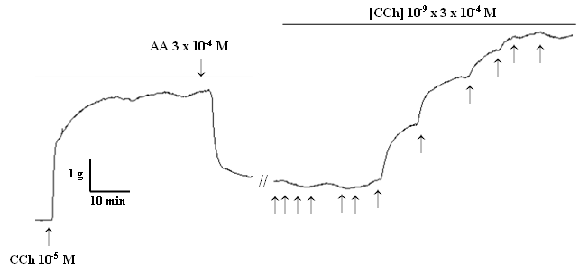
OADEXAG

CCh: carbachol; AA: arachidonic acid; W: washing.

Supplementary figure S6A – Original records representative of relaxing reactivity to nifedipine from the trachea of animals from CG, OG, AG and OAG.

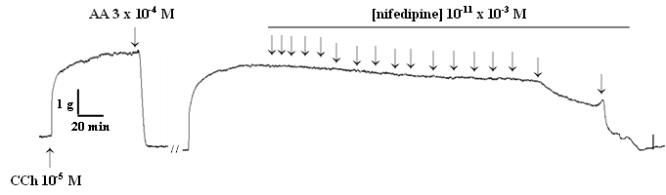
CG

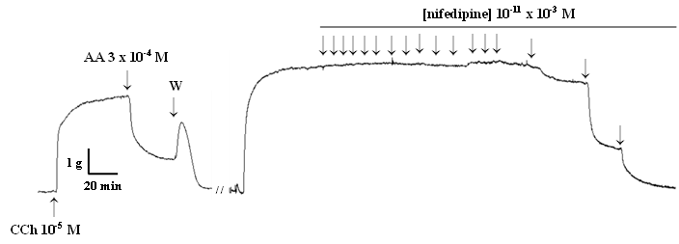
OG

AG
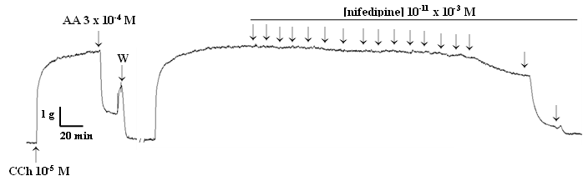

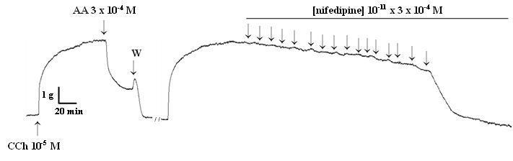
OAG

CCh: carbachol; AA: arachidonic acid; W: washing.

Supplementary figure S6B– Original records representative of relaxing reactivity to nifedipine from the trachea of animals from CG, OG, AG and OAG.

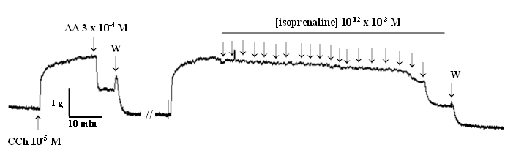
CG

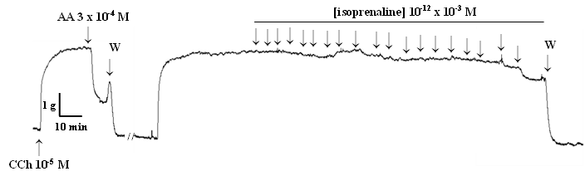
OG

AG

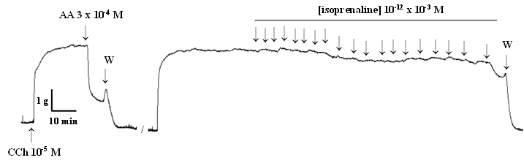

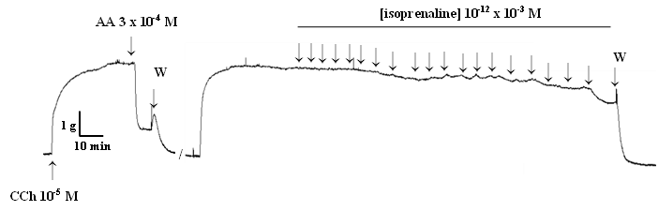
OAG

CCh: carbachol; AA: arachidonic acid; W: washing.

Supplementary figure S6C– Original records representative of relaxing reactivity to aminophylline from the trachea of animals from CG, OG, AG and OAG.

CG
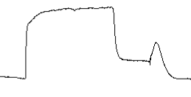
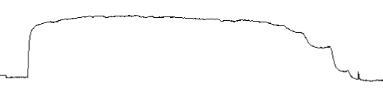
//
↑
↑
CCh 10⁻⁵ M
AA 3 x 10⁻⁴ M
[aminophylline] 10⁻⁹ x 10⁻³ M
1 g
10 min
↑
↑
↑
↑
↑
↑
↑
↑
↑
↑
↑
↑
↑
↑
↑
W

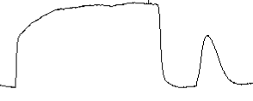
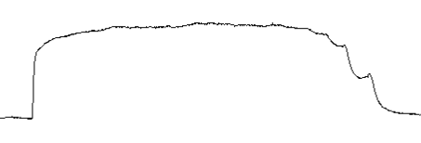
//
↑
↑
CCh 10⁻⁵ M
AA 3 x 10⁻⁴ M
[aminophylline] 10⁻⁹ x 10⁻³ M
1 g
10 min
↑
↑
↑
↑
↑
↑
↑
↑
↑
↑
↑
↑
↑
↑
↑
W
OG

AG

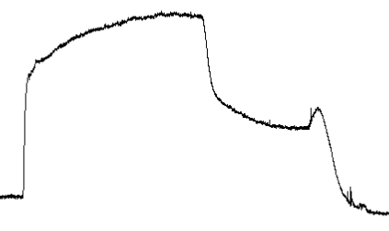
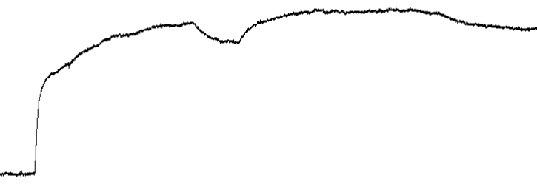
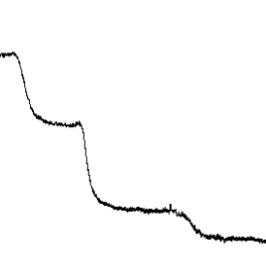
//
↑
↑
CCh 10⁻⁵ M
AA 3 x 10⁻⁴ M
[aminophylline] 10⁻⁶ x 3 x 10⁻³ M
1 g
10 min
↑
↑
↑
↑
↑
↑
↑
↑
↑
W

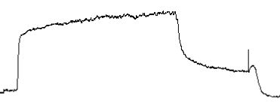
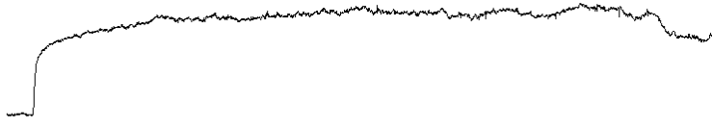
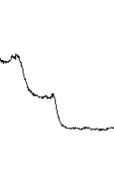
D
//
↑
↑
CCh 10⁻⁵ M
AA 3 x 10⁻⁴ M
[aminophylline] 10⁻⁹ x 10⁻³ M
1 g
10 min
↑
↑
↑
↑
↑
↑
↑
↑
↑
↑
↑
↑
↑
↑
↑
W

CCh: carbachol; AA: arachidonic acid; W: washing.

