Supplement
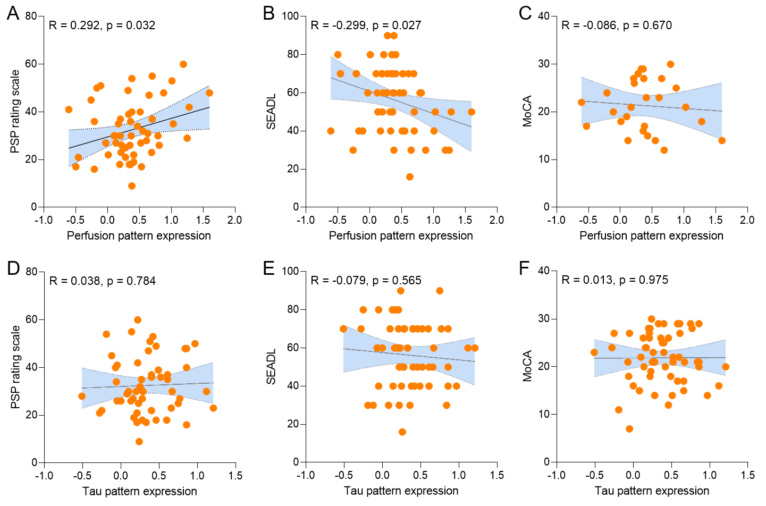
Supplemental Figure 1 – Associations of perfusion and tau pattern expression with clinical severity of patients with PSP. Pearson’s correlation coefficients (R) derived from patients with PSP with available PSP rating scale (n=54; A,D), Schwab and England activities of daily living (SEADL, n=55; B,E) and Montreal cognitive assessment (MoCA, n=57; C,F). Correlations were controlled for age, sex, and disease duration (symptom onset).

