Supplementary information

A Mammalian Commensal of the Oropharyngeal Cavity Produces Antibiotic and Antiviral Valinomycin in vivo

Species | Strain | Serotype | Virulence
Streptococcus suis | 15964 | 1/2 | ND
 | 6388 | 1 | HV
 | 6555 / NCTC 428 | 1 | V
 | T15 | 2 | AV
 | S735 / NCTC 10234 | 2 | WV
 | P1/7 | 2 | V
 | 3881 / S10 | 2 | V
 | J28 (S10 ΔcpsEF) | 2 | AV
 | 15965 | 3 | ND
 | 5213 | 4 | ND
 | 8039 | 7 | ND
 | 7997 | 9 | AV
 | 8067 | 9 | V
 | 8017 | 9 | AV
 | 7709 | 9 | ND
 | C132 | 9 | ND
 | 5973 | 9 | AV
 | 22083 R | 9 | ND
 | 7998 | 9 | ND
 | 8186 | 9 | ND
 | 13730 | 14 | ND
Streptococcus mutans | DSM 20523
Streptococcus parasuis | DSM 29126
Streptococcus porcinus | DSM 20725
Streptococcus mitis | HSISM1
Streptococcus salivarius | Is. Ms-oral-D6
Lactobacillus reuteri | ATCC 55730
Staphylococcus aureus | 8325-4 WT
Staphylococcus pasteuri | T#26
Enterococcus faecalis | DMS 20478
Salmonella enteritidis | NIZO1241
Listeria monocytogenes | EGD-e
Escherichia coli | Nissle 1917
Escherichia coli | Pro 083

Table S1. Bacterial strains used in this study. AV = avirulent, V = virulent, HV = highly virulent, ND = not determined.

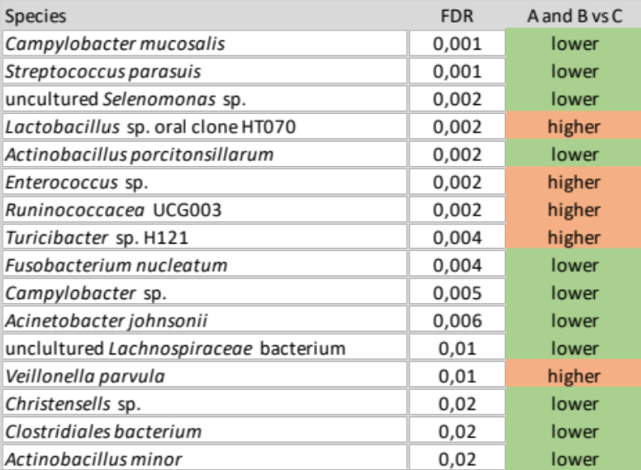

Table S2. Species that was differently abundant between R. nasisuis inoculated piglets (nursed by sow A and B) and the uninoculated control group (nursed by sow C) at day 35 after birth. Species were identified using Kruskal–Wallis rank sum test with FDR correction, and those significantly different (p <0.05) and abundant (>10000 reads) are shown.

Primers/probes |  | Sequence (5’ → 3’) | Purpose | Reference
fl_F | CTTTCCCGTATGGCTGAGAG |  | Detection of vlm cluster by conventional PCR | this study
fl_R | CGCGTACCACGTCCATTAAG |  | Detection of vlm cluster by conventional PCR | this study
int_F | CTACGTCCCAGTCGGATTATTC |  | Detection of vlm cluster by conventional PCR | this study
int_R | AGCACAGAGGATAGCCATCTAC |  | Detection of vlm cluster by conventional PCR | this study
P33 | ACGGGTGAGTAACGCGTAG |  | PCR of 16SrRNA gene from S. suis to generate a standard curve of 16S rRNA copies/ml | this study
P34 | TGATTTGACGTCATCCCCA |  |  | this study
P29 | TTCGAGAGTCACTTTCCCGT |  | PCR of vlm genomic region of R. nasisuis to generate a standard curve of vlm copies/ml | this study
P30 | CAGAAGCCCATGCGTTTACT |  |  | this study
P7 | AGAAGAGTGGAAAGTTTCTCA |  | Detection of Total S suis by qPCR | ²
P20 | TGACAGTTTCCAAAGCGT |  | Detection of Total S suis by qPCR | ²
P17 | [FAM]-CAAACCGCCTGCGCTCGCTTTACG |  | Detection of Total S suis by qPCR | ²
P3 | CAAAGTTAGTTCAGGAAGGAATAGTCT |  | Detection of S. suis serotype 9 by conventional PCR | ³
P4 | CCGAAGTATCTGGGCTACTG |  | Detection of S. suis serotype 9 by conventional PCR | ³
P21 | GCTTCTGCGAGCAAGTATCA |  | Detection of R. nasisuis vlm+ by qPCR | this study
P22 | GCTTCTGCGAGCAAGTATCA |  | Detection of R. nasisuis vlm+ by qPCR | this study
P23 | [FAM]-CCTGGTGTGTCTGTTGTTCCTTTGGA |  | Detection of R. nasisuis vlm+ by qPCR | this study
V3F | CCTACGGGAGGCAGCAG |  | Amplification of the V3/V4 region of 16S rRNA by MiSeq Illumina sequencing | ⁴
V4R | GGACTACHVGGGTWTCT |  |  | ⁴

Table S3. Primers and probes sequenced used in these studies

Figure S1. Protein sequences of the adenylation domains encoded by vlm (S. fulvissimus, S. tsusimaensis), ces (B. cereus), and vlm (R. nasisuis #32) were trimmed, aligned and a phylogenetic tree was constructed using algorithms made available at the Phylogeny.fr webserver (http://www.phylogeny.fr/) ^{5,6} with 500 times bootstrapping. Rothia A domains are more similar to Streptomyces valinomycin than to B. cereus A domains, which might partly be explained by the different substrates recognised by these domains. Accession numbers of proteins that were used are AGK81693 and AGK81692 (S. fulvissimus), ABA59547 and ABA59548 (S. tsusimaensis), ABD14711 and ABD14712 (B. cereus).

Figure S2. Conserved core domains from aligned protein sequences of the adenylation domains from Vlm1 and Vlm2 (S. fulvissimus, S. tsusimaensis), CesA and CesB (B. cereus), and Vlm1 and Vlm2 (designated R1 and R2) (R. nasisuis) and consensus motifs for these core as described by ⁷ and ⁸. Rothia A domains are more similar to Streptomyces valinomycin than to B. cereus Ces A domains, even if the A domain is involved in recognition and activation of the same l-Val residue (R2_A2). Motif: = consensus motifs in core domains.

Figure S3. Consensus topology of the putative ABC transporter permeases A) CesD (YP_001967167.1) from B. cereus and B) gene vlmC product from R. nasisuis as predicted by TOPCONS ⁹

Figure S4. MALDI-ToF-MS spectrum of crudely purified valinomycin and structural variants from MeOH R. nasisuis extract, using sequential using sequential diethyl ether and acetonitrile solvent steps. This spectrum is representative for multiple, independent extractions.

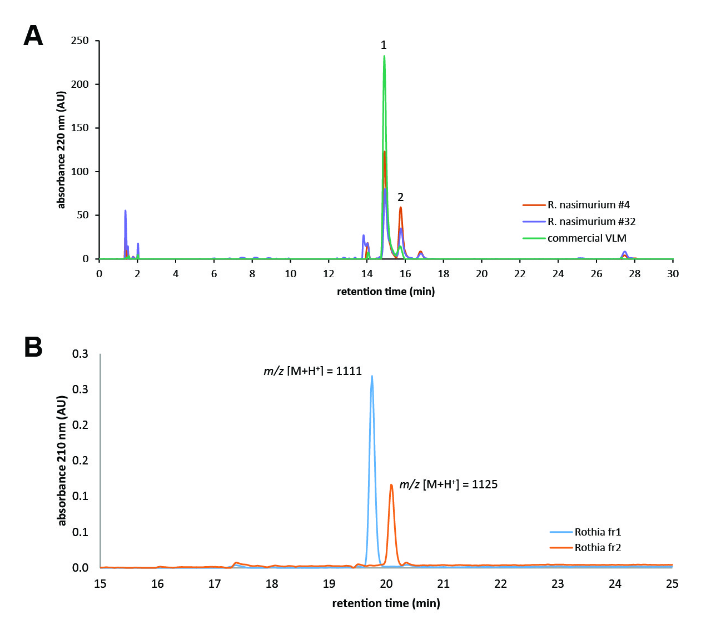

Figure S5. A) Chromatogram of an analytical HPLC of purified bacterial extracts from R. nasisuis #4 and #32. Fraction 1 (retention time = 14.7 min) and fraction 2 (retention time = 15.7 min) were further purified. Commercial valinomycin from Streptomyces fulvissimus (VLM) was used as a reference. B) Chromatogram of preparative reverse phase-HPLC purified R. nasisuis fractions 1 and 2, with the MALDI-ToF-MS mass of the purified molecule assigned to each peak (see Figure S6 for the MALDI-ToF-MS spectra for these fractions).

Figure S6. MALDI-ToF-MS spectrum of A) R. nasisuis purified valinomycin (molecular formula C₅₄H₉₀N₆O₁₈) (fraction 1, see Figure S5) with the most prominent ion adducts m/z [M+H⁺]: 1111, m/z [M+Na⁺]: 1133 and m/z [M+K⁺]: 1149, B) R. nasisuis purified valinomycin variant (fraction 2, see Figure S6) with the most prominent ion adducts m/z [M+H⁺]: 1125, m/z [M+Na⁺]: 1147 and m/z [M+K⁺]: 1163. The shift of +14 could be indicative of an additional CH₂ group.

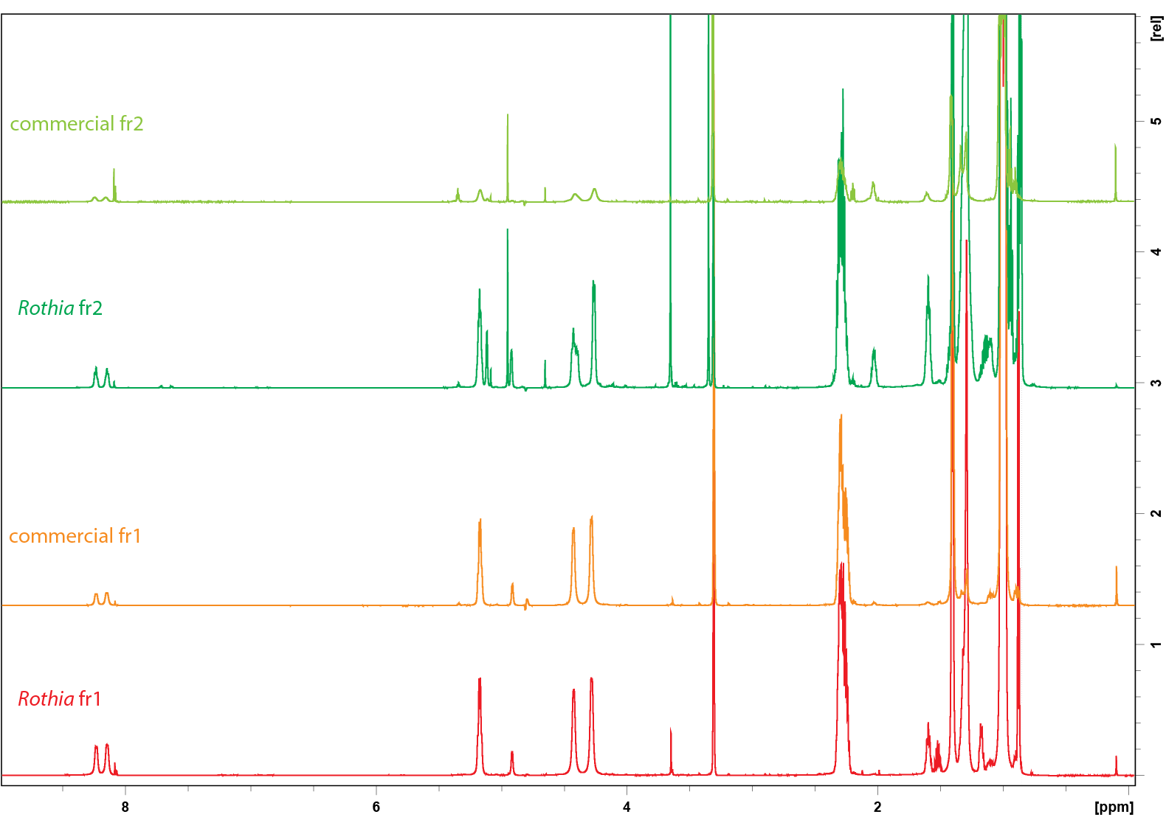

Figure S7. ¹H-NMR spectra of HPLC purified fractions 1 (red) and 2 (dark green) from R. nasisuis extracts and fractions 1 (orange) and 2 (bright green) from commercial valinomycin from S. fulvissimus.

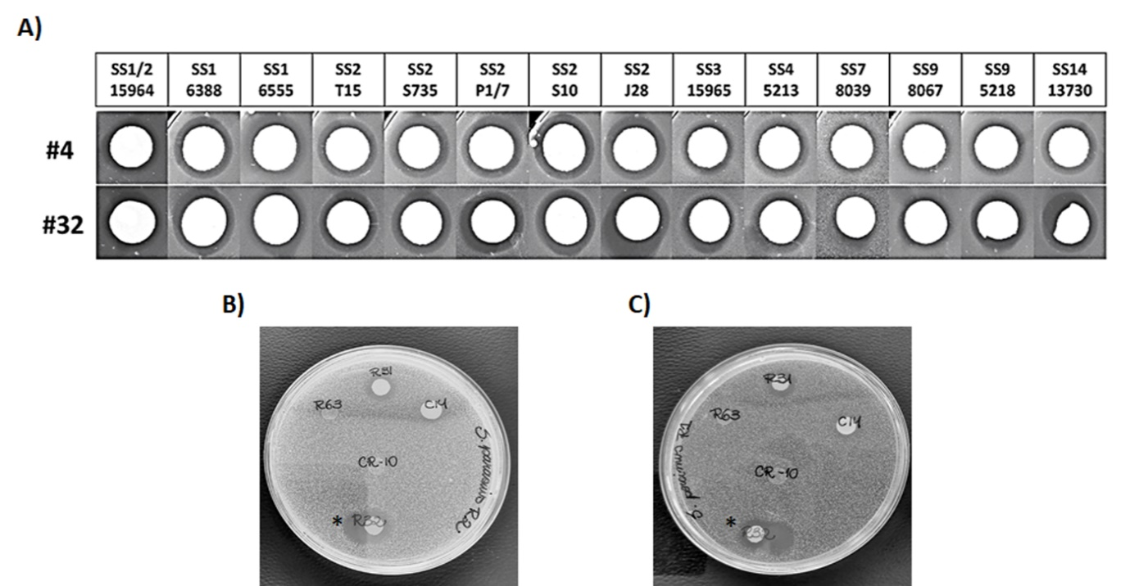

Figure S8. Antimicrobial inhibitory activity of R. nasisuis #4 and #32 against different Streptococcus species A) Antimicrobial assays overlays was tested for S. suis strains belonging to different serotypes (1, 1/2, 2, 3, 4, 7, 9, 14 and unencapsulated mutant J28 (see Table S1). B) and C) Overlay inhibition assays showing growth inhibition of S. parasuis and S. porcinus by R. nasisuis #32 (*R32) respectively.

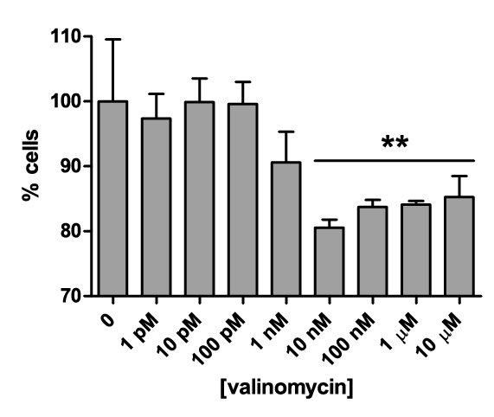

Figure S9. Effect of valinomycin on porcine NPTr upper airway epithelial cell viability, measured by the neutral red uptake assay. (n=3, mean ± SD, ** indicates P < 0.01 compared to control as determined one-way ANOVA and Dunnett's Multiple Comparison Test).

Figure S10 RDA plot of the microbiota composition of sow A, B and C on day 35. Most abundant taxa (longest arrows) contributing to the variability of the samples are indicated.

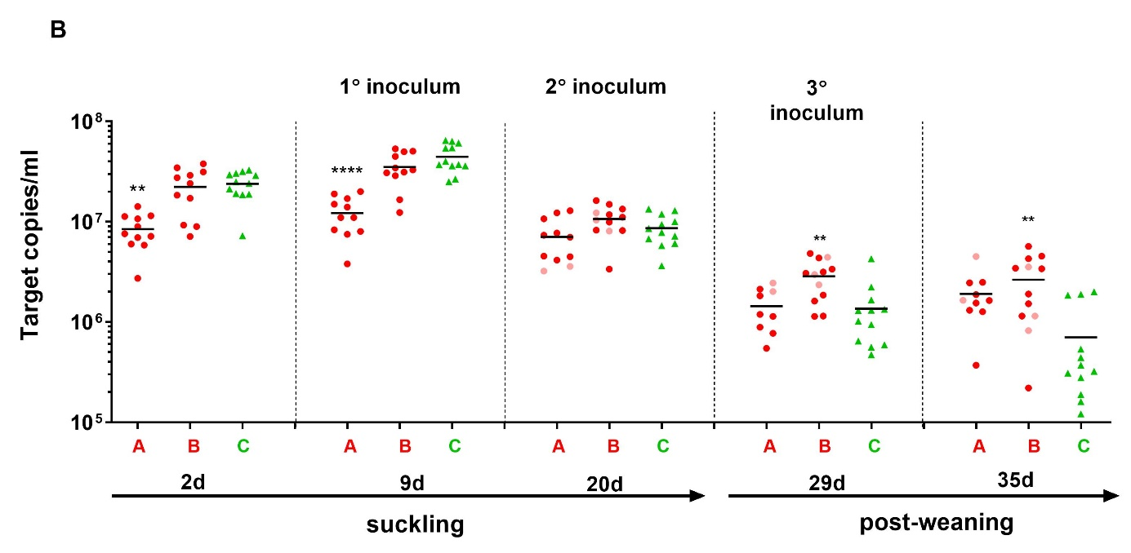

Figure S11. Quantification of S. suis in piglet tonsil swabs during suckling and post-weaning period. Only values above the detection limit are plotted in the graphs. Sows A and B (red) fostered piglets inoculated with valinomycin-producing Rothia nasisuis whereas sow C (green) fostered uninoculated piglets according to the design shown in Table S5 below. Data points shown in light red indicate piglets with sow A or B that were not inoculated with Rothia nasisuis. Samples were not available from piglet A1 on d20, d29, and d35 and from piglet A8 on d29. One-way ANOVA with Tukey’s post-test for multiple comparisons was used to assess significance from the control group; * significant at p<0.05; ** significant at p<0.01; *** significant at p<0.001, **** significant at p<0.0001.

Supplementary Methods

Colony screening assay
Pooled microbiota samples were each plated directly onto THB agar Q trays, which were incubated overnight (~18 h) aerobically at 37°C. Single colonies were isolated from THB agar Q trays using a Genetix QPIX II-XT (Molecular Devices, Berkshire, UK) colony-picking robot and inoculated into 96-well microtiter plates containing THB freezing medium, creating two separate isolate libraries originating from the tonsil and the ileum. The plates were incubated overnight at 37°C and subsequently stored at -80°C.
Individual colonies were replicated from these 96-well microtiter plates onto THB agar plates using a 96-pin microplate replicator (Boekel Scientific) and grown overnight at 37°C. Plates were exposed to UV light (λ=312 nm) for 30 min to kill the bacterial cells. Soft THB agar (0.75% w/v agar) was cooled to 50°C and seeded with a S. suis target strain (approximately 1 x 106 CFU mL⁻¹) from an overnight culture and a 35 mL aliquot was rapidly transferred to overlay each plate. The seeded soft-THB agar was allowed to solidify and dry, and growth inhibition zones were detected following overnight incubation at 37°C. Protease sensitivity of the antimicrobial compound was evaluated to ensure activity was due to a peptide and not due to non-specific fermentative metabolites such as lactate or acetate. Colonies selected on their different morphologies and consistent inhibitory activity in vitro were grown overnight and exposed to UV light, a 1 µL solution (>600 mAU mL⁻¹) of proteinase K (Qiagen) or trypsin (Sigma) was spotted next to each colony and plates were incubated for 1 h at 37°C prior to applying the S. suis seeded agar overlay.

Predicted substrate specificity of the adenylation (A) domains of the vlm NRPS
The R. nasisuis A domains were most similar to the Streptomyces A domains from the vlm NRPS (see Figures S2 and S3) and, based on the conserved features of the biosynthesis of valinomycin and cereulide ¹⁰⁻¹², are predicted to recognize and activate the substrates α-ketoisovalerate (Kiv), L-valine (L-Val), pyruvate, and L-Val. Based on these analyses, the A domains 1 and 3 of the R. nasisuis NRPS cluster were predicted to activate and load α-keto acids onto the T domain ¹⁰. Using NADPH as a redox cofactor, the ketoreductase (KR) domains in these modules then catalyse the stereospecific reduction of the T-domain-tethered α-keto acyl group to an α-hydroxyacyl group. The KR domain in module 1 would therefore reduce α-Kiv to D-α-hydroxyisovalerate (D-Hiv), and the KR domain in module 3 would reduce pyruvate to L-lactate (L-Lac), as proposed by Li et al. ¹³. The condensation (C) domains catalyse the condensation reaction between the peptidyl chain tethered to the phosphopantetheinyl arm of the upstream T domain to the amino acid bound to the downstream T domain, thereby elongating the peptidyl chain ¹⁴. The C domains in module 2 and 4 (Figure 2, C2 and C4) were classified by the bioinformatic tool NaPDoS ¹⁵ as the LCL subtype, with L-specificity for the peptidyl donor and L-specific for the aminoacyl acceptor, catalysing the peptide bond formation between two L-amino acids. The C domain in module 3 is of the DCL subtype, showing D-specificity for the peptidyl donor and L-specificity for the aminoacyl acceptor ¹⁶. Domain C3 lies immediately downstream of the E2 domain, and was predicted to catalyse chain elongation onto D-Val which results from the epimerization of L-Val by E2 in module 2 ¹⁷.

Extraction and crude purification of peptide
BHI medium was inoculated from a -80°C glycerol stock of R. nasisuis and incubated overnight at 37°C without agitation. BHI plates containing 1.25% agar were inoculated with a volume of 200 μL of the overnight bacterial culture and incubated for 48 h at 37 °C to create a lawn of bacterial growth. A volume of 15 mL cold 70% v/v isopropanol (IPA) 0.1% v/v trifluoracetic acid (TFA) or 100% methanol (MeOH) was then added to each agar plate and the bacteria were removed by gentle scraping with a sterile T-spreader (VWR International, Amsterdam, The Netherlands). The bacterial suspensions were pooled and collected in sterile 50 mL Falcon tubes (Eppendorf, Hamburg, Germany), vortexed thoroughly and incubated on a rotary shaker for 6 h at 4°C. To remove insoluble matter, the suspension was centrifuged for 25 min at 12.000 x g at 4 °C and the supernatant was filtered using a 0.2 µm cellulose acetate sterile syringe filter (Whatman, GE Healthcare). After removal of IPA by rotary evaporation, the solution was used for agar well diffusion assays as described above. For the purification, the cell-free solution was evaporated to dryness by rotary evaporation and 1 mL MeOH and 1 mL Milli-Q water were added to the residue, followed by sonication to aid re-solubilisation. Approximately 5 volumes of diethyl ether (Et₂O) were added and the suspension was sonicated thoroughly. The Et₂O solution was filtrated (589³ Blauband, Schleicher & Schuell) to remove precipitates and the solvent removed by rotary evaporation. The precipitate was subsequently resuspended by thorough sonication in acetonitrile (MeCN) and MeOH with elimination of insoluble precipitates by filtration at each step and solvent removal by rotary evaporation. The residue was dissolved in 1 mL MeOH and loaded onto a C18-E solid phase extraction column (Strata, Phenomenex), which had been conditioned with Milli-Q water. The column-bound molecules were eluted with stepwise increasing concentrations from 10% to 100% of MeOH and the collected 10 mL fractions were analysed using MALDI-ToF-MS (Bruker). The elution fractions containing peptides of interest without impurities were pooled and solvent was removed by evaporation. These crudely purified peptide preparations were stored at -20°C.

Peptide purification and characterization
Crudely purified peptides were further purified via preparative high-pressure liquid chromatography (HPLC). Analytical HPLC and MALDI-ToF-MS were employed to assess purity of the separated peptide fractions. Commercial vlm from Streptomyces fulvissimus (abcam, Cambridge, UK) was used as a reference molecule for MALDI-ToF-MS and NMR analysis and for establishing optimal HPLC conditions.

Preparative reverse-phase HPLC
Column: WatersTM XBridgeTM BEH130 C18, 10 x 250 mm, 5 µm
Pump: WatersTM 600 Pump
Detector: WatersTM 996 Photodiode Array Detector
Buffer A: 99.9% H₂O, 0.1% TFA
Buffer B: 99.9% MeOH, 0.1% TFA

Purified fractions were collected manually. Spectra were processed as follows: the raw data were exported using the Waters Empower 3 software and imported in Microsoft Excel. The baseline (blank) was subtracted, and negative absorbance values were corrected to 0 (zero).

Analytical reverse-phase HPLC
Column: Phenomenex Luna® C18, 4.6 x 150 mm, 5 µm, 100Å
Agilent 1100 Series
Pump: G1310A Isocratic Pump
Detector: G1314A Variable Wavelength Detector
Buffer A: 99.9% H₂O, 0.1% formic acid
Buffer B: 99.9% MeOH, 0.1% formic acid

Gradient:
Time (min) | Flow (mL min⁻¹) | %B
0 | 1.2 | 30
10 | 1.2 | 100
25 | 1.2 | 100
26 | 1.2 | 30
32 | 1.2 | 30

Spectra were processed as follows: the raw data were exported using the Agilent ChemStation software and imported in Microsoft Excel. The baseline (blank) was subtracted and negative absorbance values were corrected to 0 (zero).

MALDI-ToF-MS
Instrument: Bruker MicroflexTM
Matrix: α-cyano-4-hydroxycinammic acid in MeCN:H2O:TFA (50:47.5:2.5) (10 mg mL⁻¹)
Target: MSP AnchorChip 600/96 microScout (Bruker Daltonics)

NMR
HPLC purified fractions 1 and 2 from commercial (Abcam, Cambridge, UK) and R. nasisuis extracted vlm were dissolved in a minimal volume of CD₃OD and analysed by ¹H- and ¹³C-NMR on a Bruker Avance III HD 600 MHz instrument equipped with a 1.7-mm cryogenically cooled ¹³C/¹H DCH probe head.

LC-MS/MS detection of valinomycin in isolated Rothia cultures for MS networking
LC-MS/MS experiments were performed with Rothia cell extracts (obtained as described above) on a Vanquish ultra-high-performance liquid chromatography (UHPLC) system coupled to a Q-Exactive mass spectrometer (Thermo Fisher Scientific, Bremen, Germany). A C18 core-shell column (Kinetex, 50 x 2 mm, 1.8 um particle size, 100 A pore size, Phenomenex, Torrance, USA) with a flowrate of 0.5 mL/min (Solvent A: H₂O + 0.1 % formic acid (FA), Solvent B: Acetonitrile (ACN) + 0.1 % FA) was used for LC separation. A linear gradient from 0-0.5 min, 5 % B, 0.5-4 min 5-50 % B, 4-5 min 50-99 % B, followed by a 2 min washout phase at 99% B and a 2 min re-equilibration phase at 5 % B was used. For MS and MS/MS measurements the electrospray ionization (ESI) parameters were set to 35 L/min sheath gas flow, 10 L/min auxiliary gas flow, 2 L/min sweep gas flow and 400 °C auxiliary gas temperature. The spray voltage was set to 3.5 kV, the inlet capillary was set to 250 °C and a 50 V S-lens radio frequency (RF) level was applied. MS/MS spectra were recorded in data dependent acquisition (DDA) mode. Both MS¹ survey scans (150-1500 m/z) and up to 5 MS/MS scans of the most abundant ions per duty cycle were measured with a resolution (R) of 17,500 with 1 micro-scan in positive mode. The maximum ion injection time was set to 100 ms and a MS/MS precursor selection windows was set to 3 m/z with 0.5 m/z offset. Normalized collision energy was stepwise increased from 20 to 30 to 40 % with z = 2 as default charge state. MS/MS experiments were automatically triggered at the apex of a peak within 2 to 15 s from their first occurrence. A dynamic exclusion was set to 5s. Ion species with unassigned charge states as well as isotope peaks were excluded. Thermo raw data files were converted to mzXML in centroid mode using MSConvert (part of ProteoWizard) for the downstream data analysis.

MS molecular network analysis of Rothia extracts
To interpret the MS data, a molecular network of all LC-MS/MS runs was created with the online workflow at GNPS (http://gnps.ucsd.edu) ¹⁸. Similar MS/MS spectra from the same precursor mass were clustered with MS-Cluster ¹⁹ with a precursor mass tolerance of 0.02 Da and a MS/MS fragment ion tolerance of 0.02 m/z. Consensus spectra that contained less than 2 spectra were discarded. A network was then created where nodes represent masses, and edges represent node similarities. Edges were filtered to have a cosine score above 0.7 and more than 6 matched peaks. The edges between two nodes were kept in the network only when each of the nodes appeared in each other's respective top 10 most similar spectra. The spectra in the network were searched against GNPS's spectral libraries. The library spectra were filtered in the same manner as the input data. All spectra library matches were required to have a score above 0.6 and at least 6 matched peaks and were manually validated. MS raw data can be found at the Mass spectrometry Interactive Virtual Environment (MassIVE) with the following identifier: MSV000079820 or following the link: http://massive.ucsd.edu/ProteoSAFe/dataset.jsp?task=3b33186c6ac746789fff6dd907a3fe6c
The spectral network and corresponding spectrum library search results can be found at GNPS under the following link: http://gnps.ucsd.edu/ProteoSAFe/status.jsp?task=ee4a0198c3f24b7888280cd66a0a9cfc

MALDI-ToF MS Imaging (MSI)
After the cultivation of Rothia #4 and #32 isolates on thin layer BHI agar, colonies were transferred to a stainless steel MALDI target plate and a 1:1 mixtures of CHCA and DHB was sieved onto the target as described previously ²⁰. After drying the sample over night at 37° C the target plate was transferred to a Autoflex MALDI-ToF mass spectrometer equipped with a Nd:YAG smartbeam2 laser (Bruker Daltonics, Bremen, Germany). For MALDI imaging experiments, the laser width was set to “wide”. For each raster spot of 300×300 μm, 1000 laser shots (200 shots random walk) with a relative laser energy of 50% at a frequency of 1000 Hz were acquired. ToF measurements were hereby performed in positive reflectron mode. The mass spectrometer was hereby set to a suppression of matrix ions below 300 m/z. The ToF mass range was set to 300-2800 m/z with a detector gain multiply of 12. The mass spectra were recorded and further visualized using FlexImaging 4.1 (Bruker, Daltonics, Bremen, Germany).

Neutral red uptake assay
Viability of NPTr cells ²¹ was quantified using the neutral red uptake assay to determine cytotoxicity of vlm to epithelium ²². Briefly, cells were seeded in a flat-bottom 96-well microtiter plate at a density of ~1x10⁵ cells well⁻¹ in 89% Dulbecco's Modified Eagle's Medium (DMEM) + GlutaMAX™ (Gibco, Life Technologies), containing 10% heat-inactivated Fetal Bovine Serum (FBS) and 100 U mL⁻¹ penicillin and 100 μg mL⁻¹ streptomycin (Invitrogen, Breda, The Netherlands). After incubation at 37°C with 5% CO₂ for 24 h, cells reached confluency and culture medium was removed and replaced with 200 µL treatment medium (Keratinocyte Serum Free Medium (Gibco, Life Technologies)) containing a concentration range of vlm. Following 18 h incubation at 37°C with 5% CO₂, the treatment medium was removed and 100 µL neutral red solution (40 mg mL⁻¹) was added. After 3 h incubation, neutral red solution was removed, cells were washed with 150 µL PBS and neutral red was extracted from the cells by adding 150 µL 50% ethanol, 1% glacial acetic acid. The released neutral red content, indicative of cell viability, was measured spectrophotometrically at 540 nm (Spectramax M5, Molecular Devices, Sunnyvale CA, USA), values from triplicate conditions were averaged and normalized to cells treated with PBS only and expressed with the SD as percentage viable cells.

Overlay inhibition assay
Five microliters of each ON culture was spotted onto BHI medium agar to allow growth of bacterial colonies. Plates were exposed to UV light for 30 min to kill bacterial cells, then overlaid with 15 mL of soft agar (0.75% w/v agar) at 50°C, inoculated with approx. 1x10⁵ CFU/mL of the indicator (targets/pathogens) to determinate the spectrum of activity. Antimicrobial activity was determined by the presence and size of clearly visible zones of growth inhibition around the colonies after overnight incubation at 37°C with 5% CO2.

Colonisation study in vivo
Shortly before the expected farrowing date, three sows were selected for the colonization study based on PCR detection of S. suis serotype 9 in saliva. To avoid potential genetic bias the newborn piglets were randomized between the three sows and housed separately in 3 groups of 12. The piglets nursed by sow A and B received an oral inoculum of an estimated 10⁹ valinomycin-producing R. nasisuis (OD₆₀₀=1.85) in 1mL BHI plus 3.5mL of Cryo saver solution (skim milk powder solution 15% plus glycerol 10%) by syringe during suckling d2, d19 (suckling period) and after weaning d27 and d35 (Figure 6). The 12 control piglets nursed by sow C received no treatment (Table S5). The third inoculum was decreased to a final volume of 3mL to facilitate administration. Three piglets nursed by sows A and B (i.e. A1-A3, B1-B3) were uninoculated to investigate potential horizontal transmission of valinomycin-producing R. nasisuis. However, piglets A2 and B1 received the 2nd and 3rd inoculum by mistake. During the experiment one of the piglets (A4) died from unrelated causes and was excluded from the analysis.
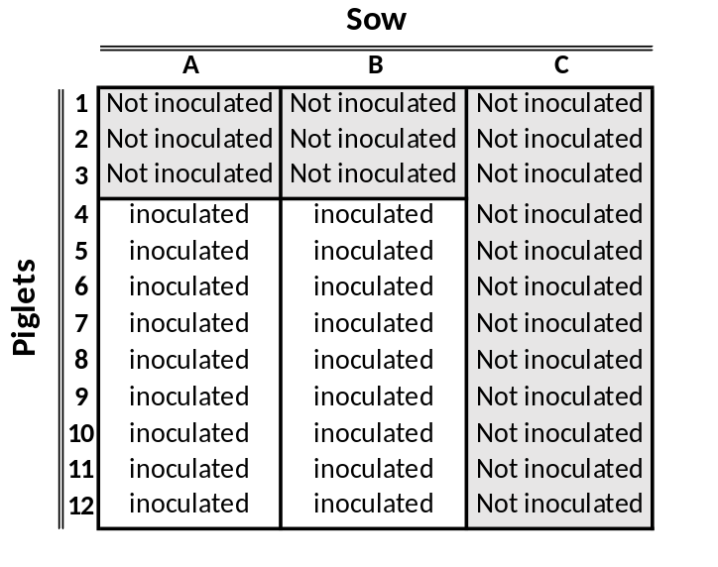

Table S5. Experimental design of the colonisation study. Piglets from all three litters were randomly assigned to sow A, B, or C which were housed separately. Piglets 4- 12 of litters A and B were inoculated orally with valinomycin-producing R. nasisuis strain #32, while piglets 1, 2 and 3, were inoculated with Cryo saver solution as a control for horizontal transfer. As controls, piglets suckled by sow C were not inoculated.

Sample collection and bacterial DNA isolation
Saliva samples (between 5-10 mL) were collected directly from the sows using the Happy bite Rope® (GD webshop cat # VDGEB086), put immediately on ice, and stored at -80°C. After defrosting, the saliva was centrifuged (8000 x g for15 min, RT) and the pellet resupended in 1-2 mL of PBS, of which 250 μl was used for bacterial DNA extraction with the PowerSoil® DNA Isolation Kit (MoBio, Qiagen). Palatine tonsil of the piglets were sampled using HydraFlock® Swabs (Cat. #25-3206-H 20mm breakpoint, Puritan, USA) at 5 time points as indicated in Figure 5. The flock of the swab was cut at the breakpoint (20 mm) and inserted directly into PowerBead Tubes (Cat. #12888-50-PBT, MoBio, Qiagen) prefilled with 750 µL of Power Bead lysis solution and garnet beads (0.7 mm Ø size). After sampling, swabs were placed immediately on dry ice before being stored at -80°C. Bacterial lysis was obtained by bead beading the PowerBead Tubes with FastPrep24™ 5G (MP-Biomedicals, France) for 40 seconds at 4.0 m/s. The lysate was centrifuged at 12,000 × g for 5 min and genomic DNA (gDNA) was purified from the recovered supernatant by the PowerSoil® DNA Isolation Kit. Total DNA yield was quantified using the Qubit 3.0 Fluorometer Broad Range DNA assay (Cat #Q32853, Life Technologies, USA) following the manufacturers guidelines and DNA quality was checked by DNA electrophoresis in 1% agarose.
Quantitative PCR
S. suis was quantified by qPCR using primers P7 and P20 and TaqMan probe P17 for the V3-V4 region of the 16S rRNA gene ² Table S2 primers). Primer and probe specificity were evaluated in silico using a 16S rRNA gene alignment to other Streptococcus species. Additionally, gDNA isolated from Streptococcus mitis and Streptococcus salivarius were used as negative controls (data not shown).
A method for qPCR detection of valinomycin-producing R. nasisuis was developed using primers upstream of vlm and a reverse primer and TaqMan probe within the vlm gene. Primers/probe specificity was checked using the gDNA isolated from vlm-negative R. nasimurium strain DSMZ15694 (Table S2, Figure S11). Standard curves were generated by a purified PCR fragment containing the full length of the 16S rRNA gene of S. suis P1/7 and vlm gene including its upstream region of R. nasisuis strain #32 which was serially diluted from 10⁸ to 10¹ copies of the target gene per mL. Analysis of qPCR data was performed using the Rotor-gene Q® software (Qiagen). Statistical analyses were performed using GraphPad Prism® version 5.03 for Windows (GraphPad Software, San Diego California USA, www.graphpad.com). Significant differences from the control group were assessed by a one-way ANOVA with Tukey’s post-test for multiple comparisons.

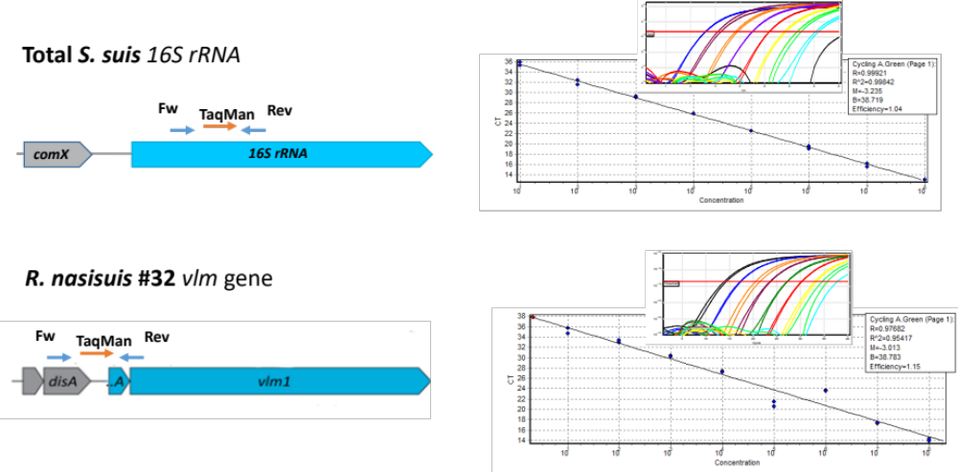

Figure S12. Schematic representation the location of primers and Taqman probes used for qPCR detection of S. suis and valinomycin-producing R. nasisuis. For both qPCR reactions standard curves were generated with 10⁸ to 10¹ copies of the PCR-amplified target DNA per mL.

Metataxonomic sequencing of tonsil samples and microbiota analysis
The V3-V4 region of the 16S rRNA gene was amplified using the primers listed in Table S2 and 300 bp paired-end sequencing using the Illumina MiSeq platform (Illumina, San Diego, CA, United States) was carried out at Wageningen Bioveterinary Research (Lelystad, The Netherlands). The sequencing data was analyzed using the CLC Genomic Workbench (Qiagen) version 11 with the Microbial Genomics plugin. Raw reads were trimmed and filtered to remove low quality reads (> Q20), and chimeras and short amplicons (<100 bases) removed. Sequences were then clustered into Operational Taxonomic Units (OTUs) at 99% similarity and taxonomy was assigned with the SILVA core database. Species level taxonomy was confirmed by blasting the representative sequences of the 200 most abundant OTUs against the NCBI 16S ribosomal RNA database. Relative taxon abundance values and microbiota diversity analysis were calculated and visualized using the online tool MicrobiomeAnalyst (https://www.microbiomeanalyst.ca/). In MicrobiomeAnalyst, the data was further filtered (minimum counts cut-off = 50, sample prevalence = 20%, percentage to remove = 1%), rarefied to the minimum library size and scaled by Total Sum Scaling (TSS) without data transformation. Beta-diversity of microbial communities was calculated based on Bray-Curtis dissimilarity and visualized using principal coordinate analysis (PCoA). Diversity profiling was determined at the OTU level and Permutational Multivariate Analysis of Variance (PERMANOVA) was used to identify group differences.

References

1 Kim, O. S. et al. Introducing EzTaxon-e: a prokaryotic 16S rRNA gene sequence database with phylotypes that represent uncultured species. Int J Syst Evol Microbiol 62, 716-721, doi:10.1099/ijs.0.038075-0 (2012).
2 Bonifait, L., Veillette, M., Letourneau, V., Grenier, D. & Duchaine, C. Detection of Streptococcus suis in bioaerosols of swine confinement buildings. Appl Environ Microbiol 80, 3296-3304, doi:10.1128/aem.04167-13 (2014).
3 Dekker, N. et al. Simultaneous Quantification and Differentiation of Streptococcus suis Serotypes 2 and 9 by Quantitative Real-Time PCR, Evaluated in Tonsillar and Nasal Samples of Pigs. Pathogens 5, doi:10.3390/pathogens5030046 (2016).
4 Jurburg, S. D. et al. Patterns of community assembly in the developing chicken microbiome reveal rapid primary succession. Microbiologyopen 8, e00821, doi:10.1002/mbo3.821 (2019).
5 Dereeper, A. et al. Phylogeny.fr: robust phylogenetic analysis for the non-specialist. Nucleic Acids Res 36, W465-469, doi:10.1093/nar/gkn180 (2008).
6 Dereeper, A., Audic, S., Claverie, J. M. & Blanc, G. BLAST-EXPLORER helps you building datasets for phylogenetic analysis. BMC Evol Biol 10, 8, doi:10.1186/1471-2148-10-8 (2010).
7 Marahiel, M. A., Stachelhaus, T. & Mootz, H. D. Modular Peptide Synthetases Involved in Nonribosomal Peptide Synthesis. Chemical Reviews 97, 2651-2674, doi:10.1021/cr960029e (1997).
8 Khayatt, B. I., Overmars, L., Siezen, R. J. & Francke, C. Classification of the Adenylation and Acyl-Transferase Activity of NRPS and PKS Systems Using Ensembles of Substrate Specific Hidden Markov Models. PLoS ONE 8, e62136 (2013).
9 Tsirigos, K. D., Peters, C., Shu, N., Kall, L. & Elofsson, A. The TOPCONS web server for consensus prediction of membrane protein topology and signal peptides. Nucleic Acids Res 43, W401-407, doi:10.1093/nar/gkv485 (2015).
10 Magarvey, N. A., Ehling-Schulz, M. & Walsh, C. T. Characterization of the cereulide NRPS alpha-hydroxy acid specifying modules: activation of alpha-keto acids and chiral reduction on the assembly line. J Am Chem Soc 128, 10698-10699, doi:10.1021/ja0640187 (2006).
11 Jaitzig, J., Li, J., Süssmuth, R. D. & Neubauer, P. Reconstituted Biosynthesis of the Nonribosomal Macrolactone Antibiotic Valinomycin in Escherichia coli. ACS Synthetic Biology 3, 432-438, doi:10.1021/sb400082j (2014).
12 Alonzo, D. A., Magarvey, N. A. & Schmeing, T. M. Characterization of Cereulide Synthetase, a Toxin-Producing Macromolecular Machine. PLoS ONE 10, e0128569 (2015).
13 Li, J., Jaitzig, J., Lu, P., Sussmuth, R. & Neubauer, P. Scale-up bioprocess development for production of the antibiotic valinomycin in Escherichia coli based on consistent fed-batch cultivations. Microbial Cell Factories 14, 83 (2015).
14 Lautru, S. & Challis, G. L. Substrate recognition by nonribosomal peptide synthetase multi-enzymes. Microbiology 150, 1629-1636, doi:10.1099/mic.0.26837-0 (2004).
15 Ziemert, N. et al. The Natural Product Domain Seeker NaPDoS: A Phylogeny Based Bioinformatic Tool to Classify Secondary Metabolite Gene Diversity. PLoS ONE 7, e34064 (2012).
16 Rausch, C., Hoof, I., Weber, T., Wohlleben, W. & Huson, D. Phylogenetic analysis of condensation domains in NRPS sheds light on their functional evolution. BMC Evolutionary Biology 7, 78 (2007).
17 Clugston, S. L., Sieber, S. A., Marahiel, M. A. & Walsh, C. T. Chirality of peptide bond-forming condensation domains in nonribosomal peptide synthetases: the C5 domain of tyrocidine synthetase is a (D)C(L) catalyst. Biochemistry 42, 12095-12104, doi:10.1021/bi035090+ (2003).
18 Wang, M. C., Jeremy; Phelan, Vanessa; Sanchez, Laura; Garg, Neha; Peng; Yao , Nguyen, Don; Watrous, Jeramie; Dorrestein C., Pieter; Bandeira, Nuno; et al. (2016).
19 Frank, A. M. et al. Clustering millions of tandem mass spectra. J Proteome Res 7, 113-122, doi:10.1021/pr070361e (2008).
20 Yang, J. Y. et al. Primer on agar-based microbial imaging mass spectrometry. J Bacteriol 194, 6023-6028, doi:10.1128/jb.00823-12 (2012).
21 Ferrari, M. et al. Establishment and characterization of two new pig cell lines for use in virological diagnostic laboratories. J Virol Methods 107, 205-212 (2003).
22 Repetto, G., del Peso, A. & Zurita, J. L. Neutral red uptake assay for the estimation of cell viability/cytotoxicity. 3, 1125-1131 (2008).

