Supplementary Information File of
How Can Environmental Impacts of Water Demand Management Policies on a Wastewater System be Assessed?
Haniye Safarpour¹, Massoud Tabesh^{*2}, Seyyed Ahmadreza Shahangian³

¹ M.Sc. School of Civil Engineering, College of Engineering, University of Tehran, Tehran, Iran. E-mail address: h.safarpour@ut.ac.ir
²* Professor, School of Civil Engineering, College of Engineering, University of Tehran, Tehran, Iran (Corresponding Author), E-mail address: mtabesh@ut.ac.ir
³ Ph.D. Candidate, School of Civil Engineering, College of Engineering, University of Tehran, Tehran, Iran. E-mail address: a.shahangian@ut.ac.ir

Equations:
Estimation of H₂S emissions from WWCN (tee et al., 2011):

(1)

S_{lim}: limit concentration of sulfide (mg/l), BOD: biochemical oxygen demand concentration (mg/l), T: wastewater’s temperature (⁰C), S: slope of the pipe (m/m), U: velocity (m/s), and P/b: ratio of wetted perimeter of the pipe wall (P) (m) to the surface width of the stream (b) (m).
Estimation of CH₄ emissions from WWCN (Chaosakul et al., 2014):
(2)

C_{CH4}: the concentration of CH₄ emission (mg/l), A/V: the surface area to volume ratio of sewer (m⁻¹), HRT: hydraulic retention time (hr), and T: wastewater’s temperature (⁰C).
Estimation CH₄ and CO₂ Emissions from Wastewater treatment unit (EPA, 2010):
(3)
(4)

CO₂: CO₂ emission rate (Mg CO₂/hr), CH₄: CH₄ emission rate (Mg CH₄/hr), Q_{ww}: Wastewater influent flow rate (m³/hr), OD: Oxygen demand of influent wastewater to the biological treatment unit determined as either BOD₅ or COD (mg/L = gr/m³), Eff_{OD}: Oxygen demand removal efficiency of the biological treatment unit, CF_{CO2}: Conversion factor for maximum CO₂ generation per unit of oxygen demand = 44/32 = 1.375 gr CO₂/ g oxygen demand, CF_{CH4}: Conversion factor for maximum CH₄ generation per unit of oxygen demand = 16/32 = 0.5 gr CH₄/ g oxygen demand, MCF_{WW}: methane correction factor for wastewater treatment unit, BG_{CH4}: Fraction of carbon as CH₄ in generated biogas (default is 0.65), and λ: Biomass yield.
Estimation CH₄ and CO₂ Emissions from sludge treatment unit (EPA, 2010):
(5)
(6)

MCF_{s}: methane correction factor for sludge digester, indicating the fraction of the influent oxygen demand that is converted anaerobically in the digester (MCFs is zero in the aerobic sludge digestion), and other parameters are defined as previous.

Type of wastewater treatment used in this work:
The case study’s Wastewater Treatment Plant (WWTP) is 5.6 Km far from Baharestan city in the north-east of it. This WWTP’s size is 28.3 ha and designed for the end year of 2036. The used treatment method is modified Ludzack-Ettinger (MLE) and contains screw pumps, mechanical screening, grit chamber, primary sedimentation tanks, anoxic tanks, aeration tanks, secondary sedimentation tanks, drum filters, UV lamps, excess sludge thickener, aerobic digesters, and dewatering as process units. The qualitative parameters such as BOD, COD, and TSS of the influent wastewater are average 342.5, 715, 268 mg per liter in 2016 in the case study, respectively.
Inventory of Life Cycle Assessment

Table 1 - Replacing cast iron manhole covers (for one replacement)
Input (process/ materials) | Ecoinvent Process/ Materials | Unit | Amount
Cast iron | Cast iron {GLO}| market for | APOS, S | Kg | 142.5
Construction of a cover | Metal working, average for metal product manufacturing {RoW}| processing | APOS, S | Kg | 142.5
Installation of a cover* | Machine operation, diesel, >= 74.57 kW, steady-state {GLO}| market for | APOS, S | hr | 0.5
Transportation of new cover to the site | Transport, freight, lorry 3.5-7.5 metric ton, euro4 {RoW}| market for transport, freight, lorry 3.5-7.5 metric ton, EURO4 | APOS, S | t.Km | 5.6
Transportation of the brokent cover to the landfill | Transport, freight, lorry 3.5-7.5 metric ton, euro4 {RoW}| market for transport, freight, lorry 3.5-7.5 metric ton, EURO4 | APOS, S | t.Km | 4.7
Transportation of workers | Transport, freight, light commercial vehicle {GLO}| market group for transport, freight, light commercial vehicle | APOS, S | t.Km | 2
*Installation of covers by use of the truck crane with power of 99.2 KW

Table 2 - Replacing reinforced concrete manhole covers (for one replacement)
Input (process/ materials) | Ecoinvent Process/ Materials | Unit | Amount
Concrete | Concrete block {GLO}| market for | APOS, S | m3 | 0.02
Reinforcing steel | Reinforcing steel {GLO}| market for | APOS, S | Kg | 47
Reinforcement* | Machine operation, diesel, >= 18.64 kW and < 74.57 kW, steady-state {GLO}| market for | APOS, S | min | 10
Installation of a cover** | Machine operation, diesel, >= 74.57 kW, steady-state {GLO}| market for | APOS, S | hr | 0.5
Tansportation of new cover to the site | Transport, freight, lorry 3.5-7.5 metric ton, euro4 {RoW}| market for transport, freight, lorry 3.5-7.5 metric ton, EURO4 | APOS, S | t.Km | 4.06
Transportation of the brokent cover to the landfill | Transport, freight, lorry 3.5-7.5 metric ton, euro4 {RoW}| market for transport, freight, lorry 3.5-7.5 metric ton, EURO4 | APOS, S | t.Km | 3.42
Transportation of workers | Transport, freight, light commercial vehicle {GLO}| market group for transport, freight, light commercial vehicle | APOS, S | t.Km | 2
*Welding mechine with the power of 50 KW
**Installation of covers by use of the truck crane with power of 99.2 KW

Table 3 - Blockages of branches' pipeline siphons (for one blockage)
Input (process/ materials) | Ecoinvent Process/ Materials | Unit | Amount
Unclogging a blockage* | Machine operation, diesel, < 18.64 kW, steady-state {GLO}| market for | APOS, S | hr | 1
Transportation of workers | Transport, freight, light commercial vehicle {GLO}| market group for transport, freight, light commercial vehicle | APOS, S | t.Km | 2
*Unclogging the siphon by use of the machine with power of 1125 W

Table 4- Blockages of main sewer pipes (for one blockage)
Input (process/ materials) | Ecoinvent Process/ Materials | Unit | Amount
Water* | Water, well, IR | l | 1800
Unclogging a pipe** | Machine operation, diesel, >= 74.57, underground mining {GLO}| market for | APOS, S | hr | 1
Transportation of deposits to the landfill | Transport, freight, lorry 3.5-7.5 metric ton, euro4 {RoW}| market for transport, freight, lorry 3.5-7.5 metric ton, EURO4 | APOS, S | t.Km | 3.32
Transportation of workers | Transport, freight, light commercial vehicle {GLO}| market group for transport, freight, light commercial vehicle | APOS, S | t.Km | 2
*Water needed for Water jet machine (30 lit/min)
**Unclogging the pipes by the use of Truckjet with the power of 198 KW

Table 5- Blockages of manholes (for one blockage)
Input (process/ materials) | Ecoinvent Process/ Materials | Unit | Amount
Unclogging a Manhole* | Machine operation, diesel, >= 74.57 kW, steady-state {GLO}| market for | APOS, S | min | 40
Transportation of deposits to the landfill | Transport, freight, lorry 3.5-7.5 metric ton, euro4 {RoW}| market for transport, freight, lorry 3.5-7.5 metric ton, EURO4 | APOS, S | t.Km | 6.64
Transportation of workers | Transport, freight, light commercial vehicle {GLO}| market group for transport, freight, light commercial vehicle | APOS, S | t.Km | 2
*Unclogging the manhole by use of Jantex machine with the power of 99.18 KW

Table 6- Construction of 1 kg of wearing course asphalt (Hajibabei et al., 2018)
Input (process/ materials) | Ecoinvent Process/ Materials | Unit | Amount
Limestone | Limestone, crushed, for mill {RoW}| market for limestone, crushed, for mill | APOS, S | Kg | 0.0386
Sand | Sand {GLO}| market for | APOS, S | Kg | 0.4032
Gravel | Gravel, crushed {RoW}| market for gravel, crushed | APOS, S | Kg | 0.4378
Gravel | Gravel, round {RoW}| market for gravel, round | APOS, S | Kg | 0.023
bitumen | Bitumen adhesive compound, hot {GLO}| market for | APOS, S | Kg | 0.0589
Energy | Electricity, medium voltage {IR}| market for | APOS, S | KWh | 0.0086
Energy | Heat, district or industrial, natural gas {GLO}| market group for | APOS, S | MJ | 0.1752
Energy | Heat, central or small-scale, other than natural gas {GLO}| market group for | APOS, S | MJ | 0.1752
Energy | Diesel, burned in building machine {GLO}| market for | APOS, S | MJ | 0.0111
Construction | Concrete mixing factory {GLO}| market for | APOS, S | p | 2.51E-10
Water | Tap water {RoW}| market for | APOS, S | Kg | 0.0085
Oil | Lubricating oil {RoW}| market for lubricating oil | APOS, S | Kg | 0.00000301

Table 7- Construction of 1 kg of base course asphalt (Hajibabei et al., 2018)
Input (process/ materials) | Ecoinvent Process/ Materials | Unit | Amount
Limestone | Limestone, crushed, for mill {RoW}| market for limestone, crushed, for mill | APOS, S | Kg | 0.055
Sand | Sand {GLO}| market for | APOS, S | Kg | 0.2
Gravel | Gravel, crushed {RoW}| market for gravel, crushed | APOS, S | Kg | 0.35
Gravel | Gravel, round {RoW}| market for gravel, round | APOS, S | Kg | 0.35
Bitumen | Bitumen adhesive compound, hot {GLO}| market for | APOS, S | Kg | 0.045
Energy | Electricity, medium voltage {IR}| market for | APOS, S | KWh | 0.0086
Energy | Heat, district or industrial, natural gas {GLO}| market group for | APOS, S | MJ | 0.1752
Energy | Heat, central or small-scale, other than natural gas {GLO}| market group for | APOS, S | MJ | 0.1752
Energy | Diesel, burned in building machine {GLO}| market for | APOS, S | MJ | 0.0111
Construction | Concrete mixing factory {GLO}| market for | APOS, S | p | 2.51E-10
Water | Tap water {RoW}| market for | APOS, S | Kg | 0.0085
Oil | Lubricating oil {RoW}| market for lubricating oil | APOS, S | Kg | 0.00000301

Table 8- Reconstruction of asphalt (for area of 1.5*1.5)
Input (process/ materials) | Ecoinvent Process/ Materials | Unit | Amount
Wearing course asphalt (Table 6) | wearing course asphalt | Kg | 148.5
Base course asphalt (Table 7) | base course asphalt | Kg | 346.5
Cutting the old asphalt layers* | Machine operation, diesel, < 18.64 kW, generators {GLO}| market for | APOS, S | min | 30
Excavation | Excavation, hydraulic digger {GLO}| market for | APOS, S | m3 | 0.225
Spraying bitumen ** | Machine operation, diesel, < 18.64 kW, generators {GLO}| market for | APOS, S | min | 20
Rolling asphalt layer*** | Machine operation, diesel, >= 18.64 kW and < 74.57 kW, steady-state {GLO}| market for | APOS, S | min | 30
Compacting**** | Machine operation, diesel, < 18.64 kW, steady-state {GLO}| market for | APOS, S | min | 20
Transportation of asphalt to the site | Transport, freight, lorry 3.5-7.5 metric ton, euro4 {RoW}| market for transport, freight, lorry 3.5-7.5 metric ton, EURO4 | APOS, S | t.Km | 29
Transportation of deposits to the landfill | Transport, freight, lorry 3.5-7.5 metric ton, euro4 {RoW}| market for transport, freight, lorry 3.5-7.5 metric ton, EURO4 | APOS, S | t.Km | 16.5
Transportation of workers | Transport, freight, light commercial vehicle {GLO}| market group for transport, freight, light commercial vehicle | APOS, S | t.Km | 2
*Cutter of asphalt with the power of 22 HP
**Potable bitumen spray with the power of 7 HP
***Finisher with the power of 55.4 KW
****Small vibrating rollers with the power of 7.3 KW

Table 9- Break in main sewer pipes (for one break) *
Input (process/ materials) | Ecoinvent Process/ Materials | Unit | Amount
Reconstruction of asphalt (Table 8) | reconstruction of asphalt | p | 1
Excavation | Excavation, hydraulic digger {GLO}| market for | APOS, S | m3 | 3.57
transportation of equipments for patching the pipe to the site | Transport, freight, lorry 3.5-7.5 metric ton, euro4 {RoW}| market for transport, freight, lorry 3.5-7.5 metric ton, EURO4 | APOS, S | t.Km | 4
Welding the pipes paches** | Machine operation, diesel, < 18.64 kW, generators {GLO}| market for | APOS, S | min | 20
Gravel | Gravel, crushed {RoW}| market for gravel, crushed | APOS, S | Kg | 382.5
Sand | Sand {GLO}| market for | APOS, S | Kg | 1695.1
Excavation | Excavation, hydraulic digger {GLO}| market for | APOS, S | m3 | 4.89
Compacting*** | Machine operation, diesel, < 18.64 kW, steady-state {GLO}| market for | APOS, S | min | 20
Transportation of Materials to the site | Transport, freight, lorry 3.5-7.5 metric ton, euro4 {RoW}| market for transport, freight, lorry 3.5-7.5 metric ton, EURO4 | APOS, S | t.Km | 222.3
Transportation of deposits to the landfill | Transport, freight, lorry 3.5-7.5 metric ton, euro4 {RoW}| market for transport, freight, lorry 3.5-7.5 metric ton, EURO4 | APOS, S | t.Km | 43.78
Transportation of workers | Transport, freight, light commercial vehicle {RoW}| market for transport, freight, light commercial vehicle | APOS, S | t.Km | 2
*The considering trench is for the pipe with 200mm diameter
**Welding machine with the power of 750W
***Small vibrating rollers with the power of 7.3 KW

Table 10- Break in sewer branches pipes (for one break) *
Input (process/ materials) | Ecoinvent Process/ Materials | Unit | Amount
Reconstruction of asphalt (Table 8) | reconstruction of asphalt | p | 1
Excavation | Excavation, hydraulic digger {GLO}| market for | APOS, S | m3 | 3.42
Transportation of equipments for patching the pipe to the site | Transport, freight, lorry 3.5-7.5 metric ton, euro4 {RoW}| market for transport, freight, lorry 3.5-7.5 metric ton, EURO4 | APOS, S | t.Km | 4
Welding the pipes paches** | Machine operation, diesel, < 18.64 kW, generators {GLO}| market for | APOS, S | min | 20
Gravel | Gravel, crushed {RoW}| market for gravel, crushed | APOS, S | Kg | 382.5
Sand | Sand {GLO}| market for | APOS, S | Kg | 1463.2
Excavation | Excavation, hydraulic digger {GLO}| market for | APOS, S | m3 | 4.59
Compacting*** | Machine operation, diesel, < 18.64 kW, steady-state {GLO}| market for | APOS, S | min | 20
Transportation of Materials to the site | Transport, freight, lorry 3.5-7.5 metric ton, euro4 {RoW}| market for transport, freight, lorry 3.5-7.5 metric ton, EURO4 | APOS, S | t.Km | 197.5
Transportation of deposits to the landfill | Transport, freight, lorry 3.5-7.5 metric ton, euro4 {RoW}| market for transport, freight, lorry 3.5-7.5 metric ton, EURO4 | APOS, S | t.Km | 38.8
Transportation of workers | Transport, freight, light commercial vehicle {RoW}| market for transport, freight, light commercial vehicle | APOS, S | t.Km | 2
*The considering trench is for the pipe with 125mm diameter
**Welding machine with the power of 750W
***Small vibrating rollers with the power of 7.3 KW

Table 11- Air emissions from WWCN (per 1 m³ of wastewater)
Scenario | Ecoinvent Process/ Materials | Unit | Amount
0 | Methane, biogenic | g | 1.57
0 | Hydrogen sulfide | g | 1.63
1 | Methane, biogenic | g | 1.58
1 | Hydrogen sulfide | g | 1.69
2 | Methane, biogenic | g | 1.58
2 | Hydrogen sulfide | g | 1.73
3 | Methane, biogenic | g | 1.58
3 | Hydrogen sulfide | g | 1.68
4 | Methane, biogenic | g | 1.59
4 | Hydrogen sulfide | g | 1.75

Table 12- Air emissions from WWTP (per 1 m³ of wastewater)
Scenario | Ecoinvent Process/ Materials | Unit | Amount
0 | Methane, biogenic | g | 14.1
0 | Carbon dioxide, biogenic | g | 321.8
0 | Dinitrogen monoxide | g | 0.053
1 | Methane, biogenic | g | 17.2
1 | Carbon dioxide, biogenic | g | 394.6
1 | Dinitrogen monoxide | g | 0.065
2 | Methane, biogenic | g | 18.1
2 | Carbon dioxide, biogenic | g | 413.5
2 | Dinitrogen monoxide | g | 0.069
3 | Methane, biogenic | g | 16.4
3 | Carbon dioxide, biogenic | g | 376
3 | Dinitrogen monoxide | g | 0.062
4 | Methane, biogenic | g | 30.9
4 | Carbon dioxide, biogenic | g | 706.9
4 | Dinitrogen monoxide | g | 0.11
*Carbon dioxide in this table is the sum of emissions from wastewater and sludge treatment unit

Table 13- Energy consumption in WWTP (per 1 m³ of wastewater flow)
Input (process/ materials) | Ecoinvent Process/ Materials | Unit | Amount
Energy | Electricity, medium voltage {IR}| market for | APOS, S | KWh | 0.179614

Table 14- Chemical consumption in WWTP (per 1 m³ of wastewater flow)
Scenario | Ecoinvent Process/ Materials | Unit | Amount
0 | Aluminium sulfate, powder {RER}| market for aluminium sulfate, powder | APOS, S | Kg | 0.00131306
1 | Aluminium sulfate, powder {RER}| market for aluminium sulfate, powder | APOS, S | Kg | 0.00161072
2 | Aluminium sulfate, powder {RER}| market for aluminium sulfate, powder | APOS, S | Kg | 0.00168745
3 | Aluminium sulfate, powder {RER}| market for aluminium sulfate, powder | APOS, S | Kg | 0.00153454
4 | Aluminium sulfate, powder {RER}| market for aluminium sulfate, powder | APOS, S | Kg | 0.0028846

Table 15- Transportations of WWTP
Input (process/ materials) | Ecoinvent Process/ Materials | Unit | Amount
Transportation of chemical per 1 m³ of wastewater flow in scenario 0 | Transport, freight, lorry 3.5-7.5 metric ton, euro4 {RoW}| market for transport, freight, lorry 3.5-7.5 metric ton, EURO4 | APOS, S | t.Km | 3.43E-05
Transportation of chemical per 1 m³ of wastewater flow in scenario 1 | Transport, freight, lorry 3.5-7.5 metric ton, euro4 {RoW}| market for transport, freight, lorry 3.5-7.5 metric ton, EURO4 | APOS, S | t.Km | 4.2E-05
Transportation of chemical per 1 m³ of wastewater flow in scenario 2 | Transport, freight, lorry 3.5-7.5 metric ton, euro4 {RoW}| market for transport, freight, lorry 3.5-7.5 metric ton, EURO4 | APOS, S | t.Km | 4.4E-05
Transportation of chemical per 1 m³ of wastewater flow in scenario 3 | Transport, freight, lorry 3.5-7.5 metric ton, euro4 {RoW}| market for transport, freight, lorry 3.5-7.5 metric ton, EURO4 | APOS, S | t.Km | 4.01E-05
Transportation of chemical per 1 m³ of wastewater flow in scenario 4 | Transport, freight, lorry 3.5-7.5 metric ton, euro4 {RoW}| market for transport, freight, lorry 3.5-7.5 metric ton, EURO4 | APOS, S | t.Km | 7.53E-05
Transportation of sludge to depot site (for 1 time) | Transport, freight, lorry >32 metric ton, euro4 {RoW}| market for transport, freight, lorry >32 metric ton, EURO4 | APOS, S | t.Km | 160
Transportation of deposits to the landfill (for 1 time) | Transport, freight, lorry 3.5-7.5 metric ton, euro4 {RoW}| market for transport, freight, lorry 3.5-7.5 metric ton, EURO4 | APOS, S | t.Km | 9.96
Transportation of treated wastewater to artificial lake (for 1 time) | Transport, tractor and trailer, agricultural {GLO}| market for | APOS, S | t.Km | 146.4

Table 16- Scenario 0
Input (process/ materials) | Unit | Amount
Replacing cast iron manhole cover (Table 1) | p | 1387
Replacing reinforced concrete manhole cover (Table 2) | p | 418
Blockages of branches' pipe siphon (Table 3) | p | 13414
Blockages of main sewer pipes (Table 4) | p | 1812
Blockages of manholes (Table 5) | p | 760
Reconstruction of asphalt (Table 8) | p | 247
Break in main sewer pipes (Table 9) | p | 76
Break in sewer branches pipes (Table 10) | p | 190
Air emissions from WWCN (Table 11) | m³ | 134478672.4
Air emissions from WWTP (Table 12) | m³ | 134478672.4
Energy consumption in WWTP (Table 13) | m³ | 134478672.4
Chemical consumption in WWTP (Table 14) | m³ | 134478672.4
Transportation of chemicals (Table 15) | m³ | 134478672.4
Transportation of sludge (Table 15) | p | 345
Transportation of WWTP's deposits (Table 15) | p | 6935
Transportation of treated wastewater (Table 15) | p | 10497

Table 17- Scenario 1
Input (process/ materials) | Unit | Amount
Replacing cast iron manhole cover (Table 1) | p | 1387
Replacing reinforced concrete manhole cover (Table 2) | p | 418
Blockages of branches' pipe siphon (Table 3) | p | 15289
Blockages of main sewer pipes (Table 4) | p | 2339
Blockages of manholes (Table 5) | p | 760
Reconstruction of asphalt (Table 8) | p | 247
Break in main sewer pipes (Table 9) | p | 76
Break in sewer branches pipes (Table 10) | p | 190
Air emissions from WWCN (Table 11) | m³ | 109206156.7
Air emissions from WWTP (Table 12) | m³ | 109206156.7
Energy consumption in WWTP (Table 13) | m³ | 109206156.7
Chemical consumption in WWTP (Table 14) | m³ | 109206156.7
Transportation of chemicals (Table 15) | m³ | 109206156.7
Transportation of sludge (Table 15) | p | 280
Transportation of WWTP's deposits (Table 15) | p | 6935
Transportation of treated wastewater (Table 15) | p | 8524

Table 18- Scenario 2
Input (process/ materials) | Unit | Amount
Replacing cast iron manhole cover (Table 1) | p | 1387
Replacing reinforced concrete manhole cover (Table 2) | p | 418
Blockages of branches' pipe siphon (Table 3) | p | 16467
Blockages of main sewer pipes (Table 4) | p | 2520
Blockages of manholes (Table 5) | p | 760
Reconstruction of asphalt (Table 8) | p | 247
Break in main sewer pipes (Table 9) | p | 76
Break in sewer branches pipes (Table 10) | p | 190
Air emissions from WWCN (Table 11) | m³ | 103977494.4
Air emissions from WWTP (Table 12) | m³ | 103977494.4
Energy consumption in WWTP (Table 13) | m³ | 103977494.4
Chemical consumption in WWTP (Table 14) | m³ | 103977494.4
Transportation of chemicals (Table 15) | m³ | 103977494.4
Transportation of sludge (Table 15) | p | 267
Transportation of WWTP's deposits (Table 15) | p | 6935
Transportation of treated wastewater (Table 15) | p | 8116

Table 19- Scenario 3
Input (process/ materials) | Unit | Amount
Replacing cast iron manhole cover (Table 1) | p | 1387
Replacing reinforced concrete manhole cover (Table 2) | p | 418
Blockages of branches' pipe siphon (Table 3) | p | 14524
Blockages of main sewer pipes (Table 4) | p | 2222
Blockages of manholes (Table 5) | p | 760
Reconstruction of asphalt (Table 8) | p | 247
Break in main sewer pipes (Table 9) | p | 76
Break in sewer branches pipes (Table 10) | p | 190
Air emissions from WWCN (Table 11) | m³ | 114632997.4
Air emissions from WWTP (Table 12) | m³ | 114632997.4
Energy consumption in WWTP (Table 13) | m³ | 114632997.4
Chemical consumption in WWTP (Table 14) | m³ | 114632997.4
Transportation of chemicals (Table 15) | m³ | 114632997.4
Transportation of sludge (Table 15) | p | 294
Transportation of WWTP's deposits (Table 15) | p | 6935
Transportation of treated wastewater (Table 15) | p | 8948

Table 20- Scenario 4
Input (process/ materials) | Unit | Amount
Replacing cast iron manhole cover (Table 1) | p | 1387
Replacing reinforced concrete manhole cover (Table 2) | p | 418
Blockages of branches' pipe siphon (Table 3) | p | 27460
Blockages of main sewer pipes (Table 4) | p | 4202
Blockages of manholes (Table 5) | p | 760
Reconstruction of asphalt (Table 8) | p | 247
Break in main sewer pipes (Table 9) | p | 76
Break in sewer branches pipes (Table 10) | p | 190
Air emissions from WWCN (Table 11) | m³ | 62281489.48
Air emissions from WWTP (Table 12) | m³ | 62281489.48
Energy consumption in WWTP (Table 13) | m³ | 62281489.48
Chemical consumption in WWTP (Table 14) | m³ | 62281489.48
Transportation of chemicals (Table 15) | m³ | 62281489.48
Transportation of sludge (Table 15) | p | 160
Transportation of WWTP's deposits (Table 15) | p | 6935
Transportation of treated wastewater (Table 15) | p | 4861

Table 21- Blockages phase
Scenario | Input (process/ materials) | Unit | Amount
0 | Blockages of branches' pipes siphon (Table 3) | p | 13414
0 | Blockages of main sewer pipes (Table 4) | p | 1812
0 | Blockages of manholes (Table 5) | p | 760
1 | Blockages of branches' pipes siphon (Table 3) | p | 15289
1 | Blockages of main sewer pipes (Table 4) | p | 2339
1 | Blockages of manholes (Table 5) | p | 760
2 | Blockages of branches' pipes siphon (Table 3) | p | 16467
2 | Blockages of main sewer pipes (Table 4) | p | 2520
2 | Blockages of manholes (Table 5) | p | 760
3 | Blockages of branches' pipes siphon (Table 3) | p | 14524
3 | Blockages of main sewer pipes (Table 4) | p | 2222
3 | Blockages of manholes (Table 5) | p | 760
4 | Blockages of branches' pipes siphon (Table 3) | p | 27460
4 | Blockages of main sewer pipes (Table 4) | p | 4202
4 | Blockages of manholes (Table 5) | p | 760

Table 22- Replacing manhole covers phase
Input (process/ materials) | Unit | Amount
Replacing cast iron manhole cover (Table 1) | p | 1387
Replacing reinforced concrete manhole cover (Table 2) | p | 418

Table 23- Asphalt and break in pipes phase
Input (process/ materials) | Unit | Amount
Reconstruction of asphalt (Table 8) | p | 247
Break in main sewer pipes (Table 9) | p | 76
Break in sewer branches pipes (Table 10) | p | 190

Table 24- Air emissions from WWCN phase
Scenario | Input (process/ materials) | Unit | Amount
0 | Air emissions from WWCN (Table 11) | m³ | 134478672.4
1 | Air emissions from WWCN (Table 11) | m³ | 109206156.7
2 | Air emissions from WWCN (Table 11) | m³ | 103977494.4
3 | Air emissions from WWCN (Table 11) | m³ | 114632997.4
4 | Air emissions from WWCN (Table 11) | m³ | 62281489.48

Table 25- Energy consumption phase
Scenario | Input (process/ materials) | Unit | Amount
0 | Energy consumption in WWTP (Table 13) | m³ | 134478672.4
1 | Energy consumption in WWTP (Table 13) | m³ | 109206156.7
2 | Energy consumption in WWTP (Table 13) | m³ | 103977494.4
3 | Energy consumption in WWTP (Table 13) | m³ | 114632997.4
4 | Energy consumption in WWTP (Table 13) | m³ | 62281489.48

Table 26- Chemical consumption phase
Scenario | Input (process/ materials) | Unit | Amount
0 | Chemical consumption in WWTP (Table 14) | m³ | 134478672.4
1 | Chemical consumption in WWTP (Table 14) | m³ | 109206156.7
2 | Chemical consumption in WWTP (Table 14) | m³ | 103977494.4
3 | Chemical consumption in WWTP (Table 14) | m³ | 114632997.4
4 | Chemical consumption in WWTP (Table 14) | m³ | 62281489.48

Table 27- Transportation phase
Scenario | Input (process/ materials) | Unit | Amount
0 | Transportation of chemicals (Table 15) | m³ | 134478672.4
0 | Transportation of sludge (Table 15) | p | 345
0 | Transportation of WWTP's deposits (Table 15) | p | 6935
0 | Transportation of treated wastewater (Table 15) | p | 10497
1 | Transportation of chemicals (Table 15) | m³ | 109206156.7
1 | Transportation of sludge (Table 15) | p | 280
1 | Transportation of WWTP's deposits (Table 15) | p | 6935
1 | Transportation of treated wastewater (Table 15) | p | 8524
2 | Transportation of chemicals (Table 15) | m³ | 103977494.4
2 | Transportation of sludge (Table 15) | p | 267
2 | Transportation of WWTP's deposits (Table 15) | p | 6935
2 | Transportation of treated wastewater (Table 15) | p | 8116
3 | Transportation of chemicals (Table 15) | m³ | 114632997.4
3 | Transportation of sludge (Table 15) | p | 294
3 | Transportation of WWTP's deposits (Table 15) | p | 6935
3 | Transportation of treated wastewater (Table 15) | p | 8948
4 | Transportation of chemicals (Table 15) | m³ | 62281489.48
4 | Transportation of sludge (Table 15) | p | 160
4 | Transportation of WWTP's deposits (Table 15) | p | 6935
4 | Transportation of treated wastewater (Table 15) | p | 4861

Table 28- Air emissions from WWTP phase
Scenario | Input (process/ materials) | Unit | Amount
0 | Air emissions from WWTP (Table 12) | m³ | 134478672.4
1 | Air emissions from WWTP (Table 12) | m³ | 109206156.7
2 | Air emissions from WWTP (Table 12) | m³ | 103977494.4
3 | Air emissions from WWTP (Table 12) | m³ | 114632997.4
4 | Air emissions from WWTP (Table 12) | m³ | 62281489.48

Fig. 1- The used trench
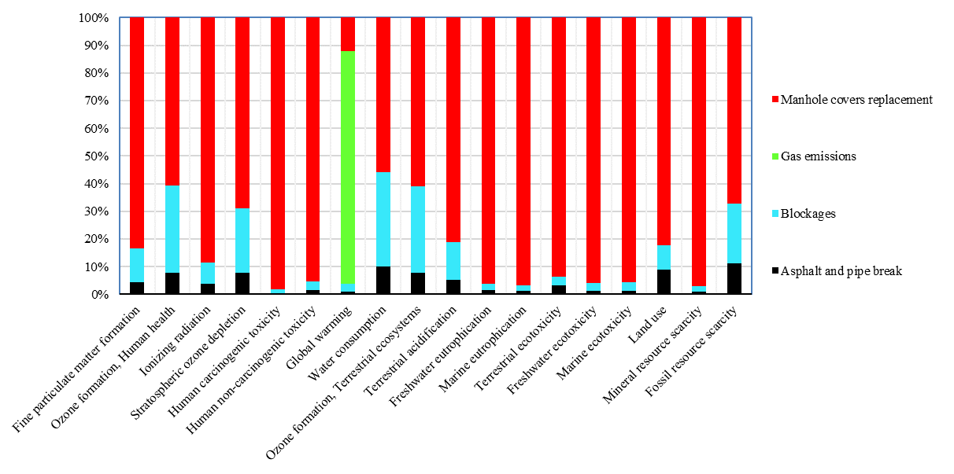
Fig. 2- midpoint impacts of WWCN's phases in scenario 0
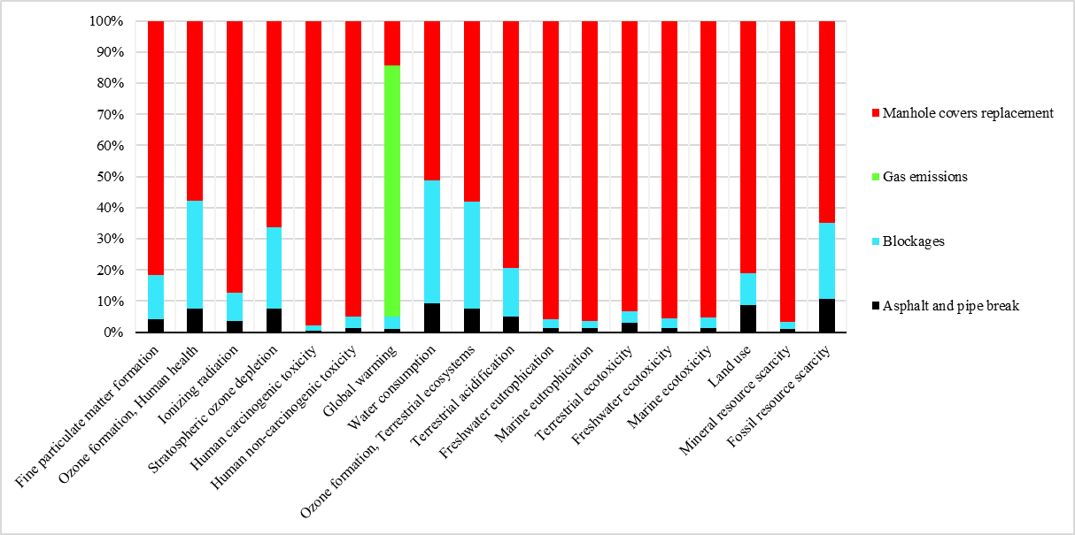
Fig. 3- midpoint impacts of WWCN's phases in scenario 1
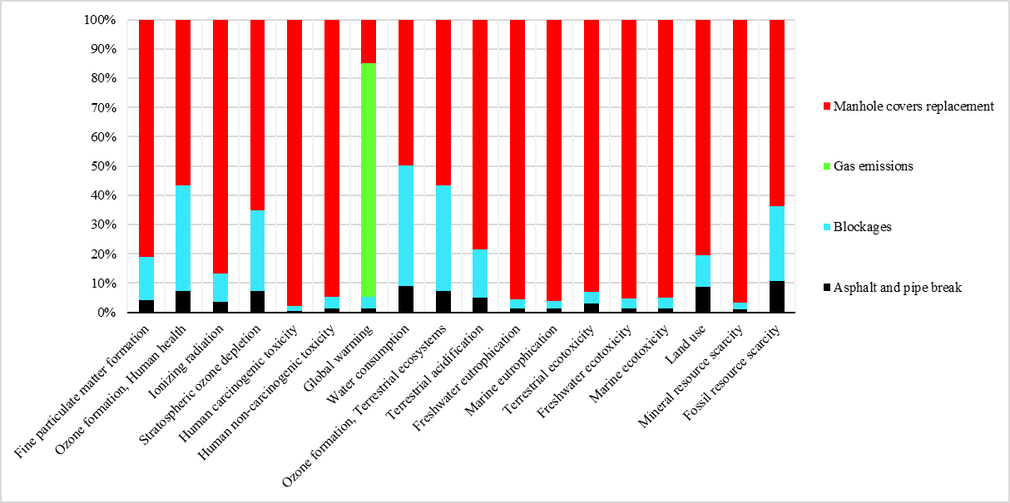
Fig. 4- midpoint impacts of WWCN's phases in scenario 2
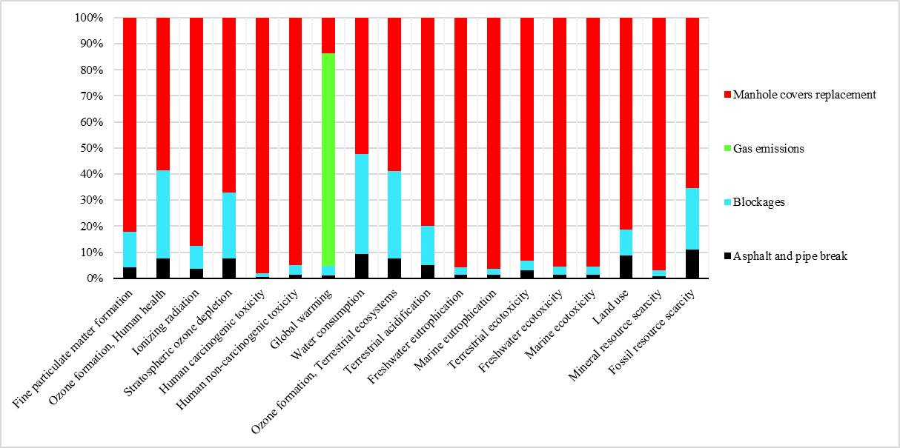
Fig. 5- midpoint impacts of WWCN's phases in scenario 3
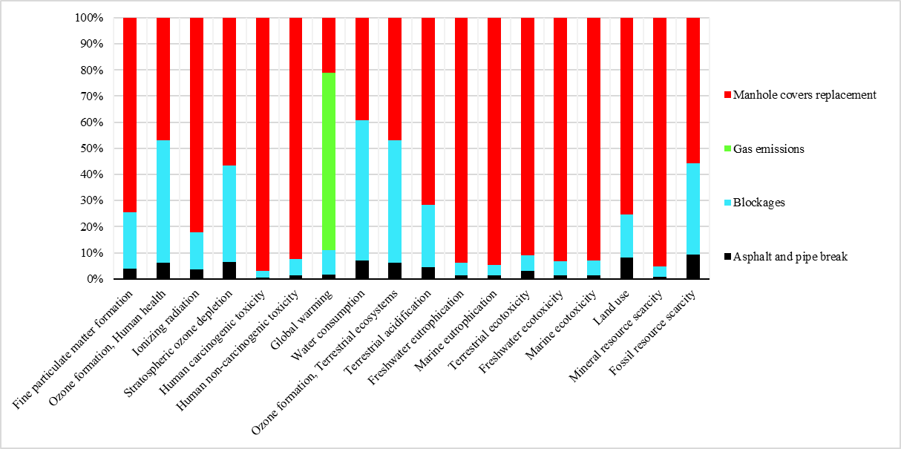
Fig. 6- midpoint impacts of WWCN's phases in scenario 4

Fig. 7- midpoint impacts of WWTP's phases in scenario 0

Fig. 8- midpoint impacts of WWTP's phases in scenario 1
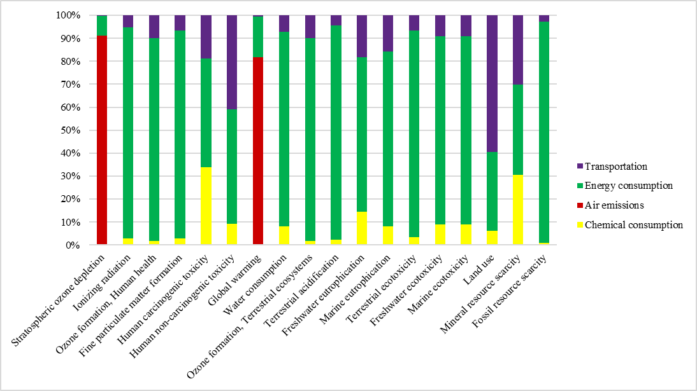
Fig. 9- midpoint impacts of WWTP's phases in scenario 2
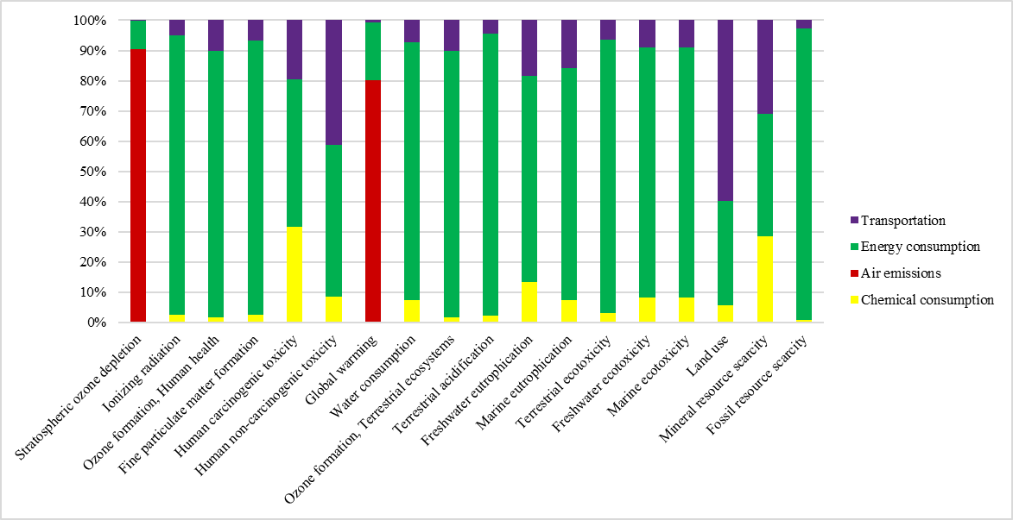
Fig. 10- midpoint impacts of WWTP's phases in scenario 3
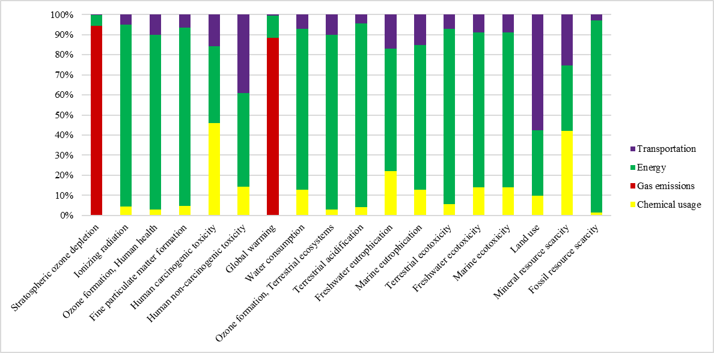
Fig. 11- midpoint impacts of WWTP's phases in scenario 4
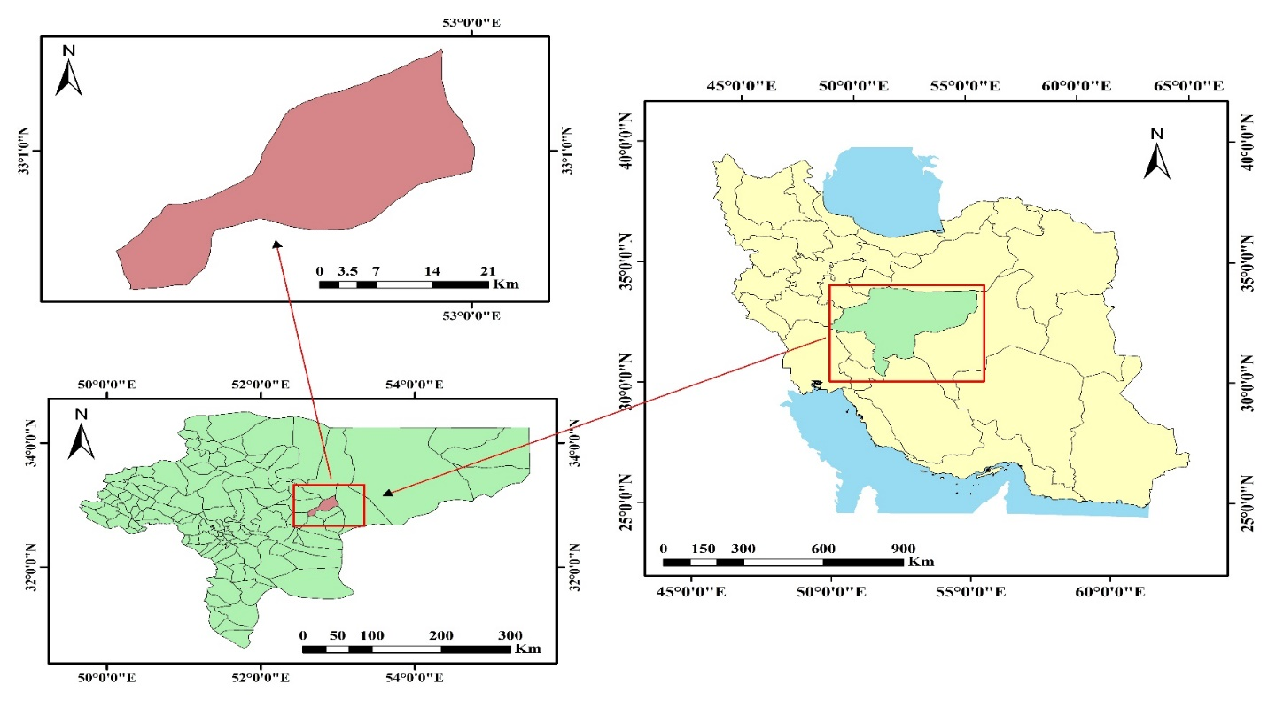
Fig. 12- Baharestan city, Isfahan province, Iran as a Case study

Table 29- midpoint impacts of WWCN's phases in scenario 0
Impact category | Asphalt and pipe break | Blockages | Gas emissions | Manhole covers replacement
Fine particulate matter formation | 124.3811711 | 351.4129464 | 0 | 2385.005417
Ozone formation, Human health | 353.0000908 | 1401.677546 | 0 | 2723.219673
Ionizing radiation | 2232.759386 | 4660.860996 | 0 | 52515.47806
Stratospheric ozone depletion | 0.045168164 | 0.136070519 | 0 | 0.400908047
Human carcinogenic toxicity | 2637.585112 | 6876.180772 | 0 | 494473.4699
Human non-carcinogenic toxicity | 60352.4505 | 136433.8147 | 0 | 4067200.511
Global warming | 85265.47966 | 236920.3625 | 7192188.357 | 1040508.648
Water consumption | 1134.386271 | 3838.11686 | 0 | 6320.52101
Ozone formation, Terrestrial ecosystems | 363.0310524 | 1432.645751 | 0 | 2810.510712
Terrestrial acidification | 304.3322973 | 802.6796524 | 0 | 4745.550232
Freshwater eutrophication | 11.89340059 | 20.67534208 | 0 | 807.2100083
Marine eutrophication | 0.863390199 | 1.477729932 | 0 | 67.37222392
Terrestrial ecotoxicity | 505710.3606 | 519655.7919 | 0 | 15165092.16
Freshwater ecotoxicity | 1703.255798 | 3901.770241 | 0 | 130657.6569
Marine ecotoxicity | 2634.94469 | 5738.40345 | 0 | 186615.9605
Land use | 2227.932276 | 2235.24857 | 0 | 20510.01633
Mineral resource scarcity | 216.8492161 | 485.4482296 | 0 | 23429.41664
Fossil resource scarcity | 40263.9641 | 78293.50291 | 0 | 242251.6514

Table 30- midpoint impacts of WWCN's phases in scenario 1
Impact category | Asphalt and pipe break | Blockages | Gas emissions | Manhole covers replacement
Fine particulate matter formation | 124.3811711 | 409.383198 | 0 | 2385.005417
Ozone formation, Human health | 353.0000908 | 1634.751188 | 0 | 2723.219673
Ionizing radiation | 2232.759386 | 5399.44034 | 0 | 52515.47806
Stratospheric ozone depletion | 0.045168164 | 0.158092402 | 0 | 0.400908047
Human carcinogenic toxicity | 2637.585112 | 8004.180927 | 0 | 494473.4699
Human non-carcinogenic toxicity | 60352.4505 | 157478.5283 | 0 | 4067200.511
Global warming | 85265.47966 | 275248.1445 | 5862841.729 | 1040508.648
Water consumption | 1134.386271 | 4878.874587 | 0 | 6320.52101
Ozone formation, Terrestrial ecosystems | 363.0310524 | 1671.200181 | 0 | 2810.510712
Terrestrial acidification | 304.3322973 | 934.0277554 | 0 | 4745.550232
Freshwater eutrophication | 11.89340059 | 23.90632663 | 0 | 807.2100083
Marine eutrophication | 0.863390199 | 1.709371622 | 0 | 67.37222392
Terrestrial ecotoxicity | 505710.3606 | 600564.6325 | 0 | 15165092.16
Freshwater ecotoxicity | 1703.255798 | 4499.775641 | 0 | 130657.6569
Marine ecotoxicity | 2634.94469 | 6619.191647 | 0 | 186615.9605
Land use | 2227.932276 | 2578.978986 | 0 | 20510.01633
Mineral resource scarcity | 216.8492161 | 562.6358257 | 0 | 23429.41664
Fossil resource scarcity | 40263.9641 | 90961.26932 | 0 | 242251.6514

Table 31- midpoint impacts of WWCN's phases in scenario 2
Impact category | Asphalt and pipe break | Blockages | Gas emissions | Manhole covers replacement
Fine particulate matter formation | 124.3811711 | 436.4876262 | 0 | 2385.005417
Ozone formation, Human health | 353.0000908 | 1741.398423 | 0 | 2723.219673
Ionizing radiation | 2232.759386 | 5759.799701 | 0 | 52515.47806
Stratospheric ozone depletion | 0.045168164 | 0.168235948 | 0 | 0.400908047
Human carcinogenic toxicity | 2637.585112 | 8539.690125 | 0 | 494473.4699
Human non-carcinogenic toxicity | 60352.4505 | 168653.9647 | 0 | 4067200.511
Global warming | 85265.47966 | 292867.1825 | 5589206.234 | 1040508.648
Water consumption | 1134.386271 | 5248.484159 | 0 | 6320.52101
Ozone formation, Terrestrial ecosystems | 363.0310524 | 1780.337407 | 0 | 2810.510712
Terrestrial acidification | 304.3322973 | 994.91154 | 0 | 4745.550232
Freshwater eutrophication | 11.89340059 | 25.54142801 | 0 | 807.2100083
Marine eutrophication | 0.863390199 | 1.825547726 | 0 | 67.37222392
Terrestrial ecotoxicity | 505710.3606 | 641150.4638 | 0 | 15165092.16
Freshwater ecotoxicity | 1703.255798 | 4818.296092 | 0 | 130657.6569
Marine ecotoxicity | 2634.94469 | 7086.208332 | 0 | 186615.9605
Land use | 2227.932276 | 2758.365644 | 0 | 20510.01633
Mineral resource scarcity | 216.8492161 | 599.8379338 | 0 | 23429.41664
Fossil resource scarcity | 40263.9641 | 96787.1 | 0 | 242251.6514

Table 32- midpoint impacts of WWCN's phases in scenario 3
Impact category | Asphalt and pipe break | Blockages | Gas emissions | Manhole covers replacement
Fine particulate matter formation | 124.3811711 | 391.8150949 | 0 | 2385.005417
Ozone formation, Human health | 353.0000908 | 1565.63764 | 0 | 2723.219673
Ionizing radiation | 2232.759386 | 5165.795535 | 0 | 52515.47806
Stratospheric ozone depletion | 0.045168164 | 0.151518468 | 0 | 0.400908047
Human carcinogenic toxicity | 2637.585112 | 7657.044015 | 0 | 494473.4699
Human non-carcinogenic toxicity | 60352.4505 | 150228.5306 | 0 | 4067200.511
Global warming | 85265.47966 | 263829.5895 | 6150289.577 | 1040508.648
Water consumption | 1134.386271 | 4639.87532 | 0 | 6320.52101
Ozone formation, Terrestrial ecosystems | 363.0310524 | 1600.473065 | 0 | 2810.510712
Terrestrial acidification | 304.3322973 | 894.5676728 | 0 | 4745.550232
Freshwater eutrophication | 11.89340059 | 22.84590922 | 0 | 807.2100083
Marine eutrophication | 0.863390199 | 1.634032284 | 0 | 67.37222392
Terrestrial ecotoxicity | 505710.3606 | 574244.9899 | 0 | 15165092.16
Freshwater ecotoxicity | 1703.255798 | 4293.133292 | 0 | 130657.6569
Marine ecotoxicity | 2634.94469 | 6316.220394 | 0 | 186615.9605
Land use | 2227.932276 | 2462.616409 | 0 | 20510.01633
Mineral resource scarcity | 216.8492161 | 538.5173719 | 0 | 23429.41664
Fossil resource scarcity | 40263.9641 | 87185.64951 | 0 | 242251.6514

Table 33- midpoint impacts of WWCN's phases in scenario 4
Impact category | Asphalt and pipe break | Blockages | Gas emissions | Manhole covers replacement
Fine particulate matter formation | 124.3811711 | 688.9846631 | 0 | 2385.005417
Ozone formation, Human health | 353.0000908 | 2734.745809 | 0 | 2723.219673
Ionizing radiation | 2232.759386 | 9117.755929 | 0 | 52515.47806
Stratospheric ozone depletion | 0.045168164 | 0.262720605 | 0 | 0.400908047
Human carcinogenic toxicity | 2637.585112 | 13528.85286 | 0 | 494473.4699
Human non-carcinogenic toxicity | 60352.4505 | 272845.7425 | 0 | 4067200.511
Global warming | 85265.47966 | 456981.9628 | 3371172.463 | 1040508.648
Water consumption | 1134.386271 | 8684.247149 | 0 | 6320.52101
Ozone formation, Terrestrial ecosystems | 363.0310524 | 2796.876229 | 0 | 2810.510712
Terrestrial acidification | 304.3322973 | 1562.053803 | 0 | 4745.550232
Freshwater eutrophication | 11.89340059 | 40.78144463 | 0 | 807.2100083
Marine eutrophication | 0.863390199 | 2.908309456 | 0 | 67.37222392
Terrestrial ecotoxicity | 505710.3606 | 1019410.999 | 0 | 15165092.16
Freshwater ecotoxicity | 1703.255798 | 7788.006565 | 0 | 130657.6569
Marine ecotoxicity | 2634.94469 | 11440.29831 | 0 | 186615.9605
Land use | 2227.932276 | 4430.663099 | 0 | 20510.01633
Mineral resource scarcity | 216.8492161 | 946.4725291 | 0 | 23429.41664
Fossil resource scarcity | 40263.9641 | 151052.7078 | 0 | 242251.6514

Table 34- midpoint impacts of WWTP's phases in scenario 0
Impact category | Chemical consumption | Air emissions | Energy consumption | Transportation
Stratospheric ozone depletion | 0.06282489 | 78.40106601 | 9.534884328 | 0.272912762
Ionizing radiation | 9280.239772 | 0 | 398422.2967 | 21864.16949
Ozone formation, Human health | 515.4102162 | 0 | 33216.02279 | 3743.905017
Fine particulate matter formation | 491.3573438 | 0 | 19856.7897 | 1441.260091
Human carcinogenic toxicity | 56443.37255 | 0 | 101885.8315 | 40314.47196
Human non-carcinogenic toxicity | 288515.5764 | 0 | 2013377.113 | 1653756.267
Global warming | 152891.7 | 66593031.7 | 18425967.59 | 618458.5645
Water consumption | 2570.004132 | 0 | 34776.63772 | 2956.995224
Ozone formation, Terrestrial ecosystems | 521.48136 | 0 | 33950.6578 | 3823.990743
Terrestrial acidification | 1174.491746 | 0 | 57755.21943 | 2725.841479
Freshwater eutrophication | 98.46433074 | 0 | 589.8846511 | 159.9528225
Marine eutrophication | 4.877084569 | 0 | 59.09001477 | 12.19174005
Terrestrial ecotoxicity | 876329.3469 | 0 | 29856029.69 | 2099107.369
Freshwater ecotoxicity | 11402.60355 | 0 | 135590.2536 | 14693.53406
Marine ecotoxicity | 16365.19897 | 0 | 195972.2226 | 21250.72131
Land use | 3647.690241 | 0 | 25978.77359 | 44796.08811
Mineral resource scarcity | 4248.122997 | 0 | 7118.699732 | 5410.510346
Fossil resource scarcity | 45941.80755 | 0 | 6405101.833 | 172220.6834

Table 35- midpoint impacts of WWTP's phases in scenario 1
Impact category | Chemical consumption | Air emissions | Energy consumption | Transportation
Stratospheric ozone depletion | 0.06282489 | 78.08240204 | 7.742997856 | 0.22453217
Ionizing radiation | 9280.239772 | 0 | 323546.9758 | 17894.24035
Ozone formation, Human health | 515.4102162 | 0 | 26973.75074 | 3068.093779
Fine particulate matter formation | 491.3573438 | 0 | 16125.11225 | 1178.812336
Human carcinogenic toxicity | 56443.37255 | 0 | 82738.47357 | 32955.85536
Human non-carcinogenic toxicity | 288515.5764 | 0 | 1635004.068 | 1348766.713
Global warming | 152891.7 | 65979083.69 | 14963183.88 | 509336.7987
Water consumption | 2570.004132 | 0 | 28241.08002 | 2422.130036
Ozone formation, Terrestrial ecosystems | 521.48136 | 0 | 27570.32613 | 3133.672488
Terrestrial acidification | 1174.491746 | 0 | 46901.30733 | 2234.033773
Freshwater eutrophication | 98.46433074 | 0 | 479.0278971 | 130.6535483
Marine eutrophication | 4.877084569 | 0 | 47.98525519 | 9.958583261
Terrestrial ecotoxicity | 876329.3469 | 0 | 24245199.62 | 1764838.809
Freshwater ecotoxicity | 11402.60355 | 0 | 110108.8389 | 12089.7156
Marine ecotoxicity | 16365.19897 | 0 | 159143.252 | 17505.8896
Land use | 3647.690241 | 0 | 21096.59449 | 36575.96872
Mineral resource scarcity | 4248.122997 | 0 | 5780.885732 | 4413.559072
Fossil resource scarcity | 45941.80755 | 0 | 5201393.96 | 142242.0374

Table 36- midpoint impacts of WWTP's phases in scenario 2
Impact category | Chemical consumption | Air emissions | Energy consumption | Transportation
Stratospheric ozone depletion | 0.06282489 | 78.91891825 | 7.372272228 | 0.214530345
Ionizing radiation | 9280.239772 | 0 | 308055.9272 | 17073.41751
Ozone formation, Human health | 515.4102162 | 0 | 25682.27929 | 2928.370533
Fine particulate matter formation | 491.3573438 | 0 | 15353.06085 | 1124.549061
Human carcinogenic toxicity | 56443.37255 | 0 | 78777.05279 | 31434.26986
Human non-carcinogenic toxicity | 288515.5764 | 0 | 1556721.997 | 1285700.64
Global warming | 152891.7 | 66125735.29 | 14246764.24 | 486777.7066
Water consumption | 2570.004132 | 0 | 26888.93033 | 2311.544552
Ozone formation, Terrestrial ecosystems | 521.48136 | 0 | 26250.29136 | 2990.950029
Terrestrial acidification | 1174.491746 | 0 | 44655.72792 | 2132.351178
Freshwater eutrophication | 98.46433074 | 0 | 456.0926049 | 124.5951939
Marine eutrophication | 4.877084569 | 0 | 45.68777763 | 9.496824179
Terrestrial ecotoxicity | 876329.3469 | 0 | 23084367.99 | 1695829.844
Freshwater ecotoxicity | 11402.60355 | 0 | 104836.9573 | 11551.34364
Marine ecotoxicity | 16365.19897 | 0 | 151523.6604 | 16731.64754
Land use | 3647.690241 | 0 | 20086.51437 | 34876.59261
Mineral resource scarcity | 4248.122997 | 0 | 5504.103724 | 4207.407754
Fossil resource scarcity | 45941.80755 | 0 | 4952357.337 | 136045.0177

Table 37- midpoint impacts of WWTP's phases in scenario 3
Impact category | Chemical consumption | Air emissions | Energy consumption | Transportation
Stratospheric ozone depletion | 0.06282489 | 78.17970423 | 8.127774842 | 0.234929419
Ionizing radiation | 9280.239772 | 0 | 339625.1709 | 18747.39164
Ozone formation, Human health | 515.4102162 | 0 | 28314.17195 | 3213.328451
Fine particulate matter formation | 491.3573438 | 0 | 16926.42619 | 1235.213284
Human carcinogenic toxicity | 56443.37255 | 0 | 86850.04135 | 34537.23878
Human non-carcinogenic toxicity | 288515.5764 | 0 | 1716253.211 | 1414309.552
Global warming | 152891.7 | 66037318.61 | 15706757.49 | 532787.6456
Water consumption | 2570.004132 | 0 | 29644.47931 | 2537.074619
Ozone formation, Terrestrial ecosystems | 521.48136 | 0 | 28940.39329 | 3282.024786
Terrestrial acidification | 1174.491746 | 0 | 49231.9994 | 2339.725179
Freshwater eutrophication | 98.46433074 | 0 | 502.8324898 | 136.9500313
Marine eutrophication | 4.877084569 | 0 | 50.36981247 | 10.43849403
Terrestrial ecotoxicity | 876329.3469 | 0 | 25450029.46 | 1836681.68
Freshwater ecotoxicity | 11402.60355 | 0 | 115580.5371 | 12649.28459
Marine ecotoxicity | 16365.19897 | 0 | 167051.6439 | 18310.66948
Land use | 3647.690241 | 0 | 22144.95899 | 38342.5158
Mineral resource scarcity | 4248.122997 | 0 | 6068.158418 | 4627.805763
Fossil resource scarcity | 45941.80755 | 0 | 5459869.648 | 148684.6475

Table 38- midpoint impacts of WWTP's phases in scenario 4
Impact category | Chemical usage | Gas emissions | Energy | Transportation
Stratospheric ozone depletion | 0.06282489 | 78.10098781 | 4.415918059 | 0.134714939
Ionizing radiation | 9280.239772 | 0 | 184522.4498 | 10524.00686
Ozone formation, Human health | 515.4102162 | 0 | 15383.43097 | 1813.451549
Fine particulate matter formation | 491.3573438 | 0 | 9196.331408 | 691.5747861
Human carcinogenic toxicity | 56443.37255 | 0 | 47186.67451 | 19294.29239
Human non-carcinogenic toxicity | 288515.5764 | 0 | 932461.0605 | 782539.1647
Global warming | 152891.7 | 67548759.61 | 8533670.699 | 306755.0873
Water consumption | 2570.004132 | 0 | 16106.20299 | 1429.149757
Ozone formation, Terrestrial ecosystems | 521.48136 | 0 | 15723.66457 | 1852.098157
Terrestrial acidification | 1174.491746 | 0 | 26748.33881 | 1320.990853
Freshwater eutrophication | 98.46433074 | 0 | 273.1949538 | 76.25833682
Marine eutrophication | 4.877084569 | 0 | 27.36652636 | 5.81264573
Terrestrial ecotoxicity | 876329.3469 | 0 | 13827307.83 | 1144424.271
Freshwater ecotoxicity | 11402.60355 | 0 | 62796.29923 | 7255.677697
Marine ecotoxicity | 16365.19897 | 0 | 90761.17205 | 10553.61373
Land use | 3647.690241 | 0 | 12031.62319 | 21315.52433
Mineral resource scarcity | 4248.122997 | 0 | 3296.903625 | 2562.670836
Fossil resource scarcity | 45941.80755 | 0 | 2966413.003 | 86588.32476

Table 39- Endpoint impacts of WWCN and WWTP in every scenario
scenarios |  | Human health | Ecosystem | Resources
Scenario 0 | WWCN | 0.209011972 | 0.015086884 | 0.000853778
Scenario 0 | WWTP | 1.602574807 | 0.145401705 | 0.01828398
Scenario 1 | WWCN | 0.189569389 | 0.01311487 | 0.000893082
Scenario 1 | WWTP | 1.490277561 | 0.136795032 | 0.014872299
Scenario 2 | WWCN | 0.185924964 | 0.012735107 | 0.000911101
Scenario 2 | WWTP | 1.471336501 | 0.135442323 | 0.014166467
Scenario 3 | WWCN | 0.193654578 | 0.013533155 | 0.000881404
Scenario 3 | WWTP | 1.513240841 | 0.138528147 | 0.015604913
Scenario 4 | WWCN | 0.157156363 | 0.009714891 | 0.001078945
Scenario 4 | WWTP | 1.324186011 | 0.125051359 | 0.008537697

Table 40- Endpoint impacts of Scenarios
Impact category | Scenario 0 | Scenario 1 | Scenario 2 | Scenario 3 | Scenario 4
Human health | 1.81158678 | 1.67984695 | 1.657261465 | 1.706895418 | 1.481342
Ecosystem | 0.160488589 | 0.149909902 | 0.14817743 | 0.152061302 | 0.134766
Resources | 0.019137758 | 0.015765381 | 0.015077569 | 0.016486316 | 0.009617
Total | 1.991213127 | 1.845522233 | 1.820516464 | 1.875443037 | 1.625725

Table 41- midpoint impacts of Scenarios
Impact category | Scenario 0 | Scenario 1 | Scenario 2 | Scenario 3 | Scenario 4
Stratospheric ozone depletion | 88.85383472 | 86.71692557 | 87.18285787 | 87.20282806 | 83.42324
Ionizing radiation | 488975.8044 | 410869.1337 | 394917.6217 | 427566.8353 | 268192.7
Ozone formation, Human health | 41953.23533 | 35268.22569 | 33943.67823 | 36684.76802 | 23523.26
Fine particulate matter formation | 24650.20667 | 20714.05171 | 19914.84146 | 21554.1985 | 13577.63
Human carcinogenic toxicity | 702630.9118 | 677252.9374 | 672305.4404 | 682598.7517 | 633564.2
Human non-carcinogenic toxicity | 8219635.732 | 7557317.848 | 7427145.14 | 7696859.831 | 6403915
Global warming | 94345232.4 | 88868360.08 | 88020016.49 | 89969648.73 | 81496006
Water consumption | 51596.66121 | 45566.99605 | 44473.87046 | 46846.34066 | 36244.51
Ozone formation, Terrestrial ecosystems | 42902.31742 | 36070.22193 | 34716.60192 | 37517.91426 | 24067.66
Terrestrial acidification | 67508.11484 | 56293.74313 | 54007.36491 | 58690.66653 | 35855.76
Freshwater eutrophication | 1688.080555 | 1551.155512 | 1523.796966 | 1580.19617 | 1307.802
Marine eutrophication | 145.8721834 | 132.7659088 | 130.1228482 | 135.5550375 | 109.2002
Terrestrial ecotoxicity | 49021924.72 | 43157734.93 | 41968480.16 | 44408087.99 | 32538275
Freshwater ecotoxicity | 297949.0742 | 270461.8465 | 264970.1133 | 276286.4713 | 221603.5
Marine ecotoxicity | 428577.4516 | 388884.4374 | 380957.6204 | 397294.6379 | 318371.2
Land use | 99395.74912 | 86637.18105 | 84107.11146 | 89335.73005 | 64163.45
Mineral resource scarcity | 40909.04717 | 38651.46949 | 38205.73827 | 39128.87041 | 34700.44
Fossil resource scarcity | 6984073.442 | 5763054.69 | 5513646.878 | 6024197.368 | 3532511

