Figure 1 Characterization and uptake of Lactobacillus plantarum-derived extracellular vesicles (LEVs) by neurons across the blood-brain barrier. (A, B) Transmission electron microscopy imaging and nanoparticle tracking analysis of LEVs (scale bar = 200 nm). (C) IVIS system observation after tail vein injection of DiR-labeled extracellular vesicles (red) for 6 h, 12 h, 18 h, and 24 h. (E) Immunofluorescence detection of PKH-26-labeled EVs internalized by neurons in vitro and in vivo (scale bar = 50 μm).

Figure 2 LEVs protect neurons from oxygen-glucose deprivation (OGD) injury. (A, B) The viability of OGD-induced neurons treated with LEVs. (C, D) Western blot analysis of the expression of apoptosis-related proteins in OGD-treated neurons after co-culture with LEVs. (E, F) TUENL staining to detect apoptosis in OGD-treated neurons after co-culture with LEVs (Scale bar = 100 μm). * p < 0.05 compared with the control group; # p < 0.05 compared with the OGD + PBS group.
Figure 3 LEVs attenuate brain injury and improve neurological recovery in tMCAO mice. (A) In vivo experimental protocol. (B) Neurological scores of tMCAO mice after treatment with PBS and LEVs. (C, D) TTC detection of brain infarcts 3 days after tMCAO mice were treated with PBS and LEVs. E. HE staining to measure neuron injury in cortical peri-ischemic brain tissues after tMCAO mice were treated with treated with PBS and LEVs (scale bar = 50 μm). (F, G) Western blot analysis of the expression of apoptosis-related proteins after tMCAO mice were treated with PBS and LEVs. (H) TUENL staining to test TUNEL⁺ and TUNEL⁺ NeuN⁺ cells in cortical peri-ischemic brain tissues after tMCAO mice were treated with PBS and LEVs (scale bar = 20 μm). (I) Histogram of the proportion of TUNEL⁺ cells in cortical peri-ischemic brain tissues after tMCAO mice were treated with PBS and LEVs. (J) Histogram of the proportion of TUNEL⁺ NeuN⁺ cells in cortical peri-ischemic brain tissues after tMCAO mice were treated with PBS and LEVs. * p < 0.05 compared with the OGD + PBS group.
Figure 4 miR-101a-3p is significantly upregulated after treatment of OGD-induced neurons with LEVs and targets c-Fos. (A) Differential expression of miRNAs after OGD + LEV treatment analyzed by miRNA microarray analysis (gray dots represented miRNAs that were not differentially expressed, blue dots represented differentially downregulated miRNAs, and red dots represented differentially upregulated miRNAs). (B) Comparison of expression between the two groups (gray dots represented miRNAs not differentially expressed, blue dots represented differentially downregulated miRNAs, and red dots represented differentially upregulated miRNAs) with the number of upregulated and downregulated miRNAs marked in the upper left corner. (C) The heat map of miRNA expression changes in neurons of the OGD group and the OGD + LEV group (Red represented high expression, and blue represented low expression). n = 3 samples/group. (D, E) miRNA sequencing results and qRT-PCR to further validate the top 10 upregulated miRNAs in ischemic cortex and ischemic neurons. (F) The intersection of predicted target genes of miR-101a-3p in miRmap, miRanda, microT, PicTar, and PITA databases using Venn diagram. (G). The TargetScan database predicting binding sites between miR-101a-3p and c-Fos in humans, rats, and mice. (H) Results of dual-luciferase reporter gene assay. * p < 0.05 between two groups.
Figure 5 miR-101a-3p protects neurons from OGD injury by disrupting the c-Fos /TGF-β1 pathway. OGD-induced neurons were treated with PBS, inhibitor-NC, miR-101a-3p inhibitor, mimic-NC, or miR-101a-3p mimic. (A) Neuron viability detected by LDH assay. (B) miR-101a-3p expression of neurons measured by qRT-PCR. (C) Representative western blots of c-Fos and TGF-β1 protein bands in neurons. (D) The expression of c-Fos and TGF-β1 proteins in neurons examined by western blot analysis. (E) Representative western blots of Bax, Bcl-2, and Cleaved caspase3 protein bands in neurons. (F) The expression of Bax, Bcl-2, and Cleaved caspase3 proteins in neurons examined by western blot analysis. (G) Representative images of TUENL staining in neurons (scale bar = 100 μm). (H) Histogram of the proportion of TUNEL⁺ neurons. * p < 0.05 compared with the inhibitor-NC group; # p < 0.05 compared with the mimic-NC group.
Figure 6 miR-101a-3p disrupted the c-Fos/TGF-β1 axis in tMCAO mice. Sham-operated mice were used as controls, and tMCAO mice were treated with PBS, antagomir-NC, miR-101a-3p antagomir, agomir-NC and miR-101a-3p agomir. (A) Expression of miR-101a-3p in cortical peri-ischemic brain tissues of mice determined by qRT-PCR. (B) Representative western blots of c-Fos and TGF-β1 protein bands in cortical peri-ischemic brain tissues of mice. (C) Histogram of c-Fos and TGF-β1 protein expression in cortical peri-ischemic brain tissues in cortical peri-ischemic brain tissues of mice detected by western blot analysis. (D) Representative images of immunofluorescence staining of c-Fos and TGF-β1 expression in cortical peri-ischemic brain tissues of mice (scale bar = 20 μm). (E) Immunofluorescence detection of the ratio of c-Fos⁺ NeuN⁺ cells in cortical peri-ischemic brain tissues of mice. * p < 0.05 compared with the sham group; # p < 0.05 compared with antagomir-NC group; & p < 0.05 compared with agomir-NC.
Figure 7 miR-101a-3p alleviates brain injury and promotes neurological recovery in tMCAO mice. Sham-operated mice were used as controls, and tMCAO mice were treated with PBS, antagomir-NC, miR-101a-3p antagomir, agomir-NC and miR-101a-3p agomir. (A) mNSS scores of mice. (B) TTC staining to detect the brain infarction of mice 3 days after treatment. (C) Histogram of infarction rate. (D) Representative western blots of Bax, Bcl-2, and Cleaved caspase3 protein bands in mouse cortex. (E) The expression of Bax, Bcl-2, and Cleaved caspase3 proteins in mouse cortex examined by western blot analysis. (F) Representative images of TUENL staining to detect TUNEL⁺ and TUNEL⁺ NeuN⁺ in cortical peri-ischemic brain tissues of mice (scale bar = 20 μm). (G) Histogram of the proportion of TUNEL⁺ cells in cortical peri-ischemic brain tissues of mice. (H) Histogram of the proportion of TUNEL⁺ NeuN⁺ cells in cortical peri-ischemic brain tissues of mice. * p < 0.05 compared with the sham group; # p < 0.05 compared with antagomir-NC group; & p < 0.05 compared with agomir-NC.
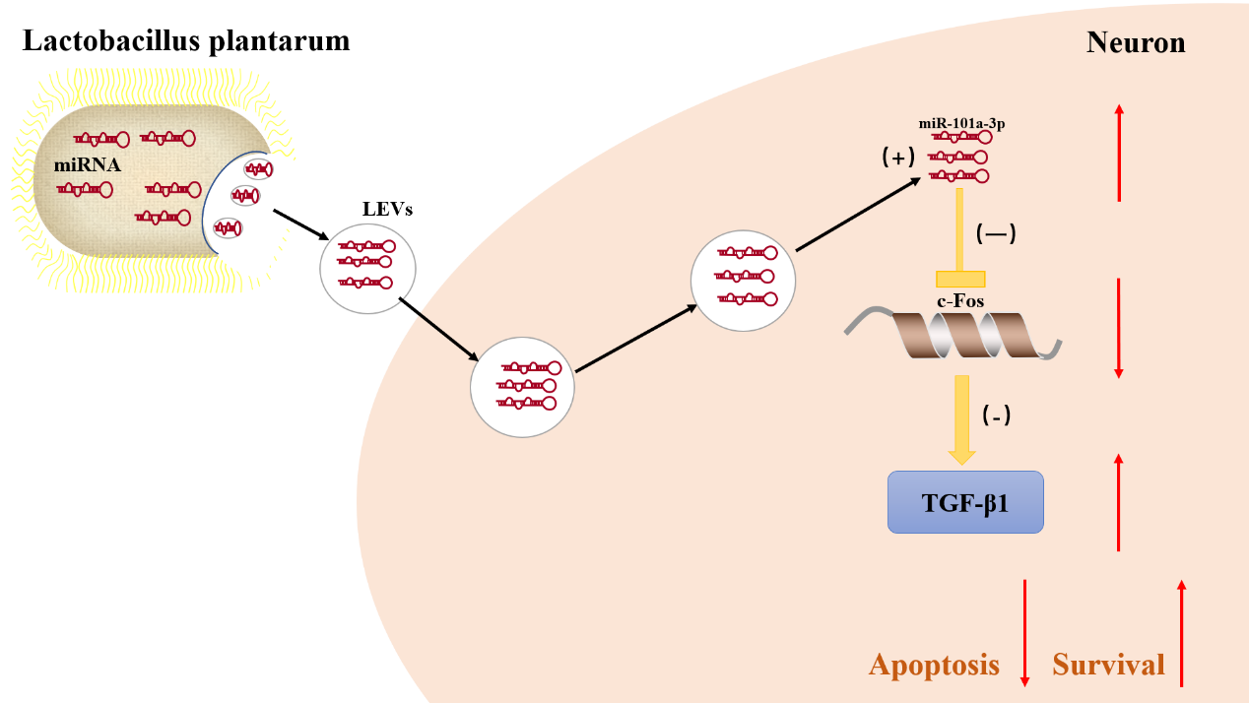
Figure 8 The potential mechanism by which LEVs ameliorated brain ischemia-reperfusion injury by regulating miR-101a-3p expression. LEVs carried miR-101a-3p, which was taken up by neurons and increased miR-101a-3p expression to inhibit c-Fos expression and inactivate the downstream TGF-β1 pathway, thus restricting neuron apoptosis.

