Supplementary Materials
Alginate modified graphene oxide for rapid and effective sorption of some heavy metal ions from aqueous solution
A.I. Abd-Elhamidª, E.M. Abu Elgoud^{b*}, H.F. Aly^{b}
ª Composites and Nanostructured Materials Research Department, Advanced Technology and New Materials Research Institute, City of Scientific Research and Technological Applications (SRTA-City), New Borg Al-Arab, Alexandria 21934, Egypt
^{b} Hot Laboratories Center, Egyptian Atomic Energy Authority, 13759, Egypt
∗Corresponding author, email: elsayedmustafa36@yahoo.com, Tel. (+2) 01552734381
2. Experimental
2.1. Materials and instrumentation
The chemicals required were of analytical grade and utilized without further purification. H₂SO₄ (95–97%, Riedel deHaen), H₂O₂ (36%, Pharaohs Trading and Import), HCl (30%, El Salam for Chemical Industries), KMnO₄ (99%, Long live), and graphite (200mesh, 99.99%, Alpha Aesar), sodium alginate (Alpha Chemika, analytical reagent), TMOS (99%, Across), ethanol absolute (Sigma-Aldrich), Pb(NO₃)₂ (99%, Sigma-Aldrich), Cd(NO₃)₂ · 4H₂O (99%, Sigma-Aldrich), ZnSO4 .5 H₂O (99%, Loba Chemie).
Analytical balance (CP 2245, Sartorius, USA.), Hot plate stirrer (IKA, C-MAG HS7, IKA®-Werke GmbH & Co. KG, Germany), pH meter (3510, Genway), Hot plate stirrer (SB 162, Stuart, UK.), Centrifuge, (Mikro 220R, Hettich, UK.).
2.4. Characterization
The prepared material was characterized by Transition Electron Microscope (TEM) analysis was carried out by a JEM-1010 unit (JEOL Ltd., Tokyo, Japan). Scanning Electron Microscope (SEM) (JEOL GSM-6610LV. Japan) with additional EDS unit, Light Optical Microscopy (LOM) (BX61, Olympus, Japan), Thermo-Gravimetric Analysis (TGA, Shimadzu Thermal Gravimetric Analysis (TGA)—50, Japan). Elemental composition of Cu (II) and Co (II) sorption on GO-C was displayed by an Oxford energy-dispersive X-ray (EDX) spectrometer (Oxford Link ISIS, Japan). Fourier Transmission Infra-Red Spectroscopy (FT-IR) (8400s, Shimadzu, Japan) covered the range from 400 to 4000 cm⁻¹ and Raman Spectroscopy (Bruker, Senterra II, Germany).
2.5. Adsorption Kinetics Study
The pseudo second order equation investigated in a term;
(2)
Where, K₂ (g mg⁻¹min⁻¹) is the rate constant of pseudo second order reaction and q_{e} (mg /g) is the quantity of sorbet species at equilibrium time, q_{t} (mg /g) is content of sorbet species at time t.
(3)
Where C_{o} is the initial concentration (mg/L), C_{e} is the dye concentration at equilibrium time intervals (mg/L), V is the volume of dye and metal ion solution (m L) and W is the mass of adsorbent (g.)
(4)
Where C_{t} is the dye and metal ion concentration at different time intervals (mg/L)
2.6. Adsorption isotherm
The interaction between the adsorbate and the solid binding sites were described using adsorption isotherm models. The two most used models Langmuir and Freundlich isotherms, and they can be expressed by as;
Langmuir isotherm:
(5)
Freundlich isotherm:
(6)
Where, C_{e} is the equilibrium concentration (mg/L), q_{e} is the adsorbed quantity at equilibrium time (mg/g), Q_{O} is the maximum pollutant species adsorbed per unit mass of adsorbent (mg/g), which is refereed to adsorption capacity and b is Langmuir constant (L/mol) which is exponentially proportional to the heat of adsorption and related to the adsorption intensity. Kf (mg/g) and n are Freundlich constants incorporating all factors affecting the adsorption process such as adsorption capacity and intensity of adsorption.

2.7. Thermodynamic Study of Adsorption
Thermodynamic parameters such as the enthalpy change (ΔH), entropy change (ΔS) and Gibbs free energy change (ΔG) resulted when the heavy metal ion adsorbed over the GO-SA can be calculated based on the equilibrium adsorption capacity at various temperatures. Measured as:
$$Ln K_{d }= \frac{∆S}{R}- \frac{∆H}{RT}$$
$$∆G= -RT Ln K_{d}$$
where ΔG describe the variation value of Gibbs free energy during the process (kJ/mol), ΔH illustrate the alter value of enthalpy during the process (kJ/mol), ΔS represent entropy change value of the process (J mol⁻¹ K⁻¹), R represent gas constant (8.314 J·mol⁻¹ K⁻¹), and T represent absolute temperature (K).
3. Results and Discussion
3.1.1. SEM
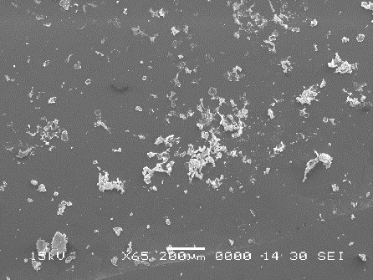  GO-SA-Pb | 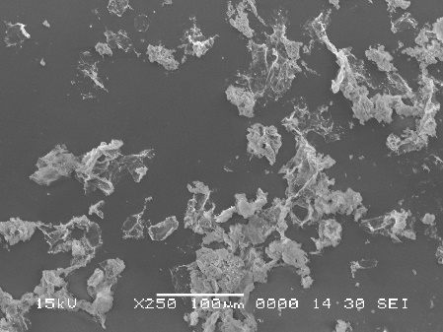 | 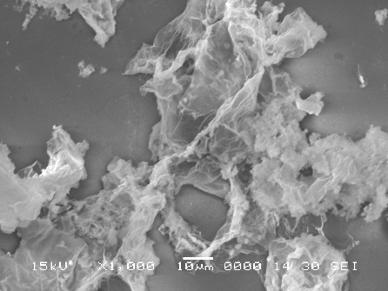
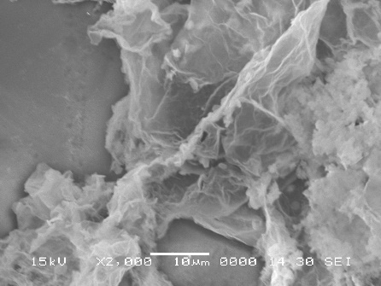
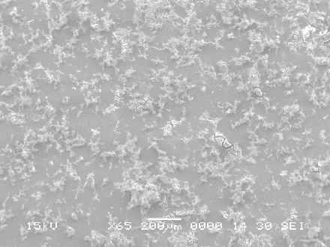  GO-SA-Cd | 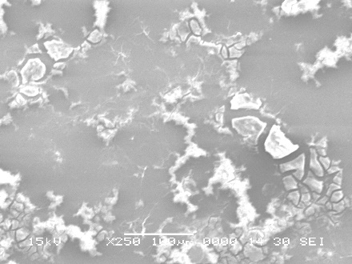 | 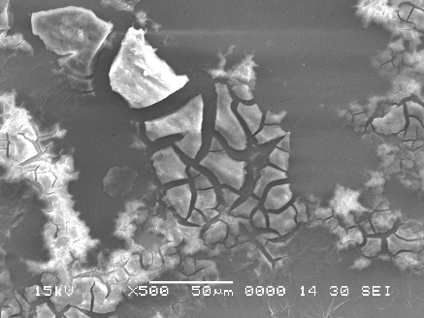
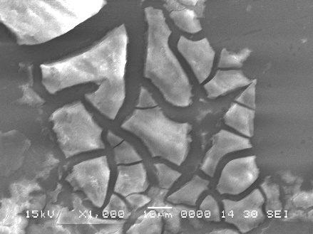
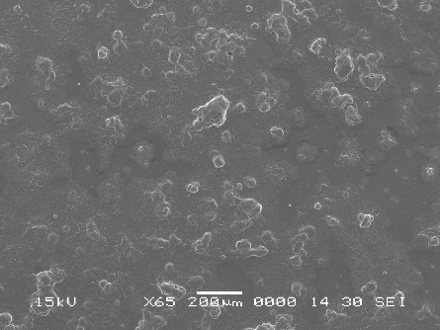  GO-SA-Zn | 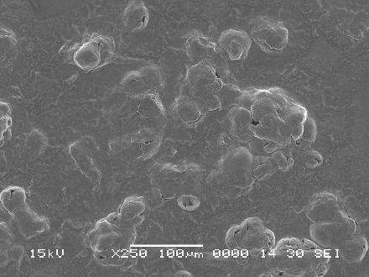 | 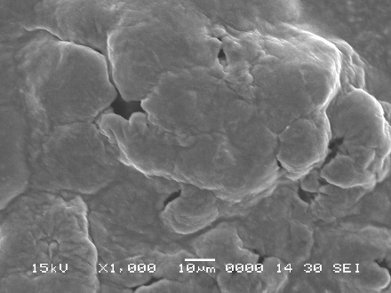
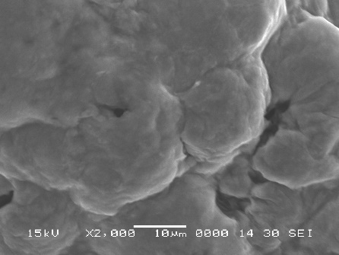

Fig. S1: SEM images GO-SA-Pb complex, GO-SA-Cd complex and GO-SA-Zn complex.
3.1.2. Raman
Raman spectroscopy is significant technique to characterize the graphene-based materials. This technique presented important data about the defects in the carbonous structure. Raman spectra of GO and GO-SA were illustrated in Fig.S2. Different data obtained from the analysis of figure were recorded in Table S1. We observed that, after modification of the GO with SA the G-band (crossponding to the vibration of sp² hybrid carbon) were shifted from 1598 cm⁻¹ to 1584 cm⁻¹. Moreover, the D-band (crossponding to the vibration of sp³ hybrid carbon) for GO (1352 cm⁻¹) shifted to (1335 cm⁻¹) after the modification process. This can imply that the modification process proceeded via covalent bond with the GO-oxygenated function groups.
Table S1: The D and G-band positions, I_{D}/I_{G} ratios and FWHMs.
Sample | D-band |  |  | G-band |  | I_{D} /I_{G}
Sample | Raman shift  (cm⁻¹) | FWHM  (cm⁻¹) |  | Raman shift  (cm⁻¹) | FWHM  (cm⁻¹) | I_{D} /I_{G}
GO | 1352 | 150 |  | 1598 | 112 | 1.34
GO-SA | 1335 | 100 |  | 1584 | 75 | 1.33

Fig. S2. Raman spectrum for GO andGO-SA composite

3.1.3. FTIR

Fig. S3 FT-IR spectrum of GO-SA-Pb complex, GO-SA-Cd complex and GO-SA-Zn complex

Table S2. Pseudo-second-order kinetic model parameters for adsorption of Pb²⁺ ([Pb²⁺] = 200 mg L⁻¹, Dose = 2.8 mg, v= 5 ml, pH = 5, T = 25 ºC) Cd²⁺([Cd²⁺] = 50 mg L⁻¹, Dose = 2.8 mg, v= 5 ml, pH = 5, T = 25 ºC) and Zn²⁺([Zn²⁺] = 50 mg L⁻¹, Dose = 2.8 mg, v= 5 ml, pH = 5, T = 25 ºC) from aqueous media.

Adsorbate | q_{e exp} (mg /g) |  | Second-order kinetic parameter
Adsorbate | q_{e exp} (mg /g) |  | K₂ (g mg⁻¹min⁻¹) | q_{ecal} (mg /g) | R²
Pb²⁺ | 338.89 |  | 0.084 | 334.83 | 0.999
Cd²⁺ | 69.05 |  | 0.033 | 75.18 | 0.998
Zn²⁺ | 66.96 |  | 0.685 | 0.033 | 1

