Title

Boosting the signal-to-noise of Low-field MRI with Deep Learning Image Reconstruction

Authors
N. Koonjoo,^{1, 2, 3}* B. Zhu,^{1,2, 3} G. C. Bagnall, ⁴ M. S. Rosen ^{1, 2, 3}
¹Athinoula A. Martinos Center for Biomedical Imaging, Department of Radiology, Massachusetts General Hospital, Charlestown, MA 02129, USA
²Harvard Medical School, Boston, MA 02115, USA
³Department of Physics, Harvard University, Cambridge, MA 02138, USA
⁴Department of Biological and Agricultural Engineering, Texas A&M University, College Station, TX, USA
*Correspondence to nkoonjoo@mgh.harvard.edu

Supplementary information
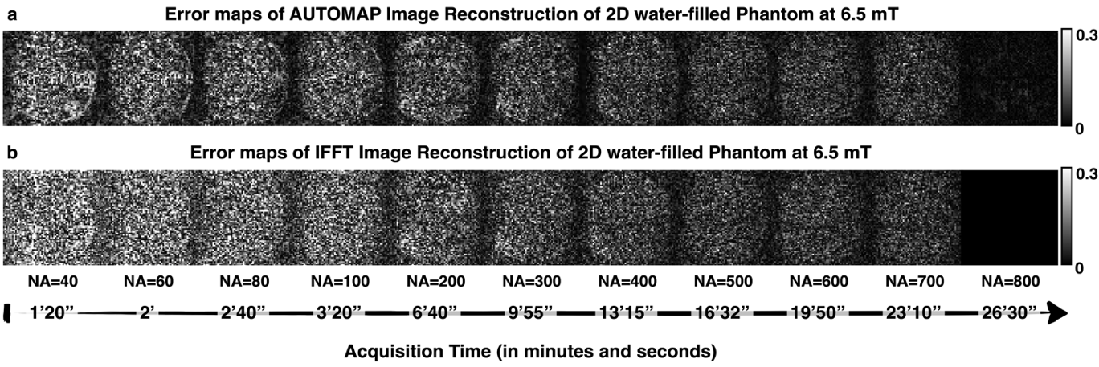
Fig S1: Error maps of AUTOMAP Image Reconstruction versus error maps of IFFT Reconstruction for 2D phantom images at 6.5 mT. The NA increases from left to right with their respective scan time below. a) Upper panel shows error maps of the AUTOMAP-reconstructed images and b) the lower panel shows the error maps computed for same dataset reconstructed with IFFT. The window level of maps (a and b for each NA) is identical. The IFFT reconstructed image with NA=800 was the reference image.

