Paeoniflorin ameliorates colonic fibrosis in rats with post-infectious irritable bowel syndrome by inhibiting the Leptin/LepRb pathway
Di Cao^{1†}, Yaning Wu^{1†}, Kunli Zhang^{2†}, Yijun Zheng², Yaqing Tian¹, Qixiang Xu¹, Ping Liu², Huihui Zhou¹, Xiaoping Liu^{1*}, Yongqiu Zheng^{1*}, ＆ Fengyun Wang^{2*}
¹Third-Grade Pharmacology Laboratory of State, Teaching and Research Section of Traditional Chinese Medicine, Center of Drug Screen and Evaluation, Anhui Provincial Engineering Laboratory for Screening and Re-evaluation of Active Compounds of Herbal Medicines in Southern Anhui, Wannan Medical College, Wuhu, 241000, Anhui, China
²China academy of Chinese Medical Sciences, Beijing, 100029, China
†these authors have contributed equally to this work
*Corresponding. author@email: yongqiuzheng@sina.com (Y. Zheng); liuxiaoping@wnmc.edu.cn (X. Liu); wfy811@163.com (F. Wang)

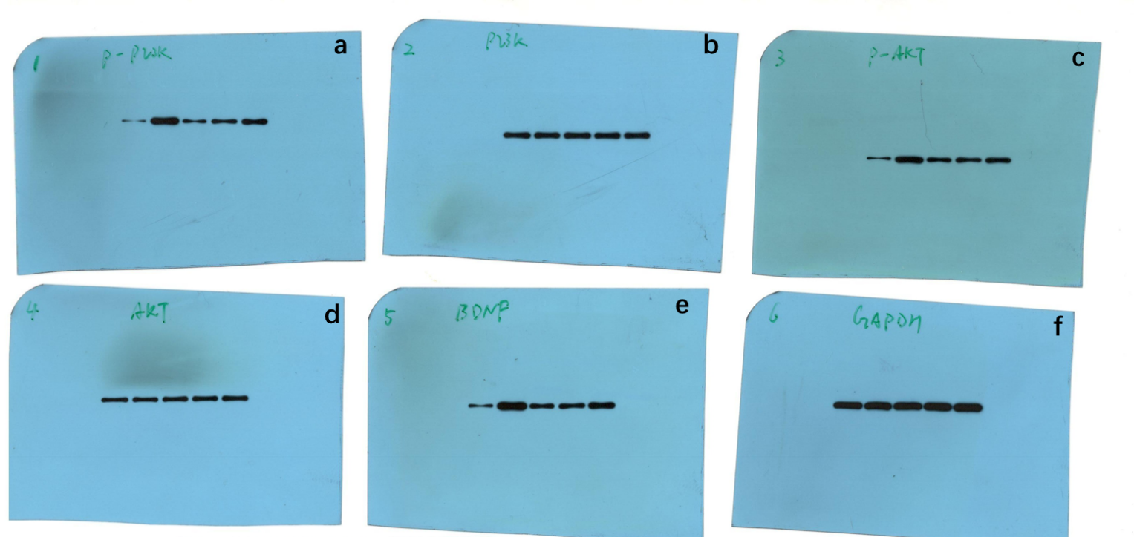
Supplementary Fig. S1: Raw images for full-length gels and blots of Figure 4d. Western blot analysis of p-PI3K/PI3K (a and b), p-AKT/AKT (c and d), and BDNF/GAPDH (e and f) protein expression.

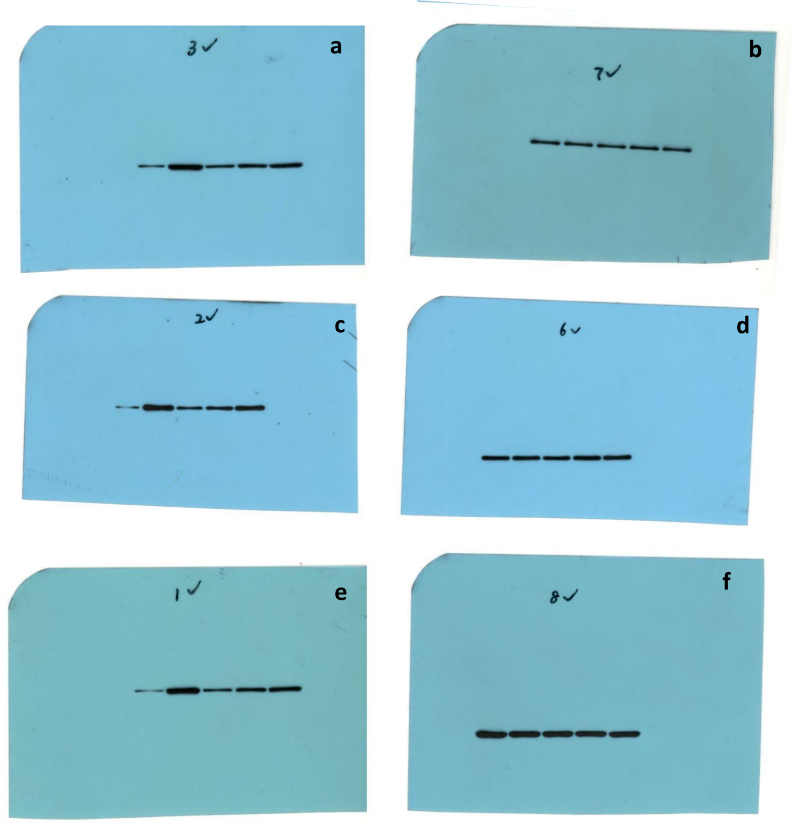
Supplementary Fig. S2: Raw images for full-length gels and blots of Figure 6c. Western blot analysis of p-PI3K/PI3K(a and b), p AKT/AKT (c and d), and BDNF/GAPDH(e and f) protein expression.

