Figure S1. The distribution of all 272 entry-exit ports in Chinese mainland.
The red, brown and purple points indicate the airports, water ports and land entry-exit stations, respectively.
Figure S2. The classification of infectious diseases at ports of Chinese mainland.
All imported infection

Excluding the possibility of infectious diseases
Infectious diseases suspected of being transmitted by other routes
Symptoms: fever, muscle pain, joint pain, headache, petechiae, ecchymosis, rash, jaundice;
Signs: three red signs;
Combined with epidemiological investigations

Symptoms: fever, nausea, vomiting, abdominal pain, diarrhea, bloody stool;
Signs: skin elasticity test, dry lips;
Combined with epidemiological investigations
Symptoms: fever, severe headache, jet vomiting;
Signs: neck ankylosis, Kernig's sign positive, Brudzinski's sign positive;
Combined with epidemiological investigations
Symptoms: fever, cough, chest pain, expectoration, hemoptysis, shortness of breath, dyspnea;
Signs: dry and wet lungs;
Combined with epidemiological
investigations

Further investigation and disposal in accordance with the “Technical Plan for the Investigation and Disposal of Gastrointestinal Infectious Diseases at Ports”
Further investigation and disposal in accordance with the “Technical Plan for the Investigation and Disposal of Vector-borne Infectious Diseases at Ports”
Further investigation and disposal in accordance with relevant regulations
Register information, give health advice, issue a "convenient card for health care", release
Further investigation and disposal in accordance with the “Technical Plan for the Investigation and Disposal of Respiratory Infectious Diseases at Ports”

Follow-up investigation
File archiving

Figure S3. Report card of infectious diseases of the People’s Republic of China.
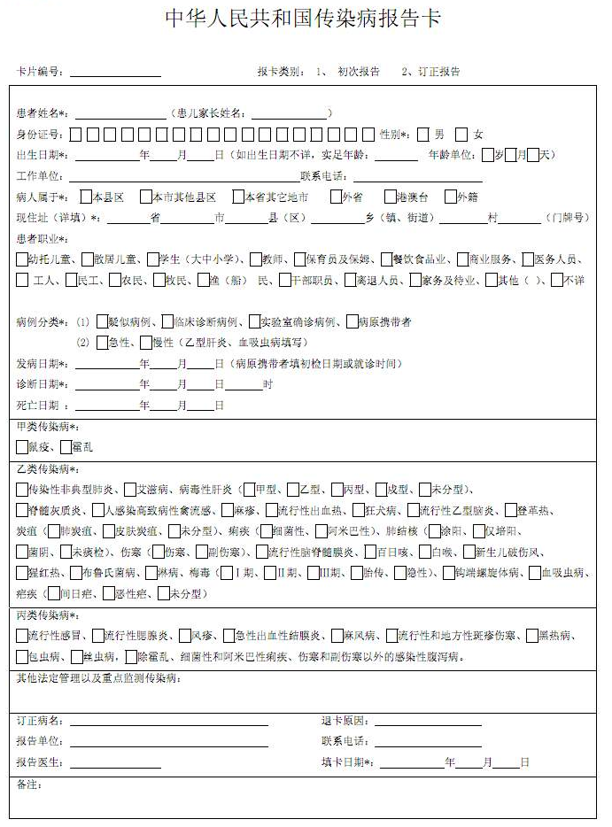

Figure S4. The disease spectrum of during-travel infectious diseases (A) and post-travel infectious diseases (B) in relation with the inbound provinces in Chinese mainland China, 2014–2018.

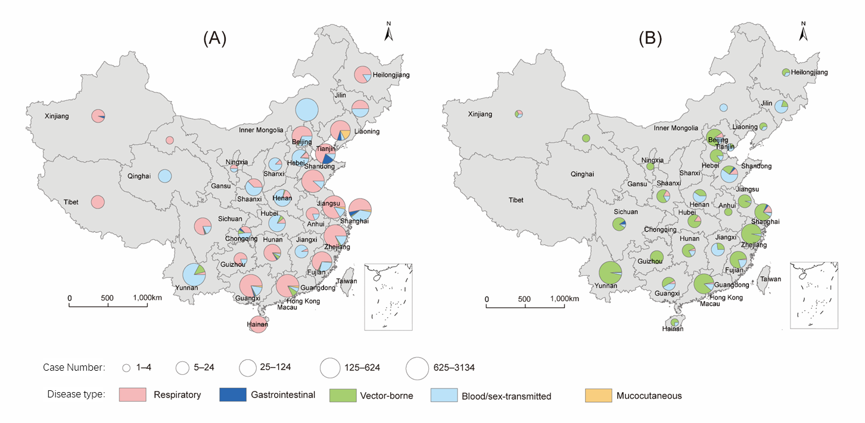
Table S1. The travel reason for during-travel cases of five type of diseases in Chinese mainland, 2014–2018
 | Total (N=14452) | Respiratory (N=7294) | Gastrointestinal (N=267) | Vector-borne (N=670) | Blood/sex-transmitted (N=5921) | Mucocutaneous (N=300) | p value
Trip reason |  |  |  |  |  |  | < 0.001
Tourism | 1699 (11.8) | 1309 (17.9) | 77 (28.8) | 68 (10.1) | 226 (3.8) | 19 (6.3)
Labour | 1556 (10.8) | 791 (10.8) | 36 (13.5) | 173 (25.8) | 517 (8.7) | 39 (13.0)
Sailor | 1085 (7.5) | 993 (13.6) | 3 (1.1) | 14 (2.1) | 37 (0.6) | 38 (12.7)
Business | 1053 (7.3) | 465 (6.4) | 33 (12.4) | 52 (7.8) | 453 (7.7) | 50 (16.7)
Visiting friends or relatives | 406 (2.8) | 316 (4.3) | 5 (1.9) | 56 (8.4) | 17 (0.3) | 12 (4.0)
Research or student | 187 (1.3) | 137 (1.9) | 6 (2.2) | 19 (2.8) | 24 (0.4) | 1 (0.3)
Others | 1662 (11.5) | 886 (12.1) | 34 (12.7) | 136 (20.3) | 556 (9.4) | 50 (16.7)
Missing | 6804 (47.1) | 2397 (32.9) | 73 (27.3) | 152 (22.7) | 4091 (69.1) | 91 (30.3)
others (including missionary, volunteer, aid work, immigration).

