Supporting Material

Tables and Figures

Tables
Table S1 Baseline tumor markers and inflammation index of patients with colorectal cancer
Variables | No. of patients (%) | No. of outcome (%)
AFP
≥20 | 5 (0.77) | 1 (1.05)
<20 | 641 (99.23) | 94 (98.95)
CEA
≥5 | 261 (40.40) | 31 (32.63)
<5 | 385 (59.60) | 64 (67.37)
CA19-9
≥37 | 88 (13.62) | 8 (8.42)
<37 | 558 (86.38) | 87 (91.58)
NLR
≥2.88 | 130 (20.12) | 31 (32.63)
<2.88 | 516 (79.88) | 64 (67.37)
LMR
≥12.24 | 110 (17.03) | 20 (21.05)
<12.24 | 536 (82.97) | 75 (78.95)
SIRI
≥0.34 | 575 (89.01) | 81 (85.26)
<0.34 | 71 (10.99) | 14 (14.74)
AGR
≥1.12 | 574 (88.85) | 87 (91.58)
<1.12 | 72 (11.15) | 8 (8.42)
PLR
≥233.08 | 68 (10.53) | 21 (22.11)
<233.08 | 578 (89.47) | 74 (77.89)
OPNI
≥56.50 | 74 (11.46) | 7 (7.37)
<56.50 | 572 (88.54) | 88 (92.63)
MHR
≥0.51 | 122 (18.89) | 24 (25.26)
<0.51 | 524 (81.11) | 71 (74.74)
MLR
≥0.33 | 95 (14.71) | 25 (26.32)
<0.33 | 551 (85.29) | 70 (73.68)
Abbreviation: AFP, alpha fetoprotein; CEA, carcinoembryonic antigen; CA19-9 cancer antigen 19-9; NLR, neutrophil count/lymphocyte count; LMR, lymphocyte count/monocyte count; SIRI (Systemic Inflammatory Response Index), neutrophil count × monocyte count/lymphocyte count; AGR albumin count/globulin count, PLR platelets count/lymphocytes count; OPNI (prognostic nutritional index), serum albumin count + 5 × total lymphocyte count; MHR, monocyte count/high density lipoprotein count; MLR, monocyte count/lymphocyte count.

Figures
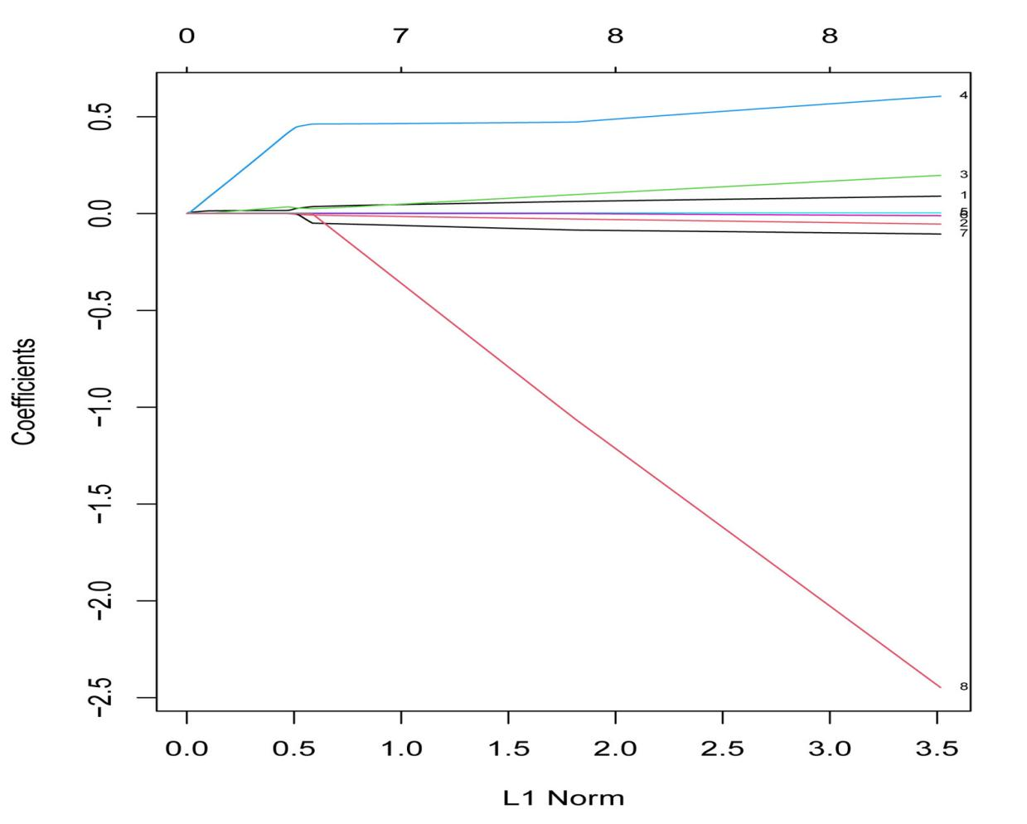

Fig. S1 Coefficients deviance of the LASSO analysis.
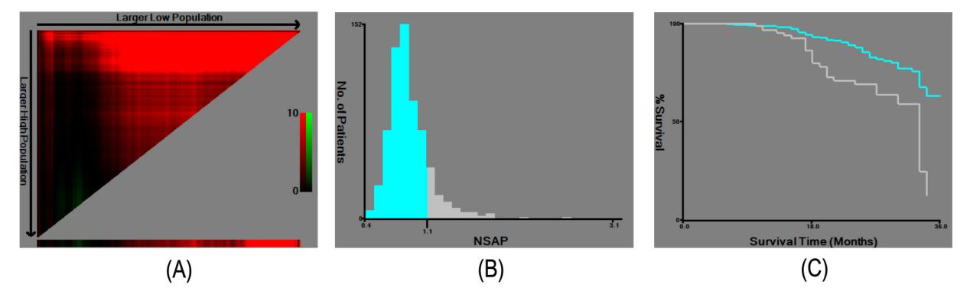
Fig. S2 A, B, C X-tile analysis on the optimal cutoff points of NSAP.
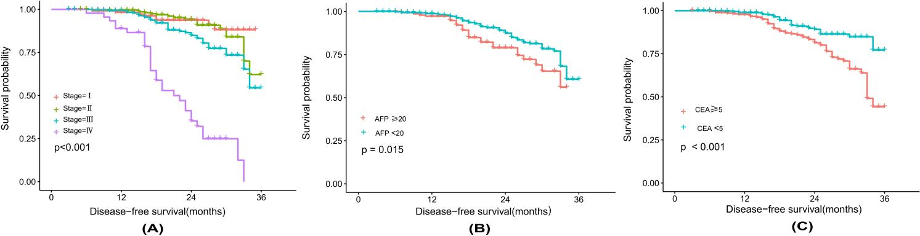
Fig. S3 A Kaplan-Meier curves for disease-free survival of CRC patients. according to stage; B according to alpha-fetoprotein (AFP); C according to carcinoembryonic antigen (CEA).
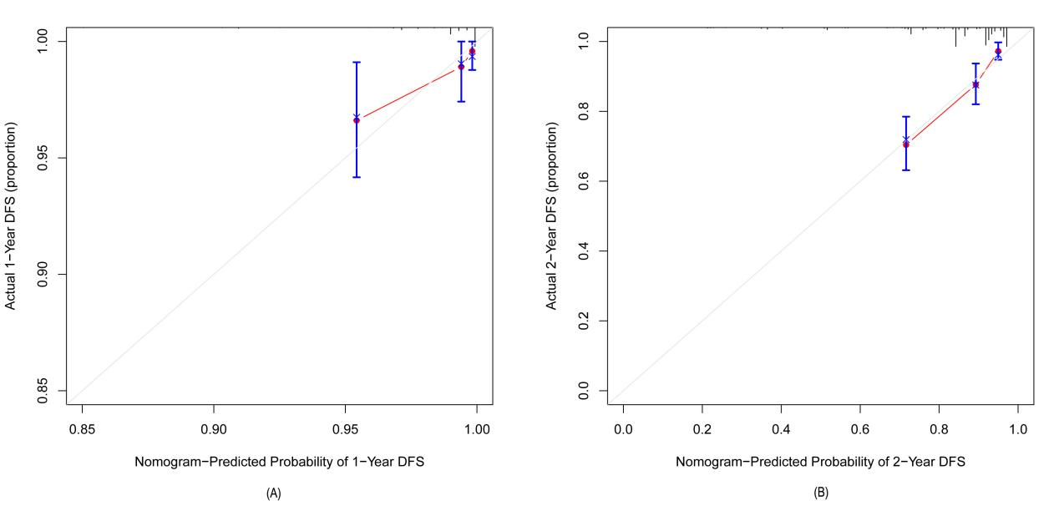
Fig. S4 A Calibration curve of nomogram of 1-Year DFS. B Calibration curve of nomogram of 2-Year DFS.

