Table 2. The left-hand playing techniques and their corresponding timbre example

Name | Explanation | Usual location in a music piece
Press  (按弦,滑音) | Use index finger, middle finger and/or ring finger to press a string to play a note outside the pentatonic scale. For example, by pressing, F changed to G or #G | Some transitional notes, or 4, 7 notes.
Press  (按弦,滑音) | 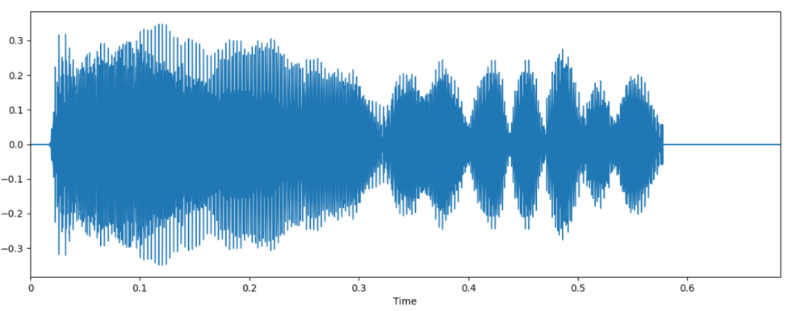  A sample waveform ⎯ press when playing D4
Vibrato  (颤音) | Rapidly alternate the pressing pressure on the original position to change the amplitude and strength of a note in time. | The last note of each complete sentence.
Vibrato  (颤音) | 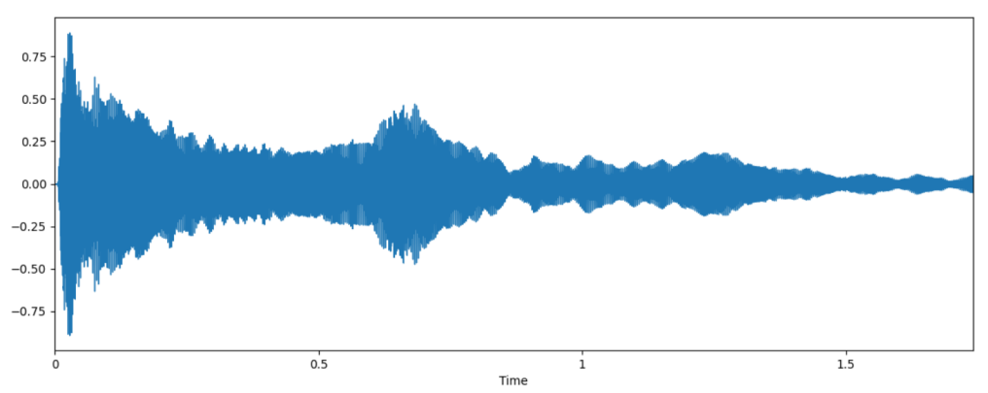  A sample waveform ⎯ vibrato when playing D4
Glide  (滑弦) | Slide pressing through several strings. It can be either down slide or up slide. Variations also include the speed, the pressure, number of times, etc. | The turning of a section.
Glide  (滑弦) | 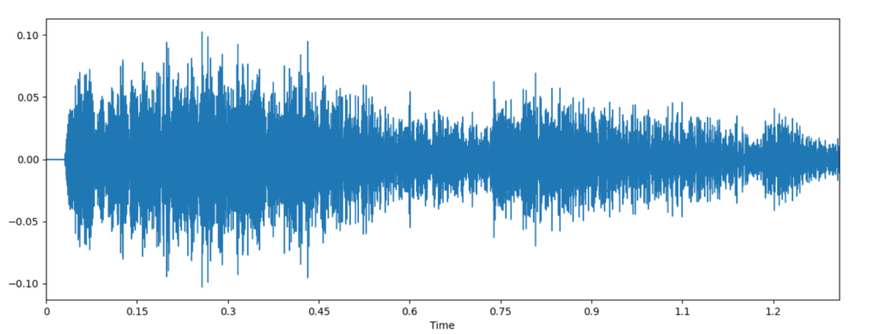 A A sample waveform ⎯ glide when playing the notes below  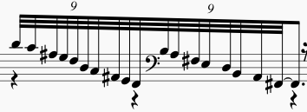

Table 3. the right-hand playing skills and their corresponding timbre example

Name | Explanation | Usual location in the music piece
Big pinch  (大撮) | Thumb rest, middle finger hook plucking on a relative full octave at the same time. | The beginning of a pieces.
Big pinch  (大撮) | 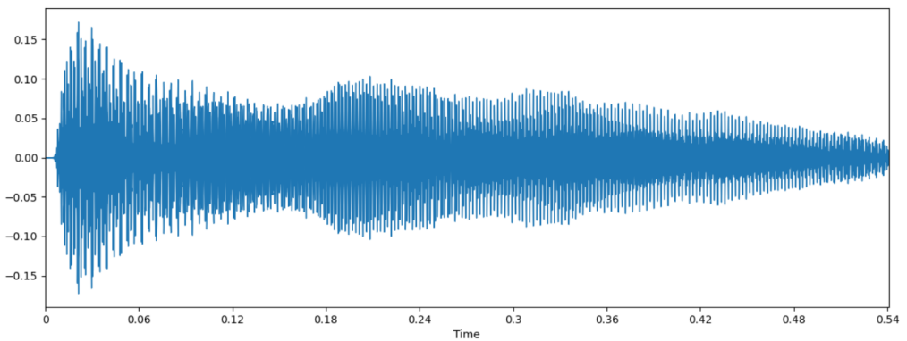  A sample waveform ⎯ big pinch when playing D3&D4
Small pinch  (小撮) | Thumb rest and index finger plucking on two strings at the same time. | Allegro
Small pinch  (小撮) | 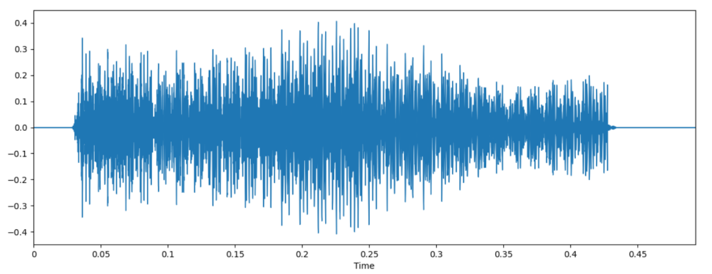  A sample waveform ⎯ small pinch when playing D4&F4
Finger shake  (摇指) | Quick in and out plucking | Adagio, transition section or cooperation with the glide and/or arpeggio
Finger shake  (摇指) | 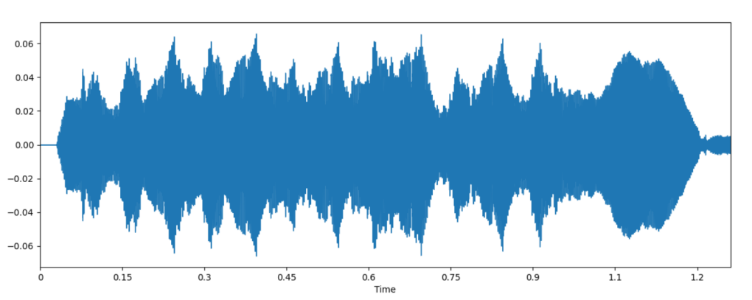  A sample waveform ⎯ finger shake when playing note below  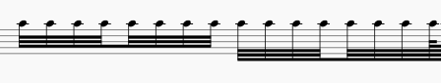
Arpeggio  (琶音) | Use ring finger, middle finger, index finger and thumb to roll from bass to treble. | Adagio, cooperate to shake
Arpeggio  (琶音) | 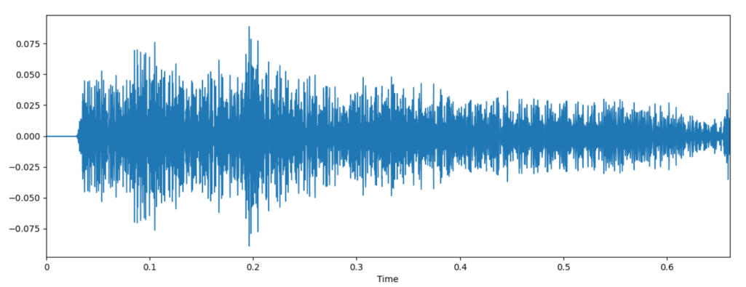  A sample waveform ⎯arpeggio when playing notes below  