Supporting Information
¹⁷⁷Lu-Labeled Near-infrared Upconversion Nanoparticles for targeted theranostics of Breast Cancer Lymphatic Metastases
Chuan Zhang^{1,2#}, Yujuan Zhang^{3#}, Maolin Liang^{1#}, Xiumin Shi^{1,2}, Longfei Fan¹, Kai Yang¹, Feng Wang², Wei Li⁴*, Ran Zhu¹*
1. State Key Laboratory of Radiation Medicine and Protection, School of Radiation Medicine and Protection, Collaborative Innovation Center of Radiation Medicine of Jiangsu Higher Education Institutions, Soochow University, Suzhou, Jiangsu 215123, China.
2. Department of Nuclear Medicine, Nanjing First Hospital, Nanjing Medical University, Nanjing, China.
3. Experimental center of Suzhou Medical College of Soochow University, Suzhou, Jiangsu 215123, China.
4. Department of General Surgery, The Second Affiliated Hospital of Soochow University, 1055 Sanxing Road, Suzhou, Jiangsu 215004, China
# Chuan Zhang, Yujuan Zhang and Maolin Liang contributed equally to this work.
Corresponding Authors Email: zhuran@suda.edu.cn, 905623032@qq.com

Preparation of NaLnF4 (Ln=Gd, Er, Yb) nanocluster precursors: Firstly, 0.5 mmol LnCl₃ (Gd, Yb, Tm = 80:18:2) was dissolved in 1 ml of water, and 2 mmol NaF was dissolved in 4 ml of water. 1.2 g of NaOH was weighed and transferred into a 50 mL single-neck flask, then 4 mL of water was added to completely dissolve NaOH. Afterwards, 9 mL of anhydrous ethanol and 20 mL of oleic acid were added into the above-mentioned solution. The mixture was stirred for about 10 min. LnCl₃ and NaF solution were added into the flask dropwise, and stirred for 1 h. The product was precipitated by adding 2 times the volume of ethanol and centrifuged at 10000 r.p.m. for 10 min, then rinsed with ethanol and cyclohexane. The final product was dispersed in 2 mL of cyclohexane. The same procedure was applied to the preparation of NaLuF4 nanocluster precursors.
Preparation of NaGdF4:Yb,Tm@NaLuF4 nanocrystals: 10 mL of octadecene and 6 mL of oleic acid were added into a 100 mL three-neck flask. The prepared NaLnF4 nanocluster precursors dispersed in cyclohexane solution was also added into the three-neck flask. The cyclohexane was removed from the system by stirring at 70 ºC for 30 min and bubbling nitrogen. The temperature was increased to 280 ºC at a rate of ~10 ºC /min. During the heating process, a condenser was added at ~200 ºC. The reaction was cooled down to room temperature after 1 h. With the same process above, NaLuF4 nanoparticle precursor was added, and the reaction stood for 1 h before cooling down to room temperature. The precipitate was collected by centrifugation at 10,000 rpm for 5 min and washed once with ethanol, and the product was finally dispersed in cyclohexane.
PEG surface modification of NaGdF₄:Yb,Tm@NaLuF₄ nanoparticles: 10 mg of hydrophobic UCNP and 3 times the volume of acetone were mixed and centrifuged to precipitate, then the supernatant was discarded, and the precipitate was dissolved in tetrahydrofuran. 100 mg of PEG dissolved in tetrahydrofuran was mixed with UCNP, and the mixture were stirred and reacted at 40 ºC for 24 h. After the reaction was completed and cooled down to room temperature, 3 times the volume of cyclohexane was used to precipitate. The nanoparticles were washed twice with cyclohexane. The precipitate was dried in a vacuum oven at room temperature for 4 h. The dried nanoparticles were dissolved in pure water and ultrafiltered through a 100 kDa ultrafiltration tube for three times to remove the excess PEG. The modified UCNP was stored at 4 °C for next experiments.

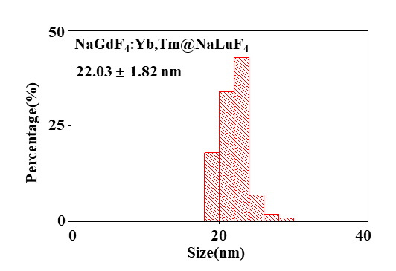
Figure S1. The size distribution of NaGdF₄:Yb,Tm@NaLuF₄.

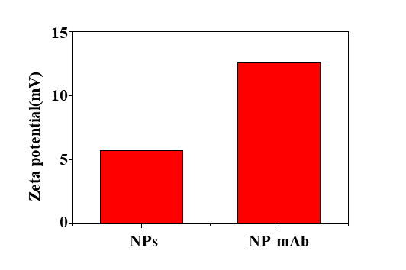
Figure S2. Zeta potential of NPs and NP-mAb.

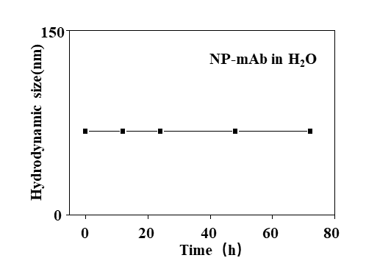
Figure S3. Colloidal stability of NP-mAb in pure water.

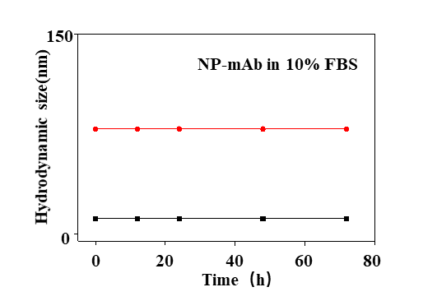
Figure S4. Colloidal stability of NP-mAb in 10% FBS.

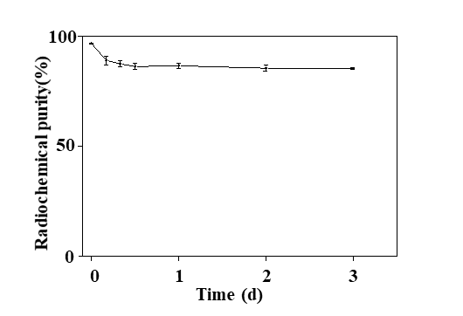
Figure S5. Radiolabeling stability of ¹⁷⁷Lu-NP-mAb in PBS solution.
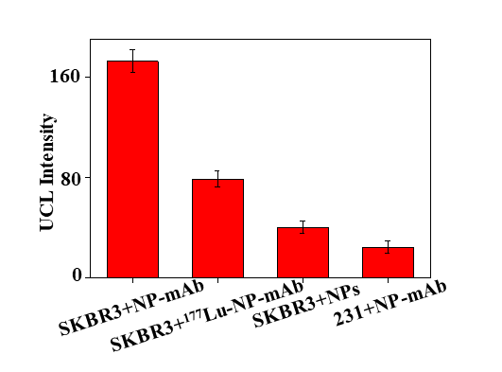

Figure S6. UCL Intensity of confocal imaging in cell binding experiment.

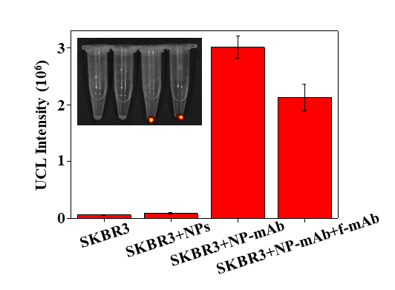
Figure S7. UCL Intensity of IVIS imaging in cell binding experiment.

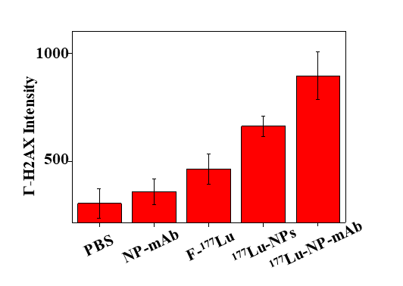
Figure S8. γ-H2AX Intensity of confocal imaging in DNA damage.

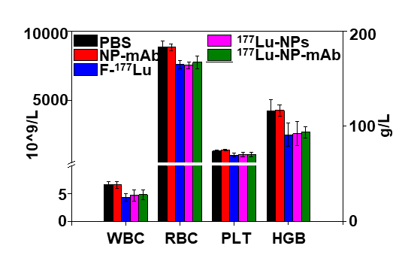

Figure S9. The blood routine tests of mice in different groups after 2 weeks post treatment.

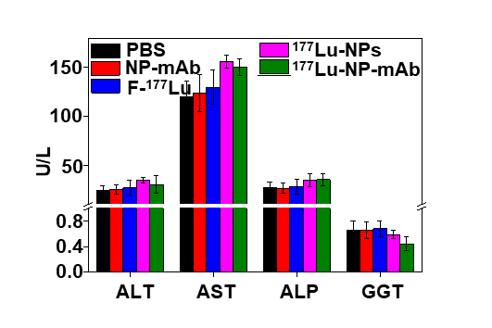
Figure S10. The liver function of mice in different groups after 2 weeks post treatment.

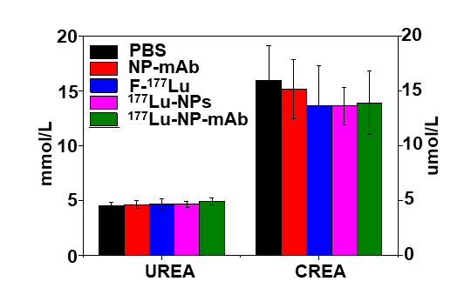

Figure S11. The kidney function of mice in different groups after 2 weeks post treatment.

