The curious case of transient plasma generated by ns-laser ablation of Ag in Ar gas
Stefan Andrei Irimiciuc^{1,2}, Sergii Chertopalov², Jiŕí Bulíř², Ladislav Fekete², Michal Novotný², Valentin Craciun^{1,3}, Jan Lancok²
¹National Institute for Laser, Plasma and Radiation Physics – NILPRP, 409 Atomistilor Street, Bucharest, Romania
²Institute of Physics of the Czech Academy of Sciences, Na Slovance 2, Prague, Czech Republic
³Extreme Light Infrastructure for Nuclear Physics, IFIN-HH, Magurele, Romania
Contact: stefan.irimiciuc@inflpr.ro

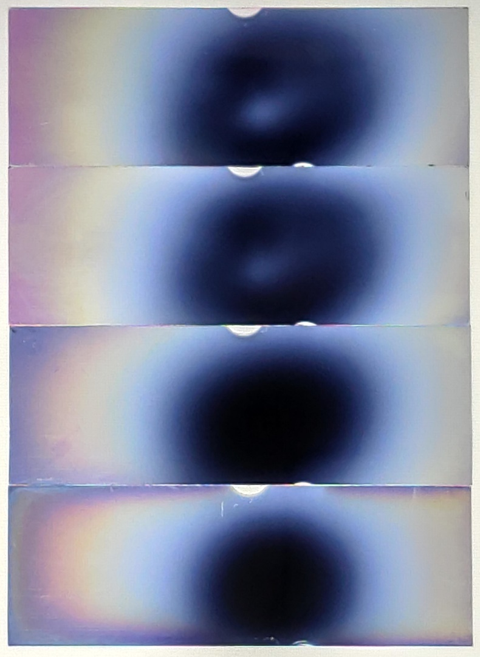
1.1×10^{–4} Pa
5×10^{–2} Pa
2 Pa
10 Pa
Figure S1. Images of transmitted irradiation through the silver films deposited in vacuum and in argon gas at pressure 5×10^{–2}, 2, 10 Pa.

Figure S2. XRD patterns of polycrystalline silver films deposited in vacuum and in argon gas at pressure 5×10^{–2}, 2, 10 Pa.

