Supplementary Information: Parts A and B

A global roll-out of nationally relevant policies bridges the emissions gap
Heleen L. van Soest^{1,2}, Lara Aleluia Reis³, Luiz Bernardo Baptista⁴, Christoph Bertram⁵, Jacques Després⁶, Laurent Drouet³, Michel den Elzen¹, Panagiotis Fragkos⁷, Oliver Fricko⁸, Shinichiro Fujimori^{9,10,8}, Neil Grant¹¹, Mathijs Harmsen^{1,2}, Gokul Iyer¹², Kimon Keramidas⁶, Alexandre C. Köberle¹¹, Elmar Kriegler⁵, Aman Malik⁵, Shivika Mittal¹¹, Ken Oshiro⁹, Keywan Riahi⁸, Mark Roelfsema², Bas van Ruijven⁸, Roberto Schaeffer⁴, Diego Silva Herran^{10,13}, Massimo Tavoni³, Gamze Unlu⁸, Toon Vandyck⁶, Detlef P. van Vuuren^{1,2}
¹ PBL Netherlands Environmental Assessment Agency, PO Box 30314, 2500 GH The Hague, the Netherlands
² Copernicus Institute of Sustainable Development, Utrecht University, Princetonlaan 8a, 3584 CB Utrecht, the Netherlands
³RFF-CMCC European Institute on Economics and the Environment, Milan 20144, Italy
⁴ Centre for Energy and Environmental Economics, Universidade Federal do Rio de Janeiro (CENERGIA/COPPE/UFRJ), 21941-914 Rio de Janeiro, Brazil
⁵ Potsdam Institute for Climate Impact Research, Member of the Leibniz Association, P.O. Box 601203 , 14412, Potsdam, Germany
⁶ European Commission, Joint Research Centre (JRC), Seville, Spain
⁷ E3Modelling S.A., Panormou 70-72, Athens, Greece
⁸ International Institute for Applied Systems Analysis, Schlossplatz 1, A-2361 Laxenburg, Austria
⁹ Department of Environmental Engineering, Kyoto University, C1-3 361, Kyotodaigaku Katsura, Nishikyoku, Kyoto city, Japan
¹⁰ National Institute for Environmental Studies, 16-2 Onogawa, Tsukuba, Ibaraki, 305-8506 Japan
¹¹ Grantham Institute, Imperial College London, Exhibition Road, London, SW7 2AZ, United Kingdom
¹² Joint Global Change Research Institute, Pacific Northwest National Laboratory and University of Maryland, College Park, MD, USA, 20740
¹³ Institute for Global Environmental Strategies, 2108-11 Kamiyamaguchi, Hayama, Kanagawa, 240-0115 Japan

Part A: implementation of good practice policies per model
The set of good practice policies was defined in dialogue with national model teams. In some cases, this process led to higher ambition than initially defined: for example, the target for the share of electric and hydrogen vehicles in new sales was brought forward by five years for China, and China was placed in the group of countries with highest assumed afforestation rates. In other cases, it led to a delay: for example, the target level for final energy intensity of buildings in the EU was adjusted, and for the USA, the carbon price was assumed to be introduced in 2025 rather than 2020.
Table A 1: All good practice policies measures and their target values per country group. 2050 values only apply to the GPP scenario.
See “Supplementary Information Table A 1.xlsx”.

Table A 2: Implementation of the good practice policies listed in Table A 1, per model (percentages behind the model name indicate the share of the policies implemented, counting the orange and green cells, and excluding the proxy indicators)
ID | AIM (56%) | IMAGE (94%) | MESSAGEix_GLOBIOM (74%) | POLES (62%) | PROMETHEUS (53%) | REMIND-MAgPIE (71%) | WITCH (68%) | TIAM-Grantham_v3.2 (44%)
1a | implemented | Included (non-CO2 abatement factor) | agriculture policies not implemented |  | agriculture policies not implemented | implemented (exact numbers as in Kriegler et al. 2018) |  | Agricultural policies not implemented
1b | implemented | Included (non-CO2 abatement factor) | agriculture policies not implemented |  |  | implemented (exact numbers as in Kriegler et al. 2018)
2a | implemented | Included (non-CO2 abatement factor) | agriculture policies not implemented |  |  | implemented (exact numbers as in Kriegler et al. 2018)
2b | implemented | Included (non-CO2 abatement factor) | agriculture policies not implemented |  |  | implemented (exact numbers as in Kriegler et al. 2018)
22 |  | Included (non-CO2 abatement factor) | agriculture policies not implemented
24a |  | Included (non-CO2 abatement factor) | agriculture policies not implemented
24b |  | Included (non-CO2 abatement factor) | agriculture policies not implemented
24c |  | Included (non-CO2 abatement factor) | agriculture policies not implemented
3a | Adjusted the AEEI of builings sector to match protocol value. | Included (Make appliance Unit Energy Consumption (kWh per appliance) improve according to the rate of the protocol) | implemented by using the proxy values | Implemented | proxy implementation finalised | implemented by using the proxy values |  | Implemented
3b | Adjusted the AEEI of builings sector to match protocol value. | Included (Make appliance Unit Energy Consumption (kWh per appliance) improve according to the rate of the protocol) | implemented by using the proxy values | Implemented | proxy implementation finalised | implemented by using the proxy values |  | Implemented
4a |  | Included (through the previous measure + transitioned to fully-LED lighting + Reduce heating and cooling intensity (kJ/m2/HDD or CDD) according to the protocol (This is an exogenous variable in the version of TIMER which was used) + the next measure) | implemented by using the proxy values | Implemented | implemented | implemented by using the proxy values
4b |  | Included (through the previous measure + transitioned to fully-LED lighting + Reduce heating and cooling intensity (kJ/m2/HDD or CDD) according to the protocol (This is an exogenous variable in the version of TIMER which was used) + the next measure) | implemented by using the proxy values | Implemented | implemented | implemented by using the proxy values
4c |  | - | implemented by using the proxy values | Implemented | implemented
4d |  | - | implemented by using the proxy values | Implemented | implemented
5a |  | Included (Deactivate coal and oil boilers for households. Only marginal capacity (existing capacity remains for their technical lifetime).) | implemented by using the proxy values | Implemented | Implemented |  |  | Implemented
5b |  | Included (Deactivate coal and oil boilers for households. Only marginal capacity (existing capacity remains for their technical lifetime).) | implemented by using the proxy values | Implemented | Implemented |  |  | Implemented
6a |  | Included (through the appliance energy consumption improvement + transitioned to fully-LED lighting + Reduce heating and cooling intensity (kJ/m2/HDD or CDD) according to the protocol (This is an exogenous variable in the version of TIMER which was used) + deactivation of coal and oil boilers for households) | implemented by using the proxy values | Implemented | Implemented | implemented by using the proxy values |  | Not Implemented
6b |  | Included (through the appliance energy consumption improvement + transitioned to fully-LED lighting + Reduce heating and cooling intensity (kJ/m2/HDD or CDD) according to the protocol (This is an exogenous variable in the version of TIMER which was used) + deactivation of coal and oil boilers for households) | implemented by using the proxy values | Implemented | Implemented | implemented by using the proxy values |  | Not Implemented
25 |  | - | implemented by using the proxy values | Implemented | implemented |  |  | Implemented
7 | implemented | Included | implemented. | Implemented | implemented | implemented |  | Implemented
8 | implemented | Included (as no coal-fired power plant; 420 gCO2/kWh) | implemented | Implemented | implemented | implemented |  | Implemented
9a | Adjusted the preference for renewables | Included (premium factors and forced capacity shares) | implemented | Implemented | implemented | implemented |  | Implemented
9b | Adjusted the preference for renewables | Included (premium factors and forced capacity shares) | implemented | Implemented | implemented | implemented |  | Implemented
10a | implemented | Included (F-gas specific tax) | implemented |  |  | implemented |  | Not implemented (TIAM_Grantham not covering F-Gases in this analysis)
10b | implemented | Included (F-gas specific tax) | implemented |  |  | implemented |  | Not implemented (TIAM_Grantham not covering F-Gases in this analysis)
11 | implemented | Included (non-CO2 abatement factor) | implemented | Implemented |  |  |  | Not implemented
12a | implemented | Included (non-CO2 abatement factor) | not implemented due to model restriction |  |  |  |  | Not implemented
12b | implemented | Included (non-CO2 abatement factor) | not implemented due to model restriction |  |  |  |  | Not implemented
26 |  | Included (non-CO2 abatement factor) |  |  |  |  |  | Implemented
13a |  | - | implemented | Implemented | implemented | implemented (Approx. 200 MtCO₂ /year CCS in industry.) |  | Implemented
13b |  | - | implemented | Implemented |  |  |  | Implemented
14a | Adjusted the AEEI of industry sector to match protocol value. | Included (added efficiency factor) | implemented by using the proxies |  | implemented | implemented by using the proxies |  | Implemented
14b | Adjusted the AEEI of industry sector to match protocol value. | Included (added efficiency factor) |  |  | implemented | implemented by using the proxies |  | Implemented
15 | implemented | Included (non-CO2 abatement factor) | implemented | Implemented |  |  |  | Not implemented
16 |  | Included (approximation, by reduced addtinal deforestation) | not implemented |  |  | implemented (10 million ha/year  afforestation) |  | Not implemented
17 |  | Included (approximation, by reduced addtinal deforestation) | not implemented |  |  | implemented (End natural forest loss;) |  | Not implemented
27 |  | - | not implemented |  |  |  |  | Not implemented
18a |  | Included (added efficiency factor) | implemented by using proxies | Implemented | implemented | implemented by using proxies |  | Implemented
18b |  | Included (added efficiency factor) | implemented by using proxies | Implemented | implemented | implemented by using proxies |  | Implemented
19a |  | Included (added efficiency factor) | implemented by using proxies | Implemented | Implemented by using proxies | implemented by using proxies |  | Implemented
19b |  | - | implemented by using proxies | Implemented | implemented | implemented by using proxies |  | Implemented
19c | Adjusted AEEI in passenger transport to match final energy proxy values from IMAGE. | - | implemented by using proxies | Implemented | implemented | implemented by using proxies |  | Implemented
20 |  | Included (by premium factors on vehicles) | implemented by using proxies | Implemented | implemented | implemented |  | Implemented
21a | implemented | Included (non-CO2 abatement factor) | implemented | Implemented |  |  |  | Not implemented
21b | implemented | Included (non-CO2 abatement factor) | implemented | Implemented |  |  |  | Not implemented

Part B: Additional figures

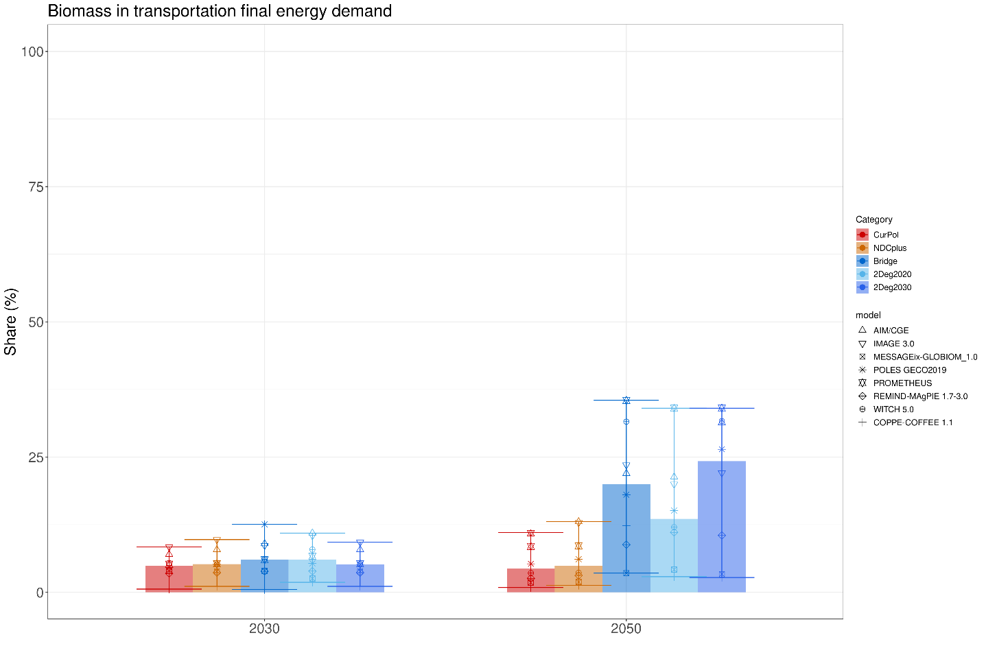
Figure B 1: Projected changes in the share of liquid biomass in final energy demand of transportation (%), for 2030 and 2050, for the CurPol, NDCplus, Bridge, 2Deg2020, and 2Deg2030 scenarios. Bars show model median, error bars show the full range, and symbols show individual model results.
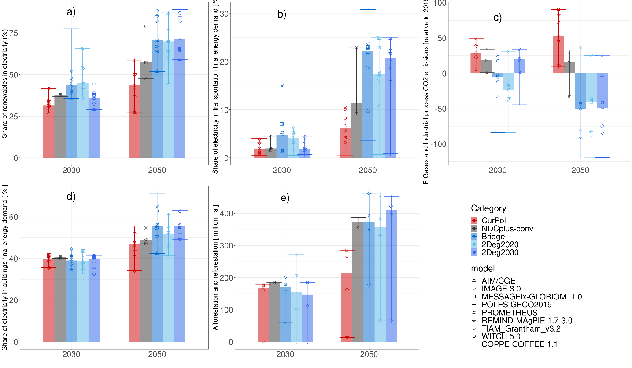
Figure B 2: Projected changes in various indicators, for 2030 and 2050, for the CurPol, NDCplus-convergence, Bridge, 2Deg2020, and 2Deg2030 scenarios. Bars show model median, error bars show the full range, and symbols show individual model results. Panel a) share of renewables in electricity production (%), panel b) share of electricity in final energy demand of transportation (%), panel c) Emissions of F-gases and industrial process CO₂ emissions, relative to 2015 levels (%), panel d) share of electricity in final energy demand of buildings (%), panel e) total afforestation and reforestation (million ha).

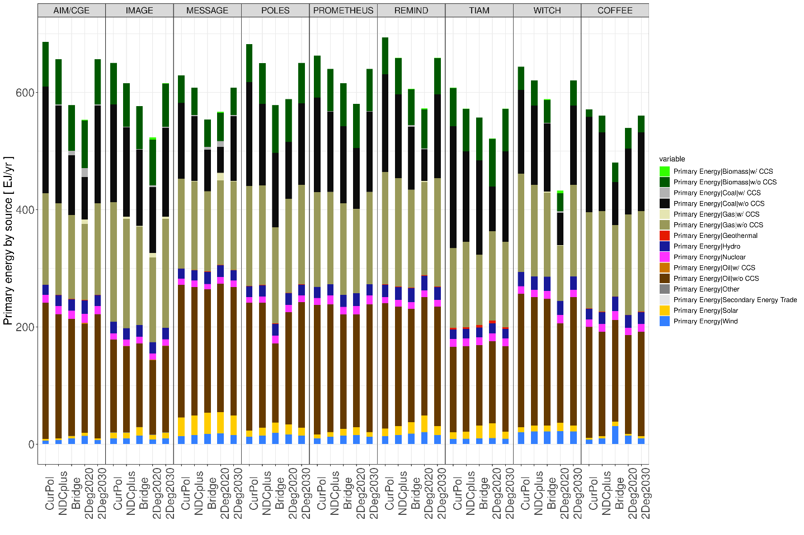
Figure B 3: Primary energy production in 2030 by source, per model, for the CurPol, NDCplus, Bridge, 2Deg2020, and 2Deg2030 scenarios.

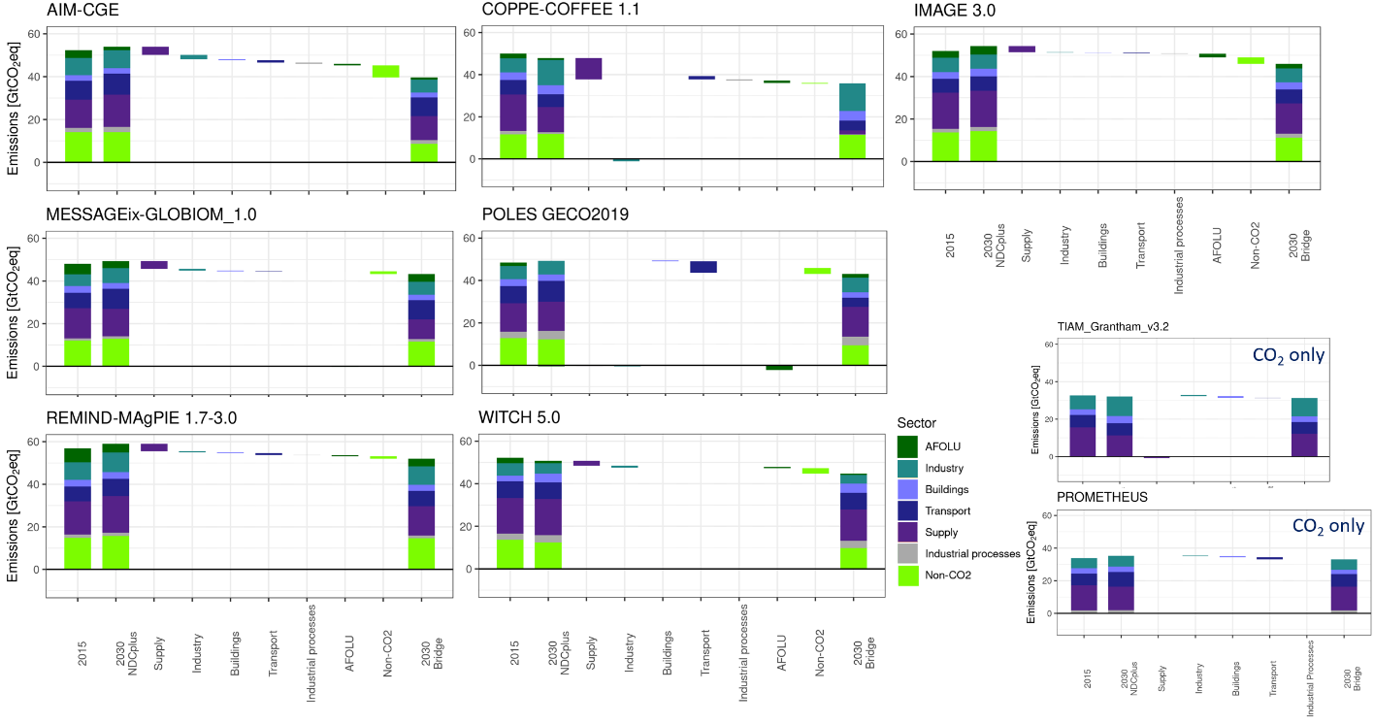
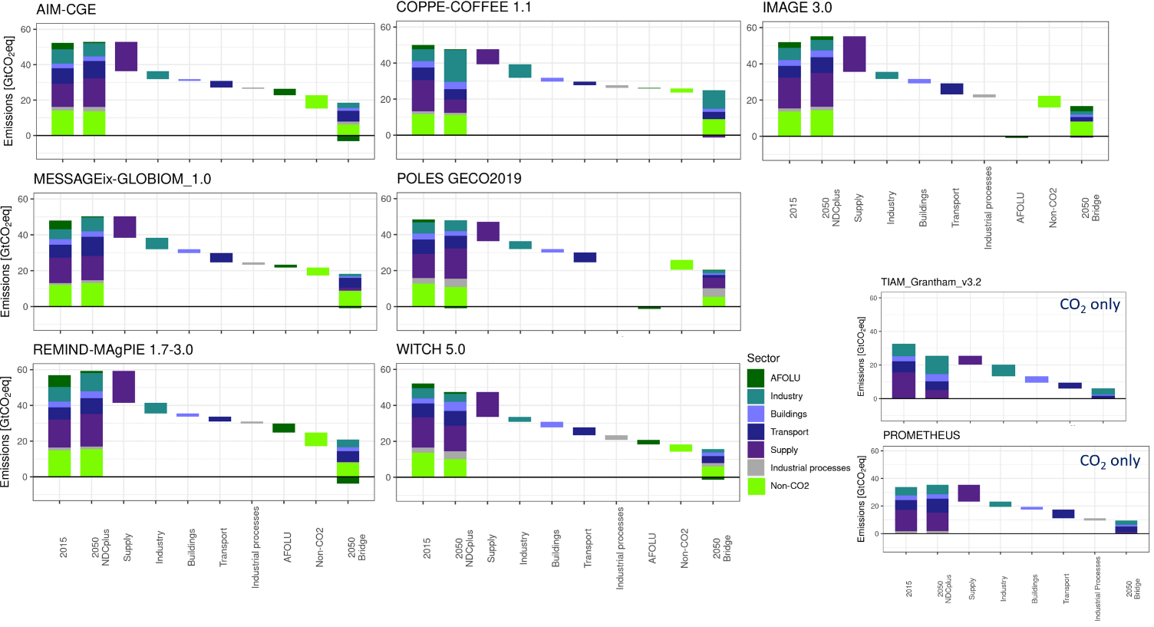
Figure B 4: Contribution of each sector to emission reductions between the NDCplus and Bridge scenario (negative values denote an increase in emissions between NDCplus and Bridge). First bar: Emissions by sector in 2015. Second bar: emissions by sector in 2030 (upper graph) or 2050 (lower graph), under NDCplus. Third - ninth bar: emission reduction in energy supply, industry, buildings, transport, industrial processes, AFOLU, non-CO₂ emissions. Last bar: emissions by sector in 2030 (upper graph) or 2050 (lower graph), under Bridge. For TIAM and PROMETHEUS, only CO₂ emissions are shown.

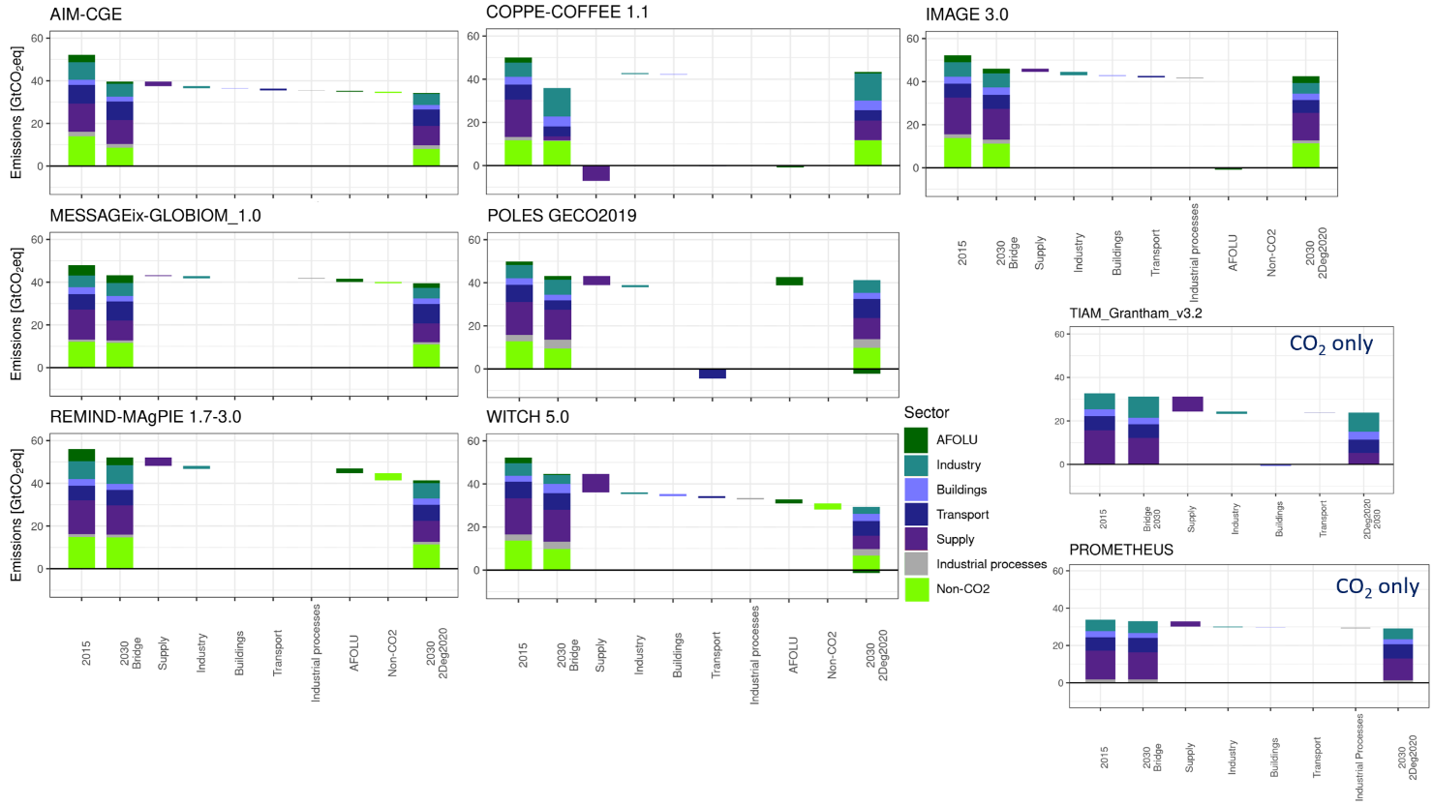
Figure B 5: Contribution of each sector to emission reductions between the Bridge and 2Deg2020 scenarios (negative values denote an increase in emissions between Bridge and 2Deg2020). First bar: Emissions by sector in 2015. Second bar: emissions by sector in 2030, under Bridge. Third - ninth bar: emission reduction in energy supply, industry, buildings, transport, industrial processes, AFOLU, non-CO₂ emissions. Last bar: emissions by sector in 2030, under 2Deg2020. For TIAM and PROMETHEUS, only CO₂ emissions are shown.

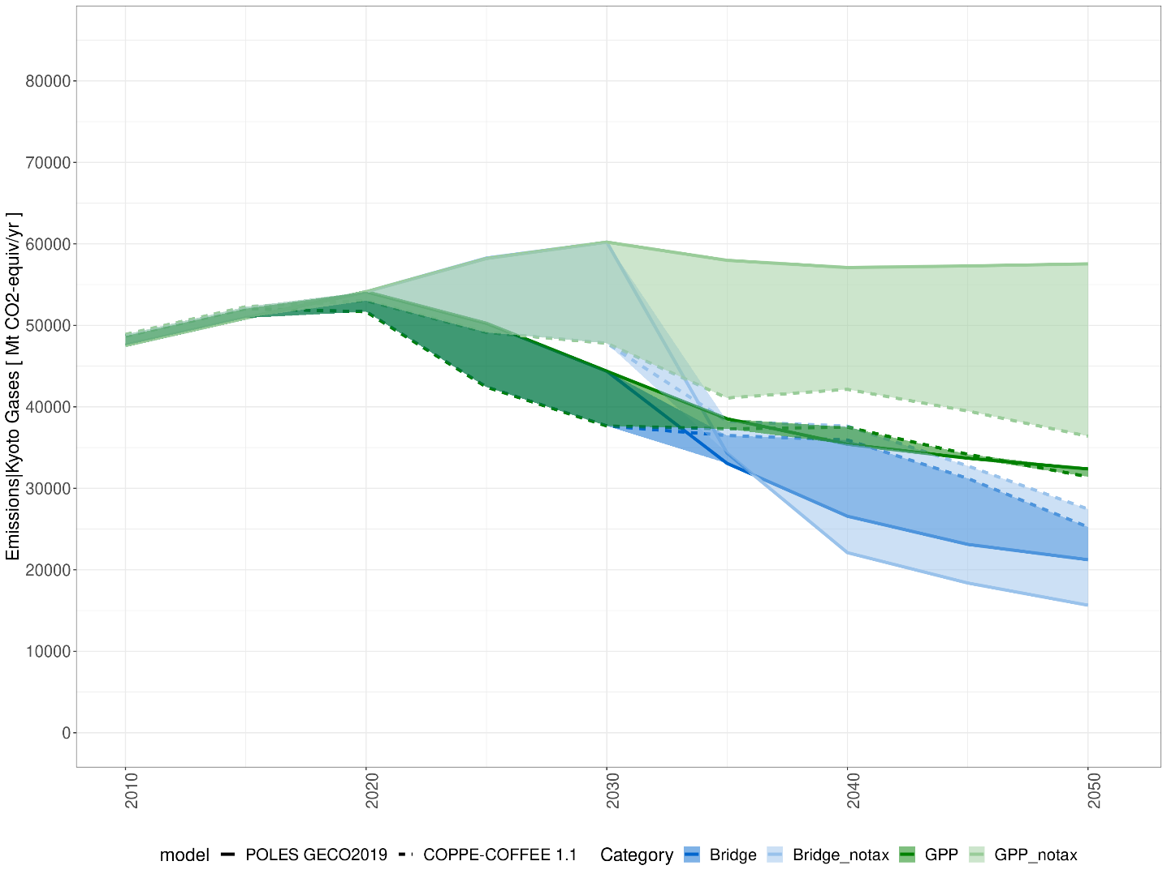
Figure B 6: Global greenhouse gas emissions for the sensitivity cases of GPP and Bridge without the carbon tax measure (measure 7)

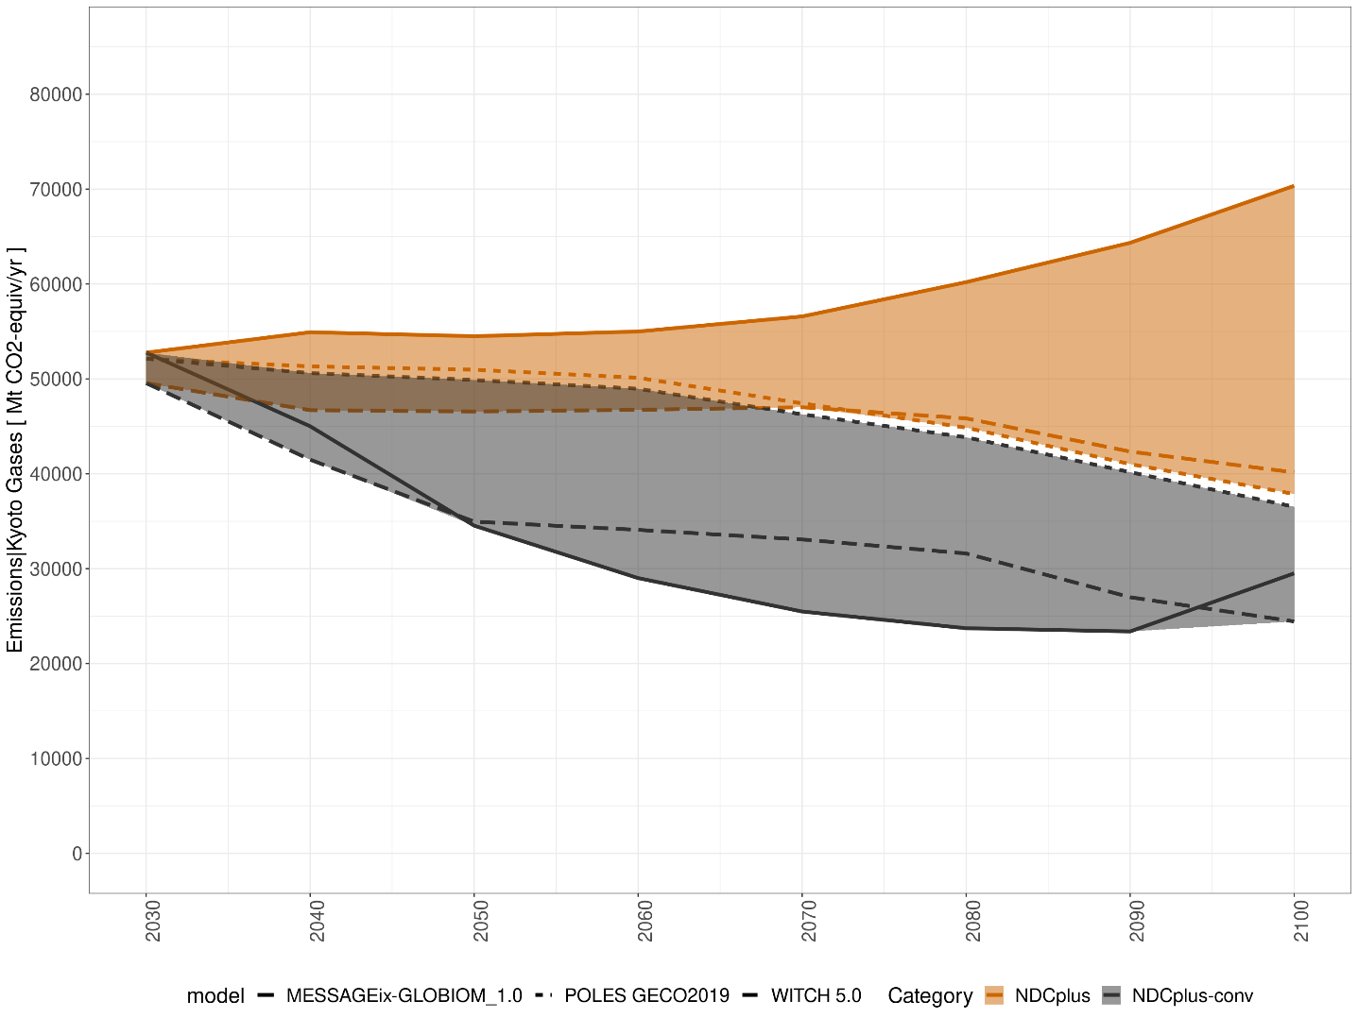
Figure B 7: Global greenhouse gas emissions for the NDC variant NDC_2050convergence, as compared to the default NDCplus scenario

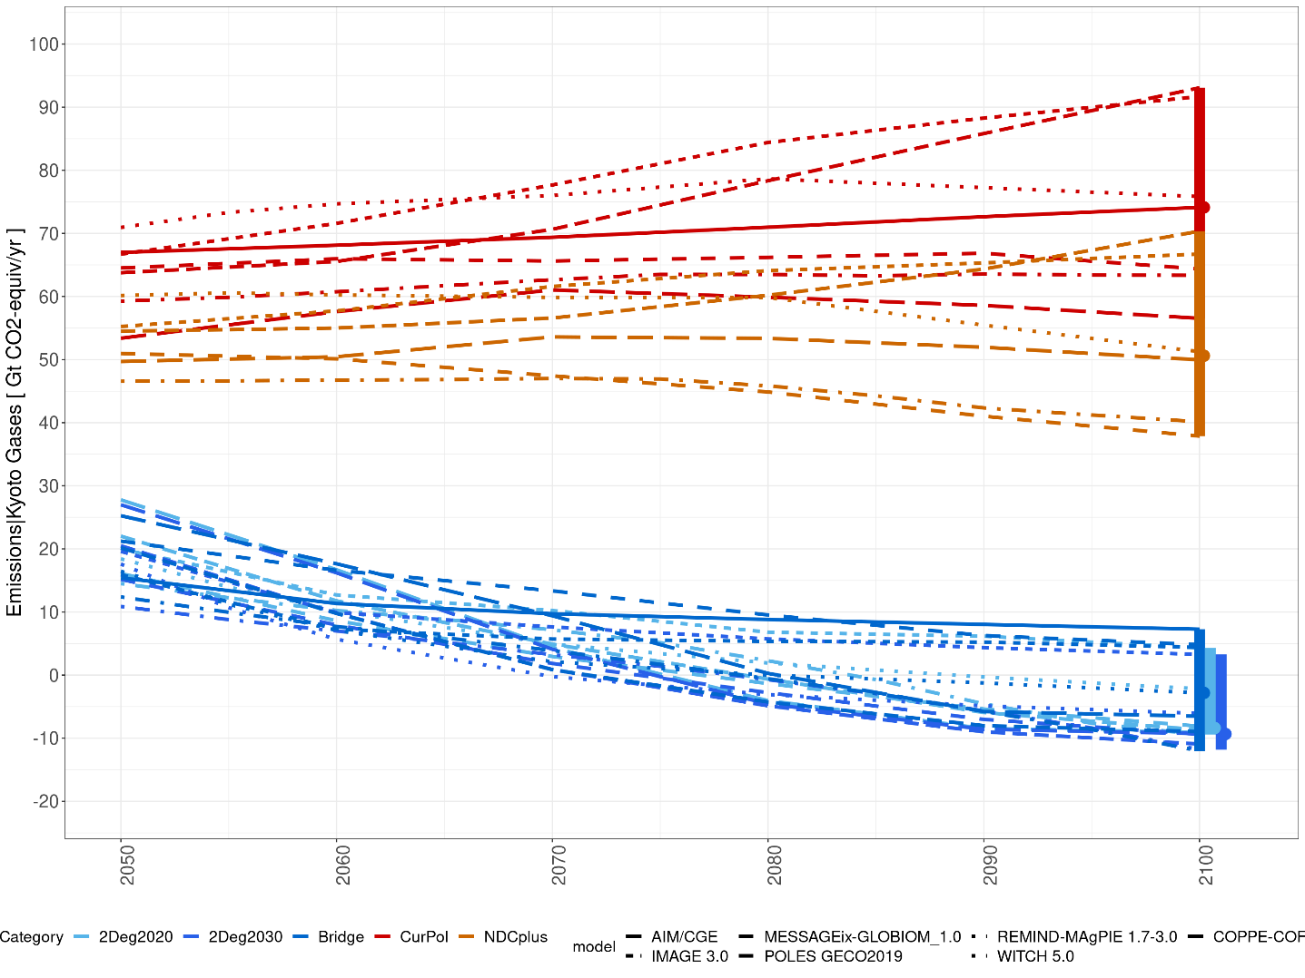
Figure B 8: Global greenhouse gas emissions (Gt CO₂eq/year) between 2050 and 2100. Vertical bars: model range in 2100. Circles: model median in 2100.
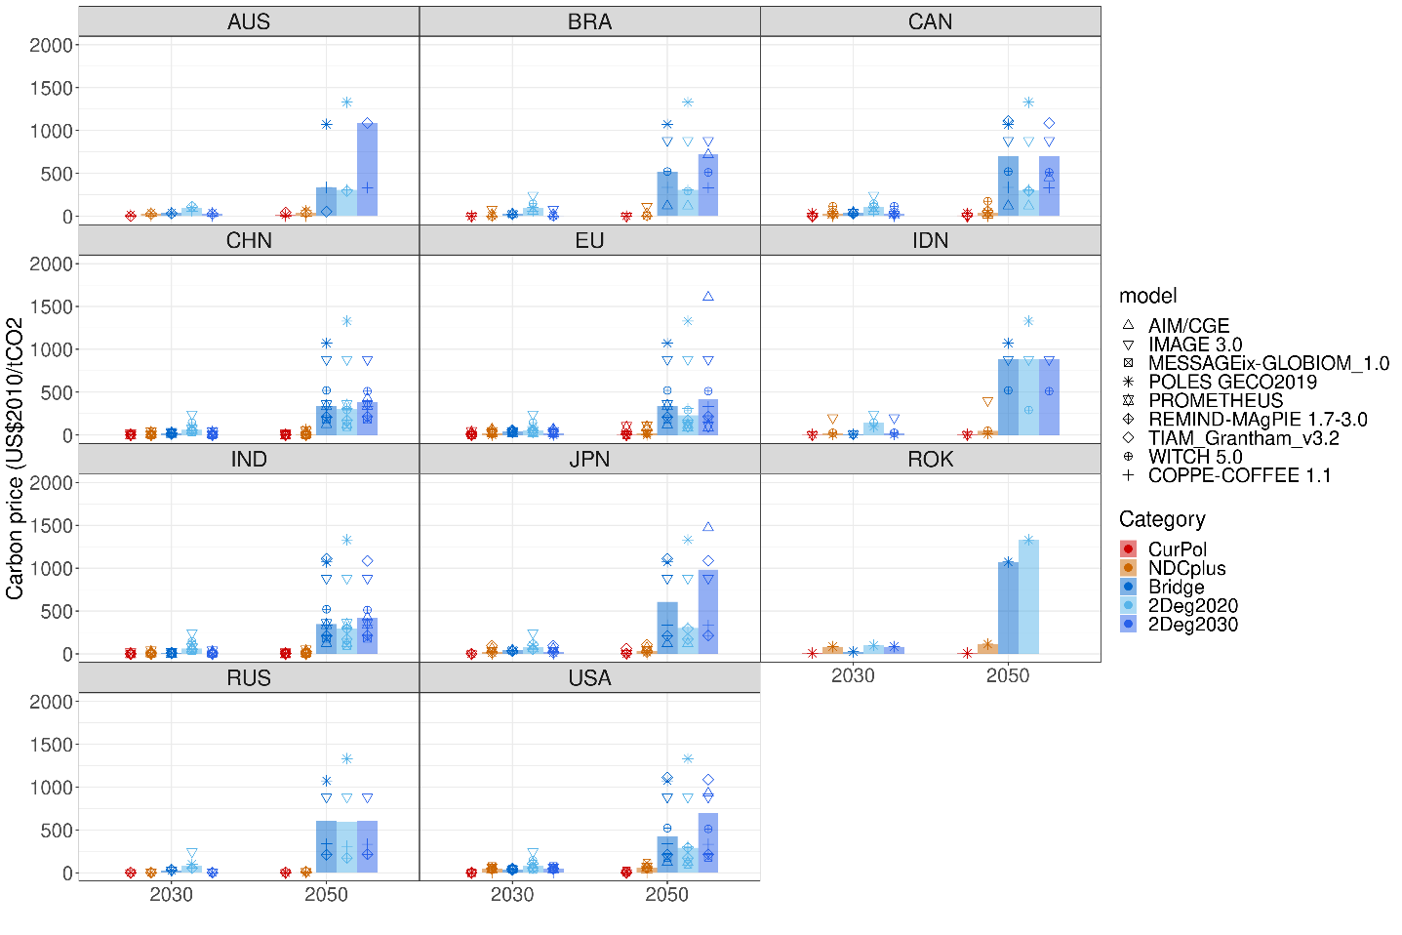
Figure B 9: Regional carbon prices (US$2010/tCO₂) in 2030 and 2050, in the CurPol, NDCplus, Bridge, 2Deg2020, and 2Deg2030 scenarios. Bars: model median, symbols: individual models.

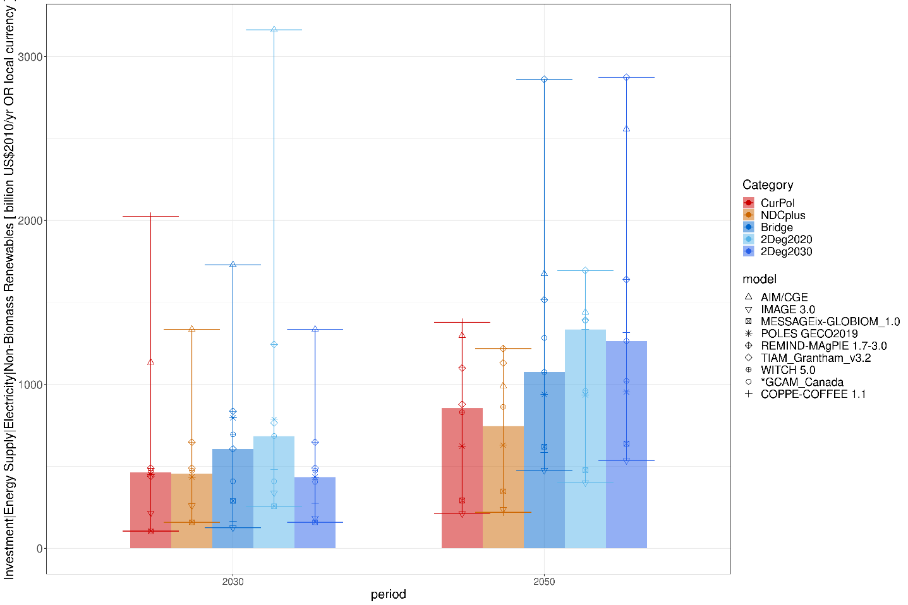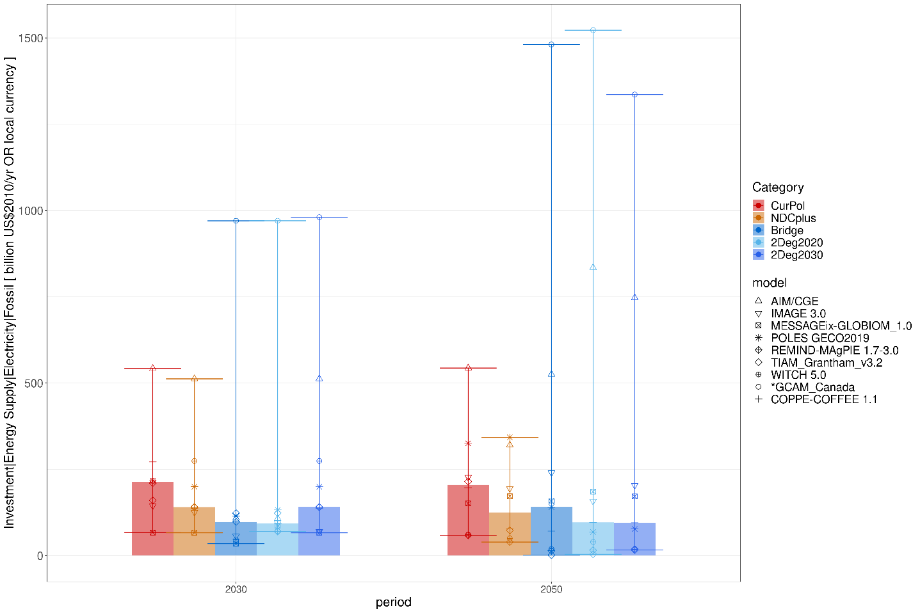
Figure B 10: Investments in energy supply – electricity (billion US$2010 per year). Upper graph: non-biomass renewables, lower graph: fossil fuels. Bars show model median, error bars show the full range, and symbols show individual model results.

