Supplementary Information
Table Captions
Table S1. Physicochemical characteristics of the raw material
Table S2. Evaluation of GI, HA, and FA value for FM, MM and CM on D0 and D40.
Table S3. Evolution of the humification ratios for FM, MM and CM on D0 and D40.
Table S4. Changes of heavy metal concentration before and after composting in three piles.
Figure Captions
Fig. S1 DTG and TGA curves of the samples collected at different times of the composting process: (a) Tl and DS; (b-d) FM, MM, and CM on D0 and D40.

Table S1 Physicochemical characteristics of the raw materials.
Characteristics | Feedstocks
 | Dewatered sludge | Triarrhena lutarioriparia | FM | MM | CM
Moisture content (wet basis %) | 78.9 | 9.63 | 54.6 | 57.3 | 50
Organic matter (dry basis %) | 45.1 | 95.8 | 86.1 | 85.9 | 87.1
pH | 7.04 | 6.53 | 7.18 | 7.19 | 7.30
EC (mS/cm) | 0.54 | 2.74 | 2.23 | 3.07 | 2.37
TN (%) | 3.7 | 1 | 1.46 | 1.54 | 1.58
TP (%) | 4.64 | 0.27 | 1.71 | 1.95 | 1.31
TK (%) | 1.85 | 1.62 | 1.81 | 1.92 | 1.61
DOC (mg/L) | 590.0 | 491.6 | 876.3 | 878.4 | 906.6

Table S2 Evaluation of GI, HA, and FA value for FM, MM and CM on D0 and D40.
Compost | Stage | GI (%) | HA (mg/g) | FA (mg/g)
FM | 0 | 62.43 | 97.6 | 43.05
FM | 40 | 116.65 | 167.55 | 37.7
MM | 0 | 58.62 | 97.71 | 44.82
MM | 40 | 110.89 | 162.93 | 38.64
CM | 0 | 65.44 | 93.32 | 46.13
CM | 40 | 65.83 | 133.07 | 43.58

Table S3 Evolution of the humification ratios for FM, MM and CM on D0 and D40.
Compost | Stage | 1643/2919 | 1643/2840 | 1525/2919 | 1425/1050
FM | 0 | 0.85 | 0.72 | 1.10 | 2.43
FM | 40 | 0.72 | 0.63 | 0.99 | 3.17
MM | 0 | 0.97 | 0.82 | 1.28 | 1.97
MM | 40 | 0.80 | 0.73 | 1.02 | 2.30
CM | 0 | 0.83 | 0.71 | 1.10 | 2.75
CM | 40 | 0.83 | 0.75 | 1.04 | 1.96

Table S4 Changes of heavy metal concentration before and after composting in three piles.
Compost | Stage | Cd(mg/kg) | Cr(mg/kg) | Cu(mg/kg) | Ni(mg/kg) | Pb(mg/kg) | Zn(mg/kg)
FM | D0 | 0.71 | 36.14 | 64.02 | 11.65 | 12.57 | 302.91
FM | D8 | 0.47 | 40.61 | 63.98 | 14.56 | 13.89 | 331.83
FM | D40 | 0.45 | 42.77 | 70.38 | 16.49 | 14.07 | 353.10
MM | D0 | 0.61 | 33.79 | 62.23 | 11.46 | 11.40 | 296.04
MM | D8 | 0.40 | 40.49 | 64.60 | 15.18 | 11.64 | 354.00
MM | D40 | 0.49 | 49.37 | 75.24 | 18.13 | 13.52 | 384.67
CM | D0 | 0.58 | 43.83 | 71.04 | 15.66 | 14.23 | 326.64
CM | D8 | 0.38 | 34.38 | 56.37 | 12.90 | 9.72 | 294.64
CM | D40 | 0.25 | 34.33 | 59.22 | 13.02 | 8.66 | 307.67

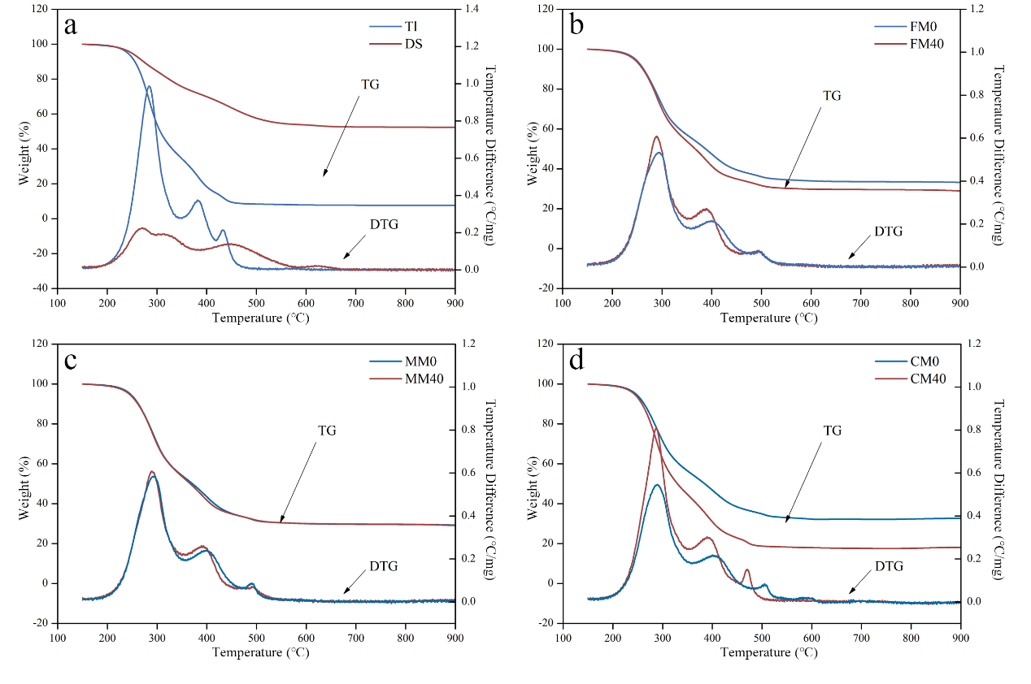
Fig. S1 DTG and TGA curves of the samples collected at different times of the composting process: (a) Tl and DS; (b-d) FM, MM, and CM on D0 and D40.

