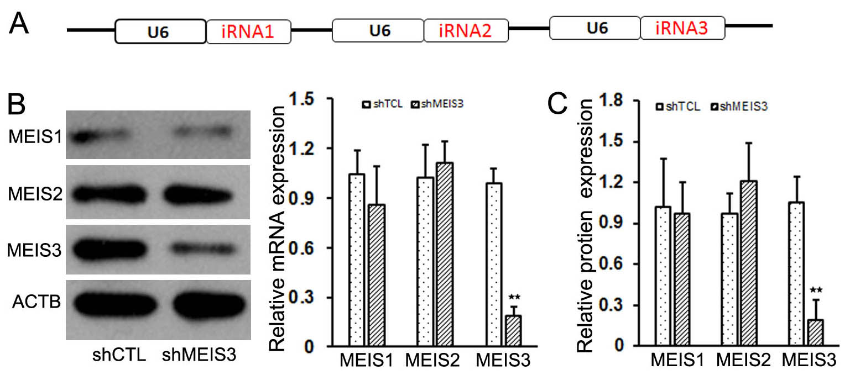
Fig S1 Silencing MEIS3 expression resulted in CRC cells
Construction of tandem U6-MEIS3 shRNA lentivirus expression vector (A). Expression of MEIS3 family member genes in SW480 (B) and SW1116 cell (C) after transfected by MEIS3 silenced lentivirus.

Table S1 Primers for MIES3 Silence
Gene |  | Primer | Primer Sequences | Tm (℃) | Product Length
ACTB |  | ACTB-F | 5'- CGCAAAGACCTGTACGCCAA -3' | 58.4 | 216bp
ACTB |  | ACTB-R | 5'- CTCCTGCTTGCTGATCCAC -3' | 58.4 | 216bp
MEIS1 |  | MEIS1-F | 5'- AAGCAGTTGGCACAAGACAC -3' | 55.1 | 186bp
MEIS1 |  | MEIS1-R | 5'- AATTCCCATATGTTGCTGACCG -3' | 55.1 | 186bp
MEIS2 |  | MEIS2-F | 5'- CGATAACTTCTGCCACCGAT -3' | 57.3 | 266bp
MEIS2 |  | MEIS2-R | 5'- TGTCTAAACCATCCCCTTGC -3' | 57.3 | 266bp
MEIS3 |  | MEIS3-F | 5'- GACATCGCTGCCTTTGCCAA -3' | 59.8 | 328bp
MEIS3 |  | MEIS3-R | 5'- TCCCCAAATGTACAGACCCACT -3' | 59.8 | 328bp
MEIS3 |  | GPNMB-R | 5'- TATCAGTTTCACAACATGGCT -3' | 59.8 | 328bp

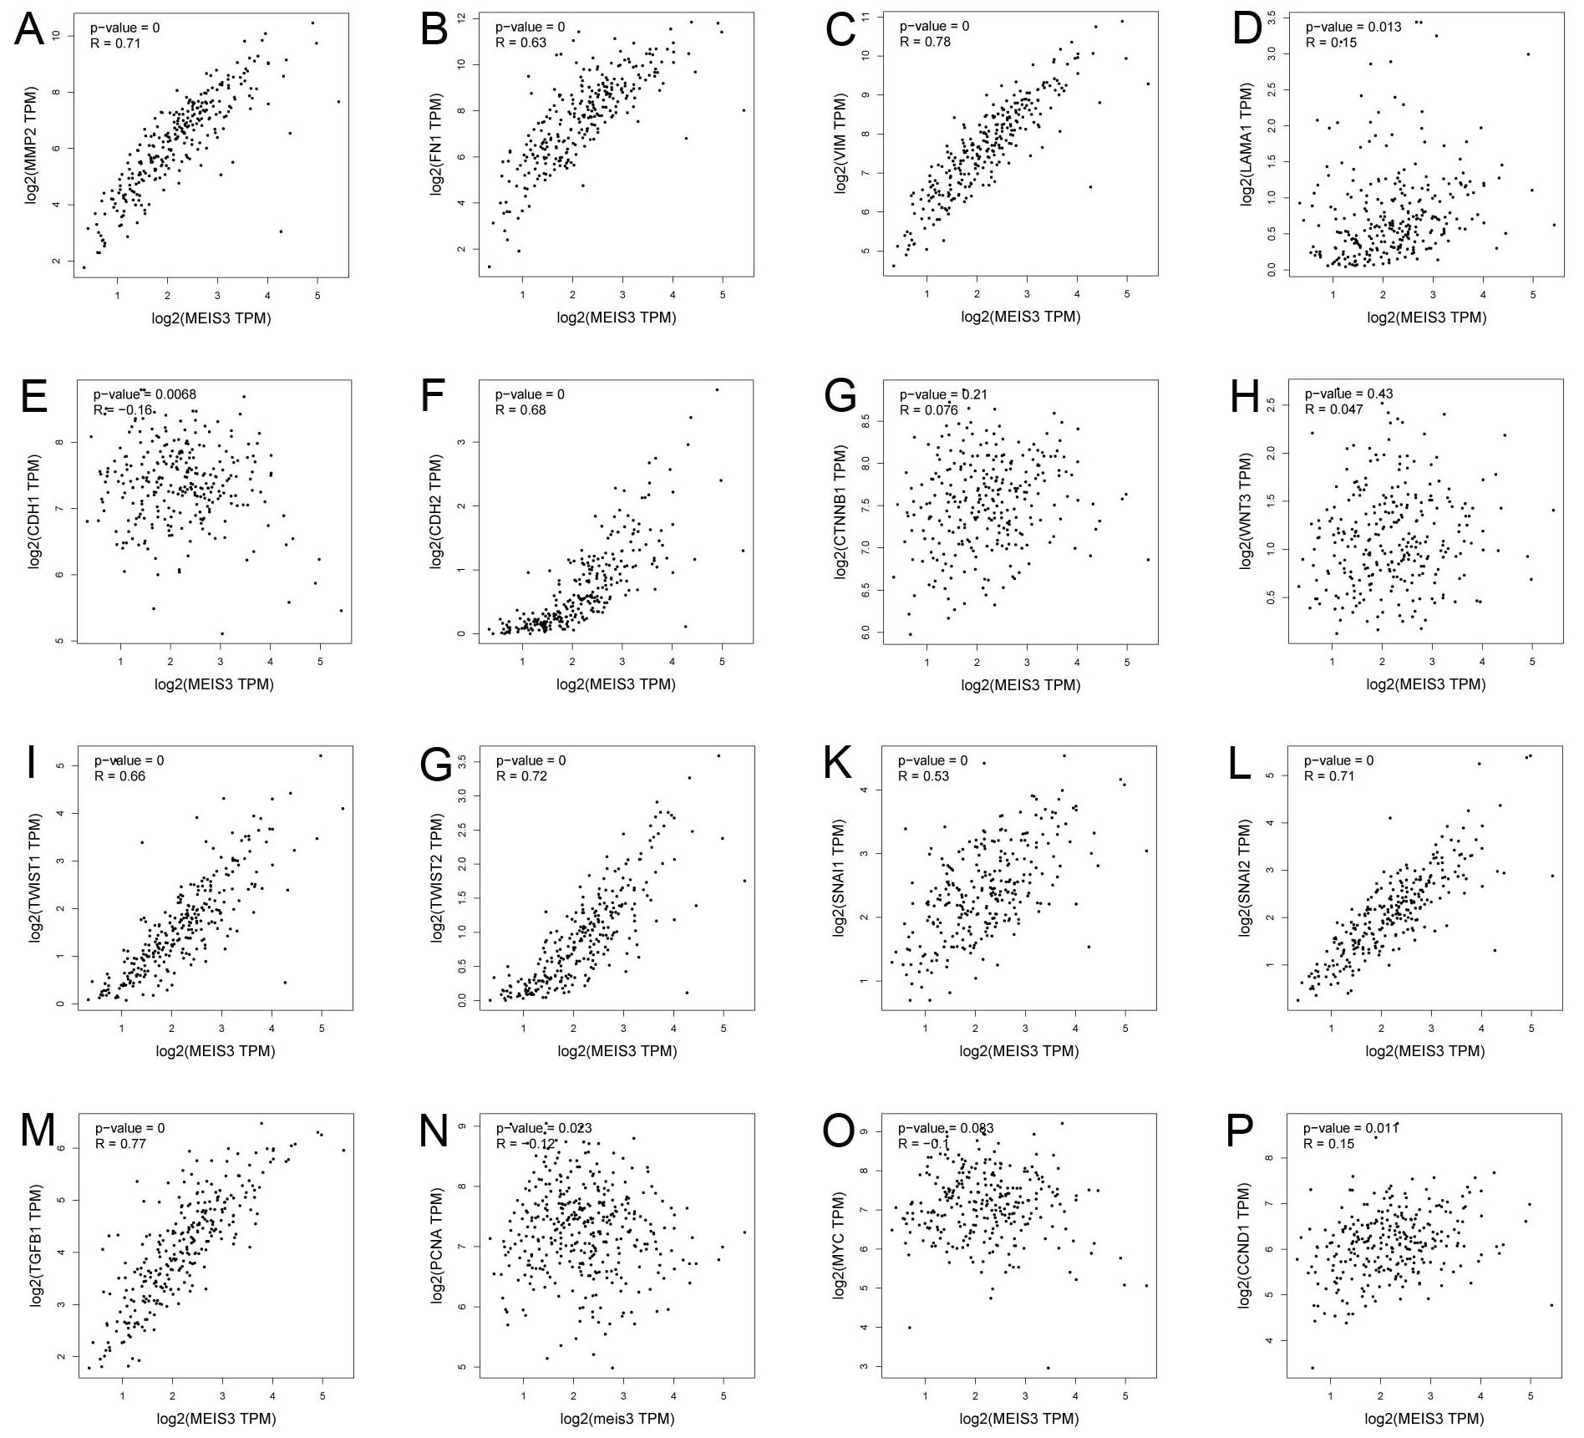
Fig S2 The correlations between the mRNA expression level of the MEIS3 gene and EMT and tumour budding genes in CRC patients.

Table S2 Clinical pathological features and univariate analyses of risk factors for DFS
Variables | Number | Percent (%) | 5-Year DFS (%) | p-value
Age(years)
<57 | 163 | 55.8 | 41.1 | 0.25
>57 | 129 | 41.2 | 48.0 | 0.25
Gender
male | 153 | 52.4 | 53.1 | 0.34
Female | 139 | 47.6 | 40.3 | 0.34
Position
Colon | 176 | 60.3 | 48.0 | 0.91
Rectum | 116 | 39.7 | 41.1 | 0.91
Tumor size (cm)
>5 | 128 | 43.8 | 39.1 | 0.62
<5 | 164 | 56.2 | 54.3 | 0.62
AJCC Stage
I | 47 | 16.1 | 82.3 | <0.0001
II | 107 | 36.6 | 62.6 | <0.0001
III | 95 | 32.5 | 40.8 | <0.0001
IV | 43 | 14.7 | 29.6 | <0.0001
MEIS3 Expression
High | 116 | 39.7 | 40.6 | <0.0001
Low | 176 | 60.3 | 61.7 | <0.0001

