Omega-3 fatty acid-rich fish oil supplementation prevents rosiglitazone-induced osteopenia in insulin resistant C57BL/6 mice and in vitro studies.
Authors’ names and Institution: Chiara Cugno¹, Dhanya Kizhakayil¹, Rita Calzone¹, Shaikh Mizanoor Rahman², Ganesh V Halade³ and Md M Rahman⁴*

Affiliations:
¹ Advanced Cell Therapy Core, Sidra Medicine, Doha, Qatar.
² Natural & Medical Sciences Research Center, University of Nizwa, Sultanate of Oman.
³ Division of Cardiovascular Sciences, the University of South Florida Health, Tampa, Florida.
⁴ Department of Biological and Environmental Sciences, Qatar University, Doha, Qatar.

*Corresponding author
Md Mizanur Rahman, PhD Email: mrahman@qu.edu.qa

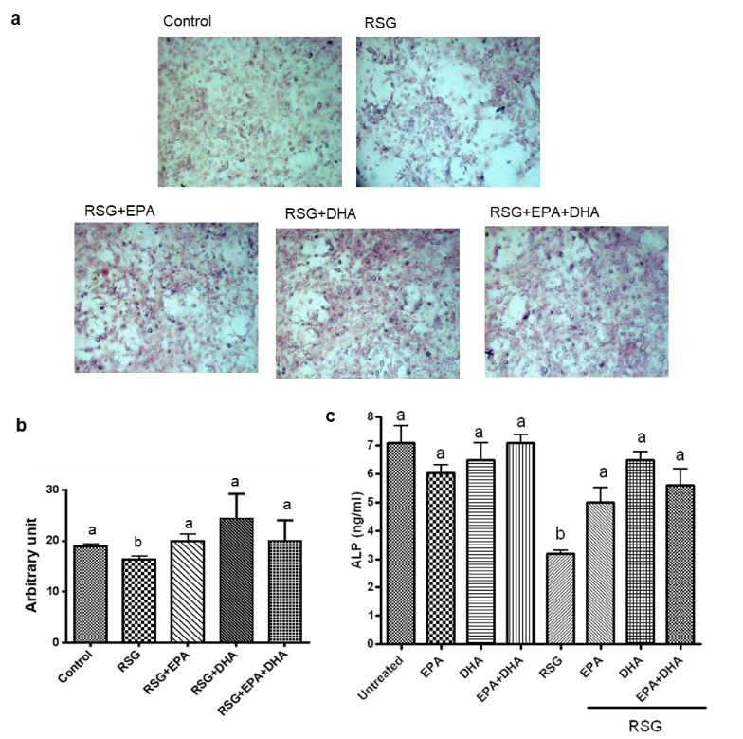

Supplemental Figure 1. Effect of RSG with or without omega-3 FAs on osteogenesis in bone marrow stromal cells
Bone marrow cells were isolated from C57BL/6 mice and cultured in α-MEM supplemented with 10% FBS to generate bone marrow (BM) stromal cells. BM stromal cells were used to visualize matrix calcification by alizarin red staining and osteoblast differentiation by alkaline phosphatase activity. To determine the effect on the matrix calcification, BM stromal cells were cultured in the presence of ascorbic acid and β-glycerophosphate with RSG 1 µM with or without EPA 10 µM and/or DHA 10 µM for 10 days. Cells were then fixed and stained for Alizarin Red. a) Representative photographs (20x) of BM stromal cells stained for alizarin red S. b) Optical Density (OD) intensity was determined by histomorphometry using the Metaview Image Analysis System software for Alizarin Red positive area. c)To determine the effect on osteoblast differentiation, BM stromal cells were cultured in the presence of ascorbic acid and β-glycerophosphate with RSG 1µM with or without EPA 10µM and/or DHA 10µM for 7 days. Then cell lysates were prepared and ALP activity was measured in cell lysates by using SensoLyte pNPP ALP Assay (AnaSpec, San Jose, CA, USA). ALP activity in each sample was determined by measuring OD405 and compared to an ALP standard curve. Each bar represents the mean ± SEM of two independent quadruplicate cultures. Value with different superscripts is significantly different at P<0.05 by Newman Keuls one way ANOVA with multiple comparison test.

Supplemental Figure 2. Effect of RSG with or without omega-3 FAs on osteoclastic activity in bone marrow cells.
Bone marrow (BM) cells isolated from C57BL/6 mice were cultured in α-MEM containing 10% FBS with 40 ng/mL PTHrP in the presence of RSG 1µM with or without EPA 10µM and/or DHA 10 µM for 7 days on sperm whale dentin slice placed in a 48 well tissue culture plate. The cells were then lysed with 200 mL of 0.2% Triton X-100. Tartrate-resistant acid phosphatase (TRAP) activity in cell lysate was determined using a TRAP solution. The absorbance was then measured at 570 nm using a microplate reader. Each bar represents the mean ± SEM of two independent quadruplicate cultures. Value with different superscripts is significantly different at P<0.05 by Newman Keuls one way ANOVA with multiple comparison test.

Supplemental Figure 3. Effect of RSG with or without FO on gene-expression of adipo-differentiated Mesenchymal Stromal Cells (MSCs).
Gene expression of adipogenic (a) and osteogenic (b) markers in MSCs differentiated in adipogenic medium with the presence of RSG, DHA and combination of RSG and DHA. Relative quantification of gene expression i) Adipsin, ii) FABP4, iii) LPL, iv) PPARγ, v) OPG, vi) RUNX2, vii) ALPL, viii) COL1A1. One-way ANOVA test followed by Dunnett’s multiple comparisons test, P values are marked against RSG; ns- P value non-significant. n = 2 donors.

Supplemental Table 1. Composition of semi-purified experimental diets
Ingredientsª | CO | FO | CO+RSG | FO+RSG
Casein | 14.00 | 14.00 | 14.00 | 14.00
Corn starch | 42.43 | 42.43 | 42.43 | 42.43
Dextronized corn starch | 14.50 | 14.50 | 14.50 | 14.50
Sucrose | 9.00 | 9.00 | 9.00 | 9.00
Cellulose | 5.00 | 5.00 | 5.00 | 5.00
AIN-93 mineral mix | 3.50 | 3.50 | 3.50 | 3.50
AIN-93 vitamin mix | 1.00 | 1.00 | 1.00 | 1.00
l-cystine | 0.18 | 0.18 | 0.18 | 0.18
Choline bitartrate | 0.25 | 0.25 | 0.25 | 0.25
TBHQ | 0.10 | 0.10 | 0.10 | 0.10
Vitamin E | 0.04 | 0.04 | 0.04 | 0.04
rosiglitazone maleate | 0.00 | 0.00 | 0.014 | 0.014
CO | 10.00 | 0.00 | 10.00 | 0.00
FO | 1.00 | 9.00 | 1.00 | 9.00
ª All diet ingredients (expressed as percent total diet) from MP Biomedicals (Irvine, CA) and FO (EPA/DHA, 30/20) from Ocean Canada Ltd.

Supplemental Table 2. Panel of tested genes and PCR primers used for gene expression studies on differentiated AD-MSCs.
Gene | Sequence (Sense and antisense 5’-3’) | Amplicon size (bp) | Marker
ADPS, Adipsin | TGAAGGTCAGGGTCACCCAA | 72 | Adipogenesis
ADPS, Adipsin | AAGACCAACCAGATGCAGGAG |  | Adipogenesis
FABP4, fatty acid binding protein 4 | GCCAGGAATTTGACGAAGTCAC | 88 | Adipogenesis
FABP4, fatty acid binding protein 4 | TTCTGCACATGTACCAGGACAC |  | Adipogenesis
LEP, Leptin | TCTTGTGGCTTTGGCCCTATCT | 181 | Adipogenesis
LEP, Leptin | CCAGTGTCTGGTCCATCTTGGATA |  | Adipogenesis
PPARγ 2, peroxisome proliferator activated receptor γ | CTATGGAGTTCATGCTTGTG | 134 | Adipogenesis
PPARγ 2, peroxisome proliferator activated receptor γ | GTAC TGAGTACTGACA TTTATTT |  | Adipogenesis
LPL, lipoprotein lipase | TGTAGATTCGCCCAGTTTCAGC | 490 | Adipogenesis
LPL, lipoprotein lipase | AAGTCAGAGCCAAAAGAAGCAGC |  | Adipogenesis
RUNX2, RUNX family transcription factor 2 | GCCTTCAAGGTGGTAGCCC | 182 | Early osteogenesis
RUNX2, RUNX family transcription factor 2 | AAGGTGAAACTCTTGCCTCGTC |  | Early osteogenesis
OPG, osteoprotegerin | GCTAACCTCACCTTCGAG | 335 | Early osteogenesis
OPG, osteoprotegerin | TGATTGGACCTGGTTACC |  | Early osteogenesis
ALPL, Alkaline phosphates | AGCTGAACAGGAACAACGTGA | 135 | Early osteogenesis
ALPL, Alkaline phosphates | CTTCATGGTGCCCGTGGTC |  | Early osteogenesis
COL1A1, collagen type I α-chain | TCTGCGACAACGGCAAGGTG | 146 | Early osteogenesis
COL1A1, collagen type I α-chain | GACGCCGGTGGTTTCTTGGT |  | Early osteogenesis
BGLAP, bone γ-carboxyglutamate protein | CGCCTGGGTCTCTTCACTAC | 141 | Late osteogenesis
BGLAP, bone γ-carboxyglutamate protein | CTCACACTCCTCGCCCTATT |  | Late osteogenesis
OPN, osteopontin | TTGCAGCCTTCTCAGCCAA | 76 | Late osteogenesis
OPN, osteopontin | GGAGGCAAAAGCAAATCACTG |  | Late osteogenesis
β-Actin | AGAGCTACGAGCTGCCTGAC | 111 | Housekeeping gene
β-Actin | GGATGCCACAGGACTCCA |  | Housekeeping gene

