Supplementary Information

An 'Intermetallic' Molecular Nanomagnet with the Lanthanide Coordinated Only by Transition Metals

Michał Magott,¹ Maria Brzozowska,¹ Stanisław Baran,² Veacheslav Vieru,³ Dawid Pinkowicz^{1,}*

¹ Faculty of Chemistry, Jagiellonian University, Gronostajowa 2, 30-387 Kraków, Poland
² Marian Smoluchowski Institute of Physics, Jagiellonian University, Łojasiewicza 11, 30-348 Kraków, Poland
³ Maastricht Science Programme, Faculty of Science and Engineering, Maastricht University, Paul-Henri Spaaklaan 1, 6229 EN Maastricht, The Netherlands
*Correspondence: dawid.pinkowicz@uj.edu.pl

Supplementary information table of contents
Description of the experimental and computational details including general synthetic considerations, details of single crystal X-ray diffraction, details of powder X-ray diffraction, details of infrared spectroscopy, description of magnetic measurements and details of ab initio calculation.
Table S1. Selected crystallographic parameters for ErRe₃ at 100 and 270 K and the starting material [Cp₂Re^{III}H] at 100 K.
Figure S1. Structural diagrams showing the asymmetric units (ASUs) of the starting material [Cp₂Re^{III}H] (A) and the target compound ErRe₃ (B). The red numbers indicate the distances (Å) between the Re atoms and the centroids of the cyclopentadienyl rings. C – grey, H – light grey, Re – blue, Er – green, centroids – white; ellipsoids at the 40 % probability level for A and 30% for B.
Figure S2. Structural diagram of ErRe₃ as viewed along the c crystallographic direction showing the hexagonal packing pattern of the [Er^{III}(Re^{I}Cp₂)₃] molecules highlighted by red dotted hexagons. This type of packing leads to the formation of channels along the c axis filled with benzene molecules (crystallization solvent). Cyclopentadienyl ligands and benzene molecules are represented by black sticks and H-atoms are omitted for clarity.
Figure S3. Structural diagram demonstrating and listing Er⋅⋅⋅Er distances between all ErRe₃ nearest neighbours. The shortest distance is 7.6318(6) Å along the c crystallographic direction.
Figure S4. Experimental (red line) and simulated (black line) powder X-ray diffraction experiments for ErRe₃. The simulated pattern is calculated based on the 270 K single crystal X-ray diffraction structural model and includes the contribution of the Cu Kβ which is observed in the experimental pattern.
Figure S5. Temperature dependence of the molar magnetic susceptibility and temperature product χT(T) for ErRe₃ recorded at μ₀H = 0.1 T (black points). The solid red line presents the χT(T) obtained from the ab initio calculations (see text for details). The observed anomaly below 20 K is caused by the magnetization blocking and the ferromagnetic interactions between the neighbouring ErRe₃ molecules.
Table S2. Results of the generalized Debye model fitting of the frequency dependence of the AC magnetic susceptibility χ' and χ'' for ErRe₃ recorded at zero magnetic field in the 5.5 – 27 K range presented in Figure 2C (main text).
Figure S6. Frequency dependence of the AC magnetic susceptibility χ' and χ'' for ErRe₃ recorded at H_{DC} = 0.15 T in the 5.5 – 27 K range using Quantum Design MPMS3 and PPMS instruments. Solid lines are the best fits to the generalized Debye model. The relevant fitting parameters can be found in Table S3 below.
Table S3. Results of the generalized Debye model fitting of the frequency dependence of the AC magnetic susceptibility χ' and χ'' for ErRe₃ recorded at H_{DC} = 0.15 T in the 5.5 – 27 K range presented in Figure S6.
Figure S7. Frequency dependence of the AC magnetic susceptibility χ' and χ'' for ErRe₃ recorded at T = 7 K in the 0.01 – 2 T range using Quantum Design MPMS3 and PPMS instruments. Solid lines are the best fits to the generalized Debye model. The relevant fitting parameters can be found in Table S4 below.
Table S4. Results of the generalized Debye model fitting of the frequency dependence of the AC magnetic susceptibility χ' and χ'' for ErRe₃ recorded at T = 7 K in the 0.01 – 2 T range presented in Figure S6.
Table S5. The employed basis sets for ab initio calculations.
Table S6. Spin-orbit energies (cm⁻¹) and the g-tensors of the four lowest in energy Kramers doublets.
Figure S8. Temperature dependence of the magnetic relaxation rate τ⁻¹(T) for ErRe₃ under applied 0.15 T DC magnetic field (circles). Solid lines represent the best fits assuming Raman-like and Orbach relaxation processes with C, n, τ₀ as free parameters and U_{eff} fixed at 224 K (A), 363 K (B), 475 K (C) or Raman-like relaxation process only (D). Fitting presented in B shows highest R² and is assumed to provide the most accurate value of the energy barrier for magnetization reversal. Fitting assuming Raman-like relaxation only (D) shows the lowest R² which sanctions the need for including the Orbach mechanism.
Figure S9. IR spectra of crushed crystals of ErRe₃ (red solid line) with the overlaid IR spectrum of SmRe₃ recorded as KBr pellet (black solid line) reproduced from ref. S13 in the 675-4000 cm⁻¹ range (the IR spectrum from Fig. S6 from the supplementary information of ref. S13 was traced using CorelDRAW 2019 software). Both spectra are very similar. Weak Re-H stretching modes at 2001 and 2034 cm⁻¹ observed for ErRe₃ are due to the slight decomposition of this extremely sensitive compound. Note, that these stretches are also present in the IR spectrum of SmRe₃, but are largely obstructed by a significant background reaching 40% transmittance at 2000 cm⁻¹ and nearly 15% transmittance at 4000 cm⁻¹.
List of references in the supplementary information

Experimental and computational details

General synthetic considerations
All manipulations were performed under argon gas atmosphere inside Inert PureLab HE glovebox (O₂ < 0.1 ppm and H₂O < 0.5 ppm). All solvents used in this study (except benzene) were of HPLC grade and were additionally dried under argon using Inert PureSolv EN7 solvent purification system and stored over molecular sieves for more than 24 h prior to use. Anhydrous benzene was purchased from commercial sources (Merck) and degassed prior to use by performing three freeze-pump-thaw cycles prior to use. Anhydrous ReCl₅ (at least 99.9%) was purchased from Merck and used as received for the preparation of [Cp₂ReH] according to the literature procedure (ref. S1). [Er^{III}(btmsm)₃] was also prepared according to the literature procedures (refs. S2 and S3).

Details of single crystal X-ray diffraction (SCXRD)
SCXRD measurements were performed using Bruker D8 Quest Eco diffractometer equipped with Photon II CPAD detector, MoKα sealed tube radiation source and Triumph® optics. The SCXRD experimental details can be found in Table S1 and in the respective crystallographic information files (cif) deposited with the Cambridge Crystallographic Data Centre accessible free of charge via www.ccdc.cam.ac.uk/data_request/cif: CCDC 2065530 (ErRe₃ at 100 K), CCDC 2065531 (ErRe₃ at 270 K) and CCDC 2027573 ([Cp₂ReH] at 100 K). The single crystals were removed from the mother liquor directly into the Type NVH Cargille Immersion Oil and mounted using a 100 μm MiTeGen cryoloop. The data collections were performed at 100 K for ErRe₃ and [Cp₂ReH] and then again for ErRe₃ at 270 K for comparison with the experimental PXRD pattern of the bulk sample of ErRe₃. Data processing was performed using Apex4 suite of programs – the details can be found in the cif files. The structures were solved using direct methods and refined anisotropically (weighted full-matrix least-squares on F², refs. S4 and S5). Hydrogen atoms were placed in the calculated positions and refined as riding on the parent atoms. Structural diagrams were prepared using Mercury 2020.2.0 software (CCDC) and CorelDRAW 2019.

Details of powder X-ray diffraction (PXRD)
PXRD pattern for ErRe₃ was collected using Bruker D8 Advance Eco diffractometer equipped with Lynxeye silicon strip detector, Cu sealed tube radiation source and capillary stage. A sample of ErRe₃ was ground to a fine powder using an agate mortar inside the glovebox and loaded into a glass capillary 0.3 mm in diameter. The capillary was broken in half inside the glovebox and the open end was sealed using silicon grease before it was moved to the PXRD instrument and mounted on the goniometer head using bee wax. The PXRD pattern was collected in 27 consecutive scans (12 minutes each) in the 3-50 2θ range to exclude the possibility of the decomposition of the sample. No signs of decomposition within the experiment time were observed: the first and the last scans are identical. The experimental PXRD pattern is presented in Figure S4 (red line) and compared against the simulated curve (gray line) obtained from the SCXRD data collected at 270 K (the simulated curves, that include the CuKβ component were exported using Mercury 2020.2.0 software).

Details of infrared spectroscopy (IR)
IR spectra were collected using Nicolet iN10 MX FT-IR microscope in the transmission mode. A small powdered sample of ErRe₃ was placed on the surface of a vacuum-dried (24 h) BaF₂ optical window and sealed inside a vacuum-dried (24 h) Linkam THMS350V temperature-controlled stage. All these operations were performed inside the glovebox and the IR spectra were recorded after removing the stage from the glovebox. The stage was used to protect the sample from decomposition and not for temperature stabilization.

Description of magnetic measurements
Magnetic measurements were performed using Quantum Design MPMS3 Evercool SQUID magnetometer in the magnetic fields up to 7 T for a powdered sample of ErRe₃ placed under a small quantity of anhydrous benzene in a flame-sealed borosilicate tube. The details of the experimental setup were described by some of us previously (ref. S6). The presence of benzene immobilizes the sample below its freezing point of 278 K. The experimental magnetic data were corrected for the diamagnetism of the sample, benzene and the sample holder. Additional AC magnetic susceptibility data in the 10-10 000 Hz range were recorded using Quantum Design PPMS instrument using the same sample as in the MPMS 3 system.

Details of ab initio calculations
To investigate the electronic structure of the compound under study and its magnetic properties, ab initio calculations have been carried out with OpenMolcas 19.11 version (ref. S7). The Cholesky decomposition with the threshold of 1.0·10⁻⁷ was employed to save disk space. First, a Complete Active Space Self-Consistent Field (CASSCF) calculation (ref. S8) was run by considering eleven electrons spanned by seven 4f-type orbitals. Two different basis sets were considered (Table S5) and both basis sets predict similar energies and values for the g-tensors, that give confidence that a much larger, though computationally more expensive basis set, would not change the results significantly. The spin-orbit coupling was introduced within the RASSI module (ref. S9) where all quartet states (35 in total) and all doublet states (112 in total) were admixed by the spin-orbit coupling. Then, magnetic properties were calculated based on the spin-orbital states within the SINGLE_ANISO module (refs. S7, S10 and S11).
The calculated spin-orbit energies (Table S6) demonstrate that the ground Kramers Doublet is well separated from the excited states and shows small transversal components of the g-tensor as compared to a very large axial one. This implies that the quantum tunneling of magnetization is suppressed and the relaxation of the magnetization occurs via the excited states. Interestingly, the main magnetic axis is oriented perpendicular to the plane formed by the trigonal Re₃ ligand field (Figure 1C). The relaxation path of the magnetization blocking (Figure 2B) was built as described elsewhere (ref. S12) using SINGLE_ANISO program.

Table S1. Selected crystallographic parameters for ErRe₃ at 100 and 270 K and the starting material [Cp₂ReH] at 100 K.
Compound | ErRe₃ (@100 K) | ErRe₃ (@270 K) | [Cp₂ReH]
T / K | 100(2) | 270(2) | 100(1)
CCDC deposition number | 2065530 | 2065531 | 2027573
Crystal system | trigonal | trigonal | monoclinic
Space group | R-3 | R-3 | Pn
a / Å | 41.1853(10) | 41.6196(10) | 5.8261(4)
b / Å | 41.1853(10) | 41.6196(10) | 9.9522(6)
c / Å | 7.6318(3) | 7.6943(3) | 13.7335(8)
α / ° | 90 | 90 | 90
β / ° | 90 | 90 | 96.651(2)
γ / ° | 120 | 120 | 90
V/Å³ | 11210.9(7) | 11542.4(7) | 790.94(9)
Z | 6 | 6 | 4
ρ_{calc} / g cm⁻³ | 3.009 | 2.901 | 2.657
μ / mm⁻¹ | 17.882 | 17.367 | 15.284
F(000) | 9168 | 9090 | 580
Crystal size / mm³ | 0.120 x 0.030 x 0.020 | 0.120 x 0.030 x 0.020 | 0.210 x 0.170 x 0.060
Instrument | Bruker D8 Quest Eco | Bruker D8 Quest Eco | Bruker D8 Quest Eco
Radiation | Mo Kα (λ = 0.71073 Å) | Mo Kα (λ = 0.71073 Å) | Mo Kα (λ = 0.71073 Å)
2θ range/˚ | 2.62-33.24 | 2.59-25.40 | 2.99-32.72
Reflections collected | 46432 | 112127 | 2988
Independent reflections | 9537 | 4720 | 2988
R_{int} | 0.0555 | 0.0845 | 0.0356
restrains/parameters | 6/328 | 0/310 | 122/200
R[F_{o} > 2σ(F_{o})] | 0.0543 | 0.0410 | 0.0339
wR(F²) | 0.1202 | 0.0793 | 0.0892
GOF on F² | 1.082 | 1.128 | 1.096
Δρ_{max}, Δρ_{min} / e⋅Å⁻³ | 4.022, -5.077 | 1.491, -2.548 | 2.216, -3.478
Completeness / % | 99.5 | 99.8 | 99.5

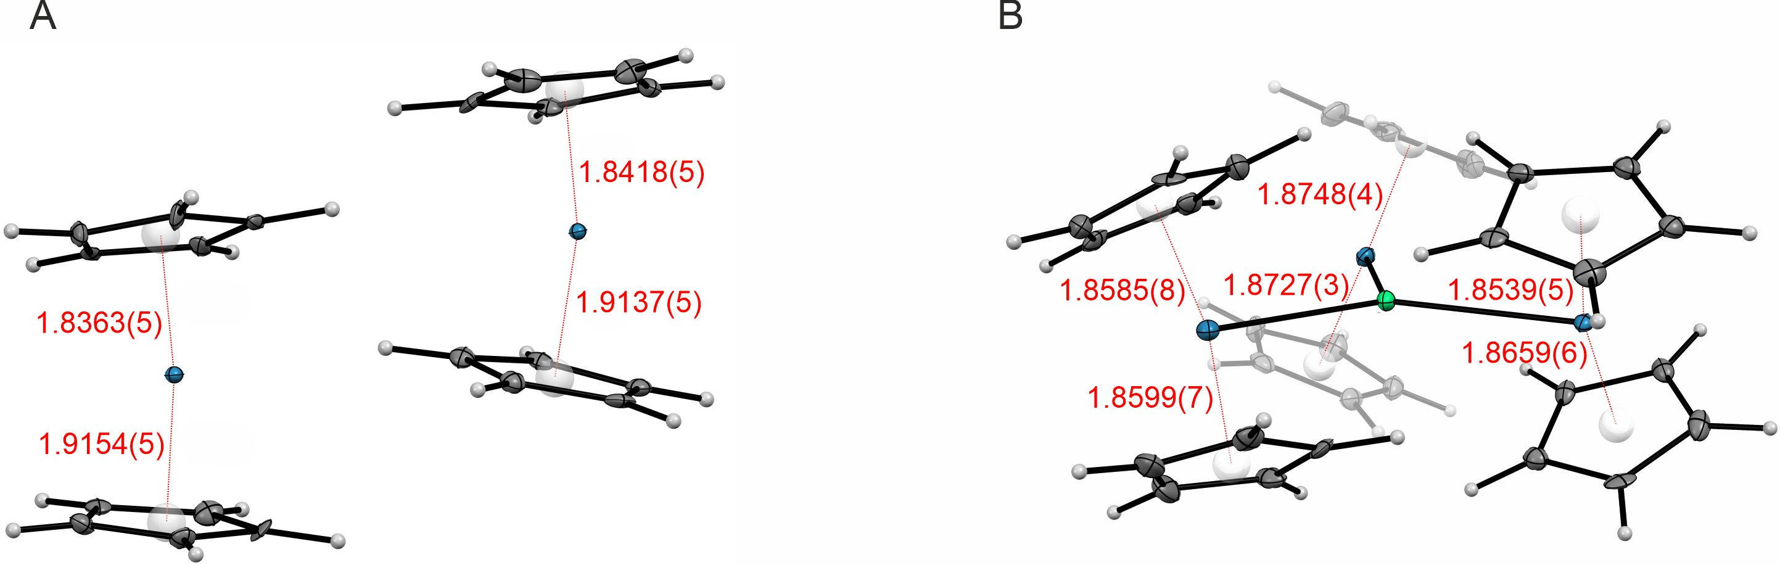

Figure S1. Structural diagrams showing the asymmetric units (ASUs) of the starting material [Cp₂ReH] (A) and the target compound ErRe₃ (B). The red numbers indicate the distances (Å) between the Re atoms and the centroids of the cyclopentadienyl rings. C – grey, H – light grey, Re – blue, Er – green, centroids – white; ellipsoids at the 40 % probability level for A and 30% for B.

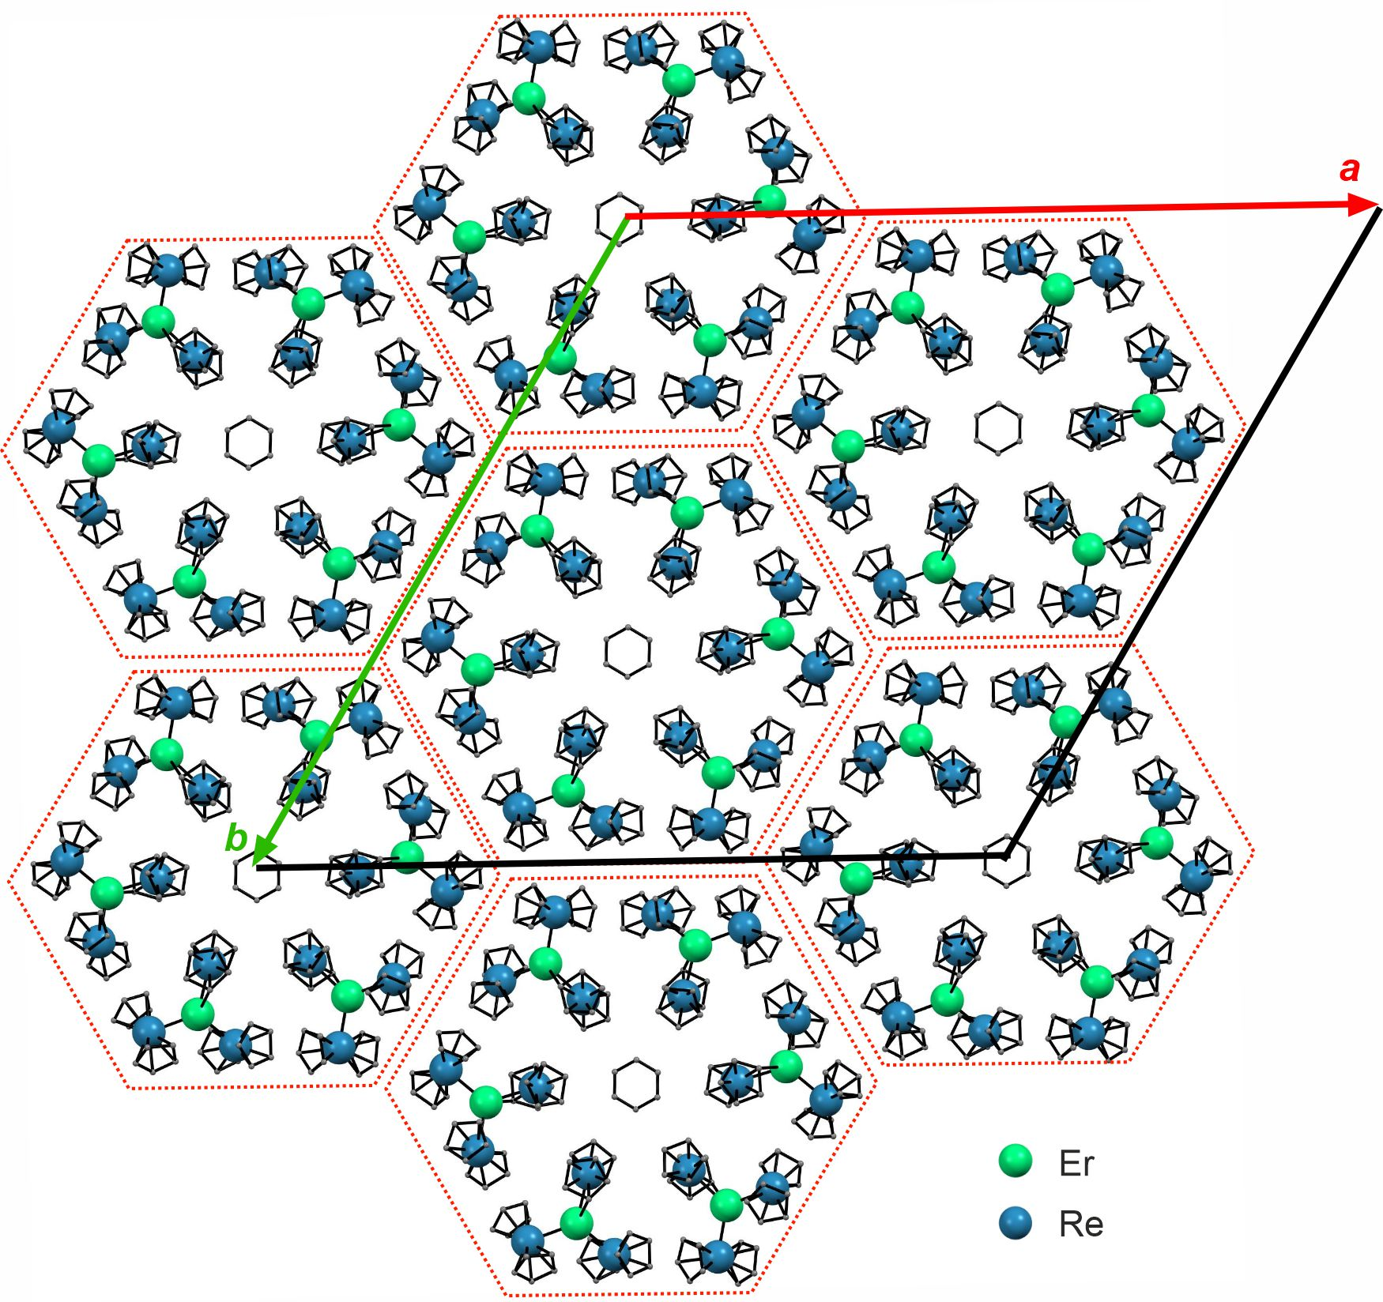
Figure S2. Structural diagram of ErRe₃ as viewed along the c crystallographic direction showing the hexagonal packing pattern of the [Er^{III}(Re^{I}Cp₂)₃] molecules highlighted by red dotted hexagons. This type of packing leads to the formation of channels along the c axis filled with benzene molecules (crystallization solvent). Cyclopentadienyl ligands and benzene molecules are represented by black sticks and H-atoms are omitted for clarity.

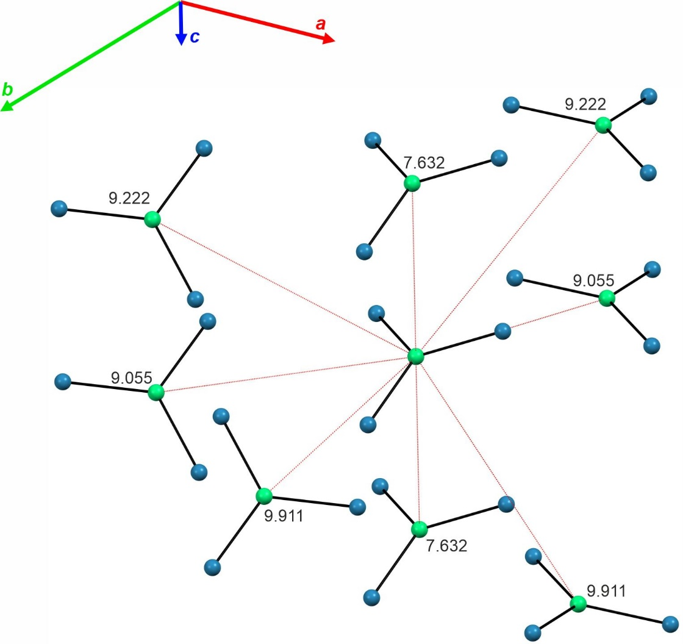
Figure S3. Structural diagram demonstrating and listing Er⋅⋅⋅Er distances between all ErRe₃ nearest neighbours. The shortest distance is 7.6318(6) Å along the c crystallographic direction.

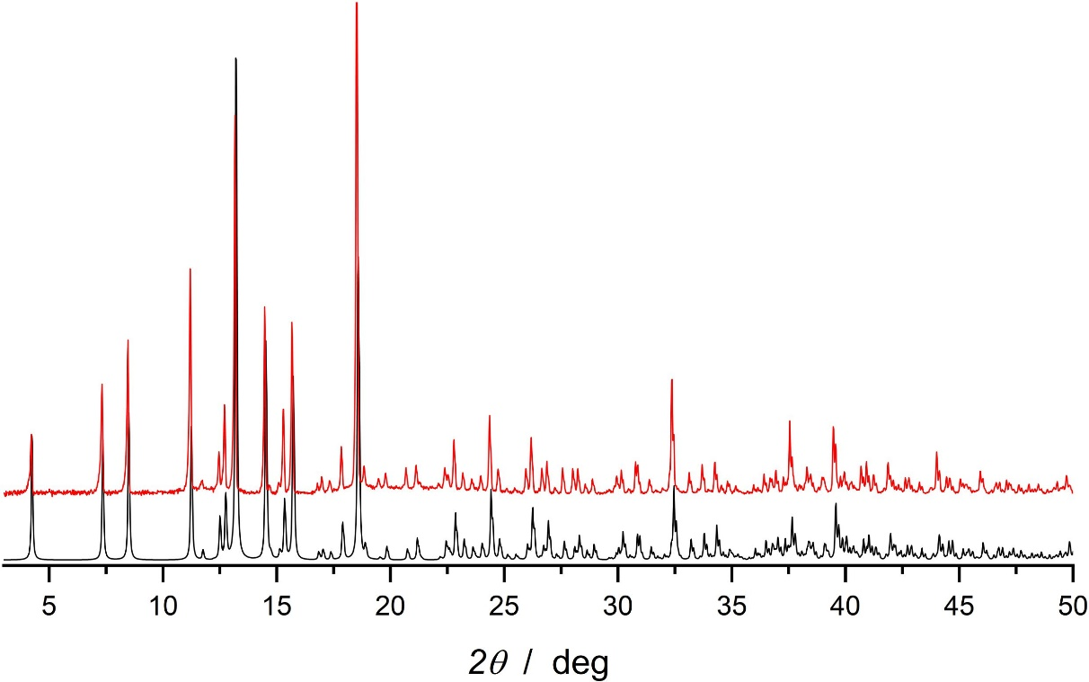
Figure S4. Experimental (red line) and simulated (black line) powder X-ray diffraction experiments for ErRe₃. The simulated pattern is calculated based on the 270 K single crystal X-ray diffraction structural model and includes the contribution of the Cu Kβ which is observed in the experimental pattern.

Figure S5. Temperature dependence of the molar magnetic susceptibility and temperature product χT(T) for ErRe₃ recorded at μ₀H = 0.1 T (black points). The solid red line presents the χT(T) obtained from the ab initio calculations (see text for details). The observed anomaly below 20 K is caused by the magnetization blocking and the ferromagnetic interactions between the neighbouring ErRe₃ molecules.
Table S2. Results of the generalized Debye model fitting of the frequency dependence of the AC magnetic susceptibility χ' and χ'' for ErRe₃ recorded at zero magnetic field in the 5.5 – 27 K range presented in Figure 2C (main text).
T / K | χ_{S} / cm³ mol⁻¹ | χ_{S} error | χ_{T} / cm³ mol⁻¹ | χ_{T} error | τ / s | τ error | α | α error | R²
2.4 | 1.277 | 0.050 | 4.601 | 0.019 | 0.00584 | 1.6E-4 | 0.206 | 0.012 | 0.99963
2.7 | 1.195 | 0.049 | 4.186 | 0.018 | 0.00576 | 1.7E-4 | 0.202 | 0.013 | 0.99958
3.0 | 1.023 | 0.044 | 3.803 | 0.018 | 0.00533 | 1.6E-4 | 0.218 | 0.013 | 0.99946
3.5 | 0.987 | 0.036 | 3.669 | 0.015 | 0.00493 | 1.2E-4 | 0.208 | 0.011 | 0.99961
4.0 | 0.845 | 0.046 | 3.346 | 0.023 | 0.00496 | 1.8E-4 | 0.240 | 0.016 | 0.99904
4.5 | 0.764 | 0.039 | 2.937 | 0.018 | 0.00469 | 1.6E-4 | 0.234 | 0.015 | 0.99917
5.0 | 0.703 | 0.032 | 2.612 | 0.014 | 0.00442 | 1.4E-4 | 0.225 | 0.014 | 0.99932
5.5 | 0.653 | 0.029 | 2.361 | 0.012 | 0.00419 | 1.3E-4 | 0.217 | 0.014 | 0.99937
6.0 | 0.616 | 0.026 | 2.161 | 0.011 | 0.00398 | 1.2E-4 | 0.206 | 0.014 | 0.99941
6.5 | 0.513 | 0.019 | 1.816 | 0.008 | 0.00323 | 8.5E-5 | 0.191 | 0.012 | 0.99947
7.0 | 0.489 | 0.017 | 1.680 | 0.007 | 0.00296 | 7.3E-5 | 0.172 | 0.012 | 0.99954
7.5 | 0.464 | 0.015 | 1.556 | 0.005 | 0.00267 | 6.2E-5 | 0.153 | 0.011 | 0.99962
8.0 | 0.420 | 0.013 | 1.454 | 0.005 | 0.00231 | 5.0E-5 | 0.146 | 0.010 | 0.99958
8.5 | 0.397 | 0.011 | 1.364 | 0.003 | 0.00206 | 4.0E-5 | 0.130 | 0.009 | 0.99970
9.0 | 0.363 | 0.010 | 1.287 | 0.003 | 0.00178 | 3.1E-5 | 0.124 | 0.008 | 0.99970
9.5 | 0.343 | 0.009 | 1.220 | 0.003 | 0.00158 | 2.7E-5 | 0.114 | 0.008 | 0.99975
10.0 | 0.317 | 0.007 | 1.160 | 0.002 | 0.00137 | 2.0E-5 | 0.108 | 0.007 | 0.99977
10.5 | 0.289 | 0.009 | 1.051 | 0.005 | 0.0012 | 2.1E-5 | 0.083 | 0.011 | 0.99936
11.0 | 0.278 | 0.010 | 0.985 | 0.005 | 0.00103 | 2.1E-5 | 0.059 | 0.013 | 0.99900
11.5 | 0.265 | 0.009 | 0.946 | 0.005 | 9.13E-4 | 1.7E-5 | 0.052 | 0.012 | 0.99914
12.0 | 0.237 | 0.006 | 0.913 | 0.003 | 7.89E-4 | 1.0E-5 | 0.072 | 0.008 | 0.99949
12.5 | 0.218 | 0.008 | 0.881 | 0.004 | 7.12E-4 | 1.4E-5 | 0.081 | 0.012 | 0.99879
13.0 | 0.216 | 0.007 | 0.835 | 0.004 | 6.14E-4 | 1.0E-5 | 0.055 | 0.011 | 0.99904
13.5 | 0.203 | 0.008 | 0.815 | 0.004 | 5.54E-4 | 1.1E-5 | 0.060 | 0.012 | 0.99892
14.0 | 0.205 | 0.007 | 0.778 | 0.003 | 4.97E-4 | 8.3E-6 | 0.031 | 0.011 | 0.99919
14.5 | 0.194 | 0.007 | 0.751 | 0.003 | 4.43E-4 | 8.0E-6 | 0.033 | 0.011 | 0.99923
15.0 | 0.183 | 0.007 | 0.729 | 0.003 | 3.98E-4 | 7.4E-6 | 0.036 | 0.011 | 0.99910
15.5 | 0.170 | 0.006 | 0.703 | 0.003 | 3.49E-4 | 6.0E-6 | 0.038 | 0.011 | 0.99894
16.0 | 0.160 | 0.004 | 0.691 | 0.002 | 3.16E-4 | 4.3E-6 | 0.052 | 0.008 | 0.99931
16.5 | 0.156 | 0.004 | 0.666 | 0.002 | 2.83E-4 | 3.2E-6 | 0.040 | 0.007 | 0.99950
17.0 | 0.151 | 0.003 | 0.647 | 0.002 | 2.55E-4 | 2.6E-6 | 0.038 | 0.006 | 0.99962
17.5 | 0.149 | 0.003 | 0.627 | 0.002 | 2.31E-4 | 2.5E-6 | 0.025 | 0.007 | 0.99960
18.0 | 0.140 | 0.004 | 0.608 | 0.002 | 2.05E-4 | 2.8E-6 | 0.031 | 0.008 | 0.99935
18.5 | 0.138 | 0.003 | 0.593 | 0.001 | 1.86E-4 | 1.9E-6 | 0.023 | 0.006 | 0.99966
19.0 | 0.131 | 0.002 | 0.577 | 0.001 | 1.64E-4 | 1.3E-6 | 0.025 | 0.005 | 0.99966
19.5 | 0.126 | 0.002 | 0.565 | 0.001 | 1.47E-4 | 1.2E-6 | 0.027 | 0.005 | 0.99971
20.0 | 0.121 | 0.002 | 0.551 | 0.001 | 1.30E-4 | 8.8E-7 | 0.028 | 0.004 | 0.99974
20.5 | 0.120 | 0.002 | 0.534 | 0.001 | 1.16E-4 | 1.2E-6 | 0.014 | 0.007 | 0.99944
21.0 | 0.115 | 0.002 | 0.525 | 0.001 | 1.03E-4 | 7.4E-7 | 0.022 | 0.005 | 0.99974
21.5 | 0.114 | 0.002 | 0.511 | 0.001 | 9.04E-5 | 8.4E-7 | 0.013 | 0.006 | 0.99961
22.0 | 0.112 | 0.004 | 0.498 | 0.001 | 8.0E-5 | 1.2E-6 | 0.007 | 0.009 | 0.99907
22.5 | 0.110 | 0.004 | 0.488 | 0.001 | 7.04E-5 | 1.0E-6 | 0.005 | 0.009 | 0.99914
23.0 | 0.106 | 0.002 | 0.480 | 0.001 | 6.17E-5 | 4.8E-7 | 0.011 | 0.005 | 0.99978
23.5 | 0.102 | 0.005 | 0.471 | 0.001 | 5.41E-5 | 9.6E-7 | 0.013 | 0.011 | 0.99906
24.0 | 0.102 | 0.003 | 0.460 | 0.001 | 4.71E-5 | 5.6E-7 | 0.004 | 0.007 | 0.99961
24.5 | 0.100 | 0.006 | 0.449 | 0.001 | 4.07E-5 | 8.7E-7 | 0.000 | 0.012 | 0.99898
25.0 | 0.099 | 0.006 | 0.441 | 0.001 | 3.54E-5 | 7.9E-7 | 0.000 | 0.012 | 0.99910
25.5 | 0.097 | 0.006 | 0.435 | 0.001 | 3.08E-5 | 7.2E-7 | 0.004 | 0.012 | 0.99926
26.0 | 0.096 | 0.007 | 0.425 | 0.001 | 2.64E-5 | 7.5E-7 | 0.000 | 0.014 | 0.99917
26.5 | 0.094 | 0.008 | 0.418 | 0.001 | 2.27E-5 | 6.7E-7 | 0.000 | 0.013 | 0.99938
27.0 | 0.093 | 0.008 | 0.411 | 0.001 | 1.96E-5 | 6.0E-7 | 0.000 | 0.012 | 0.99955

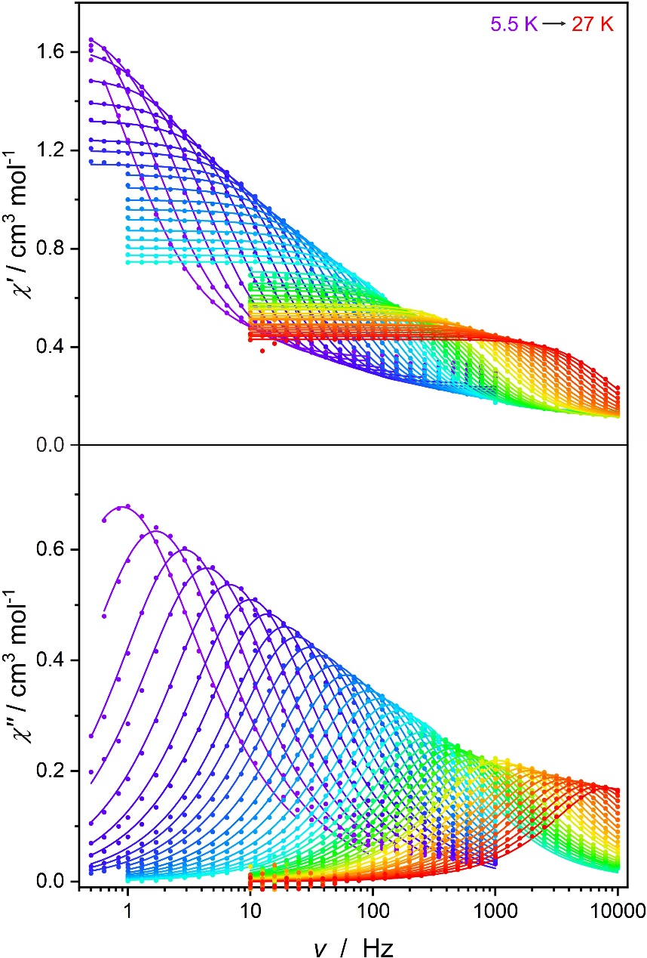
Figure S6. Frequency dependence of the AC magnetic susceptibility χ' and χ'' for ErRe₃ recorded at H_{DC} = 0.15 T in the 5.5 – 27 K range using Quantum Design MPMS3 and PPMS instruments. Solid lines are the best fits to the generalized Debye model. The relevant fitting parameters can be found in Table S3 below.

Table S3. Results of the generalized Debye model fitting of the frequency dependence of the AC magnetic susceptibility χ' and χ'' for ErRe₃ recorded at H_{DC} = 0.15 T in the 5.5 – 27 K range presented in Figure S6.
T / K | χ_{S} / cm³ mol⁻¹ | χ_{S} error | χ_{T} / cm³ mol⁻¹ | χ_{T} error | τ / s | τ error | α | α error | R²
5.5 | 0.382 | 0.004 | 2.201 | 0.019 | 0.1769 | 0.0033 | 0.185 | 0.006 | 0.99954
6.0 | 0.348 | 0.004 | 1.949 | 0.013 | 0.0943 | 0.0013 | 0.148 | 0.006 | 0.99935
6.5 | 0.330 | 0.004 | 1.749 | 0.007 | 0.0549 | 5.1E-4 | 0.106 | 0.005 | 0.99950
7.0 | 0.302 | 0.004 | 1.644 | 0.005 | 0.0362 | 3.1E-4 | 0.107 | 0.005 | 0.99959
7.5 | 0.287 | 0.003 | 1.507 | 0.003 | 0.0235 | 1.5E-4 | 0.081 | 0.004 | 0.99976
8.0 | 0.269 | 0.003 | 1.403 | 0.003 | 0.0160 | 1.1E-4 | 0.068 | 0.004 | 0.99973
8.5 | 0.250 | 0.003 | 1.325 | 0.003 | 0.01151 | 7.9E-5 | 0.067 | 0.004 | 0.99971
9.0 | 0.235 | 0.003 | 1.244 | 0.003 | 0.00831 | 6.5E-5 | 0.058 | 0.005 | 0.99961
9.5 | 0.224 | 0.002 | 1.200 | 0.002 | 0.00663 | 4.7E-5 | 0.063 | 0.004 | 0.99970
10.0 | 0.214 | 0.002 | 1.145 | 0.002 | 0.00517 | 3.5E-5 | 0.060 | 0.004 | 0.99974
10.5 | 0.206 | 0.002 | 1.103 | 0.002 | 0.00423 | 2.5E-5 | 0.060 | 0.004 | 0.99979
11.0 | 0.198 | 0.002 | 1.050 | 0.002 | 0.00331 | 1.9E-5 | 0.055 | 0.004 | 0.99981
11.5 | 0.190 | 0.002 | 0.999 | 0.001 | 0.00261 | 1.3E-5 | 0.051 | 0.003 | 0.99987
12.0 | 0.184 | 0.002 | 0.959 | 0.001 | 0.00214 | 1.0E-5 | 0.048 | 0.003 | 0.99989
12.5 | 0.177 | 0.002 | 0.918 | 0.001 | 0.00174 | 8.0E-6 | 0.046 | 0.003 | 0.99990
13.0 | 0.171 | 0.002 | 0.874 | 0.001 | 0.00140 | 6.4E-6 | 0.038 | 0.003 | 0.99991
13.5 | 0.167 | 0.002 | 0.834 | 0.001 | 0.00116 | 5.3E-6 | 0.030 | 0.003 | 0.99991
14.0 | 0.164 | 0.002 | 0.802 | 0.001 | 9.81E-4 | 4.4E-6 | 0.021 | 0.003 | 0.99992
14.5 | 0.161 | 0.002 | 0.773 | 0.001 | 8.42E-4 | 3.7E-6 | 0.014 | 0.003 | 0.99993
15.0 | 0.157 | 0.002 | 0.747 | 0.001 | 7.25E-4 | 3.4E-6 | 0.010 | 0.003 | 0.99992
15.5 | 0.139 | 0.002 | 0.708 | 0.002 | 6.19E-4 | 5.5E-6 | 0.032 | 0.006 | 0.99935
16.0 | 0.136 | 0.002 | 0.686 | 0.002 | 5.35E-4 | 5.0E-6 | 0.027 | 0.006 | 0.99929
16.5 | 0.134 | 0.002 | 0.660 | 0.002 | 4.59E-4 | 4.5E-6 | 0.019 | 0.006 | 0.99923
17.0 | 0.129 | 0.002 | 0.646 | 0.003 | 4.05E-4 | 3.6E-6 | 0.029 | 0.006 | 0.99942
17.5 | 0.125 | 0.002 | 0.631 | 0.003 | 3.53E-4 | 3.0E-6 | 0.031 | 0.005 | 0.99949
18.0 | 0.123 | 0.002 | 0.610 | 0.003 | 3.06E-4 | 3.2E-6 | 0.023 | 0.007 | 0.99920
18.5 | 0.120 | 0.002 | 0.595 | 0.002 | 2.68E-4 | 2.7E-6 | 0.024 | 0.006 | 0.99929
19.0 | 0.117 | 0.003 | 0.578 | 0.002 | 2.32E-4 | 3.2E-6 | 0.020 | 0.009 | 0.99877
19.5 | 0.114 | 0.002 | 0.567 | 0.002 | 2.03E-4 | 2.1E-6 | 0.024 | 0.007 | 0.99930
20.0 | 0.110 | 0.002 | 0.553 | 0.001 | 1.77E-4 | 1.7E-6 | 0.027 | 0.006 | 0.99947
20.5 | 0.114 | 0.003 | 0.574 | 0.002 | 1.54E-4 | 1.9E-6 | 0.031 | 0.008 | 0.99914
21.0 | 0.112 | 0.003 | 0.557 | 0.002 | 1.31E-4 | 1.5E-6 | 0.025 | 0.007 | 0.99926
21.5 | 0.112 | 0.005 | 0.537 | 0.002 | 1.11E-4 | 2.2E-6 | 0.008 | 0.013 | 0.99790
22.0 | 0.108 | 0.005 | 0.527 | 0.002 | 9.53E-5 | 1.7E-6 | 0.012 | 0.011 | 0.99845
22.5 | 0.106 | 0.004 | 0.516 | 0.002 | 8.21E-5 | 1.2E-6 | 0.013 | 0.009 | 0.99908
23.0 | 0.102 | 0.004 | 0.511 | 0.001 | 7.11E-5 | 1.0E-6 | 0.025 | 0.009 | 0.99923
23.5 | 0.102 | 0.007 | 0.493 | 0.002 | 5.99E-5 | 1.7E-6 | 0.008 | 0.017 | 0.99729
24.0 | 0.098 | 0.004 | 0.489 | 0.001 | 5.17E-5 | 7.0E-7 | 0.022 | 0.008 | 0.99949
24.5 | 0.094 | 0.005 | 0.480 | 0.001 | 4.35E-5 | 8.1E-7 | 0.027 | 0.010 | 0.99923
25.0 | 0.094 | 0.007 | 0.470 | 0.002 | 3.70E-5 | 9.9E-7 | 0.022 | 0.014 | 0.99875
25.5 | 0.093 | 0.008 | 0.460 | 0.001 | 3.16E-5 | 8.9E-7 | 0.016 | 0.014 | 0.99892
26.0 | 0.092 | 0.008 | 0.451 | 0.001 | 2.67E-5 | 8.0E-7 | 0.016 | 0.014 | 0.99912
26.5 | 0.089 | 0.011 | 0.443 | 0.001 | 2.26E-5 | 8.8E-7 | 0.017 | 0.016 | 0.99899
27.0 | 0.092 | 0.017 | 0.431 | 0.002 | 1.95E-5 | 1.2E-6 | 0.000 | 0.025 | 0.99802

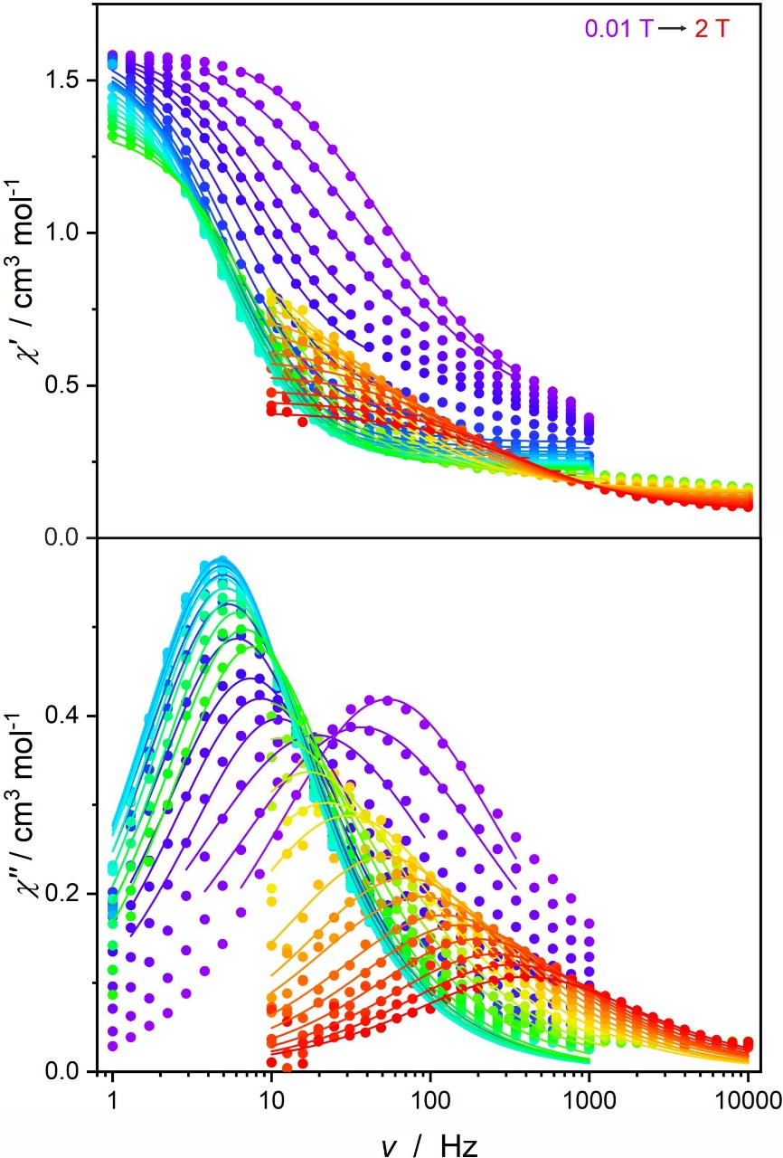
Figure S7. Frequency dependence of the AC magnetic susceptibility χ' and χ'' for ErRe₃ recorded at T = 7 K in the 0.01 – 2 T range using Quantum Design MPMS3 and PPMS instruments. Solid lines are the best fits to the generalized Debye model. The relevant fitting parameters can be found in Table S4 below.

Table S4. Results of the generalized Debye model fitting of the frequency dependence of the AC magnetic susceptibility χ' and χ'' for ErRe₃ recorded at T = 7 K in the 0.01 – 2 T range presented in Figure S6.
H / T | χ_{S} / cm³ mol⁻¹ | χ_{S} error | χ_{T} / cm³ mol⁻¹ | χ_{T} error | τ / s | τ error | α | α error | R²
0.01 | 0.371 | 0.014 | 1.677 | 0.013 | 0.00295 | 7.1E-5 | 0.274 | 0.012 | 0.99924
0.02 | 0.352 | 0.013 | 1.700 | 0.013 | 0.00433 | 1.1E-4 | 0.336 | 0.012 | 0.99931
0.03 | 0.442 | 0.019 | 1.700 | 0.017 | 0.00828 | 2.6E-4 | 0.311 | 0.016 | 0.99933
0.04 | 0.583 | 0.018 | 1.628 | 0.010 | 0.01433 | 4.1E-4 | 0.173 | 0.016 | 0.99942
0.05 | 0.559 | 0.014 | 1.630 | 0.010 | 0.01855 | 4.1E-4 | 0.154 | 0.014 | 0.99939
0.06 | 0.517 | 0.012 | 1.630 | 0.012 | 0.02158 | 4.3E-4 | 0.145 | 0.013 | 0.99916
0.08 | 0.442 | 0.008 | 1.624 | 0.011 | 0.02617 | 4.2E-4 | 0.123 | 0.010 | 0.99914
0.10 | 0.374 | 0.008 | 1.636 | 0.013 | 0.02972 | 5.6E-4 | 0.115 | 0.011 | 0.99835
0.12 | 0.313 | 0.006 | 1.625 | 0.017 | 0.03095 | 7.5E-4 | 0.119 | 0.012 | 0.99673
0.14 | 0.294 | 0.006 | 1.606 | 0.016 | 0.03208 | 7.1E-4 | 0.102 | 0.012 | 0.99696
0.16 | 0.281 | 0.006 | 1.598 | 0.016 | 0.03283 | 7.0E-4 | 0.093 | 0.011 | 0.99700
0.18 | 0.273 | 0.006 | 1.588 | 0.017 | 0.03329 | 7.3E-4 | 0.086 | 0.012 | 0.99670
0.20 | 0.266 | 0.006 | 1.579 | 0.017 | 0.03332 | 7.4E-4 | 0.082 | 0.012 | 0.99647
0.25 | 0.254 | 0.004 | 1.560 | 0.011 | 0.03379 | 4.9E-4 | 0.083 | 0.008 | 0.99849
0.30 | 0.247 | 0.004 | 1.538 | 0.010 | 0.03303 | 4.4E-4 | 0.085 | 0.007 | 0.99875
0.35 | 0.243 | 0.004 | 1.515 | 0.010 | 0.03268 | 4.3E-4 | 0.086 | 0.007 | 0.99875
0.40 | 0.239 | 0.004 | 1.486 | 0.010 | 0.03076 | 4.6E-4 | 0.087 | 0.008 | 0.99841
0.45 | 0.235 | 0.004 | 1.454 | 0.011 | 0.02849 | 4.5E-4 | 0.089 | 0.009 | 0.99818
0.50 | 0.231 | 0.005 | 1.425 | 0.011 | 0.02604 | 4.4E-4 | 0.092 | 0.009 | 0.99802
0.55 | 0.227 | 0.005 | 1.391 | 0.011 | 0.02350 | 4.2E-4 | 0.099 | 0.010 | 0.99782
0.60 | 0.222 | 0.005 | 1.355 | 0.011 | 0.02073 | 3.9E-4 | 0.108 | 0.010 | 0.99765
0.70 | 0.205 | 0.003 | 1.275 | 0.032 | 0.01686 | 8.6E-4 | 0.160 | 0.013 | 0.99699
0.80 | 0.188 | 0.004 | 1.242 | 0.029 | 0.01419 | 7.2E-4 | 0.213 | 0.013 | 0.99725
0.90 | 0.183 | 0.003 | 1.119 | 0.016 | 0.00927 | 3.0E-4 | 0.205 | 0.010 | 0.99817
1.00 | 0.170 | 0.002 | 1.057 | 0.010 | 0.00710 | 1.5E-4 | 0.239 | 0.006 | 0.99935
1.10 | 0.154 | 0.004 | 1.004 | 0.018 | 0.00527 | 2.4E-4 | 0.242 | 0.015 | 0.99480
1.20 | 0.149 | 0.003 | 0.847 | 0.008 | 0.00310 | 7.8E-5 | 0.229 | 0.010 | 0.99785
1.30 | 0.142 | 0.003 | 0.769 | 0.007 | 0.00227 | 5.3E-5 | 0.227 | 0.010 | 0.99800
1.40 | 0.132 | 0.003 | 0.717 | 0.005 | 0.00182 | 3.9E-5 | 0.246 | 0.009 | 0.99842
1.50 | 0.124 | 0.002 | 0.644 | 0.004 | 0.00132 | 2.6E-5 | 0.243 | 0.009 | 0.99863
1.60 | 0.119 | 0.003 | 0.597 | 0.005 | 0.00103 | 2.6E-5 | 0.230 | 0.012 | 0.99763
1.70 | 0.113 | 0.004 | 0.543 | 0.005 | 8.03E-4 | 2.5E-5 | 0.228 | 0.014 | 0.99670
1.80 | 0.104 | 0.004 | 0.493 | 0.004 | 6.29E-4 | 2.1E-5 | 0.239 | 0.015 | 0.99656
1.90 | 0.095 | 0.004 | 0.454 | 0.004 | 4.90E-4 | 1.7E-5 | 0.248 | 0.015 | 0.99668
2.00 | 0.085 | 0.004 | 0.417 | 0.003 | 4.01E-4 | 1.4E-5 | 0.272 | 0.015 | 0.99704

Table S5. The employed basis sets for ab initio calculations.
Basis set 1 | Basis set 2
Er.ANO-RCC-VDZP  Re.ANO-RCC-VDZ  C.ANO-RCC-VDZ  H.ANO-RCC-VDZ | Er.ANO-RCC-VTZP  Re.ANO-RCC-VDZP  C.ANO-RCC-VDZP  H.ANO-RCC-VDZ

Table S6. Spin-orbit energies (cm⁻¹) and the g-tensors of the lowest in energy Kramers doublets.
Multiplet |  | Basis set 1 | Basis set 2
1  2  3  4  5  6  7  8 |  | 0  0  155.3678  155.3678  252.3421  252.3421  330.1533  330.1533  400.1957  400.1957  482.2936  482.2936  536.0058  536.0058  567.7605  567.7605 | 0  0  154.0022  154.0022  251.7256  251.7256  330.4627  330.4627  400.5357  400.5357  484.0622  484.0622  536.8215  536.8215  568.1037  568.1037
Multiplet
1 | g_{x}=  g_{y}=  g_{z}= | 0.000174  0.000394  17.905279 | 0.000254  0.000486  17.905174
2 | g_{x}=  g_{y}=  g_{z}= | 0.044452  0.045268  15.501484 | 0.050255  0.051285  15.500554
3 | g_{x}=  g_{y}=  g_{z}= | 0.027204  0.095619  13.092686 | 0.020446  0.097873  13.089441
4 | g_{x}=  g_{y}=  g_{z}= | 0.165059  0.286776  10.589177 | 0.176105  0.296341  10.573533
5 | g_{x}=  g_{y}=  g_{z}= | 4.367102  4.803154  7.248873 | 4.578907  5.038692  7.139900

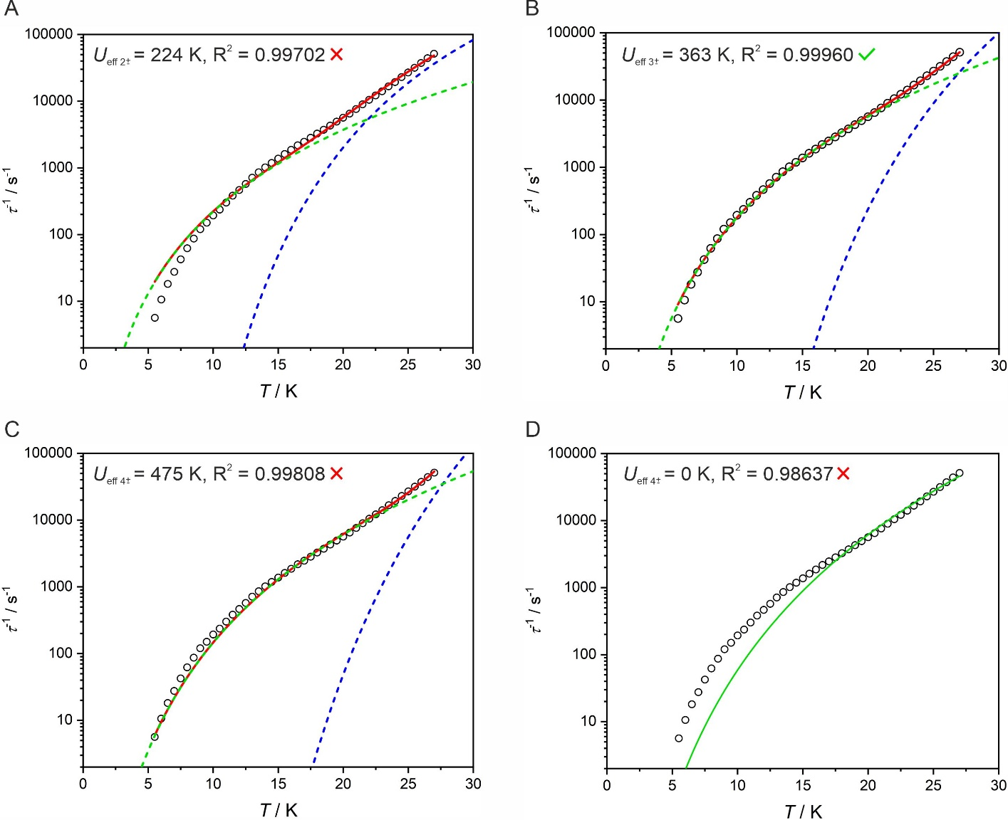
Figure S8. Temperature dependence of the magnetic relaxation rate τ⁻¹(T) for ErRe₃ under applied 0.15 T DC magnetic field (circles). Solid lines represent the best fits assuming Raman-like and Orbach relaxation processes with C, n, τ₀ as free parameters and U_{eff} fixed at 224 K (A), 363 K (B), 475 K (C) or Raman-like relaxation process only (D). Fitting presented in B shows highest R² and is assumed to provide the most accurate value of the energy barrier for magnetization reversal. Fitting assuming Raman-like relaxation only (D) shows the lowest R² which sanctions the need for including the Orbach mechanism.

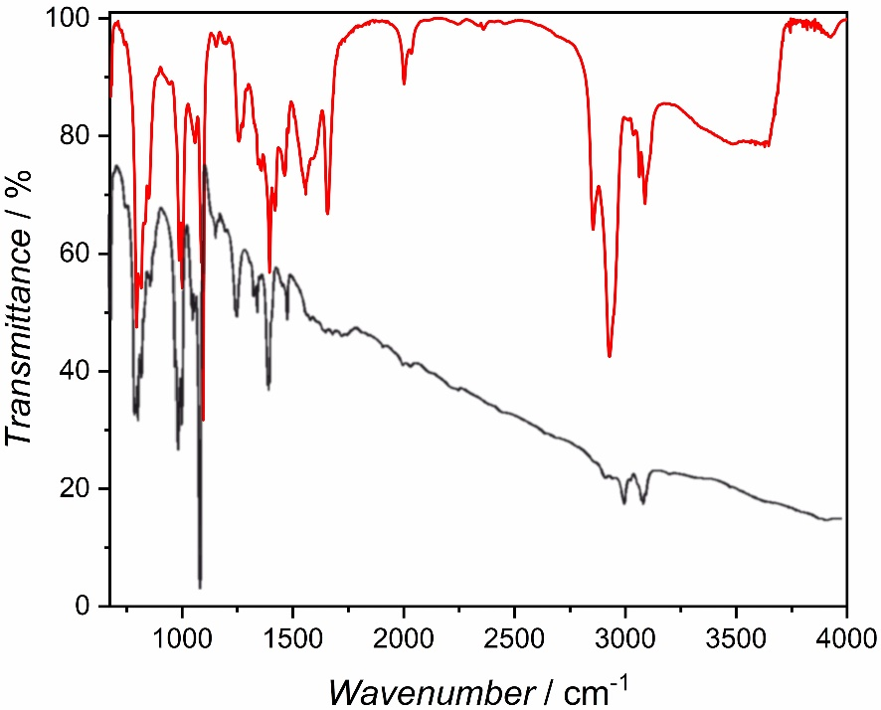
Figure S9. IR spectra of crushed crystals of ErRe₃ (red solid line) with the overlaid IR spectrum of SmRe₃ recorded as KBr pellet (black solid line) reproduced from ref. S13 in the 675-4000 cm⁻¹ range (the IR spectrum from Fig. S6 from the supplementary information of ref. S13 was traced using CorelDRAW 2019 software). Both spectra are very similar. Weak Re-H stretching modes at 2001 and 2034 cm⁻¹ observed for ErRe₃ are due to the slight decomposition of this extremely sensitive compound. Note, that these stretches are also present in the IR spectrum of SmRe₃, but are largely obstructed by a significant background reaching 40% transmittance at 2000 cm⁻¹ and nearly 15% transmittance at 4000 cm⁻¹.

List of references in the supplementary information
S1. M. L. H. Green, L. Pratt and G. Wilkinson. 795. Biscyclopentadienylrhenium hydride. Journal of the Chemical Society (Resumed), 1958, 3916-3922.
S2. A. G. Avent, C. F. Caro, P. B. Hitchcock, M. F. Lappert, Z. Li and X.-H. Wei. Synthetic and structural experiments on yttrium, cerium and magnesium trimethylsilylmethyls and their reaction products with nitriles; with a note on two cerium β-diketiminates. Dalton Transactions, 2004, DOI: 10.1039/B316695N, 1567-1577.
S3. H. Zhang, R. Nakanishi, K. Katoh, B. K. Breedlove, Y. Kitagawa and M. Yamashita. Low coordinated mononuclear erbium(iii) single-molecule magnets with C3v symmetry: a method for altering single-molecule magnet properties by incorporating hard and soft donors. Dalton Transactions, 2018, 47, 302-305.
S4. G. M. Sheldrick, Acta Crystallogr. C, 2015, 71, 3–8
S5. O. V Dolomanov, L. J. Bourhis, R. J. Gildea, J. A. K. Howard and H. Puschmann, J. Appl. Crystallogr., 2009, 42, 339–341
S6. M. Ren, D. Pinkowicz, M. Yoon, K. Kim, L.-M. Zheng, B. K. Breedlove, M. Yamashita. Dy(III) Single-Ion Magnet Showing Extreme Sensitivity to (De)hydration. Inorg. Chem., 2013, 52, 8342-8348.
S7. F. Aquilante, J. Autschbach, A. Baiardi, S. Battaglia, V. A. Borin, L. F. Chibotaru, I. Conti, L. D. Vico, M. Delcey, I. F. Galván, N. Ferré, L. Freitag, M. Garavelli, X. Gong, S. Knecht, E. D. Larsson, R. Lindh, M. Lundberg, P. Å. Malmqvist, A. Nenov, J. Norell, M. Odelius, M. Olivucci, T. B. Pedersen, L. Pedraza-González, Q. M. Phung, K. Pierloot, M. Reiher, I. Schapiro, J. Segarra-Martí, F. Segatta, L. Seijo, S. Sen, D.-C. Sergentu, C. J. Stein, L. Ungur, M. Vacher, A. Valentini and V. Veryazov. Modern quantum chemistry with [Open]Molcas. J. Chem. Phys., 2020, 152, 214117.
S8. B. O. Roos, P. R. Taylor, P. E. M. Sigbahn. A complete active space SCF method (CASSCF) using a density matrix formulated super-CI approach. Chem. Phys., 1980, 48, 157–173.
S9. P. Å. Malmqvist, B. O. Roos, B. Schimmelpfennig. The restricted active space (RAS) state interaction approach with spin–orbit coupling. Chem. Phys. Lett., 2002, 357, 230–240.
S10. L. F. Chibotaru, L. Ungur. Ab initio calculation of anisotropic magnetic properties of complexes. I. Unique definition of pseudospin Hamiltonians and their derivation. J. Chem. Phys., 2012, 137, 064112.
S11. L. Ungur, L. F. Chibotaru. in Lanthanides and actinides in molecular magnetism (eds. R. A. Layfield, M. Murugesu) 153–184 (Wiley-VCH Verlag GmbH & Co. KGaA, 2015).
S12. L. Ungur, M. Thewissen, J.-P. Costes, W. Wernsdorfer, L. F. Chibotaru. Interplay of strongly anisotropic metal ions in magnetic blocking of complexes. Inorg. Chem., 2013, 52, 6328–6337.
S13. M. V. Butovskii, C. Döring, V. Bezugly, F. R. Wagner, Y. Grin and R. Kempe. Molecules containing rare-earth atoms solely bonded by transition metals. Nature Chemistry, 2010, 2, 741-744

