Supplementary Information

Intensity and phase imaging through scattering media via deep despeckle complex neural networks
Shuai Liu^{1,*}, Peng Li^{1,*}, Hao Sha^{2,*}, Jiuyang Dong¹, Yue Huang¹, Yanjing Zhao⁴, Xuri Yao⁵, Wenzhen Zou², Yu Chen¹, Mingzhe Wang¹, Qin Peng⁴, Xiu Li¹, Xing Lin^{3,6,†}, Yongbing Zhang^{2,†}
¹Shenzhen International Graduate School, Tsinghua University, Shenzhen 518055, China
²School of Computer Science and Technology, Harbin Institute of Technology (Shenzhen), Shenzhen, Guangdong 518055, China
³Department of Electronic Engineering, Tsinghua University, Beijing 100084, China
⁴Institute of Systems and Physical Biology, Shenzhen Bay Laboratory, Shenzhen, Guangdong 518055, China
⁵Center for Quantum Technology Research, School of Physics, Beijing Institute of Technology, Beijing 100081, China
⁶Beijing National Research Center for Information Science and Technology, Tsinghua University, Beijing 100084, China
*Co-first author
†Correspondence: X.L. (lin-x@tsinghua.edu.cn), Y.Z. (ybzhang08@hit.edu.cn)

Experimental setup
We use a Spinning Disk Confocal microscope (Dragonfly 200, Andor) with a 40×/1.25NA objective for data acquisition of living cells (Hela). The living cells are placed in the Petri dish for observation, and the plastic shell of the Petri dish actually functions as the diffuser. Therefore, the laser (405nm, 50mW) will scatter twice by the upper and lower surfaces of the Petri dish. Additionally, we remove the reflector and switch the laser with LED to directly illuminate the samples to capture 1 in-focus and 4 out-of-focus images, which ensures the ground truth is aligned with the speckle image pixel-wisely.
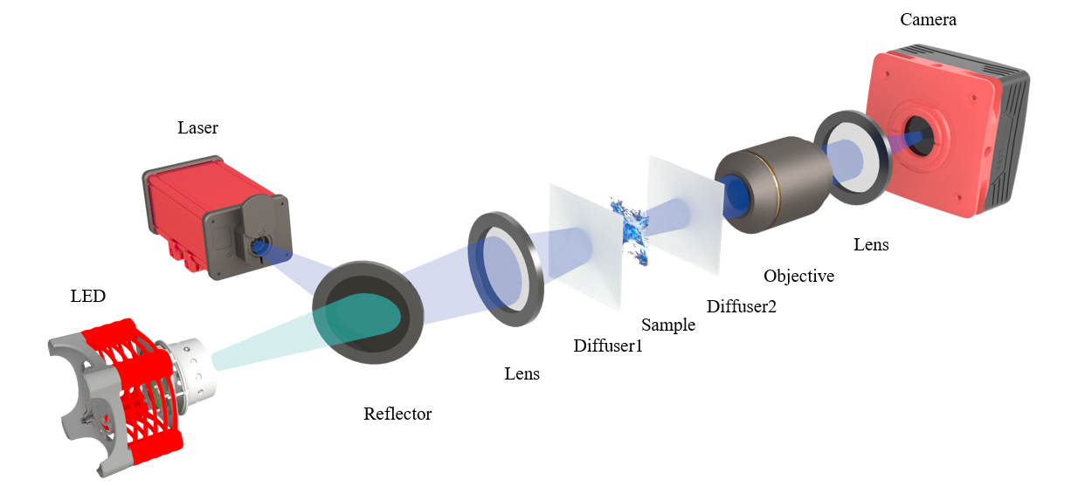
Figure S1. Experimental setup. For the speckle image acquisition, the sample is illuminated by the laser through diffusers to capture the sample speckle image. For the ground truth acquisition, the reflector is removed, and the LED illuminates the biological sample to capture the in-focus image and out-focus image.
The schematic diagram of the single scattering mode
We replace the sample and diffuser in the experimental optical path of Fig. S1, as shown in Fig. S2. The breast cancer cells, nasopharyngeal carcinoma cells, and breast cancer HER2 tissue are imaged through thin tape and tissue section, respectively. We use the microscope (BX43 OLYMPUS) with a 40×/0.65NA objective for cell sample imaging and a 20×/0.5NA for tissue sample imaging. A laser light source (405nm, 50mW) is employed to illuminate the samples through the diffuser.
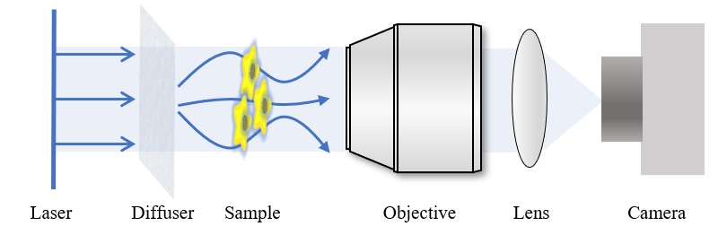
Figure S2. The schematic diagram of single scattering mode.

TIE algorithm
Teague¹ first proposed the transport of intensity equation (TIE) algorithm to describe the quantitative relationship between the intensity changes along the optical axis and the phase perpendicular to the plane of the optical axis. The TIE can be described as
$-k\frac{∂I}{∂z}=∇•\left[I\left(r\right)∇φ\left(r\right)\right]$, | (1)
where $k$ is the wave number, $I$ is the light intensity, $r$ is the position vector representing transverse spatial coordinates $(x,y)$, $∇$ is the gradient operator over $r$, and $φ\left(r\right)$ is the phase distribution. To solve the intensity transmission equation, the partial derivation of the intensity along the z-axis is required a priori, which cannot be measured directly. Instead, it can be approximated by numerical discrete difference as
$\frac{∂I\left(r\right)}{∂z}≈\frac{I\left(r,Δz\right)-I\left(r,-Δz\right)}{2Δz}$, | (2)
where $Δz$ is the out-of-focus distance. This solution is simple but introduces a nonlinear error². In the ideal case, the smaller the out-of-focus amount $Δz$ is, the higher the accuracy of the differential approximation would be, leading to the higher spatial resolution of the reconstructed phase. To avoid the complicated and time-consuming iterations of the TIE, we adopt the fast Fourier transform solution proposed by Allen³. It is sufficient for applications to samples whose phase obeys continuous distribution.

Optical thickness analysis based on phase information
Cell morphology and deformability have been widely studied in the analysis of biophysical phenomena. Especially in the study of cancer cells, the deformability of cancer cells appears to be strongly related to their metastatic potential. Quantitative phase recovery has the ability to reveal the optical morphology of cells, allowing observation of optical morphological changes in cells without invasive labeling. The quantitative phase microscopy works in the "transmission mode" (TM), where the light wave passes through the sample. In the TM, the optical thickness (OT)⁴ of the sample, which is represented by the differential phase $φ$, can be calculated through:
$OT=\int{Δn\left(z\right)}dz=\frac{λ_{c}}{2π}⋅\frac{φ}{2}$, | (3)
where $Δn\left(z\right)$ is the relative refractive index along the z-axis and $λ_{c}$ is the center wavelength of the light source.
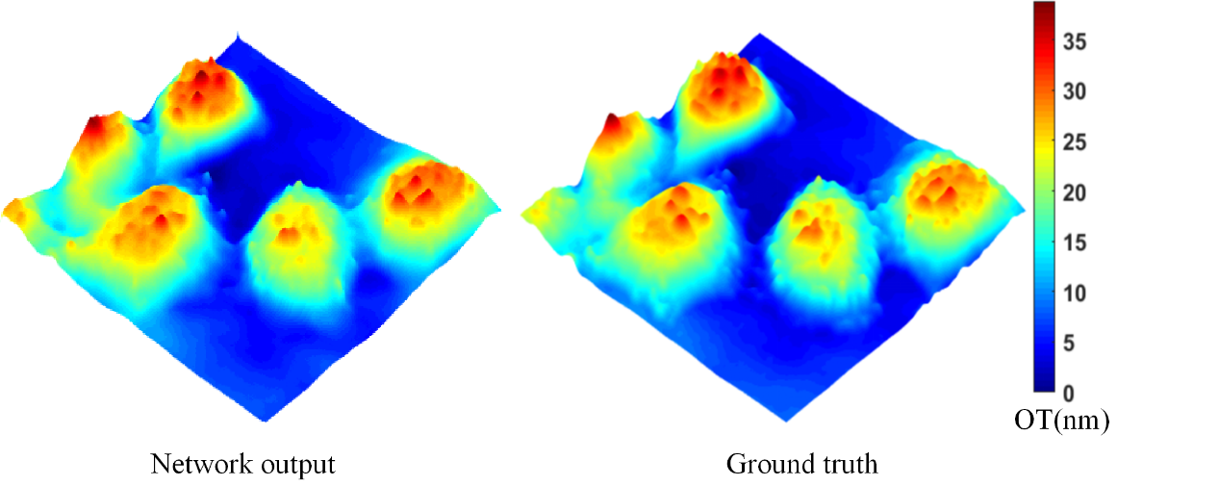
Figure S3. Comparison of OT distribution of Hela cells between our model and ground truth.
Figure S3 shows the optical thickness of Hela cells in 3D pseudo-color calculated from the recovered phase by our network and the ground truth by the TIE algorithm. The shape of the cells and the relative positions of the different cells can be roughly observed, and our network output is highly consistent with the ground truth. Furthermore, we use the quantitative phase information to calculate the OT of living Hela cells. Fig. S4 shows a pseudo-color 3D rendering result, which has high-quality and high-contrast cellular morphological features. We can observe the morphological changes of Hela cells during division.

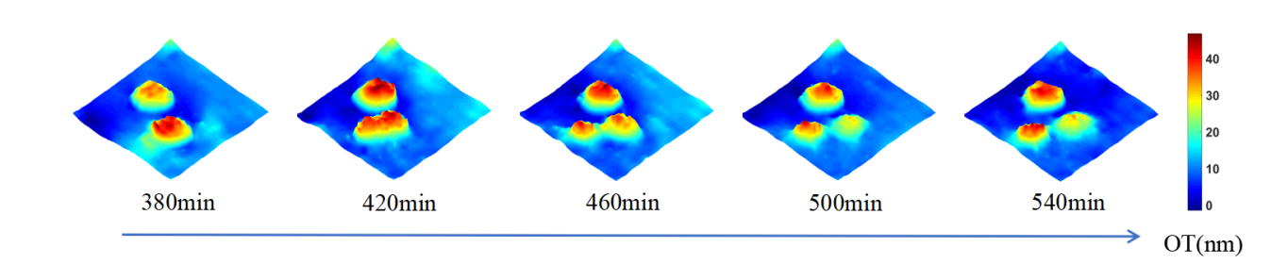
Figure S4. The optic thickness reconstruction of the living Hela dividing process.

Performance comparison among different networks over Hela cell data
We made comparison experiments with different despeckle networks proposed by previous researchers. Three different networks are trained on the same Hela cell dataset, including DespeckleNet, UNet⁵, and IDiffNet⁶. Notably, the UNet and IDiffNet only output the intensity reconstruction result. To facilitate the comparison of phase recovery, we add phase channels to the outputs of the UNet and IDiffNet, without changing the structure of the networks. Fig. S5 shows the phase and intensity reconstruction results for two different cellular speckle images. It can be observed that our network outputs the recovery with high quality, while the other two networks fail to reconstruct the cellular morphology.
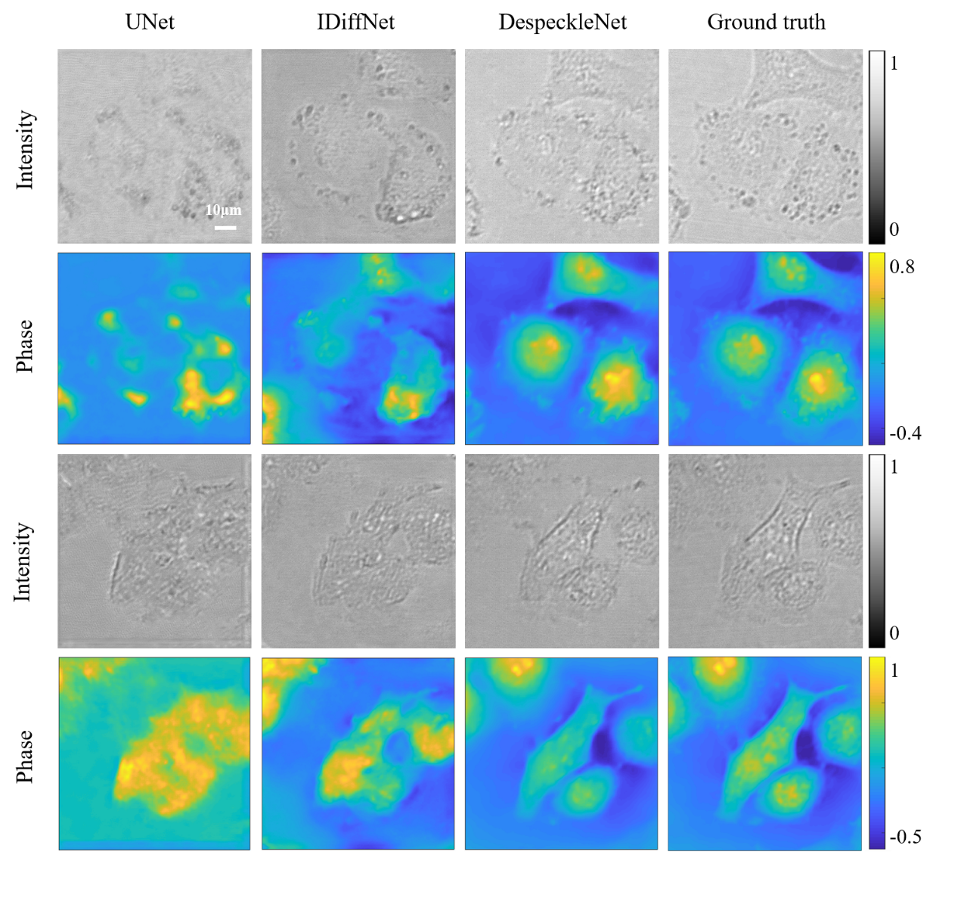
Figure S5. The visual comparison among different networks over Hela cells.
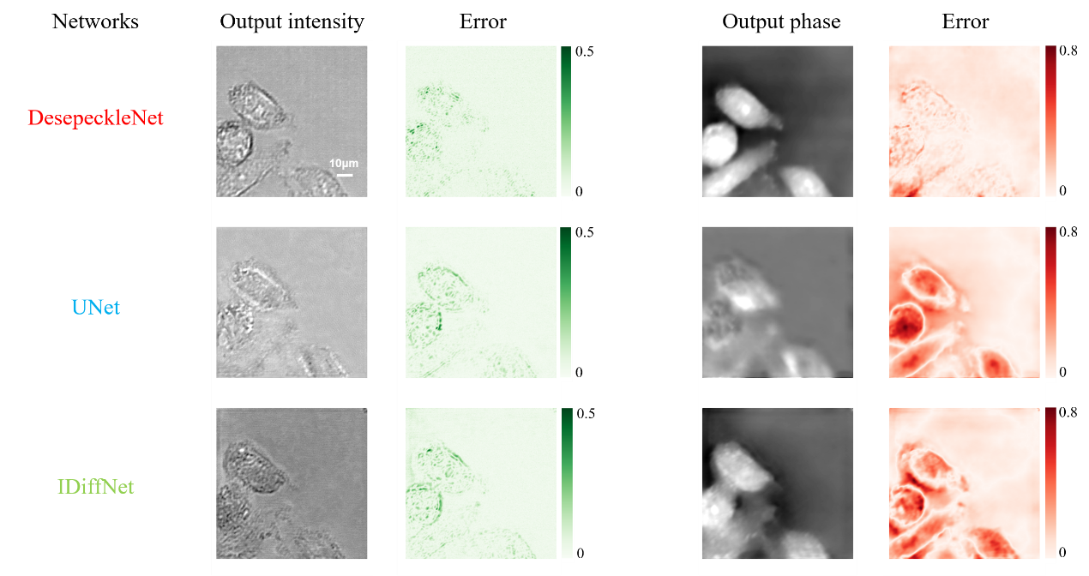
Figure S6. The quantitative error comparison among different networks over Hela cells.
Figure S6 shows the quantitative visualization error results of the reconstructed phase and intensity images. It can be found that the corresponding error between the output of our network and ground truth is the smallest. In the error map, the contours of the phase error generated by our method are nearly invisible, while other methods have distinct contours. This fully illustrates the superiority of our method.

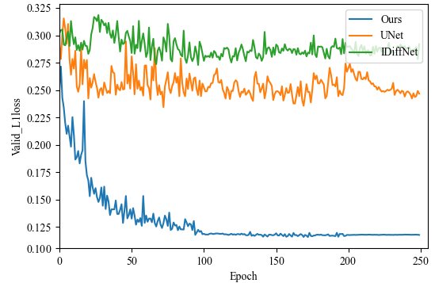
Figure S7. The validation loss curves of different networks over the Hela cell dataset.
In Fig. S7, we exhibit the loss curves of our method and the other two competitive methods over the validated dataset. All the losses consider both intensity and phase reconstructions. It can be seen that our method converges around 100 epochs, while the other two methods have no converged tendency even after 250 epochs.
Performance evaluation of DespeckleNet over different correlation lengths of speckles
In this experiment, we verify the performance of the network using speckle datasets at different correlation lengths⁷. Representative examples of the speckle and prediction pairs are shown in Fig. S8. In contrast to other whole-image classification⁸ or simple binary image prediction tasks^{5,6}, we predict both pixel-wise grayscale intensity and quantitative phase. Despite such a difficult task, the intensity and phase reconstruction results show the robustness of our network for the different correlation lengths of speckles. Furthermore, we provide an NRMSE comparison at different correlation lengths of speckles in Fig. S9. It shows that the NRMSE values of our network remain constant at different correlation lengths of speckles. This demonstrates the stable performance of our network over different scattering mediums.
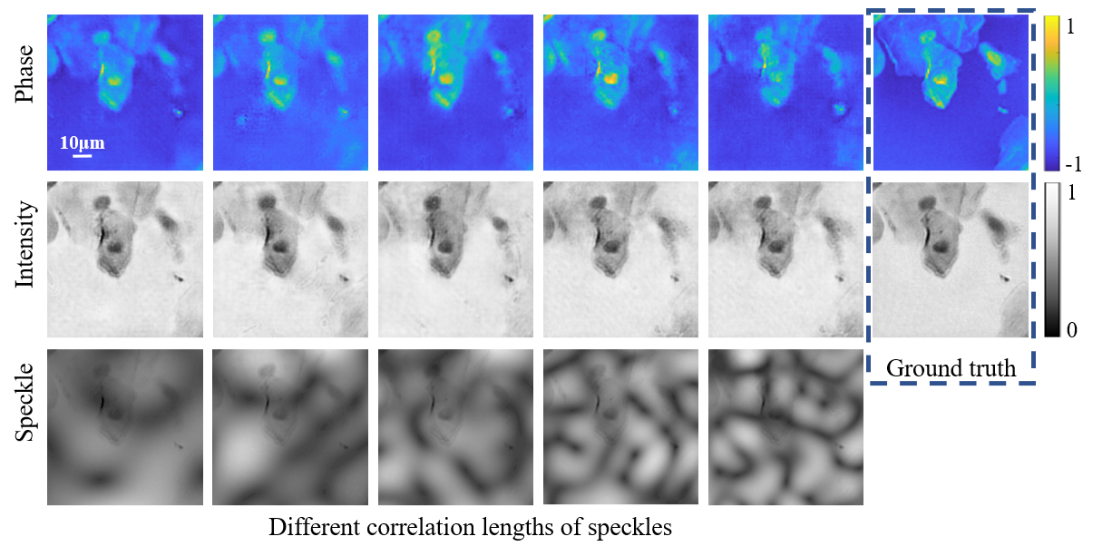
Figure S8. The simulated experiments over different correlation lengths of speckles.
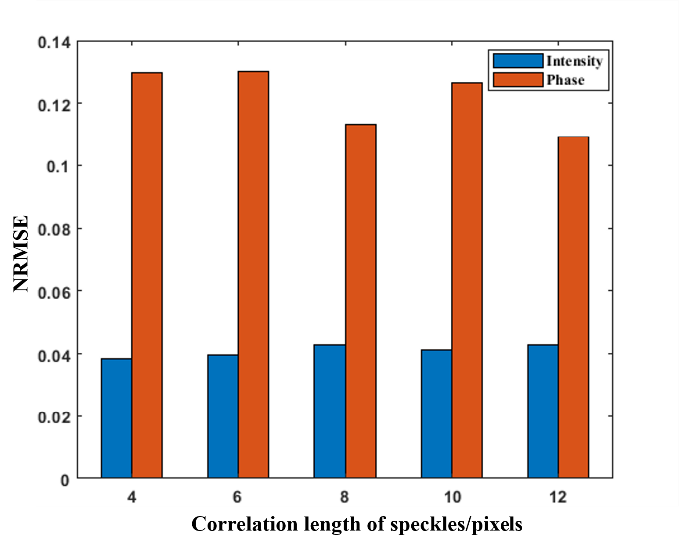
Figure S9. The NRMSE for different correlation lengths of speckles.

Visualization of the intermediate feature maps of our trained network
To illustrate the intensity and phase recovery process in our network, we visualize the intermediate feature maps of the network in the living Hela dataset. The corresponding feature maps in deeper layers become more similar to both the intensity and phase of the ground truth.
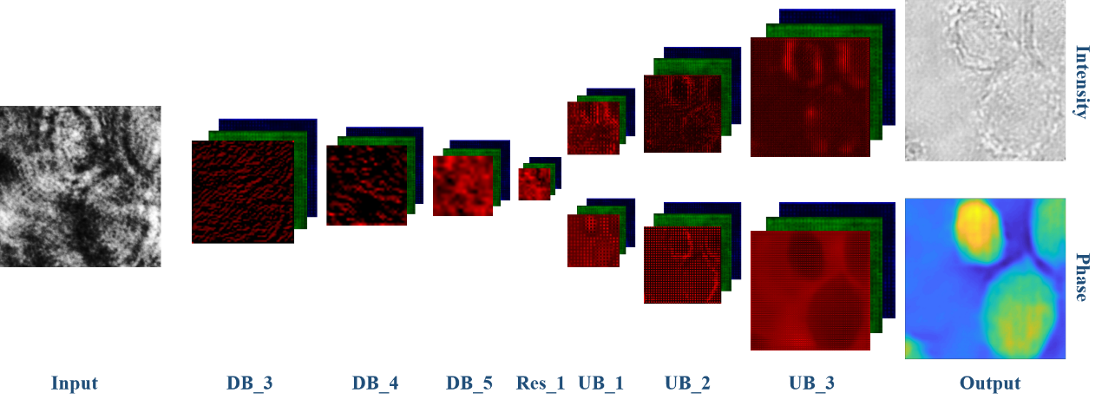
Figure S10. Visualization of the intermediate feature maps.

Table S1. Details of generator in our model for intensity recovery. Comments denote the types of convolution layer, activation function, and normalization method. Notations: B: batch size, N: number of kernels, K: kernel size, S: stride, P: padding, TransConv: transposed convolution, DB: downsampling block, Res: residual block, UB: upsampling block, Cat: concatenate.
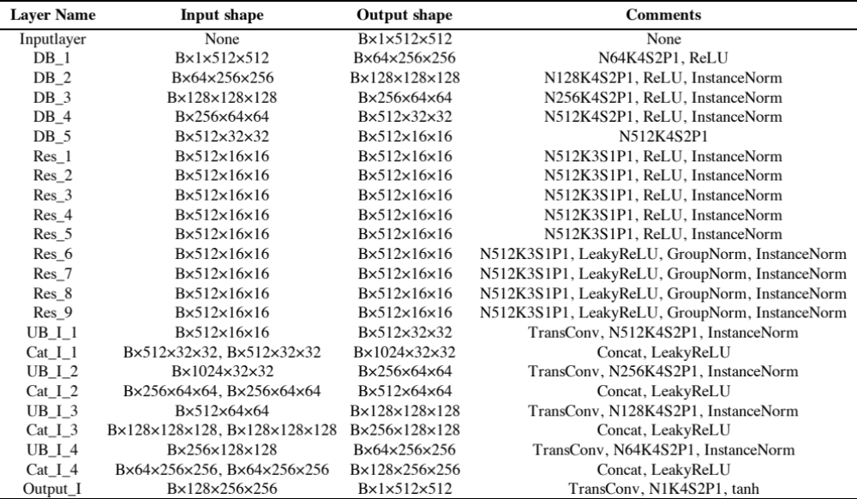

Table S2. Details of generator in our model for phase recovery. Comments denote the types of convolution layer, activation function, and normalization method. Notations: B: batch size, N: number of kernels, K: kernel size, S: stride, P: padding, TransConv: transposed convolution, DB: downsampling block, Res: residual, UB: upsampling block, Cat: concatenate. The weights from DB_1 to Res_9 in Table S1(intensity) and Table S2(phase) are shared.
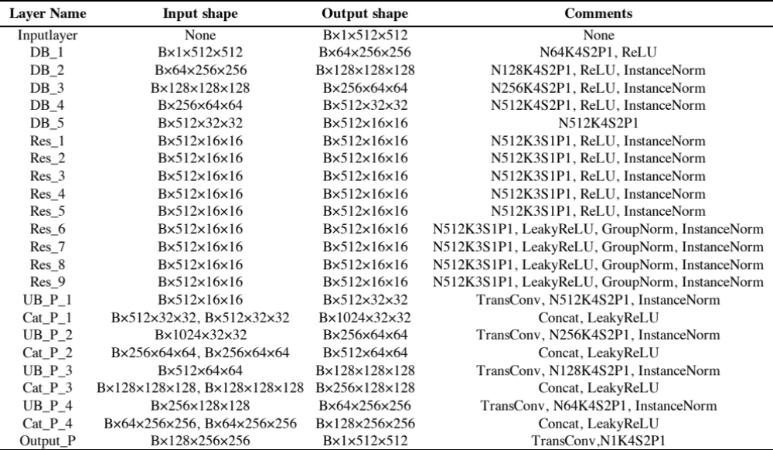

Table S3. Details of discriminator in our model. Comments denote the types of convolution layer, activation function, and normalization method. Notations: B: batch size, N: number of kernels, K: kernel size, S: stride, P: padding.
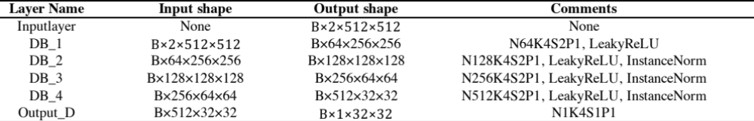

More results exhibition
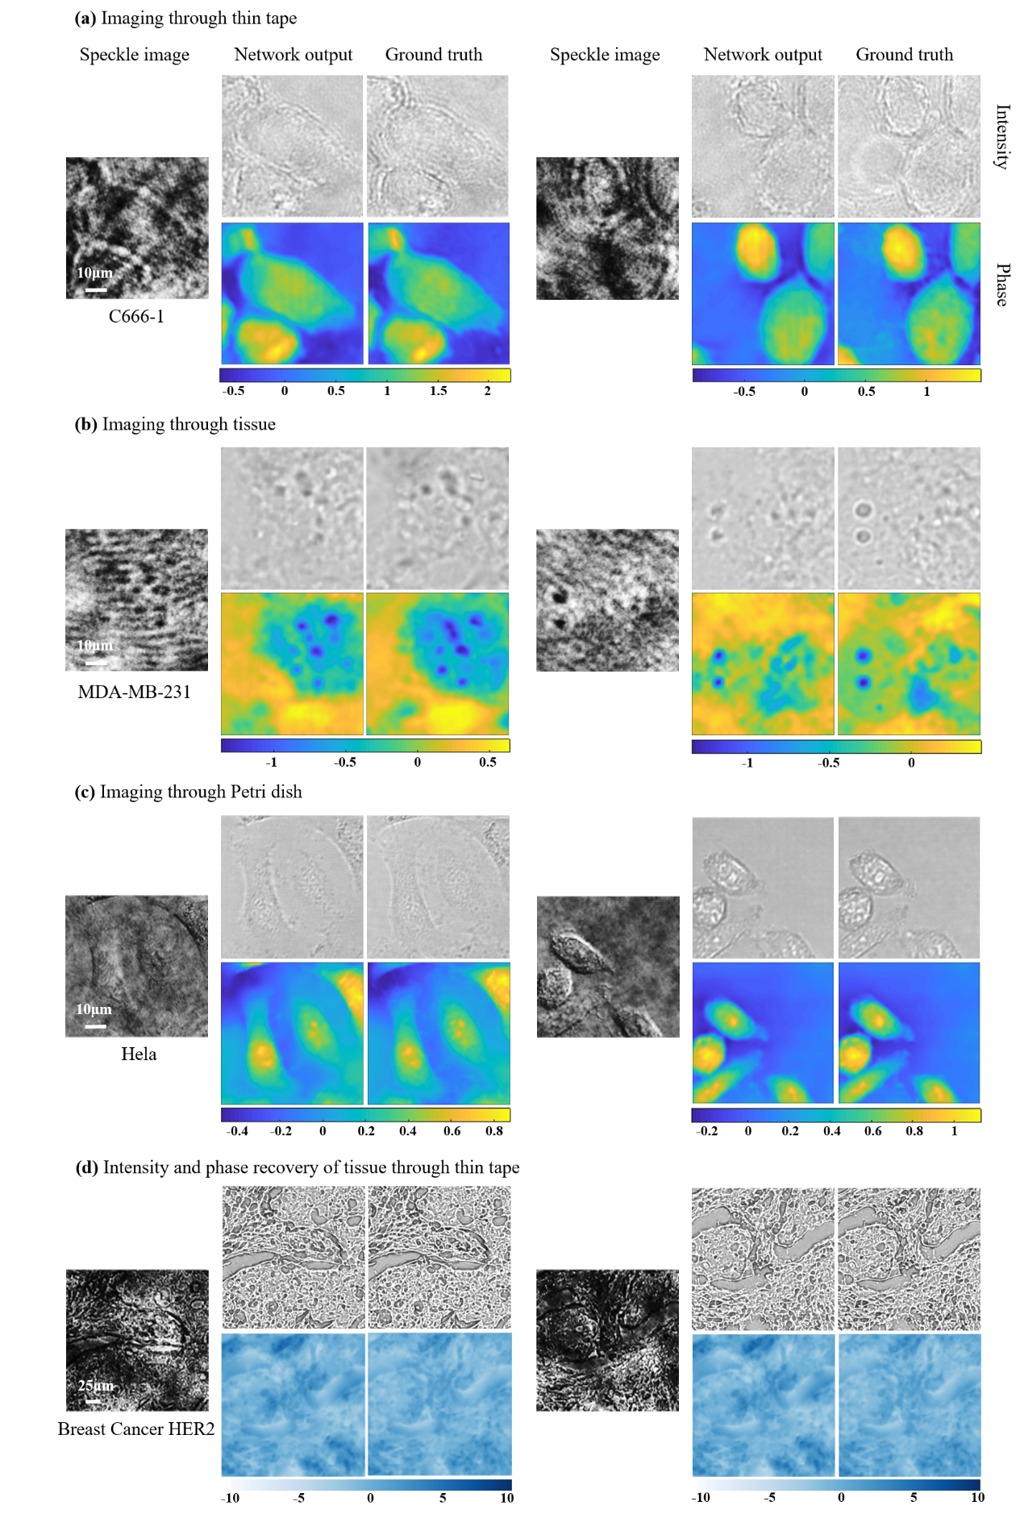
Figure S11. More results exhibition.
References
1. Teague M. R. Deterministic phase retrieval: a Green’s function solution. JOSA 73, 1434-1441 (1983).
2. Paganin D., Barty A., McMahon P., Nugent K. A. Quantitative phase‐amplitude microscopy. III. The effects of noise. Journal of microscopy 214, 51-61 (2004).
3. Allen L., Oxley M. Phase retrieval from series of images obtained by defocus variation. Opt. Commun. 199, 65-75 (2001).
4. Yamauchi T., Iwai H., Miwa M., Yamashita Y. Low-coherent quantitative phase microscope for nanometer-scale measurement of living cells morphology. Opt. Express 16, 12227-12238 (2008).
5. Li Y., Xue Y., Tian L. Deep speckle correlation: a deep learning approach toward scalable imaging through scattering media. Optica 5 (2018).
6. Li S., Deng M., Lee J., Sinha A., Barbastathis G. Imaging through glass diffusers using densely connected convolutional networks. Optica 5 (2018).
7. Gatti A., Magatti D., Ferri F. Three-dimensional coherence of light speckles: theory. Phys. Rev. A 78, 063806 (2008).
8. Krizhevsky A., Sutskever I., Hinton G. E. Imagenet classification with deep convolutional neural networks. Advances in neural information processing systems 25, 1097-1105 (2012).

