Appendix Figure 1:

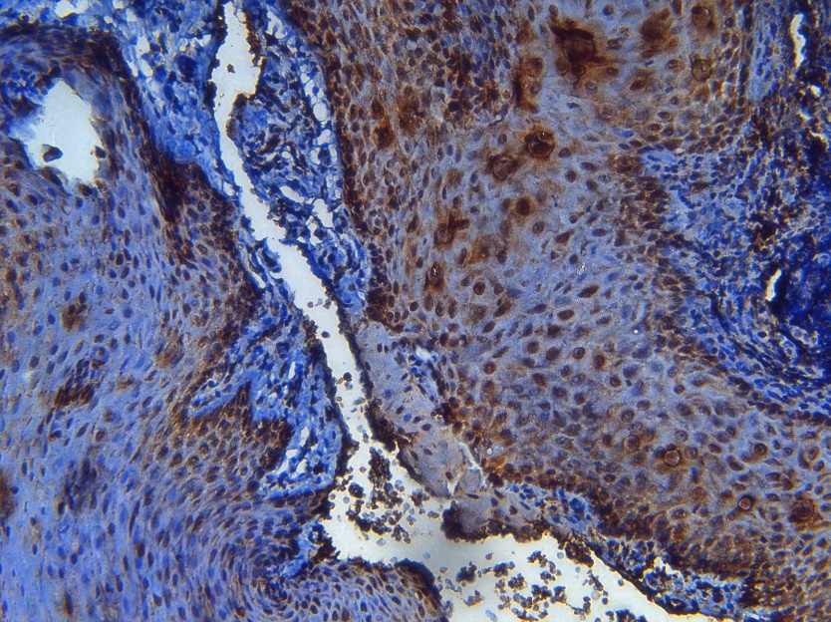

Appendix Figure 1: Immunohistochemical expression of Kaiso in healthy control oral mucosa (x200).

Appendix Figure 2:

Appendix Figure 2: Association between histological tumour grade and Kaiso localization. All grade groups showed stronger association with low nuclear Kaiso localization (p-value = 0.06). Low histological grade showed no difference in cytoplasmic Kaiso localization, whereas moderate grade group (GII) showed stronger association with low cytoplasmic Kaiso, and high-grade group (GIII) showed stronger association with high cytoplasmic Kaiso (p-value = 0.16)

Appendix Figure 3:

Appendix Figure 3. Association between Kaiso expression and target proteins. Both low and strong cyclin D1 expression was most frequently noted in low Kaiso expression group, whereas moderate cyclin D1 expression was most frequently (75%) in strong Kaiso expression group (p-value = 0.007*). No significant variation was noted in expression of c-Myc in relation to Kaiso protein expression. Both low and strong c-Myc expression groups were most frequently recorded with low Kaiso expression groups (p-value =0.85)

Appendix Table 1:

Appendix Table 1. Correlation between clinicopathological characteristics and Kaiso localization
 |  | Kaiso localization
 |  | Nuclear positive | Nuclear negative | p-value | Cytoplasmic positive | Cytoplasmic negative | p-value
Gender | Female | 10 | 2 | 0.25 | 11 | 1 | 1.0
Gender | Male | 23 | 12 | 0.25 | 30 | 5 | 1.0
Age | 21-30 | 4 | 4 | 0.023* | 7 | 1 | 0.64
Age | 31-40 | 7 | 3 | 0.023* | 10 | 0 | 0.64
Age | 41-50 | 6 | 6 | 0.023* | 10 | 2 | 0.64
Age | >50 | 16 | 1 | 0.023* | 14 | 3 | 0.64
Histological grade | GI | 13 | 3 | 0.52 | 14 | 2 | 0.49
Histological grade | GII | 10 | 5 | 0.52 | 12 | 3 | 0.49
Histological grade | GIII | 10 | 6 | 0.52 | 15 | 1 | 0.49
Lymph node metastasis | N/A | 3 | 3 | 0.44 | 4 | 2 | 0.19
Lymph node metastasis | Negative | 11 | 5 | 0.44 | 14 | 2 | 0.19
Lymph node metastasis | Positive | 19 | 6 | 0.44 | 23 | 2 | 0.19
 |  | 33 | 14 |  | 41 | 6
Values are presented as No. GI, Grade I; GII, Grade II; GIII, Grade III; N/A, Not Available. *p-value <0.05.

Appendix Table 2:
Appendix Table 2. Correlation between clinicopathological characteristics and E-cadherin expression
 |  | E-cadherin expression |  |  | p-value
 |  | Low | Moderate | Strong | p-value
Gender | Female | 8 | 3 | 1 | 0.036*
Gender | Male | 9 | 16 | 10 | 0.036*
Age | 21-30 | 2 | 3 | 3 | 0.87
Age | 31-40 | 5 | 4 | 1 | 0.87
Age | 41-50 | 6 | 2 | 4 | 0.87
Age | >50 | 4 | 10 | 3 | 0.87
Histological grade | GI | 6 | 6 | 4 | 0.37
Histological grade | GII | 5 | 5 | 5 | 0.37
Histological grade | GIII | 6 | 8 | 2 | 0.37
Lymph node metastasis | N/A | 2 | 3 | 1 | 0.175
Lymph node metastasis | Negative | 7 | 4 | 5 | 0.175
Lymph node metastasis | Positive | 8 | 12 | 5 | 0.175
 |  | 17 | 19 | 11

Appendix table 3:

Table 3. Correlation between clinicopathological characteristics and p120ctn localization.
 |  | P120ctn localization |  | p-value
 |  | Membranous | Reduced membranous/ ectopic cytoplasmic | p-value
Gender | Female | 2 | 10 | 0.8
Gender | Male | 7 | 28 | 0.8
Age | 21-30 | 2 | 6 | 0.87
Age | 31-40 | 1 | 9 | 0.87
Age | 41-50 | 2 | 10 | 0.87
Age | >50 | 4 | 13 | 0.87
Histological grade | GI | 4 | 12 | 0.37
Histological grade | GII | 1 | 14 | 0.37
Histological grade | GIII | 4 | 12 | 0.37
Lymph node metastasis | N/A | 2 | 4 | 0.175
Lymph node metastasis | Negative | 1 | 15 | 0.175
Lymph node metastasis | Positive | 6 | 19 | 0.175
 |  | 9 | 38

Appendix Figures 6 and 7:

Appendix Figure 6: Association of nuclear Kaiso localization with nuclear p120ctn localization. P-value= 0.25

Appendix Figure 7: Association of cytoplasmic Kaiso localization with cytoplasmic p120ctn localization. P-value= 0.65

