Supplementary Information
Selection of oxygen reduction catalysts for secondary tri-electrode zinc-air batteries
Adeline Loh¹, David P. Trudgeon¹, Xiaohong Li^{1*}, Mao-Cheng Liu², Ling-Bin Kong², Frank C. Walsh³
¹ Renewable Energy Group, College of Engineering, Mathematics and Physical Sciences, University of Exeter, Penryn Campus, Cornwall TR10 9FE, UK
² State Key Laboratory of Advanced Processing and Recycling of Non-Ferrous Metals, School of Materials Science and Engineering, Lanzhou University of Technology, Lanzhou 730050, China
³ Electrochemical Engineering Laboratory, Energy Technology Group, Department of Mechanical Engineering, University of Southampton, SO17 1BJ, UK.

* Corresponding author. Email: X.Li@exeter.ac.uk Tel: 0044 (0)1326 255769

Data availability ​ statements
- The datasets used and/or analysed during the current study available from the corresponding author on reasonable request.
- All data generated or analysed during this study are included in this published article [and its supplementary information files].

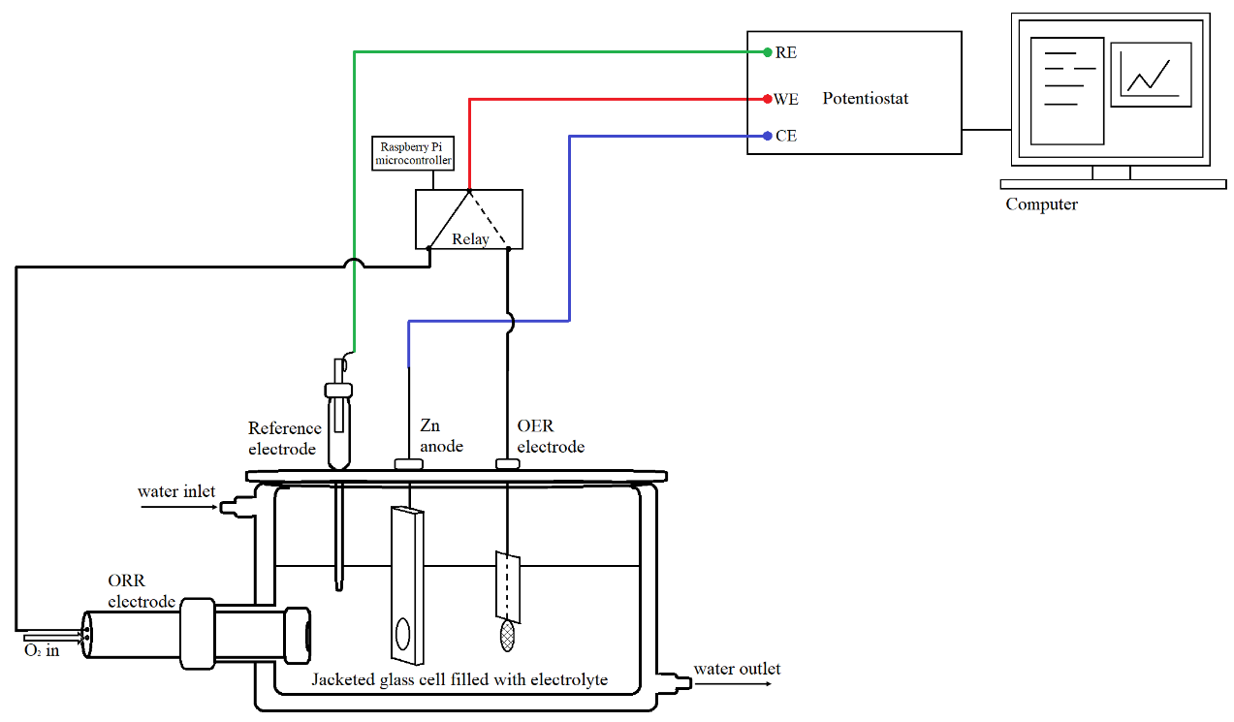

Figure S1. Schematic illustration of electrodes in a jacketed glass cell, connected to Raspberry Pi-microcontroller and relay for galvanostatic cycling.
(a)

(b)

Figure S2. Tafel slope plots for various ORR catalysts (a) without XC-72R and (b) with XC-72R, in O₂ saturated 1 M NaOH at 298 K taken from LSVs measured at 400 rpm and scan rate of 5 mV s⁻¹.

(a)

(b)

Figure S3. Koutecky-Levich plots j⁻¹ versus ω^{-1/2} for (a) catalysts and (b) catalysts with Vulcan XC-72R taken from the mass transfer controlled region of -0.4 V for rotation rates 100, 400, 900, 1600 and 2500 rpm.

Table S1. Corresponding performance data of oxygen electrodes at different current densities as shown in Fig. 6a
j/ mA cm⁻² | Charge / V |  |  | Discharge / V |  |  | Δ E / mV |  | Energy efficiency / %
j/ mA cm⁻² | E_{cell} | E_{we} vs Hg/HgO | E_{ce} vs Hg/HgO | E_{cell} | E_{we} vs Hg/HgO | E_{ce} vs Hg/HgO | ORR and OER | Zn | Energy efficiency / %
10 | -1.903 | 0.532 | -1.371 | 1.281 | -0.070 | -1.351 | 606 | 20 | 67
20 | -1.926 | 0.551 | -1.375 | 1.238 | -0.108 | -1.346 | 659 | 29 | 64
50 | -1.956 | 0.571 | -1.385 | 1.140 | -0.204 | -1.344 | 775 | 41 | 58
100 | -2.011 | 0.596 | -1.415 | 0.978 | -0.346 | -1.324 | 942 | 91 | 49

Table S2. Corresponding performance data of oxygen electrodes at different electrolyte molarities as shown in Fig. 6b

Electrolyte molarity / M | Charge / V |  |  | Discharge / V |  |  | Δ E / mV |  | Energy efficiency / %
Electrolyte molarity / M | E_{cell} | E_{we} vs Hg/HgO | E_{ce} vs Hg/HgO | E_{cell} | E_{we} vs Hg/HgO | E_{ce} vs Hg/HgO | ORR and OER | Zn | Energy efficiency / %
2 | -1.944 | 0.590 | -1.354 | 1.195 | -0.126 | -1.321 | 716 | 33 | 62
4 | -1.926 | 0.551 | -1.375 | 1.238 | -0.108 | -1.346 | 659 | 29 | 64
6 | -1.927 | 0.535 | -1.392 | 1.247 | -0.117 | -1.364 | 652 | 28 | 65
8 | -1.939 | 0.525 | -1.414 | 1.241 | -0.140 | -1.381 | 665 | 33 | 64

Table S3. Corresponding performance data of oxygen electrodes at different operating temperature as shown in Fig. 6c
Temperature / ºC | Charge / V |  |  | Discharge / V |  |  | Δ E / mV |  | Energy efficiency / %
Temperature / ºC | E_{cell} | E_{we} vs Hg/HgO | E_{ce} vs Hg/HgO | E_{cell} | E_{we} vs Hg/HgO | E_{ce} vs Hg/HgO | ORR and OER | Zn | Energy efficiency / %
25 | -1.993 | 0.604 | -1.389 | 1.159 | -0.189 | -1.348 | 793 | 42 | 58
40 | -1.955 | 0.575 | -1.380 | 1.200 | -0.147 | -1.347 | 722 | 33 | 61
60 | -1.926 | 0.551 | -1.375 | 1.238 | -0.108 | -1.346 | 659 | 29 | 64
80 | -1.904 | 0.526 | -1.378 | 1.260 | -0.094 | -1.354 | 620 | 24 | 66

Table S4. Corresponding performance data of oxygen electrodes with effect of oxygen purity as shown in Fig. 6d
O₂ purity | Charge / V |  |  | Discharge / V |  |  | Δ E / mV |  | Energy efficiency / %
O₂ purity | E_{cell} | E_{we} vs Hg/HgO | E_{ce} vs Hg/HgO | E_{cell} | E_{we} vs Hg/HgO | E_{ce} vs Hg/HgO | ORR and OER | Zn | Energy efficiency / %
Bottled O₂ | -1.926 | 0.551 | -1.375 | 1.238 | -0.108 | -1.346 | 659 | 29 | 64
Air | -1.925 | 0.553 | -1.372 | 1.180 | -0.164 | -1.344 | 718 | 28 | 61
Air (alt. arrangement) | -1.934 | 0.560 | -1.374 | 1.192 | -0.135 | -1.327 | 695 | 47 | 62

Table S5. Conductivities of selected NaOH electrolyte concentrations
Electrolyte | Conductivity / S cm⁻¹
2 M NaOH + 0.3 M ZnO | 0.266
4 M NaOH + 0.3 M ZnO | 0.353
6 M NaOH + 0.3 M ZnO | 0.362
8 M NaOH + 0.3 M ZnO | 0.369

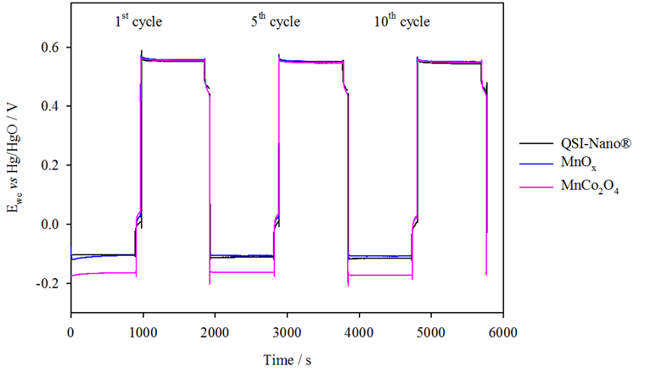

Figure S4. Comparison of ORR electrodes at 20 mA cm⁻² in static electrolyte 4 M NaOH + 0.3 M ZnO at 333 K and O₂ flow rate 200 cm³ min⁻¹.
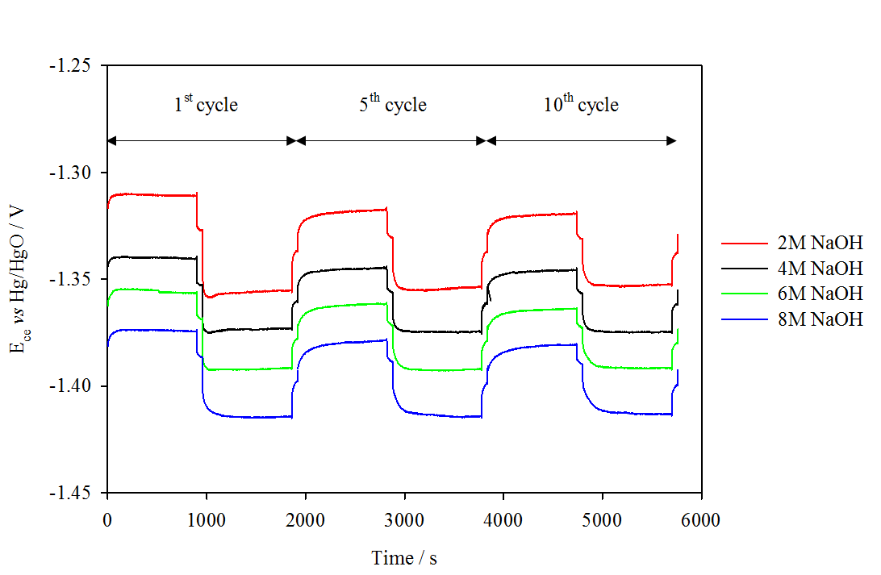

Figure S5. Comparison of Zn electrode performance at 20 mA cm⁻² in static electrolyte of varying NaOH concentration. A constant concentration of 0.3 M ZnO was added to the electrolyte and experiments were run at 333 K.
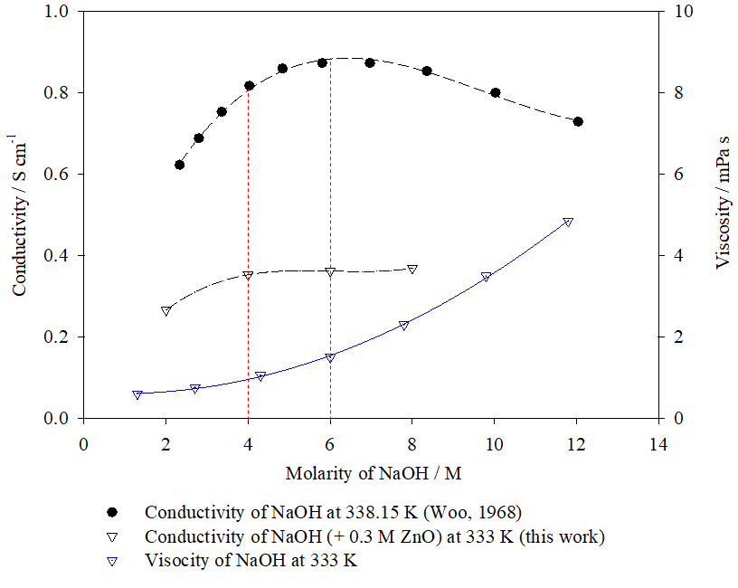
Figure S6. Comparison of the conductivity¹ and viscosity² of NaOH over a range of concentrations at 333 K.
The reported conductivities of different NaOH molarities at 338.15 K are much greater than that of the NaOH + 0.3 M ZnO electrolytes measured in this work which indicates that the addition of ZnO reduces the conductivity³. In Fig. S6, conductivities of 4 M NaOH + 0.3 M ZnO and 6 M NaOH + 0.3 M ZnO electrolytes at 333 K are observed to be similar at around 0.36 S cm⁻¹, however the viscosity of 6 M NaOH is much greater than 4 M NaOH.

Figure S7. Changes in overpotential at the ORR and OER electrode versus (a) current density, (b) electrolyte molarity and (c) temperature.
(a) (b)

(c)

Figure S8. Galvanostatic cycling performance of MnO_{x} + Ni-Fe-Co(OH)₂ electrodes (―) and commercial QSI-Nano® ORR and Magneto OER electrodes (―) in a tri-electrode Zn-air set-up over 50 h at 20 mA cm⁻² with 30 min cycle periods, in static electrolyte of 4 M NaOH + 0.3 M ZnO at 333 K. Compressed air was supplied at 200 cm³ min⁻¹.
Table S6. Performance of tri-electrode secondary Zn-air systems in the literature
Cathode | Anode | Electrolyte | Cycling conditions and stability | Voltage polarisation at 20 mA cm⁻² / V | Ref.
ORR: MnO₂ on C paper  OER: NiFeCo hydroxide coated SS mesh | Zn foil | 4 M NaOH + 0.3 M ZnO, static | - 10-50 mA cm⁻², 30 min cycle periods for 50 h  - 58-61 % energy efficiency at 20 mA cm⁻² | 0.69 at 20 mA cm⁻² | This work
ORR: CoO or MnO₂  OER: 316 L SS mesh | 3D metal foam current collector filled with Zn, TiN and polymer binder | Commercial electrolyte mainly consisting of 7 M KOH, static | - 5-15 mA cm⁻², 24-30 h cycle periods for ~120 h (4 cycles)  - 50 % energy efficiency | > 0.90 at 5-15 mA cm⁻² | 4
ORR: CoO/ N-CNT on carbon fibre paper  OER: NiFe LDH on Ni foam | Zn foil | 6 M KOH + 0.2 M zincate, static | - 20-50 mA cm⁻², 4-20 h cycle periods for > 200 h (10 cycles)  - 65 % energy efficiency at 20 mA cm⁻² | 0.70 at 20 mA cm⁻² | 5
ORR: macro/ meso-NC-NH₃  OER: Co₃O₄ on Ni foam | Zn foil | 6 M KOH + 0.2 M ZnCl₂, static | - 10 mA cm⁻², 4 h cycle periods for ~800 h (200 cycles)  - 60-65 % voltage efficiency at 10 mA cm⁻² | 0.75 at 10 mA cm⁻² | 6
ORR: Commercial  GDE  OER: RuO₂ on Ti net | Zn coated C felt on porous Cu foam | 6 M KOH + 0.4 M ZnO, static | - 20 mA cm⁻², ~2 h cycle periods for 1917 h (1000 cycles)  - 40 % energy efficiency | 1.1 V to 1.4 V at 20 mA cm⁻² | 7
ORR: Ag-based catalyst  OER: Ni foam | Cu foam soldered on Zn (not in contact with electrolyte) | 30 wt% KOH + 2 wt% ZnO, 30ºC, flowing 0.4 L min⁻¹ | - 50 mA cm⁻², ~8 min cycle periods, (>600 cycles) with short circuits  - ~58 % voltage efficiency at 20 mA cm⁻² | 1.2 V at 50 mA cm⁻² (0.75 V at 20 mA cm⁻²) | 8

References
1. Woo, A.L.W. Conductance studies of concentrated solutions of sodium hydroxide and potassium hydroxide electrolytes in Chemistry (South Dakota State University: South Dakota, USA, 1968).
2. O'Brien, T. F., Bommaraju, T.V. & Hine, F. Handbook of Chlor-Alkali Technology (Boston, 2005).
3. Liu, M. B. et al. Conductivity of KOH electrolyte supersaturated with zincate. J. Electrochem. Soc. 128, 2049-2052. https://doi.org/10.1149/1.2127187 (1981).
4. Toussaint, G., Stevens, P., Moureau, F., Rouget, R. & Fourgeot, F. Development of a rechargeable zinc-air battery. ECS Trans. 28, 25-34. https://doi.org/10.1149/MA2010-01/12/757 (2010).
5. Li, Y. et al. Advanced zinc-air batteries based on high-performance hybrid electrocatalysts. Nat. Commun. 4, 1805. https://doi.org/10.1038/ncomms2812 (2013).
6. Li, L., Liu, C., He, G., Fan, D. & Manthiram, A. Hierarchical pore-in-pore and wire-in-wire catalysts for rechargeable Zn– and Li–air batteries with ultra-long cycle life and high cell efficiency. Energy Environ. Sci. 8, 3274-3282. https://doi.org/10.1039/C5EE02616D (2015).
7. Hong, W., Li, H. & Wang, B. A horizontal three-electrode structure for zinc-air batteries with long-term cycle life and high performance. Int. J. Electrochem. Sci. 11, 3843-3851. https://doi.org/10.20964/110384 (2016).
8. Bockelmann, M., Kunz, U. & Turek, T. Electrically rechargeable zinc-oxygen flow battery with high power density. Electrochem. Commun. 69, 24-27. https://doi.org/10.1016/j.elecom.2016.05.013 (2016).

