Supplementary material:

Bio-inspired, strong, flexible lignin/cellulose film with UV-blocking，water-stable and antioxidant properties
Liangxian Liu^{1a}, Boyu Cui^{1a}, Shuang Li, Chaodong Liu, Lei Tan, Weihong Wang*
Key Laboratory of Bio-Based Material Science and Technology (Ministry of Education), Material Science and Engineering College, Northeast Forestry University, Harbin 150040, China
* Correspondence: weihongwang2001@mefu.edu.cn (Weihong Wang).

Sample code | Process parameters |  |  | Ultrasonic  treatment
Sample code | Cellulose  (g) | Lignin/acetone  (mg/ml) | ZnCl₂/H₂O  (g/100g) | Ultrasonic  treatment
C  UC  UCZn-15  UCL  UCLZn-15  UCLZn-30  UCLZn-45 | 0.5  0.5  0.5  0.5  0.5  0.5  0.5 | 0  0  0  30  30  30  30 | 0  0  15  0  15  30  45 | No  Yes  Yes  Yes  Yes  Yes  Yes
Table S1. Films with different process parameters.
Figure S1. The basic length range of C and UC determined by L&W Fiber tester plus (Sweden).
The MFC length ranges were mainly 1–200 μm (approximately 48.9483%) and 200–400 μm (approximately 37.7%). After ultrasonic treatment, the MFC ranges were mainly 1–200 μm (approximately 52.4%) and 200–400 μm (approximately 34.7%).
Figure S2 X-ray diffraction pattern (a) and Crl of C, UC, UCL, and UCLZn-15 (b).
To characterize the crystallization of the films, we performed XRD tests. The crystallinity of the cellulose film was 72.75%, whereas the UC films exhibited a high degree of crystallinity of up to 77.52% after ultrasound treatment, which was attributed to the transformation of amorphous cellulose to cellulose microcrystals. After the addition of lignin, the non-crystalline lignin attenuated the crystallinity of the material. With the addition of Zn²⁺, the crystallinity of the film decreased to 72.86%, illustrating that the crystal structure of the material was changed, which may be attributed to the coordination interactions of cellulose hydroxyl groups and lignin oxygen-containing groups with Zn²⁺.

Figure S2 XPS spectra of UCLZn15 and UCL.
Compared to UCL, UCLZn-15 produced a new peak at 1021.7 eV, attributed to the Zn 2p_{2/3} binding energy after the addition of Zn²⁺.
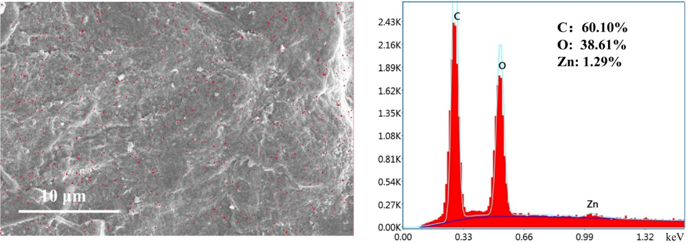
Figure S3 SEM micrographs and corresponding surface layer element scanning results (EDS) of the UCLZn-15.
The characteristic element “Zn” (red spots) was uniformly distributed on the film surface. The relative amounts of C, O, and Zn were 60.10%, 38.61%, and 1.29%, respectively.

