Appendix 1.

ParticipantInclusion Criteria
1. Participant is willing and able to give informed consent for participation in the study
2. Male or female, aged 18 years or above
3. Previous history of stroke and/or specialist confirmed TIA at least one month before randomisation
4. Baseline systolic blood pressure > 130mmHg (mean of 2nd and 3rd readings after five minutes sitting)
5. Willing and able to comply with all study procedures

Appendix 2.

Participant exclusion criteria
1. Diagnosis of dementia
2. Score over 10 on the short orientation memory concentration test
3. Any other significant disease or disorder which, in the opinion of the Investigator, may put the participants at risk because of participation in the trial
4. Pregnancy
5. BP > 180/110mmHg at baseline (to be referred to GP but could be subsequently rescreened if BP < 180/110mmHg)
6. Patient taking more than three antihypertensives
7. Unwilling to self-monitor
8. Receiving care for blood pressure by a specialist rather than a primary care physician
9. Stage 4 CKD or worse – i.e.: eGFR less than 30 mL/min/1.73 m2 (as these persons are more likely to be managed by specialists, are more prone to Acute Kidney Injury and/or hyperkalaemia and less responsive to certain antihypertensives)
10. Diagnosed atrial fibrillation
11. Orthostatic hypotension: more than 20mmHg systolic drop after standing for 1 minute. Not relevant if participant unable to stand
12. Participation in other studies that concern hypertension and/or adjustment of antihypertensive medication

Appendix 3. The BP:Together Study – Participant Summary Sheet Ireland
    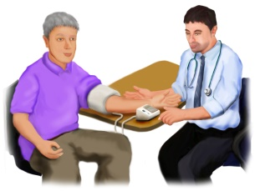    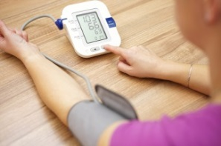  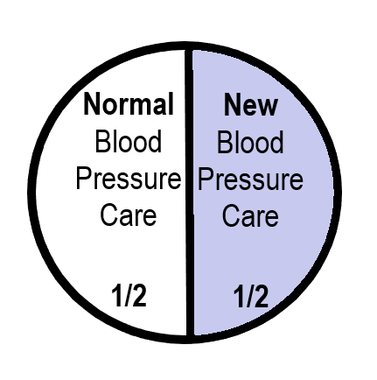   | - We need to know more about how to help people look after their blood pressure after a strokeor TIA (Transient Ischemic Attack).  - 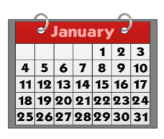Researchers from Limerick, Oxford, Cambridge, Southampton and Edinburgh Universities aredoing a research study.  - Your GP practice is supporting the research.  - You can choose if you want to take part.  What will happen?  - We need people from Ireland and the UK to take part  - Half the people in the research will use the newprogramme with their doctor  - Half will do the same things they are doing already with their doctor  - A computer decides at random which group you willbe in.This is like flipping a coin.  If you are trying the new programme:  - We will lend you a blood pressure monitor and show you how to use it.  - You will use the blood pressure monitor at home for 3 days each month.  - You will send your blood pressure readings by text message, a mobile phone app or a computer to the researchers in Oxford and Limerick Universities  - Your doctor will be sent a copy of your readings  - Your doctor may change your medicine if your blood pressure is too high  - You would be in the researchfor 3 months and may then be invited to take part in a longer, 12 month trial  - A nurse will check everyone’s blood pressure at the start and end of the study  - If you decide to take part you can change your mind at any time  - Before you decide you might want to know more  Ring us with any questions 08x xxxxxxx  - If you want to take part in the research:  Please ring us – 08x xxxxxxx  Or post back the reply slip in the FREEPOST  envelope
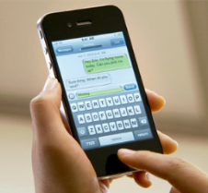
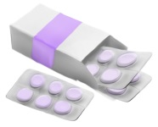

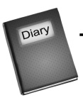



x 3 months

Appendix 4.
Intervention Flowchart
