Supplementary Information

Van der Waals heterostructure of Bi_{x}I_{y} for ultra-sensitive x-ray detection

Renzhong Zhuang^{1, 2}, Songhua Cai³, Zengxia Mei¹, Huili Liang¹, Ningjiu Zhao¹, Haoran Mu¹, Wenzhi Yu^{1, 4}, Yan Jiang¹, Jian Yuan¹, Shuping Lau³, Shiming Deng⁵, Mingyue Han¹, Peng Jin⁶, Cailin Wang¹, Guangyu Zhang^{1, 4,} *, Shenghuang Lin^{1,} *

1 State Key Laboratory of Modern Optical Instrumentation
College of Optical Science and Engineering
Zhejiang University
Hangzhou, Zhejiang 310027, China
1 State Key Laboratory of Modern Optical Instrumentation
College of Optical Science and Engineering
Zhejiang University
Hangzhou, Zhejiang 310027, China
¹Songshan Lake Materials Laboratory, Dongguan 523808, Guangdong, P. R. China.
²Fujian Provincial Key Laboratory of Welding Quality Intelligent Evaluation, Longyan University, Longyan, Fujian, P. R. China.
³Department of Applied Physics, The Hong Kong Polytechnic University, Hunghom, Kowloon, Hong Kong, P. R. China.
⁴Institute of Physics, Chinese Academy of Science, Beijing, 100190, P. R. China.
⁵HAMAMATSU Photonics (China) Co., LTD., Beijing, 100020, P. R. China.
⁶State Key Laboratory of Modern Optical Instrumentation, College of Optical Science and Engineering, Zhejiang University, Hangzhou, Zhejiang, China.

*Email Address: linshenghuang@sslab.org.cn (S. Lin) & gyzhang@sslab.org.cn, gyzhang@iphy.ac.cn (G. Zhang)
State Key Laboratory of Modern Optical Instrumentation
College of Optical Science and Engineering
Zhejiang University
Hangzhou, Zhejiang 310027, China

Figure caption
Fig. S1 ｜Morphology characterization of Bi_{x}I_{y}. a, A typical as-grown crystal with the stripped surface. b, c, Complete and flexible slices exfoliated by PDMS, respectively. d, SEM image of an exfoliated flake transferred onto a conductive tape. e, f, AFM image (e) and corresponding surface profile (f) of a freshly exfoliated flake.
Fig. S2 ｜XRD pattern of Bi_{x}I_{y} with (001) surface, the red arrows point to a minor secondary diffraction.
Fig. S3 ｜XPS spectra of valance band BE of Bi_{x}I_{y} and commercial BiI₃.
Fig. S4 ｜Thermogravimetric analysis curves of Bi_{x}I_{y} and commercial BiI₃.
Fig. S5 ｜Cross-sectional HAADF-STEM images of stripped Bi_{x}I_{y} slices. a, SEM image of Bi_{x}I_{y} slices for FIB. b-d, Alternate stacking of thin bright Bi-rich layers and thick dark BiI₃ layers with 670 nm (b), 163 nm (c) and 154 nm (d) thickness. e-g, STEM-EDS mapping of Bi (f) and I (g) in a region with bright Bi-rich phase and dark BiI₃ (e).
Fig. S6 ｜a-d, HAADF-STEM images of BiI₃ and BiI structure viewed along the [100] zone axis (a, b) and the [010] zone axis (c, d).
Fig. S7 ｜HAADF-STEM image of an exfoliated BiI film with 7 I-Bi-Bi-I layers.
Fig. S8 ｜Absorption spectrum of Bi_{x}I_{y}.
Fig. S9 ｜Photoluminescence spectrum of the BiI₃ and Bi_{x}I_{y}.
Fig. S10 ｜Raman spectrum of the Bi_{x}I_{y}.
Fig. S11 ｜photo response of the Bi_{x}I_{y}. a, A planar-type Ag/Bi_{x}I_{y}/Ag photodetector made on the (001) surface of Bi_{x}I_{y}. b, Infrared on/off responses from 1100-1900 nm. c, On/off responses under ambient light.
Fig. S12 ｜Transient absorption spectra of Bi_{x}I_{y} (a) and BiI₃ (b).
Fig. S13 ｜On/off x-ray responses of the lateral device (a) and vertical device (b) at different dose rates measured by cavity-edge configuration at room temperature.
Fig. S14 ｜Room temperature self-powered device. a, A Si/Bi_{x}I_{y}/Bi detector configuration. The Si and Bi electrodes were prepared by mixed the ground Si and Bi powders with the supernatant of silver paste. b, On/off responses of the Si/Bi_{x}I_{y}/Bi detector at different dose rates under zero bias measured by cavity-edge configuration. c, X-ray photocurrent densities of self-powered device at different dose rates measured by cavity-edge configuration. The sensitivity of 7.5 μC Gy⁻¹ cm⁻² was obtained from the current-dose rate relations.
Fig. S15 ｜Comparison of the x-ray detection sensitivities of the Bi_{x}I_{y} detector in this work with some traditional (CdZnTe, PbI₂, HgI₂, α-Se³⁸) and recently reported (MAPbBr₃³⁹, MAPbBr₃/Si⁴⁰, CsPbBr₃, Cs₂AgBiBr₆⁴¹, MAPbI₃⁸, BDAPbI₄⁴², Cs₃Bi₂I₉⁹, (NH₄)₃Bi₂I₉⁷) detectors. Data for CdZnTe, PbI₂, HgI₂ and CsPbBr₃ were extracted from ref. 43.

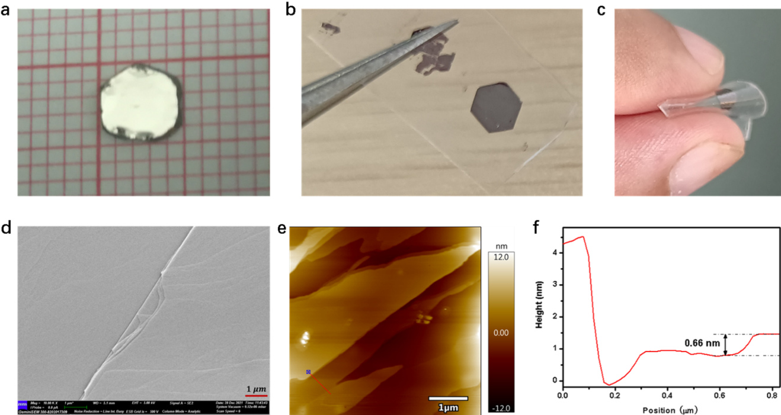
Fig. S1 ｜Morphology characterization of Bi_{x}I_{y}. a, A typical as-grown crystal with the stripped surface. b, c, Complete and flexible slices exfoliated by PDMS, respectively. d, SEM image of an exfoliated flake transferred onto a conductive tape. e, f, AFM image (e) and corresponding surface profile (f) of a freshly exfoliated flake.

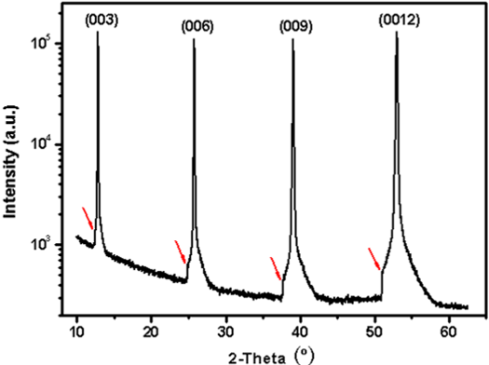
Fig. S2 ｜XRD pattern of Bi_{x}I_{y} with (001) surface, the red arrows point to a minor secondary diffraction.

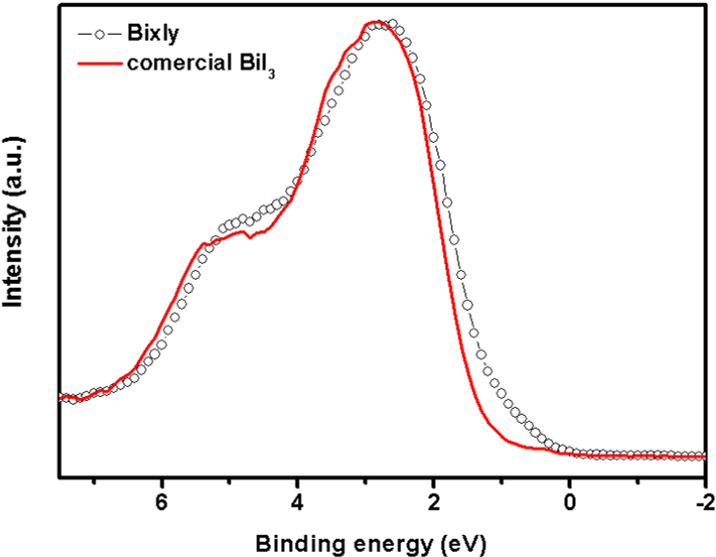
Fig. S3 ｜XPS spectra of valance band BE of Bi_{x}I_{y} and commercial BiI₃.

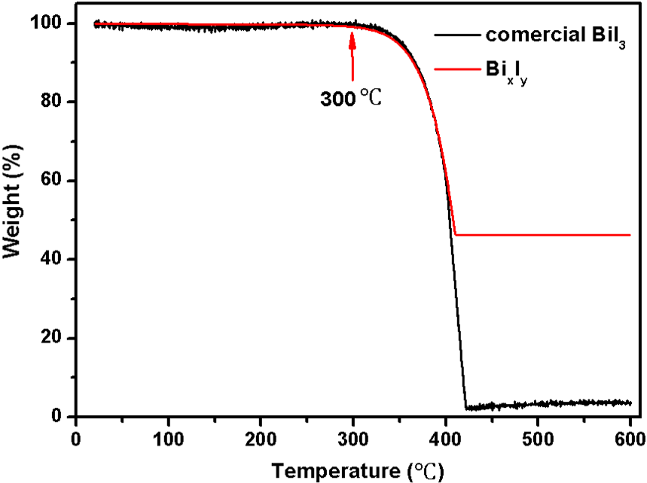
Fig. S4 ｜Thermogravimetric analysis curves of Bi_{x}I_{y} and commercial BiI₃.

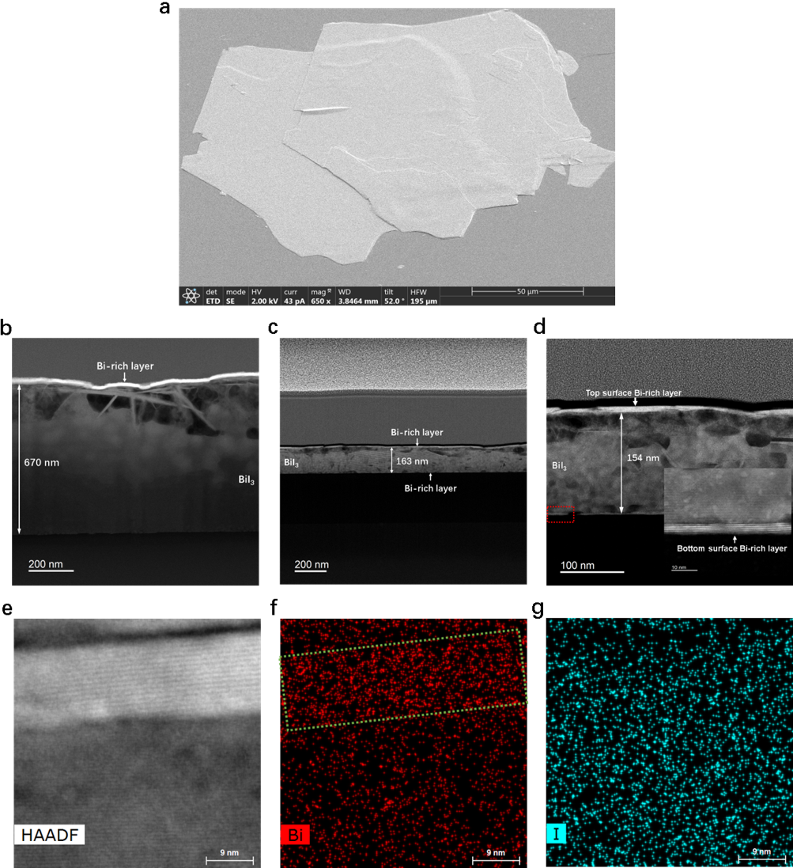
Fig. S5 ｜Cross-sectional HAADF-STEM images of stripped Bi_{x}I_{y} slices. a, SEM image of Bi_{x}I_{y} slices for FIB. b-d, Alternate stacking of thin bright Bi-rich layers and thick dark BiI₃ layers with 670 nm (b), 163 nm (c) and 154 nm (d) thickness. e-g, STEM-EDS mapping of Bi (f) and I (g) in a region with bright Bi-rich phase and dark BiI₃ (e).

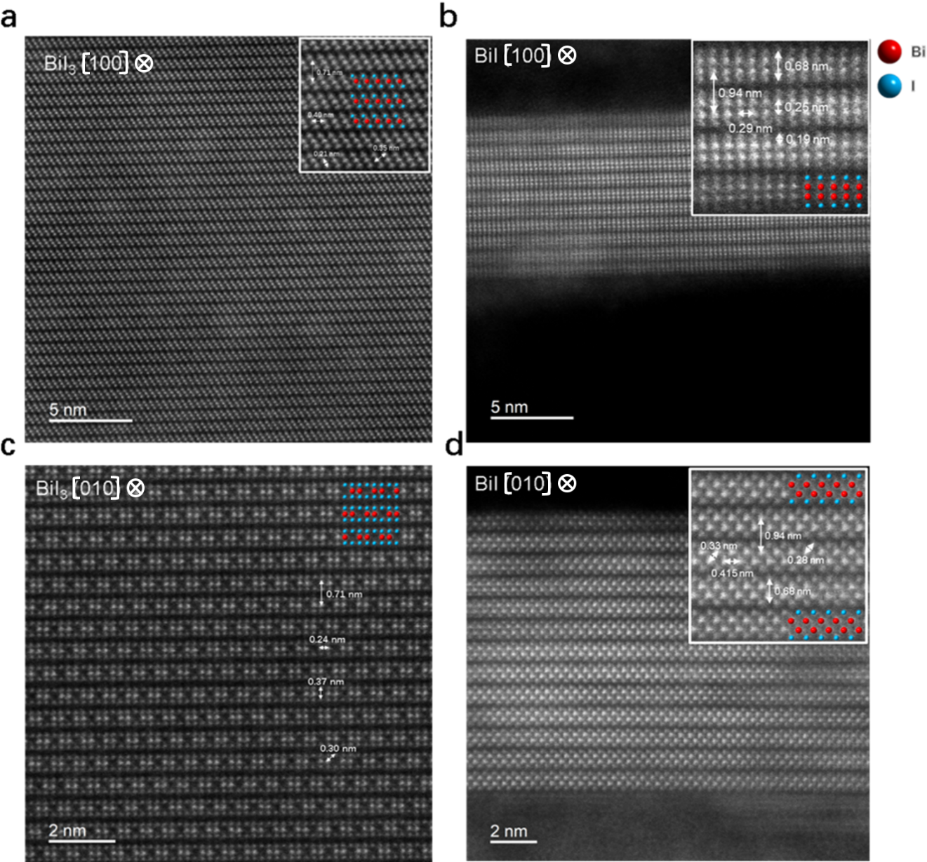
Fig. S6 ｜a-d, HAADF-STEM images of BiI₃ and BiI structure viewed along the [100] zone axis (a, b) and the [010] zone axis (c, d).

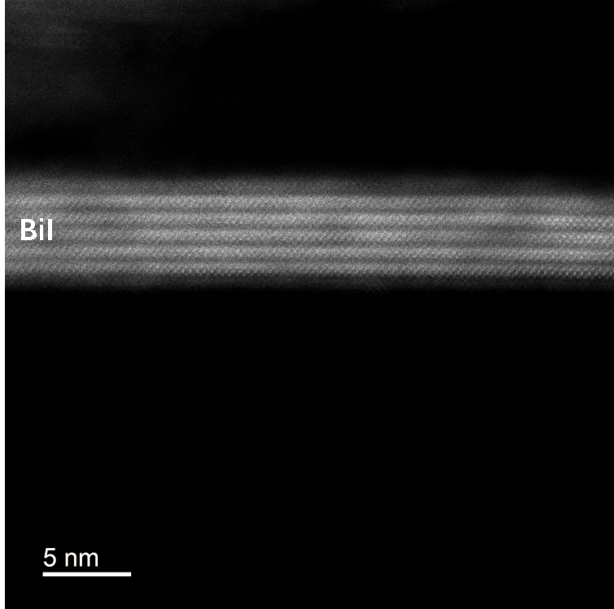
Fig. S7 ｜HAADF-STEM image of an exfoliated BiI film with 7 I-Bi-Bi-I layers.

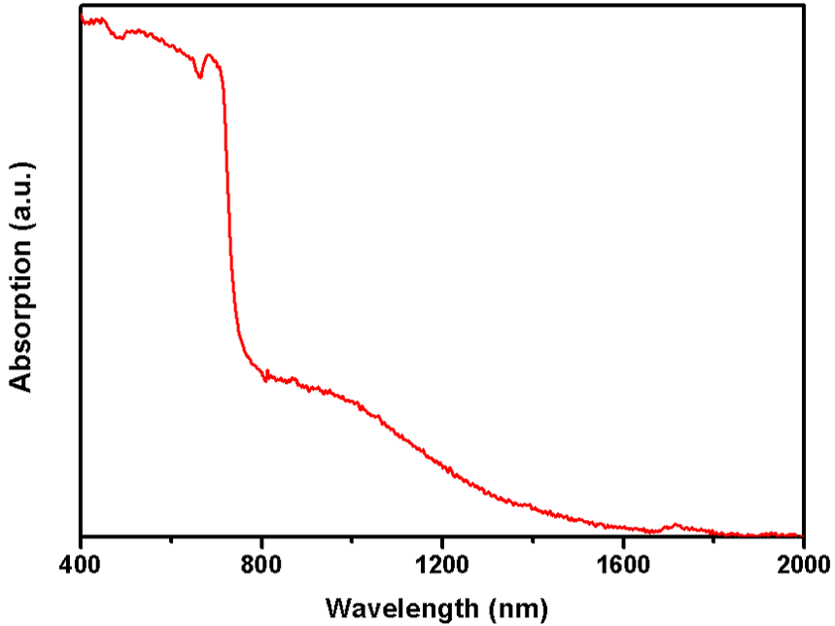

Fig. S8 ｜Absorption spectrum of Bi_{x}I_{y}.

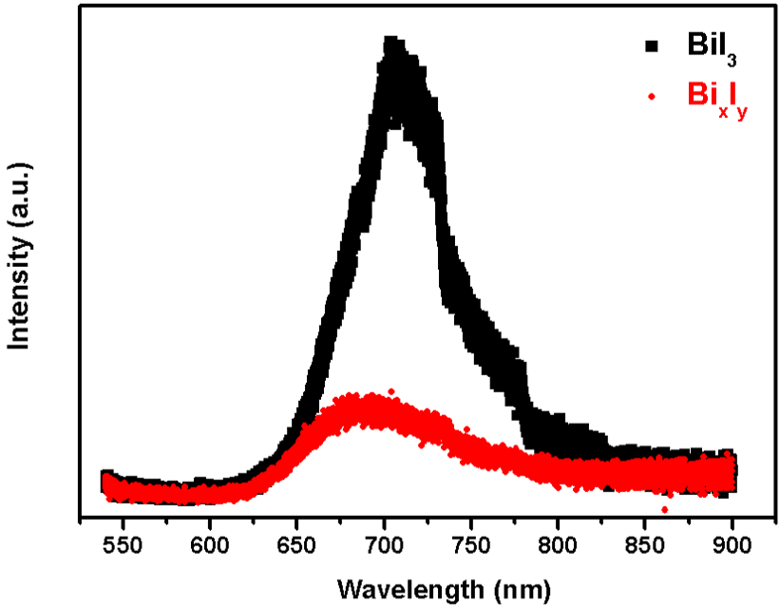
Fig. S9 ｜Photoluminescence spectrum of the BiI₃ and Bi_{x}I_{y}.

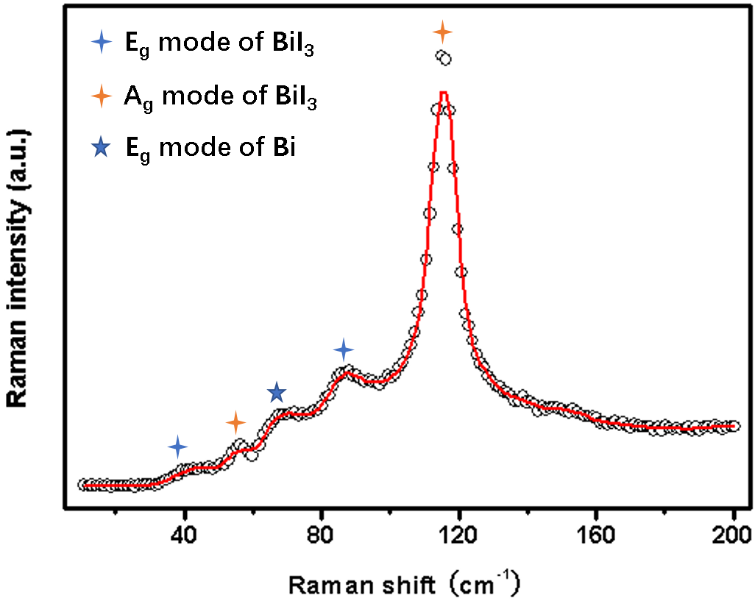
Fig. S10 ｜Raman spectrum of the Bi_{x}I_{y}.

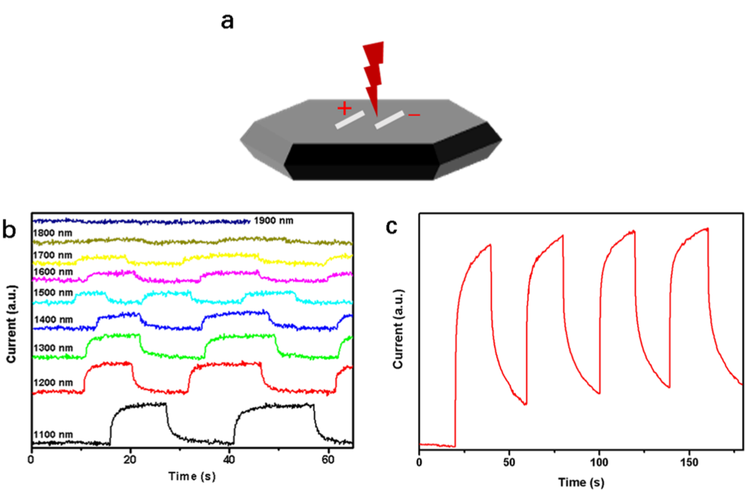
Fig. S11 ｜photo response of the Bi_{x}I_{y}. a, A planar-type Ag/Bi_{x}I_{y}/Ag photodetector made on the (001) surface of Bi_{x}I_{y}. b, Infrared on/off responses from 1100-1900 nm. c, On/off responses under ambient light.

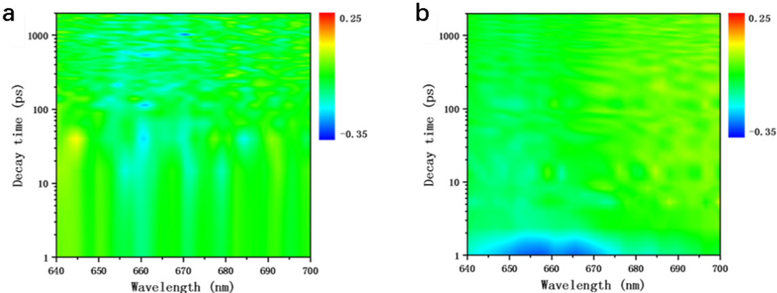
Fig. S12 ｜Transient absorption spectra of Bi_{x}I_{y} (a) and BiI₃ (b).

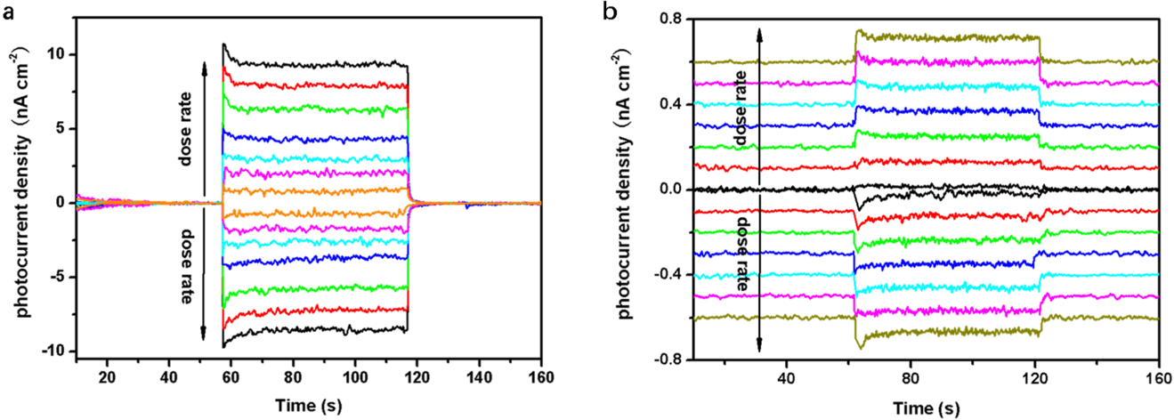
Fig. S13 ｜On/off x-ray responses of the lateral device (a) and vertical device (b) at different dose rates measured by cavity-edge configuration at room temperature.

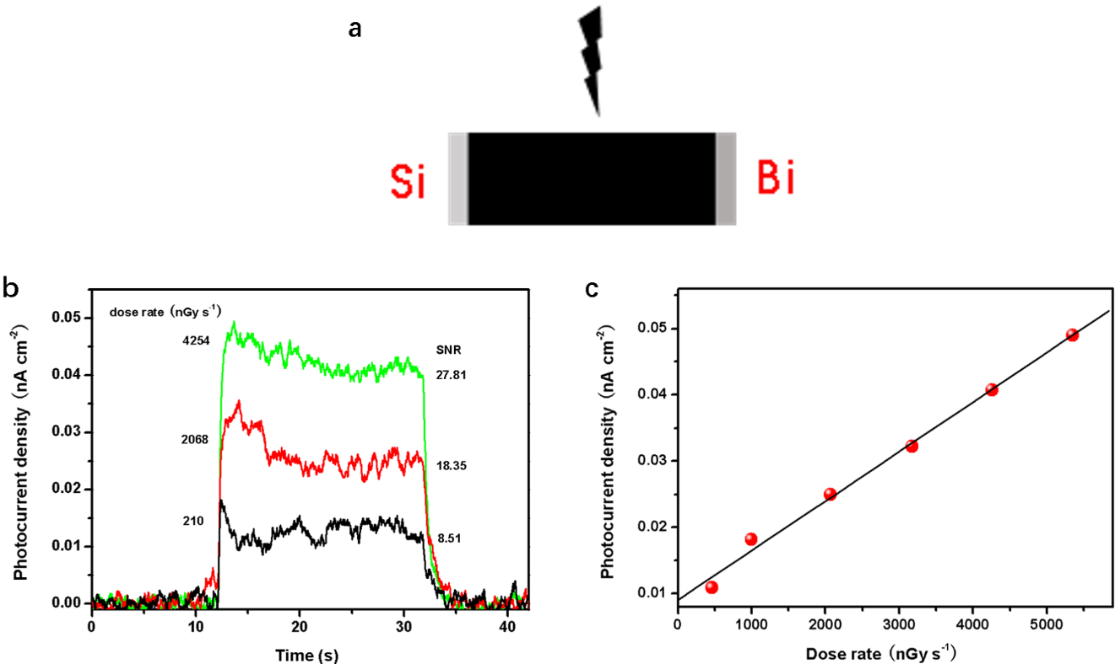
Fig. S14 ｜Room temperature self-powered device. a, A Si/Bi_{x}I_{y}/Bi detector configuration. The Si and Bi electrodes were prepared by mixed the ground Si and Bi powders with the supernatant of silver paste. b, On/off responses of the Si/Bi_{x}I_{y}/Bi detector at different dose rates under zero bias measured by cavity-edge configuration. c, X-ray photocurrent densities of self-powered device at different dose rates measured by cavity-edge configuration. The sensitivity of 7.5 μC Gy⁻¹ cm⁻² was obtained from the current-dose rate relations.

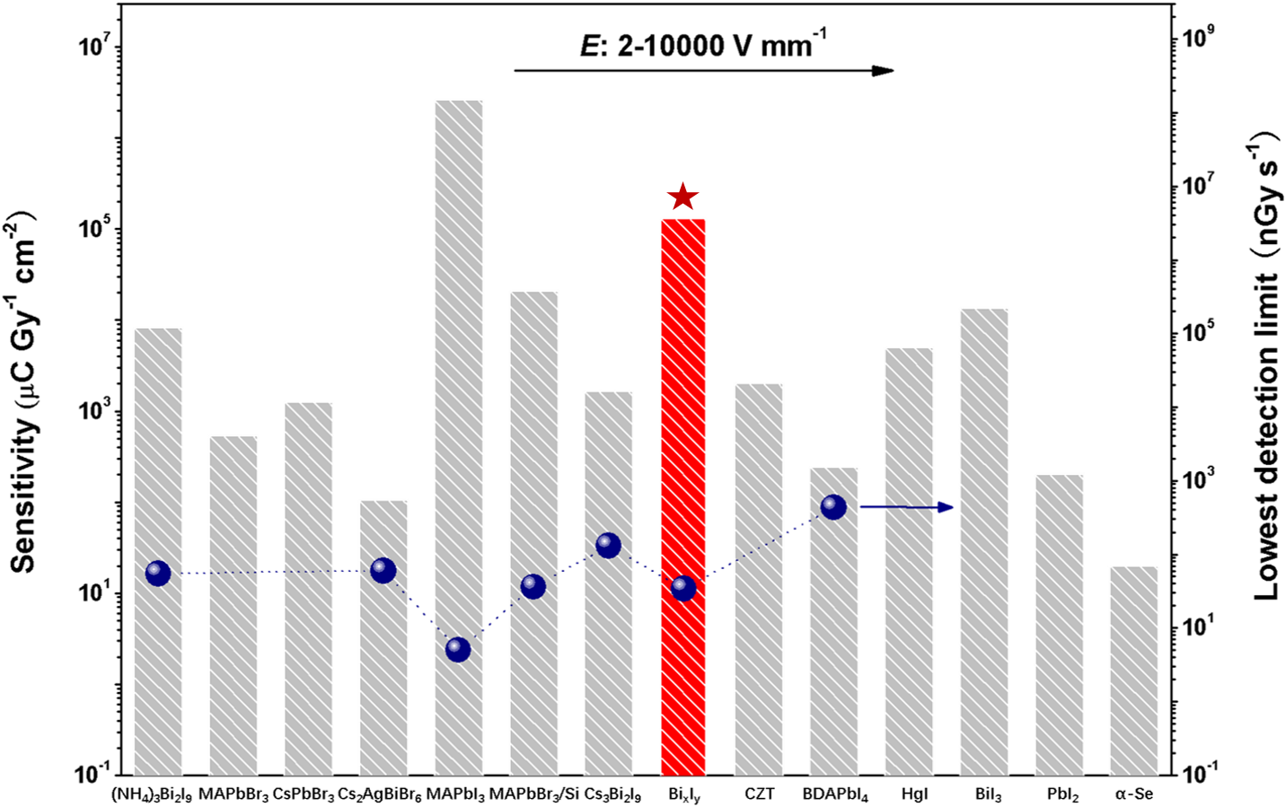
Fig. S15 ｜Comparison of the x-ray detection sensitivities of the Bi_{x}I_{y} detector in this work with some traditional (CdZnTe, PbI₂, HgI₂, α-Se³⁸) and recently reported (MAPbBr₃³⁹, MAPbBr₃/Si⁴⁰, CsPbBr₃, Cs₂AgBiBr₆⁴¹, MAPbI₃⁸, BDAPbI₄⁴², Cs₃Bi₂I₉⁹, (NH₄)₃Bi₂I₉⁷) detectors. Data for CdZnTe, PbI₂, HgI₂ and CsPbBr₃ were extracted from ref. 43.

