Supplemental Information

Title
Efficient management of the nitritation-anammox microbiome through intermittent aeration: Loss of the NOB guild and expansion and diversity of the NOx reducing guild suggests a highly reticulated nitrogen cycle.

Authors
Alejandro Palomo¹, Bruna Daniela Azevedo da Silva¹, María Touceda Suárez¹, Carlos Domingo Félez¹, A. Gizem Mutlu¹, Arnaud Dechesne¹, Yulin Wang², Tong Zhang², Barth F. Smets¹
¹ Microbial Ecology and Technology Lab, Department of Environmental Engineering, Technical University of Denmark, Kgs Lyngby, DK
² Environmental Microbiome Engineering and Biotechnology Laboratory, Department of Civil Engineering, The University of Hong Kong, Hong Kong SAR, People’s Republic of China

Reactor operation/performance summary
The PNA reactor was a sequencing batch reactor with 8-hour cycles consisting of anoxic feeding, reaction with continuous mechanical stirring and intermittent aeration, settling, discharge, and idle phases, with a hydraulic retention time of 16 hours. The seeding biomass originated from a full-scale moving bed biofilm reactor treating anaerobic digester supernatant via PNA (ANITA Mox). The reactor was fed an anoxic synthetic medium modified after [1] with deionised water and NH₄HCO₃ as the sole energy source, at a volumetric loading of 750 mg N/L·day. The solids retention time was set to 100 days by daily manual wasting of mixed reactor biomass. The oxygen to ammonium loading was nominally 1.09 g O₂/g N, increased to 1.20 g O₂/g N during the final high frequency period to regain TN-removal efficiency while dissolved oxygen concentration was below detection limit throughout. The reference aeration frequency of 3, length of aerated/non-aerated period and the air flow rate were attained during 19-month operation following an aeration regimen based start-up protocol. The reactor was operated at 30ºC. Nitrogen species NH₄⁺, NO₂⁻, NO₃ ⁻ were monitored for all the cycles and throughout one cycle at the end of each frequency setting period to determine the performance per cycle and during redox cycling. In-cycle liquid NO and N₂O levels were also monitored per frequency setting period.
Nitrite accumulation and N₂O production were observed during aerated periods, overall both decreased with increasing frequency. Average aggregate size increased and settling properties (SVI_{5/30}) improved with increasing aeration frequency. Based on 16S rRNA gene targeted qPCR and FISH, the community architecture switched from size-segregated AOB (<90µm) and AnAOB (>90µm) with bi-modal aggregate size distribution to uni-modal stratified AOB-AnAOB coaggregates. Other (non-autotrophic) guilds had initially higher abundance in <90µm size fraction, with increasing aeration frequency their relative abundance increased in all size fractions.

Table S1. Quality of the recovered metagenome assembled genomes (attached xl spreadsheet)
Table S2 Overview of the genetic content of the recovered genomes (attached xl spreadsheet)
Table S3. Reads per million (RPM) mapped against AnAOB and canonical nxrA.
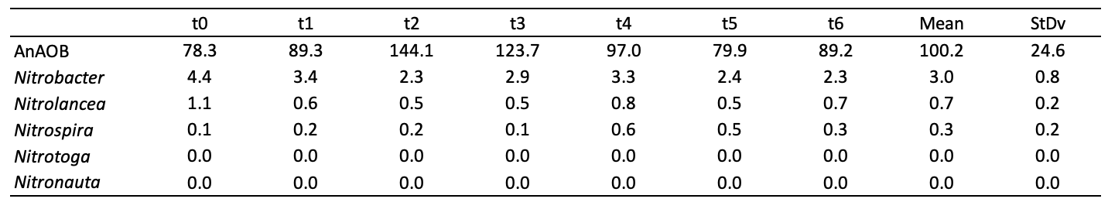

PCR for pyrosequencing
Ten nanograms of extracted DNA was PCR amplified using Phusion (Pfu) DNA polymerase (Finnzymes, Finland) and 16S rRNA gene-targeted universal primers PRK341F (5'-CCTAYGGGRBGCASCAG-3') and PRK806R (5'- GGACTACNNGGGTATCTAAT-3') (Yu et al. 2005). PCR was performed as described elsewhere [2]. The adapter- and sample-specific tag addition and pyrosequencing were done as described previously [3].
Bioinformatic analysis
All raw 16S rRNA sequence were processed in QIIME [4]. Chimera removal and denoising were performed with Ampliconnoise [5]. Sequences were quality trimmed and clustered into operational taxonomic units (OTUs) using a 97% identity threshold with uclust [6]. These OTUs were aligned against the Greengenes reference set (DeSantis et al. 2006) using the Pynast algorithm[7]. Taxonomy assignment of each representative sequence was implemented using the BLAST algorithm against the Silva 108 curated database [8]. Graphical visualisation of taxonomic composition was done with “phyloseq” package in R environment [9].
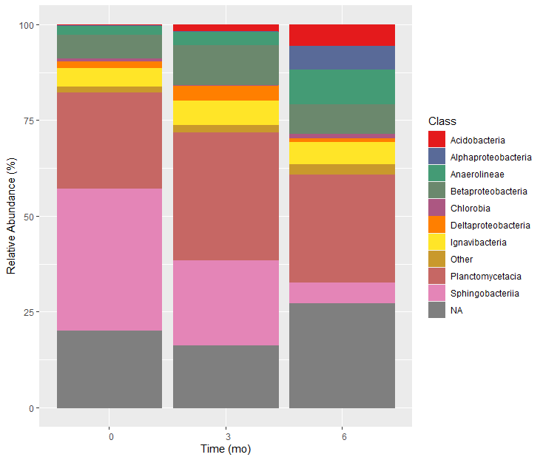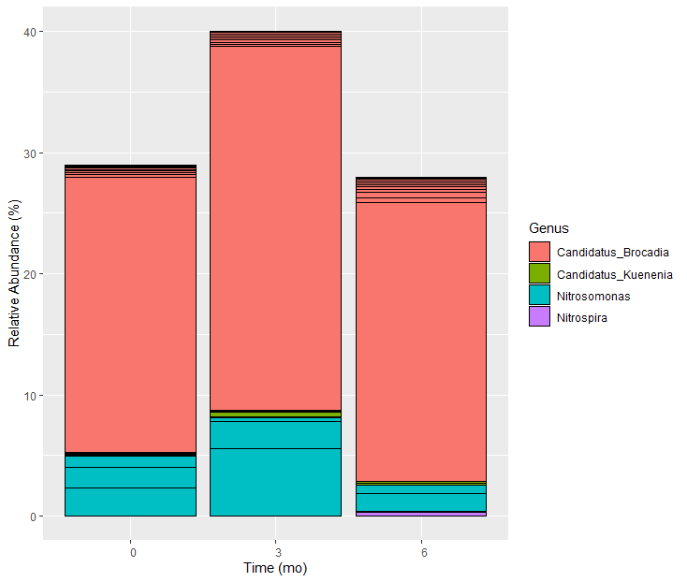
Figure S1 16S rRNA amplicon-inferred community composition at time 0, 3, 6 months for total community (left) and the AOB and NOB-oxidizing guilds (right)

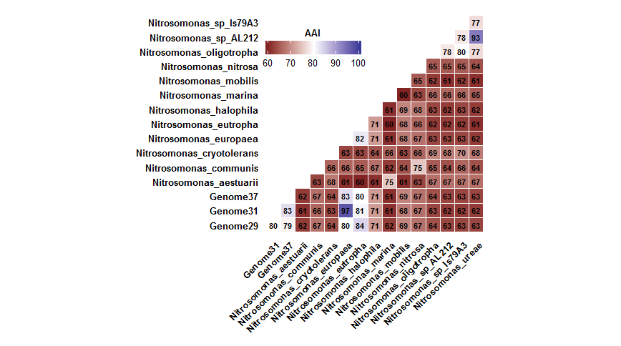
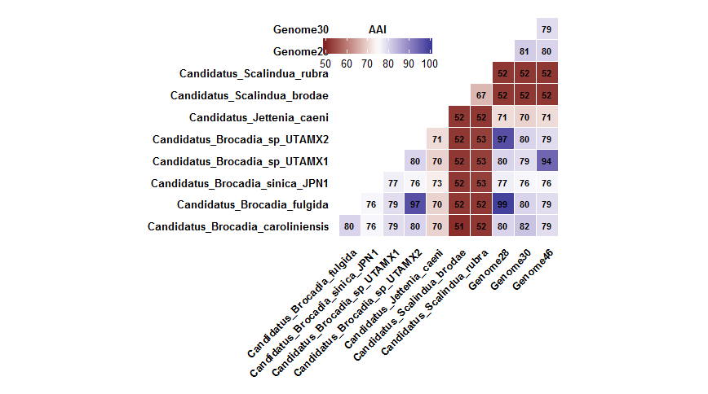
Genome 37- AOB3
Genome 31- AOB2
Genome 29- AOB1
Genome 28 - AMX1
Genome 30 - AMX2
Genome 46 - AMX3
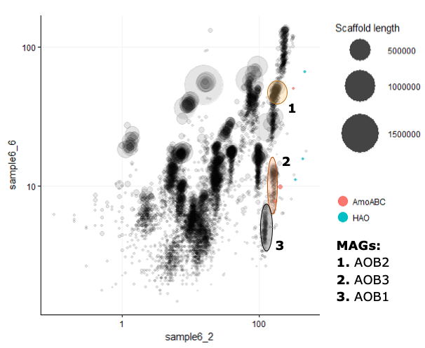
Figure S2 Pairwise AAI comparison of retrieved AeAOB and AnAOB MAGs against reference species.
Figure S3 Differential coverage plot of sample6 using two different subsamples of the total reads. amo and hao genes are highlighted and the Nitrosomonas genomes position identified.
The AMO operon was solely detected in AOB3 MAG, and not in AOB1 and AOB2. Similarly, no AOB MAG contained the HAO operon. However, three AMO and HAO operons where found when searching the whole metagenome, instead of only the recovered MAGs. A likely explanation is that the typical presence of 2-3 almost identical copies of the amo and hao genes in Nitrosomonas spp. [10] can result in a singular unique copy during de novo assembly. This results in artificially increased sequencing depth of the mentioned unique assembled operons. As this genomic region then has a higher depth than the rest of the genome proper binning is not possible when differential coverage binning methods are used (as in this study) [11]. In fact, when the AMO and HAO operons were highlighted in a differential coverage plot, both genomic regions were closely placed to the AOB bins (Fig. S3). Therefore, we concluded that the missing operons in the AOB MAGs are artefacts and that each MAG harbours the AMO and HAO operons.

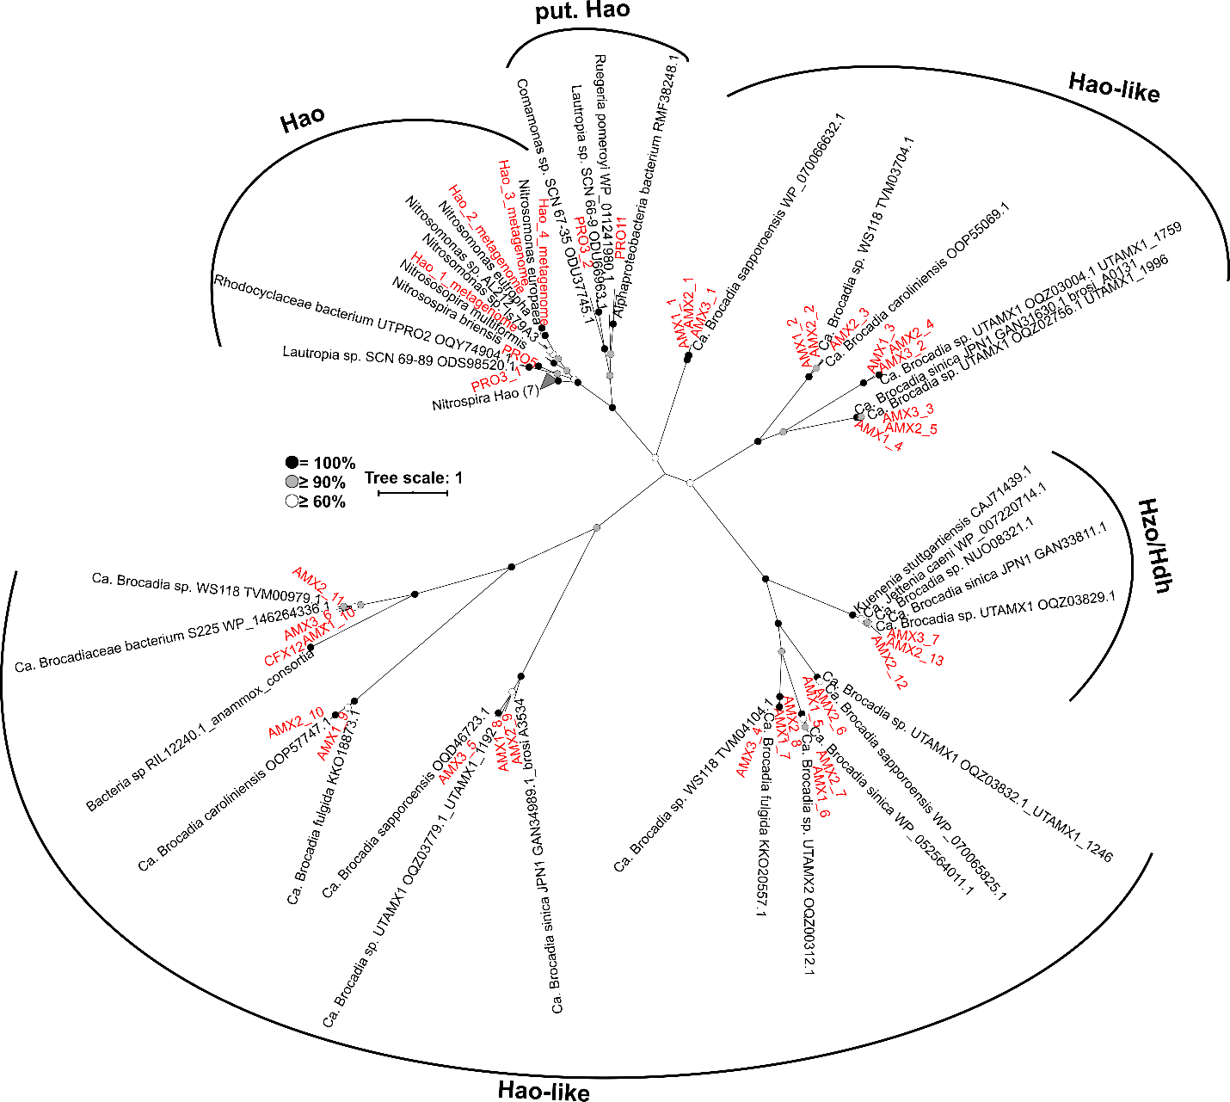Figure S4 Phylogeny of the retrieved hao and hao-like genes
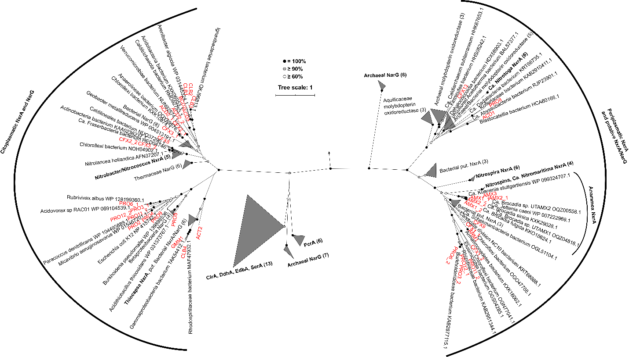Figure S5 Phylogeny of the retrieved nxr and nxr-like genes

Figure S6. Relation between completeness of biosynthetic pathways for amino acid and B-vitamins across MAGs, MAG completeness, and MAG abundance.

References
1. van de Graaf AA, Mulder A, de Bruijn P, Jetten MS, Robertson LA, Kuenen JG. Anaerobic oxidation of ammonium is a biologically mediated process. Appl Env Microbiol 1995; 61: 1246–1251.
2. Pellicer-Nàcher C, Sun S-PS, Lackner S, Terada A, Schreiber F, Zhou Q, et al. Sequential Aeration of Membrane-Aerated Biofilm Reactors for High-Rate Autotrophic Nitrogen Removal: Experimental Demonstration. Environ Sci Technol 2010; 44: 7628–7634.
3. Farnelid H, Andersson AF, Bertilsson S, Al-Soud WA, Hansen LH, Sørensen S, et al. Nitrogenase Gene Amplicons from Global Marine Surface Waters Are Dominated by Genes of Non-Cyanobacteria. PLoS One 2011; 6: e19223.
4. Caporaso JG, Kuczynski J, Stombaugh J, Bittinger K, Bushman FD, Costello EK, et al. QIIME allows analysis of high- throughput community sequencing data Intensity normalization improves color calling in SOLiD sequencing. Nat Publ Gr 2010; 7: 335–336.
5. Quince C, Lanzen A, Davenport RJ, Turnbaugh PJ. Removing Noise From Pyrosequenced Amplicons. BMC Bioinformatics 2011; 12: 38.
6. Edgar RC. Search and clustering orders of magnitude faster than BLAST. Bioinformatics 2010; 26: 2460–2461.
7. Caporaso JG, Bittinger K, Bushman FD, DeSantis TZ, Andersen GL, Knight R. PyNAST: a flexible tool for aligning sequences to a template alignment. Bioinformatics 2010; 26: 266–267.
8. Pruesse E, Quast C, Knittel K, Fuchs BM, Ludwig W, Peplies J, et al. SILVA: a comprehensive online resource for quality checked and aligned ribosomal RNA sequence data compatible with ARB. Nucleic Acids Res 2007; 35: 7188–7196.
9. McMurdie PJ, Holmes S. Phyloseq: An R Package for Reproducible Interactive Analysis and Graphics of Microbiome Census Data. PLoS One 2013; 8.
10. Kozlowski JA, Stieglmeier M, Schleper C, Klotz MG, Stein LY. Pathways and key intermediates required for obligate aerobic ammonia-dependent chemolithotrophy in bacteria and Thaumarchaeota. ISME J 2016; 10: 1836–1845.
11. Zhou W, Chen T, Zhao H, Eterovic AK, Meric-Bernstam F, Mills GB, et al. Bias from removing read duplication in ultra-deep sequencing experiments. Bioinformatics 2014; 30: 1073–1080.

