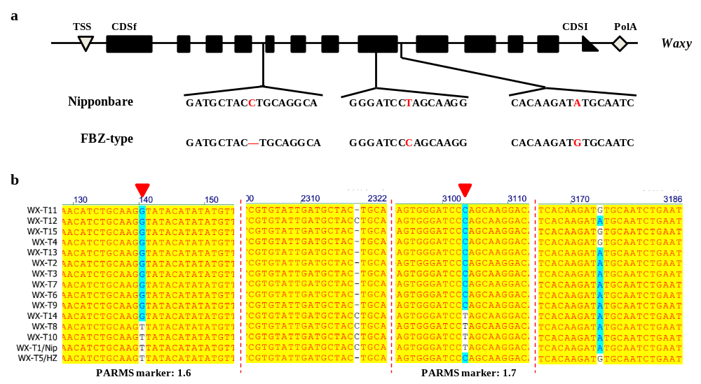
Additional file 1: Figure S1. Sequence features of FBZ-type allele in coding regions of the Waxy gene.
a. Comparison of Waxy gene sequence between Nipponbare (Wx-b) and Huazhan (FBZ-type allele). High-quality genome of Huazhan (Zhang et al., 2021) was used for extracting gene sequence of FBZ-type allele. b. Sequence alignment analysis of multiple haplotypes of Waxy. The red filled arrows SNP mutation sites are used for designing PARMS markers 1.6 and 1.7.

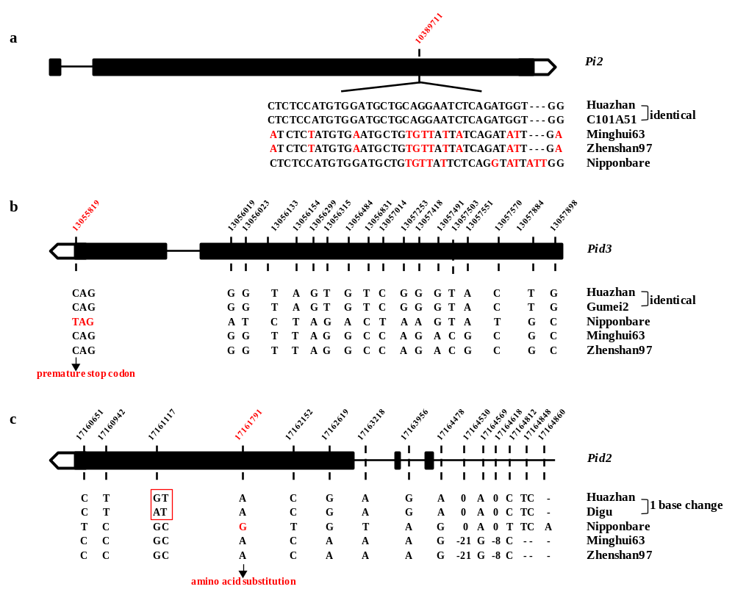
Additional file 1: Figure S2. Sequence analysis of Pi2, Pid3 and Pid2 in Huazhan.
a. Functional variation site of Pi2. b. Sequence features of Pid3 in Huazhan. c. Sequence features of Pid2 in Huazhan. High-quality genome of Huazhan (Zhang et al. 2021), Minghui63 and Zhenshan97 (Zhang et al., 2016) were used for sequence extraction. Genomic DNA sequences in cvs. C101A51 (Pi2-carrying line), Gumei2 (Pid3-carrying line), Digu (Pid2-carrying line) and Nipponbare were retrieved from Genbank. Positions in red represent functional polymorphic sites.
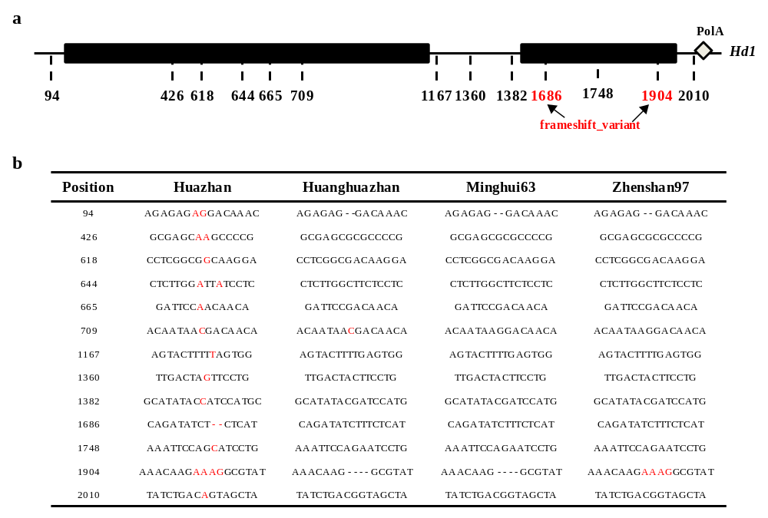
Additional file 1: Figure S3. Sequence features of the Hd1 locus in Huazhan and Huanghuazhan.
High-quality genome of Huazhan (Zhang et al., 2021) , Minghui63 and Zhenshan97 (Zhang et al., 2016) were used for extracting sequence extraction. Hd1 sequence of Huanghuazhan was extracted from MBKbase database (Peng et al., 2019). Position 1686 and 1904 are identical to QTN sites of 9338004 and 9338220, respectively.

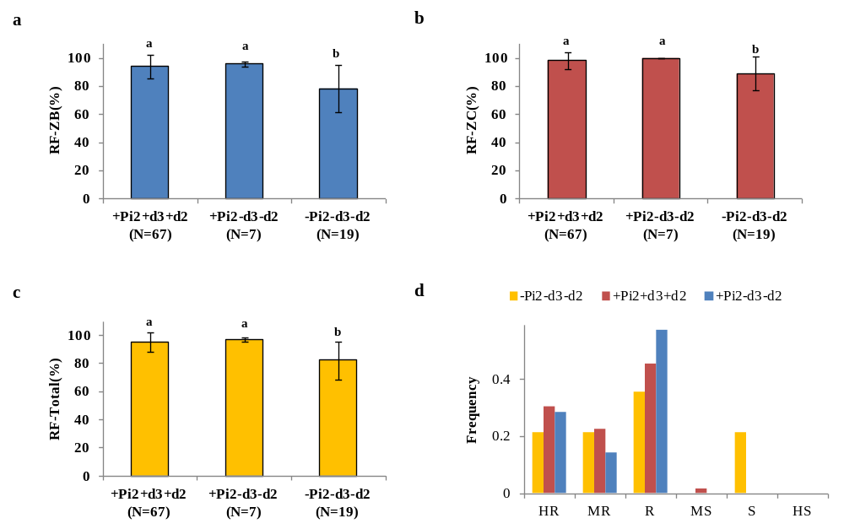
Additional file 1: Figure S4. Effects of the Pi2-Pid3-Pid2 locus on rice blast resistance.
a. ZB group of blast fungus. b. ZC group of blast fungus. c. Total blast fungus. d. Frequency of comprehensive resistance to rice blast. RF, resistance frequency to blast fungus in guangdong province. HS, high susceptible. S, susceptible. MS, moderately susceptible. R, resistant. MR, moderately resistant. HR, high resistant. The presence of different lowercase letter denotes a significant difference between them (P < 0.05).

Additional file 1: Table S1. The most widely planted varieties of conventional indica rice in 1982-2019.
Rank | Variety name | Release year | Area (×10⁴hm²) | Rice quality grade
1 | Zhefu802 | 1980 | 977.8 | Poor quality
2 | Guichao2 | 1976 | 737.9 | Poor quality
3 | Guangluai4 | 1967 | 550.6 | Poor quality
4 | Shuanggui1 | 1979 | 457.7 | Poor quality
5 | Zhongjiazao17 | 2004 | 435.6 | Poor quality
6 | Huanghuazhan | 2005 | 340.6 | Grade 1
7 | Qiguizao25 | 1981 | 290.0 | Poor quality
8 | Erjiuqing | 1969 | 279.7 | Poor quality
9 | Yuchi231-8 | 1975 | 259.0 | Poor quality
10 | Erjiufeng | 1980 | 257.5 | Poor quality
Data was obtained from China Rice Data Center. Rice quality grade was evaluated according to national standard for high quality rice (GB/T 17891-2017).

Additional file 1: Table S2. The top 20 most widely planted hybrid rice varieties in 2019.
Rank | Variety name | Restorer lines | Pedigree | Area (×10⁴ha)
1 | Jingliangyou534 | Wushansimiao | FBZ series | 35.3
2 | Jingliangyouhuazhan | Huazhan | FBZ series | 33.2
3 | Longliangyouhuazhan | Huazhan | FBZ series | 29.6
4 | Taiyou390 | Guanghui390 | Others | 18.2
5 | Longliangyou534 | Wushansimiao | FBZ series | 18.1
6 | Cliangyouhuazhan | Huazhan | FBZ series | 17.3
7 | Huiliangyou898 | YR0822 | FBZ series | 14.5
8 | Yixiangyou2115 | Yahui2115 | Others | 14.2
9 | Tianyouhuazhan | Huazhan | FBZ series | 13.9
10 | Liangyou688 | Nanhui688 | Others | 13.7
11 | Zhongzheyou8 | T-8 | Others | 13.6
12 | Jingliangyou1212 | R1212 | FBZ series | 13.5
13 | Longliangyou1377 | Huangyuesimiao | FBZ series | 12.3
14 | Shenliangyou5814 | Bing4114 | Others | 11.9
15 | Quanyou822 | YR0822 | FBZ series | 10.9
16 | Quanyousimiao | Wushansimiao | FBZ series | 10.3
17 | Yexiangyoulisi | Rlisi | FBZ series | 10.0
18 | Yongyou1540 | F7540 | Others | 9.8
19 | Jingliangyou1377 | Huangyuesimiao | FBZ series | 9.1
20 | Hanyou73 | Hanhui3 | Others | 8.8
Data source: Chinese National Agricultural Technology Extension Service Center (2019).
Additional file 1: Table S3. Approval of FBZ-series varieties in Asian and African countries.
Country | Registered name | Approved year | Variety information
Pakistan | NIBGE GSR-I | 2015 | developed from crosses between Huanghuazhan (recurrent patent) and eight donors
Pakistan | NIBGE GSR-II | 2015
Philippines | GSR 1 | 2014
Philippines | GSR 5 | 2014
Philippines | GSR 5a | 2014
Philippines | GSR 12a | 2015
Philippines | Tubigan 37 | 2016
Philippines | GSR 8 | 2016
Philippines | Salinas 29 | 2018
Philippines | Tubigan 45 | 2018
Philippines | Tubigan 44 | 2018
Vietnam | Gia Loc 501 | 2016
Vietnam | Gia Loc 502 | 2016
Mozambique | Huang-Hua-Zhan | 2014 | identical to Huanghuazhan
India | PR126 | 2017 | identical to Huanghuazhan
Indonesia | Impari 42 Agritan GSR | 2015 | identical to Huanghuazhan
Data source: Wang et al. 2018b.

