Efflux dynamics of the anti-epileptic, levetiracetam, through the P-glycoprotein channel revealed by advanced comparative molecular simulations

Esmaeil Behmard,^{a,b} Ebrahim Barzegari,^{c} Sohrab Najafipour,^{b} Amin Kouhpayeh,^{d} Younes Ghasemi,^{e} Ali A. Asadi-Pooya ^{a,f}
ª Epilepsy Research Center, Shiraz University of Medical Sciences, Shiraz, Iran.
^{b} School of Advanced Technologies in Medicine, Fasa University of Medical Sciences, Fasa, Iran.
^{c} Medical Biology Research Center, Health Technology Institute, Kermanshah University of Medical Sciences, Kermanshah, Iran.
^{d} Department of Pharmacology, Faculty of Medicine, Fasa University of Medical Sciences, Fasa, Iran
^{e} Pharmaceutical Sciences Research Center, Shiraz University of Medical Sciences, Shiraz, Iran.
^{f} Jefferson Comprehensive Epilepsy Center, Department of Neurology, Thomas Jefferson University, Philadelphia, USA.

SUPPLEMENTARY INFORMATION

Table S1: Molecular docking results for the binding of P-gp to zosuquidar
mode | affinity(kcal/mol) | dist from best mode (rmsd l.b.) | dist from best mode(rmsd u.b.)
1 | -9.2 | 0 | 0
2 | -9.1 | 1.098 | 2.020
3 | -8.9 | 2.948 | 5.373
4 | -8.9 | 1.288 | 1.696
5 | -8.7 | 3.491 | 5.978
6 | -8.6 | 3.905 | 6.743
7 | -8.6 | 2.423 | 5.352
8 | -8.5 | 3.590 | 6.013
9 | -8.5 | 3.789 | 6.505
10 | -8.4 | 2.618 | 6.417
11 | -8.2 | 2.948 | 5.893
12 | -8.2 | 2.948 | 4.401
13 | -8 | 3.270 | 6.050
14 | -7.9 | 2.717 | 4.600
15 | -7.9 | 2.553 | 4.011
16 | -7.8 | 2.519 | 4.767
17 | -7.7 | 3.907 | 6.450
18 | -7.7 | 3.357 | 5.568
19 | -7.7 | 3.663 | 5.919
20 | -7.6 | 4.103 | 7.807

Table S2: Molecular docking results for the binding of P-gp to verapamil
mode | affinity(kcal/mol) | dist from best mode (rmsd l.b.) | dist from best mode(rmsd u.b.)
1 | -6.6 | 0 | 0
2 | -6.5 | 1.574 | 2.653
3 | -6.4 | 1.688 | 2.308
4 | -6.3 | 3.658 | 6.177
5 | -6.2 | 1.469 | 5.820
6 | -6.1 | 3.391 | 7.203
7 | -6.1 | 3.177 | 5.755
8 | -6.0 | 2.006 | 2.815
9 | -6.0 | 2.595 | 5.806
10 | -5.9 | 3.517 | 7.982
11 | -5.9 | 2.725 | 4.871
12 | -5.9 | 2.419 | 5.981
13 | -5.9 | 3.681 | 6.966
14 | -5.8 | 2.239 | 6.363
15 | -5.8 | 2.948 | 6.476
16 | -5.7 | 3.507 | 6.664
17 | -5.7 | 3.029 | 6.089
18 | -5.7 | 3.211 | 8.306
19 | -5.6 | 3.634 | 6.097
20 | -5.6 | 2.791 | 5.746

Table S3: Molecular docking results for the binding of P-gp to brivaracetam
mode | affinity(kcal/mol) | dist from best mode (rmsd l.b.) | dist from best mode(rmsd u.b.)
1 | -5.8 | 0 | 0
2 | -5.8 | 2.271 | 4.327
3 | -5.6 | 1.672 | 3.422
4 | -5.5 | 2.744 | 4.376
5 | -5.5 | 3.264 | 4.589
6 | -5.4 | 3.110 | 4.355
7 | -5.3 | 1.986 | 3.178
8 | -5.3 | 2.186 | 4.631
9 | -5.0 | 1.694 | 3.651
10 | -5.0 | 2.050 | 3.099
11 | -5.0 | 2.665 | 3.901
12 | -4.9 | 1.914 | 4.746
13 | -4.9 | 2.418 | 4.009
14 | -4.9 | 1.933 | 4.032
15 | -4.8 | 2.145 | 3.360
16 | -4.7 | 2.465 | 4.411
17 | -4.6 | 2.229 | 3.419
18 | -4.5 | 2.184 | 3.825
19 | -4.5 | 3.278 | 5.461
20 | -4.4 | 2.428 | 3.465

Table S4: Molecular docking results for the binding of P-gp to levetiracetam
mode | affinity(kcal/mol) | dist from best mode (rmsd l.b.) | dist from best mode(rmsd u.b.)
1 | -5.5 | 0 | 0
2 | -5.3 | 1.962 | 4.124
3 | -5.2 | 2.066 | 3.913
4 | -5.1 | 1.527 | 4.244
5 | -5.1 | 2.189 | 3.452
6 | -5.0 | 1.653 | 2.455
7 | -5.0 | 2.335 | 4.690
8 | -5.0 | 2.393 | 2.653
9 | -5.0 | 1.882 | 2.463
10 | -4.9 | 2.532 | 2.993
11 | -4.9 | 2.874 | 4.336
12 | -4.9 | 1.596 | 2.552
13 | -4.8 | 1.966 | 3.856
14 | -4.8 | 1.983 | 2.744
15 | -4.8 | 2.327 | 3.387
16 | -4.7 | 2.894 | 3.538
17 | -4.8 | 2.558 | 4.037
18 | -4.8 | 2.732 | 4.912
19 | -4.6 | 2.023 | 4.642
20 | -4.6 | 2.403 | 3.127

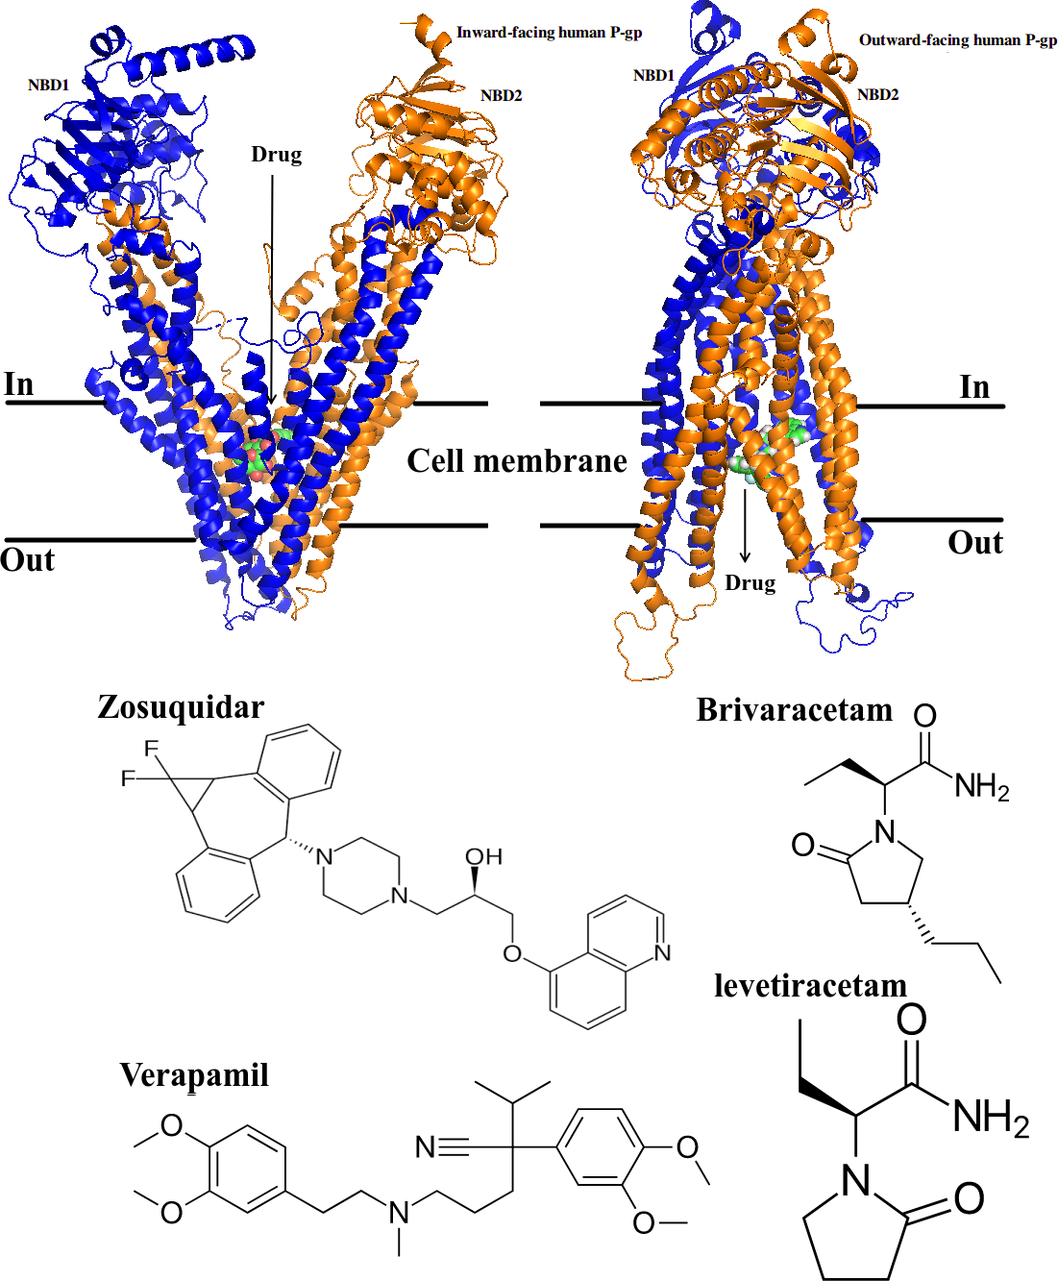
Figure S1: (Top) Structural conformation of the P-glycoprotein channel in the inward-facing (PDB ID: 4F4C) and outward-facing states (PDB ID: 2ONJ). Structurally, the export channel is composed of two homologous halves, each comprising a nucleotide-binding domain (NBD) and a transmembrane domain (TM) [1,2]. According to the ATP-switch model, proposed for the drug transfer process by P-gp, the binding of ATP molecules to NBDs results in domain dimerization. A subsequent conformational change in the TM domains first leads to the exposure of the binding site to enable the substrate binding and then progresses from the inward to the outward side to pump the substrate to the out of the cell. The channel finally resumes its inward-facing conformation, by ATP hydrolysis products leaving the NBDs [1,2]. (Bottom) Molecular structure of the studied drugs.
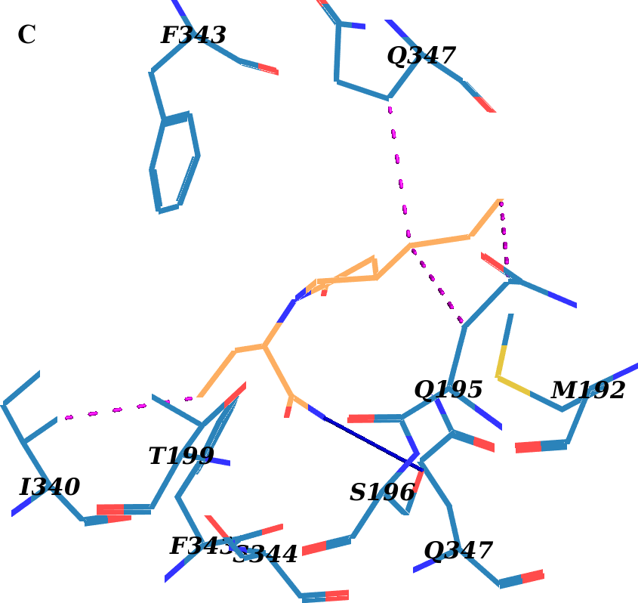
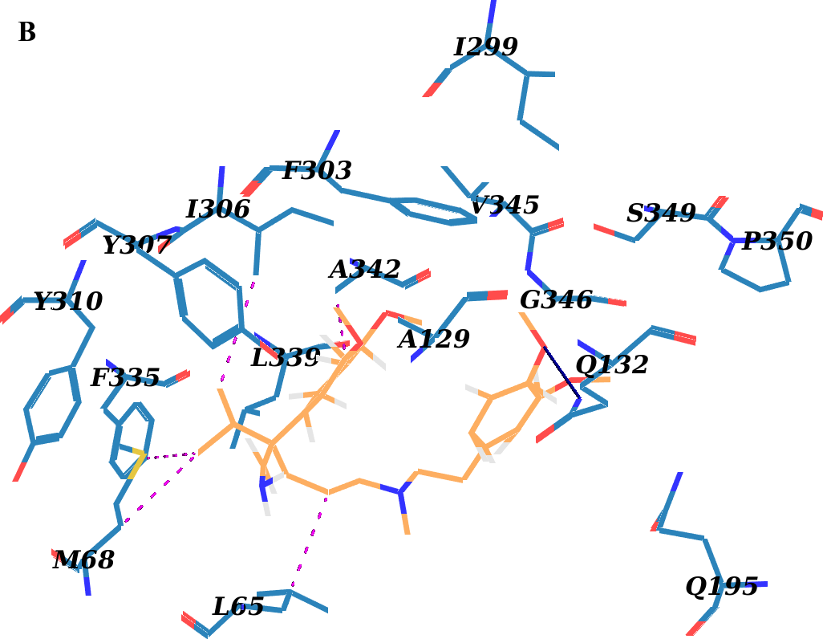
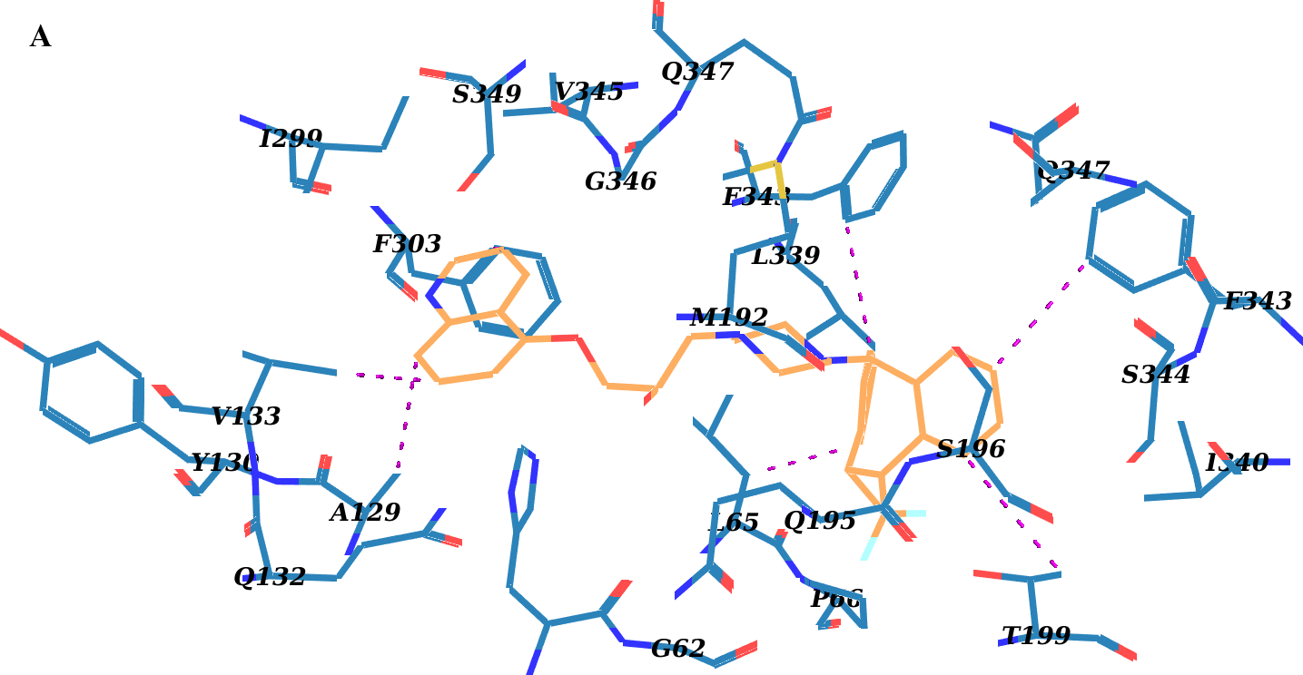
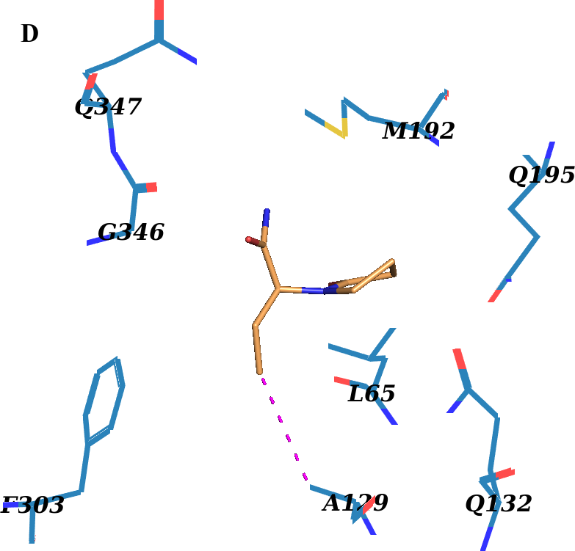
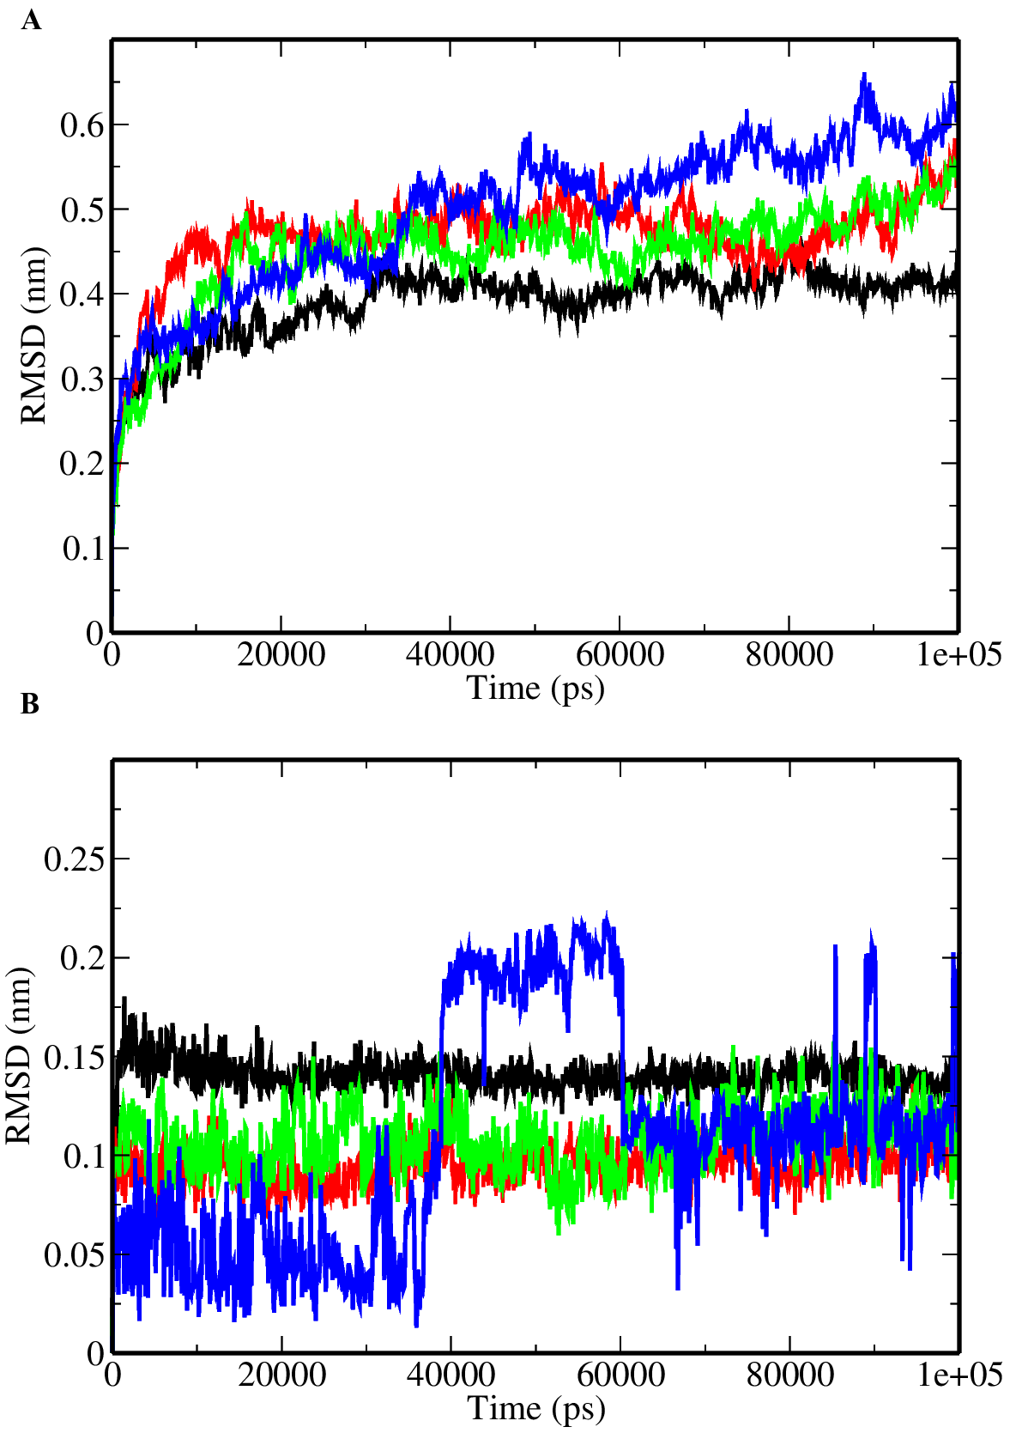
Figure S2: Human P-gp complex with (A) zosuquidar , (B) verapamil, (C) brivaracetam, and (D) levetiracetam, after molecular dynamics simulations. ligands are represented as wheat sticks. The binding pocket residues (blue sticks) are labeled. Hydrogen bonds are shown as blue line, and hydrophobic interactions in magenta dots.

Figure S3: Molecular dynamics simulation analyses for complexes of P-gp with the drugs, zosuquidar (black), verapamil (red), brivaracetam (green) and levetiracetam (blue). (A) The Cα-RMSD graph for P-gp; (B) The heavy-atom RMSD of the drug molecules.

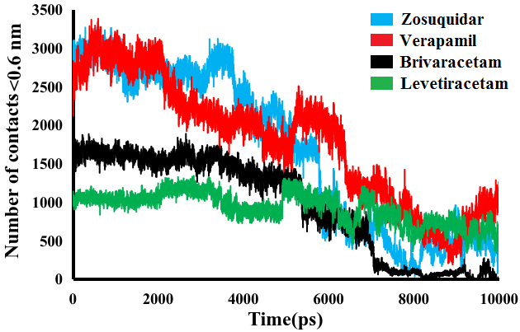
Figure S4: The number of contacts between the studied drugs and the hP-gp channel during steered molecular dynamics.

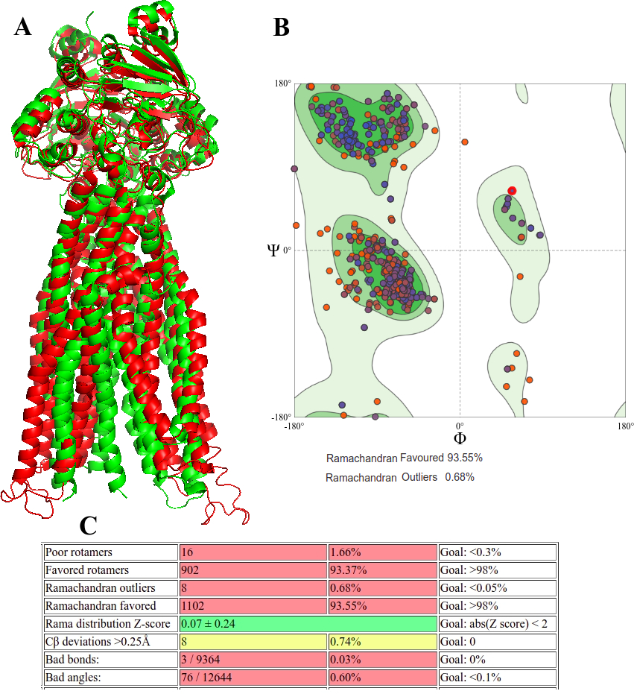
Figure S5: Human P-gp (hP-gp) outward-facing structure was modeled based on the crystal outward-facing structure of a bacterial ABC transporter (S. aureus Sav1866) [3]. (A) The modeled hP-gp structure (red cartoon), was similar to the recently determined cryo-EM structure of hP-gp (green cartoon; PDB ID: 6C0V; RMSD = 2.6 Å) [4], which was identified using partially opened transmembrane domains. Structure assessment was carried out using SWISS-MODEL (B) and MolProbity server (C), showing high qualityy of the built model.

References
- Higgins, C., Linton, K. The ATP switch model for ABC transporters. Nat Struct Mol Biol 11, 918–926 (2004). DOI: 10.1038/nsmb836.
- Urbatsch, I. L., Al-Shawi, M. K., & Senior, A. E. (1994). Characterization of the ATPase activity of purified Chinese hamster P-glycoprotein. Biochemistry, 33(23), 7069-7076. DOI: 10.1021/bi00189a008.
- Dawson, R. J., & Locher, K. P. (2006). Structure of a bacterial multidrug ABC transporter. Nature, 443(7108), 180-185. DOI: 10.1038/nature05155.
- Kim, Y., & Chen, J. (2018). Molecular structure of human P-glycoprotein in the ATP-bound, outward-facing conformation. Science, 359(6378), 915-919. DOI: 10.1126/science.aar7389.

