Supplementary data:
Design, synthesis, and biological evaluation of sartan derivatives
Bertsetseg Dalaijargal¹, Le Mi¹, Zhuo Wu¹, Yao Yin¹, Hongyu Liang¹, Yan Qiu², Yi-Jia Yan¹, Hui Jin²✉, Zhi-Long Chen¹✉
¹Department of Pharmaceutical Science and Technology, College of Chemistry and Biology, Donghua University, Shanghai 201620, China
² Pudong New Area People’s Hospital, Shanghai 201200, China
✉Zhi-Long Chen
zlchen1967@qq.com
Hui Jin
jinhui7002@163.com

Table of contents
ESI-MS spectra of compound 1 | S2
¹H NMR spectra of compound 1 in CDCl3 | S3
¹³C NMR spectra of compound 1 in DMSO-d₆ | S3
ESI-MS spectra of compound 2 | S4
¹H NMR spectra of compound 2 in DMSO-d₆ | S4
¹³C NMR spectra of compound 2 in DMSO-d₆ | S5
ESI-MS spectra of compound 3 | S5
¹H NMR spectra of compound 3 in DMSO-d₆ | S6
¹³C NMR spectra of compound 3 in DMSO-d₆ | S6
ESI-MS spectra of compound 4 | S7
¹H NMR spectra of compound 4 in DMSO-d₆ | S7
¹³C NMR spectra of compound 4 in DMSO-d₆ | S8
ESI-MS spectra of compound 5 | S9
¹H NMR spectra of compound 5 in CDCl3 | S9
¹³C NMR spectra of compound 5 in DMSO-d₆ | S10
ESI-MS spectra of compound 6 | S10
¹H NMR spectra of compound 6 in DMSO-d₆ | S11
¹³C NMR spectra of compound 6 in DMSO-d₆ | S11

Compound 1

ESI-MS spectra of compound 1
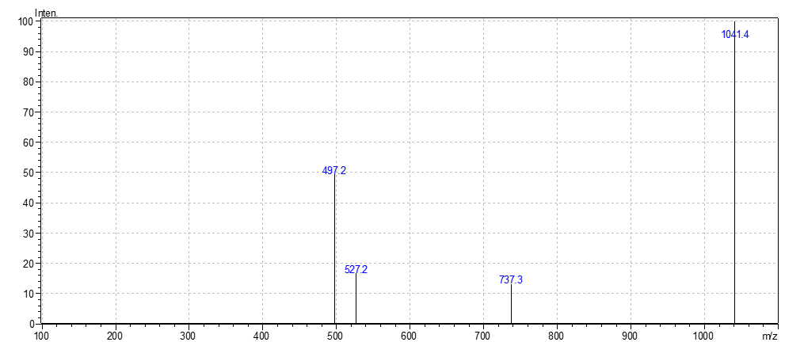
¹H NMR spectra of compound 1 in CDCl₃
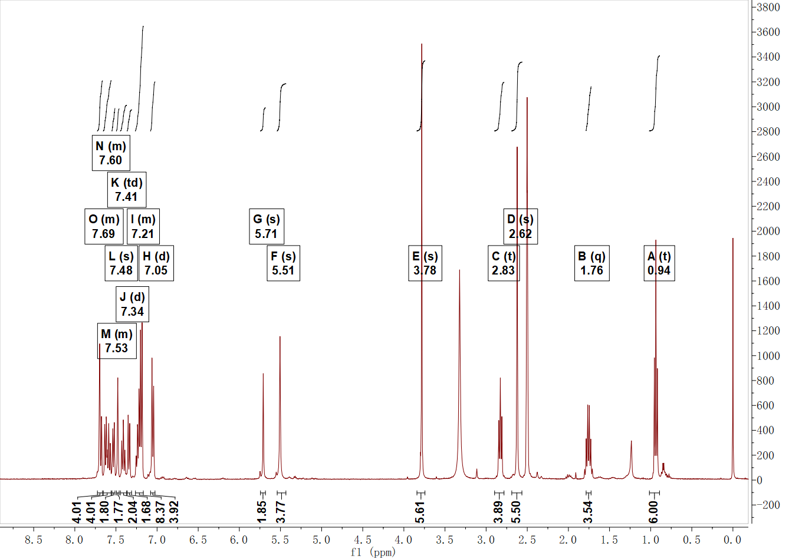
¹³C NMR spectra of compound 1 in DMSO-d₆
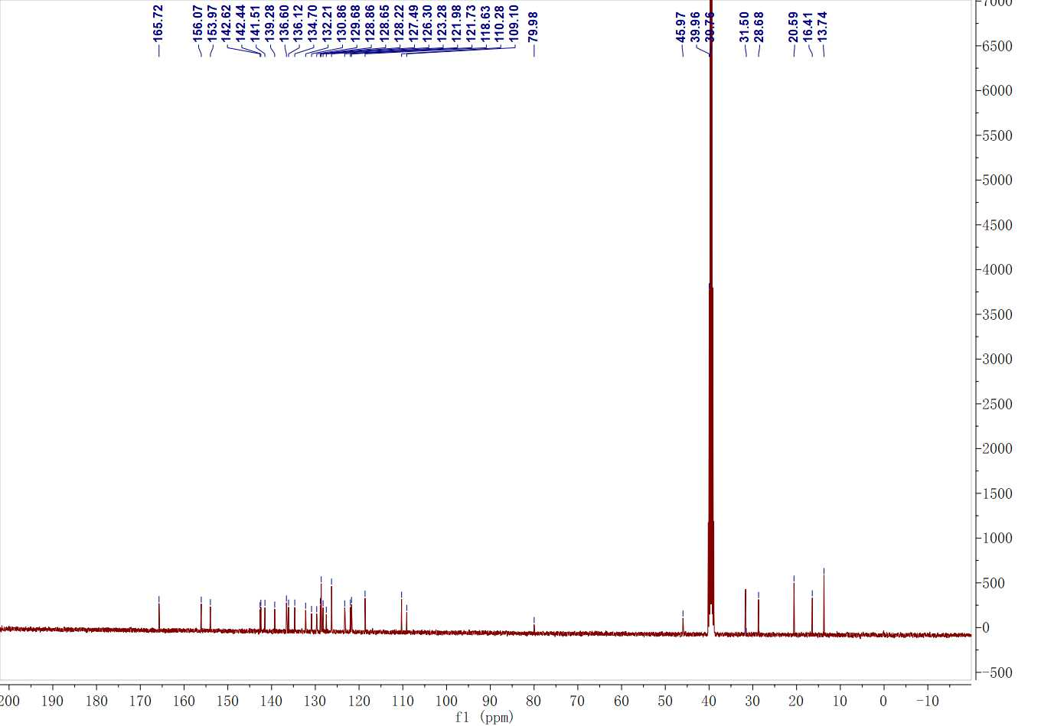

Compound 2

ESI-MS spectra of compound 2
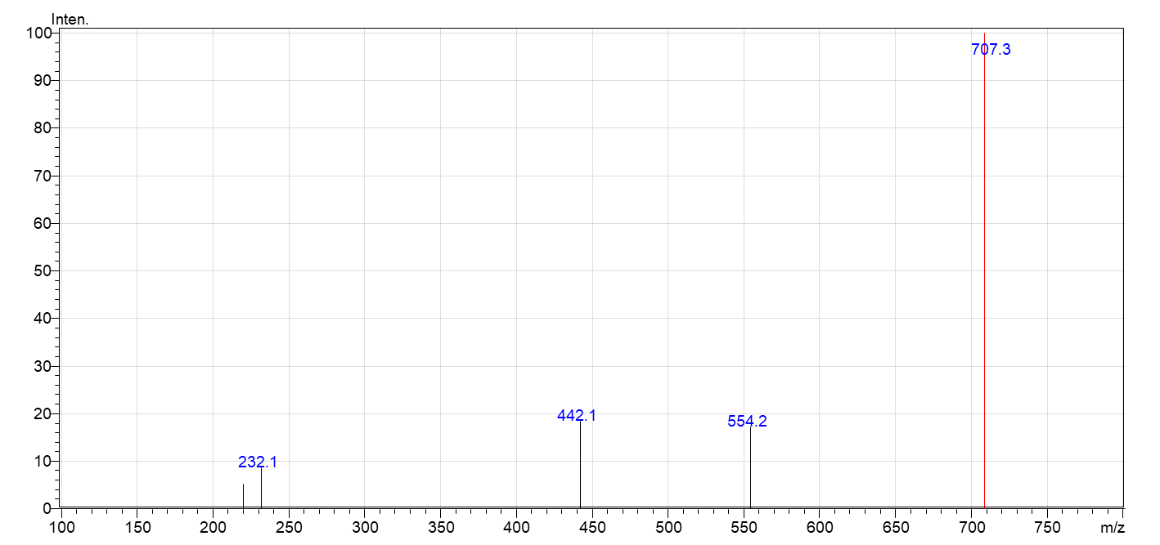
¹H NMR spectra of compound 2 in DMSO-d₆
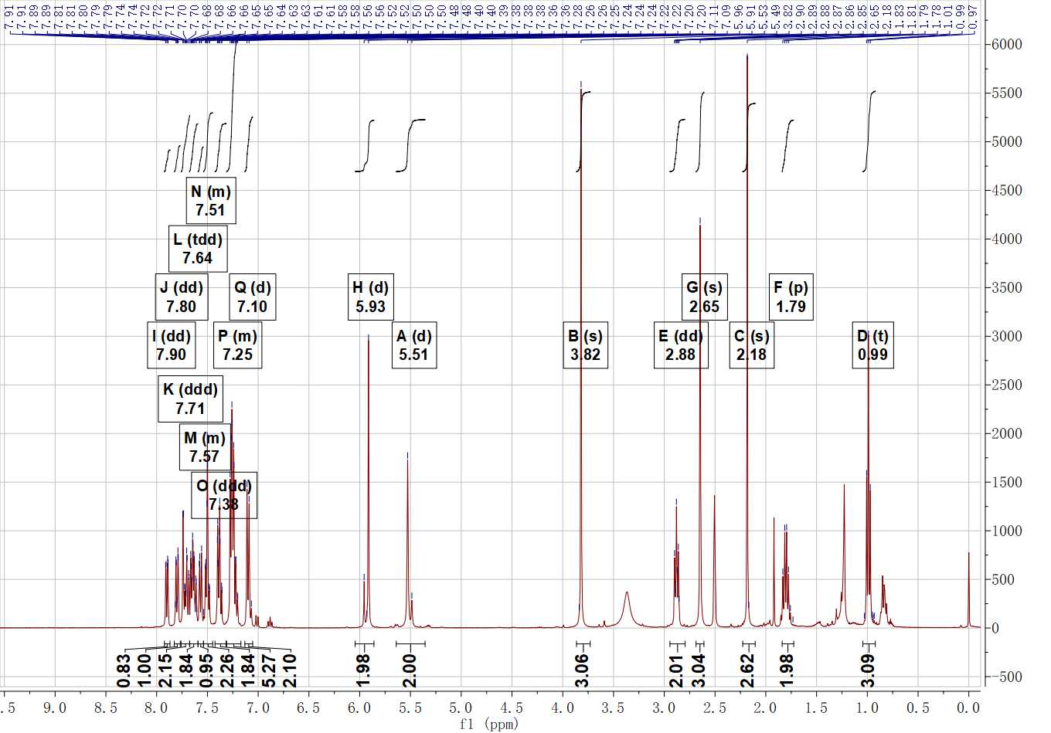
¹³C NMR spectra of compound 2 in DMSO-d₆
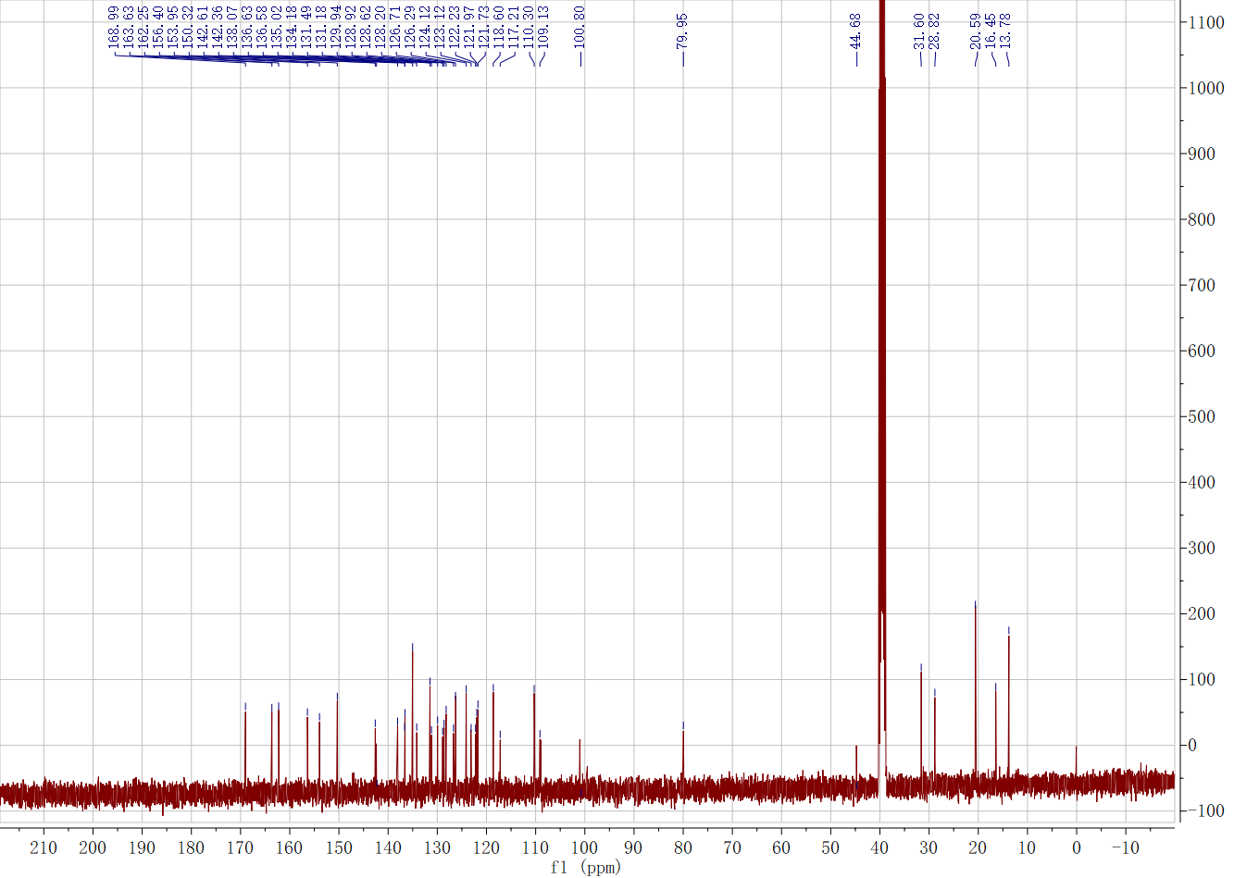

Compound 3
ESI-MS spectra of compound 3
¹H NMR spectra of compound 3 in DMSO-d₆
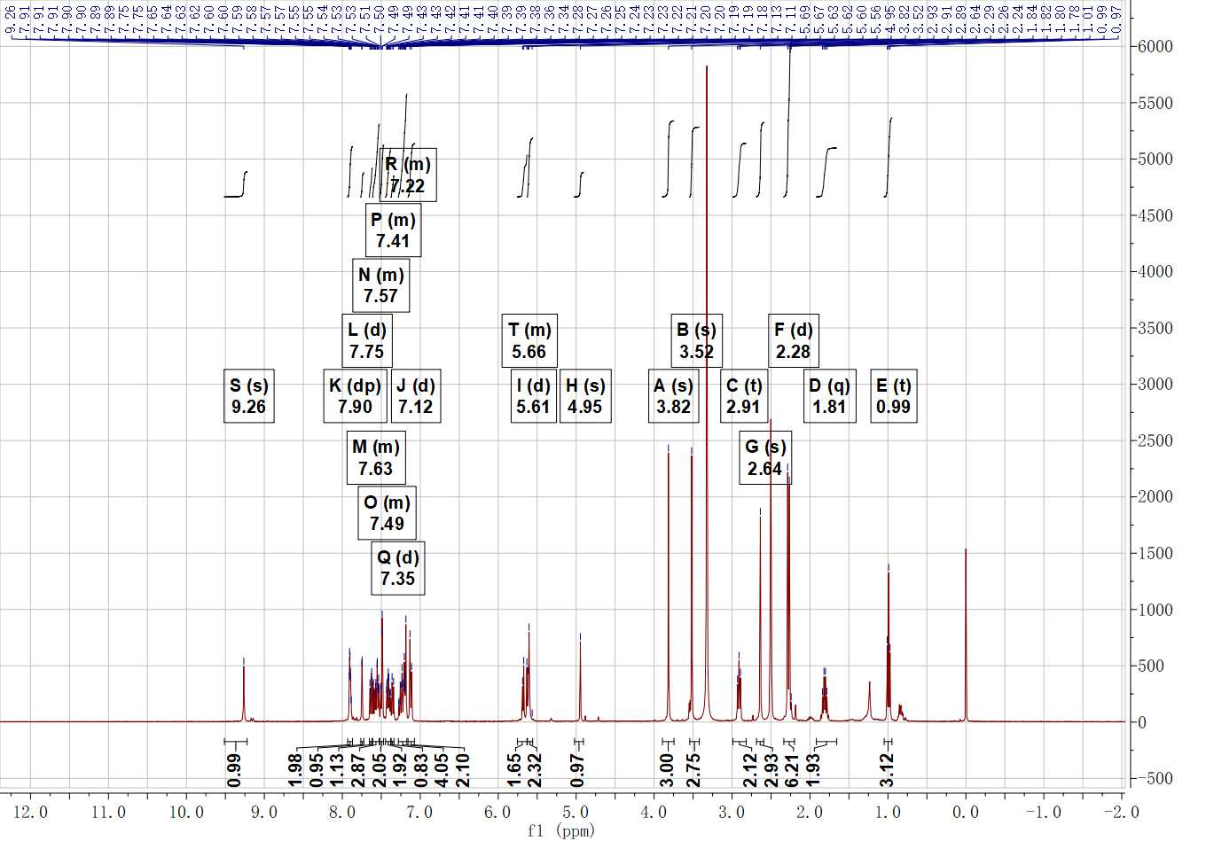

¹³C NMR spectra of compound 3 in DMSO-d₆
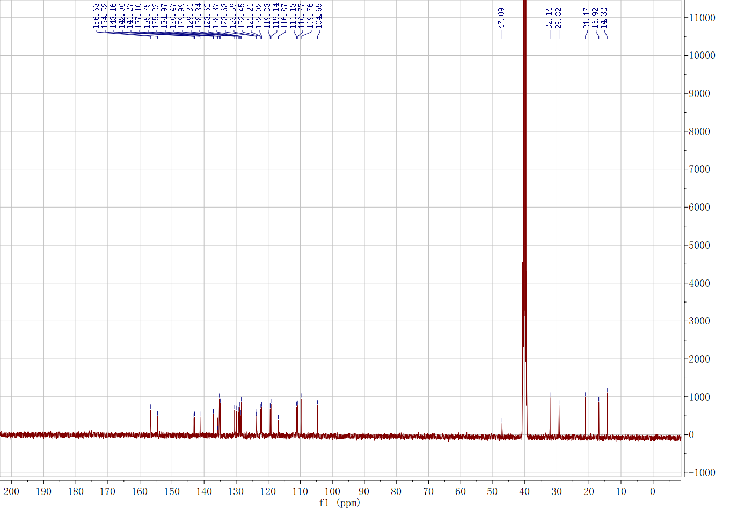

Compound 4
ESI-MS spectra of compound 4
¹H NMR spectra of compound 4 in DMSO-d₆
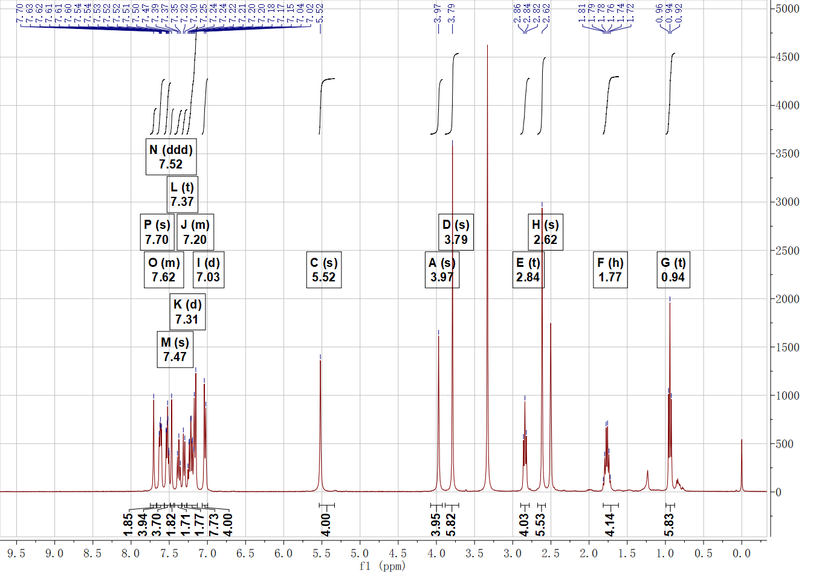
¹³C NMR spectra of compound 4 in DMSO-d₆
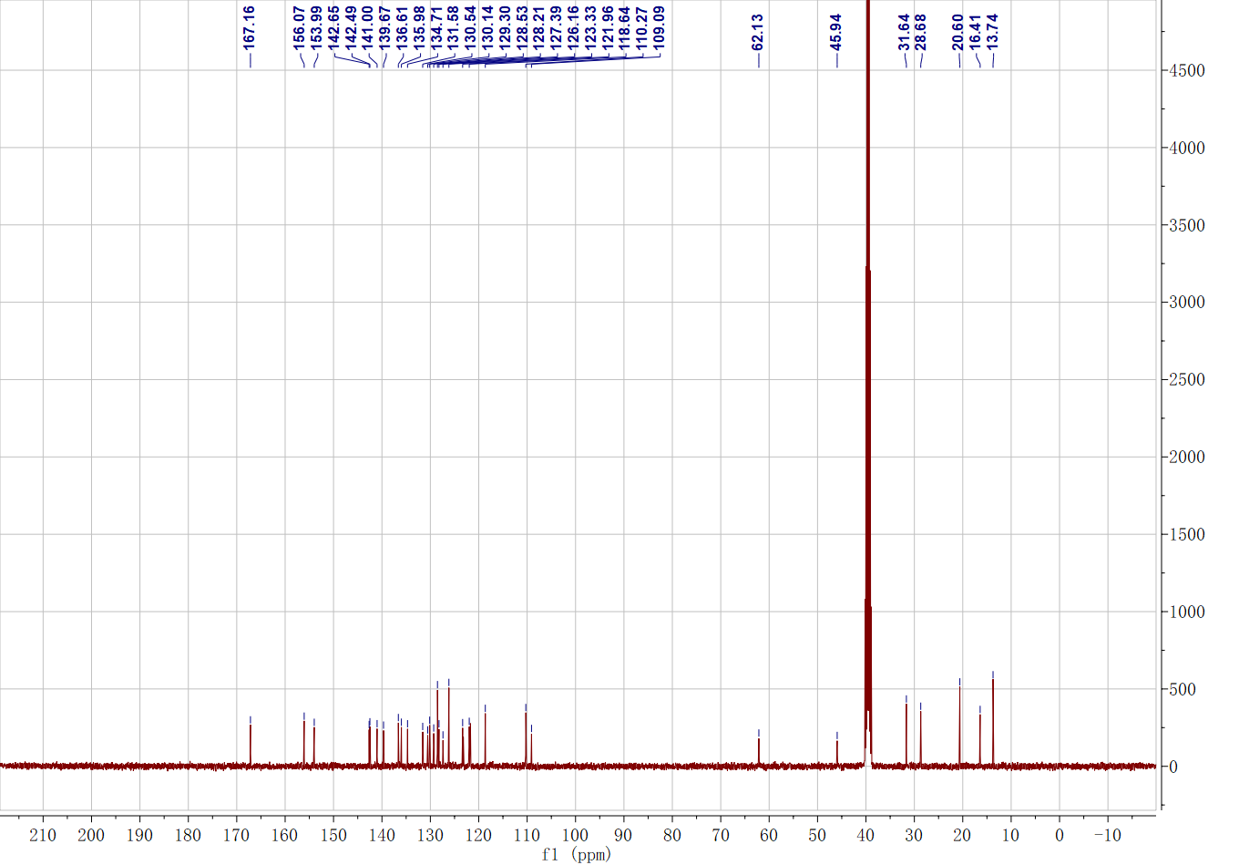

Compound 5

ESI-MS spectra of compound 5

¹H NMR spectra of compound 5 in CDCl₃
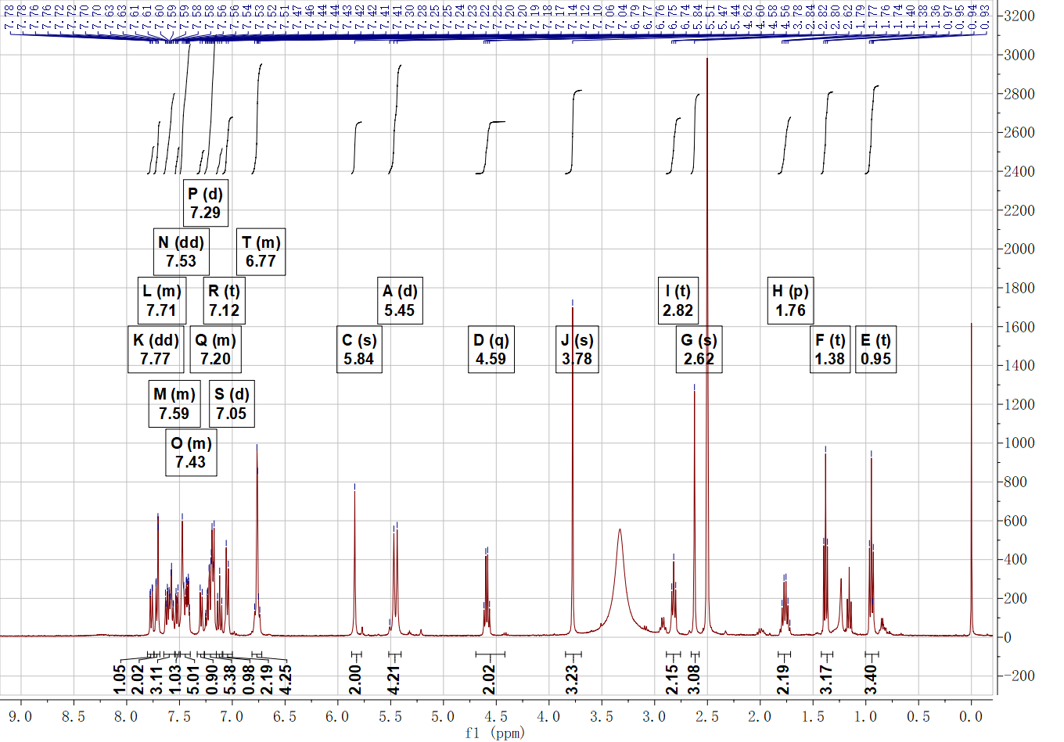

¹³C NMR spectra of compound 5 in DMSO-d₆
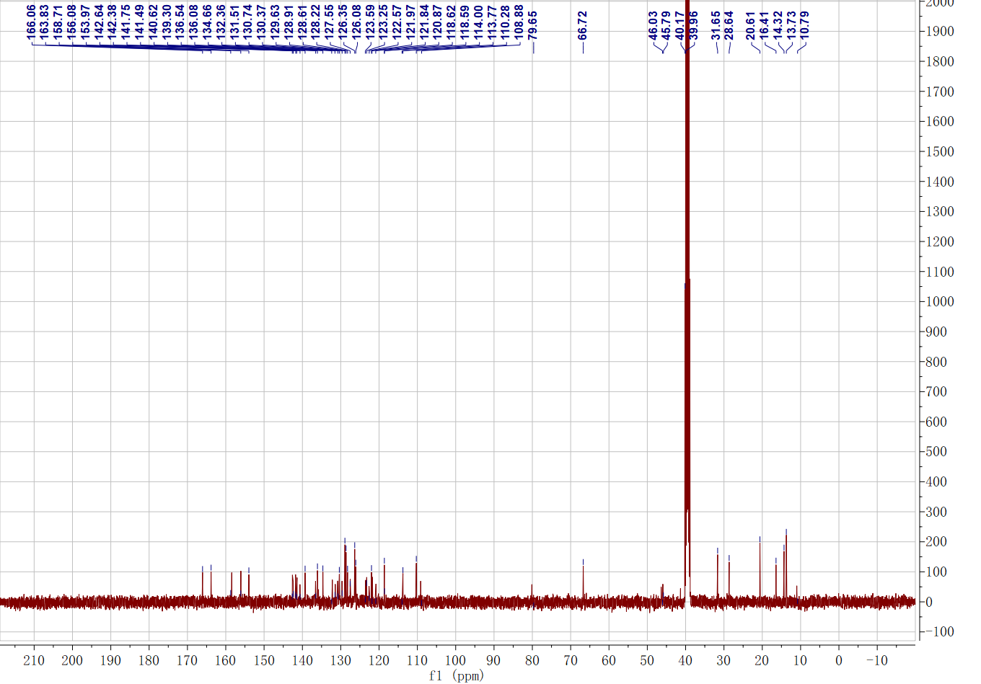
Compound 6
ESI-MS spectra of compound 6

¹H NMR spectra of compound 6 in DMSO-d₆
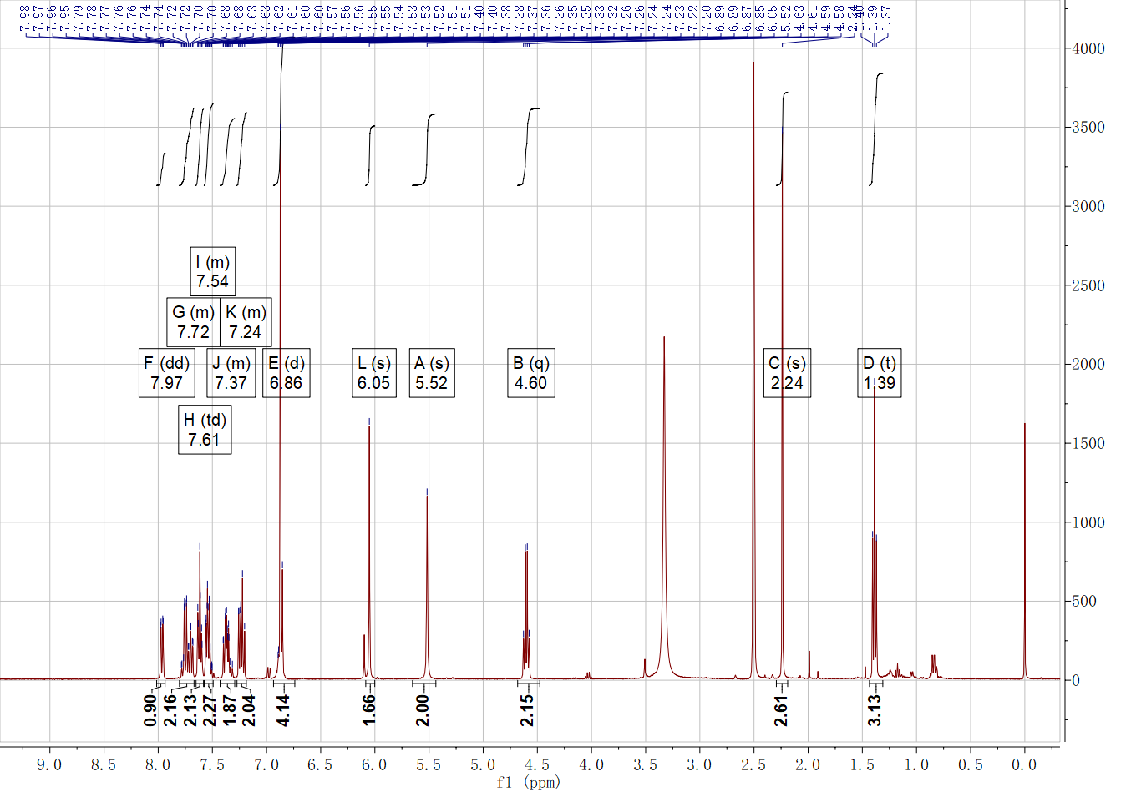
¹³C NMR spectra of compound 6 in DMSO-d₆
