A feasibility trial of HoloLens 2™;
Using mixed reality headsets to deliver remote bedside teaching during COVID-19

Sivananthan A^{1,2*}, Gueroult A^{2*}, Zijlstra G³, Martin G^{1,4}, Baheerathan A⁵, Pratt P⁶, Darzi A^{1,4}, Patel N^{1,2}, Kinross J⁴.

¹Institute of Global Health Innovation, Imperial College London, London, UK
²Department of Gastroenterology and Hepatology, Imperial College Healthcare NHS trust, London, UK.
³Department of Academic Public Health, Imperial College London, London, UK
⁴Department of Surgery and Cancer, Imperial College London, UK
⁵Department of Neurology, Imperial College Healthcare NHS trust, London, UK.
⁶Chief Scientific Officer, Medical iSight Corporation

*Joint first author

Corresponding author:
Arun Sivananthan, Imperial College Healthcare NHS Trust, London, UK
10th Floor QEQM Building
London
W2 1NY
Arun.sivananthan@nhs.net
07971608727

Word count: 2529
Figures: 3
Tables: 2

Supplementary Materials
Appendix 1: Pre-session questionnaire
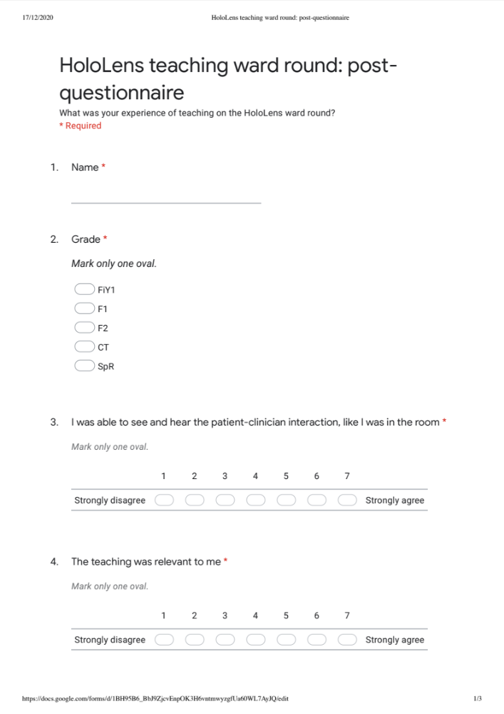
Appendix 2: Post-session questionnaire

