Supplemental Data.
1. Partial correlation analysis may fail to identify related genes.
Synthetic network consisting of 4 genes was simulated (Fig. S1). The network model was:
$λ=λ_{0}+N(0,λ_{noise)}$ (s1.1)
$θ=β_{θλ}λ+N(0,θ_{noise})$ (s1.2)
$φ=β_{φλ}λ+N(0,φ_{noise})$ (s1.3)
$ψ=β_{φψ}φ+β_{θψ}θ+N\left(0,ψ_{φ noise}\right)+N\left(0,ψ_{θ noise}\right)$ (s1.4)

Table S1. Parameters of the network model
letter | meaning | value
$$λ_{0}$$ | base expression level of TF3 | 100.0
$$λ_{noise}$$ | TF3 expression noise | 100.0
$$β_{θλ}$$ | strength of TF1-TF3 interaction | 1.0
$$θ_{noise}$$ | Noise of TF1-TF3 interaction | 100.0
$$β_{φλ}$$ | strength of TF2-TF3 interaction | 1.0
$$φ_{noise}$$ | Noise of TF2-TF3 interaction | 100.0
$$β_{θψ}$$ | strength of TF1-gene A interaction | 0.1
$$β_{φψ}$$ | strength of TF2-gene A interaction | 0.1
$$ψ_{θ noise}$$ | Noise of TF1-gene A interaction | 100.0
$$ψ_{φ noise}$$ | Noise of TF2-gene A interaction | 100.0
For every gene 74 sample values were generated. Then Pearson and partial Pearson correlations were estimated (Table S2 and Table S3).

Fig.S1. Diagram of the example network
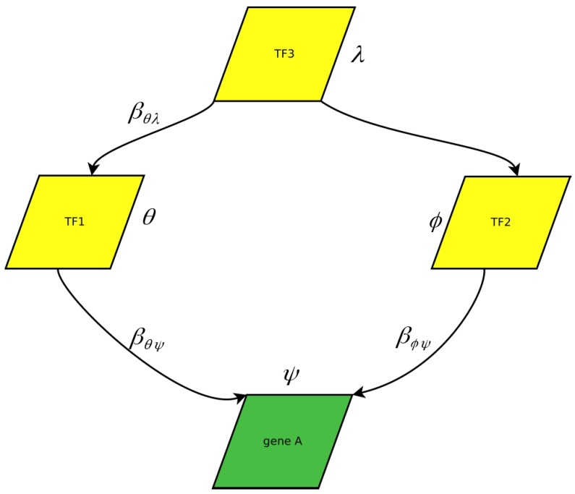

Table S2. Pearson correlation coefficients for the synthetic network.
 | TF3 | TF1 | TF2 | Gene A
TF3 | 1.0 | 0.968 | 0.964 | 0.542
TF1 |  | 1.0 | 0.945 | 0.547
TF2 |  |  | 1.0 | 0.580
Gene A |  |  |  | 1.0
Table S3. Partial Pearson correlation coefficients for the synthetic network.
 | TF3 | TF1 | TF2 | Gene A
TF3 | 1.0 | 0.657 | 0.601 | -0.097
TF1 |  | 1.0 | 0.160 | 0.061
TF2 |  |  | 1.0 | 0.240
Gene A |  |  |  | 1.0
P-values for TF1-gene A and TF2-gene A partial correlations were 0.61 and 0.042, correspondingly. While simple Pearson correlations have appreciable magnitude, partial correlation fails to identify the impact of TF1 and/or TF2 upon gene A expression.

Table S4. Mean relative distances for candidate adjusting TFs of the IL6 gene. Ensembl IDs of transcription factors identified as adjusting are in red.
index | Ensembl ID | Mean relative distance
1 | ENSG00000166454 | 0.14
2 | ENSG00000160094 | 0.14
3 | ENSG00000152518 | 0.13
4 | ENSG00000169740 | 0.1
5 | ENSG00000197619 | 0.13
6 | ENSG00000059728 | 0.09
7 | ENSG00000150347 | 0.08
8 | ENSG00000168610 | 0.13
9 | ENSG00000130940 | 0.07
10 | ENSG00000125347 | 0.13
Table S5. Mean relative distances for candidate adjusting lncRNAs of the IL6 gene. Ensembl ID of lncRNA identified as adjusting is in red.
index | Ensembl ID | Mean relative distance
1 | ENSG00000263753 | 0.08
2 | ENSG00000178977 | 0.06
3 | ENSG00000088970 | 0.09
4 | ENSG00000225339 | 0.09
5 | ENSG00000260804 | 0.08
6 | ENSG00000233834 | -0.02
7 | ENSG00000232680 | 0.06
8 | ENSG00000232759 | 0
9 | ENSG00000261618 | 0.07
10 | ENSG00000251230 | 0.05

