Additional file 1
Table S1: Percentage alignment rates of pair-end reads from 114 Mock and Cp-inoculated libraries against the International Wheat Genome Sequencing Consortium (IWGSC) wheat genomic reference from wheat variety Chinese Spring [30].
Library | No. of reads | Percentage alignments against RefSeq | Average coverage
10 min
MockStigmaLib1 | 8338638 | 78.12 | 9.265153333
MockStigmaLib4 | 8140388 | 80.08 | 9.044875556
MockTTLib1 | 5342892 | 78.82 | 5.936546667
MockTTLib4 | 10329694 | 83.5 | 11.47743778
MockTTLib5 | 8266242 | 83.73 | 9.184713333
MockBaseLib1 | 8646439 | 83.08 | 9.607154444
MockBaseLib4 | 4110531 | 68.87 | 4.567256667
MockBaseLib5 | 26563767 | 82.14 | 29.51529667
CpStigmaLib1 | 3719359 | 78.47 | 4.132621111
CpStigmaLib5 | 2565118 | 80.02 | 2.850131111
CpStigmaLib6 | 5282310 | 78.49 | 5.869233333
CpTTLib2 | 7106179 | 84.62 | 7.895754444
CpTTLib7 | 7402362 | 82.87 | 8.224846667
CpBaseLib1 | 9518508 | 84.08 | 10.57612
CpBaseLib5 | 5570863 | 83.86 | 6.189847778
CpBaseLib6 | 10349223 | 82.69 | 11.49913667
1 hour
MockStigmaLib1 | 3005658 | 77.75 | 3.33962
MockStigmaLib4 | 6943134 | 78.11 | 7.714593333
MockStigmaLib7 | 958381 | 77.46 | 1.064867778
MockTTLib1 | 3392286 | 83.05 | 3.769206667
MockTTLib5 | 15227496 | 84.2 | 16.91944
MockTTLib7 | 3991733 | 80.92 | 4.435258889
MockBaseLib1 | 4039352 | 81.54 | 4.488168889
MockBaseLib5 | 10455117 | 84.6 | 11.61679667
MockBaseLib7 | 9038734 | 82 | 10.04303778
CpStigmaLib2 | 1471138 | 78.01 | 1.634597778
CpStigmaLib3 | 13566658 | 81.34 | 15.07406444
CpTTLib2 | 10616236 | 67.8 | 11.79581778
CpTTLib3 | 14022049 | 84.34 | 15.58005444
CpTTLib5 | 2801902 | 81.08 | 3.113224444
CpBaseLib2 | 14530662 | 81.46 | 16.14518
CpBaseLib3 | 1698614 | 83.85 | 1.887348889
CpBaseLib5 | 5722919 | 82.14 | 6.358798889
5 hours
MockStigmaLib4 | 728409 | 74.87 | 0.809343333
MockStigmaLib5 | 751563 | 75.17 | 0.83507
MockTTLib4 | 1068529 | 80.87 | 1.187254444
MockTTLib5 | 1274409 | 81.71 | 1.41601
MockBaseLib4 | 4144793 | 80.54 | 4.605325556
MockBaseLib5 | 1181001 | 78.29 | 1.312223333
CpStigmaLib1 | 581836 | 77.63 | 0.646484444
CpStigmaLib4 | 148791 | 71.69 | 0.165323333
CpStigmaLib5 | 526205 | 79.66 | 0.584672222
CpTTLib1 | 5894932 | 82.41 | 6.549924444
CpTTLib3 | 6345375 | 82.29 | 7.050416667
CpTTLib4 | 1808326 | 80.71 | 2.009251111
CpBaseLib1 | 11222147 | 83.59 | 12.46905222
CpBaseLib3 | 19834227 | 83.62 | 22.03803
CpBaseLib4 | 2644868 | 81.83 | 2.938742222
24 hours
MockStigmaLib1 | 12260120 | 79.1 | 13.62235556
MockStigmaLib3 | 11062304 | 30.37 | 12.29144889
MockStigmaLib4 | 7840358 | 79.24 | 8.711508889
MockTTLib1 | 14926364 | 84.52 | 16.58484889
MockTTLib3 | 3630257 | 73.83 | 4.033618889
MockTTLib4 | 1942409 | 83.12 | 2.158232222
MockBaseLib1 | 8996380 | 83.46 | 9.995977778
MockBaseLib3 | 13532668 | 84.26 | 15.03629778
MockBaseLib4 | 10663021 | 84.14 | 11.84780111
CpStigmaLib2 | 14346498 | 79.38 | 15.94055333
CpStigmaLib5 | 2016424 | 78.79 | 2.240471111
CpTTLib1 | 9443334 | 83.24 | 10.49259333
CpTTLib2 | 6285660 | 83.19 | 6.984066667
CpTTLib5 | 2906021 | 82.51 | 3.228912222
CpBaseLib1 | 20206113 | 76.82 | 22.45123667
CpBaseLib2 | 12578496 | 82.87 | 13.97610667
CpBaseLib5 | 6087878 | 83.95 | 6.764308889
48 hours
MockTTLib2 | 7569385 | 84.89 | 8.410427778
MockTTLib4 | 11137831 | 83.71 | 12.37536778
MockTTLib5 | 4312611 | 83.64 | 4.79179
MockBaseLib2 | 12703101 | 84.76 | 14.11455667
MockBaseLib4 | 5248668 | 83.65 | 5.831853333
MockBaseLib5 | 5189031 | 84.11 | 5.76559
CpTTLib1 | 10173382 | 82.79 | 11.30375778
CpTTLib2T | 4245053 | 80.79 | 4.716725556
CpTTLib5 | 8949836 | 84.1 | 9.944262222
CpBaseLib1 | 14567310 | 83.88 | 16.1859
CpBaseLib2 | 10873847 | 83.26 | 12.08205222
CpBaseLib5 | 7322356 | 83.59 | 8.135951111
72 hours
MockTTLib1 | 8230101 | 83.24 | 9.144556667
MockTTLib2 | 9334661 | 80.54 | 10.37184556
MockTTLib4 | 11068654 | 82.04 | 12.29850444
MockBaseLib1 | 2925436 | 84.73 | 3.250484444
MockBaseLib2 | 9009199 | 83.58 | 10.01022111
MockBaseLib3 | 3226946 | 83.89 | 3.585495556
CpTTLib1 | 8182526 | 83.47 | 9.091695556
CpTTLib2 | 5640401 | 83.6 | 6.267112222
CpTTLib4 | 2599522 | 71.53 | 2.888357778
CpBaseLib1 | 13473051 | 84.21 | 14.97005667
CpBaseLib2 | 10309054 | 83.62 | 11.45450444
CpBaseLib4 | 9270608 | 82.79 | 10.30067556
5 days
MockTTLib1 | 4083856 | 81.48 | 4.537617778
MockTTLib4 | 6065295 | 82.39 | 6.739216667
MockTTLib5 | 489017 | 64.66 | 0.543352222
MockBaseLib1 | 5143207 | 83.23 | 5.714674444
MockBaseLib4 | 5273324 | 83.92 | 5.859248889
CpTTLib1 | 6021216 | 51.34 | 6.69024
CpTTLib2 | 7411083 | 52.28 | 8.234536667
CpTTLib4 | 12101102 | 53.75 | 13.44566889
CpBaseLib1 | 9874448 | 53.15 | 10.97160889
CpBaseLib2 | 7576524 | 56.18 | 8.41836
CpBaseLib4 | 10439653 | 55.51 | 11.59961444
7 days
MockTTLib3 | 2935220 | 79.94 | 3.261355556
MockTTLib5 | 2410978 | 81.92 | 2.678864444
MockBaseLib1 | 8124653 | 84.67 | 9.027392222
MockBaseLib3 | 5635053 | 84.01 | 6.26117
MockBaseLib5 | 11842104 | 84.29 | 13.15789333
CpTTLib1 | 8740565 | 46.11 | 9.711738889
CpTTLib2 | 5550154 | 50.12 | 6.166837778
CpTTLib3 | 5232927 | 39.19 | 5.814363333
CpBaseLib1 | 11398753 | 43.64 | 12.66528111
CpBaseLib2 | 16517028 | 52.71 | 18.35225333
CpBaseLib3 | 9605947 | 36.06 | 10.67327444
TT represents the RNA libraries made from ovary transmitting tissue.
30. The International Wheat Genome Sequencing Consortium (IWGSC), et al. 2018. Science, 17 (361) eaar7191 DOI: 10.1126/science.aar7191. Available online at: https://wheat-urgi.versailles.inra.fr/

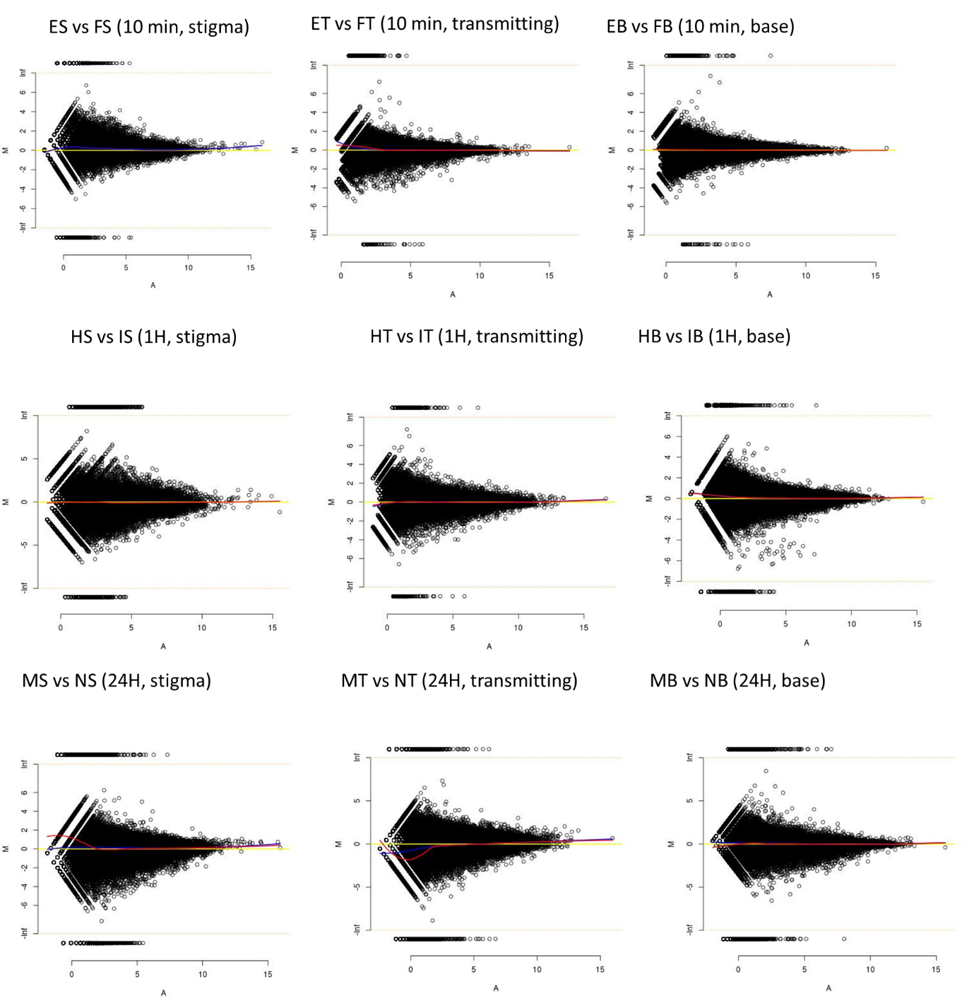
Figure S1: MA plots for wheat transcripts at 10 mins, 1 hour and 24 hours. Loess curves (red/blue) were drawn along with the line of symmetry at M=0 (yellow). The blue Loess curve are smoothened curves set at family = “symmetric”. The red is a regular Loess curve (M~A). In some figures, only one line is visible since two/all curves may overlap.

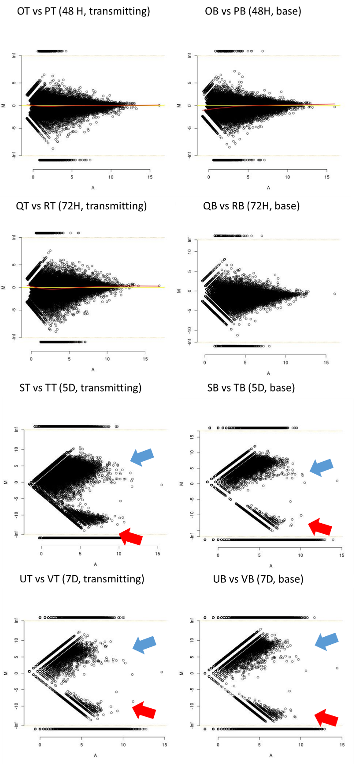
Figure S2: MA plots for wheat transcripts at 48 hours, 72 hours, 5 days, and 7 days. Loess curves (red/blue) were drawn along with the line of symmetry at M=0 (yellow). The blue Loess curve are smoothened curves set at family = “symmetric”. The red is a regular Loess curve (M~A). In some figures, only one line is visible since two/all curves may overlap. To demonstrate the asymmetric distribution of points, MA plots were generated using both wheat (blue arrow) and C. purpurea (red) transcripts.

Table S2: Table of all differentially expressed hormone-related genes at the base tissue. The red colour represents up-regulated genes and the green represents down-regulated genes. At the top, a schematic representation of the stage of fungal development in the wheat ovule at each time point is shown.
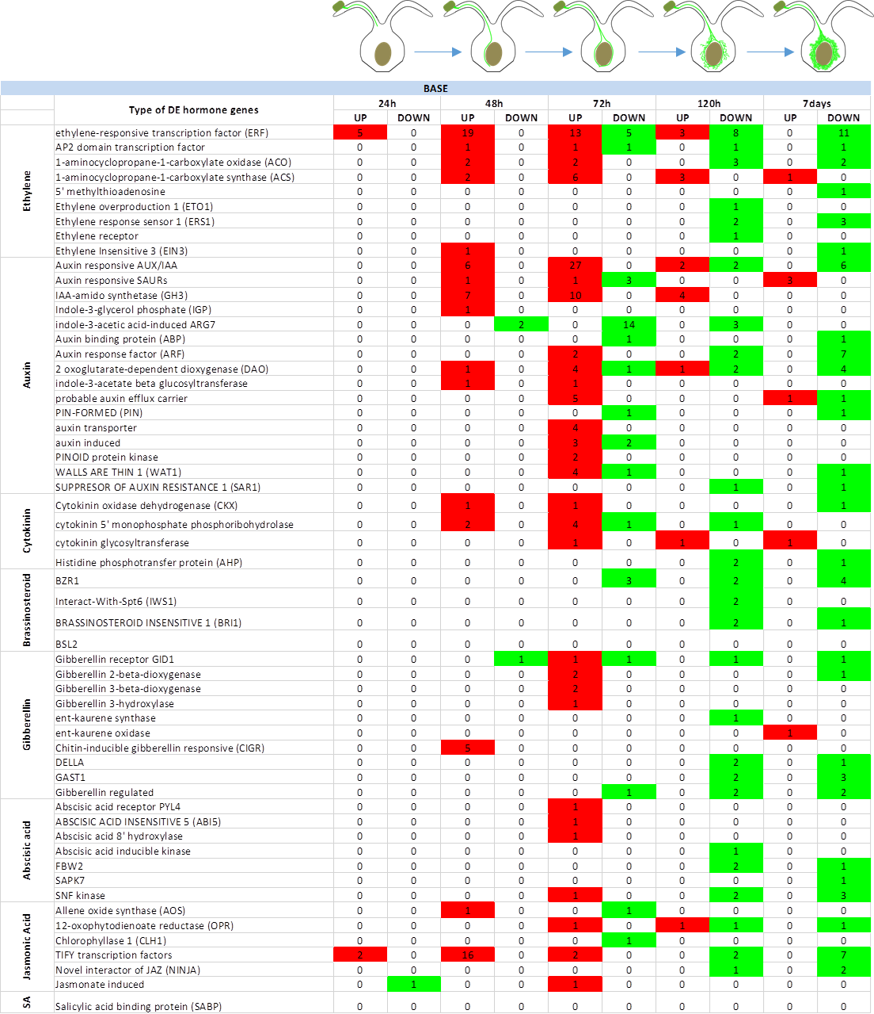

Table S3: Table of all differentially expressed hormone-related genes at the transmitting tissue. The red colour represents up-regulated genes and the green represents down-regulated genes. At the top, a schematic representation of the stage of fungal development in the wheat ovule at each time point is shown.
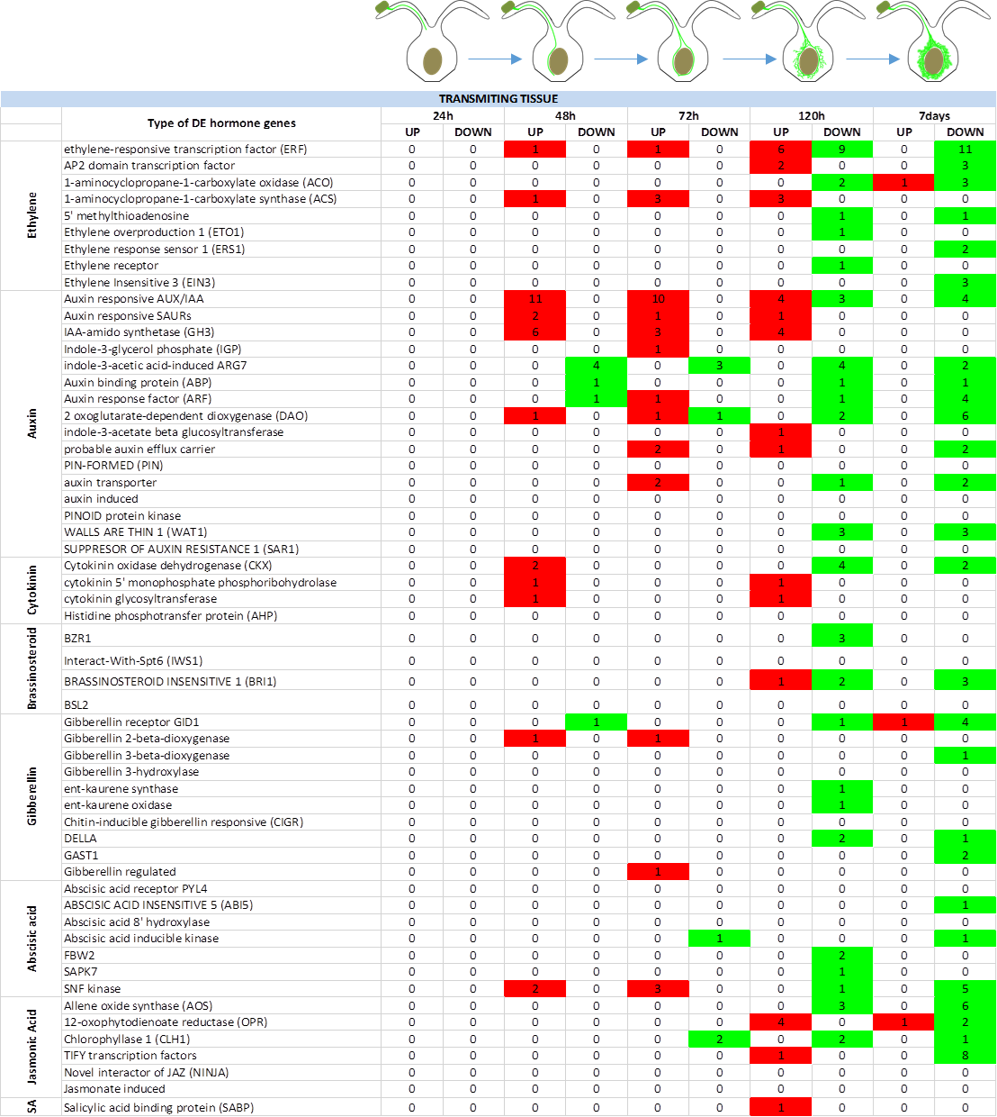

Table S4: Table of all differentially expressed hormone-related genes at the stigma tissue. The red colour represents up-regulated genes and the green represents down-regulated genes. At the top, a schematic representation of the stage of fungal development in the wheat ovule at each time point is shown.

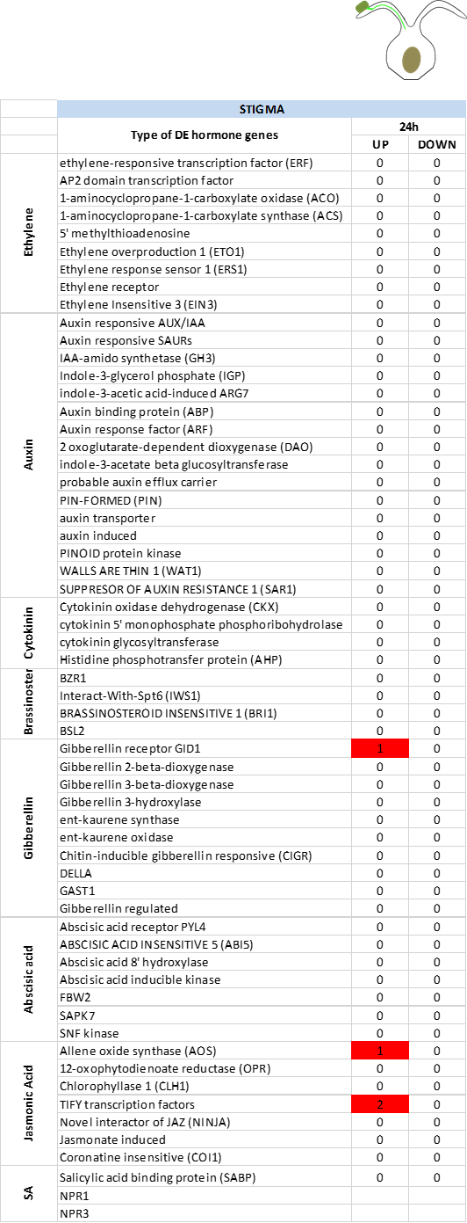
Table S5: Table of all differentially expressed defence-related genes at the stigma tissue. The red colour represents up-regulated genes and the green represents down-regulated genes. At the top, a schematic representation of the stage of fungal development in the wheat ovule at each time point is shown.

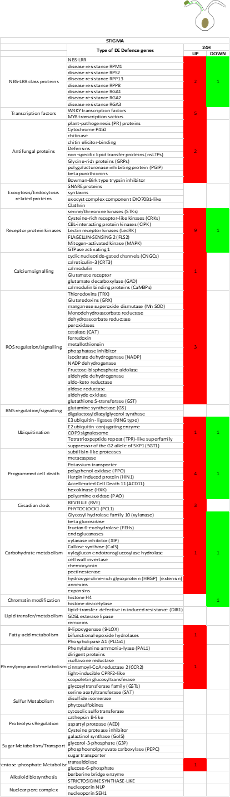
Table S6: Table of all differentially expressed defence-related genes at the transmitting tissue. The red colour represents up-regulated genes and the green represents down-regulated genes. At the top, a schematic representation of the stage of fungal development in the wheat ovule at each time point is shown.

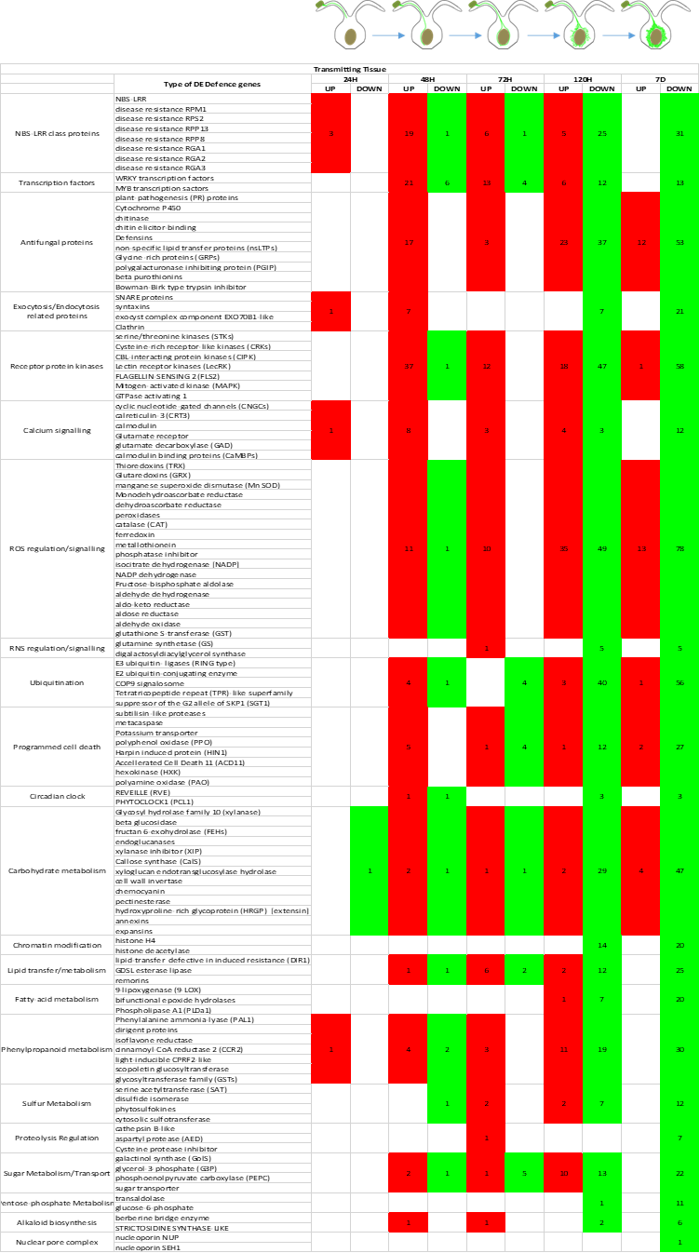
Table S7: Table of all differentially expressed defence-related genes at the Base tissue. The red colour represents up-regulated genes and the green represents down-regulated genes. At the top, a schematic representation of the stage of fungal development in the wheat ovule at each time point is shown.

