Title page for supplementary file

Manuscript complete title: Understanding Patient Journey in Ulcerative Colitis Prior to Biologic Initiation: A 5-Year Exploration
Manuscript short title: Ulcerative Colitis Patient Journey
Authors:
Yiting Wang, Janssen Research & Development, LLC, Email: ywang28@its.jnj.com
Rupa Makadia, Janssen Research & Development, LLC, Email: rmakadia@its.jnj.com
Christopher Knoll, Janssen Research & Development, LLC, Email: cknoll1@its.jnj.com
Jill Hardin, Janssen Research & Development, LLC, Email: jhardi10@ITS.JNJ.com
Erica A. Voss, Janssen Research & Development, LLC, Email: EVoss3@its.jnj.com
Daniel Fife, Janssen Research & Development, LLC, Email: DFife@its.jnj.com
Kourtney Davis, Janssen Research & Development, LLC, Email: KDavis24@its.jnj.com
Sheldon Sloan, Janssen Global Services, LLC, Email: sheldonsloan1@gmail.com

Address for correspondence: Yiting Wang, 1125 Trenton-Harbourton Road, Titusville, NJ 08560, USA, Telephone: 1-302-740-5195.

Supplementary Figures and Tables

Supplementary Figure 1. Empirical evaluation of the accuracy for ulcerative colitis (UC) identification algorithm
For the empirical evaluation of the accuracy for UC definition from the claims database, we included all patients (n=10,969) who were classified as having UC on the index date, and did not restrict to the smaller subset of patients who had at least five years of post-UC enrollment history.
From the n=10,969 patients, n=7,054 (64.3% of 10,969) had at least 1 year of enrollment data after index date, with an estimated post-index classification accuracy was ((4313+6120) + (1125+422))/7054=92% overall.

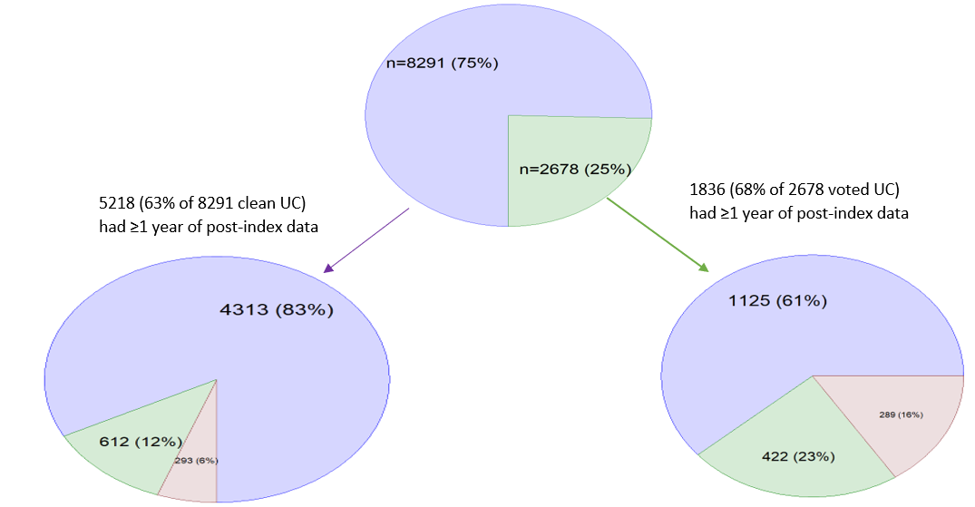
Color legend: Purple, no Crohn’s diagnosis ever before or after index; Green, Crohn’s diagnosis before or after index but still voted as UC by majority of UC coding frequency and recency criteria; Maroon, post-index Crohn’s diagnosis and not voted as UC by both the recency and majority criteria.

International Classification of Disease (ICD) diagnosis codes:
- CD, ICD-9-CM, 555; ICD-10-CM, K50
- UC, ICD-9-CM, 556 (556.6 for extensive/pancolitis; 556.5 for left-sided; 556.2 and 556.3 for proctitis/proctosigmoiditis); ICD-10-CM, K51 (K51.0 for extensive/pancolitis; K51.5 for left-sided; K51.2 and K51.3 for proctitis/proctosigmoiditis)

Supplementary Figure 2. Cohort creation flow chart

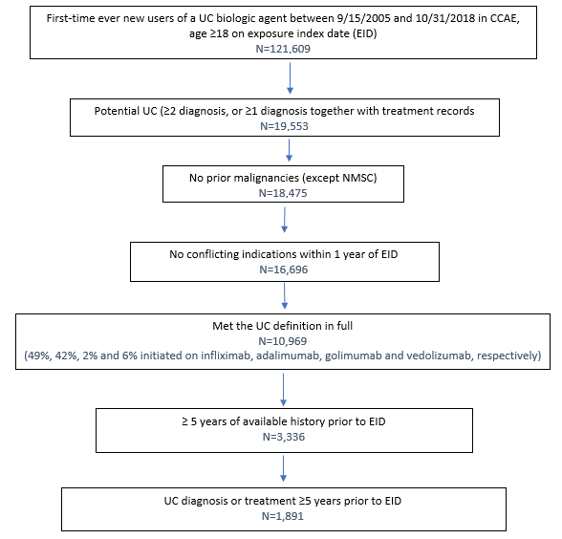

Supplementary Table 1. 5-ASA products and formulations, 22 combinations
Compound (molecular formula) | Product name | Formulations
Balsalazide (C₁₇H₁₅N₃O₆) | Balsalazide disodium | capsule
Balsalazide (C₁₇H₁₅N₃O₆) | Balsalazide disodium | tablet
Balsalazide (C₁₇H₁₅N₃O₆) | Colazal | capsule
Balsalazide (C₁₇H₁₅N₃O₆) | Giazo | tablet
Mesalamine (C₇H₇NO₃) | Apriso | Capsule
Mesalamine (C₇H₇NO₃) | Asacol HD | Tablet
Mesalamine (C₇H₇NO₃) | Canasa | Suppository
Mesalamine (C₇H₇NO₃) | Delzicol | Capsule
Mesalamine (C₇H₇NO₃) | Lialda | Tablet
Mesalamine (C₇H₇NO₃) | Mesalamine | Enema
Mesalamine (C₇H₇NO₃) | Mesalamine | Tablet
Mesalamine (C₇H₇NO₃) | Mesalamine | Suppository
Mesalamine (C₇H₇NO₃) | Mesalamine | Capsule
Mesalamine (C₇H₇NO₃) | Pentasa | Capsule
Mesalamine (C₇H₇NO₃) | Rowasa | Enema
Mesalamine (C₇H₇NO₃) | Rowasa | Suppository
Mesalamine (C₇H₇NO₃) | Sfrowasa | Enema
Olsalazine (C₁₄H₁₀N₂O₆) | Dipentum | Capsule
Sulfasalazine (C₁₈H₁₄N₄O₅S) | Azulfidine | Tablet
Sulfasalazine (C₁₈H₁₄N₄O₅S) | Azulfidine EN-tabs | Tablet
Sulfasalazine (C₁₈H₁₄N₄O₅S) | Azulfidine EN-tabs | Tablet, delayed release
Sulfasalazine (C₁₈H₁₄N₄O₅S) | Sulfasalazine | Tablet

Supplementary Table 2. Corticosteroids Conversion
Compound | Anti-inflammatory /immunosuppressive potency | Prednisone-equivalent dose | Multiplication factor to derive prednisone-equivalent mg
Betamethasone | 25.00 | 0.80 | x 6.25
Budesonide | 16.00 | 1.25 | x 4.00
Cortisol/Hydrocortisone | 1.00 | 20.00 | x 0.25
Cortisone | 0.80 | 25.00 | x 0.20
Deflazacort | 2.70 | 7.50 | x 0.67
Dexamethasone | 25.00 | 0.80 | x 6.25
(6alpha-) methylprednisolone | 5.00 | 4.00 | x 1.25
Paramethasone | 10.00 | 2.00 | x 2.50
Prednisolone | 4.00 | 5.00 | x 1.00
Prednisone | 4.00 | 5.00 | x 1.00
Triamcinolone | 5.00 | 4.00 | x 1.25
* Fludrocortisone, Aldosterone, Cloprednol, Trilostane and Cortivazol are not used for treatment of inflammatory bowel disease.

