Supplementary table 3
Description of control subjects and SBMA patients.

Controls | External ID | Age | Age of Onset | Muscle | Clinical Status | AR Q length
1 | 9931 | 37 | N/A | quadriceps femoris | no | N/A
2 | 9161 | 42 | N/A | vastus lateralis | no | N/A
3 | 5930 | 52 | N/A | vastus lateralis | mild myopathic signs | N/A
4 | ORTHO11 | 61 | N/A | vastus lateralis | no | N/A
5 | ORTHO13 | 49 | N/A | vastus lateralis | no | N/A
6 | ORTHO12 | 56 | N/A | vastus lateralis | no | N/A
7 | ORTHO10 | 76 | N/A | vastus lateralis | no | N/A
Kennedy’s Disease | External ID | Age | Age of Onset | Muscle | Clinical Status | AR Q length
1 | 51788 | 54 | 60 | quadriceps femoris | SBMA | 44
2 | 53355 | 51 | 48 | vastus lateralis | SBMA | 44
3 | 53293 | 54 | 45 | vastus lateralis | SBMA | 49
4 | 51766 | 71 | 64 | vastus lateralis | SBMA | 44
5 | 52176 | 45 | 41 | vastus lateralis | SBMA | 47

Supplementary table 4
Primers used for quantitative real-time PCR analyses.
 |  | FW | RV
Cacna1s |  | CAGACACAGAGAGCTTGTATGAA | TTCACTAGGTCATGGCACTTC
Casq1 |  | CCCTGTAGAGTTGATTGAAGGTGAACG | CCTCGTAGGCTTTGTAATGCTCTGAGTC
Casq2 |  | CCAGCTGAAGGAGATTGTACTG | AGCAAGCTTGGCCTCTTT
Atp2a1 |  | CCACCAACCAGATGTCAGTT | TCCCTCAGGAGCATAAGTAGAG
Atp2a2 |  | CTTATCTTGGTAGCCAATGCAATC | TTGCCCATTTCAGGCTCATA
Pv |  | AGGTGAAGAAGGTGTTCCATATT | TCTCTGGCATCTGAGGAGGAA
Sln |  | GCTCCTCTTCAGGAAGTGAAG | TGGCCCCTCAGTATTGGTAGG
Ryr1 |  | GCAACCGCCTTTGCTTTC | ACTGACAGAGACTGCTCCA
Gss |  | GGACTTCAACATACTGGTGGAT | CAAAGAGACGGGCAGTATAGTC
Gsr |  | GGACGGGACCCAAATTCTAA | GACGCCTTTGACATTGGTATTC
Nfe2l1 |  | CAGCAGTGGCAAGATCTCAT | GGGCATTGTACAGAATCTCACT
Nfe2l2 |  | CAGGAGAATTCCTCCCAATTCA | GGCATCTTGTTTGGGAATGTG
Nrf1 |  | GCGATTGTACTCTGCATCTCA | TTTGTCCACAGAGACTGGAATC
Nrf2 |  | GATCAGGCGACATGTTAACGTT | AGAGCCCAGTCAAACCCTTTC
Nqo1 |  | CATGTACTCTCTTCAGGGTGTC | CAATGCTGTAAACCAGTTGAGG
Tfam |  | AGCACTGGTAAAGAGAAGAGAATTA | CGAATCATCCTTTGCCTCCT
Sdha |  | TTACCTGCGTTTCCCCTCAT | AAGTCTGGCGCAACTCAATC
Mpc2 |  | CCGACTCATGGATAAAGTGGAG | CCATTTCATTATTGGAGCCCAGA
Cpt1 |  | CTGCACTCCTGGAAGAAGAAG | CTGTGCACTGAGGTATCTCTTC
Fkbp12 |  | GTGATCCGAGGCTGGGAGGAAG | GGCTCCATAGGCATAGTCTGAGGAGA
Stac3 |  | CACTCTACAGCGACCAACAGTA | CACTCTACAGCGACCAACAGTA
Junctin |  | CATGGTTCATGGTCATTGCATTGC | TCAAAGTCTCCATCGCCATCCG
Triadin |  | GCACCCACCATGACTGAGATCAC | AGCACCTTTCCAGGGGATTTAGG
B-actin |  | GACAGGATGCAGAAGGAGATTACTG | CTCAGGAGGAGCAATGATCTTGAT

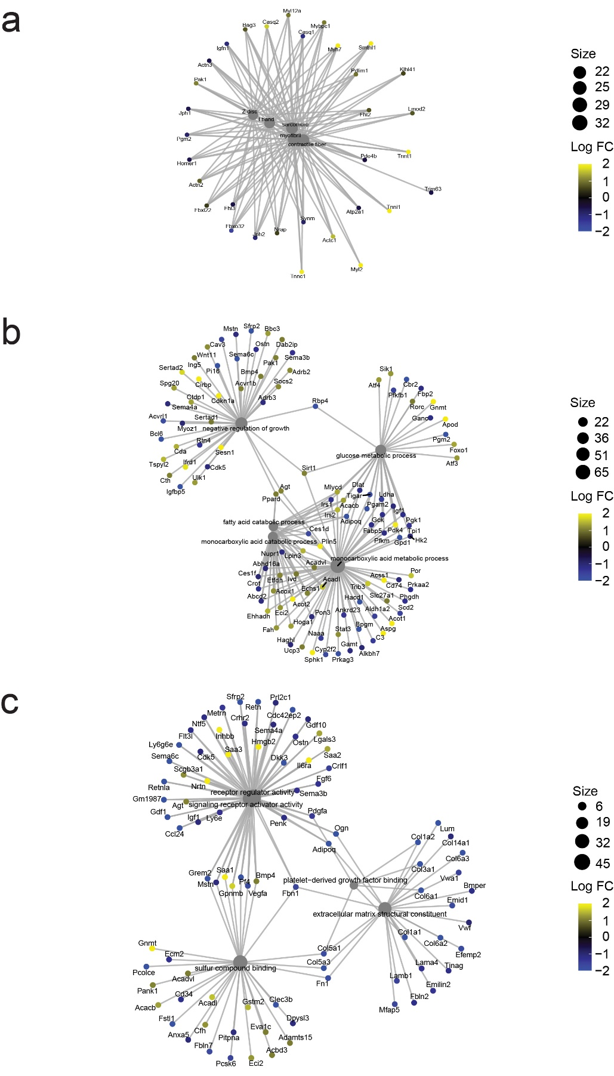
Supplementary Figure 1: Early altered expression of genes involved in muscle structure, contraction and metabolism.
Gene onthology analysis of differentially expressed genes in 24-week-old (a) and 12-week-old AR113Q (b, c) AR113Q mice compared to control mice (n = 3 mice/genotype).

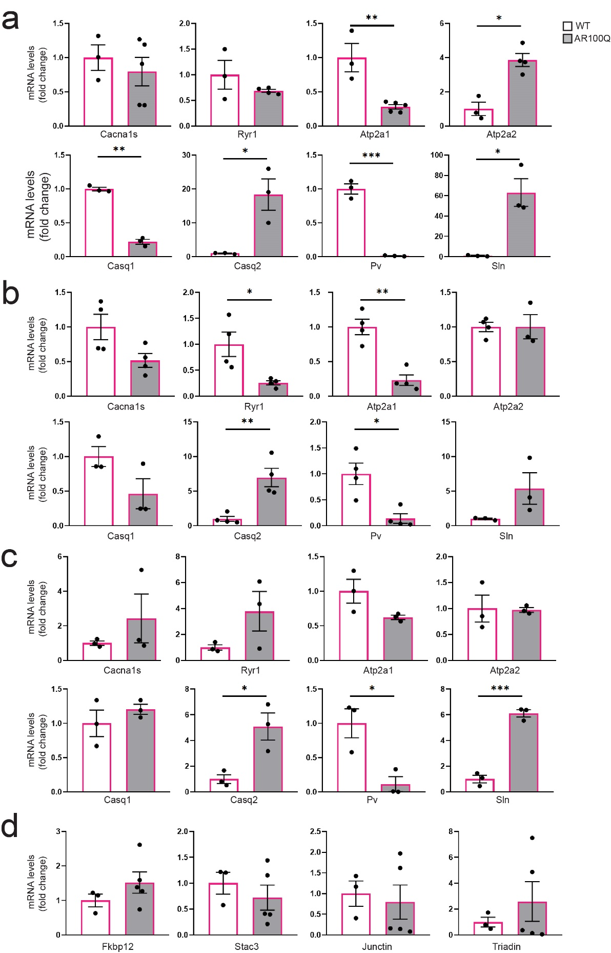
Supplementary Figure 2: Altered expression of ECC genes in fast-twitch muscles of AR100Q mice.
a-d) RT-PCR analysis of the indicated genes normalized to beta-actin in the EDL (a), FDB (b), soleus (c), and quadriceps (d) muscles of 8-week-old WT and AR100Q mice. Graphs show mean ± SEM, n = 3-5 mice/genotype, student’s t test, * p = 0.05, ** p = 0.01, *** p = 0.001.

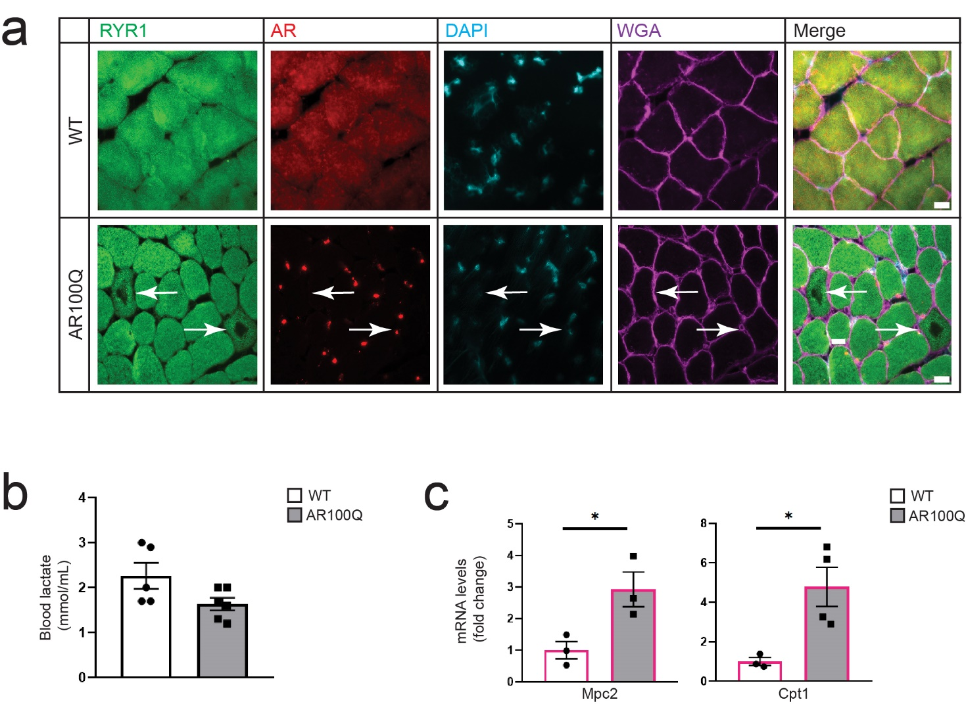
Supplementary Figure 3: Core-like pathology and normal lactate levels in the bloodstream of AR100Q mice.
a)Immunofluorescence analysis of RYR1 (green), AR (red), nuclei (DAPI, blue), and wheat germ agglutinin (WGA, purple) in the quadriceps muscle of 8-week-old WT and AR100Q mice (n = 3 mice/genotype). Shown are representative images of 3 biological replicates. Bar, 20 μm. Arrows point to fibers with areas deprived of RYR1. b) Blood lactate level analysis in 12-week-old mice (n = 3-5 mice/genotype). c)RT-PCR analysis of the transcript levels of the indicated genes normalized to beta-actin in the quadriceps muscle of 8-week-old WT and AR100Q mice (n = 3-5 mice/genotype). Graphs show mean ± SEM, student’s t-test; * p < 0.05.

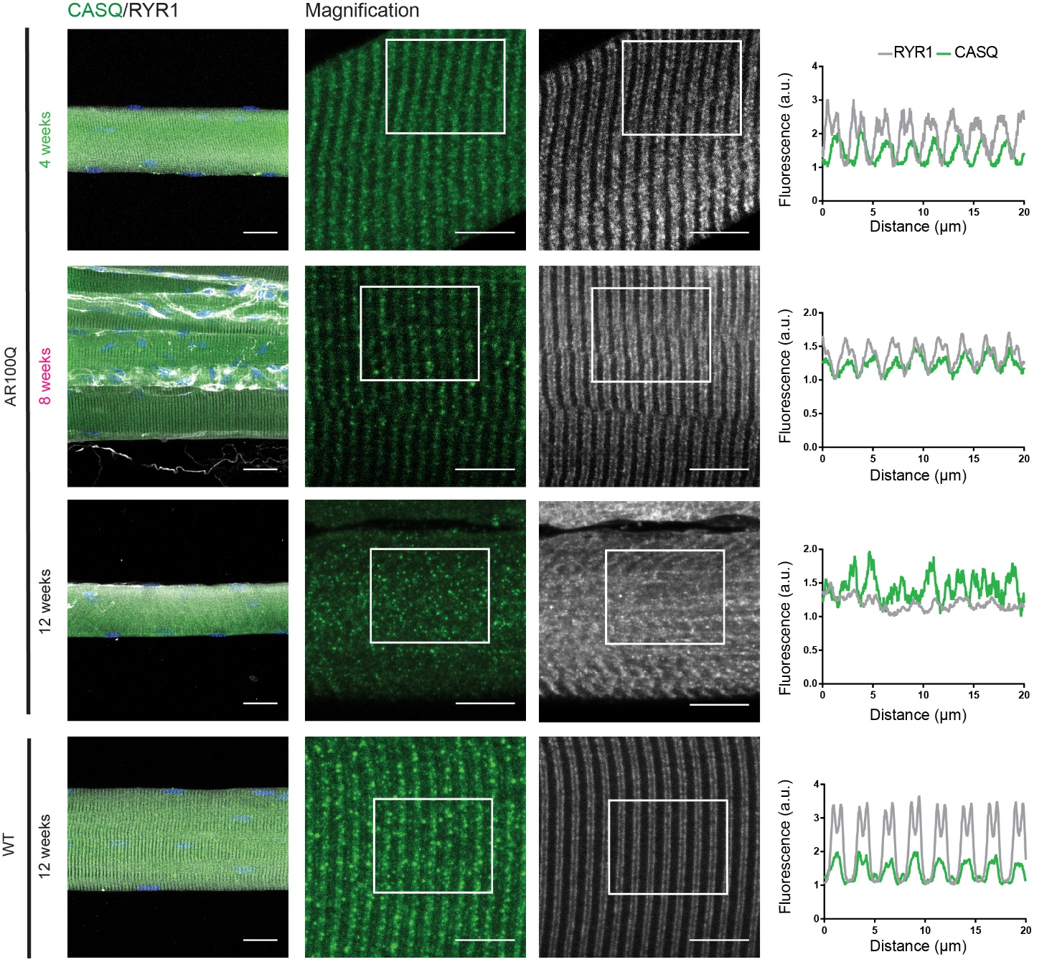
Supplementary Figure 4: Disrupted sarcomere organization in the muscle of SBMA mice.
Immunofluorescence and confocal microscopy analysis of RYR1 (white) and CASQ (green) in fibers isolated from the TA muscle of WT and AR100Q mice (n = 3 mice/genotype). Shown are representative images. Bar = 25 μm, magnification bar = 10 μm. Graphs show fluorescence quantification (described in the Methods section).

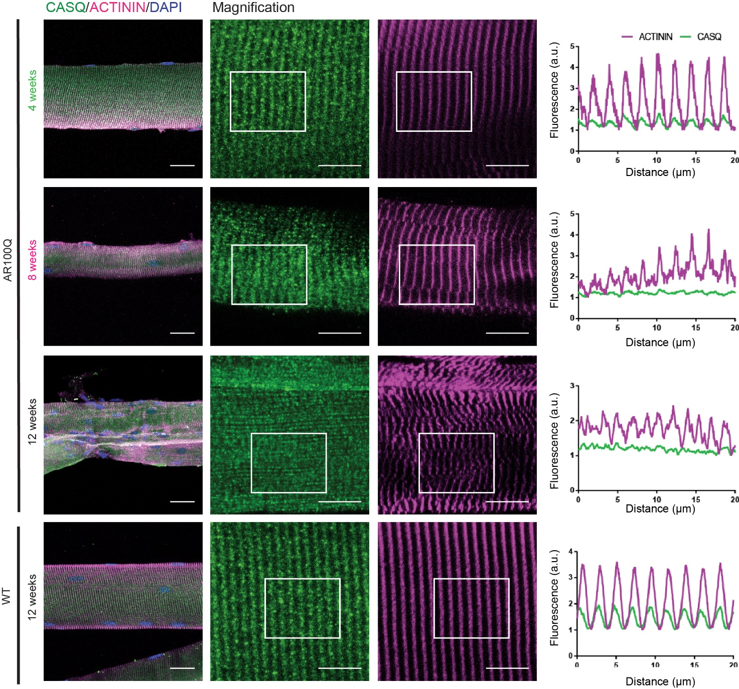
Supplementary Figure 5: Disruption of myofiber organization in SBMA mice.
Immunofluorescence and confocal microscopy analysis of Actinin (purple), CASQ (green), and DAPI (blue) in myofibers isolated from the TA muscle of WT and AR100Q mice (n = 3 mice/genotype). Shown are representative images. Bar = 25 μm, Magnification bar = 10 μm. Graphs show fluorescence quantification (see Methods).

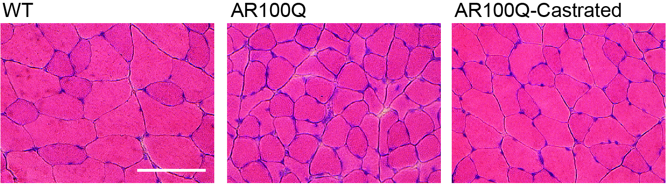
Supplementary Figure 6: Amelioration of muscle pathology by surgical castration.
Haematoxylin and eosin analysis of the quadriceps muscle of 8-week-old WT and AR100Q mice (n = 3 mice/genotype). Shown are representative images. Bar = 100 μm.

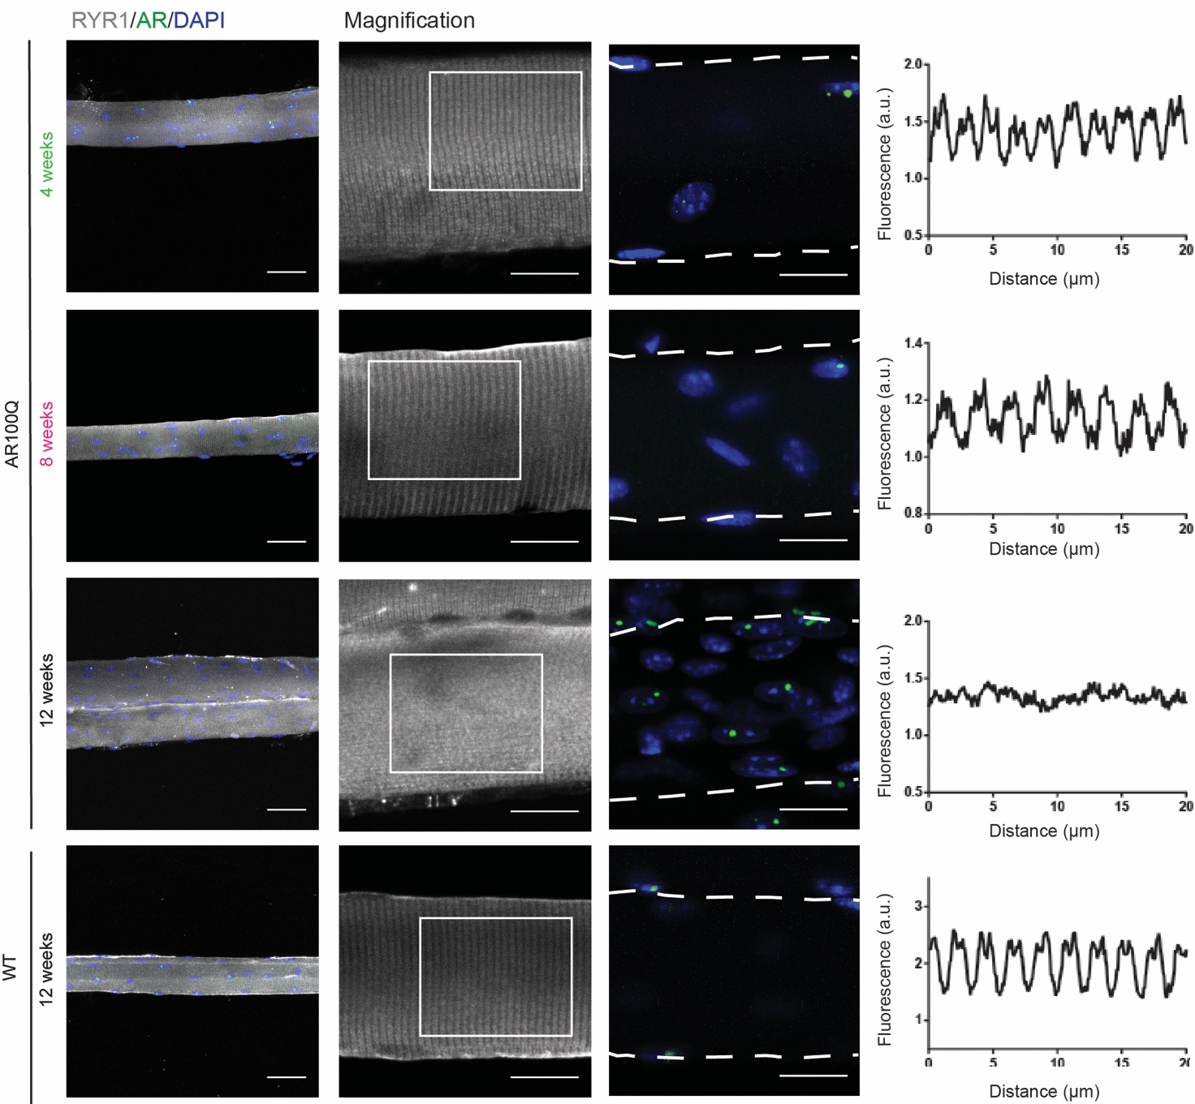
Supplementary Figure 7: Amelioration of myofiber organization by surgical castration.
Immunofluorescence analysis of RYR (grey), AR (green), and DAPI (blue) in myofibers isolated from the TA muscle of WT and AR100Q mice (n = 3 mice/genotype). Shown are representative images. Bar = 25 μm, Magnification bar = 10 μm. Graphs show fluorescence quantification (see Methods).

