Supplementary Information for

Who pollutes and who suffers from air pollution in India

Narasimha D. Rao^{1,2}, Jihoon Min¹, Gregor Kiesewetter¹, Shonali Pachauri¹, Fabian Wagner^{1,}
¹International Institute for Applied Systems Analysis (IIASA), Schlossplatz 1, A-2361 Laxenburg, Austria
²Yale School of the Environment, Yale University, New Haven, CT 08511, USA
November 2020

Contents
1 Methods 1
1.1 Relating emissions to concentrations 2
1.2 From concentrations to mortality 4
2 Data 5
2.1 Population shares in deciles 5
2.2 The three scenarios 5
2.3 Open data / open code 7
3 Results 7
3.1 Sensitivity case: mortality related to ambient air pollution only 7
3.2 The PEI for ambient PM_{2.5} pollution only 8
3.3 Sensitivity: constant baseline mortality vs income-dependent mortality 8
4 References 9

Methods
In this section we provide additional information on specific aspect of the methodology.

Relating emissions to concentrations
The GAINS source-receptor matrices rely on perturbation simulations of atmospheric CTMs, in which emissions from a given source region and pollutant are reduced from base case, and the change in ambient concentration levels is used to calculate a linear transfer coefficient. Source pollutants considered for the formation of PM_{2.5} are primary PM_{2.5} (PPM), SO₂, NO_{x}, NH₃, and VOC. For PPM, the transfer coefficients are split into one describing low-level emissions from residential combustion and traffic, and one for all other sources, to account for different atmospheric dispersion characteristics of emissions injected at different heights.

Base case and reduction simulations (15% reduction runs for pollutants PPM total, PPM low-level (SNAP 2+7), SO₂, NO_{X}, NH₃, VOC, with meteorological year 2015) have been run with the EMEP CTM at 0.5⁰ resolution, with either an Asia-wide domain as used in the UNEP-CCAC Assessment of Air Pollution in Asia and the Pacific³⁶, or a global domain for all other regions.

Transfer coefficients for source regions $j$, source pollutants $p$, to 0.5⁰ grid cells $i$ are defined as
$$π_{i}^{pj}=\frac{Δ{\left[{PM}_{2.5}\right]}_{i}}{ΔE_{pj}}$$
with $p∈\left\{P,PL,S,N,V\right\}$ and
$$Δ{\left[{PM}_{2.5}\right]}_{i}={\left[{PM}_{2.5}\right]}_{base}-{\left[{PM}_{2.5}\right]}_{red}$$

the difference between base case ($base$) and reduction case ($red$) in modelled PM_{2.5} concentrations in grid cell $i$ when emissions $E$ of pollutant $p$ from source region $j$ are changed. For easier reading, we use upper indices on $π$ for sources and lower indices for receptor grid cells.

The 0.5⁰ resolution is not sufficient to capture local gradients of ambient PM_{2.5}, which are mostly related to near-ground emissions from sources such as traffic, residential combustion, and waste burning. Therefore, on top of these ordinary transfer coefficient calculations, two global simulations with 0.1⁰ resolution were conducted for meteorological year 2015: a base case simulation, and a simulation in which all residential emissions from located urban areas (all pollutants) were reduced by 30% simultaneously. This additional reduction run was used to split the PPM low-level transfer coefficient into urban and non-urban, and to split the SO₂ and NO_{x} transfer coefficients ($π_{i}^{Sj}$ and $π_{i}^{Nj}$) into low-level urban and the rest.

While the overall urban reduction simulation allows to identify contributions from cities versus rural areas, the contributions of different source regions are not identified from these two simulations. Here we use the region-specific contributions from low-level sources to the respective 0.5⁰ grid cell to split the effects from urban emission reductions into source regions:

$${Δ\left[{PPM}_{2.5}\right]}_{m}^{Lju}=Δ{\left[{PPM}_{2.5}\right]}_{m}^{u}⋅π_{i}^{PLj}$$

where $j$ is the source region, $u$ the urban origin, $m$ the 0.1⁰ receptor grid cell, and $i$ the 0.5⁰ grid cell which contains $m$. $π_{i}^{j}$ are the transfer coefficients for PPM from low-level sources in region $j$ to grid cell $i$. The corresponding transfer coefficient from low-level urban emissions in region $j$ to grid cell $m$ is then defined by dividing the changes in grid concentrations by the urban PPM emissions from region $j$,
$$π_{m}^{PLju}=\frac{Δ{\left[{PPM}_{2.5}\right]}_{m}^{ju}}{ΔE_{}^{Pju}}$$

Since doing a separate reduction simulation for rural low-level emissions at 0.1⁰ resolution was not feasible due to financial and time constraints, the transfer coefficient for rural low-level PPM emissions is estimated from $π_{i}^{PLj}$ and $π_{m}^{PLju}$. For this purpose, the residual between urban and total low-level PPM transfer coefficient at the 0.5⁰ resolution is linked to rural low-level PPM emissions to define the equivalent transfer coefficient from rural low-level sources to ambient PM concentrations,

$$π_{i}^{PLjr}=\frac{E^{Pj,SNAP2}π_{i}^{PLj}-E^{Pj,SNAP2}π_{i}^{PLju}}{E^{Pju,SNAP2}}$$

To represent the variability of this transfer coefficient at 0.1⁰ level, we apply the pattern of sub-grid variability of PPM in the 0.1⁰ base case simulation, after subtracting the total contribution from urban low-level emissions estimated as ${\left[{PPM}_{2.5}\right]}_{base,m}-\frac{\left({\left[{PPM}_{2.5}\right]}_{base,m}-{\left[{PPM}_{2.5}\right]}_{red,m}\right)}{0.3}$.

Equivalently, modelled changes in SO₄²⁻ from the urban reduction simulation are linked to changes in urban residential SO₂ emissions to construct an SO₂ low-level urban transfer coefficient,
$$π_{m}^{SLju}=\frac{Δ{\left[{PPM}_{2.5}\right]}_{m}^{ju}}{ΔE_{}^{SLju}}$$
and NO₃⁻ changes are related to NOx emissions to construct a transfer coefficient from urban low-level NOx emissions,
$$π_{m}^{NLju}=\frac{Δ{\left[{NO}_{3}^{-}\right]}_{m}^{ju}}{ΔE_{}^{NLju}}$$
The counterparts $π_{i}^{SLjr}$ and $π_{i}^{NLjr}$ at 0.5⁰ resolution are estimated equivalently to PPM, however with the total SO₂ and NO_{x} transfer coefficients used instead of the low-level PPM region-to-grid coefficient. We again apply the spatial pattern of SO₄²⁻ and NO₃⁻ variability at 0.1⁰ resolution, after subtracting the estimated contribution from urban low-level sources, to downscale $π_{i}^{SLjr}$ and $π_{i}^{NLjr}$ to the 0.1⁰ resolution.

From concentrations to mortality
Within each 0.1° grid cell $m$ within a region $j$, the relative risk $RR_{mda}$ for population of age $a$ to die from disease $d$ is given by the disease and (partly) age specific IER, which is a non-linear function of the PM_{2.5} concentration,
$$RR_{mda}=IER\left({\left[{PM}_{2.5}\right]}_{jm}, d,a\right)$$The population-attributable fraction (PAF) of incidence of disease $d$ within each population subgroup of region $j$, residence $z= \left\{u,r\right\}$, and age $a$ is given by

$$PAF_{djza}=\frac{\sum_{im}{\frac{pop_{jzim}}{pop_{jz}}}\left(RR_{imda}-1\right)}{1+\sum_{im}{\frac{pop_{jzim}}{pop_{jz}}}\left(RR_{imda}-1\right)}$$The attributable number of deaths from disease $d$ among residents of region $j$. The number of premature deaths attributable to AAP in region $j$, age $a$, residence $z$ is calculated as
$$d_{AAP}=d_{0,jaz}⋅\frac{\sum{pop_{jar}RR_{da}\left(PM\right)}-1}{\sum{pop_{jar}RR_{da}\left(PM\right)}}$$
Thus, the mortality calculation reflects the spatial pattern of sources, as well as the population densities in each grid cell. It also takes into account the mortality rate, which in turn may also be a function of the average per capita income within the subnational region (in general the state) the grid cell is located in.

Data

Population shares in deciles
Figure 1 shows the urban and rural population shares by decile in India in 2010. We use a total population of 1,049,504,637 people.
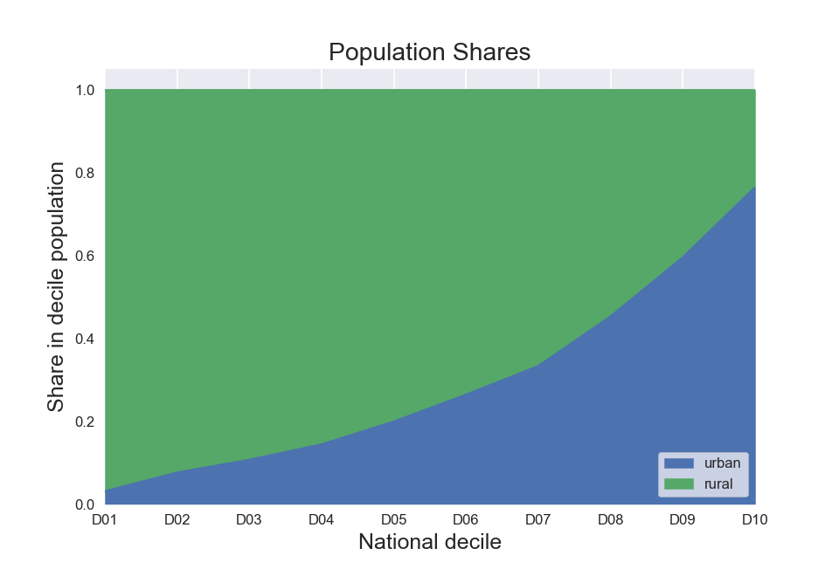
Figure 1 Urban and rural population shares by decile in India in 2010.

The three scenarios
Figure 2 shows the emissions of of primary PM_{2.5} and its precursors in the three scenarios discussed in the paper, aggregated to GNFR sectors. GNFR is an aggregated version of the NFR (Nomenclature For Reporting) which is used by individual country emission reporting to the EU.

The effects of the two alternative policies can clearly be discerned. For the CC scenario, only the household emissions (‘C_SmallComb’ = small combustion, light grey) is reduced for all relevant pollutants, whereas all other emission categories stay at reference levels. For the MCO emissions from all other sectors are reduced to the maximum technically feasible reduction level. This level is determined by essentially applying emission standards from a major western European country to India. The CC scenario is obtained by removing all solid fuels for cooking from the reference scenario, assuming that the replacement fuels will not cause significant emissions for the relevant air pollutants. This is certainly true for primary PM_{2.5}, SO2 and NH3. For NOx and VOC this is a minor simplification, so the resulting NOx and VOC reduction in the CC scenario may be slightly overestimated; however, the impact of VOC on secondary PM_{2.5} is relatively small and for NOx the relative error introduced by this simplification is minor already at the level of emissions.

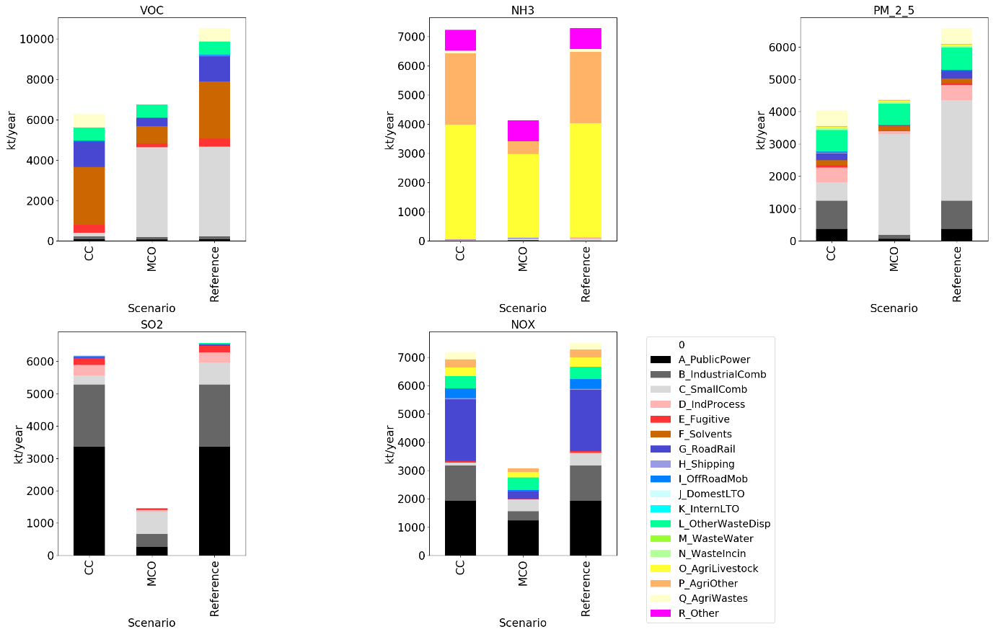
Figure 2 Emissions of primary PM_{2.5} and its precursors in the three scenarios discussed in the paper, aggregated to GNFR source categories. (Source: GAINS)

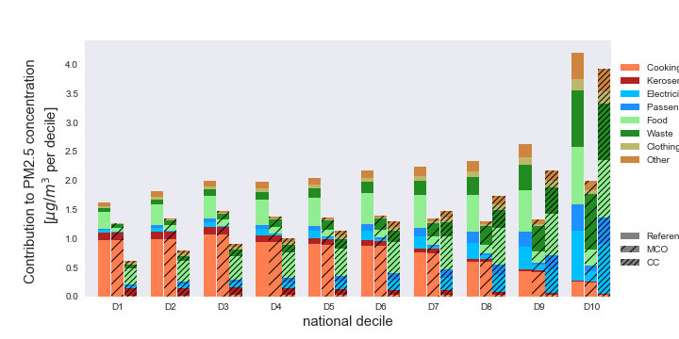
Figure 3 Contributions by sector groups to ambient PM_{2.5} concentration for each of the scenarios.
Figure 3 shows the breakdown of contributions to ambient PM_{2.5} levels for the different scenarios, i.e. a comparison of the right hand panel of Figure 1 of the main text across scenarios.

Open data / open code
The scenario data are available in the GAINS online model. While emission data are in principle openly accessible, interested parties are requested to contact the authors to obtain guidance on the choice of datasets that have actually been used for this paper.

Results

Sensitivity case: mortality related to ambient air pollution only
Figure 4 shows a version of Figure 3 of the main text, when only the mortality from ambient PM_{2.5} concentration is considered instead of the total mortality from PM_{2.5} including indoor air pollution (dashed lines). The full lines (contributions) are unchanged. While the scale of the mortality is different (right axis), the inequality across deciles is comparable comparing the two figures.

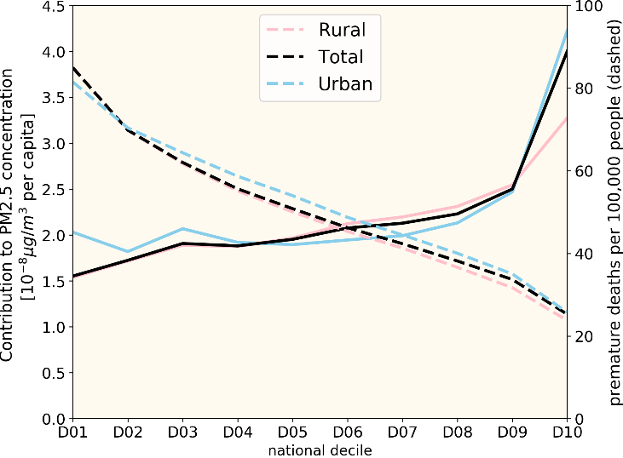
Figure 4 Version of Figure 3 (left panel) of the main text, when only the mortality from ambient PM_{2.5} concentration is considered instead of the total mortality from PM_{2.5} including indoor air pollution. (dashed lines)

The PEI for ambient PM_{2.5} pollution only
If only ambient air pollution is considered for the calculation of mortality, also the PEI values change relative to those given in the main text. At the national level the PEI is 23.2 [in units of number of deaths per 10⁻³ µg/m³ of ambient concentration contributed], while for the poorest and richest deciles the values are 54.7 and 6.3, respectively. Thus, the poorest decile suffers 2.4 times as many deaths per unit of contributed ambient pollution than the national average; conversely, the richest deciles suffers 3.7 times fewer deaths per unit of contributed pollution. Thus, in this metric, the poorest decile is disadvantaged relative to the richest decile by a factor of 8.7.

Sensitivity: constant baseline mortality vs income-dependent mortality
Figure 5 shows the mortality (normalized by population) associated with indoor pollution across income deciles for two alternative assumptions about the specific vulnerability. The left panel assumes that the vulnerability decreases with income, as proposed by Chowdhury et al.¹ The right panel assumes the baseline mortality . Thus, the right panel reflects the different fuel mixes and amounts being used across urban and rural, as well as across deciles, while the left panel in addition reflects the income dependence in the vulnerability.
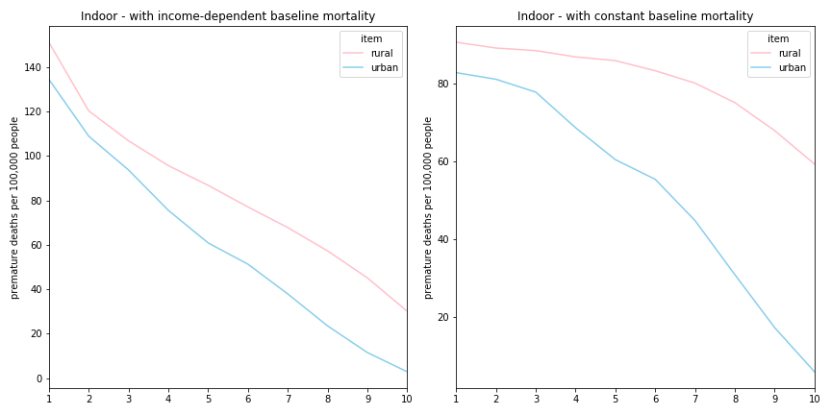
Figure 5 Mortality (per 100,000 persons) from indoor air pollution by decile (x-axis), calculated using income-dependent baseline mortality (left panel) and income-independent mortality (right-panel) for rural and urban population.

References
1. Chowdhury, S. & Dey, S. Cause-specific premature death from ambient PM_{2.5} exposure in India: Estimate adjusted for baseline mortality. Environ. Int. 91, 283–290 (2016).

Corresponding author: fabian@iiasa.ac.at
http://gains.iiasa.ac.at . A (free) registration is required to log in.

