Supporting Information

High Stability and Recyclable Cellulose-based Fluorescent Paper Derived from Waste Bagasse for Anti-counterfeiting

Lei Guoª, Hongchen Liu^{a, b *}, Fang Pengª, Jian Kang ^{c *}, Haisong Qi^{a *}

ª State Key Laboratory of Pulp and Paper Engineering, South China University of Technology, Guangzhou 510641, China
^{b} College of Textiles, Zhongyuan University of Technology, Zhengzhou 450007, China
^{c} State Key Laboratory of NBC Protection for Civilian, Beijing, 100191, China.
E-mail: liuhongchen.beyond@163.com; larance0130@163.com; qihs@scut.edu.cn
*Corresponding authors:
Haisong Qi: qihs@scut.edu.cn
Hongchen Liu: liuhongchen.beyond@163.com
Jian Kang: larance0130@163.com

Table. S1. Elemental analysis of bagasse and CAA-FA paper
Sample | Elements contents (%)
Sample | C | H | N
Bagasse | 41.76 | 6.621 | 0
CAA-FA | 44.11 | 6.271 | 0.19

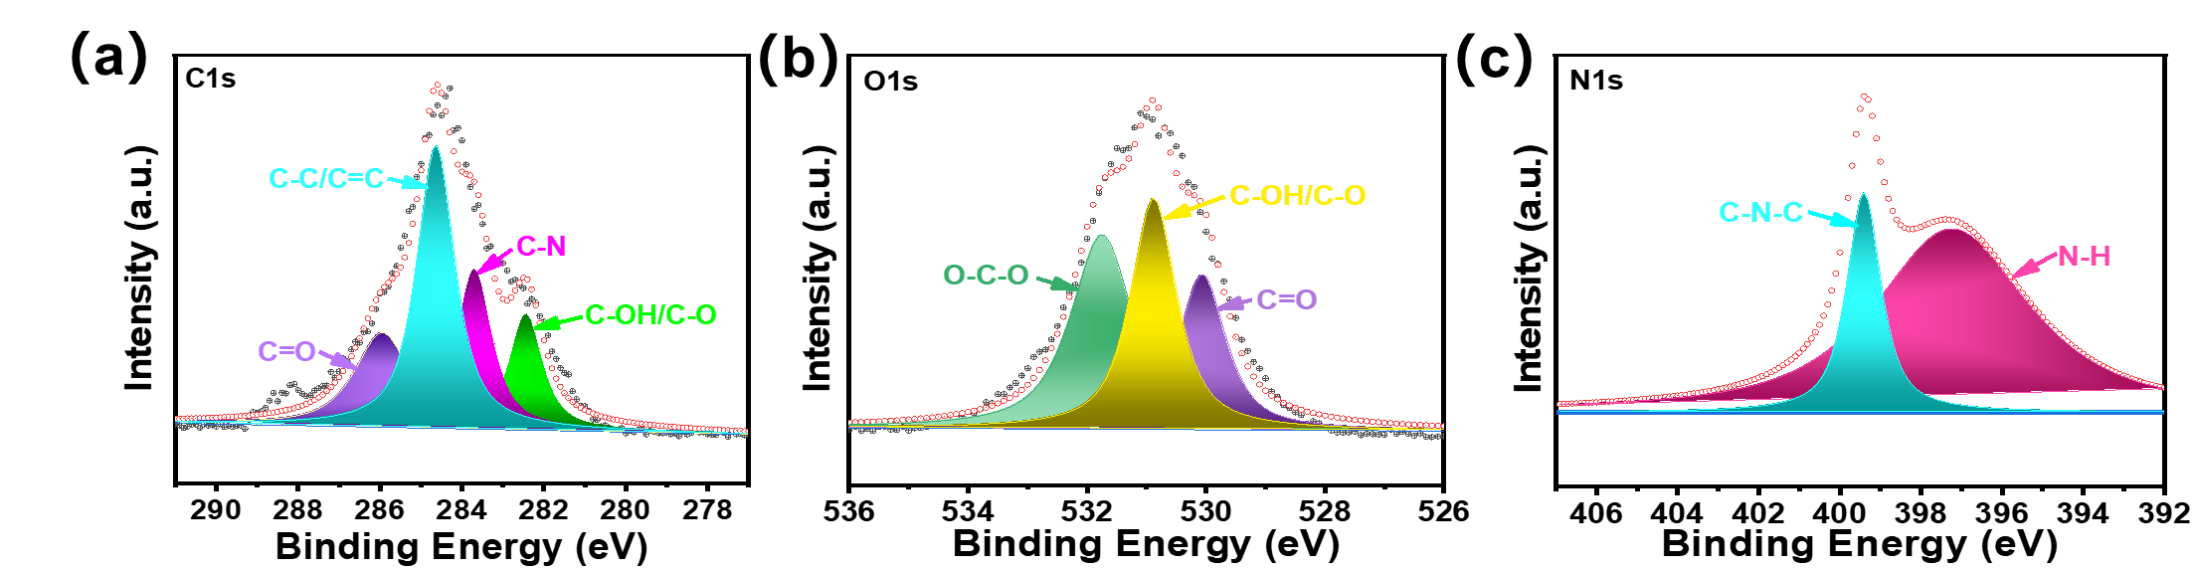
Fig. S1. (a) C1s (b) O1s and (c) N1s peak of CAA-FA paper.

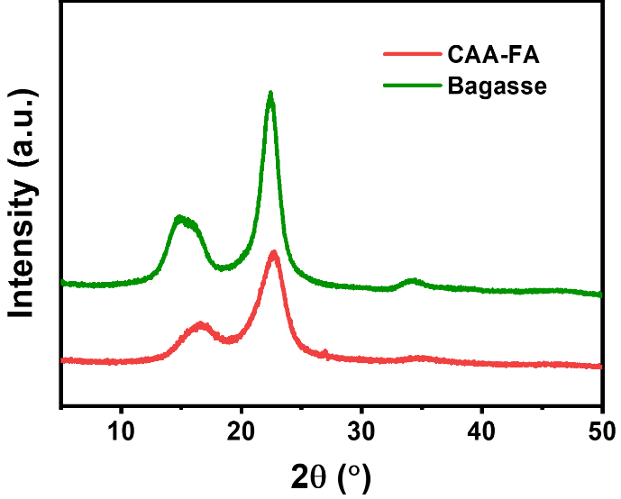
Fig. S2. XRD of bagasse and CAA-FA paper.

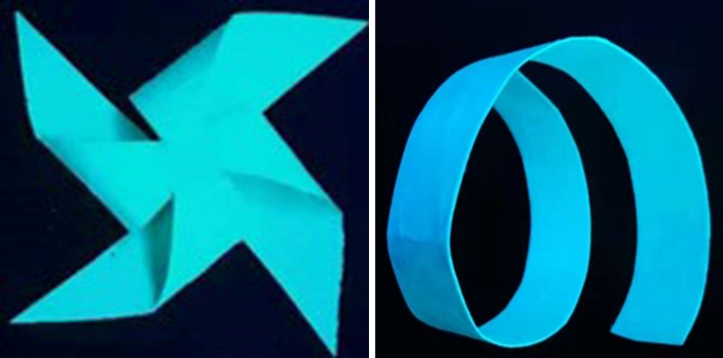
Fig. S3. Photographs of CAA-FA paper under UV light

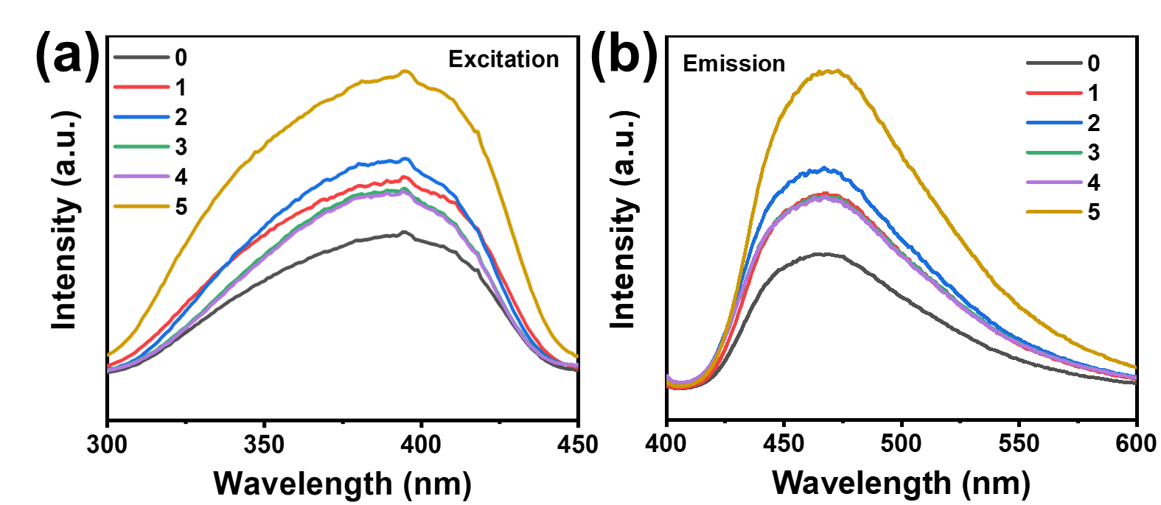
Fig. S4. The fluorescence (a) excitation and (b) emission of CAA-FA paper after different recycling times.

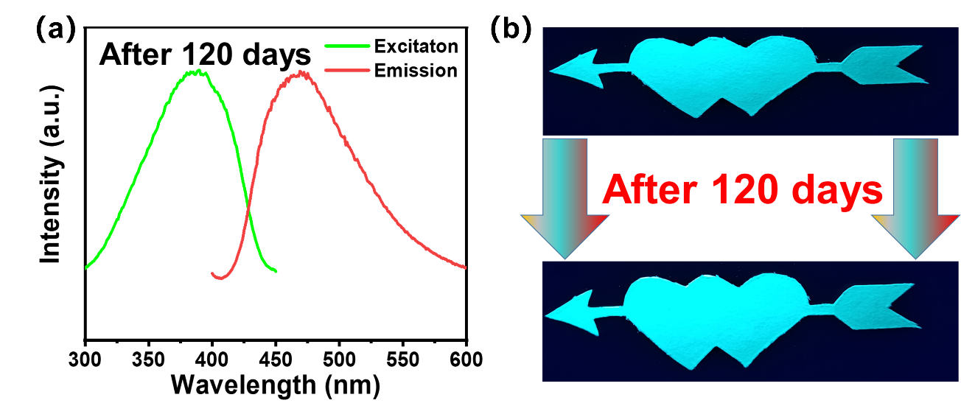
Fig. S5. (a) The fluorescence spectrum and (b) photograph of CAA-FA paper store for 120 days.

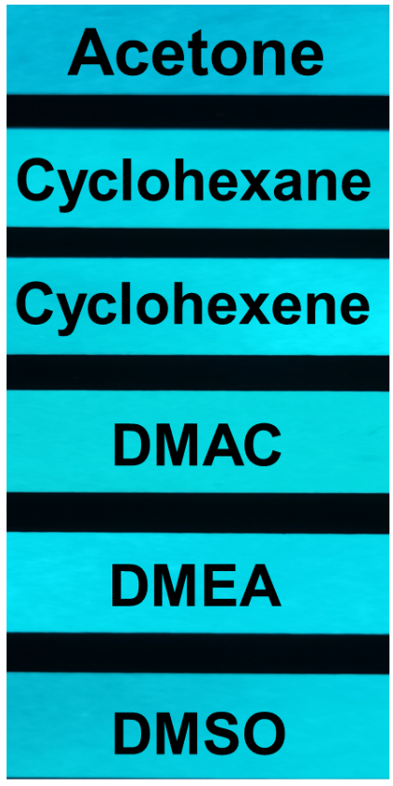
Fig. S6. The photo of CAA-FA paper after 24 h treatment with different organic reagents.

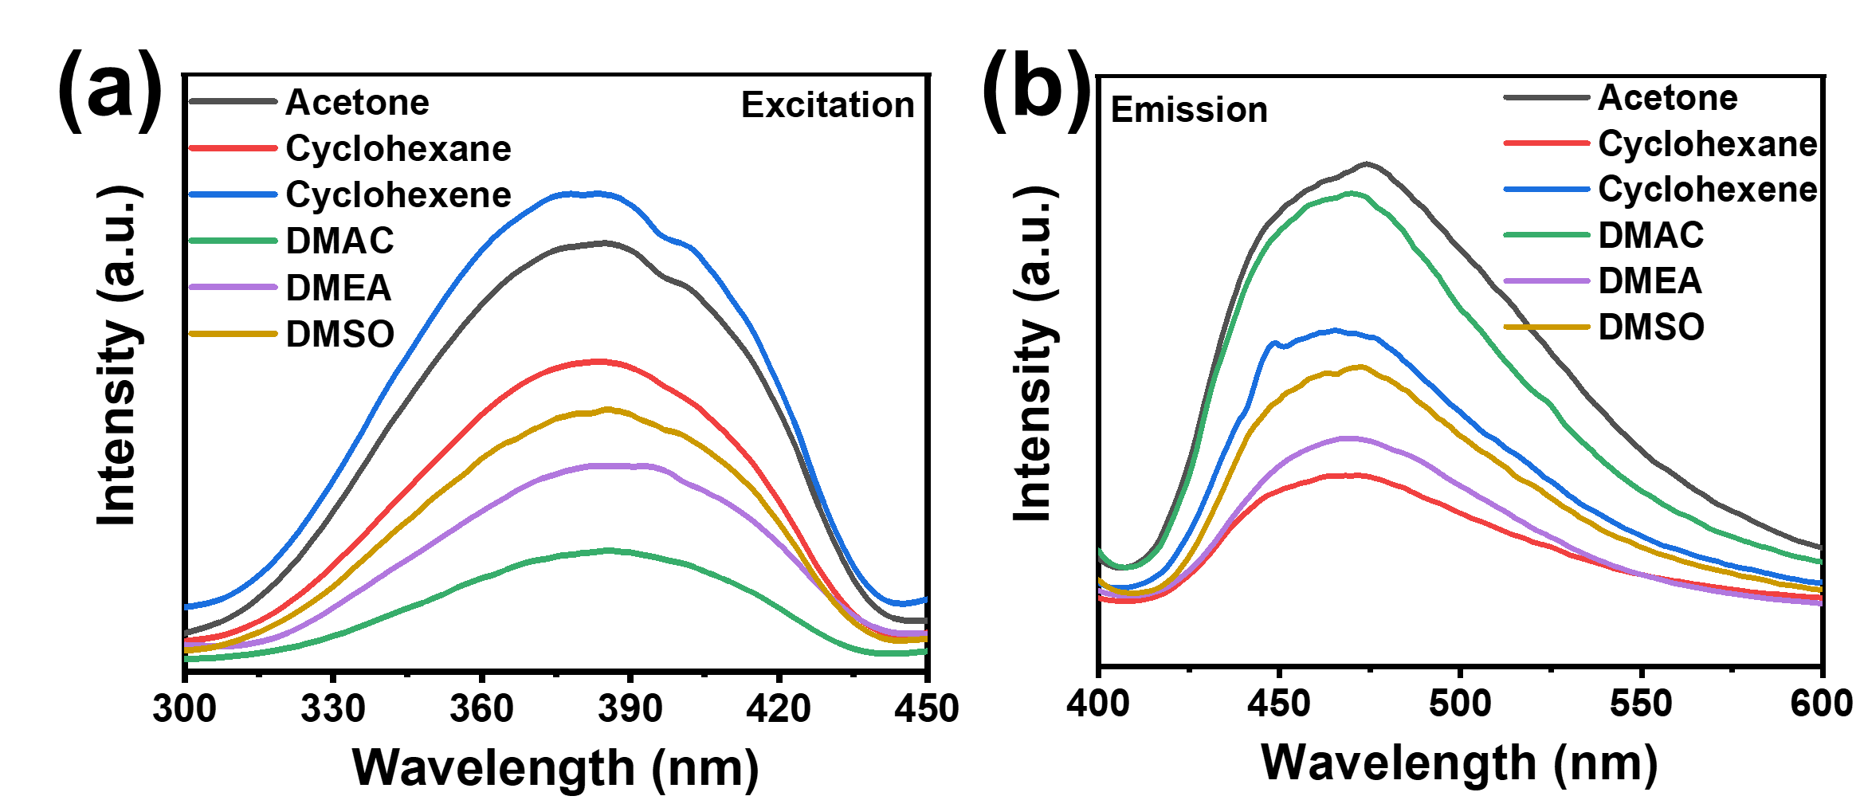
Fig. S7. The fluorescence (a) excitation and (b) emission of CAA-FA paper after different solvents treated with 24 h.

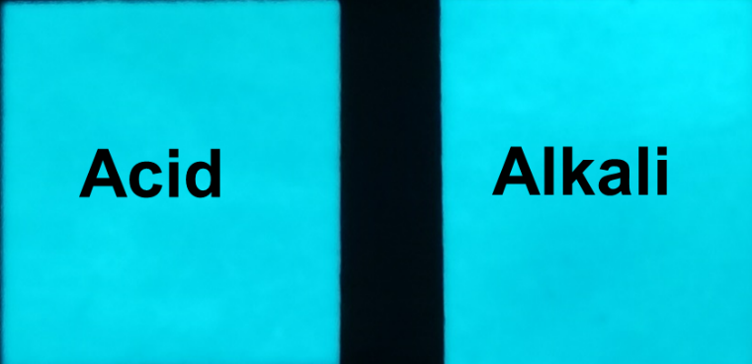
Fig. S8. The photo of CAA-FA paper after 24 h treatment with acid and alkali solutions.

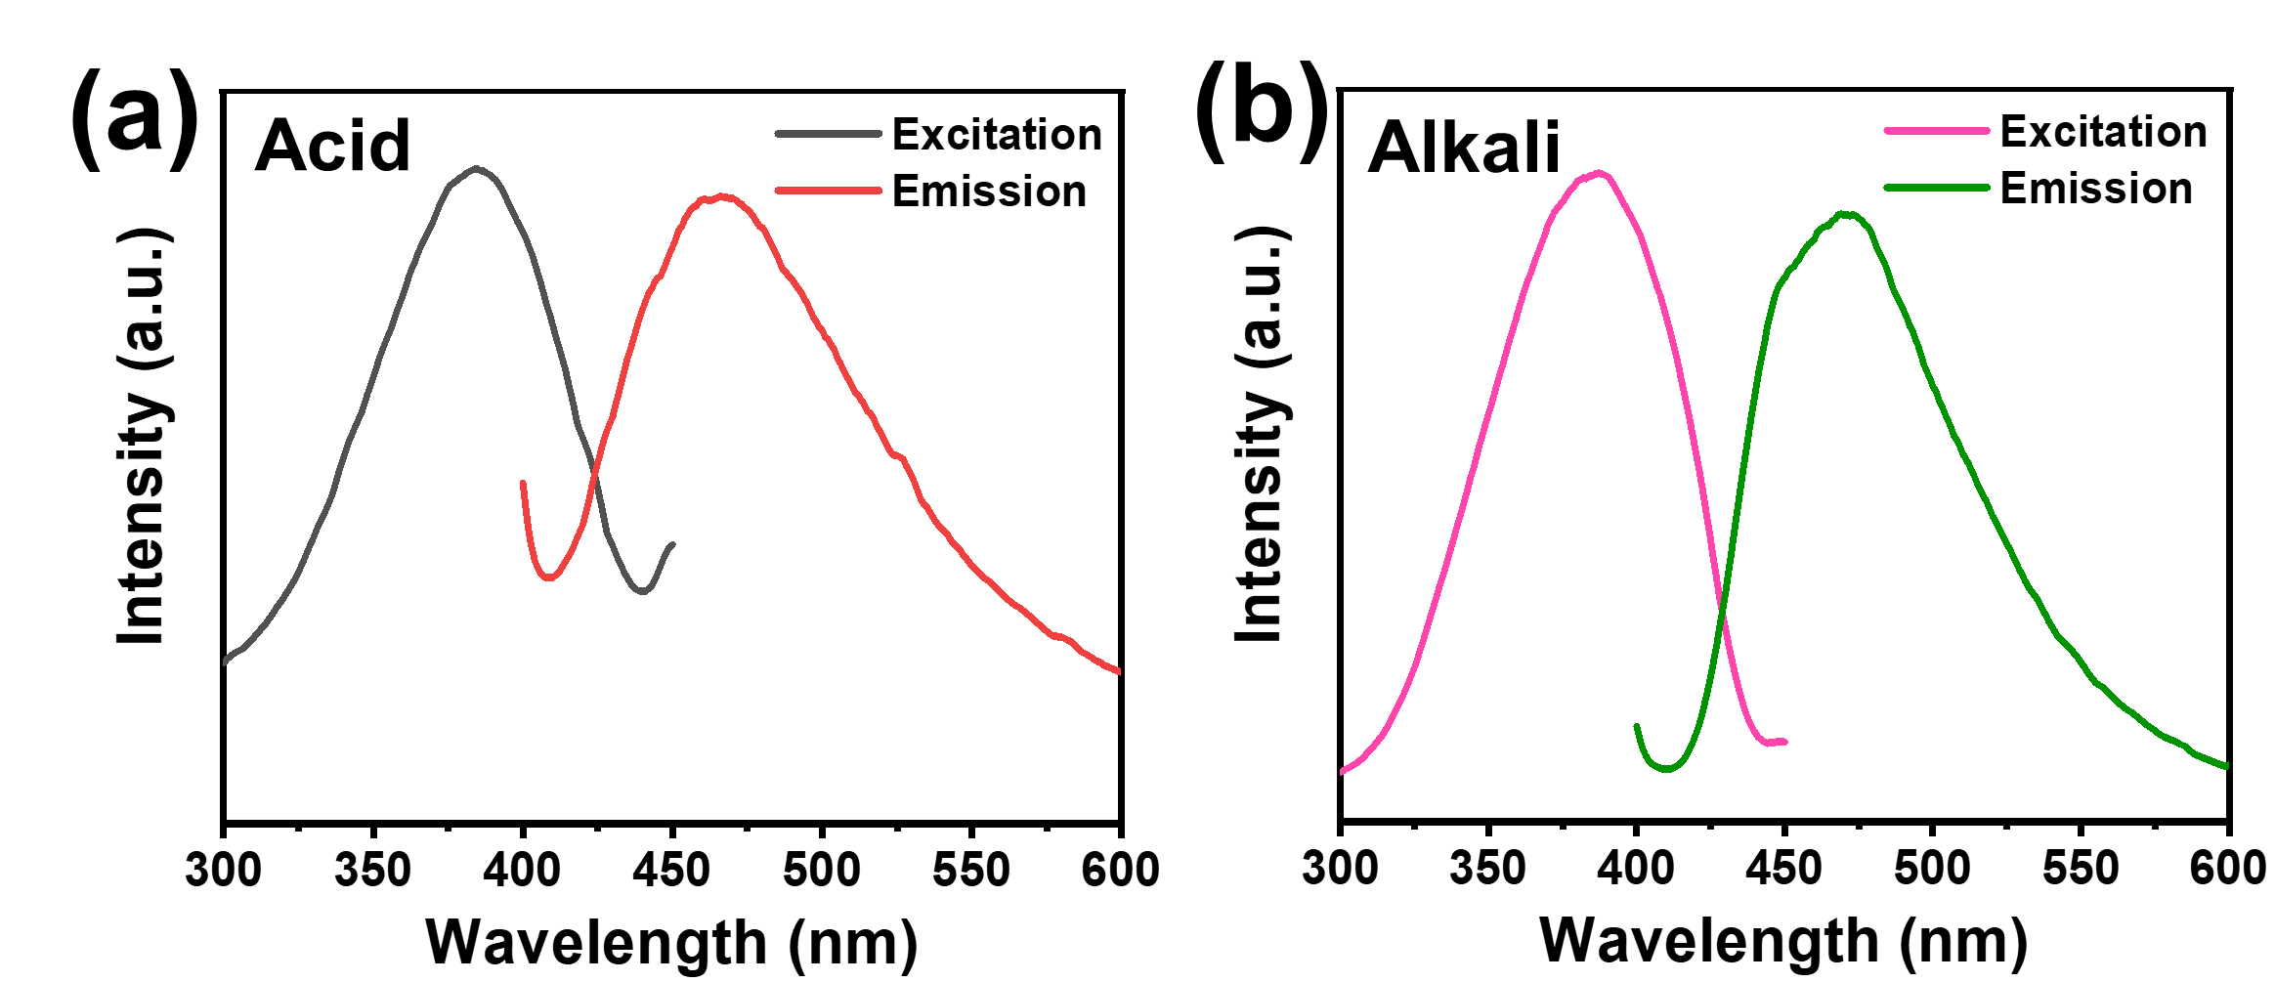
Fig. S9. The fluorescence spectrum of CAA-FA paper after (a) acid and (b) alkali treated with 24 h.

