Supplementary Materials

Effects of rainfall on human leptospirosis in Thailand: Evidence of multi-province study using distributed lag non-linear model

Arthit Phosri^{1,2 *}
¹Department of Environmental Health Sciences, Faculty of Public Health, Mahidol University, Bangkok, Thailand
²Center of Excellence on Environmental Health and Toxicology (EHT), OPS, Ministry of Higher Education, Science, Research and Innovation, Thailand

*Address correspondence to Arthit Phosri, Department of Environmental Health Sciences, 4th Floor, 2nd Building, Faculty of Public Health, Mahidol University, Rajvithi Road, Bangkok 10400, Thailand. Telephone: +66 2354 8525.
E-mail: arthit.pho@mahidol.ac.th, ORCID: https://orcid.org/0000-0002-5541-867X
Table of Contents
Table S1 Descriptive statistics of the monthly number of human leptospirosis, monthly cumulative rainfall, average temperature and relative humidity during the study period for each region
Table S2 Descriptive statistics of the monthly number of human leptospirosis, monthly cumulative rainfall, average temperature and relative humidity during the study period for each province
Table S3 Summary statistics for province-specific characteristics used to examine its contribution to the residual heterogeneity through multivariate meta-regression model
Table S4 Descriptive statistics for study-level characteristics for 60 provinces of Thailand
Table S5 Province-specific and BLUP estimate of leptospirosis associated with exposure to rainfall at 90th, 95th, and 99th percentiles at lag 0 month
Table S6 Region-specific and national estimate of leptospirosis associated with exposure to rainfall at 90th, 95th, and 99th percentiles at different lag structures
Table S7 Cochran Q test, I² and information criteria statistics obtained from multivariate meta-analysis at different lag structures
Table S8 Cochran Q test, I², information criteria and Wald test statistics obtained from multivariate meta-analysis by incorporating province-specific geographical and population characteristics into the model as meta-predictor
Table S9 The pooled national RR (95% CI) of leptospirosis at 90th, 95th, and 99th percentiles of monthly cumulative rainfall relative to 0 cm for different levels of geographical and population characteristics
Fig. S1 Study locations in which grey areas represent the provinces that included in this study
Fig. S2 Seasonal pattern of rainfall for each province, showing monthly average rainfall for each month from 2007 to 2017, excepting for those in Nong Bua Lam Phu (2014 to 2017)
Fig. S3 Seasonal pattern of human leptospirosis cases for each province, showing aggregated monthly number of human leptospirosis adjusting for number of days for each month and number of years for each province and then standardized as z-score.
Fig. S4 The national rainfall-leptospirosis associations using different DFs for temperature and relative humidity, estimated through multivariate meta-regression model. Grey solid line indicates rainfall level at 0 cm, whereas black, blue, and red dotted lines indicate monthly cumulative rainfall level at 90th, 95th, and 99th percentile, respectively
Fig. S5 The national rainfall-leptospirosis association using ML and REML for the multivariate meta-regression model. Black solid line indicates the national rainfall-leptospirosis association using REML for meta-regression model, whereas blue dashed line defines the rainfall-leptospirosis association using ML for meta-regression model. The shade areas define their corresponding 95% confidence intervals
Fig. S6 The model residual vs. predicted plot, normal Q-Q plot, time-series residual plot, and partial autocorrelation plot in Chiang Mai derived from province-specific DLNM model
Fig. S7 The model residual vs. predicted plot, normal Q-Q plot, time-series residual plot, and partial autocorrelation plot in Lampang derived from province-specific DLNM model
Fig. S8 The model residual vs. predicted plot, normal Q-Q plot, time-series residual plot, and partial autocorrelation plot in Si Sa Ket derived from province-specific DLNM model
Fig. S9 The model residual vs. predicted plot, normal Q-Q plot, time-series residual plot, and partial autocorrelation plot in Buri Ram derived from province-specific DLNM model
Fig. S10 The model residual vs. predicted plot, normal Q-Q plot, time-series residual plot, and partial autocorrelation plot in Nakhon Si Thammarat derived from province-specific DLNM model

Table S1 Descriptive statistics of the monthly number of human leptospirosis, monthly cumulative rainfall, average temperature and relative humidity during the study period for each region
Variables | Mean | Min | P25 | P50 | P75 | Max
60 provinces
Monthly leptospirosis counts | 4.9 | 0.0 | 0.0 | 1.0 | 5.0 | 264.0
Rainfall (cm) | 15.3 | 0.0 | 2.6 | 11.3 | 21.8 | 186.3
Temperature (ºC) | 27.3 | 17.7 | 26.5 | 27.6 | 28.5 | 34.4
Humidity (%) | 76.5 | 43.4 | 71.5 | 78.3 | 82.3 | 92.2
Northern
Monthly leptospirosis counts | 2.4 | 0.0 | 0.0 | 1.0 | 3.0 | 42.0
Rainfall (cm) | 11.6 | 0.0 | 1.5 | 9.2 | 19.1 | 59.7
Temperature (ºC) | 26.5 | 17.7 | 25.0 | 27.1 | 28.3 | 34.4
Humidity (%) | 75.5 | 43.4 | 70.0 | 77.6 | 82.1 | 88.5
North-eastern
Monthly leptospirosis counts | 11.1 | 0.0 | 1.0 | 5.0 | 13.0 | 264.0
Rainfall (cm) | 12.6 | 0.0 | 1.0 | 8.8 | 20.1 | 98.5
Temperature (ºC) | 27.0 | 19.1 | 25.7 | 27.6 | 28.5 | 32.9
Humidity (%) | 73.7 | 52.5 | 67.9 | 73.9 | 80.4 | 90.3
Central
Monthly leptospirosis counts | 1.0 | 0.0 | 0.0 | 0.0 | 1.0 | 9.0
Rainfall (cm) | 11.1 | 0.0 | 1.7 | 8.6 | 17.7 | 50.0
Temperature (ºC) | 28.3 | 22.7 | 27.4 | 28.3 | 29.3 | 34.0
Humidity (%) | 74.5 | 54.3 | 70.1 | 75.1 | 79.6 | 89.1
Eastern
Monthly leptospirosis counts | 0.8 | 0.0 | 0.0 | 0.0 | 1.0 | 21.0
Rainfall (cm) | 19.3 | 0.0 | 3.7 | 13.1 | 24.8 | 186.3
Temperature (ºC) | 27.9 | 22.7 | 27.2 | 27.9 | 28.7 | 32.4
Humidity (%) | 78.2 | 59.5 | 73.6 | 79.1 | 83.3 | 90.3
Southern
Monthly leptospirosis counts | 4.5 | 0.0 | 1.0 | 2.0 | 5.0 | 250.0
Rainfall (cm) | 22.4 | 0.0 | 8.0 | 16.8 | 30.9 | 148.8
Temperature (ºC) | 27.5 | 24.0 | 26.9 | 27.5 | 28.1 | 31.0
Humidity (%) | 81.2 | 63.3 | 78.8 | 81.7 | 84.2 | 92.2

Note: Descriptive statistics are reported, where Min and Max denote minimum and maximum value, respectively. P25, P50, and P75 refer to 25th percentile, 50th percentile (median), and 75th percentile, respectively.
Table S2 Descriptive statistics of the monthly number of human leptospirosis, monthly cumulative rainfall, average temperature and relative humidity during the study period for each province
Province | Variables | Mean | Min | P25 | P50 | P75 | Max
Central
Bangkok  (2007 – 2017) | Leptospirosis | 0.8 | 0.0 | 0.0 | 1.0 | 1.0 | 5.0
Bangkok  (2007 – 2017) | Rainfall (cm) | 15.8 | 0.0 | 3.4 | 12.3 | 25.3 | 50.0
Bangkok  (2007 – 2017) | Temperature (ºC) | 29.3 | 25.6 | 28.6 | 29.3 | 30.0 | 32.4
Bangkok  (2007 – 2017) | Humidity (%) | 70.9 | 57.9 | 68.0 | 71.8 | 74.8 | 82.3
Chai Nat  (2007 – 2017) | Leptospirosis | 1.1 | 0.0 | 0.0 | 1.0 | 2.0 | 7.0
Chai Nat  (2007 – 2017) | Rainfall (cm) | 9.6 | 0.0 | 0.7 | 7.0 | 14.2 | 44.6
Chai Nat  (2007 – 2017) | Temperature (ºC) | 28.0 | 22.7 | 27.2 | 28.2 | 28.9 | 33.0
Chai Nat  (2007 – 2017) | Humidity (%) | 74.5 | 62.0 | 70.9 | 75.3 | 78.6 | 85.8
Kanchanaburi  (2007 – 2017) | Leptospirosis | 0.7 | 0.0 | 0.0 | 0.0 | 1.0 | 4.0
Kanchanaburi  (2007 – 2017) | Rainfall (cm) | 13.3 | 0.0 | 3.5 | 12.2 | 21.3 | 37.1
Kanchanaburi  (2007 – 2017) | Temperature (ºC) | 27.8 | 22.8 | 27.2 | 27.8 | 28.8 | 33.1
Kanchanaburi  (2007 – 2017) | Humidity (%) | 74.2 | 57.2 | 68.2 | 76.2 | 80.6 | 84.3
Lop Buri  (2007 – 2017) | Leptospirosis | 0.4 | 0.0 | 0.0 | 0.0 | 1.0 | 5.0
Lop Buri  (2007 – 2017) | Rainfall (cm) | 10.6 | 0.0 | 1.8 | 9.2 | 17.0 | 46.5
Lop Buri  (2007 – 2017) | Temperature (ºC) | 28.2 | 23.1 | 27.4 | 28.3 | 29.2 | 32.9
Lop Buri  (2007 – 2017) | Humidity (%) | 73.2 | 56.8 | 67.1 | 73.1 | 79.1 | 86.7
Nakhon Sawan  (2007 – 2017) | Leptospirosis | 1.4 | 0.0 | 0.0 | 1.0 | 2.0 | 9.0
Nakhon Sawan  (2007 – 2017) | Rainfall (cm) | 11.8 | 0.0 | 2.1 | 8.6 | 18.8 | 43.9
Nakhon Sawan  (2007 – 2017) | Temperature (ºC) | 28.3 | 23.1 | 27.4 | 28.2 | 29.3 | 34.0
Nakhon Sawan  (2007 – 2017) | Humidity (%) | 73.5 | 54.3 | 67.0 | 73.9 | 80.5 | 87.3
Phetchaburi  (2007 – 2017) | Leptospirosis | 0.2 | 0.0 | 0.0 | 0.0 | 0.0 | 4.0
Phetchaburi  (2007 – 2017) | Rainfall (cm) | 8.8 | 0.0 | 1.4 | 6.4 | 13.2 | 41.9
Phetchaburi  (2007 – 2017) | Temperature (ºC) | 28.4 | 24.1 | 27.5 | 28.6 | 29.4 | 31.6
Phetchaburi  (2007 – 2017) | Humidity (%) | 76.2 | 66.9 | 74.1 | 76.2 | 78.6 | 84.4
Phra Nakhon Sri Ayutthaya  (2007 – 2017) | Leptospirosis | 1.3 | 0.0 | 0.0 | 1.0 | 2.0 | 6.0
Phra Nakhon Sri Ayutthaya  (2007 – 2017) | Rainfall (cm) | 9.4 | 0.0 | 1.0 | 7.5 | 15.4 | 35.0
Phra Nakhon Sri Ayutthaya  (2007 – 2017) | Temperature (ºC) | 28.3 | 23.8 | 27.5 | 28.5 | 29.2 | 32.7
Phra Nakhon Sri Ayutthaya  (2007 – 2017) | Humidity (%) | 75.4 | 60.0 | 71.2 | 76.4 | 80.5 | 86.6
Ratchaburi  (2007 – 2017) | Leptospirosis | 0.3 | 0.0 | 0.0 | 0.0 | 0.0 | 6.0
Ratchaburi  (2007 – 2017) | Rainfall (cm) | 9.3 | 0.0 | 1.3 | 7.7 | 15.0 | 29.7
Ratchaburi  (2007 – 2017) | Temperature (ºC) | 27.6 | 22.9 | 26.7 | 27.8 | 28.6 | 31.6
Ratchaburi  (2007 – 2017) | Humidity (%) | 78.2 | 66.7 | 73.8 | 78.6 | 82.3 | 89.1
Northern
Kamphaeng Phet  (2007 – 2017) | Leptospirosis | 0.5 | 0.0 | 0.0 | 0.0 | 1.0 | 6.0
Kamphaeng Phet  (2007 – 2017) | Rainfall (cm) | 11.8 | 0.0 | 1.2 | 9.8 | 19.5 | 59.7
Kamphaeng Phet  (2007 – 2017) | Temperature (ºC) | 27.8 | 22.4 | 26.8 | 27.9 | 28.7 | 34.4
Kamphaeng Phet  (2007 – 2017) | Humidity (%) | 76.0 | 47.6 | 70.1 | 77.2 | 83.0 | 87.3
Chiang Mai  (2007 – 2017) | Leptospirosis | 3.9 | 0.0 | 1.0 | 3.0 | 5.0 | 24.0
Chiang Mai  (2007 – 2017) | Rainfall (cm) | 13.6 | 0.0 | 1.7 | 11.4 | 22.8 | 47.0
Chiang Mai  (2007 – 2017) | Temperature (ºC) | 23.1 | 17.7 | 21.6 | 23.6 | 24.5 | 28.7
Chiang Mai  (2007 – 2017) | Humidity (%) | 73.5 | 43.4 | 64.9 | 77.8 | 83.7 | 88.5
Chiang Rai  (2007 – 2017) | Leptospirosis | 5.9 | 0.0 | 2.0 | 3.5 | 9.0 | 38.0
Chiang Rai  (2007 – 2017) | Rainfall (cm) | 15.0 | 0.0 | 3.3 | 11.5 | 23.2 | 52.3
Chiang Rai  (2007 – 2017) | Temperature (ºC) | 24.8 | 18.3 | 22.4 | 26.2 | 26.9 | 29.5
Chiang Rai  (2007 – 2017) | Humidity (%) | 78.1 | 59.9 | 73.9 | 79.2 | 82.6 | 86.1
Lampang  (2007 – 2017) | Leptospirosis | 4.3 | 0.0 | 0.8 | 2.0 | 4.0 | 42.0
Lampang  (2007 – 2017) | Rainfall (cm) | 11.3 | 0.0 | 2.2 | 10.1 | 18.0 | 37.6
Lampang  (2007 – 2017) | Temperature (ºC) | 26.8 | 20.4 | 25.5 | 27.3 | 28.2 | 33.2
Lampang  (2007 – 2017) | Humidity (%) | 73.4 | 45.9 | 67.2 | 77.0 | 81.3 | 86.1
Mae Hong Son  (2007 – 2017) | Leptospirosis | 1.0 | 0.0 | 0.0 | 0.0 | 1.0 | 8.0
Mae Hong Son  (2007 – 2017) | Rainfall (cm) | 11.1 | 0.0 | 1.4 | 10.3 | 20.0 | 37.7
Mae Hong Son  (2007 – 2017) | Temperature (ºC) | 26.0 | 19.9 | 23.4 | 26.8 | 27.5 | 32.4
Mae Hong Son  (2007 – 2017) | Humidity (%) | 76.8 | 52.4 | 70.3 | 80.4 | 83.6 | 86.5
Nan  (2007 – 2017) | Leptospirosis | 5.1 | 0.0 | 1.0 | 3.0 | 7.0 | 25.0
Nan  (2007 – 2017) | Rainfall (cm) | 12.0 | 0.0 | 2.3 | 8.9 | 18.3 | 49.4
Nan  (2007 – 2017) | Temperature (ºC) | 25.8 | 19.4 | 23.8 | 26.8 | 27.5 | 30.2
Nan  (2007 – 2017) | Humidity (%) | 78.5 | 64.2 | 74.5 | 79.6 | 83.5 | 86.9
Phayao  (2007 – 2017) | Leptospirosis | 3.4 | 0.0 | 1.0 | 2.0 | 4.3 | 26.0
Phayao  (2007 – 2017) | Rainfall (cm) | 9.3 | 0.0 | 1.7 | 8.0 | 15.2 | 31.8
Phayao  (2007 – 2017) | Temperature (ºC) | 25.5 | 18.9 | 23.3 | 26.5 | 27.4 | 31.3
Phayao  (2007 – 2017) | Humidity (%) | 76.8 | 53.8 | 71.9 | 79.8 | 82.5 | 86.7
Phetchabun  (2007 – 2017) | Leptospirosis | 2.0 | 0.0 | 0.0 | 1.0 | 3.0 | 12.0
Phetchabun  (2007 – 2017) | Rainfall (cm) | 10.9 | 0.0 | 2.1 | 9.8 | 18.1 | 36.2
Phetchabun  (2007 – 2017) | Temperature (ºC) | 27.6 | 22.4 | 26.7 | 27.8 | 28.7 | 32.8
Phetchabun  (2007 – 2017) | Humidity (%) | 72.7 | 56.4 | 65.8 | 72.8 | 79.9 | 86.4
Phichit  (2007 – 2017) | Leptospirosis | 0.6 | 0.0 | 0.0 | 0.0 | 1.0 | 6.0
Phichit  (2007 – 2017) | Rainfall (cm) | 10.9 | 0.0 | 0.7 | 7.6 | 17.0 | 52.4
Phichit  (2007 – 2017) | Temperature (ºC) | 27.9 | 22.2 | 26.7 | 28.1 | 28.9 | 34.0
Phichit  (2007 – 2017) | Humidity (%) | 77.5 | 54.1 | 74.6 | 78.6 | 82.4 | 86.8
Phitsanulok  (2007 – 2017) | Leptospirosis | 2.3 | 0.0 | 1.0 | 2.0 | 3.0 | 10.0
Phitsanulok  (2007 – 2017) | Rainfall (cm) | 11.7 | 0.0 | 2.1 | 8.6 | 21.1 | 41.3
Phitsanulok  (2007 – 2017) | Temperature (ºC) | 28.0 | 22.5 | 26.9 | 28.1 | 29.0 | 33.9
Phitsanulok  (2007 – 2017) | Humidity (%) | 74.3 | 52.0 | 69.4 | 74.8 | 80.4 | 85.7
Phrae  (2007 – 2017) | Leptospirosis | 1.6 | 0.0 | 0.0 | 1.0 | 2.0 | 17.0
Phrae  (2007 – 2017) | Rainfall (cm) | 10.0 | 0.0 | 1.7 | 8.1 | 15.7 | 35.4
Phrae  (2007 – 2017) | Temperature (ºC) | 26.8 | 20.6 | 25.1 | 27.4 | 28.2 | 33.6
Phrae  (2007 – 2017) | Humidity (%) | 75.7 | 52.3 | 70.5 | 77.3 | 82.2 | 87.6
Sukhothai  (2007 – 2017) | Leptospirosis | 0.8 | 0.0 | 0.0 | 1.0 | 1.0 | 5.0
Sukhothai  (2007 – 2017) | Rainfall (cm) | 11.1 | 0.0 | 1.0 | 9.3 | 19.5 | 44.1
Sukhothai  (2007 – 2017) | Temperature (ºC) | 27.9 | 22.2 | 26.7 | 28.3 | 28.9 | 34.2
Sukhothai  (2007 – 2017) | Humidity (%) | 77.0 | 54.0 | 73.5 | 78.2 | 81.8 | 86.8
Tak  (2007 – 2017) | Leptospirosis | 0.7 | 0.0 | 0.0 | 0.0 | 1.0 | 8.0
Tak  (2007 – 2017) | Rainfall (cm) | 12.3 | 0.0 | 1.8 | 11.4 | 20.9 | 41.0
Tak  (2007 – 2017) | Temperature (ºC) | 25.7 | 19.9 | 24.5 | 25.9 | 27.1 | 31.3
Tak  (2007 – 2017) | Humidity (%) | 74.8 | 52.5 | 69.6 | 77.6 | 82.1 | 85.5
Uttaradit  (2007 – 2017) | Leptospirosis | 1.7 | 0.0 | 0.0 | 1.0 | 2.0 | 11.0
Uttaradit  (2007 – 2017) | Rainfall (cm) | 11.1 | 0.0 | 0.5 | 8.8 | 18.2 | 47.5
Uttaradit  (2007 – 2017) | Temperature (ºC) | 27.9 | 22.4 | 26.6 | 28.2 | 29.0 | 34.0
Uttaradit  (2007 – 2017) | Humidity (%) | 72.0 | 49.8 | 66.0 | 72.8 | 78.5 | 84.7
North-eastern
Buri Ram  (2007 – 2017) | Leptospirosis | 27.1 | 0.0 | 4.8 | 11.0 | 35.3 | 264.0
Buri Ram  (2007 – 2017) | Rainfall (cm) | 12.3 | 0.0 | 1.4 | 11.0 | 20.1 | 40.5
Buri Ram  (2007 – 2017) | Temperature (ºC) | 27.0 | 20.8 | 25.5 | 27.5 | 28.3 | 32.3
Buri Ram  (2007 – 2017) | Humidity (%) | 75.8 | 57.1 | 71.0 | 76.6 | 81.9 | 90.3
Chaiyaphum  (2007 – 2017) | Leptospirosis | 3.7 | 0.0 | 1.0 | 2.5 | 5.0 | 18.0
Chaiyaphum  (2007 – 2017) | Rainfall (cm) | 10.5 | 0.0 | 0.7 | 7.9 | 16.1 | 41.9
Chaiyaphum  (2007 – 2017) | Temperature (ºC) | 27.6 | 21.8 | 26.5 | 27.9 | 28.8 | 32.6
Chaiyaphum  (2007 – 2017) | Humidity (%) | 69.7 | 52.5 | 63.1 | 68.9 | 76.8 | 85.6
Kalasin  (2007 – 2017) | Leptospirosis | 16.9 | 1.0 | 7.0 | 13.0 | 22.0 | 64.0
Kalasin  (2007 – 2017) | Rainfall (cm) | 11.5 | 0.0 | 0.6 | 7.8 | 18.4 | 44.6
Kalasin  (2007 – 2017) | Temperature (ºC) | 27.6 | 20.6 | 26.3 | 28.2 | 29.3 | 32.9
Kalasin  (2007 – 2017) | Humidity (%) | 73.3 | 55.0 | 66.6 | 73.2 | 79.7 | 88.4
Khon Kaen  (2007 – 2017) | Leptospirosis | 17.3 | 0.0 | 6.0 | 11.0 | 21.3 | 91.0
Khon Kaen  (2007 – 2017) | Rainfall (cm) | 10.4 | 0.0 | 0.7 | 8.2 | 16.6 | 46.2
Khon Kaen  (2007 – 2017) | Temperature (ºC) | 27.1 | 20.9 | 25.7 | 27.5 | 28.4 | 32.6
Khon Kaen  (2007 – 2017) | Humidity (%) | 73.6 | 55.4 | 67.4 | 73.5 | 80.4 | 87.8
Loei  (2007 – 2017) | Leptospirosis | 9.8 | 0.0 | 4.0 | 8.0 | 14.0 | 57.0
Loei  (2007 – 2017) | Rainfall (cm) | 11.1 | 0.0 | 1.8 | 10.5 | 16.3 | 52.1
Loei  (2007 – 2017) | Temperature (ºC) | 25.8 | 19.1 | 24.3 | 26.7 | 27.5 | 30.5
Loei  (2007 – 2017) | Humidity (%) | 76.8 | 55.7 | 72.1 | 78.2 | 83.0 | 88.9
Maha Sarakham  (2007 – 2017) | Leptospirosis | 7.0 | 0.0 | 2.0 | 5.5 | 9.3 | 33.0
Maha Sarakham  (2007 – 2017) | Rainfall (cm) | 11.9 | 0.0 | 0.7 | 7.7 | 19.9 | 44.7
Maha Sarakham  (2007 – 2017) | Temperature (ºC) | 27.6 | 21.2 | 26.2 | 28.1 | 29.1 | 32.9
Maha Sarakham  (2007 – 2017) | Humidity (%) | 73.8 | 58.0 | 69.4 | 73.9 | 78.7 | 85.6
Mukdahan  (2007 – 2017) | Leptospirosis | 1.1 | 0.0 | 0.0 | 0.0 | 2.0 | 8.0
Mukdahan  (2007 – 2017) | Rainfall (cm) | 12.0 | 0.0 | 0.4 | 7.9 | 20.4 | 67.5
Mukdahan  (2007 – 2017) | Temperature (ºC) | 26.9 | 20.0 | 25.1 | 27.6 | 28.7 | 32.8
Mukdahan  (2007 – 2017) | Humidity (%) | 72.1 | 53.7 | 66.9 | 70.8 | 79.2 | 85.6
Nakhon Phanom  (2007 – 2017) | Leptospirosis | 0.9 | 0.0 | 0.0 | 0.0 | 1.0 | 11.0
Nakhon Phanom  (2007 – 2017) | Rainfall (cm) | 18.0 | 0.0 | 1.1 | 9.6 | 27.9 | 98.5
Nakhon Phanom  (2007 – 2017) | Temperature (ºC) | 26.2 | 19.5 | 24.8 | 27.0 | 28.0 | 30.8
Nakhon Phanom  (2007 – 2017) | Humidity (%) | 75.2 | 58.1 | 68.3 | 73.8 | 83.5 | 89.0
Nakhon Ratchasima  (2007 – 2017) | Leptospirosis | 8.1 | 0.0 | 3.0 | 6.0 | 11.0 | 45.0
Nakhon Ratchasima  (2007 – 2017) | Rainfall (cm) | 11.7 | 0.0 | 2.8 | 10.5 | 18.5 | 38.7
Nakhon Ratchasima  (2007 – 2017) | Temperature (ºC) | 27.0 | 21.4 | 25.8 | 27.4 | 28.3 | 31.7
Nakhon Ratchasima  (2007 – 2017) | Humidity (%) | 73.1 | 58.5 | 68.8 | 73.8 | 78.3 | 86.1
Nong Bua Lam Phu  (2014 – 2017) | Leptospirosis | 1.9 | 0.0 | 1.0 | 1.0 | 2.3 | 8.0
Nong Bua Lam Phu  (2014 – 2017) | Rainfall (cm) | 11.1 | 0.0 | 1.8 | 7.9 | 20.7 | 33.9
Nong Bua Lam Phu  (2014 – 2017) | Temperature (ºC) | 26.7 | 20.3 | 24.9 | 27.4 | 28.3 | 32.2
Nong Bua Lam Phu  (2014 – 2017) | Humidity (%) | 74.3 | 54.2 | 68.1 | 75.1 | 82.5 | 86.5
Nong Khai  (2007 – 2017) | Leptospirosis | 2.9 | 0.0 | 0.0 | 1.0 | 3.0 | 21.0
Nong Khai  (2007 – 2017) | Rainfall (cm) | 15.1 | 0.0 | 1.6 | 8.2 | 26.7 | 71.8
Nong Khai  (2007 – 2017) | Temperature (ºC) | 27.1 | 20.6 | 26.0 | 27.7 | 28.6 | 32.3
Nong Khai  (2007 – 2017) | Humidity (%) | 73.2 | 57.4 | 66.7 | 72.3 | 80.9 | 86.1
Roi Et  (2007 – 2017) | Leptospirosis | 7.6 | 0.0 | 3.0 | 6.0 | 11.0 | 35.0
Roi Et  (2007 – 2017) | Rainfall (cm) | 11.8 | 0.0 | 1.2 | 9.1 | 18.9 | 48.1
Roi Et  (2007 – 2017) | Temperature (ºC) | 27.2 | 21.0 | 25.5 | 27.8 | 28.7 | 32.5
Roi Et  (2007 – 2017) | Humidity (%) | 74.1 | 57.7 | 68.9 | 74.3 | 80.2 | 87.8
Sakon Nakhon  (2007 – 2017) | Leptospirosis | 1.6 | 0.0 | 0.0 | 0.5 | 2.3 | 12.0
Sakon Nakhon  (2007 – 2017) | Rainfall (cm) | 14.4 | 0.0 | 1.4 | 9.5 | 22.9 | 84.9
Sakon Nakhon  (2007 – 2017) | Temperature (ºC) | 26.2 | 19.2 | 24.6 | 27.2 | 28.0 | 31.7
Sakon Nakhon  (2007 – 2017) | Humidity (%) | 75.1 | 54.7 | 69.8 | 74.8 | 81.4 | 86.7
Si Sa Ket  (2007 – 2017) | Leptospirosis | 35.6 | 3.0 | 16.0 | 27.0 | 46.3 | 203.0
Si Sa Ket  (2007 – 2017) | Rainfall (cm) | 11.8 | 0.0 | 0.4 | 6.9 | 19.6 | 53.3
Si Sa Ket  (2007 – 2017) | Temperature (ºC) | 27.3 | 21.6 | 25.9 | 27.8 | 28.8 | 32.1
Si Sa Ket  (2007 – 2017) | Humidity (%) | 74.7 | 58.5 | 69.3 | 74.0 | 80.7 | 86.6
Surin  (2007 – 2017) | Leptospirosis | 25.0 | 2.0 | 9.0 | 17.0 | 31.3 | 167.0
Surin  (2007 – 2017) | Rainfall (cm) | 12.6 | 0.0 | 1.3 | 9.6 | 21.4 | 45.9
Surin  (2007 – 2017) | Temperature (ºC) | 27.5 | 21.4 | 26.1 | 28.0 | 28.8 | 32.3
Surin  (2007 – 2017) | Humidity (%) | 73.9 | 59.0 | 68.8 | 74.0 | 79.7 | 86.6
Ubon Ratchathani  (2007 – 2017) | Leptospirosis | 10.2 | 0.0 | 4.0 | 8.0 | 15.0 | 46.0
Ubon Ratchathani  (2007 – 2017) | Rainfall (cm) | 14.7 | 0.0 | 0.8 | 9.6 | 23.3 | 72.9
Ubon Ratchathani  (2007 – 2017) | Temperature (ºC) | 27.2 | 21.5 | 25.9 | 27.6 | 28.5 | 32.3
Ubon Ratchathani  (2007 – 2017) | Humidity (%) | 73.5 | 57.2 | 67.4 | 73.8 | 80.3 | 87.2
Udon Thani  (2007 – 2017) | Leptospirosis | 5.6 | 0.0 | 1.0 | 3.0 | 8.0 | 46.0
Udon Thani  (2007 – 2017) | Rainfall (cm) | 11.8 | 0.0 | 1.1 | 8.5 | 19.6 | 46.9
Udon Thani  (2007 – 2017) | Temperature (ºC) | 27.0 | 20.2 | 25.7 | 27.8 | 28.6 | 32.3
Udon Thani  (2007 – 2017) | Humidity (%) | 71.5 | 53.3 | 66.4 | 70.6 | 78.0 | 84.6
Eastern
Chachoengsao  (2007 – 2017) | Leptospirosis | 0.6 | 0.0 | 0.0 | 0.0 | 1.0 | 5.0
Chachoengsao  (2007 – 2017) | Rainfall (cm) | 13.2 | 0.0 | 3.1 | 11.9 | 20.3 | 50.8
Chachoengsao  (2007 – 2017) | Temperature (ºC) | 27.1 | 22.7 | 26.5 | 27.2 | 28.0 | 30.5
Chachoengsao  (2007 – 2017) | Humidity (%) | 79.2 | 59.5 | 74.9 | 80.7 | 84.3 | 88.3
Chanthaburi  (2007 – 2017) | Leptospirosis | 2.7 | 0.0 | 0.0 | 2.0 | 4.0 | 21.0
Chanthaburi  (2007 – 2017) | Rainfall (cm) | 28.4 | 0.0 | 4.9 | 21.3 | 46.5 | 107.7
Chanthaburi  (2007 – 2017) | Temperature (ºC) | 27.5 | 24.4 | 27.0 | 27.6 | 28.1 | 30.3
Chanthaburi  (2007 – 2017) | Humidity (%) | 80.3 | 61.4 | 77.4 | 82.2 | 85.6 | 89.6
Chon Buri  (2007 – 2017) | Leptospirosis | 0.4 | 0.0 | 0.0 | 0.0 | 1.0 | 4.0
Chon Buri  (2007 – 2017) | Rainfall (cm) | 11.3 | 0.0 | 3.3 | 9.2 | 16.9 | 51.6
Chon Buri  (2007 – 2017) | Temperature (ºC) | 28.5 | 25.1 | 27.7 | 28.6 | 29.3 | 31.4
Chon Buri  (2007 – 2017) | Humidity (%) | 76.0 | 62.6 | 73.6 | 76.8 | 78.8 | 84.5
Prachin Buri  (2007 – 2017) | Leptospirosis | 0.2 | 0.0 | 0.0 | 0.0 | 0.0 | 2.0
Prachin Buri  (2007 – 2017) | Rainfall (cm) | 14.7 | 0.0 | 2.2 | 11.8 | 22.3 | 68.2
Prachin Buri  (2007 – 2017) | Temperature (ºC) | 28.2 | 24.2 | 27.6 | 28.2 | 29.0 | 32.3
Prachin Buri  (2007 – 2017) | Humidity (%) | 76.0 | 60.7 | 70.4 | 76.5 | 82.5 | 86.7
Rayong  (2007 – 2017) | Leptospirosis | 0.8 | 0.0 | 0.0 | 0.0 | 1.0 | 6.0
Rayong  (2007 – 2017) | Rainfall (cm) | 13.6 | 0.0 | 4.7 | 10.7 | 20.6 | 44.0
Rayong  (2007 – 2017) | Temperature (ºC) | 28.1 | 24.4 | 27.2 | 28.3 | 29.0 | 31.0
Rayong  (2007 – 2017) | Humidity (%) | 77.4 | 64.6 | 75.5 | 77.9 | 80.6 | 85.9
Sa Kaeo  (2007 – 2017) | Leptospirosis | 0.7 | 0.0 | 0.0 | 0.0 | 1.0 | 7.0
Sa Kaeo  (2007 – 2017) | Rainfall (cm) | 12.4 | 0.0 | 2.9 | 11.3 | 19.8 | 44.3
Sa Kaeo  (2007 – 2017) | Temperature (ºC) | 28.0 | 23.4 | 27.3 | 28.0 | 28.9 | 32.4
Sa Kaeo  (2007 – 2017) | Humidity (%) | 76.5 | 59.5 | 70.5 | 78.2 | 82.6 | 86.9
Trat  (2007 – 2017) | Leptospirosis | 0.3 | 0.0 | 0.0 | 0.0 | 0.0 | 2.0
Trat  (2007 – 2017) | Rainfall (cm) | 41.7 | 0.0 | 8.2 | 26.3 | 65.4 | 186.3
Trat  (2007 – 2017) | Temperature (ºC) | 27.6 | 25.5 | 27.2 | 27.5 | 28.0 | 29.8
Trat  (2007 – 2017) | Humidity (%) | 81.6 | 65.8 | 78.4 | 82.6 | 87.1 | 90.3
Southern
Chumphon  (2007 – 2017) | Leptospirosis | 0.6 | 0.0 | 0.0 | 0.0 | 1.0 | 4.0
Chumphon  (2007 – 2017) | Rainfall (cm) | 17.0 | 0.0 | 7.2 | 14.2 | 23.0 | 78.0
Chumphon  (2007 – 2017) | Temperature (ºC) | 27.2 | 24.0 | 26.7 | 27.3 | 27.9 | 30.4
Chumphon  (2007 – 2017) | Humidity (%) | 80.7 | 72.7 | 78.8 | 80.7 | 82.6 | 87.3
Krabi  (2007 – 2017) | Leptospirosis | 2.5 | 0.0 | 0.0 | 2.0 | 3.0 | 29.0
Krabi  (2007 – 2017) | Rainfall (cm) | 20.4 | 0.0 | 7.0 | 18.7 | 30.9 | 58.5
Krabi  (2007 – 2017) | Temperature (ºC) | 27.6 | 26.3 | 27.1 | 27.5 | 28.0 | 30.4
Krabi  (2007 – 2017) | Humidity (%) | 82.0 | 70.1 | 79.3 | 83.3 | 85.5 | 90.3
Nakhon Si Thammarat  (2007 – 2017) | Leptospirosis | 13.9 | 1.0 | 8.0 | 12.0 | 18.0 | 80.0
Nakhon Si Thammarat  (2007 – 2017) | Rainfall (cm) | 23.2 | 0.0 | 11.4 | 17.2 | 29.0 | 125.6
Nakhon Si Thammarat  (2007 – 2017) | Temperature (ºC) | 27.3 | 25.4 | 26.7 | 27.4 | 27.9 | 30.4
Nakhon Si Thammarat  (2007 – 2017) | Humidity (%) | 83.5 | 75.5 | 81.5 | 83.2 | 85.8 | 90.8
Narathiwat  (2007 – 2017) | Leptospirosis | 3.3 | 0.0 | 1.0 | 2.5 | 5.0 | 22.0
Narathiwat  (2007 – 2017) | Rainfall (cm) | 24.8 | 0.0 | 9.1 | 14.7 | 29.3 | 124.2
Narathiwat  (2007 – 2017) | Temperature (ºC) | 27.4 | 25.0 | 26.6 | 27.5 | 28.0 | 30.2
Narathiwat  (2007 – 2017) | Humidity (%) | 81.1 | 75.0 | 78.9 | 80.7 | 82.8 | 88.4
Pattani  (2007 – 2017) | Leptospirosis | 1.5 | 0.0 | 0.0 | 1.0 | 2.0 | 12.0
Pattani  (2007 – 2017) | Rainfall (cm) | 16.6 | 0.0 | 5.3 | 11.6 | 22.7 | 86.7
Pattani  (2007 – 2017) | Temperature (ºC) | 27.5 | 25.4 | 26.9 | 27.6 | 28.1 | 30.0
Pattani  (2007 – 2017) | Humidity (%) | 81.1 | 73.4 | 78.8 | 80.9 | 83.4 | 89.8
Phangnga  (2007 – 2017) | Leptospirosis | 4.9 | 0.0 | 2.0 | 4.0 | 7.0 | 17.0
Phangnga  (2007 – 2017) | Rainfall (cm) | 34.8 | 0.2 | 11.2 | 33.0 | 51.1 | 121.9
Phangnga  (2007 – 2017) | Temperature (ºC) | 27.3 | 25.9 | 26.9 | 27.2 | 27.6 | 29.7
Phangnga  (2007 – 2017) | Humidity (%) | 83.7 | 66.7 | 80.3 | 85.2 | 87.0 | 92.2
Phatthalung  (2007 – 2017) | Leptospirosis | 4.7 | 0.0 | 1.0 | 3.0 | 6.3 | 30.0
Phatthalung  (2007 – 2017) | Rainfall (cm) | 20.2 | 0.0 | 6.0 | 11.4 | 27.6 | 113.4
Phatthalung  (2007 – 2017) | Temperature (ºC) | 27.7 | 25.9 | 27.1 | 27.8 | 28.3 | 30.6
Phatthalung  (2007 – 2017) | Humidity (%) | 82.1 | 72.3 | 79.7 | 81.9 | 84.5 | 90.8
Phuket  (2007 – 2017) | Leptospirosis | 1.4 | 0.0 | 0.0 | 1.0 | 2.0 | 7.0
Phuket  (2007 – 2017) | Rainfall (cm) | 23.6 | 0.0 | 9.4 | 22.9 | 35.6 | 62.6
Phuket  (2007 – 2017) | Temperature (ºC) | 28.4 | 26.8 | 27.9 | 28.3 | 28.8 | 30.9
Phuket  (2007 – 2017) | Humidity (%) | 78.4 | 65.9 | 75.9 | 79.6 | 81.8 | 86.0
Ranong  (2007 – 2017) | Leptospirosis | 7.3 | 0.0 | 1.0 | 3.0 | 5.0 | 118.0
Ranong  (2007 – 2017) | Rainfall (cm) | 36.3 | 0.0 | 7.7 | 27.8 | 59.7 | 148.8
Ranong  (2007 – 2017) | Temperature (ºC) | 27.3 | 25.9 | 26.8 | 27.1 | 27.7 | 30.5
Ranong  (2007 – 2017) | Humidity (%) | 79.2 | 65.1 | 74.8 | 81.8 | 84.1 | 88.5
Satun  (2007 – 2017) | Leptospirosis | 1.9 | 0.0 | 0.0 | 1.0 | 3.0 | 14.0
Satun  (2007 – 2017) | Rainfall (cm) | 20.5 | 0.0 | 10.7 | 19.1 | 30.3 | 61.2
Satun  (2007 – 2017) | Temperature (ºC) | 27.8 | 26.5 | 27.3 | 27.7 | 28.3 | 30.4
Satun  (2007 – 2017) | Humidity (%) | 79.2 | 63.3 | 77.1 | 81.5 | 82.8 | 87.5
Songkhla  (2007 – 2017) | Leptospirosis | 8.5 | 1.0 | 3.0 | 5.0 | 8.0 | 250.0
Songkhla  (2007 – 2017) | Rainfall (cm) | 18.9 | 0.4 | 7.7 | 14.8 | 27.3 | 77.0
Songkhla  (2007 – 2017) | Temperature (ºC) | 27.6 | 25.9 | 27.0 | 27.6 | 28.2 | 30.2
Songkhla  (2007 – 2017) | Humidity (%) | 79.8 | 73.1 | 77.1 | 79.7 | 82.4 | 88.3
Surat Thani  (2007 – 2017) | Leptospirosis | 4.6 | 0.0 | 2.0 | 4.0 | 7.0 | 16.0
Surat Thani  (2007 – 2017) | Rainfall (cm) | 17.6 | 0.0 | 9.0 | 15.2 | 21.3 | 109.6
Surat Thani  (2007 – 2017) | Temperature (ºC) | 27.3 | 25.4 | 26.7 | 27.3 | 27.9 | 30.5
Surat Thani  (2007 – 2017) | Humidity (%) | 82.6 | 73.4 | 80.8 | 82.8 | 84.6 | 89.6
Trang  (2007 – 2017) | Leptospirosis | 4.4 | 0.0 | 1.0 | 3.0 | 5.0 | 42.0
Trang  (2007 – 2017) | Rainfall (cm) | 19.6 | 0.0 | 9.4 | 19.2 | 27.3 | 63.7
Trang  (2007 – 2017) | Temperature (ºC) | 27.5 | 26.0 | 27.0 | 27.4 | 27.9 | 31.0
Trang  (2007 – 2017) | Humidity (%) | 81.6 | 67.1 | 79.7 | 83.4 | 85.5 | 90.0
Yala  (2007 – 2017) | Leptospirosis | 2.9 | 0.0 | 1.0 | 2.0 | 5.0 | 17.0
Yala  (2007 – 2017) | Rainfall (cm) | 20.6 | 0.0 | 7.4 | 14.7 | 28.6 | 100.5
Yala  (2007 – 2017) | Temperature (ºC) | 27.2 | 24.8 | 26.4 | 27.2 | 27.8 | 30.3
Yala  (2007 – 2017) | Humidity (%) | 81.1 | 70.2 | 78.5 | 80.9 | 83.6 | 89.4

Note: Descriptive statistics are reported, where Min and Max denote minimum and maximum value, respectively. P25, P50, and P75 refer to 25th percentile, 50th percentile (median), and 75th percentile, respectively

Table S3 Summary statistics for province-specific characteristics used to examine its contribution to the residual heterogeneity through multivariate meta-regression model
Provinces | Latitude (ºN) | Longitude (ºE) | DTR (ºC) | Population (x10⁵) | High education (%) | Agriculturists (%)
Central | 14.30±0.88 | 100.16±0.40 | 9.64±1.26 | 13.52±17.67 | 14.71±13.57 | 6.78±3.27
Bangkok | 13.72790 | 100.52412 | 7.84 | 56.86 | 47.86 | 0.16
Chai Nat | 15.18520 | 100.12513 | 9.66 | 3.33 | 7.64 | 9.99
Kanchanaburi | 14.02278 | 99.53281 | 11.26 | 8.43 | 7.63 | 7.91
Lop Buri | 14.79951 | 100.65337 | 10.28 | 7.58 | 10.87 | 7.81
Nakhon Sawan | 15.69301 | 100.12256 | 10.14 | 10.73 | 8.30 | 9.22
Phetchaburi | 13.11116 | 99.93913 | 7.85 | 4.71 | 11.47 | 8.69
Phra Nakhon Sri Ayutthaya | 14.35321 | 100.56896 | 10.80 | 7.98 | 14.01 | 3.82
Ratchaburi | 13.52829 | 99.81342 | 9.32 | 8.50 | 9.91 | 6.61
Northern | 17.86±1.20 | 99.82±0.79 | 10.86±0.98 | 7.16±3.70 | 8.93±3.06 | 11.72±2.27
Chiang Mai | 18.78775 | 98.99313 | 8.71 | 16.67 | 17.31 | 8.06
Chiang Rai | 19.90717 | 99.83096 | 11.21 | 12.05 | 8.59 | 12.15
Kamphaeng Phet | 16.48278 | 99.52266 | 10.00 | 7.29 | 6.67 | 10.57
Lampang | 18.28884 | 99.49087 | 11.91 | 7.55 | 10.93 | 12.28
Mae Hong Son | 19.29906 | 97.96562 | 12.58 | 2.47 | 5.66 | 13.79
Nan | 18.77563 | 100.77304 | 11.91 | 4.78 | 8.05 | 16.19
Phayao | 19.16648 | 99.90194 | 11.22 | 4.87 | 7.83 | 13.89
Phetchabun | 16.41898 | 101.15509 | 11.13 | 9.94 | 6.01 | 9.84
Phichit | 16.44295 | 100.34823 | 10.02 | 5.49 | 8.63 | 9.18
Phitsanulok | 16.82980 | 100.26149 | 10.12 | 8.56 | 12.65 | 9.19
Phrae | 18.14458 | 100.14028 | 11.07 | 4.56 | 9.18 | 13.88
Sukhothai | 17.00556 | 99.82637 | 10.27 | 6.03 | 7.53 | 12.53
Tak | 16.88399 | 99.12585 | 11.09 | 5.32 | 6.64 | 10.66
Uttaradit | 17.62009 | 100.09929 | 10.82 | 4.61 | 9.39 | 11.86
North-eastern | 16.31±1.01 | 103.32±0.99 | 10.30±0.48 | 12.03±5.85 | 6.75±2.13 | 12.87±2.01
Buri Ram | 14.99300 | 103.10292 | 10.91 | 15.73 | 5.06 | 11.21
Chaiyaphum | 15.80682 | 102.03150 | 9.70 | 11.36 | 4.85 | 12.99
Kalasin | 16.43141 | 103.50588 | 9.66 | 9.84 | 5.88 | 14.18
Khon Kaen | 16.44194 | 102.83599 | 10.52 | 17.82 | 12.21 | 11.13
Loei | 17.48602 | 101.72230 | 11.12 | 6.32 | 6.30 | 14.52
Maha Sarakham | 16.18509 | 103.30265 | 10.75 | 9.56 | 8.18 | 14.21
Mukdahan | 16.54244 | 104.72092 | 10.07 | 3.44 | 7.32 | 15.66
Nakhon Phanom | 17.39204 | 104.76955 | 10.00 | 7.11 | 5.37 | 14.73
Nakhon Ratchasima | 14.97990 | 102.09777 | 9.83 | 26.10 | 9.18 | 9.95
Nong Bua Lam Phu | 17.22182 | 102.42604 | 10.83 | 5.07 | 5.03 | 11.44
Nong Khai | 17.87828 | 102.74126 | 10.02 | 5.15 | 10.01 | 9.35
Roi Et | 16.05382 | 103.65200 | 9.74 | 13.09 | 6.00 | 13.80
Sakon Nakhon | 17.15460 | 104.13484 | 10.24 | 11.34 | 5.47 | 15.68
Si Sa Ket | 15.11860 | 104.32201 | 9.97 | 14.62 | 4.19 | 13.91
Surin | 14.88291 | 103.49371 | 10.32 | 13.88 | 5.29 | 13.45
Ubon Ratchathani | 15.22869 | 104.85642 | 10.98 | 18.37 | 7.53 | 12.48
Udon Thani | 17.41384 | 102.78723 | 10.47 | 15.64 | 6.89 | 10.03
Eastern | 13.21±0.70 | 101.62±0.60 | 8.70±1.31 | 6.45±3.62 | 12.25±5.85 | 7.06±2.89
Chachoengsao | 13.69042 | 101.07796 | 10.26 | 6.90 | 10.66 | 7.88
Chanthaburi | 12.61134 | 102.10385 | 8.43 | 5.24 | 8.89 | 9.67
Chon Buri | 13.36114 | 100.98467 | 7.33 | 13.90 | 21.93 | 1.63
Prachin Buri | 14.05097 | 101.37274 | 9.91 | 4.76 | 11.39 | 6.46
Rayong | 12.68331 | 101.23743 | 7.01 | 6.61 | 18.67 | 5.31
Sa Kaeo | 13.82404 | 102.06458 | 9.83 | 5.51 | 5.87 | 9.62
Trat | 12.24276 | 102.51747 | 8.16 | 2.24 | 8.36 | 8.87
Southern | 7.95±1.26 | 99.83±1.10 | 8.62±0.72 | 6.52±4.09 | 11.59±4.90 | 11.15±3.93
Chumphon | 10.49305 | 99.18002 | 8.37 | 4.98 | 8.15 | 17.89
Krabi | 8.08630 | 98.90628 | 7.57 | 4.51 | 7.46 | 9.64
Nakhon Si Thammarat | 8.43040 | 99.96312 | 9.57 | 15.42 | 11.41 | 12.45
Narathiwat | 6.42546 | 101.82531 | 8.56 | 7.66 | 6.52 | 8.58
Pattani | 6.86948 | 101.25048 | 9.01 | 6.79 | 8.04 | 10.15
Phangnga | 8.44075 | 98.51930 | 7.72 | 2.59 | 8.78 | 12.08
Phatthalung | 7.61668 | 100.07402 | 7.91 | 5.18 | 10.16 | 14.82
Phuket | 7.98105 | 98.36388 | 7.85 | 3.70 | 24.03 | 0.55
Ranong | 9.95287 | 98.60846 | 8.21 | 1.75 | 10.88 | 12.82
Satun | 6.62382 | 100.06737 | 8.78 | 3.10 | 17.72 | 11.14
Songkhla | 7.17560 | 100.61435 | 8.71 | 13.90 | 17.55 | 8.59
Surat Thani | 9.13824 | 99.32175 | 8.97 | 10.32 | 11.66 | 12.46
Trang | 7.55939 | 99.61101 | 9.71 | 6.36 | 10.94 | 13.68
Yala | 6.54115 | 101.28039 | 9.70 | 5.06 | 9.00 | 11.18

Note: DTR, diurnal temperature range indicating monthly average DTR during the study period (i.e., 2007 – 2017, and 2014 – 2017 for a province of Nong Bua Lam Phu); the number of population (in 2013) is shown as per 10⁵ populations; high education indicates the proportion of populations who have received bachelor’s degree or above (using the information from the population and housing census version 2010); agriculturists illustrate the proportion of populations who have registered as agricultural workers (using the information of 2013)

Table S4 Descriptive statistics for study-level characteristics for 60 provinces of Thailand
Variables | Mean | Min | P25 | Median | P75 | Max
Latitude (ºN) | 14.09 | 6.43 | 12.52 | 15.06 | 16.91 | 19.91
Longitude (ºE) | 101.07 | 97.97 | 99.83 | 100.63 | 102.18 | 104.86
Diurnal temperature range (ºC) | 9.76 | 7.01 | 8.76 | 9.98 | 10.76 | 12.58
Population size (x 100,000) | 9.15 | 1.75 | 4.95 | 7.01 | 11.35 | 56.86
Population with high education (%) | 10.09 | 4.19 | 6.66 | 8.48 | 10.93 | 47.86
Population with agriculturist (%) | 10.71 | 0.16 | 9.10 | 11.14 | 13.51 | 17.89

Descriptive statistics are reported, where Min and Max denote minimum and maximum value, respectively. P25 and P75 refer to 25th percentile (1st quartile), and 75th percentile (3rd quartile), respectively

Table S5 Province-specific and BLUP estimate of leptospirosis associated with exposure to rainfall at 90th, 95th, and 99th percentiles at lag 0 month
Province | Percentile | RR (95% confidence interval)
Province | Percentile | Province-specific | BLUP
Bangkok | 90th (34.0) | 0.3209 (0.0686, 1.5000) | 1.0009 (0.6685, 1.4986)
Bangkok | 95th (37.6) | 0.3481 (0.0749, 1.6188) | 1.0277 (0.7014, 1.5058)
Bangkok | 99th (48.3) | 0.3748 (0.0520, 2.7045) | 1.1015 (0.8308, 1.4604)
Phra Nakhon Sri Ayutthaya | 90th (23.4) | 2.4985 (0.8066, 7.7391) | 1.1328 (0.7623, 1.6834)
Phra Nakhon Sri Ayutthaya | 95th (26.3) | 2.5038 (0.7851, 7.9844) | 1.1529 (0.7674, 1.7321)
Phra Nakhon Sri Ayutthaya | 99th (32.0) | 2.0258 (0.5729, 7.1632) | 1.1917 (0.7962, 1.7836)
Ratchaburi | 90th (22.4) | 4.0915 (0.2671, 62.6805) | 1.0215 (0.6796, 1.5353)
Ratchaburi | 95th (25.7) | 1.8156 (0.1338, 24.6387) | 1.0378 (0.6795, 1.5851)
Ratchaburi | 99th (29.4) | 0.8929 (0.0233, 34.2824) | 1.0599 (0.6916, 1.6243)
Kanchanaburi | 90th (28.7) | 2.4485 (0.3551, 16.8801) | 1.1004 (0.7204, 1.6808)
Kanchanaburi | 95th (31.5) | 2.1971 (0.3204, 15.0679) | 1.1183 (0.7354, 1.7006)
Kanchanaburi | 99th (36.5) | 1.5063 (0.1352, 16.7762) | 1.1503 (0.7749, 1.7075)
Nakhon Sawan | 90th (26.7) | 2.8245 (0.6817, 11.7025) | 1.1381 (0.7513, 1.7241)
Nakhon Sawan | 95th (33.4) | 2.9532 (0.7332, 11.8947) | 1.1819 (0.7880, 1.7727)
Nakhon Sawan | 99th (39.9) | 2.0414 (0.5256, 7.9287) | 1.2161 (0.8459, 1.7484)
Chai Nat | 90th (24.8) | 1.05345 (0.3549, 3.1272) | 1.0829 (0.7285, 1.6096)
Chai Nat | 95th (29.1) | 1.3175 (0.4724, 3.6745) | 1.1101 (0.7423, 1.6601)
Chai Nat | 99th (36.2) | 1.0469 (0.2892, 3.7897) | 1.1555 (0.7924, 1.6851)
Lop Buri | 90th (25.9) | 0.9889 (0.1255, 7.7903) | 1.0428 (0.6841, 1.5895)
Lop Buri | 95th (29.8) | 1.1476 (0.1417, 9.2912) | 1.0667 (0.6982, 1.6297)
Lop Buri | 99th (38.8) | 1.6869 (0.1234, 23.0593) | 1.1253 (0.7699, 1.6445)
Phetchaburi | 90th (19.6) | 0.0201 (0.0023, 0.1719) | 0.9645 (0.6599, 1.4097)
Phetchaburi | 95th (25.0) | 0.0919 (0.0106, 0.8003) | 0.9822 (0.6462, 1.4929)
Phetchaburi | 99th (40.8) | 1.6309 (0.1822, 14.5962) | 1.0846 (0.7554, 1.5575)
Chiang Mai | 90th (30.4) | 1.9810 (0.7729, 5.0778) | 1.1869 (0.8008, 1.7590)
Chiang Mai | 95th (37.8) | 2.0139 (0.7604, 5.3339) | 1.2293 (0.8571, 1.7629)
Chiang Mai | 99th (42.4) | 2.1684 (0.8001, 5.8767) | 1.2452 (0.9006, 1.7217)
Chiang Rai | 90th (30.4) | 1.2353 (0.7085, 2.1536) | 1.0362 (0.7577, 1.4171)
Chiang Rai | 95th (37.8) | 1.3494 (0.7681, 2.3705) | 1.0666 (0.8001, 1.4219)
Chiang Rai | 99th (42.4) | 1.7704 0.9386, 3.3393) | 1.1064 (0.8703, 1.4067)
Kamphaeng Phet | 90th (27.1) | 0.6529 (0.0887, 4.8050) | 0.9807 (0.6436, 1.4946)
Kamphaeng Phet | 95th (31.3) | 0.5485 (0.0748, 4.0222) | 1.0058 (0.6622, 1.5279)
Kamphaeng Phet | 99th (42.3) | 0.7146 (0.0936, 5.4529) | 1.0834 (0.7662, 1.5321)
Lampang | 90th (22.7) | 0.6965 (0.3007, 1.6133) | 0.9271 (0.6358, 1.3518)
Lampang | 95th (28.3) | 0.5132 (0.2142, 1.2296) | 0.9500 (0.6412, 1.4077)
Lampang | 99th (34.7) | 0.5120 (0.1950, 1.3444) | 0.9925 (0.6810, 1.4466)
Mae Hong Son | 90th (24.4) | 1.2114 (0.1975, 7.4322) | 1.0350 (0.6838, 1.5667)
Mae Hong Son | 95th (26.9) | 1.1613 (0.1828, 7.3785) | 1.0485 (0.6878, 1.5985)
Mae Hong Son | 99th (34.6) | 1.78567 (0.2382, 13.3869) | 1.0986 (0.7327, 1.6474)
Nan | 90th (27.8) | 0.9685 (0.5232, 1.7926) | 0.9287 (0.6488, 1.3295)
Nan | 95th (34.3) | 0.8714 (0.4607, 1.6481) | 0.9709 (0.6873, 1.3716)
Nan | 99th (47.1) | 1.9415 (0.9012, 4.1828) | 1.0689 (0.8265, 1.3824)
Phayao | 90th (20.6) | 1.5263 (0.6373, 3.6558) | 1.1583 (0.8070, 1.6624)
Phayao | 95th (24.5) | 1.6557 (0.6928, 3.9572) | 1.1895 (0.8085, 1.7498)
Phayao | 99th (28.4) | 2.4084 (1.0145, 5.7173) | 1.2186 (0.8223, 1.8058)
Phetchabun | 90th (24.2) | 1.2820 (0.4341, 3.7857) | 1.0724 (0.7214, 1.5941)
Phetchabun | 95th (30.1) | 1.4335 (0.4891, 4.2012) | 1.1097 (0.7409, 1.6620)
Phetchabun | 99th (35.1) | 1.3951 (0.4270, 4.5577) | 1.1417 (0.7758, 1.6800)
Phichit | 90th (28.3) | 0.9696 (0.2445, 3.8447) | 1.0580 (0.7001, 1.5990)
Phichit | 95th (33.1) | 0.8979 (0.2290, 3.5205) | 1.0891 (0.7278, 1.6296)
Phichit | 99th (42.2) | 0.8325 (0.2094, 3.3094) | 1.1453 (0.8153, 1.6089)
Phitsanulok | 90th (28.1) | 0.5480 (0.2204, 1.3628) | 0.9547 (0.6421, 1.4193)
Phitsanulok | 95th (31.5) | 0.5025 (0.1976, 1.2783) | 0.9749 (0.6585, 1.4434)
Phitsanulok | 99th (36.1) | 0.4606 (0.1648, 1.2872) | 1.0082 (0.6947, 1.4632)
Phrae | 90th (22.8) | 0.8955 (0.2673, 3.0001) | 1.0487 (0.7089, 1.5514)
Phrae | 95th (30.0) | 1.1222 (0.3600, 3.4984) | 1.0911 (0.7265, 1.6387)
Phrae | 99th (34.4) | 1.0535 (0.2836, 3.9140) | 1.1203 (0.7569, 1.6582)
Sukhothai | 90th (26.0) | 0.3478 (0.0959, 1.2621) | 0.9410 (0.6240, 1.4190)
Sukhothai | 95th (30.8) | 0.3127 (0.0835, 1.1709) | 0.9681 (0.6419, 1.4601)
Sukhothai | 99th (39.0) | 0.3963 (0.0884, 1.7760) | 1.0278 (0.7113, 1.4852)
Tak | 90th (25.2) | 0.7296 (0.1514, 3.5165) | 1.0022 (0.6624, 1.5165)
Tak | 95th (28.4) | 0.6133 (0.1287, 2.9225) | 1.0195 (0.6703, 1.5505)
Tak | 99th (35.4) | 0.5611 (0.1157, 2.7217) | 1.0657 (0.7159, 1.5864)
Uttaradit | 90th (27.7) | 0.7988 (0.2614, 2.4406) | 1.0184 (0.6778, 1.5303)
Uttaradit | 95th (34.1) | 0.9963 (0.3279, 3.0269) | 1.0599 (0.7155, 1.5701)
Uttaradit | 99th (42.4) | 1.2015 (0.3714, 3.8873) | 1.1143 (0.7977, 1.5565)
Buri Ram | 90th (28.6) | 1.1625 (0.7005, 1.9293) | 1.1029 (0.7831, 1.5533)
Buri Ram | 95th (31.4) | 1.1856 (0.7214, 1.9486) | 1.1207 (0.7983, 1.5731)
Buri Ram | 99th (37.7) | 1.2319 (0.6586, 2.3039) | 1.1601 (0.8477, 1.5876)
Chaiyaphum | 90th (28.0) | 0.4806 (0.2669, 0.8653) | 0.8126 (0.5679, 1.1627)
Chaiyaphum | 95th (34.3) | 0.5374 (0.2971, 0.9721) | 0.8532 (0.6042, 1.2049)
Chaiyaphum | 99th (39.1) | 0.6444 (0.3261, 1.2733) | 0.8962 (0.6515, 1.2327)
Kalasin | 90th (30.0) | 1.1150 (0.7347, 1.6924) | 1.0943 (0.7969, 1.5026)
Kalasin | 95th (36.2) | 1.2560 (0.8403, 1.8774) | 1.1346 (0.8414, 1.5300)
Kalasin | 99th (42.5) | 1.5432 (0.9028, 2.6379) | 1.1688 (0.8981, 1.5209)
Khon Kaen | 90th (25.4) | 1.3078 (0.7363, 2.3230) | 1.1122 (0.7807, 1.5844)
Khon Kaen | 95th (28.9) | 1.3416 (0.7538, 2.3879) | 1.1351 (0.7939, 1.6229)
Khon Kaen | 99th (34.4) | 1.4273 (0.7992, 2.5492) | 1.1705 (0.8297, 1.6511)
Loei | 90th (24.4) | 1.1626 (0.6808, 1.9852) | 1.0453 (0.7458, 1.4649)
Loei | 95th (32.0) | 1.0243 (0.6083, 1.7248) | 1.0924 (0.7780, 1.5338)
Loei | 99th (35.7) | 0.9661 (0.5698, 1.6383) | 1.1163 (0.8059, 1.5465)
Maha Sarakham | 90th (31.2) | 0.8159 (0.4662, 1.4280) | 0.9916 (0.6983, 1.4081)
Maha Sarakham | 95th (37.8) | 0.8666 (0.4986, 1.5061) | 1.0384 (0.7515, 1.4350)
Maha Sarakham | 99th (43.5) | 1.2179 (0.6234, 2.3795) | 1.0794 (0.8131, 1.4329)
Mukdahan | 90th (29.5) | 1.3077 (0.3542, 4.8279) | 1.1070 (0.7333, 1.6710)
Mukdahan | 95th (37.8) | 1.1223 (0.2979, 4.2281) | 1.1595 (0.7964, 1.6880)
Mukdahan | 99th (53.2) | 0.5167 (0.0419, 6.3780) | 1.2040 (0.9608, 1.5088)
Nakhon Phanom | 90th (45.9) | 7.3892 (1.3792, 39.5880) | 1.2169 (0.9167, 1.6153)
Nakhon Phanom | 95th (59.2) | 7.8868 (1.3640, 45.6019) | 1.2133 (1.0300, 1.4293)
Nakhon Phanom | 99th (87.1) | 8.9230 (1.0575, 75.2918) | 1.1679 (0.8218, 1.6598)
Nakhon Ratchasima | 90th (24.5) | 1.1245 (0.5984, 2.1133) | 1.0552 (0.7347, 1.5156)
Nakhon Ratchasima | 95th (30.1) | 1.0296 (0.5322, 1.9916) | 1.0894 (0.7540, 1.5739)
Nakhon Ratchasima | 99th (37.4) | 0.8553 (0.3249, 2.2517) | 1.1369 (0.8097, 1.5962)
Nong Bua Lam Phu | 90th (25.3) | 1.0787 (0.1485, 7.8358) | 1.0373 (0.6820, 1.5778)
Nong Bua Lam Phu | 95th (26.6) | 0.9098 (0.1237, 6.6938) | 1.0446 (0.6845, 1.5941)
Nong Bua Lam Phu | 99th (33.1) | 1.2962 (0.0785, 21.4116) | 1.0859 (0.7177, 1.6430)
Nong Khai | 90th (36.7) | 1.0233 (0.3423, 3.0591) | 1.0380 (0.7239, 1.4883)
Nong Khai | 95th (41.5) | 1.1518 (0.3785, 3.5054) | 1.0724 (0.7742, 1.4856)
Nong Khai | 99th (70.2) | 1.4695 (0.2696, 8.0102) | 1.2145 (1.0262, 1.4375)
Roi Et | 90th (30.3) | 1.1166 (0.6379, 1.9545) | 1.0460 (0.7362, 1.4861)
Roi Et | 95th (34.1) | 1.2222 (0.6941, 2.1523) | 1.0715 (0.7623, 1.5060)
Roi Et | 99th (40.1) | 1.4739 (0.8093, 2.6845) | 1.1113 (0.8173, 1.5109)
Sakon Nakhon | 90th (33.9) | 0.7489 (0.2764, 2.0294) | 0.9699 (0.6694, 1.4054)
Sakon Nakhon | 95th (40.7) | 0.7792 (0.2824, 2.1498) | 1.0235 (0.7370, 1.4214)
Sakon Nakhon | 99th (58.1) | 1.3753 (0.3810, 4.9649) | 1.1436 (0.9634, 1.3574)
Si Sa Ket | 90th (28.7) | 1.4419 (1.0059, 2.0669) | 1.2881 (0.9624, 1.7241)
Si Sa Ket | 95th (39.6) | 1.4753 (1.0343, 2.1044) | 1.3388 (1.0334, 1.7343)
Si Sa Ket | 99th (50.9) | 1.2905 (0.7528, 2.2125) | 1.3123 (1.0851, 1.5870)
Surin | 90th (28.9) | 1.9025 (1.2043, 3.0054) | 1.3958 (1.0031, 1.9423)
Surin | 95th (34.8) | 1.9152 (1.2189, 3.0090) | 1.4290 (1.0412, 1.9613)
Surin | 99th (38.9) | 1.7292 (1.0634, 2.8121) | 1.4351 (1.0672, 1.9299)
Ubon Ratchathani | 90th (36.9) | 0.7727 (0.4596, 1.2989) | 0.9855 (0.7435, 1.3063)
Ubon Ratchathani | 95th (44.7) | 0.8000 (0.4819, 1.3281) | 1.0475 (0.8262, 1.3282)
Ubon Ratchathani | 99th (62.8) | 1.0942 (0.5992, 1.9983) | 1.1719 (1.0143, 1.3539)
Udon Thani | 90th (30.0) | 0.5316 (0.2752, 1.0270) | 0.8743 (0.6043, 1.2648)
Udon Thani | 95th (34.8) | 0.5407 (0.2847, 1.0271) | 0.9080 (0.6369, 1.2944)
Udon Thani | 99th (44.0) | 0.5831 (0.2442, 1.3927) | 0.9893 (0.7391, 1.3242)
Chachoengsao | 90th (28.5) | 0.3768 (0.0731, 1.9424) | 0.9859 (0.6487, 1.4984)
Chachoengsao | 95th (34.2) | 0.4586 (0.1026, 2.0506) | 1.0237 (0.6839, 1.5321)
Chachoengsao | 99th (44.1) | 0.9011 (0.1746, 4.6508) | 1.0927 (0.7883, 1.5147)
Chanthaburi | 90th (65.1) | 1.2766 (0.4659, 3.4983) | 1.2043 (1.0404, 1.3941)
Chanthaburi | 95th (72.1) | 1.2444 (0.4421, 3.5022) | 1.1906 (0.9968, 1.4219)
Chanthaburi | 99th (90.0) | 1.1660 (0.3734, 3.6411) | 1.1562 (0.8272, 1.6161)
Chon Buri | 90th (23.8) | 1.7738 (0.2640, 11.9197) | 1.0425 (0.6903, 1.5742)
Chon Buri | 95th (28.7) | 1.1355 (0.1460, 8.8312) | 1.0708 (0.7011, 1.6354)
Chon Buri | 99th (39.5) | 0.8891 (0.0789, 10.0148) | 1.1398 (0.7851, 1.6549)
Prachin Buri | 90th (36.2) | 0.2073 (0.0212, 2.0239) | 1.0724 (0.7197, 1.5980)
Prachin Buri | 95th (39.0) | 0.2119 (0.0224, 2.0070) | 1.0915 (0.7476, 1.5936)
Prachin Buri | 99th (54.9) | 0.0295 (0.0005, 1.8267) | 1.1663 (0.9422, 1.4437)
Rayong | 90th (30.2) | 1.0772 (0.2832, 4.0964) | 1.0714 (0.7090, 1.6190)
Rayong | 95th (34.0) | 0.9451 (0.2490, 3.5878) | 1.0963 (0.7345, 1.6362)
Rayong | 99th (42.8) | 2.9217 (0.6275, 13.6049) | 1.1487 (0.8207, 1.6079)
Sa Kaeo | 90th (26.3) | 0.2328 (0.0382, 1.4175) | 1.0440 (0.6868, 1.5871)
Sa Kaeo | 95th (31.2) | 0.1776 (0.0282, 1.1192) | 1.0750 (0.7083, 1.6316)
Sa Kaeo | 99th (36.7) | 0.0006 (0.0000, 0.0287) | 1.1109 (0.7510, 1.6434)
Trat | 90th (99.1) | 0.2494 (0.0284, 2.1890) | 1.0483 (0.6406, 1.7155)
Trat | 95th (118.5) | 0.1622 (0.0139, 1.8986) | 0.9661 (0.4590, 2.0336)
Trat | 99th (168.0) | 0.0540 (0.0018, 1.6608) | 0.7842 (0.1933, 3.1818)
Chumphon | 90th (32.2) | 1.3609 (0.2928, 6.3261) | 1.1103 (0.7360, 1.6751)
Chumphon | 95th (42.2) | 1.1016 (0.2320, 5.2318) | 1.1685 (0.8281, 1.6488)
Chumphon | 99th (59.9) | 0.9451 (0.0781, 11.4378) | 1.1998 (1.0167, 1.4159)
Krabi | 90th (42.8) | 1.4259 (0.6307, 3.2240) | 1.2900 (0.9434, 1.7641)
Krabi | 95th (48.2) | 1.3510 (0.5284, 3.4539) | 1.2853 (0.9883, 1.6715)
Krabi | 99th (58.4) | 1.3759 (0.2586, 7.3198) | 1.2455 (1.0507, 1.4764)
Nakhon Si Thammarat | 90th (43.5) | 1.0916 (0.6613, 1.8020) | 1.0035 (0.8415, 1.1968)
Nakhon Si Thammarat | 95th (69.1) | 1.3691 (0.8333, 2.2495) | 1.2182 (1.0387, 1.4288)
Nakhon Si Thammarat | 99th (98.5) | 1.7538 (0.9842, 3.1254) | 1.5088 (1.0622, 2.1432)
Narathiwat | 90th (65.5) | 0.8334 (0.3397, 2.0447) | 1.2037 (1.0391, 1.3943)
Narathiwat | 95th (81.6) | 0.7878 (0.3077, 2.0169) | 1.1717 (0.9132, 1.5033)
Narathiwat | 99th (115.3) | 0.7004 (0.2116, 2.3181) | 1.1075 (0.6208, 1.9757)
Pattani | 90th (38.9) | 1.0770 (0.3966, 2.9246) | 1.1131 (0.7997, 1.5492)
Pattani | 95th (48.6) | 1.0725 (0.3575, 3.2177) | 1.1603 (0.9035, 1.4900)
Pattani | 99th (79.4) | 1.8125 (0.3900, 8.4242) | 1.2223 (0.9485, 1.5752)
Phangnga | 90th (72.7) | 1.3954 (0.6067, 3.2095) | 1.2249 (1.0258, 1.4627)
Phangnga | 95th (86.8) | 1.4797 (0.6206, 3.5283) | 1.2880 (0.9809, 1.6913)
Phangnga | 99th (115.5) | 1.6671 (0.6181, 4.4962) | 1.4264 (0.8598, 2.3662)
Phatthalung | 90th (50.9) | 1.2565 (0.6297, 2.5071) | 1.1895 (1.0053, 1.4074)
Phatthalung | 95th (75.9) | 1.1516 (0.5760, 2.3026) | 1.2035 (0.9868, 1.4679)
Phatthalung | 99th (96.3) | 1.0553 (0.4841, 2.3004) | 1.2105 (0.8439, 1.7363)
Phuket | 90th (46.6) | 1.8994 (0.5689, 6.3417) | 1.1488 (0.8588, 1.5368)
Phuket | 95th (51.1) | 2.3008 (0.5984, 8.8460) | 1.1663 (0.9175, 1.4825)
Phuket | 99th (57.9) | 3.1128 (0.5619, 17.2447) | 1.1824 (0.9896, 1.4127)
Ranong | 90th (81.7) | 0.9150 (0.3069, 2.7282) | 1.3143 (1.0355, 1.6681)
Ranong | 95th (90.8) | 0.9579 (0.3146, 2.9162) | 1.3901 (1.0195, 1.8954)
Ranong | 99th (127.7) | 1.1530 (0.3311, 4.0149) | 1.7445 (0.9274, 3.2813)
Satun | 90th (38.6) | 0.9110 (0.3500, 2.3714) | 1.0781 (0.7560, 1.5374)
Satun | 95th (43.3) | 0.9636 (0.3647, 2.5458) | 1.1080 (0.8072, 1.5209)
Satun | 99th (54.7) | 1.3784 (0.3165, 6.0030) | 1.1602 (0.9462, 1.4225)
Songkhla | 90th (37.8) | 2.5194 (1.0771, 5.8933) | 1.5303 (1.1109, 2.1081)
Songkhla | 95th (49.1) | 2.1135 (0.8295, 5.3851) | 1.4503 (1.1468, 1.8342)
Songkhla | 99th (74.2) | 0.7220 (0.2244, 2.3225) | 1.1075 (0.9090, 1.3495)
Surat Thani | 90th (33.4) | 1.4139 (0.7199, 2.7766) | 1.2292 (0.8959, 1.6866)
Surat Thani | 95th (43.6) | 1.4290 (0.6973, 2.9286) | 1.2664 (0.9753, 1.6444)
Surat Thani | 99th (64.4) | 1.2390 (0.6228, 2.4648) | 1.2113 (1.0471, 1.4014)
Trang | 90th (36.6) | 1.0973 (0.5519, 2.1820) | 1.3041 (0.9477, 1.7944)
Trang | 95th (43.3) | 0.9834 (0.4801, 2.0145) | 1.3157 (0.9988, 1.7332)
Trang | 99th (54.0) | 0.7987 (0.3478, 1.8339) | 1.2803 (1.0592, 1.5475)
Yala | 90th (41.6) | 0.8969 (0.4390, 1.8326) | 1.0948 (0.8490, 1.4117)
Yala | 95th (56.5) | 0.9413 (0.4467, 1.9836) | 1.1651 (0.9923, 1.3680)
Yala | 99th (85.9) | 1.1436 (0.4457, 2.9340) | 1.2656 (0.9408, 1.7026)

Note: The relative risk (RR) of human leptospirosis was estimated at 90th, 95th, and 99th percentile of rainfall for each province relative to 0 cm controlling for temperature, humidity, month, and year. Province-specific estimate is the results obtained from the DLNM model for each province, whereas BLUP estimate is the province-specific estimate obtained through BLUP method. Monthly data during 2007 – 2017 was used for the analysis in all provinces other than a province of Nong Bua Lam Phu where the data during 2014 – 2017 was used. BLUP, best linear unbiased prediction

Table S6 Region-specific and national estimate of leptospirosis associated with exposure to rainfall at 90th, 95th, and 99th percentiles at different lag structures
Percentile | RR (95% confidence interval)
Percentile | Lag 0 | Lag 1 | Lag 2
Whole nation (60 provinces)
90th (34.5) | 1.0994 (0.9747, 1.2401) | 0.9882 (0.8972, 1.0884) | 0.9126 (0.8207, 1.0149)
95th (41.6) | 1.1428 (1.0154, 1.2862) | 0.9669 (0.8745, 1.0691) | 0.9216 (0.8173, 1.0393)
99th (54.5) | 1.1848 (1.0494, 1.3378) | 0.9750 (0.8536, 1.1136) | 0.9546 (0.8345, 1.0919)
Northern (14 provinces)
90th (26.6) | 1.0309 (0.7658, 1.3877) | 1.1160 (0.8818, 1.4126) | 1.0550 (0.8452, 1.3170)
95th (31.6) | 1.0530 (0.7715, 1.4371) | 1.1147 (0.8742, 1.4215) | 1.0757 (0.8567, 1.3505)
99th (38.7) | 1.2362 (0.9110, 1.6775) | 1.1000 (0.8424, 1.4363) | 0.9720 (0.7696, 1.2276)
North-eastern (17 provinces)
90th (30.5) | 1.0611 (0.8664, 1.2995) | 0.9274 (0.8112, 1.0602) | 0.8746 (0.7636, 1.0018)
95th (36.7) | 1.0944 (0.8913, 1.3437) | 0.9139 (0.8009, 1.0428) | 0.8909 (0.7728, 1.0271)
99th (47.6) | 1.2046 (0.9728, 1.4918) | 0.9490 (0.8165, 1.1031) | 0.9226 (0.7800, 1.0912)
Central (8 provinces)
90th (25.7) | 1.1351 (0.4600, 2.8005) | 1.1996 (0.6881, 2.0914) | 0.9660 (0.6623, 1.4088)
95th (29.8) | 1.1897 (0.5889, 2.4037) | 1.2045 (0.6798, 2.1342) | 0.9840 (0.6765, 1.4313)
99th (37.7) | 1.0289 (0.5530, 1.9142) | 1.1783 (0.6700, 2.0724) | 0.8752 (0.5241, 1.4616)
Eastern (7 provinces)
90th (44.2) | 1.1042 (0.6336, 1.9244) | 0.9227 (0.4238, 2.0088) | 1.2131 (0.4528, 3.2498)
95th (51.1) | 1.1791 (0.6701, 2.0746) | 0.9086 (0.4564, 1.8088) | 1.1422 (0.4519, 2.8870)
99th (68.0) | 1.1145 (0.6082, 2.0422) | 0.9175 (0.4899, 1.7182) | 1.0134 (0.4383, 2.3433)
Southern (14 provinces)
90th (47.3) | 1.1419 (0.9246, 1.4102) | 0.9786 (0.7868, 1.2172) | 0.7911 (0.6173, 1.0139)
95th (59.3) | 1.1383 (0.9022, 1.4361) | 0.9500 (0.7363, 1.2258) | 0.7788 (0.5839, 1.0387)
99th (81.6) | 1.1769 (0.8888, 1.5583) | 1.1413 (0.4815, 2.7051) | 0.8086 (0.6122, 1.0680)

Note: The RR of leptospirosis was estimated at 90th, 95th, and 99th percentile of rainfall for each region relative to 0 cm controlling for temperature, humidity, month, and year at different lag structures. The pooled RR for each region was estimated through the multivariate meta-regression model using random-effect meta-analysis

Table S7 Cochran Q test, I² and information criteria statistics obtained from multivariate meta-analysis at different lag structures
Regions | Lag (month) | Cochrane Q test |  |  | I² | Information criteria
Regions | Lag (month) | Q | DF | p-value | % | AIC | BIC
Whole country  (60 provinces) | 0 | 242.8526 | 177 | 0.0007 | 27.1 | 599.6473 | 628.2327
Whole country  (60 provinces) | 1 | 202.6745 | 177 | 0.0903 | 12.7 | 554.8833 | 583.5686
Whole country  (60 provinces) | 2 | 252.4195 | 177 | 0.0002 | 29.9 | 603.2658 | 631.8511
Northern  (14 provinces) | 0 | 42.1882 | 39 | 0.3348 | 7.6 | 109.5998 | 124.5719
Northern  (14 provinces) | 1 | 31.8488 | 39 | 0.7848 | 1.0 | 102.8413 | 117.8134
Northern  (14 provinces) | 2 | 32.1599 | 39 | 0.7729 | 1.0 | 103.3403 | 118.3124
North-eastern  (17 provinces) | 0 | 55.9669 | 48 | 0.2007 | 14.2 | 114.8950 | 131.7358
North-eastern  (17 provinces) | 1 | 35.7064 | 48 | 0.9052 | 1.0 | 93.2705 | 110.1113
North-eastern  (17 provinces) | 2 | 61.6113 | 48 | 0.0897 | 22.1 | 114.8446 | 131.6854
Central  (8 provinces) | 0 | 45.2972 | 21 | 0.0016 | 53.6 | 101.4575 | 110.8582
Central  (8 provinces) | 1 | 26.7342 | 21 | 0.1798 | 21.4 | 94.3576 | 103.7583
Central  (8 provinces) | 2 | 27.2685 | 21 | 0.1621 | 23.0 | 95.8494 | 105.2501
Eastern  (7 provinces) | 0 | 31.6601 | 18 | 0.0241 | 43.1 | 128.8567 | 136.8701
Eastern  (7 provinces) | 1 | 25.0703 | 18 | 0.1230 | 28.2 | 113.8554 | 121.8688
Eastern  (7 provinces) | 2 | 34.0407 | 18 | 0.0125 | 47.1 | 118.2440 | 126.2574
Southern  (14 provinces) | 0 | 36.6481 | 39 | 0.5776 | 1.0 | 115.1136 | 130.0857
Southern  (14 provinces) | 1 | 89.9845 | 39 | 0.0001 | 56.7 | 145.8472 | 160.8192
Southern  (14 provinces) | 2 | 70.2042 | 39 | 0.0016 | 44.4 | 151.6694 | 166.6415

AIC, Akaike Information Criterion; BIC, Bayesian Information Criterion

Table S8 Cochran Q test, I², information criteria and Wald test statistics obtained from multivariate meta-analysis by incorporating province-specific geographical and population characteristics into the model as meta-predictor
Meta-predictors | Cochran Q test |  |  | I² (%) | Information criteria |  | Wald test
Meta-predictors | Q | DF | p-value | I² (%) | AIC | BIC | Statistic | DF | p-value
Intercept only* | 242.85 | 177 | 0.0007 | 27.12 | 599.65 | 628.23 | - | - | -
DTR | 238.43 | 174 | 0.0009 | 27.02 | 613.50 | 651.41 | 4.24 | 3 | 0.2369
Latitude | 236.80 | 174 | 0.0011 | 26.52 | 619.73 | 657.64 | 5.07 | 3 | 0.1671
Population | 239.90 | 174 | 0.0007 | 27.47 | 622.97 | 660.88 | 3.49 | 3 | 0.3223
High education | 239.25 | 174 | 0.0008 | 27.27 | 621.98 | 659.89 | 3.43 | 3 | 0.3293
Agriculturist | 239.91 | 174 | 0.0007 | 27.47 | 621.00 | 658.91 | 3.13 | 3 | 0.3717

* Intercept only refers to the model with no meta-predictor

Table S9 The pooled national RR (95% CI) of leptospirosis at 90th, 95th, and 99th percentiles of monthly cumulative rainfall relative to 0 cm for different levels of geographical and population characteristics
Parameters | Percentiles of monthly cumulative rainfall at national level
Parameters | 90th (34.5) | 95th (41.6) | 99th (54.5)
Intercept only | 1.0994 (0.9747, 1.2401) | 1.1428 (1.0154, 1.2862) | 1.1848 (1.0494, 1.3378)
DTR (ºC)
8.8 (25th percentile) | 1.0991 (0.9480, 1.2743) | 1.1288 (0.9767, 1.3047) | 1.1434 (0.9898, 1.3208)
10.8 (75th percentile) | 1.1047 (0.9400, 1.2983) | 1.1766 (1.0023, 1.3812) | 1.2948 (1.0869, 1.5425)
Latitude (ºN)
12.5 (25th percentile) | 1.1022 (0.9699, 1.2526) | 1.1419 (1.0067, 1.2952) | 1.1766 (1.0357, 1.3366)
16.9 (75th percentile) | 1.1040 (0.9477, 1.2861) | 1.1741 (1.0085, 1.3669) | 1.2822 (1.0907, 1.5073)
Population (x10⁵)
5.0 (25th percentile) | 1.1246 (0.9752, 1.2969) | 1.1553 (1.0044, 1.3289) | 1.1704 (1.0164, 1.3479)
11.3 (75th percentile) | 1.0846 (0.9513, 1.2366) | 1.1438 (1.0041, 1.3029) | 1.2468 (1.0669, 1.4570)
High education (%)
6.7 (25th percentile) | 1.1320 (0.9835, 1.3029) | 1.1625 (1.0124, 1.3348) | 1.1802 (1.0260, 1.3575)
10.9 (75th percentile) | 1.0898 (0.9620, 1.2346) | 1.1426 (1.0096, 1.2931) | 1.2152 (1.0592, 1.3941)
Agriculturist (%)
9.1 (25th percentile) | 1.0801 (0.9473, 1.2315) | 1.1188 (0.9845, 1.2714) | 1.1572 (1.0171, 1.3166)
13.5 (75th percentile) | 1.1433 (0.9791, 1.3350) | 1.2076 (1.0366, 1.4069) | 1.2948 (1.0978, 1.5270)

Note: The RR of leptospirosis was estimated at 90th, 95th, and 99th percentile of rainfall for each region relative to 0 cm controlling for temperature, humidity, month, and year at different levels of geographical and population characteristics, predicted through the multivariate meta-regression model using random-effect meta-analysis. Intercept only defines no parameter incorporated in the meta-regression model

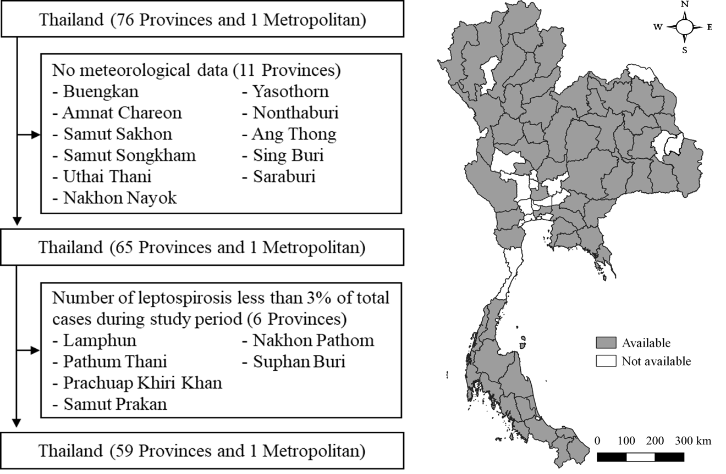
Fig. S1 Study locations in which grey areas represent the provinces that included in this study

Fig. S2 Seasonal pattern of rainfall for each province, showing monthly average rainfall for each month from 2007 to 2017, except for those in Nong Bua Lam Phu (2014 to 2017)
Fig. S3 Seasonal pattern of human leptospirosis cases for each province, showing aggregated monthly number of human leptospirosis adjusting for number of days for each month and number of years for each province and then standardized as z-score

Fig. S4 The national rainfall-leptospirosis associations using different DFs for temperature and relative humidity, estimated through multivariate meta-regression model. Grey solid line indicates rainfall level at 0 cm, whereas black, blue, and red dotted lines indicate monthly cumulative rainfall level at 90th, 95th, and 99th percentile, respectively
Fig. S5 The national rainfall-leptospirosis association using ML and REML for the multivariate meta-regression model. Black solid line indicates the national rainfall-leptospirosis association using REML for meta-regression model, whereas blue dashed line defines the rainfall-leptospirosis association using ML for meta-regression model. The shade areas define their corresponding 95% confidence intervals
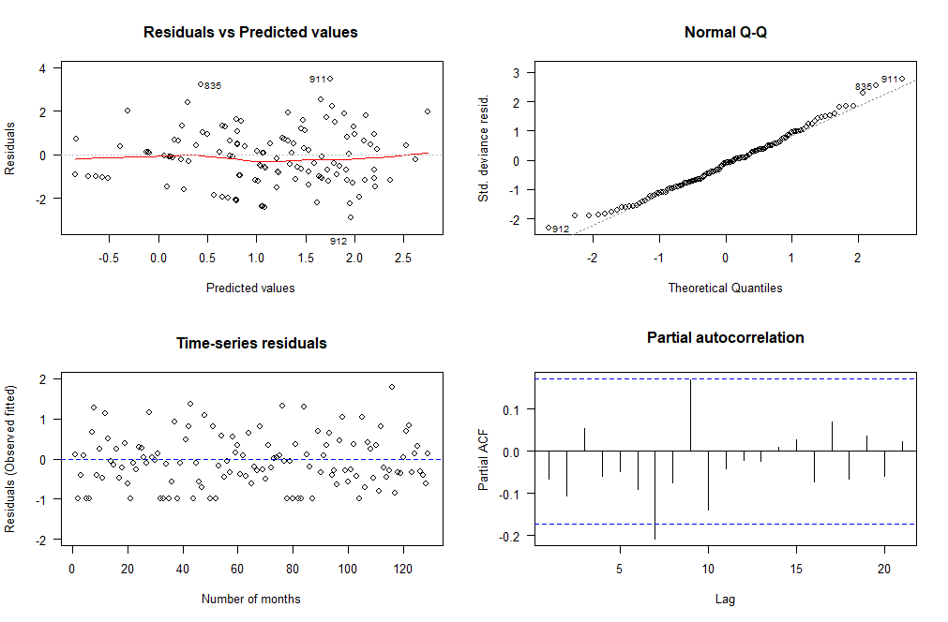
Fig. S6 The model residual vs. predicted plot, normal Q-Q plot, time-series residual plot, and partial autocorrelation plot in Chiang Mai derived from province-specific DLNM model
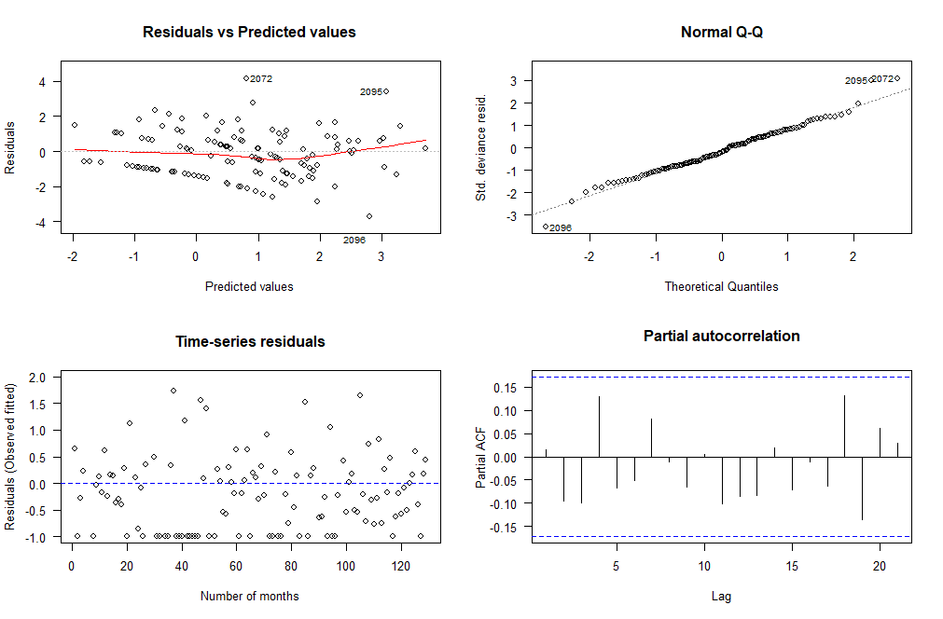
Fig. S7 The model residual vs. predicted plot, normal Q-Q plot, time-series residual plot, and partial autocorrelation plot in Lampang derived from province-specific DLNM model
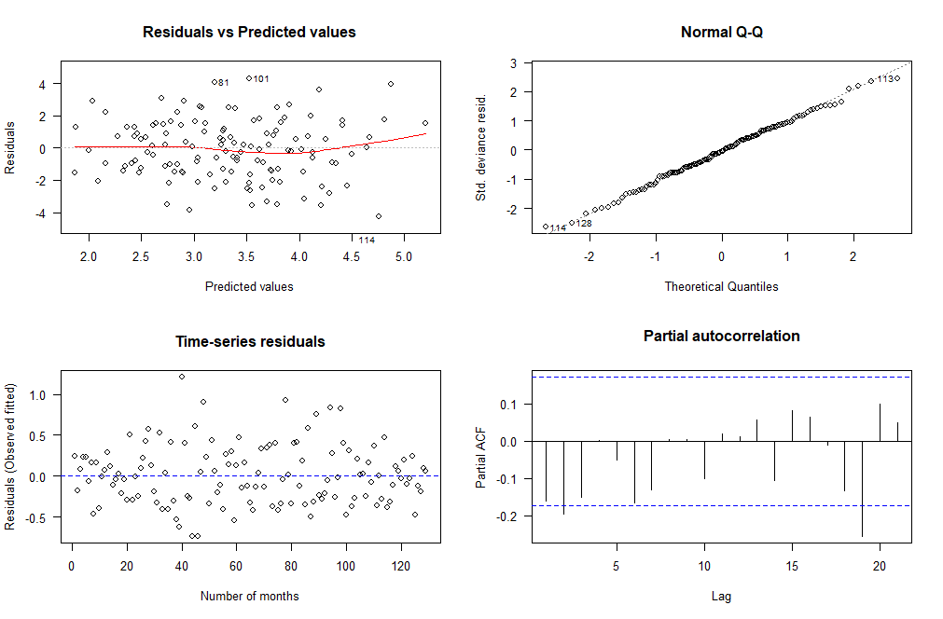
Fig. S8 The model residual vs. predicted plot, normal Q-Q plot, time-series residual plot, and partial autocorrelation plot in Si Sa Ket derived from province-specific DLNM model
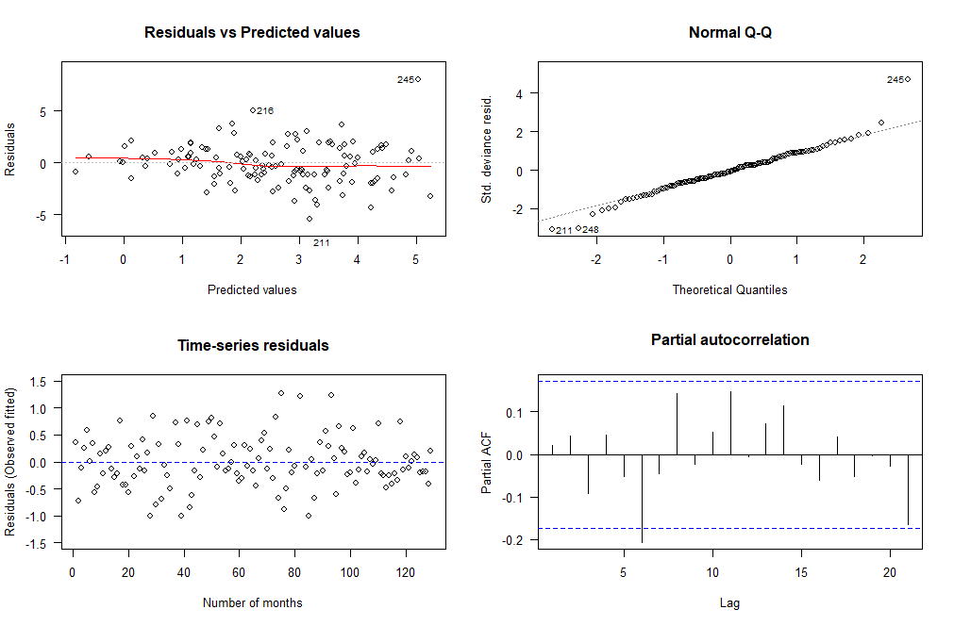
Fig. S9 The model residual vs. predicted plot, normal Q-Q plot, time-series residual plot, and partial autocorrelation plot in Buri Ram derived from province-specific DLNM model
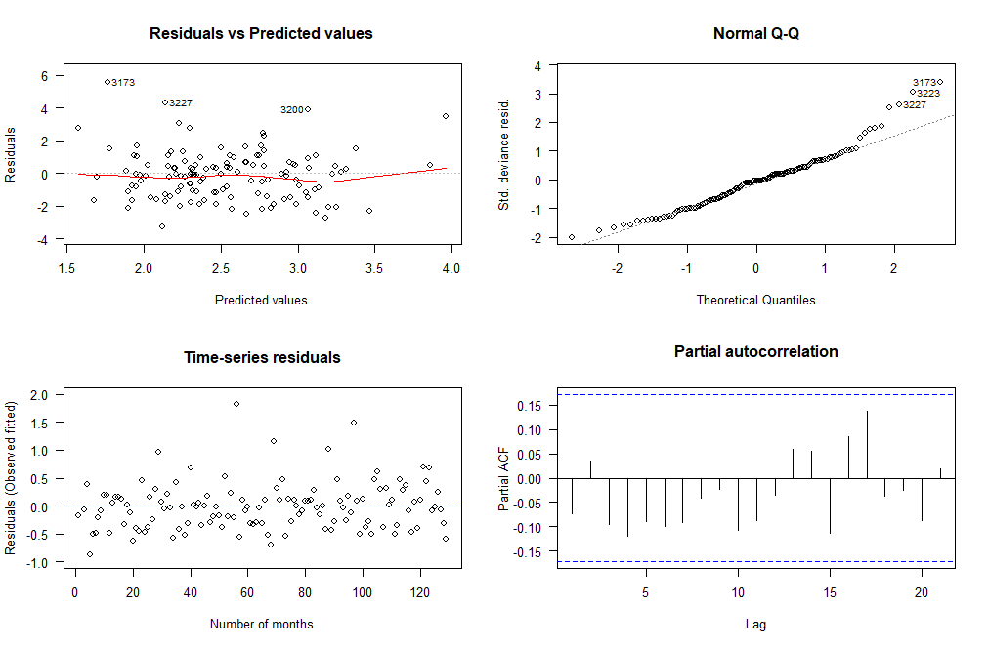
Fig. S10 The model residual vs. predicted plot, normal Q-Q plot, time-series residual plot, and partial autocorrelation plot in Nakhon Si Thammarat derived from province-specific DLNM model

