SUPPLEMENTARY INFORMATION

Dose-Dependent Role of a New Biotin Compounds in Hippocampal Demyelination in Rats
- Burak Yulug¹, Ertugrul Kilic², Cemal Orhan³, Besir Er⁴, Mehmet Tuzcu⁴, Ibrahim Hanifi Ozercan⁵, Nurhan Sahin³, Sinan Canpolat⁶, James Komorowski⁷, Sara Perez Ojalvo⁷, Sarah Sylla⁷, Seyda Cankaya¹, Kazim Sahin^{3,}*
¹Alaaddin Keykubat University, School of Medicine, Department of Neurology, Alanya, Turkey.
²Istanbul Medipol University, Department of Physiology, Istanbul, 34810, Turkey.
³Department of Nutrition, Faculty of Veterinary Medicine, Firat University, Elazig, Turkey
⁴Department of Biology, Faculty of Science, Firat University, Elazig, Turkey
⁵Department of Pathology, Faculty of Medicine, Firat University, Elazig, Turkey
⁶Department of Physiology, Faculty of Medicine, Firat University, Elazig, Turkey
⁷Research and Development, Nutrition 21, Harrison, NY 10577, USA
Correspondence: Kazim Sahin, DVM, Ph.D., F.A.C.N. Member of The Turkish Academy of Sciences, Professor of Nutrition Veterinary Faculty, Firat University 23119 Elazig, Turkey. Phone: +904242370000/3938
Email: nsahinkm@yahoo.com, ksahin@firat.edu.tr

(a) IL-6
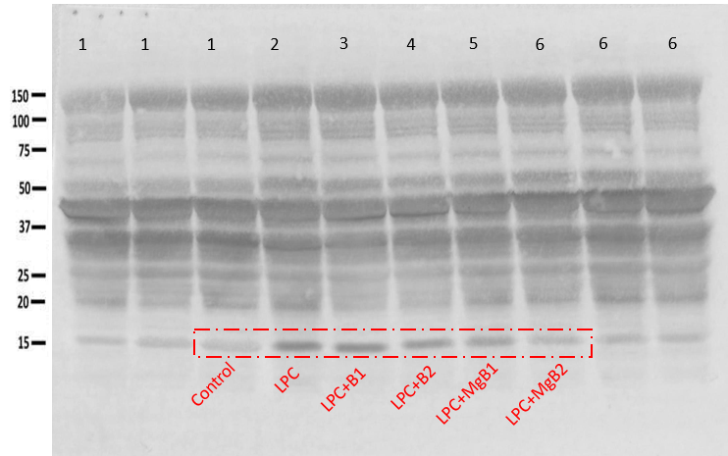
(b) IL-17
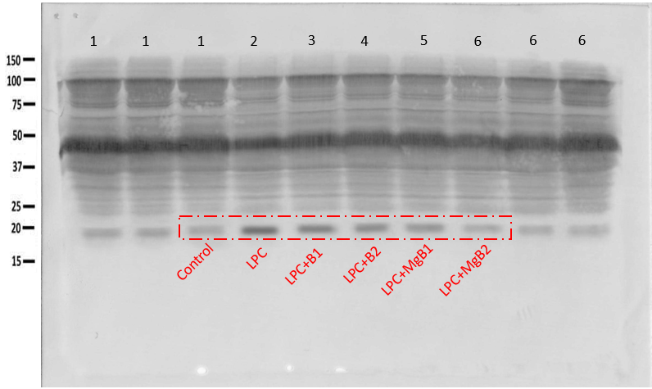
(c) TNF-α
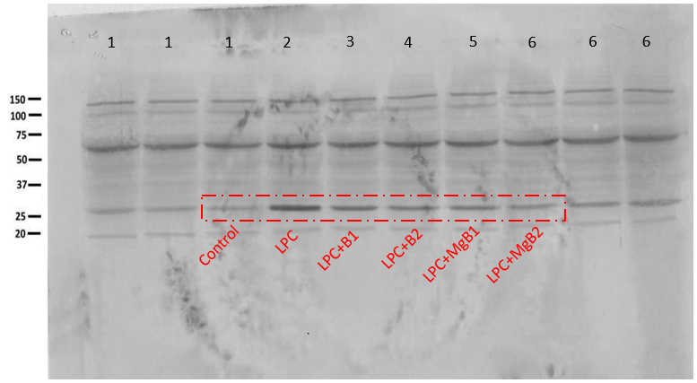
(d) NF-ĸB
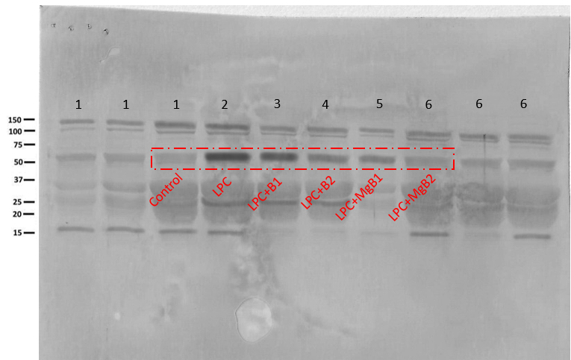

(e) CCL-3
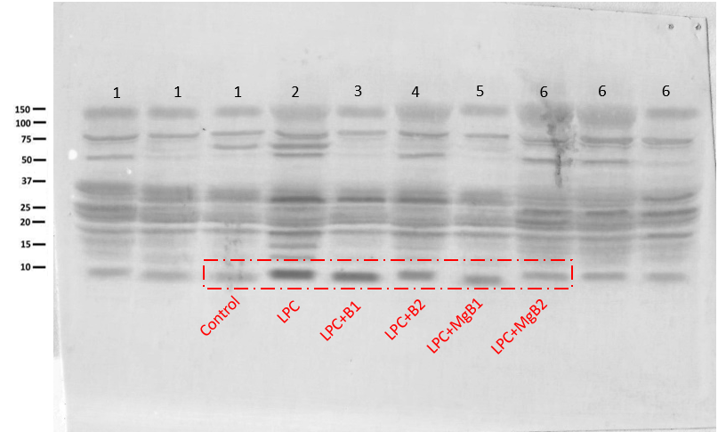
(f) CCL-5
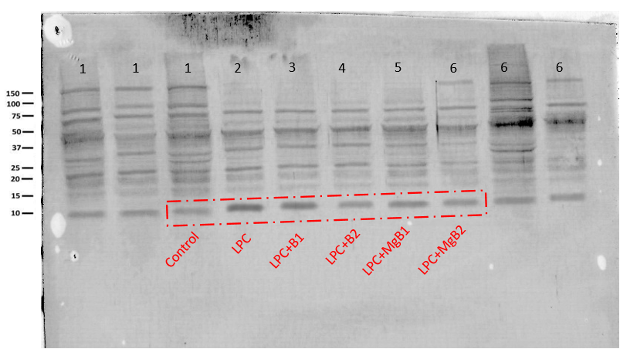
(g) CXCL-16
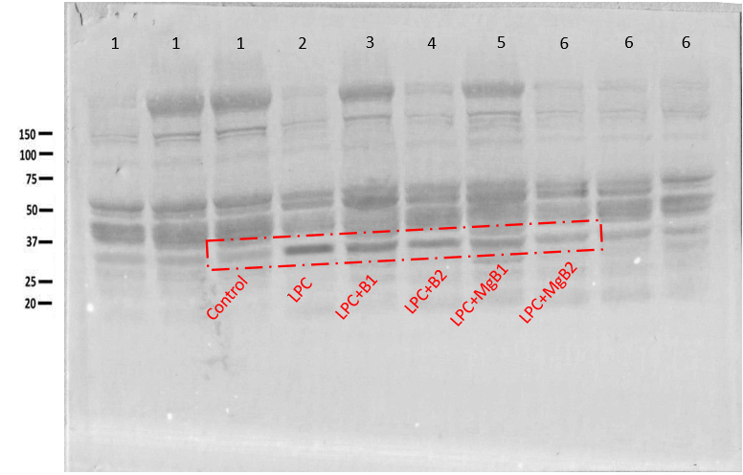
(h) OPG
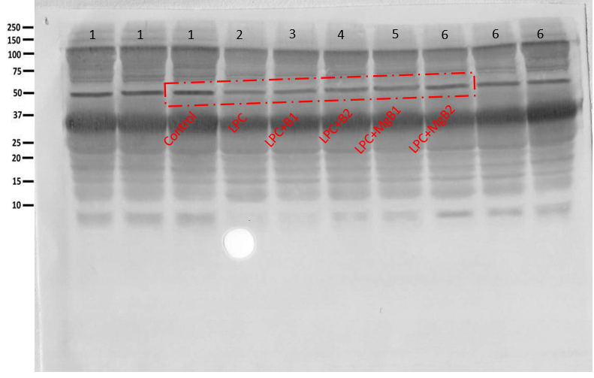

(i) MMP-9
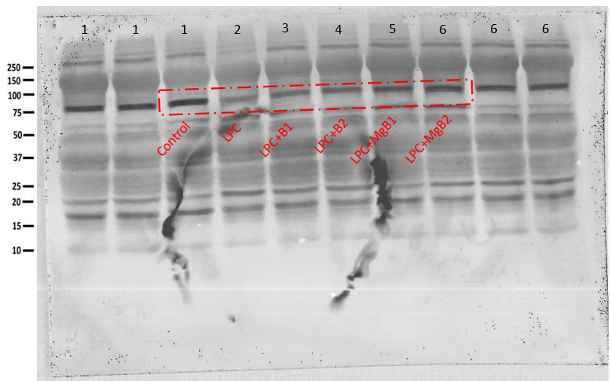
(j) β-Actin (a, b, c)
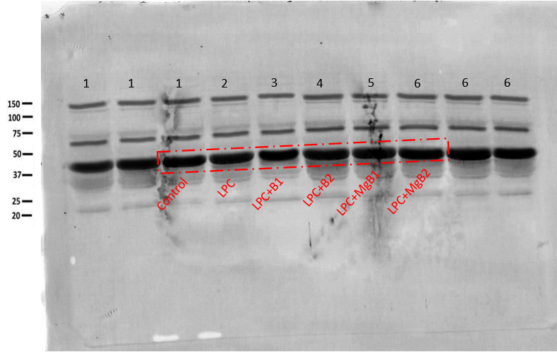
(k) β-Actin (d,e,f)
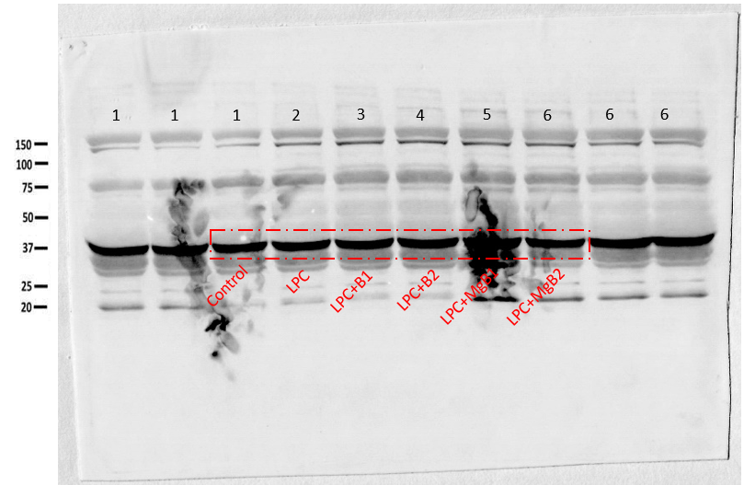
(l) β-Actin (g,h,i)
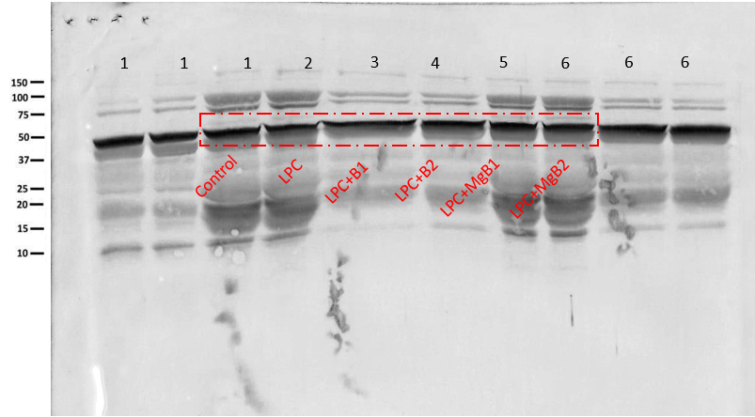

Supplementary Figure 1. Full immunoblots related to Fig. 3 on brain tissue of rats; (a) interleukin 6 (IL-6), (b) interleukin 17 (IL-17), (c) tumor necrosis factor alpha (TNF-α), (d) nuclear factor kappa light chain enhancer of activated B cells (NF-κB), (e) chemokine (C-C motif) ligand 3 (CCL-3), (f) chemokine (C-C motif) ligand 5 (CCL-5), (g) chemokine (C-X-C motif) ligand 16 (CXCL-16), (h) osteoprotegerin (OPG), (i) matrix metallopeptidase 9 (MMP-9), (j) β-Actin (a, b, c), (k) β-Actin (d, e, f). and (l) β-Actin (g, h, i). Each immunoblot is a representative of three independent experiments. Results shown in Fig. 3 are delineated by red dotted rectangles. MW (in kDa) are indicated.

(a) ACC-1
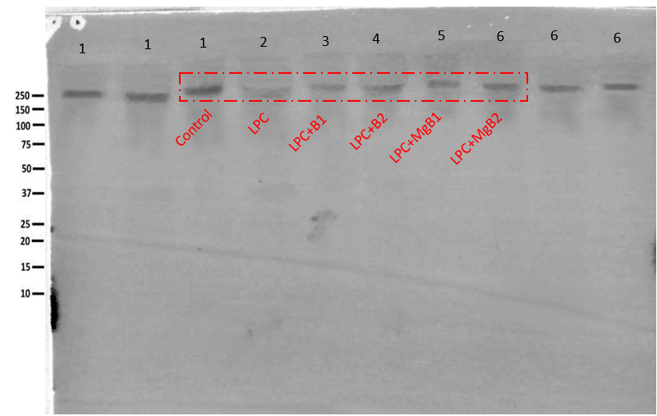
(b) ACC-2
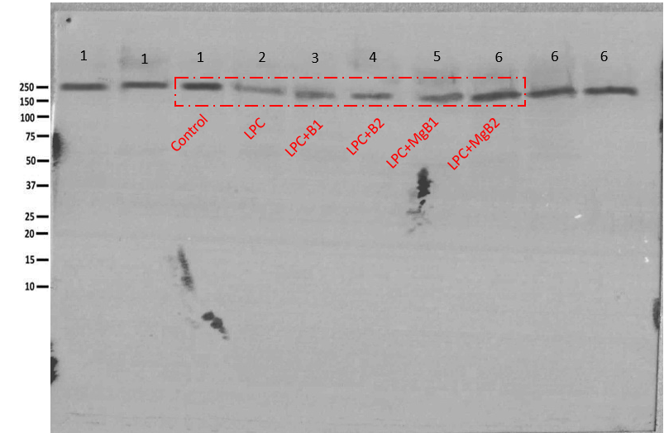
(c) PC
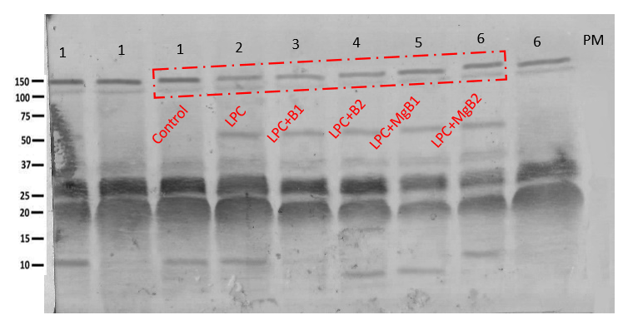

(d) PCC
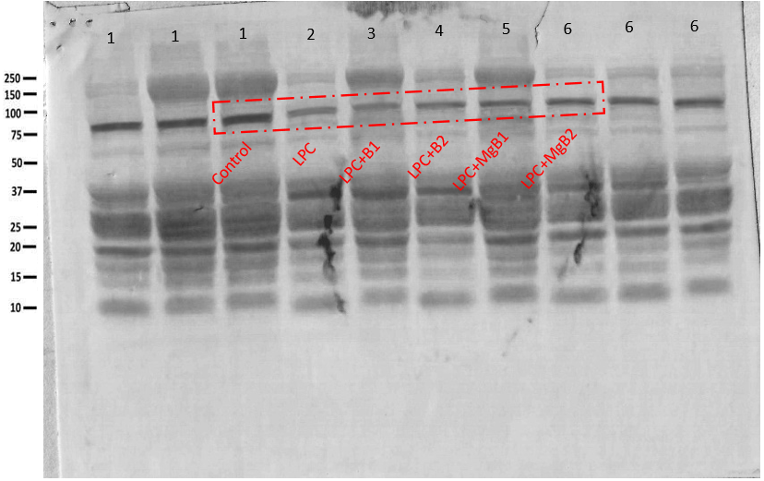
(e) MCC
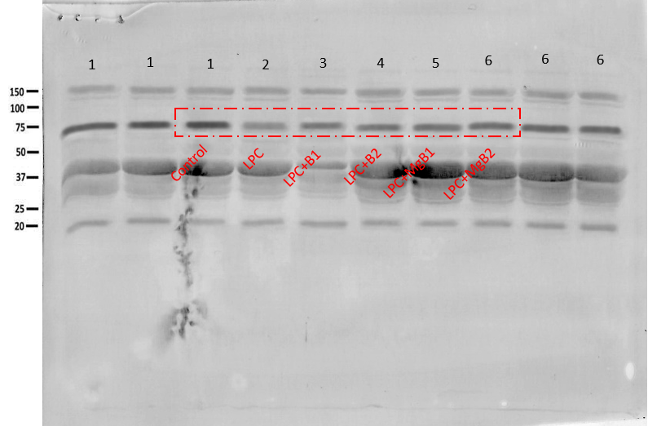
(f) β-Actin
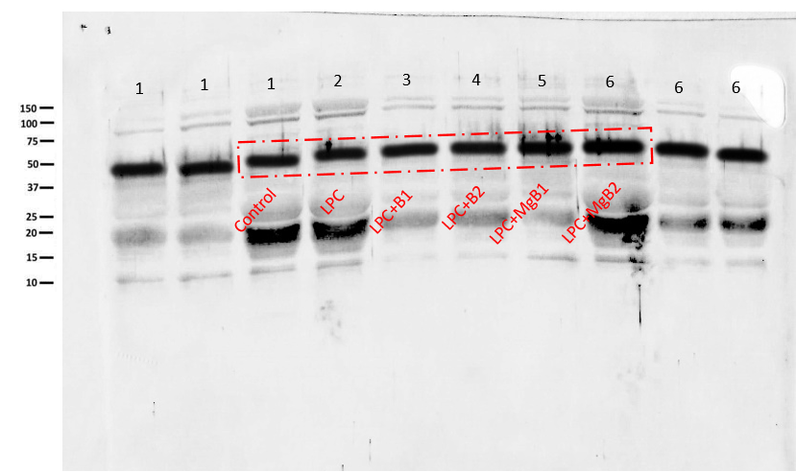
Supplementary Figure 2. Full immunoblots related to Fig. 4 on brain tissue of rats; (a) acetyl CoA carboxylase 1 (ACC-1), (b) acetyl CoA carboxylase 2 (ACC-2), (c) pyruvate carboxylase (PC), (d) propionyl-CoA carboxylase (PCC), (e) 3-methylcrotonyl-CoA carboxylase (MCC), and (f) β-Actin. Each immunoblot is a representative of three independent experiments. Results shown in Fig. 4 are delineated by red dotted rectangles. MW (in kDa) are indicated.

(a) BDNF
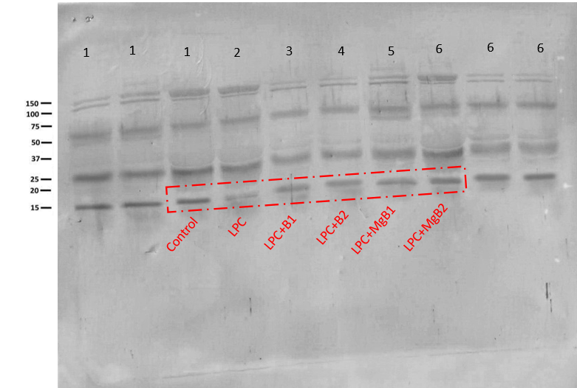

(b) GAP-43
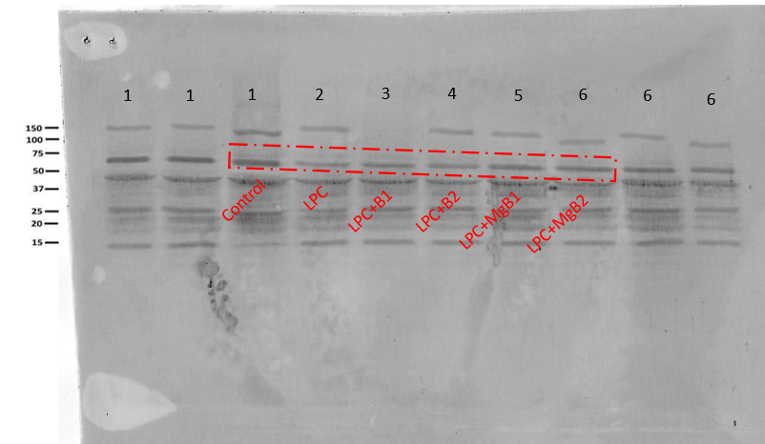

(c) GFAP
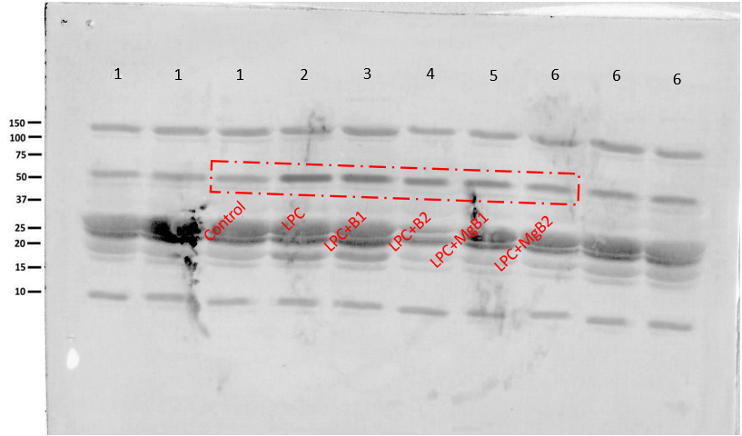
(d) ICAM-1
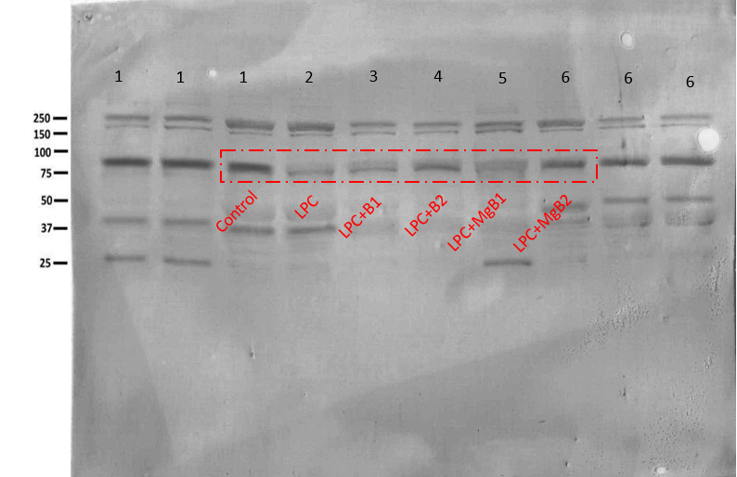

(e) β-Actin
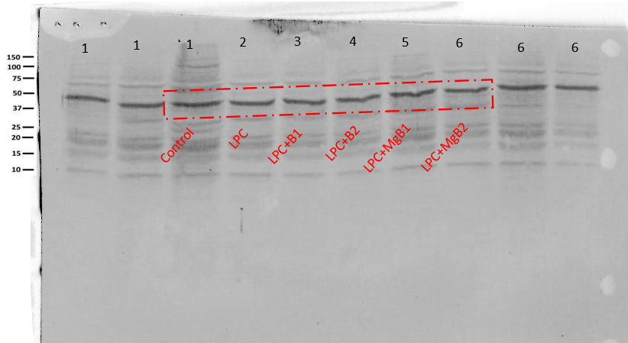
Supplementary Figure 3. Full immunoblots related to Fig. 5 on brain tissue of rats; (a) on brain-derived neurotrophic factor (BDNF), (b) growth-associated protein (GAP-43), (c) glial fibrillary acidic protein (GFAP), (d) intercellular adhesion molecule 1 (ICAM-1), and (e) β-Actin. Each immunoblot is a representative of three independent experiments. Results shown in Fig. 5 are delineated by red dotted rectangles. MW (in kDa) are indicated.

(a) Synapsin-I
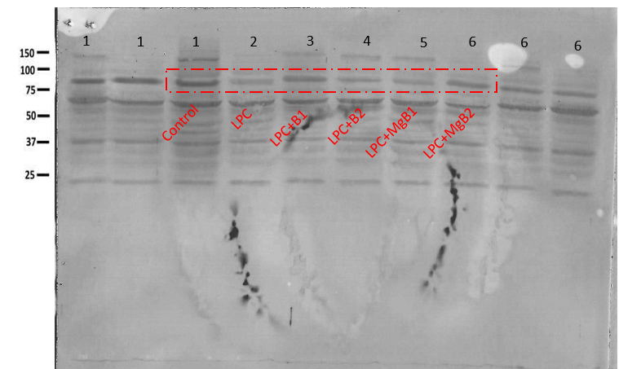
(b) PSD-93
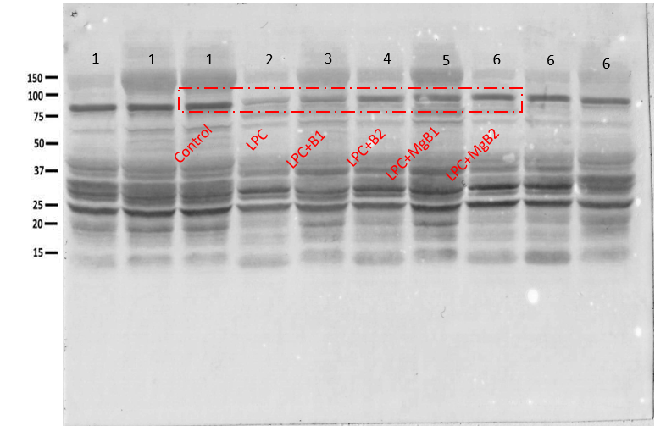

(c) PSD-95
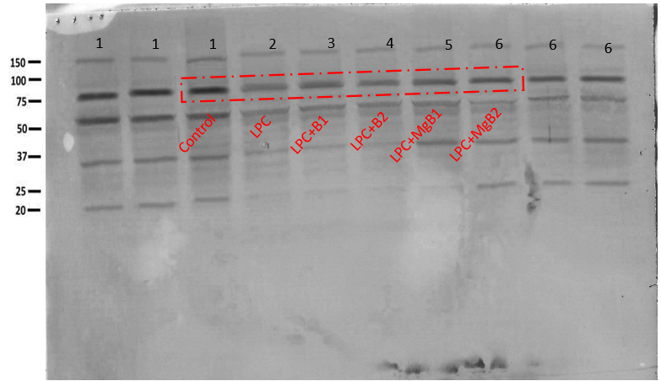
(d) β-Actin
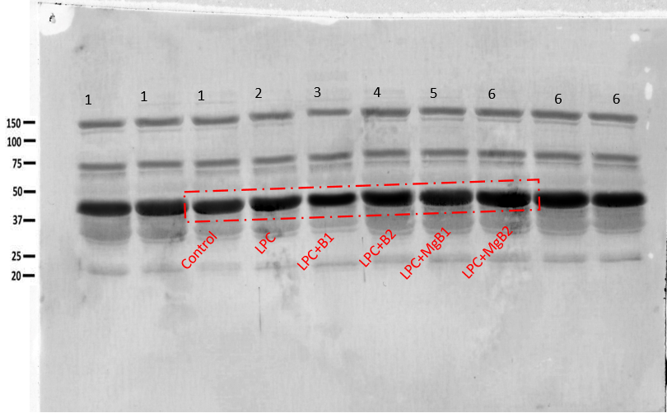

Supplementary Figure 4. Full immunoblots related to Fig. 6 on brain tissue of rats; (a) Synapsin-I, (b) postsynaptic density protein 93 (PSD-93), (c) postsynaptic density protein 95 (PSD-95), and (d) β-Actin. Each immunoblot is a representative of three independent experiments. Results shown in Fig. 6 are delineated by red dotted rectangles. MW (in kDa) are indicated.

