Supplementary material for
Dapsone is an anticatalysis for Alzheimer’s disease exacerbation.

Section 1. 4
Seoul study: The proof of concept: 4
Fig. S1. The Study Design of the preventive and treatment of the neuroinflammasome in Sorokdo National Hospital 4
Fig. S2. The histogram of Age in the study cohort of Sorok Island 5
Standard Code: Korean Standard Classification of Diseases (KCD) disease code 6
Section 2. Study of AD group 8
Calculation: STUDY OF AD (+/-) GROUP 8
Supplementary Table 1. AD Prevalence in the dapsone (+/-) subgroup. 8
Supplementary Table 2. AD Prevalence in the dapsone (+/-) subgroup. 9
Supplementary Table 3. AD Prevalence in the Dapsone (+/-) subgroup. 10
Effect Size Calculator for T-Test 11
Pearson Correlation Coefficient Calculator 12
1. The variables dapsone (+) and dapsone (-) in Alzheimer's disease (AD) patients 12
2. The variables dapsone (+) and dapsone (-) in non-AD patients 14
Section 3. Study of DDS group: Analysis applying DATA normalization technique 16
One-Way Repeated Measures ANOVA Calculator 16
Supplementary Table 4. Alzheimer's Disease prevalences and the DDS prescription (+) /non-prescription (-) group from January 2007 to June 2020 16
Independent-measures one-factor ANOVA calculator 18
Post Hoc Tukey honestly significant difference (HSD) 19
T-Test for T1: DDS (+) AD (+) T2: DDS (+) AD (-) 20
Independent Means 20
Dependent Means 21
Fig. S3. T1:T2 Test 22
T-Test for T3: DDS (-) AD (+) T4: DDS (-) AD (-) 23
Independent Means 23
Dependent Means 24
Fig. S4. T3:T4 Test 24
T-Test for T1: DDS (+) AD (+) T3: DDS (-) AD (+) 25
Independent Means 25
2 Dependent Means 25
Fig. S5. T1:T3 Test 26
T-Test for T2: DDS (+) AD (-) T3: DDS (-) AD (+) 27
Independent Means 27
Dependent Means 28
Fig. S6. T2:T3 Test 28
T-Test for T1: DDS (+) AD (+) T4: DDS (-) AD (-) 30
Independent Means 30
Dependent Means 31
Fig. S7. T1:T4 Test 31
Reference: STUDY OF DDS (+/-) GROUP in the Sorokdo National Hospital 33
Supplementary Table 4. DDS dosing in possible dementia (+) subgroup. 33
Section 4. STROBE Statement 34
Discussion 42
References 44

Section 1.

Seoul study: The proof of concept:
A patient diagnosed with MCI through MRI and mental and neurological examination in 2008 continued to take dapsone regularly until 2016 and lived a normal routine (online suppl. 4–6). However, after discontinuation, the patient was diagnosed with Alzheimer's disease in 2018 but lived with MCI as of November 2019 after taking dapsone (online suppl. 1, 2).

Fig. S1. The Study Design of the Preventive and Treatment of Neuroinflammasomes in Sorokdo National Hospital
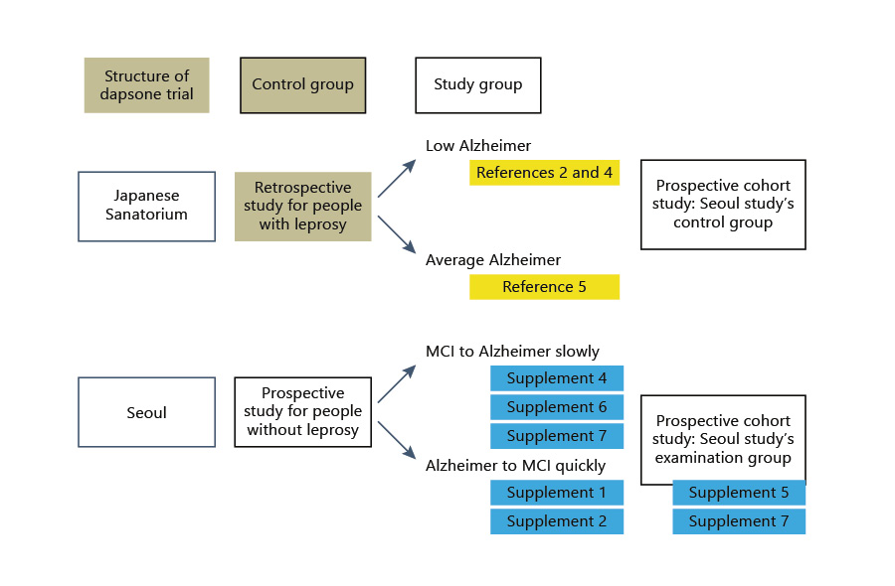
J., Lee; S., Choi; C.J., Lee; S., Oh (2020): Recovery of Dementia Syndrome following Treatment of Brain Inflammation. Karger AG, Basel, DOI: 10.1159/000504880, Figure 2. Structure and result of cohorts. https://www.karger.com/Article/FullText/504880
Structure and result of a prospective cohort. Japanese Sanatorium Study: In the 1990s, a Japanese epidemiological survey study of leprosy patients aged 65 years or older revealed the incidence of dementia in leprosy patients. A neuropathological case series of leprosy patients detected the absence of senile plaques. However, a similar study the following year showed no difference in discovering senile plaques between the patient and control groups. Thus, the Japanese Sanatorium Study may be a null hypothesis.
There were a total of 451 ICD codes in Sorokdo National Hospital. Therefore, a total of 7603 ICD code persons from 2005 to 2020, when computerization was performed, were the study cohort of Sorok Island. (Sorokdo_hospital_All_Cohort_Data (disclosure 7511041.xls)
Data site - https://osf.io/trfbz/
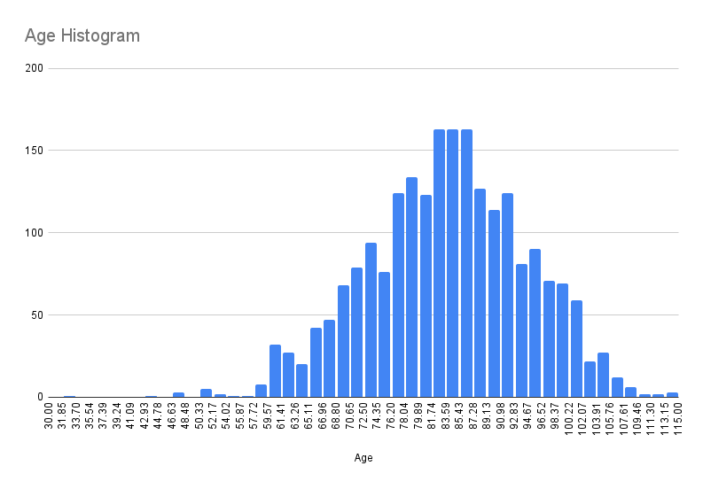

Fig. S2. The histogram of age in the study cohort of Sorok Island

The mean age was 81.72 years, and the median age was 82.1 years. The average age was 83.7 years (median (M) 84, interquartile range (IQR) 76.8 – 91.2, standard deviation (SD) 10.8, 95% confidence interval (CI): 0.45, 83.6 – 84.5).
The annual total number of participants was 4,064 male subjects and 3,539 female subjects. The known average residence period was 20.1 years. For this study, a total of leprosy patients who could study the relationship between AD and dapsone were observed through ICD-9 and -10 codes.

Standard Code: Korean Standard Classification of Diseases (KCD) disease code
(1) Mental and behavioural disorders, F00-F09, G30
[F00 code Dementia in Alzheimer's disease (G30.-+)]
[F01 code Vascular dementia]
[F02 code Dementia in other diseases classified elsewhere]
[F03 code Unspecified dementia]
[F04 code Organic amnesic syndrome, not induced by alcohol and other psychoactive substances]
[F05 code - Delirium, not induced by alcohol and other psychoactive substances]
[F06 code - Other mental disorders due to brain damage and dysfunction and to physical disease]
[F07 code - Personality and behavioural disorders due to brain disease, damage and dysfunction]
[F09 code - Unspecified organic or symptomatic mental disorder]
[G30 Alzheimer's disease]

(2) For symptomatic relief of Alzheimer's disease
First Group: For symptomatic relief of Alzheimer’s disease
[donepezil hydrochloride] 148603ATB 148602ATD 148602ATB 148601ATD 148601ATB 643401ATD 643402ATD
[rivastigmine] 224501ACH 224503ACH 224504ACH 224505ACH 224506CPC 224507CPC 224508CPC
[galantamine] 385203ACR 385203ATR 385204ACR 385204ATR 385205ACR 385205ATR
[N-methyl-D-aspartate (NMDA) receptor antagonist] 190031ALQ 190001ATB 190003ATD 190004ATB 190004ATD

Second Group: For psychologic symptoms of Alzheimer’s disease
[haloperidol] 167903ATB 167904ATB 167905ATB 167906ATB 167908ATB 167908ATB 168030BIJ
[Risperidone] 224201ATB 224201ATD 224202ATB 224202ATD 224203ATB 224204ATB 224205BIJ 224206BIJ
[Quetiapine] 378601ATB 378602ATB 378603ATB 378604ATB 378605ATB 378605ATR 378606ATR 378607ATR 378608ATR 378608ATR 378610ATB
[Olanzapine]
204001ATB 204001ATD 204002ATB 204002ATD 204004ATB 204005ATB
[Aripiprazole]
451501ATB 451501ATD 451502ATB 451502ATD 451503ATB 451504ATB 451505ATB 451506BIJ 451507BIJ
[Oxcarbazepine] 206330ASS 206301ATB 206302ATB 206303ATB
[Fluvoxamine] 162501ATB 162502ATB
[Escitalopram] 474801ATB 474802ATB 474803ATB 474804ATB
[Trazodone] 242901ACH 242901ATB 242902ATB 242903ATR
[Sertraline] 227001ATB 227002ATB 227003ATB
[Escitalopram] 474801ATB 474802ATB 474803ATB 474804ATB
[Fluoxetine] 161501ACH 161501ATB 161502ACH 161502ATB 161502ATD

Section 2. Study of AD group
Participants were randomized in a 2:1 ratio to DDS (+) or matching placebo DDS (-). Randomization was unrestricted (no blocking or stratification), and we analysed the ICE codes in databases of Sorokdo National Hospital. A 2:1 allocation ratio was performed because of HD patients taking dapsone for a lifetime. Therefore, it increases participants' probability of receiving the active study drug without compromising statistical power. Furthermore, the 2:1 allocation ratio led to a 10% increase in the overall sample size relative to a 1:1 allocation ratio¹.

Calculation: STUDY OF AD (+/-) GROUP

Supplementary Table 1. AD Prevalence in the dapsone (+/-) subgroup.
year | DDS (+) | DDS (-) | sum AD (+) | Mean | SD | 95% CI | [CI | CI]
2005 | 18 | 19 | 37 | 18.5 | 0.71 | 0.24 | 18.26 | 19.21
2006 | 20 | 37 | 57 | 28.5 | 12.02 | 3.19 | 25.31 | 40.52
2007 | 22 | 51 | 73 | 36.5 | 20.51 | 4.78 | 31.72 | 57.01
2008 | 22 | 58 | 80 | 40 | 25.46 | 5.66 | 34.34 | 65.46
2009 | 19 | 66 | 85 | 42.5 | 33.23 | 7.17 | 35.33 | 75.73
2010 | 25 | 82 | 107 | 53.5 | 40.31 | 7.73 | 45.77 | 93.81
2011 | 35 | 98 | 133 | 66.5 | 44.55 | 7.64 | 58.86 | 111.05
2012 | 39 | 135 | 174 | 87 | 67.88 | 10.16 | 76.84 | 154.88
2013 | 34 | 172 | 206 | 103 | 97.58 | 13.40 | 89.60 | 200.58
2014 | 25 | 190 | 215 | 107.5 | 116.67 | 15.68 | 91.82 | 224.17
2015 | 26 | 242 | 268 | 134 | 152.74 | 18.37 | 115.63 | 286.74
2016 | 33 | 255 | 288 | 144 | 156.98 | 18.21 | 125.79 | 300.98
2017 | 37 | 268 | 305 | 152.5 | 163.34 | 18.40 | 134.10 | 315.84
2018 | 45 | 292 | 337 | 168.5 | 174.66 | 18.71 | 149.79 | 343.16
2019 | 46 | 334 | 380 | 190 | 203.65 | 20.54 | 169.46 | 393.65
2020 | 32 | 352 | 384 | 192 | 226.27 | 22.70 | 169.30 | 418.27
Sum | 478 | 2651
Mean | 29.88 | 165.69
SD | 9.03 | 112.31
95% CI | 0.81 | 4.28 | 4.18
 | 29.06 | 161.41 | 191.39
 | 30.69 | 169.96 | 199.74

Supplementary Table 2. AD Prevalence in the dapsone (+/-) subgroup.
year | DDS (+) | DDS (-) | sum AD (-) | Mean | SD | 95% CI | [CI | CI]
2005 | 290 | 417 | 707 | 353.5 | 89.80 | 6.63 | 346.87 | 443.30
2006 | 302 | 363 | 665 | 332.5 | 43.13 | 3.28 | 329.22 | 375.63
2007 | 317 | 332 | 649 | 324.5 | 10.61 | 0.82 | 323.68 | 335.11
2008 | 310 | 312 | 622 | 311 | 1.41 | 0.11 | 310.89 | 312.41
2009 | 300 | 283 | 583 | 291.5 | 12.02 | 0.98 | 290.52 | 303.52
2010 | 270 | 286 | 556 | 278 | 11.31 | 0.94 | 277.06 | 289.31
2011 | 255 | 268 | 523 | 261.5 | 9.19 | 0.79 | 260.71 | 270.69
2012 | 238 | 241 | 479 | 239.5 | 2.12 | 0.19 | 239.31 | 241.62
2013 | 195 | 248 | 443 | 221.5 | 37.48 | 3.50 | 218.00 | 258.98
2014 | 172 | 236 | 408 | 204 | 45.25 | 4.40 | 199.60 | 249.25
2015 | 167 | 168 | 335 | 167.5 | 0.71 | 0.08 | 167.42 | 168.21
2016 | 154 | 149 | 303 | 151.5 | 3.54 | 0.40 | 151.10 | 155.04
2017 | 143 | 115 | 258 | 129 | 19.80 | 2.43 | 126.57 | 148.80
2018 | 132 | 87 | 219 | 109.5 | 31.82 | 4.24 | 105.26 | 141.32
2019 | 114 | 40 | 154 | 77 | 52.33 | 8.33 | 68.67 | 129.33
2020 | 109 | 4 | 113 | 56.5 | 74.25 | 13.84 | 42.66 | 130.75
Sum | 3468 | 3549
Mean | 216.75 | 221.81
SD | 76.04 | 117.71
95% CI | 2.53 | 3.87 | 4.45
 | 214.22 | 217.94 | 434.11
 | 219.28 | 225.69 | 443.01

Supplementary Table 3. AD Prevalence in the Dapsone (+/-) subgroup.
Year | DDS (+) | DDS (-) | AD (+) | Dapsone (+) | Dapsone (-) | AD (-) | P-value* | chi-square | p-value
2005 | 18 | 19 | 37 | 290 | 417 | 707 | .3583 | 0.8438 | 0.358314
2006 | 20 | 37 | 57 | 302 | 363 | 665 | .1324 | 2.2655 | 0.132282
2007 | 22 | 51 | 73 | 317 | 332 | 649 | .0024** | 9.22 | 0.002394
2008 | 22 | 58 | 80 | 310 | 312 | 622 | .00028** | 14.191 | 0.000165
2009 | 19 | 66 | 85 | 300 | 283 | 583 | < .00001** | 25.1874 | 0.00001
2010 | 25 | 82 | 107 | 270 | 286 | 556 | < .00001** | 23.0669 | 0.00001
2011 | 35 | 98 | 133 | 255 | 268 | 523 | < .00001** | 21.651 | 0.00001
2012 | 39 | 135 | 174 | 238 | 241 | 479 | < .00001** | 38.8685 | 0.00001
2013 | 34 | 172 | 206 | 195 | 248 | 443 | < .00001** | 46.6137 | 0.00001
2014 | 25 | 190 | 215 | 172 | 236 | 408 | < .00001** | 60.6925 | 0.00001
2015 | 26 | 242 | 268 | 167 | 168 | 335 | < .00001** | 110.2835 | 0.00001
2016 | 33 | 255 | 288 | 154 | 149 | 303 | < .00001** | 105.7934 | 0.00001
2017 | 37 | 268 | 305 | 143 | 115 | 258 | < .00001** | 120.4582 | 0.00001
2018 | 45 | 292 | 337 | 132 | 87 | 219 | < .00001** | 134.6692 | 0.00001
2019 | 46 | 334 | 380 | 114 | 40 | 154 | < .00001** | 200.2285 | 0.00001
2020 | 32 | 352 | 384 | 109 | 4 | 113 | < .00001** | 333.6671 | 0.00001
 |  |  |  |  |  |  |  | 252.58 | < 0.00001

Effect Size Calculator for T-Test
Cohen's d = (M₂ - M₁) ⁄ SD_{pooled}
where:
SD_{pooled} = √((SD₁² + SD₂²) ⁄ 2)

Group 1 AD (+) DDS (+)  Mean (M): 29.9  Standard deviation (s): 9.03  Sample size (n): 478 | Group 2 AD (+) DDS (-)  Mean (M): 165.7  Standard deviation (s): 112.31  Sample size (n): 2651

Cohen's d = (165.7 - 29.9) ⁄ 79.671441 = 1.7045.
Glass's delta = (165.7 - 29.9) ⁄ 9.03 = 15.03876.
Hedges' g = (165.7 - 29.9) ⁄ 103.449871 = 1.312713.

Group 3 AD (-) DDS (+)  Mean (M): 216.75  Standard deviation (s): 76.04  Sample size (n): 3468 | Group 4 AD (-) DDS (+)  Mean (M): 221.81  Standard deviation (s): 117.71  Sample size (n): 3549

Cohen's d = (221.81 - 216.75) ⁄ 99.090175 = 0.051065.
Glass's delta = (221.81 - 216.75) ⁄ 76.04 = 0.066544.
Hedges' g = (221.81 - 216.75) ⁄ 99.325094 = 0.050944.

Pearson Correlation Coefficient Calculator
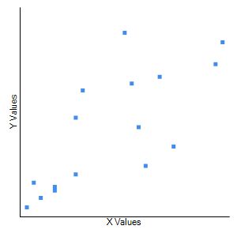
- The variables dapsone (+) and dapsone (-) in Alzheimer's disease (AD) patients
We calculated Pearson's r (Pearson's correlation coefficient) to examine whether it was correlated.

X Values | Y Values
18  20  22  22  19  25  35  39  34  25  26  33  37  45  46  32 | 19  37  51  58  66  82  98  135  172  190  242  255  268  292  334  352

X - M_{x} | Y - M_{y} | (X - M_{x})² | (Y - M_{y})² | (X - M_{x})(Y - M_{y})
-11.875  -9.875  -7.875  -7.875  -10.875  -4.875  5.125  9.125  4.125  -4.875  -3.875  3.125  7.125  15.125  16.125  2.125  Mx: 29.875 | -146.688  -128.688  -114.688  -107.688  -99.688  -83.688  -67.688  -30.688  6.312  24.312  76.312  89.312  102.312  126.312  168.312  186.312  My: 165.688 | 141.016  97.516  62.016  62.016  118.266  23.766  26.266  83.266  17.016  23.766  15.016  9.766  50.766  228.766  260.016  4.516  Sum: 1223.750 | 21517.223  16560.473  13153.223  11596.598  9937.598  7003.598  4581.598  941.723  39.848  591.098  5823.598  7976.723  10467.848  15954.848  28329.098  34712.348  Sum: 189187.438 | 1741.914  1270.789  903.164  848.039  1084.102  407.977  -346.898  -280.023  26.039  -118.523  -295.711  279.102  728.977  1910.477  2714.039  395.914  Sum: 11269.375

Result Details & Calculation  X Values  ∑ = 478  Mean = 29.875  ∑(X - M_{x})² = SS_{x} = 1223.75  Y Values  ∑ = 2651  Mean = 165.688  ∑(Y - M_{y})² = SS_{y} = 189187.438  X and Y Combined  N = 16  ∑(X - M_{x})(Y - M_{y}) = 11269.375  R Calculation  r = ∑((X - M_{y})(Y - M_{x}))/√((SS_{x})(SS_{y}))  r = 11269.375/√((1223.75)(189187.438)) = 0.7406  Meta Numerics (cross-check)  r = 0.7406 | Key  X: X Values  Y: Y Values  M_{x}: Mean of X Values  M_{y}: Mean of Y Values  X - M_{x} & Y - M_{y}: Deviation scores  (X - M_{x})² & (Y - M_{y})²: Deviation Squared  (X - M_{x})(Y - M_{y}): Product of Deviation Scores

The value of R is 0.7406.
This is a moderate positive correlation, which means there is a tendency for high X variable scores to go with high Y variable scores (and vice versa).
The P-Value is .001033. The result is significant at p < .05.
The value of R², the coefficient of determination, is 0.5485.
The variables dapsone (+) and dapsone (-) were found to be moderately correlated, r(15) = .74, p < .01.

- The variables dapsone (+) and dapsone (-) in non-AD patients
We calculated Pearson's r (Pearson's correlation coefficient) to examine whether it was correlated.

The variables dapsone (+) and dapsone (-) in Alzheimer's disease patients were calculated to be strongly correlated or not by Pearson's r (Pearson's correlation coefficient).
X Values | Y Values
290  302  317  310  300  270  255  238  195  172  167  154  143  132  114  109 | 417  363  332  312  283  286  268  241  248  236  168  149  115  87  40  4
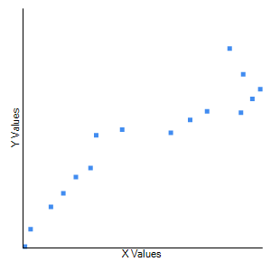

X - M_{x} | Y - M_{y} | (X - M_{x})² | (Y - M_{y})² | (X - M_{x})(Y - M_{y})
73.250  85.250  100.250  93.250  83.250  53.250  38.250  21.250  -21.750  -44.750  -49.750  -62.750  -73.750  -84.750  -102.750  -107.750  Mx: 216.750 | 195.188  141.188  110.188  90.188  61.188  64.188  46.188  19.188  26.188  14.188  -53.812  -72.812  -106.812  -134.812  -181.812  -217.812  My: 221.812 | 5365.562  7267.562  10050.062  8695.562  6930.562  2835.562  1463.062  451.562  473.062  2002.562  2475.062  3937.562  5439.062  7182.562  10557.562  11610.062  Sum: 86737.000 | 38098.160  19933.910  12141.285  8133.785  3743.910  4120.035  2133.285  368.160  685.785  201.285  2895.785  5301.660  11408.910  18174.410  33055.785  47442.285  Sum: 207838.438 | 14297.484  12036.234  11046.297  8409.984  5093.859  3417.984  1766.672  407.734  -569.578  -634.891  2677.172  4568.984  7877.422  11425.359  18681.234  23469.297  Sum: 123971.250

Result Details & Calculation  X Values  ∑ = 3468  Mean = 216.75  ∑(X - M_{x})² = SS_{x} = 86737  Y Values  ∑ = 3549  Mean = 221.812  ∑(Y - M_{y})² = SS_{y} = 207838.438  X and Y Combined  N = 16  ∑(X - M_{x})(Y - M_{y}) = 123971.25  R Calculation  r = ∑((X - M_{y})(Y - M_{x}))/√((SS_{x})(SS_{y}))  r = 123971.25/√((86737)(207838.438)) = 0.9233  Meta Numerics (cross-check)  r = 0.9233 | Key  X: X Values  Y: Y Values  M_{x}: Mean of X Values  M_{y}: Mean of Y Values  X - M_{x} & Y - M_{y}: Deviation scores  (X - M_{x})² & (Y - M_{y})²: Deviation Squared  (X - M_{x})(Y - M_{y}): Product of Deviation Scores

The value of R is 0.9233.
This is a strong positive correlation, which means that high X variable scores have high Y variable scores (and vice versa).
The P-Value is < .00001. The result is significant at p < .05.
The value of R², the coefficient of determination, is 0.8525.

The variables dapsone (+) and dapsone (-) were found to be strongly correlated, r(15) = .92, p < .00001.

Section 3. Study of DDS group: Analysis applying DATA normalization technique

One-Way Repeated Measures ANOVA Calculator

Supplementary Table 4. Alzheimer's disease prevalence and the DDS prescription (+)/nonprescription (-) group from January 2007 to June 2020
Year | T1: DDS(+)/AD(+)total | T2: DDS(+)/AD (-)total | T3: DDS(-)/AD (+)total | T4: DDS(-)/AD(-)total
2007 | 0.3014 | 0.4884 | 0.6986 | 0.5116
2008 | 0.2750 | 0.4984 | 0.7250 | 0.5016
2009 | 0.2235 | 0.5146 | 0.7765 | 0.4854
2010 | 0.2336 | 0.4856 | 0.7664 | 0.5144
2011 | 0.2632 | 0.4876 | 0.7368 | 0.5124
2012 | 0.2241 | 0.4969 | 0.7759 | 0.5031
2013 | 0.1650 | 0.4402 | 0.8350 | 0.5598
2014 | 0.1163 | 0.4216 | 0.8837 | 0.5784
2015 | 0.0970 | 0.4985 | 0.9030 | 0.5015
2016 | 0.1146 | 0.5083 | 0.8854 | 0.4917
2017 | 0.1213 | 0.5543 | 0.8787 | 0.4457
2018 | 0.1335 | 0.6027 | 0.8665 | 0.3973
2019 | 0.1211 | 0.7403 | 0.8789 | 0.2597
2020 | 0.0833 | 0.9646 | 0.9167 | 0.0354

Treatment 1: DDS (+) AD (+) Treatment 2: DDS (+) AD (-) Treatment 3: DDS (-) AD (+) Treatment 4: DDS (-) AD (-)
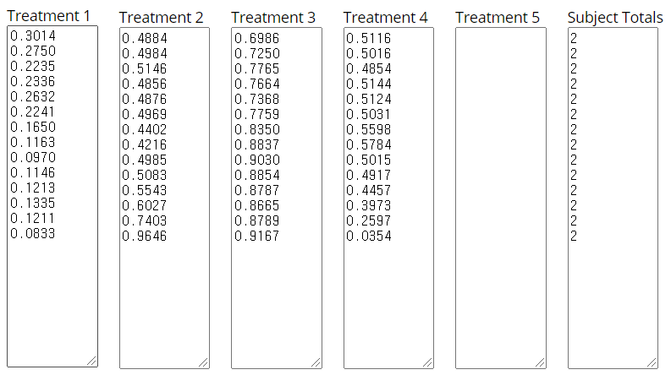

Summary of Data
 | Treatments
 | 1 | 2 | 3 | 4 | 5 | Total
N | 14 | 14 | 14 | 14 |  | 56
∑X | 2.4729 | 7.702 | 11.5271 | 6.298 |  | 28
Mean | 0.1766 | 0.5501 | 0.8234 | 0.4499 |  | 0.5
∑X² | 0.5079 | 4.4996 | 9.5621 | 3.0956 |  | 17.6652
Std.Dev. | 0.074 | 0.1421 | 0.074 | 0.1421 |  | 0.2581
Result Details
Source |  | SS | df | MS
Between-treatments |  | 2.9982 | 3 | 0.9994 | F = 58.43208
Within-treatments |  | 0.667 | 52 | 0.0128
Error |  | 0.667 | 39 | 0.0171
The F-ratio value is 58.43208. The p-value is < .00001. The result is significant at p < .05.

Independent-measures one-factor ANOVA calculator
Treatment 1: DDS (+) AD (+) Treatment 2: DDS (+) AD (-) Treatment 3: DDS (-) AD (+) Treatment 4: DDS (-) AD (-)
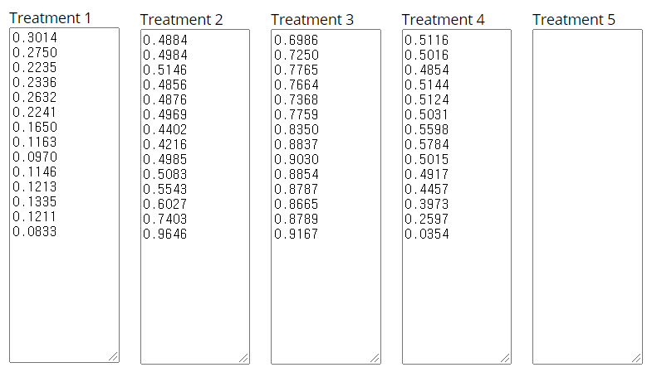

Summary of Data
 | Treatments
 | 1 | 2 | 3 | 4 | 5 | Total
N | 14 | 14 | 14 | 14 |  | 56
∑X | 2.4729 | 7.702 | 11.5271 | 6.298 |  | 28
Mean | 0.1766 | 0.5501 | 0.8234 | 0.4499 |  | 0.5
∑X² | 0.5079 | 4.4996 | 9.5621 | 3.0956 |  | 17.6652
Std.Dev. | 0.074 | 0.1421 | 0.074 | 0.1421 |  | 0.2581
Result Details
Source |  | SS | df | MS
Between-treatments |  | 2.9982 | 3 | 0.9994 | F = 77.90945
Within-treatments |  | 0.667 | 52 | 0.0128
Total |  | 3.6652 | 55
The f-ratio value is 77.90945. The p-value is < .00001. The result is significant at p < .05.

Post hoc Tukey honestly significant difference (HSD)
T1: DDS (+) AD (+) T2: DDS (+) AD (-) T3: DDS (-) AD (+) T4: DDS (-) AD (-)

Pairwise Comparisons |  | HSD_{.05} = 0.1136  HSD_{.01} = 0.1400 | Q_{.05} = 3.7535 Q_{.01} = 4.6251
T₁:T₂ | M₁ = 0.18  M₂ = 0.55 | 0.37 | Q = 12.34 (p = .00000)
T₁:T₃ | M₁ = 0.18  M₃ = 0.82 | 0.65 | Q = 21.37 (p = .00000)
T₁:T₄ | M₁ = 0.18  M₄ = 0.45 | 0.27 | Q = 9.03 (p = .00000)
T₂:T₃ | M₂ = 0.55  M₃ = 0.82 | 0.27 | Q = 9.03 (p = .00000)
T₂:T₄ | M₂ = 0.55  M₄ = 0.45 | 0.10 | Q = 3.31 (p = .10198)
T₃:T₄ | M₃ = 0.82  M₄ = 0.45 | 0.37 | Q = 12.34 (p = .00000)

- According to the pairwise comparisons, we did not use T₂:T_{4.}

T-Test for T1: DDS (+) AD (+) T2: DDS (+) AD (-)

Independent Means
Significance Level: 0.05, Two-tailed hypothesis.
The t-value is -8.72515. The p-value is < .00001. The result is significant at p < .05.
Difference Scores Calculations
Treatment 1
N₁: 14
df₁ = N - 1 = 14 - 1 = 13
M₁: 0.18
SS₁: 0.07
s²₁ = SS₁/(N - 1) = 0.07/(14-1) = 0.01
Treatment 2
N₂: 14
df₂ = N - 1 = 14 - 1 = 13
M₂: 0.55
SS₂: 0.26
s²₂ = SS₂/(N - 1) = 0.26/(14-1) = 0.02
T-value Calculation
s²_{p} = ((df₁/(df₁ + df₂)) * s²₁) + ((df₂/(df₂ + df₂)) * s²₂) = ((13/26) * 0.01) + ((13/26) * 0.02) = 0.01
s²_{M1} = s²_{p}/N₁ = 0.01/14 = 0
s²_{M2} = s²_{p}/N₂ = 0.01/14 = 0
t = (M₁ - M₂)/√(s²_{M1} + s²_{M2}) = -0.37/√0 = -8.73

Dependent Means
Significance Level: 0.05, Two-tailed hypothesis.
The value of t is 7.448323. The value of p is < .00001. The result is significant at p < .05.
Difference Scores Calculations
Mean: 0.37
μ = 0
S² = SS⁄df = 0.46/(14-1) = 0.04
S²_{M} = S²/N = 0.04/14 = 0
S_{M} = √S²_{M} = √0 = 0.05
T-value Calculation
t = (M - μ)/S_{M} = (0.37 - 0)/0.05 = 7.45

Fig. S3. T1:T2 Test
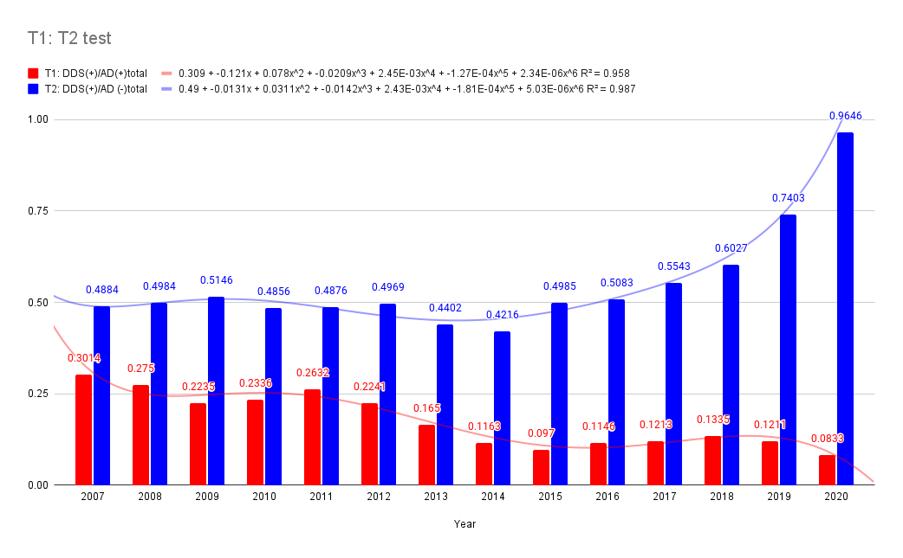
The participants with T1 (M = 0.1766, SD = 0.074) were compared to those with T2 (M = 0.5501, SD = 0.1421). T1:T2 in the group taking Dapsone also demonstrated that the group with AD and the group without AD were distinguished.

T-Test for T3: DDS (-) AD (+) T4: DDS (-) AD (-)

Independent Means
Significance Level: 0.05, Two-tailed hypothesis.
The t-value is 8.72515. The p-value is < .00001. The result is significant at p < .05.
Difference Scores Calculations
Treatment 3
N₁: 14
df₁ = N - 1 = 14 - 1 = 13
M₁: 0.82
SS₁: 0.07
s²₁ = SS₁/(N - 1) = 0.07/(14-1) = 0.01
Treatment 4
N₂: 14
df₂ = N - 1 = 14 - 1 = 13
M₂: 0.45
SS₂: 0.26
s²₂ = SS₂/(N - 1) = 0.26/(14-1) = 0.02
T-value Calculation
s²_{p} = ((df₁/(df₁ + df₂)) * s²₁) + ((df₂/(df₂ + df₂)) * s²₂) = ((13/26) * 0.01) + ((13/26) * 0.02) = 0.01
s²_{M1} = s²_{p}/N₁ = 0.01/14 = 0
s²_{M2} = s²_{p}/N₂ = 0.01/14 = 0
t = (M₁ - M₂)/√(s²_{M1} + s²_{M2}) = 0.37/√0 = 8.73

Dependent Means
Significance Level: 0.05, Two-tailed hypothesis.
The value of t is -7.448323. The value of p is < .00001. The result is significant at p < .05.
Difference Scores Calculations
Mean: -0.37
μ = 0
S² = SS⁄df = 0.46/(14-1) = 0.04
S²_{M} = S²/N = 0.04/14 = 0
S_{M} = √S²_{M} = √0 = 0.05
T-value Calculation
t = (M - μ)/S_{M} = (-0.37 - 0)/0.05 = -7.45

Fig. S4. T3:T4 Test
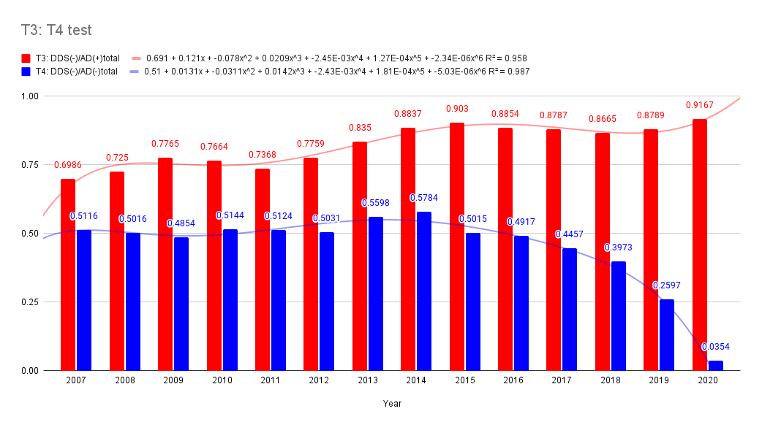
We compared T3 (M = 0.1766, SD = 0.074) and T4 (M = 0.5501, SD = 0.1421). T3:T4 in the group not taking Dapsone also demonstrated that the group with AD and without AD was distinguished.

T-Test for T1: DDS (+) AD (+) T3: DDS (-) AD (+)

Independent Means
Significance Level: 0.05, Two-tailed hypothesis.
The t-value is -23.13483. The p-value is < .00001. The result is significant at p < .05.
Difference Scores Calculations
Treatment 1
N₁: 14
df₁ = N - 1 = 14 - 1 = 13
M₁: 0.18
SS₁: 0.07
s²₁ = SS₁/(N - 1) = 0.07/(14-1) = 0.01
Treatment 3
N₂: 14
df₂ = N - 1 = 14 - 1 = 13
M₂: 0.82
SS₂: 0.07
s²₂ = SS₂/(N - 1) = 0.07/(14-1) = 0.01
T-value Calculation
s²_{p} = ((df₁/(df₁ + df₂)) * s²₁) + ((df₂/(df₂ + df₂)) * s²₂) = ((13/26) * 0.01) + ((13/26) * 0.01) = 0.01
s²_{M1} = s²_{p}/N₁ = 0.01/14 = 0
s²_{M2} = s²_{p}/N₂ = 0.01/14 = 0
t = (M₁ - M₂)/√(s²_{M1} + s²_{M2}) = -0.65/√0 = -23.13

2 Dependent Means
Significance Level: 0.05, Two-tailed hypothesis.
The value of t is 16.358793. The value of p is < .00001. The result is significant at p < .05.
Difference Scores Calculations
Mean: 0.65
μ = 0
S² = SS⁄df = 0.28/(14-1) = 0.02
S²_{M} = S²/N = 0.02/14 = 0
S_{M} = √S²_{M} = √0 = 0.04
T-value Calculation
t = (M - μ)/S_{M} = (0.65 - 0)/0.04 = 16.36

Fig. S5. T1:T3 Test
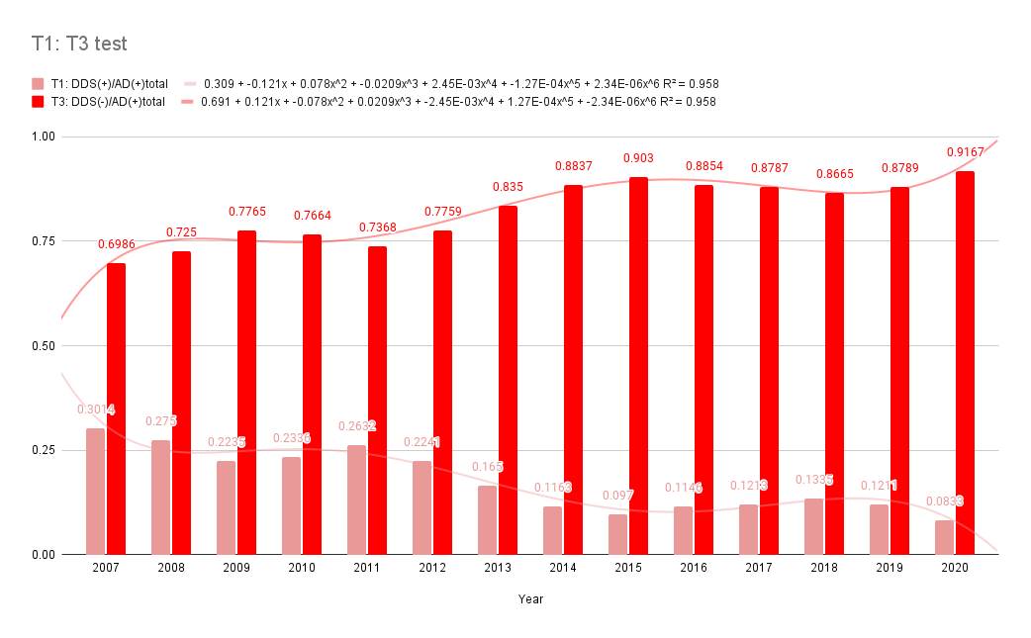
The participants with T1 (M = 0.1766, SD = 0.074) were compared to those with T3 (M = 0.1766, SD = 0.074). The T1:T3 test proved that the incidence of AD was significantly reduced by dapsone. The t-value is -23.13483 m, p-value is < .00001. (significant at p < .05)

T-Test for T2: DDS (+) AD (-) T3: DDS (-) AD (+)

Independent Means
Significance Level: 0.05, Two-tailed hypothesis.
The t-value is -6.38247. The p-value is < .00001. The result is significant at p < .05.
Difference Scores Calculations

Treatment 1
N1: 14
df1 = N - 1 = 14 - 1 = 13
M1: 0.55
SS1: 0.26
s21 = SS1/(N - 1) = 0.26/(14-1) = 0.02

Treatment 2
N2: 14
df2 = N - 1 = 14 - 1 = 13
M2: 0.82
SS2: 0.07
s22 = SS2/(N - 1) = 0.07/(14-1) = 0.01

T-value Calculation
s2p = ((df1/(df1 + df2)) * s21) + ((df2/(df2 + df2)) * s22) = ((13/26) * 0.02) + ((13/26) * 0.01) = 0.01
s2M1 = s2p/N1 = 0.01/14 = 0
s2M2 = s2p/N2 = 0.01/14 = 0

t = (M1 - M2)/√(s2M1 + s2M2) = -0.27/√0 = -6.38

Dependent Means
Significance Level: 0.05, Two-tailed hypothesis.
The value of t is 8.055466. The value of p is < .00001. The result is significant at p < .05.
Difference Scores Calculations

Mean: 0.27
μ = 0
S2 = SS⁄df = 0.21/(14-1) = 0.02
S2 M = S2/N = 0.02/14 = 0
SM = √S2 M = √0 = 0.03

T-value Calculation

t = (M - μ)/SM = (0.27 - 0)/0.03 = 8.06

Fig. S6. T2:T3 Test
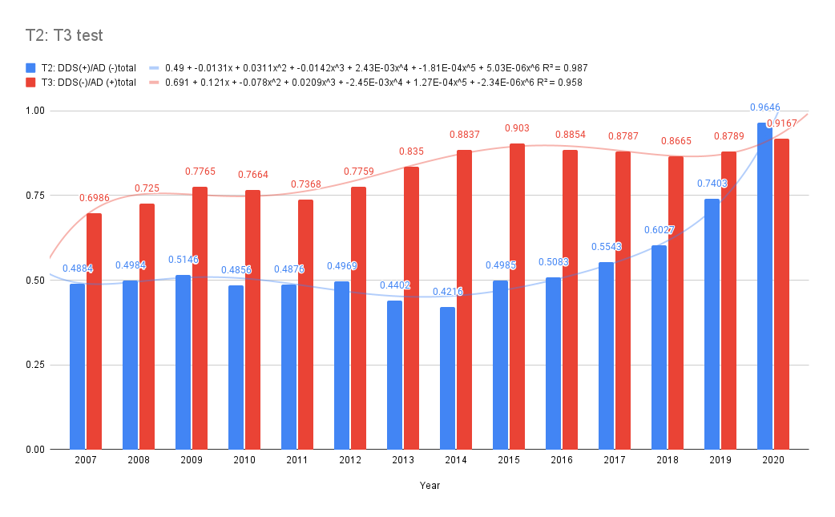
The participants with T2 disease (M = 0.5501, SD = 0.1421) were compared to those with T3 disease (M = 0.1766, SD = 0.074). The T2:T3 test proved that the prevalence of AD is significantly high without dapsone, and the proportion of HD patients without AD is increased with dapsone.

T-Test for T1: DDS (+) AD (+) T4: DDS (-) AD (-)

Independent Means
Significance Level: 0.05, Two-tailed hypothesis.
The t-value is -6.38247. The p-value is < .00001. The result is significant at p < .05.
Difference Scores Calculations
Treatment 1
N1: 14
df1 = N - 1 = 14 - 1 = 13
M1: 0.18
SS1: 0.07
s21 = SS1/(N - 1) = 0.07/(14-1) = 0.01

Treatment 2
N2: 14
df2 = N - 1 = 14 - 1 = 13
M2: 0.45
SS2: 0.26
s22 = SS2/(N - 1) = 0.26/(14-1) = 0.02

T-value Calculation
s2p = ((df1/(df1 + df2)) * s21) + ((df2/(df2 + df2)) * s22) = ((13/26) * 0.01) + ((13/26) * 0.02) = 0.01

s2M1 = s2p/N1 = 0.01/14 = 0
s2M2 = s2p/N2 = 0.01/14 = 0

t = (M1 - M2)/√(s2M1 + s2M2) = -0.27/√0 = -6.38

Dependent Means
Significance Level: 0.05, Two-tailed hypothesis.
The value of t is 8.055466. The value of p is < .00001. The result is significant at p < .05.
Difference Scores Calculations
Mean: 0.27
μ = 0
S2 = SS⁄df = 0.21/(14-1) = 0.02
S2 M = S2/N = 0.02/14 = 0
SM = √S2 M = √0 = 0.03

T-value Calculation

t = (M - μ)/SM = (0.27 - 0)/0.03 = 8.06

Fig. S7. T1:T4 Test
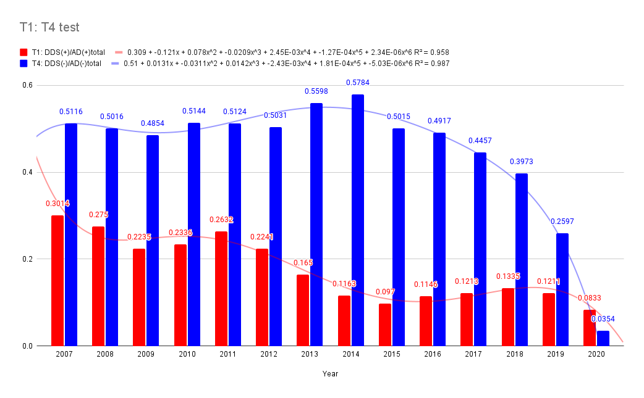
The participants with T1 (M = 0.1766, SD = 0.074) were compared to T4 (M = 0.5501, SD = 0.1421). The T1:T4 test demonstrated that the trend was similar for patients with DDS (+)/AD (+) and DDS (-)/AD (-). This demonstrates that HD patients also develop AD but at a significantly lower rate when taking dapsone. Fewer people who do not develop AD without taking dapsone suggest that there is a clear distinction between the group taking dapsone and the group not taking dapsone.

Reference: STUDY OF DDS (+/-) GROUP in the Sorokdo National Hospital

Supplementary Table 4. DDS dosing in possible dementia (+) subgroup.

year | Possible dementia | AD (-) | DDS (+) SUM |  | Mean | SD | 95% CI | [CI | CI]
2005 | 181 | 556 | 737 |  | 368.5 | 265.17 | 19.18 | 349.32 | 633.67
2006 | 186 | 533 | 719 |  | 359.5 | 245.37 | 17.97 | 341.53 | 604.87
2007 | 187 | 531 | 718 |  | 359 | 243.24 | 17.82 | 341.18 | 602.24
2008 | 195 | 506 | 701 |  | 350.5 | 219.91 | 16.31 | 334.19 | 570.41
2009 | 195 | 470 | 665 |  | 332.5 | 194.45 | 14.81 | 317.69 | 526.95
2010 | 206 | 456 | 662 |  | 331 | 176.78 | 13.49 | 317.51 | 507.78
2011 | 224 | 430 | 654 |  | 327 | 145.66 | 11.18 | 315.82 | 472.66
2012 | 228 | 419 | 647 |  | 323.5 | 135.06 | 10.43 | 313.07 | 458.56
2013 | 236 | 410 | 646 |  | 323 | 123.04 | 9.51 | 313.49 | 446.04
2014 | 231 | 388 | 619 |  | 309.5 | 111.02 | 8.76 | 300.74 | 420.52
2015 | 218 | 382 | 600 |  | 300 | 115.97 | 9.30 | 290.70 | 415.97
2016 | 210 | 378 | 588 |  | 294 | 118.79 | 9.62 | 284.38 | 412.79
2017 | 190 | 362 | 552 |  | 276 | 121.62 | 10.17 | 265.83 | 397.62
2018 | 184 | 366 | 550 |  | 275 | 128.69 | 10.78 | 264.22 | 403.69
2019 | 174 | 353 | 527 |  | 263.5 | 126.57 | 10.83 | 252.67 | 390.07
2020 | 151 | 314 | 465 |  | 232.5 | 115.26 | 10.50 | 222.00 | 347.76
Sum | 3196 | 6854 | 10050
Mean | 199.75 | 428.38 | 628.13
SD | 23.50 | 73.07 | 96.57
95% CI | 0.82 | 1.73 | 2.55
 | 198.93 | 426.64 | 625.58
 | 200.57 | 430.11 | 630.67

Section 4. STROBE Statement
STROBE Statement—Checklist of items that should be included in reports of case-control studies
 | No |  | Recommendation
Title and abstract | 1 |  | (a) Indicate the study's design with a commonly used term in the title or the abstract:  According to the Official Information Disclosure Act in Korea, the Seoul study analysed AD and anti-Alzheimer's disease drug (AAD) use in Hansen subjects. The Seoul study analysed AD, and anti-AD drugs (AADs) in the Sorokdo National Hospital's EDI database archived from January 2005 to June 2020 through the ICD-9 and -10 codes.
Title and abstract |  |  | (b) Provide in the abstract an informative and balanced summary of what was done and what was found:  We analysed AD in HD patients at Sorokdo National Hospital. The HD patients in Sorokdo National Hospital have lived only on Sorokdo (an island for HD patients) all their lives. Korean HD patients continue to take DDS throughout their lives. Based on the relative prevalence of AD in patients who have been prescribed DDS and those who have not, this drug appears to have a preventive effect against AD. (Table 2) It shows that DDS's action as a neuro-inflammasome competitor² can be conjectured by comparing the AD prevalence in HD patients who have been prescribed DDS and those who have not. Thus, DDS appears to be a neuro-inflammasome competitor.
Background/rationale | 2 |  | Explain the scientific background and rationale for the investigation being reported:  The Seoul study analysed the causes of low AD prevalence of Hansen's disease (HD) patients at the Sorokdo National Hospital. We have also analysed infectious respiratory diseases of HD at Sorokdo National Hospital³. The Korean Hansen Welfare Association reported that HD patients had no known outbreaks of four respiratory infectious diseases (SARS-CoV (2002), influenza A virus subtype H1N1 (2009), MERS (2015), and SARS-CoV-2 (2020)) between 2002 and 2020.6². DDS approved for HD has potent antimicrobial effects, even at a small dose⁴. This study shows that DDS is also a neuro-inflammasome competitor because of the preventive effects of AD or infectious diseases.
Objectives | 3 |  | State-specific objectives, including any prespecified hypotheses  We hypothesized that the deterioration of MCI to AD should be prevented by NLRP3 inflammasome inhibitors⁵, such as DDS. The DDS tablets had been produced by the local pharmaceutical company, which stopped the production of DDS. Since then, the Korea Food and Drug Administration has designated DDS as an anti-retraction drug and produced it only for HD. The Korea Orphan & Essential Drug Center imported it from Germany. After administering the two types of DDSs to patients, we found a significant difference in clinical effectiveness empirically. DDS from the local pharmaceutical company had one-third the effective dose (ED₅₀) of Germany's drugs. So DDS efficacy is also a very significant factor to prevent AD.
Study design | 4 |  | Present critical elements of study design early in the paper  According to the Official Information Disclosure Act in Korea, the Seoul study analysed AD and anti-Alzheimer's disease drug (AAD) use in Hansen subjects. We searched all medical records of the National Health Insurance Service (NHIS) in Korea and the Sorokdo National Hospital from the time when the International Classification of Diseases (ICD)-9 code and Electronic Data Interchange (EDI) were computerized. The Sorokdo National Hospital was established in May 1916 to treat leprosy. We connected to the medical record database of the Sorokdo National Hospital and archived it from January 2005 to June 2020. With the ICD-9 and -10 codes, medical data on the correlation between DDS and AD were then analysed.
Setting | 5 |  | Describe the environment, locations, and relevant dates, including periods of recruitment, exposure, follow-up, and data collection  Korea's Dementia Management Act came into effect on 05 February 2012. It was amended by Act No. 15649, 12 June 2018. The purposes of this Act are to mitigate personal pain and damage from dementia; to lighten its burden on society, and to help enhance national health by establishing and implementing a comprehensive policy on the prevention of dementia, protection of and support for dementia patients, and research for the eradication of dementia. Korea government help HD patient's AD treatment freely and supply AAD for free.  We utilize Object-Relational DBMS and SPSS. In addition, according to the Official Information Disclosure Act in Korea, we also requested and analysed the entire ICD 9 and 10 code data (from 2010 to 2019) of AD and AAD from the Health Insurance Review & Assessment system.
Participants | 6 |  | (a) Give the eligibility criteria and the sources and methods of case ascertainment and control selection. Give the rationale for the choice of cases and controls  The HD patients in Sorokdo National Hospital have lived only on Sorokdo (an island for HD patients) all their lives. Korean HD patients continue to take DDS throughout their lives.  Protocol for administration: For HD patients, doctors perform standard treatment based on AD diagnosis and test results. Our research does not intervene at all.
Participants |  |  | (b) For matched studies, give matching criteria and the number of controls per case\  The relation between DDS and AD in the Sorokdo National Hospital from January 2005 to June 2020.  Matching criteria – Only HD patient and (AD (+) OR AD (-)) and (DDS (+) OR DDS (-))
  Year | AD(+) |  |  | AD(-)
  Year | DDS (+) | DDS (-) | Total | DDS (+) | DDS (-) | Total
  2005 | 18 | 19 | 37 | 290 | 417 | 707
  2006 | 20 | 37 | 57 | 302 | 363 | 665
  2007 | 22 | 51 | 73 | 317 | 332 | 649
  2008 | 22 | 58 | 80 | 310 | 312 | 622
  2009 | 19 | 66 | 85 | 300 | 283 | 583
  2010 | 25 | 82 | 107 | 270 | 286 | 556
  2011 | 35 | 98 | 133 | 255 | 268 | 523
  2012 | 39 | 135 | 174 | 238 | 241 | 479
  2013 | 34 | 172 | 206 | 195 | 248 | 443
  2014 | 25 | 190 | 215 | 172 | 236 | 408
  2015 | 26 | 242 | 268 | 167 | 168 | 335
  2016 | 33 | 255 | 288 | 154 | 149 | 303
  2017 | 37 | 268 | 305 | 143 | 115 | 258
  2018 | 45 | 292 | 337 | 132 | 87 | 219
  2019 | 46 | 334 | 380 | 114 | 40 | 154
  2020 | 32 | 352 | 384 | 109 | 4 | 113
Variables | 7 |  | Clearly, define all outcomes, exposures, predictors, potential confounders, and effect modifiers. Give diagnostic criteria, if applicable  Outcomes: It shows that DDS's action as a neuro-inflammasome competitor can be conjectured by comparing the AD prevalence in HD patients who have been prescribed DDS and those who have not. Thus, DDS appears to be a neuro-inflammasome competitor because of low AD prevalence.  Exposure: There are only definitive diagnoses and treatments for AD. Doctors prescribe dapsone and AAD for AD (+) HD patients or AD (-) HD patients.  Predictors: The Hansen people have a long lifespan. If there is no significant impact on Hansenin's lifespan, it is determined that there is no significant risk factor.  Potential confounders: Korean doctors sometimes replace military service with public health doctors. Since the period is three years, new doctors sometimes make new diagnoses and medications every three years. However, the standard for dementia management was clear and could be overcome.  Effect modifiers: The risk of AAD in patients with dementia is well known. Doctors who benefit from increasing AAD prescriptions can skew the results. However, since it was a public institution, the doctors were thoroughly audited.  Diagnostic criteria: including Geriatric depression scale (GDS), Korean modified Mini-Mental Status Exam (k-MMSE), and Global Deterioration Scale (GDS).
Data sources/measurement | 8* |  | For each variable of interest, give sources of data and details of assessment methods (measurement). Describe comparability of assessment methods if there is more than one group  According to the Official Information Disclosure Act in Korea, we also requested data from the Health Insurance Review & Assessment system. Additionally, we requested data from the Health Insurance Review & Assessment system, according to Korea's Official Information Disclosure Act. From 2010 to 2019, all ICD 9 and 10 code data on AD and AAD were analysed. We connected the Sorokdo National Hospital's EDI database archived from January 2005 to June 2020 and searched it using the ICD-9 and -10 codes. Hansen's disease patients were evaluated for DDS or AAD prescriptions at Sorokdo National Hospital, dedicated to treating patients with this disease.
Bias | 9 |  | Describe any efforts to address potential sources of bias  For HD patients, doctors perform standard treatment according to AD diagnosis and test results, but AD misdiagnosis is also possible. However, there are no misdiagnoses since the tests have been repeatedly conducted.
Study size | 10 |  | Explain how the study size was arrived at  In Korea, leprosy patients have been quarantined for long years. Freedom of movement was guaranteed approximately 2000, but they still live as a living place. The Sorokdo National Hospital was established as a hospital dedicated to HD patients, and public health doctors were employed to enable various diagnoses and management.
Quantitative variables | 11 |  | Explain how quantitative variables were handled in the analyses. If applicable, describe which groupings were chosen and why  From 2010 to June 2020, the diagnosis of patients with MCI and AD in Korea increased dramatically. (Table 1)  AAD prescriptions for leprosy patients have increased in Korea. In the past, there were no doctors, so HD patients took dapsone without stopping. As more doctors increased, more patients did not take dapsone. Such changes in the medical environment could form a comparative control group.
Statistical methods | 12 |  | (a) Describe all statistical methods, including those used to control for confounding  We tried the chi-square test in Table 2. The p-value and statement of significance appear beneath the Table. Above all, it was a study of HD patients living in the same area in the same hospital for 15 years, which was a factor in reducing confounding.
Statistical methods |  |  | (b) Describe any methods used to examine subgroups and interactions  The chi-square statistic, p-value and statement of significance for 15 years were of the utmost importance and consistent with the medical staff's patient management and the Sorokdo Cathedral Sisters' patient management.
Statistical methods |  |  | (c) Explain how missing data were addressed  There are no missing data.
Statistical methods |  |  | (d) If applicable, explain how matching of cases and controls was addressed  We define the Korean Standard Classification of Diseases (KCD) disease code for "Alzheimer's disease."  1. Mental and behavioural disorders, F00-F09, G30  2. Korea Drug Code Medicine  First Group: For symptomatic relief of Alzheimer’s disease  [donepezil hydrochloride]  [rivastigmine]  [galantamine]  [N-methyl-D-aspartate (NMDA) receptor antagonist]  Second Group: For psychologic symptoms of Alzheimer’s disease  [haloperidol]  [Risperidone]  [Quetiapine]  [Olanzapine]  [Aripiprazole]  [Oxcarbazepine]  [fluvoxamine]  [Escitalopram]  [Trazodone]  [sertraline]  [Escitalopram]  [Fluoxetine]
Statistical methods |  |  | (e) Describe any sensitivity analyses  It was sensitive to medical data because medical experts examined complete inspections, according to the Dementia Act.
Participants | 13* |  | (a) Report numbers of individuals at each stage of study—e.g., numbers potentially eligible, examined for eligibility, confirmed eligible, included in the study, completing follow-up, and analysed
  Year | AD(+) |  |  | AD(-)
  Year | DDS (+) | DDS (-) | Total | DDS (+) | DDS (-) | Total
  2005 | 18 | 19 | 37 | 290 | 417 | 707
  2006 | 20 | 37 | 57 | 302 | 363 | 665
  2007 | 22 | 51 | 73 | 317 | 332 | 649
  2008 | 22 | 58 | 80 | 310 | 312 | 622
  2009 | 19 | 66 | 85 | 300 | 283 | 583
  2010 | 25 | 82 | 107 | 270 | 286 | 556
  2011 | 35 | 98 | 133 | 255 | 268 | 523
  2012 | 39 | 135 | 174 | 238 | 241 | 479
  2013 | 34 | 172 | 206 | 195 | 248 | 443
  2014 | 25 | 190 | 215 | 172 | 236 | 408
  2015 | 26 | 242 | 268 | 167 | 168 | 335
  2016 | 33 | 255 | 288 | 154 | 149 | 303
  2017 | 37 | 268 | 305 | 143 | 115 | 258
  2018 | 45 | 292 | 337 | 132 | 87 | 219
  2019 | 46 | 334 | 380 | 114 | 40 | 154
  2020 | 32 | 352 | 384 | 109 | 4 | 113
Participants |  |  | (b) Give reasons for non-participation at each stage  In Korea, patients with HD are compulsory for medical tests according to the Disease Control Act. No non-participation
Participants |  |  | (c) Consider the use of a flow diagram  It is a distinct dataset for 2010-2019.  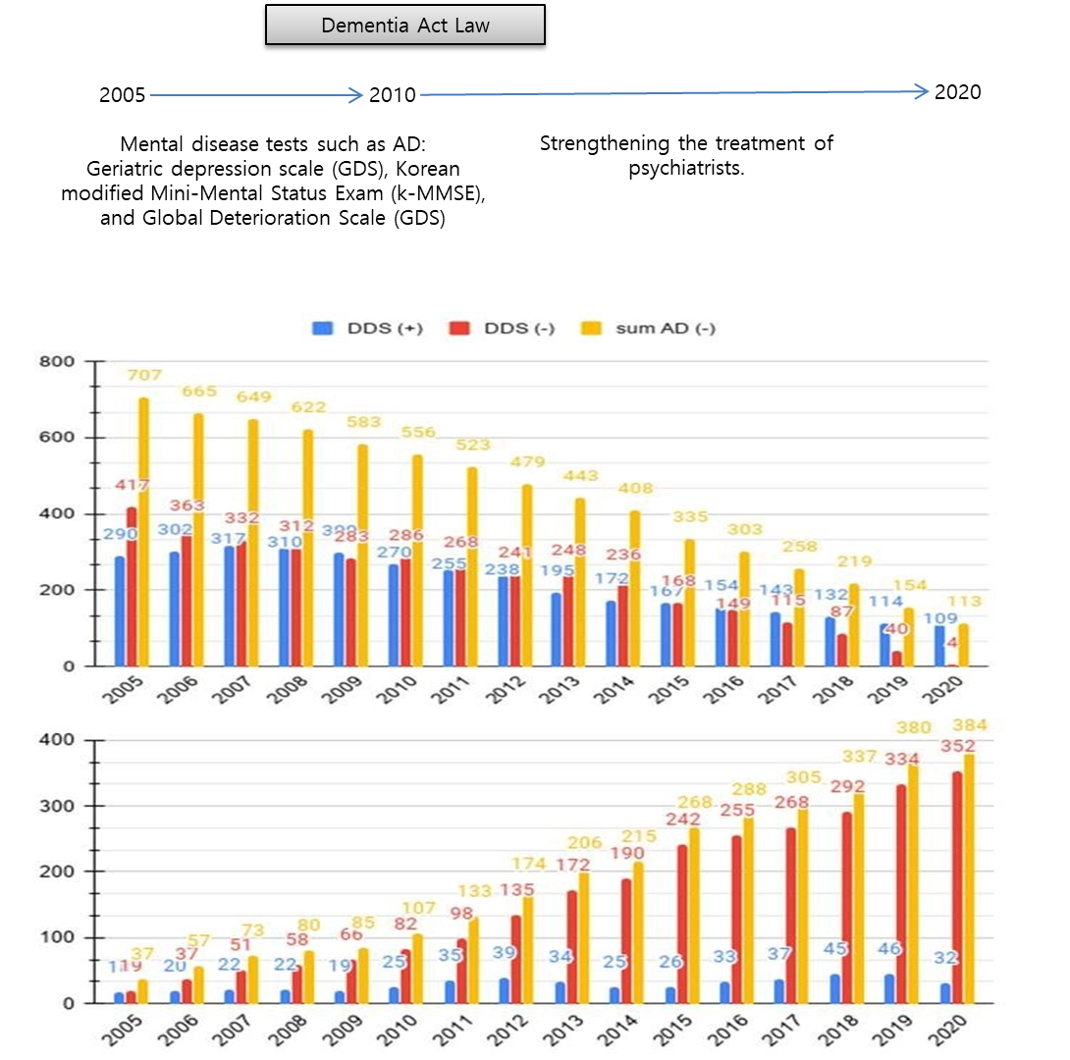  Figure 2. A flow diagram.
Descriptive data | 14* |  | (a) Give characteristics of study participants (e.g., demographic, clinical, social) and information on exposures and potential confounders  Korea Centers for Disease Control and Prevention (KCDC) is supplying DDS to Hansen's patients. KCDC reported that DDS was supplied free for all (DDS 100 mg–1000 tablet/bottle to 3814 of 9134 Hansen's patients). With a bottle, each of three people can take one tablet per day for one year.  We also analysed infectious respiratory diseases among Hansen's patients at Sorokdo National Hospital. The data shows that the patients of Sorokdo National Hospital are responsible for the development of respiratory infectious diseases according to the occurrence of SARS-CoV (2002), Influenza A virus subtype H1N1 (2009), MERS (2015), and SARS-CoV-2 (2020). There is no significant change and no statistical correlation. After President Dae-Jung Kim came to power in 1998, Hansen's patients were given freedom. Many were devout Christians, but as more and more became smokers, as in a typical rural village, RIS increased. Sorok-do became a tourist destination, and travellers have come and gone freely, but SARS-CoV (2002), influenza A virus subtype H1N1 (2009), MERS (2015), and SARS-CoV-2 (2020) have not occurred. All patients have continued to take DDS after they were leprosy-diagnosed. The proportion of the oldest demographic group (80 years and over) is still 38.5% (2019), higher than for all Koreans²  From 2010 to June 2020, the diagnosis of patients with MCI and AD in Korea increased dramatically. (Table 1) AAD prescriptions for leprosy patients have increased in Korea. In the past, there were no doctors, so HD patients took dapsone without stopping. As more doctors increased, more patients did not take dapsone. Such changes in the medical environment could form a comparative control group.
Descriptive data |  |  | (b) Indicate the number of participants with missing data for each variable of interest  There are no missing data because HD patients live their life until death.
Outcome data | 15* |  | Report numbers in each exposure category, or summary measures of exposure  2. Korea Drug Code Medicine  First Group: [donepezil hydrochloride]148603ATB 148602ATD 148602ATB 148601ATD 148601ATB 643401ATD 643402ATD [rivastigmine]224501ACH 224503ACH 224504ACH 224505ACH 224506CPC 224507CPC 24508CPC[galantamine]385203ACR 385203ATR 385204ACR 385204ATR 385205ACR 385205ATR[N-methyl-D-aspartate (NMDA) receptor antagonist]190031ALQ 190001ATB 190003ATD 190004ATB 190004ATD  Second Group: [haloperidol]167903ATB 167904ATB 167905ATB 167906ATB 167908ATB 167908ATB 168030BIJ[Risperidone]224201ATB 224201ATD 224202ATB 224202ATD 224203ATB 224204ATB 224205BIJ 224206BIJ[Quetiapine]378601ATB 378602ATB 378603ATB 378604ATB 378605ATB 378605ATR 378606ATR 378607ATR 378608ATR 378608ATR 378610ATB[Olanzapine]204001ATB 204001ATD 204002ATB 204002ATD 204004ATB 204005ATB[Aripiprazole]451501ATB 451501ATD 451502ATB 451502ATD 451503ATB 451504ATB 451505ATB 451506BIJ 451507BIJ[Oxcarbazepine]206330ASS 206301ATB 206302ATB 206303ATB  [fluvoxamine]162501ATB 162502ATB[Escitalopram]474801ATB 474802ATB 474803ATB 474804ATB[Trazodone]242901ACH 242901ATB 242902ATB 242903ATR  [sertraline]227001ATB 227002ATB 227003ATB[Escitalopram]474801ATB 474802ATB 474803ATB 474804ATB[Fluoxetine]161501ACH 161501ATB 161502ACH 161502ATB 161502ATD
  year | 2005 | 2006 | 2007 | 2008 | 2009 | 2010 | 2011 | 2012 | 2013 | 2014 | 2015 | 2016 | 2017 | 2018 | 2019 | 2020
  AD (+) | 37 | 57 | 73 | 80 | 85 | 107 | 133 | 174 | 206 | 215 | 268 | 288 | 305 | 337 | 380 | 384
  AD (+) DDS EXPOSURE | 18 | 20 | 22 | 22 | 19 | 25 | 35 | 39 | 34 | 25 | 26 | 33 | 37 | 45 | 46 | 32
  AD (-) | 707 | 665 | 649 | 622 | 583 | 556 | 523 | 479 | 443 | 408 | 335 | 303 | 258 | 219 | 154 | 113
  AD (-) DDS EXPOSURE | 290 | 302 | 317 | 310 | 300 | 270 | 255 | 238 | 195 | 172 | 167 | 154 | 143 | 132 | 114 | 109
  We use the Korean Standard Classification of Diseases (KCD) disease code for "Alzheimer's disease."
  1. Mental and behavioural disorders, F00-F09, G30
  [F00] [F01] [F02] [F03] [F04] [F05] [F06] [F07] [F09] [G30]
Main results | 16 |  | (a) Give unadjusted estimates and, if applicable, confounder-adjusted estimates and their precision (e.g., 95% confidence interval). Make clear which confounders were adjusted for and why they were included  The relation between DDS and AD each year was analysed using the chi-square test. A P-value < .05 was considered significant. ** indicates a P-value < 0.05.
  Year | 2005 | 2006 | 2007 | 2008 | 2009 | 2010 | 2011 | 2012 | 2013 | 2014 | 2015 | 2016 | 2017 | 2018 | 2019 | 2020
  P-value | 0.3583 | 0.1324 | .0024** | .0002** | < .00001** | < .00001** | < .00001** | < .00001** | < .00001** | < .00001** | < .00001** | < .00001** | < .00001** | < .00001** | < .00001** | < .00001**
Main results |  |  | (b) Report category boundaries when continuous variables were categorized  To remove diverse confounding factors, we searched all medical records of the National Health Insurance Service (NHIS) in Korea and the Sorokdo National Hospital from the time when the International Classification of Diseases (ICD)-9 code and Electronic Data Interchange (EDI) were computerized by medical staffs. With the ICD-9 and -10 codes, medical data on the correlation between DDS and AD were then analysed.  - AD group with DDS (+)  - AD group with DDS (-)  - AD free group with DDS (+)  - AD free group with DDS (-)
Main results |  |  | (c) If relevant, consider translating estimates of relative risk into absolute risk for a meaningful period  Depending on the 15-year analysis, the diagnosis and treatment of AD are precise according to medical standards.
Other analyses | 17 | Report other analyses are done—e.g., analyses of subgroups and interactions and sensitivity analyses  - Mortality study by ADD the second group.  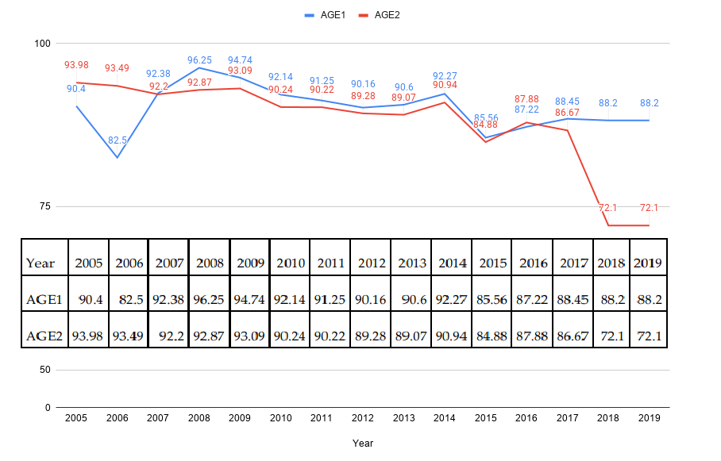

Discussion
Key results | 18 | Summarize key results concerning study objectives  We analysed AD in HD patients at Sorokdo National Hospital. The HD patients in Sorokdo National Hospital have lived only on Sorokdo (an island for HD patients) all their lives. Korean HD patients continue to take DDS throughout their lives. Based on the relative prevalence of AD in patients who have been prescribed DDS and those who have not, DDS appears to have a preventive effect against AD.
Limitations | 19 | Discuss the limits of the study, taking into account sources of potential bias or imprecision. Discuss both direction and magnitude of any potential bias  As a long-term study of HD patients living in Sorok Island for 15 years, the relationship between AD and dapsone is clear.  In 1992, an AD research team published a method of preventing and treating human AD dementia with DDS, its didextrose sulfonate derivative, and other closely related sulfones (sulfetrone and thiazolsulfone)⁶⁻⁸. It is the same result. However, it is not a study of inflammation but a study of the inflammasome.
Interpretation | 20 | Give a cautious overall interpretation of results considering objectives, limitations, the multiplicity of analyses, the results from similar studies, and other relevant evidence  If people who have been prescribed dapsone and then did not receive it are reflected in the statistical data, the effects of dapsone as an inflammasome competitor are mixed. It is essential to distinguish them. It is why further investigations by Japanese Sanatorium autopsy studies^{8, 9} did not detect any differences in AD prevalence among HD patients treated with DDS and failed to demonstrate that it had any protective effects against Aβ neurotoxicity.  Furthermore, because of the validation study that denied the AD prevention effect of dapsone as an experimental study corresponding to the null hypothesis, dapsone did not even have a proper cohort study^{10, 11}.
Generalizability | 21 | Discuss the generalizability (external validity) of the study results  This study is for HD patients have been taking dapsone consistently under the nursing oSorokdo Cathedral's sisters for a long time (over 30 years) without medical doctors. The only change factors were doctor's prescription (i.e., stop dapsone) and introduction of dementia management law. This is a fantastic scientific result that is different from the works of other researchers. We searched individual identified medical records of the National Health Insurance Service (NHIS) in Korea and the Sorokdo National Hospital from the time when the International Classification of Diseases (ICD)-9 code and Electronic Data Interchange (EDI) were computerized. It is only objective studies for DDS and Dementia relationships.
Other information
Funding | 22 | Give the source of funding and the role of the funders for the present study and, if applicable, for the original study on which the present article is based  No funding.

References
1 Oldenburg, C. E. et al. Effect of Oral Azithromycin vs Placebo on COVID-19 Symptoms in Outpatients With SARS-CoV-2 Infection: A Randomized Clinical Trial. JAMA, doi:10.1001/jama.2021.11517 (2021).
2 Lee, J. H., An, H. K., Sohn, M. G., Kivela, P. & Oh, S. 4,4′-Diaminodiphenyl sulfone (DDS) as an inflammasome competitor. Int. J. Mol. Sci. 21, 5953 (2020).
3 Ahn, Y. H., Park, H. & Kweon, S. S. Causes of death among persons affected by leprosy in Korea, 2010–2013. Am. J. Trop. Med. Hyg. 102, 42-47 (2020).
4 Zhu, Y. I. & Stiller, M. J. Dapsone and sulfones in dermatology: overview and update. J. Am. Acad. Dermatol. 45, 420-434, doi:10.1067/mjd.2001.114733 (2001).
5 Ismael, S., Zhao, L., Nasoohi, S. & Ishrat, T. Inhibition of the NLRP3-inflammasome as a potential approach for neuroprotection after stroke. Sci. Rep. 8, 5971, doi:10.1038/s41598-018-24350-x (2018).
6 McGeer, P. L., Harada, N., Kimura, H., McGeer, E. G. & Schulzer, M. Prevalence of dementia amongst elderly Japanese with leprosy: apparent effect of chronic drug therapy. Dement. Geriatr. Cogn. Disord. 3, 146-149 (1992).
7 McGeer, P. L., Harada, N., Kimura, H., McGeer, E. G. & Schulzer, M. Dapsone and promin for the treatment of dementia. (Google Patents, 1996).
8 McGeer, P. L., Klegeris, A., Walker, D. G., Yasuhara, O. & McGeer, E. G. Pathological proteins in senile plaques. Tohoku J. Exp. Med. 174, 269-277, doi:10.1620/tjem.174.269 (1994).

8 Namba, Y., Kawatsu, K., Izumi, S., Ueki, A. & Ikeda, K. Neurofibrillary tangles and senile plaques in brain of elderly leprosy patients. Lancet 340, 978 (1992).
9 Kimura, T. & Goto, M. Existence of senile plaques in the brains of elderly leprosy patients. Lancet 342, 1364 (1993).
10 Endoh, M., Kunishita, T. & Tabira, T. No effect of anti-leprosy drugs in the prevention of Alzheimer's disease and beta-amyloid neurotoxicity. J. Neurol. Sci. 165, 28-30 (1999).
11 Lee, J. H., Choi, S. H., Lee, C. J. & Oh, S. S. Recovery of dementia syndrome following treatment of brain inflammation. Dement. Geriatr. Cogn. Dis. Extra 10, 1-12 (2020).

