Online Supplementary Materials
Shang H, Chu Q, et al. A retrospective study of mortality for perioperative cardiac arrests towards personalized treatment

1. The data and codes for analysis, including the following files,
1.1. The data file: “150CA_EN20210701.xlsx”;
1.2. The R code for statistical analysis: “ANOVA-test_patient-characteristics.Rmd”;
1.3. The Python code for ML model validations: “Predicting CA Mortality V4.ipynb”;
1.4. The python code for ML model explainability: “Model Explanation_V4.ipynb”.
2. Supplementary Figure1. Predicted Mortality Ratio by Age Group. Sensitivity analysis comparing model performance across age groups by six machine learning models
1. The data and codes for analysis, are accessible on Github if required, at
https://github.com/niuneo/Risk-factor-analysis-of-mortality-for-perioperative-cardiac-arrest-using-machine-learning, including the following files,
1.1. The data file: “150CA_EN20210701.xlsx”;
1.2. The R code for statistical analysis: “ANOVA-test_patient-characteristics.Rmd”;
1.3. The Python code for ML model validations: “Predicting CA Mortality V4.ipynb”;
1.4. The python code for ML model explainability: “Model Explanation_V4.ipynb”.
2. Supplementary Figure 1. 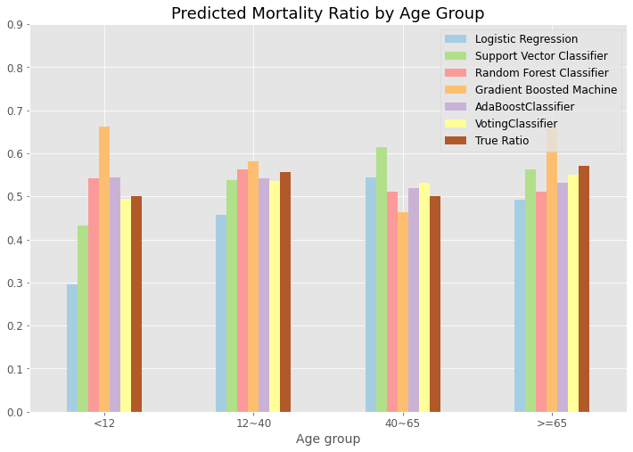
Supplementary Figure 1. Sensitivity analysis comparing model performance across age groups. True mortality for each group is indicated in dark red.

