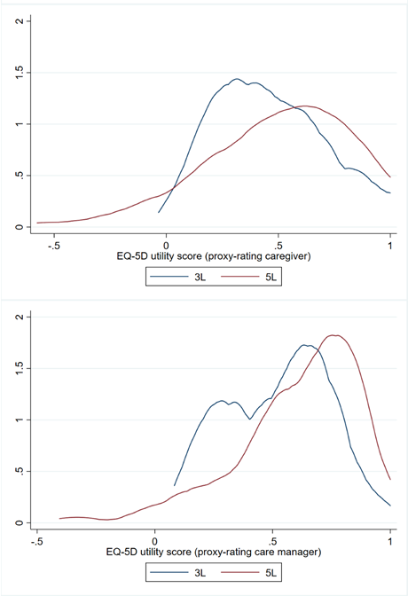
Supplementary Figure 1: Density plots of the self- and proxy-rating EQ-5D-3L and 5L index values

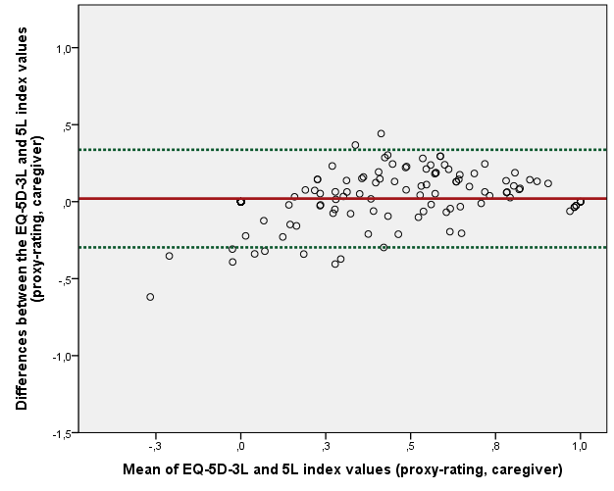
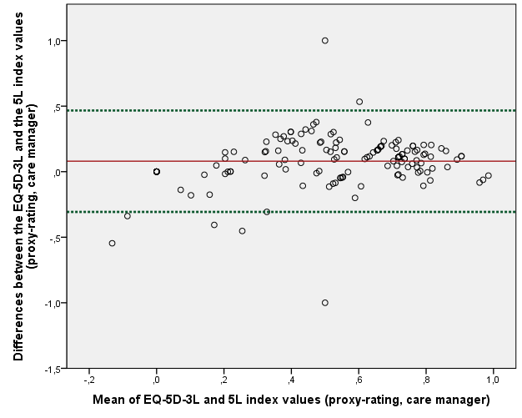
Supplementary Figure 2: Bland-Altman plots of the EQ-5D-3L and the EQ-5D-5L index values
Vertical Axis represents the difference between the EQ-5D-5L and EQ-5D-3L (5L minus 3L)

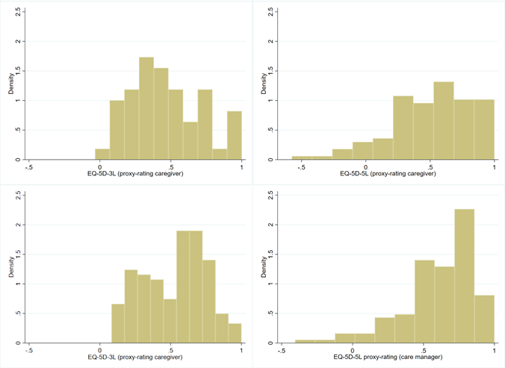
Supplementary Figure 3: Histograms of the self- and proxy-rating EQ-5D-3L and 5L index values

