Supplementary material
Table S1 Sequences of primers used in recombinant vector construction
Name | Sequence | Description
ArCel5 fw | 5'-CGGAATTCGCCCAAGAGTCTCGGGGTTACGGAC-3' | Construction primer of expression vector pPICZαA-ArCel5 (EcoR I restriction site underlined)
ArCel5 rev | 5'-GCTCTAGACGCAAGAAAGACTCAAGAACTGG-3' | Construction primer of expression vector pPICZαA-ArCel5 (Xba I restriction site underlined)
ArCel5-LD fw | 5'-GGAATTCCCAGGAGGTAATGGTGGTGGTGG-3' | Used as primers to construct the expression vector pPICZαA-ArCel5-LD with ArCel5 rev (EcoR I restriction site underlined)
ArCel5-D fw | 5'-GGAATTCGACCTCTTCGGTGTCAACGAGGC-3' | Used as primers to construct the expression vector pPICZαA-ArCel5-D with ArCel5 rev (EcoR I restriction site underlined)
ArCel5 rev1 | 5'-GCAAGCTTTTACAAGAAAGACTCAAGAACTGG-3' | Used as primers to construct the expression vector pET28a-ArCel5 with ArCel5 rev (Hind III restriction site underlined)
NG fw | 5'-CATACTCCAACCCTTACTA-3'， | Construction primer of expression vector pPICZαA-ArCel5-NG
NG rev | 5'-GCACCGGCCTCGTTGAC-3' | Construction primer of expression vector pPICZαA-ArCel5-NG

Table S2 The specific activity of ArCel5 mutants
Mutants | CMCase (U/mg) | Filter paper (U/mg) | Cotton (U/mg) | Avicel (U/mg)
Pp-ArCel5 | 2.00±0.08 | 0.13±0.01 | 0.12±0.00 | 0.07±0.01
Pp-ArCel5-NG | 0.63±0.04 | 0.11±0.01 | 0.07±0.01 | 0.02±0.00
Pp-ArCel5-LD | 0.76±0.07 | 0.02±0.00 | 0.02±0.00 | 0.05±0.00
Pp-ArCel5-D | 0.49±0.03 | 0.09±0.01 | 0.07±0.00 | 0.01±0.00

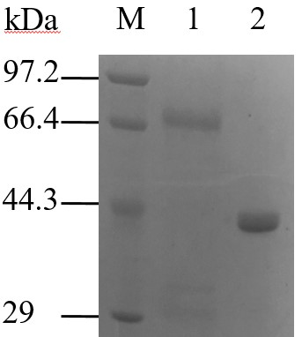
Fig. S1.
Fig. S1 SDS-PAGE analysis of Ec-ArCel5 and Pp-ArCel5. M, molecular mass marker (in kilodaltons); lanes 1, Pp-ArCel5; lanes 2, Ec-ArCel5.

Fig. S2 Adsorption isotherms of purified proteins on filter paper and Avicel. Experiments were done at 25℃ in 50 mM acetic acid-sodium acetate buffer, pH 5.0, over 1 h with 120 rpm. Substrate concentration was 10 mg/mL in a total reaction volume of 500 µL. The corresponding parameters, maximum binding capacity related to the unit mass of substrate (B_{max}) and the dissociation constant K_{d}, are summarized in Table 1.

