Supplementary Information

Design and discovery of a highly potent ultralong-acting GLP-1 and glucagon co-agonist for attenuating renal fibrosis by modulating mitochondrial function

Zhao et al.

Supplementary materials include:
Methods
Supplementary Figures 1 to 10
Supplementary Tables 1 to 11

Methods
Kidney samples of patients. All clinical kidney samples were obtained from the First Affiliated Hospitals of Sun Yat-sen University (Guangzhou, China), following the protocol conformed the ethical guidelines of the 1975 Declaration of Helsinki Principles and approved by the Ethics Committee of the Sun Yat-sen University.

Synthesis of peptides. According to the standard protocol of slid-phase peptide synthesis (SPSS), a series of dual glucagon-like peptide 1/glucagon receptor agonist (1901-1917 and 1907-B) were synthesized using 4-methylbenzhy-drylamine (MBHA) resin (GL Biochem, Shanghai, China). Reversed-phase high performance liquid chromatography mass spectrometric (RP-HPLC-MS, Agilent Technologies, USA) was used to perform the peptide purification and atomic accumulation process. The analysis results were shown in Supplementary Fig.9-10.

Circular dichroism (CD) measurements. The CD measurements of the series of dual glucagon-like peptide 1/glucagon receptor agonist were performed by the Chirascan CD spectrometer in a 2 mm pathlength cuvette at 25℃. The spectra were recorded from 190 nm to 260 nm and averaged over 3 scans with a resolution of 0.5 nm, a bandwidth of 1.0 nm and a response time of 3 s. All peptides were dissolved to 40 μM in PBS or 50% TFE. The mean residue ellipticity was plotted vs wavelength.

Generation of CRE-Luc stable cell line over-expressing GLP-1R or GCGR. HEK-293 cell line was obtained from the Type Culture Collection of the Chinese Academy of Sciences (Shanghai, China). Cell was cultured in DMEM with 10% FBS and 1% penicillin-streptomycin (Gibco, Thermo Fisher Scientific, USA) in a humidified atmosphere with 5% CO₂ at 37℃. Lentivirus encoding firefly luciferase gene under the control of cAMP responsive element (CRE) promoter was used to establish the CRE-Luc stable HEK-293 cell line. After exposed to the complete medium containing 1 μg/mL puromycin for 1 week, the surviving cells (CRE-HEK293) were amplified and then transfected with a G418 selective mammalian expression plasmid which encoded renilla luciferase gene under the control of human GLP-1R or GCGR. Single colony stable cell line over-expressing both CRE-firefly luciferase and GLP-1R- or GCGR- renilla luciferase (GLP-1R- or GCGR-CRE-HEK293) was then generated for GLP-1R or GCGR activation reporter assay in vitro.

GLP-1R or GCGR activation reporter assay In vitro. GLP-1R- or GCGR-CRE-HEK293 cells were seeded in 96-well plates at a density of 4×10⁴ cells per well and cultured for 36 hours in DMEM containing 10% FBS and 1% penicillin-streptomycin. After starving for 6 hours, GLP-1R- or GCGR-CRE-HEK293 cells were treated with peptides in a series of doses for 5 hours. The GLP-1R or GCGR activation was assessed by the radio of firefly luminescence intensities to renilla luminescence intensities, using Dual Luciferase Reporter Gene Assay Kit (Yeasen, Shanghai, China) following manufacturer’s instruction. The data were fit by GraphPad Prism 9.0 software (GraphPad, San Diego, CA). to calculate the EC₅₀ of each peptide.

Cell culture and treatment. The mTEC cells and GMC cells were kindly provided by Professor Wang from Lanzhou University. Both mTEC cells and GMC cells were cultured in low-glucose DMEM (Gibco, Thermo Fisher Scientific, USA) with 10% FBS and 1% penicillin-streptomycin. Cells were plated on 6-well plates and cultured for 24 h. After serum-free overnight, cells were exposed in high glucose or 10 ng/ml TGF-β and meanwhile treated with 20 μM peptides for 48 h. In indicated experiments, cells were administrated with PKA inhibitor, H89 (5 µM) (Beyotime Biotechnology, China).

Animal model and samples collection. Mice in all studies were healthy and immune-normal and kept in a 12 h light–dark cycle in the specific-pathogen-free (SPF) environment, permitting to access to food and water freely. All the protocols of animal research conformed to the U.S. Public Health Service Policy on Use of Laboratory Animals, and were approved by the Ethics Committee on Use and Care of Animals of Sun Yat-sen University.

For DN model, eight-week-old male Lepr db/db (db/db) and Lepr db/m (db/m) mice in a C57BLKS/J background were purchased from the GemPharmatechTM. To assess the pharmacological effects of 1907-B, DN mice were administrated with semaglutide (120 μg/kg/d), glucagon (120 μg/kg/d) or 1907-B (60, 120 and 240 μg/kg/d or 120 μg/kg/2d) for 8 weeks (n = 6 for per group; subcutaneous injection). The fasting blood glucose and body weight of DN mice were recorded every two days.

For unilateral ureteral obstruction (UUO) model, eight-week-old male C57BL/6J mice were obtained to establish UUO model following a standard protocol. After administrated with 5% chloral hydrate, mice were incised dorsally to expose the left ureter near the renal pelvis. Then the complete unilateral ureteral obstruction was performed in the left ureter by double-ligating using 6-0 nylon. The ureters of mice in the sham operated group were exposed, but not ligated. To evaluate the effects of 1907-B, UUO mice were administrated with semaglutide (120 μg/kg/d), glucagon (120 μg/kg/d) or 1907-B (60, 120 and 240 μg/kg/d or 120 μg/kg/2d) for 14 days (n = 6 for per group; intraperitoneal injection). Kidneys were harvested 14 days after UUO surgery.

Prior to the sacrifice at the study terminal, all mice were fasted overnight and anesthetized by 5% chloral hydrate. Blood samples were collected from the posterior venous plexus of the eyes, and were separated to obtain serum by centrifugation at 1000 g for 15 min. The serum was stored at -80°C for further biochemical assays. Kidney tissue, liver tissue and epididymal adipose tissue were collected and frozen in liquid nitrogen immediately, and then stored at -80°C or fixed in 10% paraformaldehyde for histological assessment.

The pharmacokinetic parameters of semaglutide and 1907-B in rats. Twenty-four SD rats (12 male and 12 female) were randomly divided into four groups: SC-semaglutide, SC-1907-B, IV-semaglutide and IV-1907-B. SC-semaglutide and SC-1907-B were treated with 0.05 mg/kg semaglutide and 1907-B by subcutaneous injection, respectively. Blood samples were collected at 0 min (before peptides administration) and 10 min, 20 min, 30 min, 1 h, 2 h, 4 h, 6 h, 8 h, 24 h, 36 h, 48 h, 72 h, 4 d, 5 d, 6 d and 7 d after peptides administration. IV-semaglutide and IV-1907-B were given 0.05 mg/kg semaglutide and 1907-B via tail vein, respectively. Blood samples were collected at 0 min (before peptides administration) and 10 min, 20 min, 30 min, 1 h, 2 h, 4 h, 6 h, 8 h, 24 h, 36 h, 48 h, 72 h, 4 d, 5 d, 6 d and 7 d after peptides administration. The concentrations of semaglutide and 1907-B in plasma were determined by the developed LC-MS/MS method. The pharmacokinetic parameters were calculated by non-compartment model using WinNonlin 6.4.

The pharmacokinetic parameters of semaglutide and 1907-B in cynomolgus monkeys. The pharmacokinetic study was performed in Covance (Shanghai, China). Cynomolgus monkeys of either sex (n=2) were given a iv. dose of 25 μg/kg and sc. dose of 25 μg/kg. Serial blood samples were collected for determination of plasma 1907-B concentrations using a validated HPLC-MS/MS method. Pharmacokinetic analysis was carried out using non-compartmental procedures with Phoenix WinNonlin (version 8.1).

Toxicology studies. Male or female SD rats (7 to 8 weeks of age, n = 10 per group) were administered vehicle alone or 1907-B at 0.25, 0.75 and 1.50 mg/kg for 30 days by subcutaneous injection every two days. External signs, behavioral activities, urine and feces shapes, abnormal secretions from mouth, nose and eyes, pupils and respiration were observed, and the body weight was measured once a week. The weight of the heart, liver, spleen, lung, kidney, adrenal gland, thymus, brain, epididymis, testis, ovary and uterus were respectively measured to calculate the organ index. After the animals were anesthetized, blood was taken from the peritoneal vein and the whole blood was taken to assay the hematology as follow: the total number of red blood cells, hemoglobin concentration, red blood cells deposited, average red blood cell volume, average haemoglobin content, total average concentration of hemoglobin, platelet, reticulocyte percentage and reticulocyte percentage number of red blood cells, white blood cell count, neutrophils, lymphocytes percentage, monocyte percentage, percentage of eosinophils, basophils, percentage. After the animals were anesthetized, blood was taken from the peritoneal vein and separated after placing in stasis, and the serum was taken to measure the blood biochemical indexes: glutamic-oxalacetic transaminase, glutamic-pyruvic transaminase, alkaline phosphatase, creatine phosphokinase, urea nitrogen, creatinine, total protein, albumin, blood sugar, total bilirubin, total cholesterol, triglyceride, γ-glutamyl transferase, potassium ion concentration, chloride ion concentration, sodium ion concentration. The blood methemoglobin content shall be measured according to the kit instructions. For histological assay, the heart, liver, spleen, lung, kidney, adrenal gland, thymus, brain, epididymis, testis, ovary, uterus, stomach, rectum, colon and ileum were fixed in 10% paraformaldehyde and Hematoxylin and Eosin (H&E) was performed.

AAV9-RNAi mediated GLP-1R and GCGR knockdown. The custom-made adeno-associated virus (AAV) serotype 9 carrying shRNA for mouse GLP-1R (AAV9-GLP-1R-shRNA), shRNA for mouse GCGR (AAV9-GCGR-shRNA), and mouse nonsense control shRNA (AAV9-Control-shRNA) were purchased from Genechem (Shanghai, China). The adeno-associated virus was injected into mice (10¹¹ v.g., via tail vein) to knock down GLP-1R and GCGR, respectively. Target sequences are listed in Supplementary Table 9.

Four weeks after administration with AAV9-RNAi to knock down GLP-1R or GCGR, GLP-1R^{-/-} or GCGR^{-/-} db/db mice were treated with semaglutide (120 μg/kg/d), glucagon (120 μg/kg/d) and 1907-B (120 μg/kg/2d) for 8 weeks to evaluate the pharmacological effects of 1907-B (n = 6 for per group; subcutaneous injection). Fasting blood glucose and body weight were measured every two days.

Three weeks after administration with AAV9-RNAi to knock down GLP-1R or GCGR, GLP-1R^{-/-} or GCGR^{-/-} C57BL/6J mice were used to establish UUO model, as above described. To assess the pharmacological effects of 1907-B, GLP-1R^{-/-} or GCGR^{-/-} UUO mice were treated with semaglutide (120 μg/kg/d), glucagon (120 μg/kg/d) and 1907-B (120μg/kg/2d) for 14 days (n = 6 for per group; daily intraperitoneal injection). Kidneys were harvested 14 days after UUO surgery.

Fasting blood glucose measure, OGTT and ITT. Fasting blood glucose was evaluated utilizing blood from tail nicks by OneTouch UltraVue Blood Glucose Metet and test strips (Johnson & Johnson, USA). After administrated with semaglutide, glucagon, 1907, 1917 or 1907-B, all mice were fasted for 6 hours and were performed fasting blood glucose assays.

For OGTT, KM or db/db mice were treated with 1901-1917 or 1907-B for indicated time. After fasting overnight, glucose solution (0.5 g/ml, Tianjin Zhiyuan Reagent Co., Ltd, China) were oral injected to mice (2 g/kg of body weight). Blood glucose level was recorded at baseline, 15, 30, 60, 90 and 120 min.

One week after OGTT assay, ITT in db/db mice was performed. After fasting for 6h, db/db mice were injected intraperitoneally with 0.25 U·kg⁻¹ insulin (Novolin R, Denmark). Blood glucose level was assessed at 15, 30, 60 and 90 min.

Biochemical assays. The levels of serum creatinine, blood urea nitrogen, 24 h-albuminuria, urine glucose, serum ALT, serum AST, serum TC and serum TG were determined using the corresponding assay kits (Nanjing Jiancheng Bioengineering Institute, China). The levels of insulin in db/db mice serum were examined utilizing relative ELISA kits (Cloud-Clone Corp, China) referring to the protocols. The HbA1c levels in serum of db/db mice were measured using A1CNow®+ following the manufacture’s instruction (Sinocare, China). The levels of GSH, the activities of CAT and SOD in kidneys of db/db mice were assessed according to the standard protocols provided by manufacture (Nanjing Jiancheng Bioengineering Institute, China).

Surface plasmon resonance assay. SPR assays were used to assessed the peptides 1907 and 1907-B binding affinities of human serum albumin (HSA) via Biacore 8K, a high-sensitivity SPR system (Cytiva, United Kingdom). Following the standard amine coupling protocol, HSA was overlaid on the sensor. 1907 or 1907-B was dissolved respectively to a series of concentrations in running buffer (PBS, pH = 7.4, Sigma-Aldrich Ltd., Merck, Germany). Samples were permitted to flow through the chip surface at the flow rate of 25 μL/min. After each injection cycle, the surface was injected 25 μL of 10 mM NaOH (Sigma-Aldrich Ltd., Merck, Germany) twice to regeneration. The data were fit by Biacore 8K analysis software (Cytiva) to calculate the binding constants of 1907 or 1907-B.

Isothermal titration calorimetry. ITC assays were performed on a Microcal VP-ITC (Malvern Instruments Ltd) in PBS (pH = 7.4) at 37℃. In all experiments, 1907, 1907-B or GGSGSG was in the syringe and human serum albumin was in the sample cell. The data was analyzed using Origin 7.0 software. Heats of dilution were assessed using the final injections of each individual titration and subtracted before data analysis.

Mitochondrial oxygen consumption. The evaluation of mitochondrial oxygen consumption was performed using the Seahorse Xfe96 Analyzer (Agilent). The mTEC cells or GMC cells were plated at a density of 5000 cells per well and were administrated as mentioned above. Prior to being placed in the Seahorse Xfe96 Analyzer, the plate was placed in a CO₂-free incubator for 30 min. 1 µM oligomycin (Agilent), 0.5 µM FCCP (Agilent) and 5 µM antimycin A (Agilent) were used in the mitochondrial stress test according to the standard protocols. The OCRs were normalized to the protein mass.

Histological examination. Formalin-fixed kidney tissues embedded in paraffin were sectioned into 5 μm slices. After deparaffinization and rehydration, the Hematoxylin and Eosin (H&E), Sirius Red staining and Masson staining for collagen and Periodic Acid-Schiff for glycogen accumulation were performed in section slices, referring to the standard protocols, respectively.

Immunohistochemistry staining. For immunofluorescent staining, after deparaffinization and rehydration, antigen retrieval was carried out by heating section slices in 10 mM sodium citrate buffer (pH 6.0) for 15 min. The section slices were then incubated with 3% hydrogen peroxide for 10 min to eliminate the endogenous peroxidase activity. Next, section slices were blocked with 1% BSA solution for 1 h at room temperature, and then were incubated with primary antibodies at 4℃ overnight following secondary antibodies for 1 h. After administrated with DAB, hematoxylin staining was performed in the section slices. The antibodies used for immunohistochemistry staining are described in Supplementary Table 10.

Immunofluorescent staining. For immunofluorescent staining, after deparaffinization and rehydration, antigen retrieval was carried out by heating section slices in 10 mM sodium citrate buffer (pH 6.0) for 15 min. Next, section slices were blocked with 1% BSA solution for 1 h at room temperature, and then were incubated with primary antibodies at 4℃ overnight following secondary antibodies for 1 h. Nucleus were counterstained with DAPI. The staining was viewed and photographed under the confocal microscopy. The antibodies used for immunofluorescent staining are described in Supplementary Table 10.

Protein isolation and western blotting. Total protein extracts from mTEC cells, GMC cells or kidney tissues using RIPA (Beyotime Biotechnology, China). The concentration of protein was assessed by the BCA Kit (Pierce, ThermoFisher Scientific, USA). Thirty micrograms protein were separated by 10% or 12% sodium dodecyl sulfate-polyacrylamide gel electrophoresis depending on the band of target protein. Next, the proteins in gel were transferred onto equilibrated polyvinylidene difluoride membrane (PVDF, Immobilon®-PSQ transfer membranes, Merck Millipore, Germany). Membranes were blocked by 5% skim milk and then interacted overnight with primary antibodies at 4℃, following HRP-labeled secondary antibody at room temperature for 1 h. The blots were detected by enhanced chemiluminescence (GlarityTM Western ECL Substrate, Bio-Rad, USA) and the signals were recorded and quantified via Tanon-Image Software (Shanghai, China). Data normalization was performed using reference antibody GAPDH. The antibodies used for western botting are described in Supplementary Table 10.

RNA isolation and quantitative real-time polymerase chain reaction. Total RNA was isolated and purified using TRIZOL Reagent (Invitrogen, Massachusetts, USA) from kidney tissues, following the manufacturer’s instructions. The concentration of RNA was assessed by Nanodrop 2000 (ThermoFisher Scientific, USA). First Strand cDNA synthesis Super Mix (TransGen Biotech, China) was used to reverse transcribe 4 μg of total RNA into cDNA. Quantitative real-time PCR (qRT-PCR) was performed in the Light Cycler 480 Real-Time PCR System (Roche, Swiss) using SYBR Green qPCR Super Mix (TransGen Biotech, China). The Cp values were calculated and the data was normalized to the housekeeping expression (β-actin). Primers sequences are described in Supplementary Table 11.

RNA sequencing. The isolation and prurition of total RNA from kidney tissues were perform as mentioned above. RNA libraries were sequenced on the Illumina sequencing platform by LC-BIO Co., Ltd (HangZhou, China).

Gene Set Enrichment Analysis. Gene Set Enrichment Analysis (GSEA) was performed using the OmicShare tools, a free online platform for data analysis (http://www.omicshare.com/tools). For each KEGG biological pathway, involved genes were defined as a gene set, and then a ranked list and a ‘gene set’ permutation type of the gene set were constructed. Gene sets with |NES|>1，NOM p-values <0.05 and FDR q-values < 0.25 were considered statistically significant.

Quantification and Statistical Analysis. The positive area of stained slices was quantified by ImageJ (https://imagej.nih.gov/ij/). All data in this study were shown as the mean ± SD (Standard Deviation). GraphPad Prism 9.0 software (https://www.graphpad.com/) was used to determine the statistical significance. The differences were compared using Student’s t-test and significance was considered when p < 0.05.

Supplementary Figures

Supplementary Fig.1 | Peptide design and in vitro screening for GLP-1R/GCGR analogues. a, Sequence information of GLP-1, Glucagon, Liraglutide, Semaglutide and GLP-1R/GCGR dual-agonist analogues and the chemical structures of their linkers and protractors. b, Circular dichroism of GLP-1, Glucagon, Liraglutide, Semaglutide and GLP-1R/GCGR dual-agonist analogues. c, The expression level of key protein α-SMA in mTEC cells of the indicated groups. d, The expression level of key protein FN in GMC cells of the indicated groups.

Supplementary Fig.2 | OGTT screening for GLP-1R/GCGR analogues in KM mice. a-b, Oral glucose tolerance test (OGTT) was performed at 8 h and 12 h after peptides administration, respectively. The corresponding area under curves (AUC) of blood glucose levels were calculated. c, Oral glucose tolerance test (OGTT) was performed at the 24 h after Liraglutide, Semaglutide, 1907 or 19017 administrations, respectively. The corresponding area under curves (AUC) of blood glucose levels were calculated.

Supplementary Fig.3 | Concentration optimization of 1907 and 1917 in db/db model. a, The fasting blood glucose and change in body weight of db/db mice during 12 days administration with 80 μg/kg or 120 μg/kg/2d Semaglutide. b-c, The fasting blood glucose and change in body weight of db/db mice during 12 days administration with Semaglutide, 1907 or 1917 at the dose of 80, 100 and 120 μg/kg. d, The average food-intake and water inflow of db/db mice treated with Semaglutide, 1907 or 1917.

Supplementary Fig.4 | In vivo evaluation of 1907 and 1917 in db/db model. a, Representative macrograph of db/db mice of the indicated groups and their epididymal fat and liver, and images of H&E staining of liver. b, The change in body weight of db/db mice of the indicated groups in the administration and their BMI at the study termination. c, The average food-intake and water inflow of db/db mice of the indicated groups. d, The liver weight, liver index and the weight of epididymis fat of db/db mice of the indicated groups. e, The serum ALT, AST, TC and TG of db/db mice of the indicated groups.

Supplementary Fig.5 | In vivo evaluation of 1907 and 1917 for renal function and islets in db/db model. a, Representative macrograph of kidneys from db/db mice administrated with Semaglutide, 1907 or 1917. b, Representative images of immunohistochemistry staining of α-SMA and TGF-β1 on kidneys from db/db mice at indicated groups and statistical positive area, respectively. c, Representative images of H&E staining and insulin immunofluorescence staining on islets, respectively. d, The plasma insulin of db/db mice of the indicated groups.

Supplementary Fig.6 | Pharmacological effects of 1907-B on db/db mice and construct of adeno-associated viral vector serotype 9-GLP-1R or GCGR-small hairpin RNA (AAV9-GLP-1R or GCGR-shRNA) knock-down mice on db/db mice and UUO mice. a, The body weight of db/db mice of the indicated groups. b, The fasting blood glucose and glycated hemoglobin of db/db mice of the indicated groups. c, GSEA of pathways related to fibrosis, inflammation and mitochondrial function in db/db mice treated with Semaglutide or Glucagon. d, The mRNA levels of GLP-1R and GCGR expression in kidneys from mice treated with AAV9-CON, AAV9-GLP1R-RNAi or AAV9-GCGR-RNAi. e, Experimental design of the pharmacological effects of 1907-B on GLP-1R^{-/-} or GCGR^{-/-} db/db mice. f, Experimental design of the pharmacological effects of 1907-B on UUO mice. g, Experimental design of the pharmacological effects of 1907-B on GLP-1R^{-/-} or GCGR^{-/-} UUO mice. h, GSEA of pathways related to fibrosis, inflammation and mitochondrial function in UUO mice treated with 1907-B.

Supplementary Fig.7 | The effects of drugs on islets in db/db mice. a-b, Insulin and Glucagon immunofluorescence staining of kidneys from db/db mice of the indicated groups.

Supplementary Fig.8 | Toxicity study of 1907-B in SD rats. a, Representative images of H&E staining on myocardium, liver, spleen, lung, kidney and stomach from SD rats treated with 1907-B, respectively. b, Representative images of H&E staining on duodenum, uterus, ovary, testis and epididymis from SD rats treated with 1907-B, respectively.

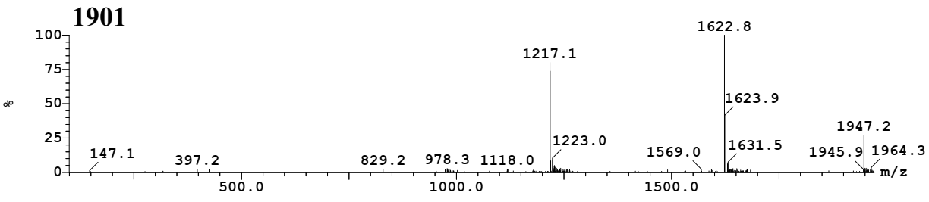

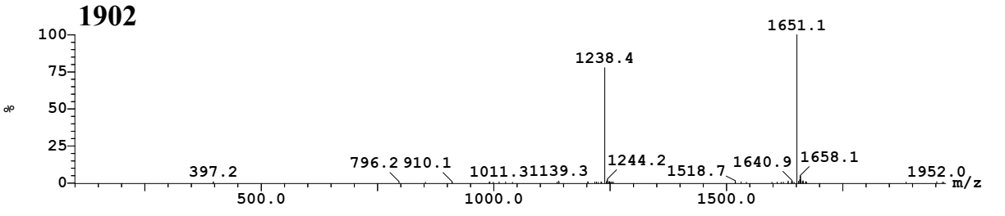

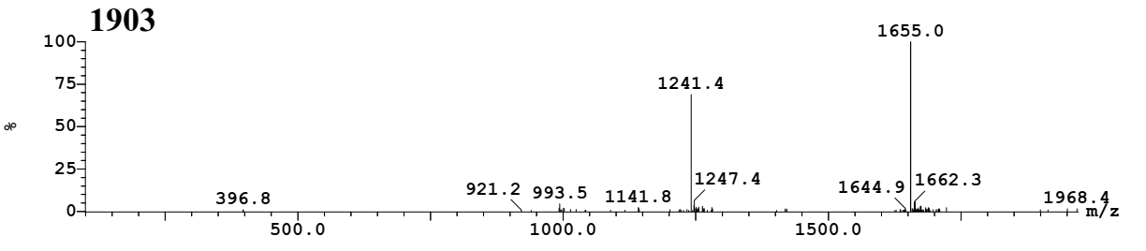

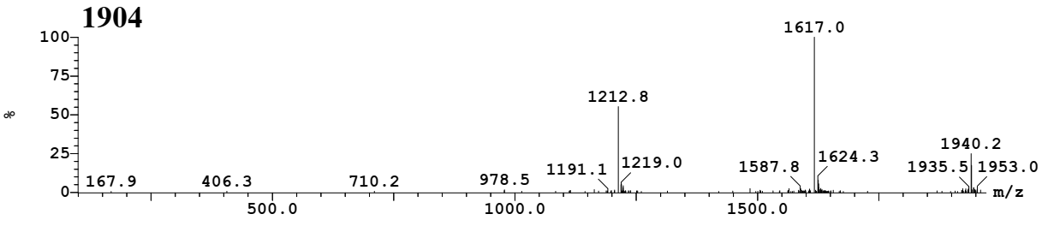

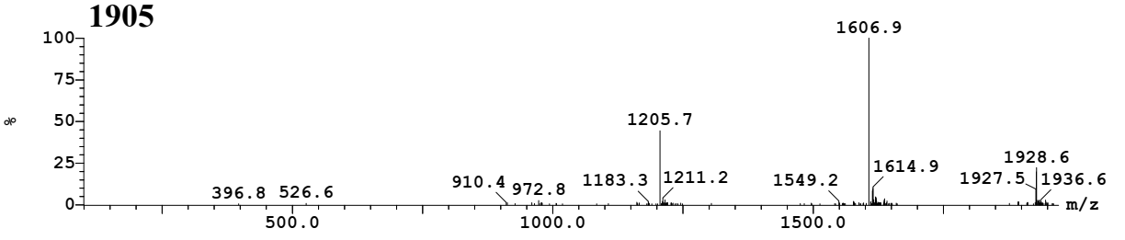

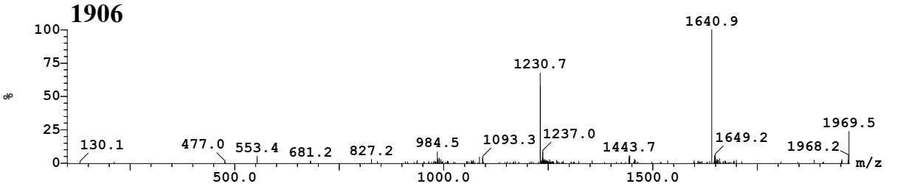

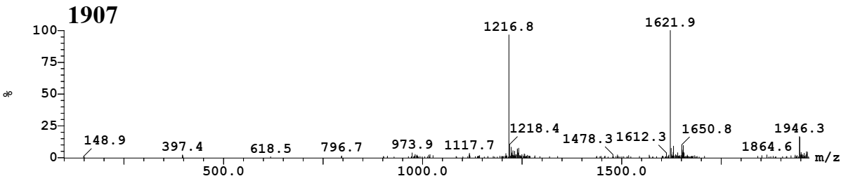
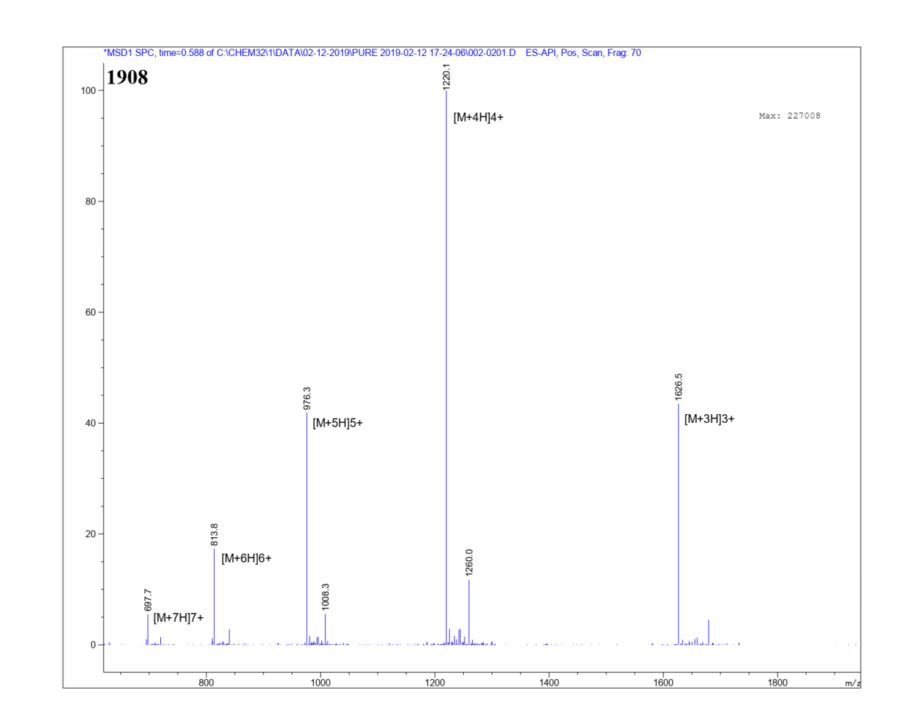
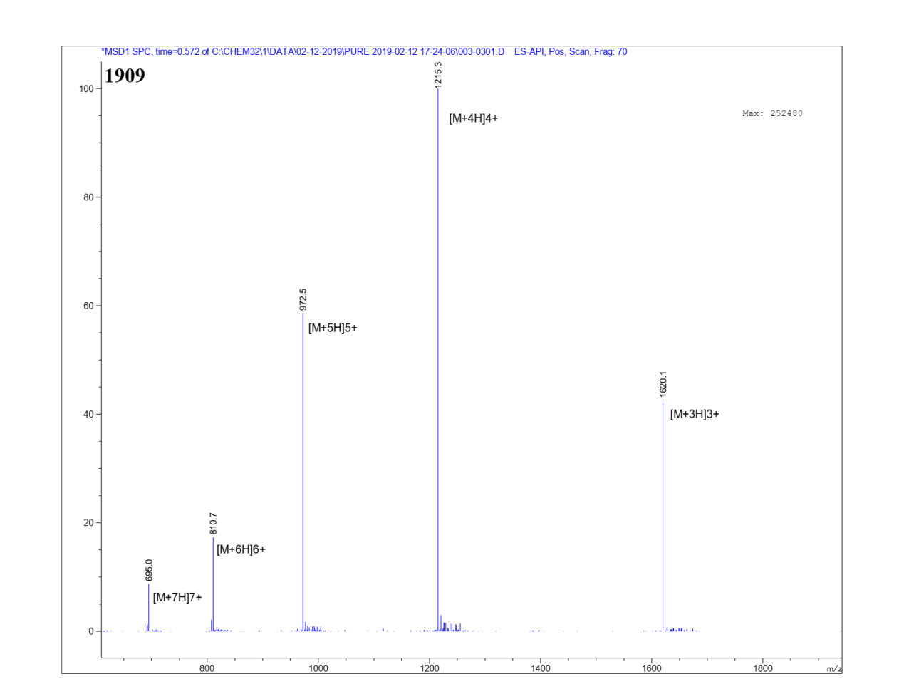
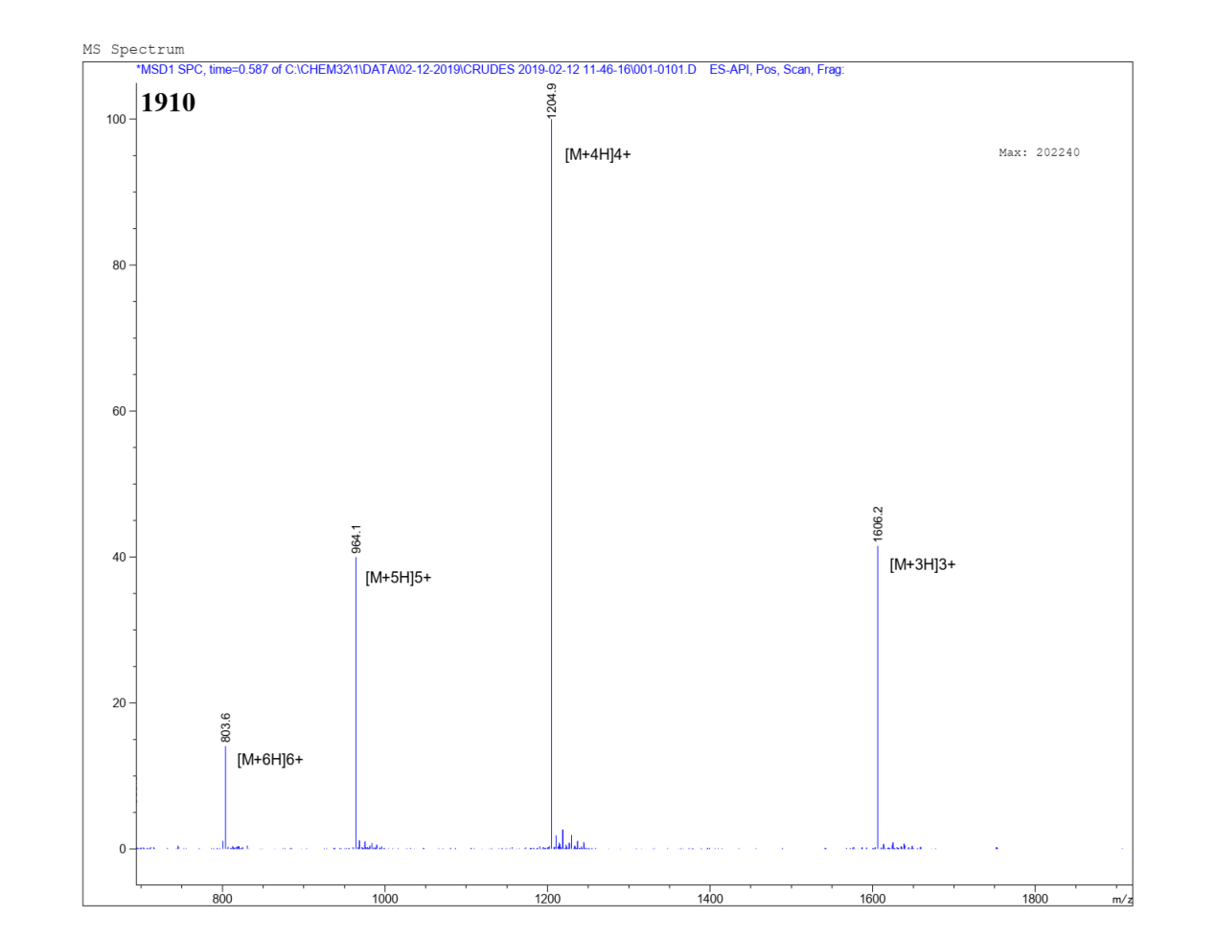
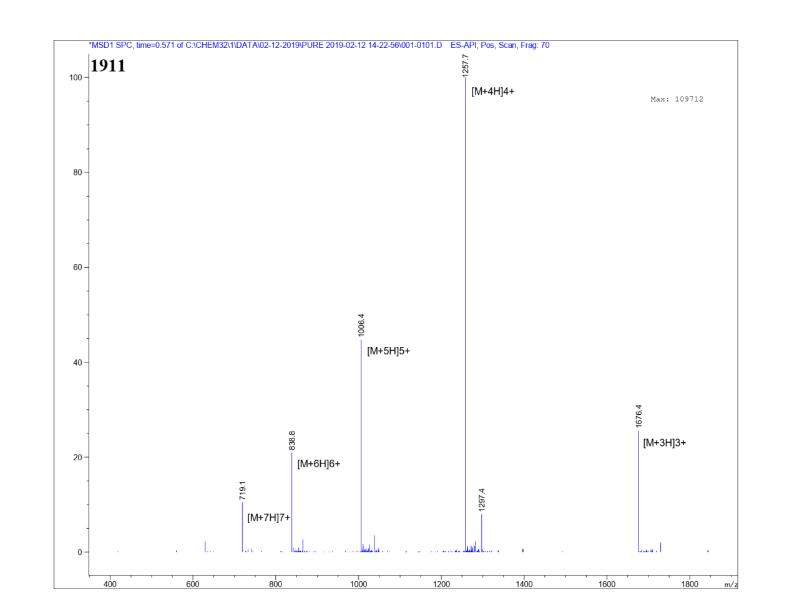
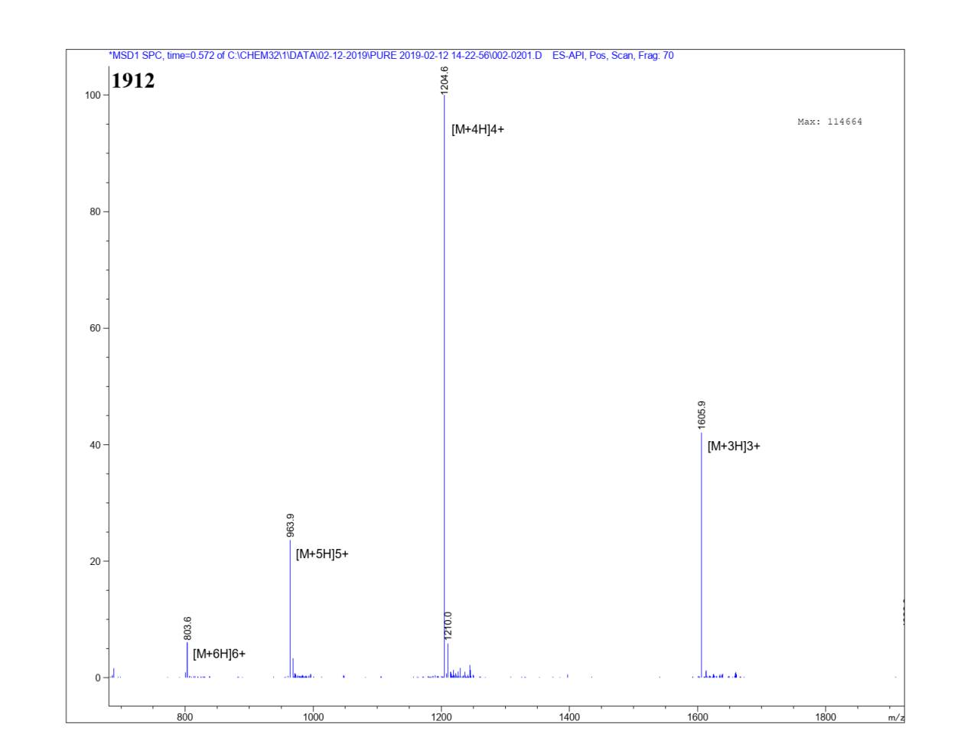
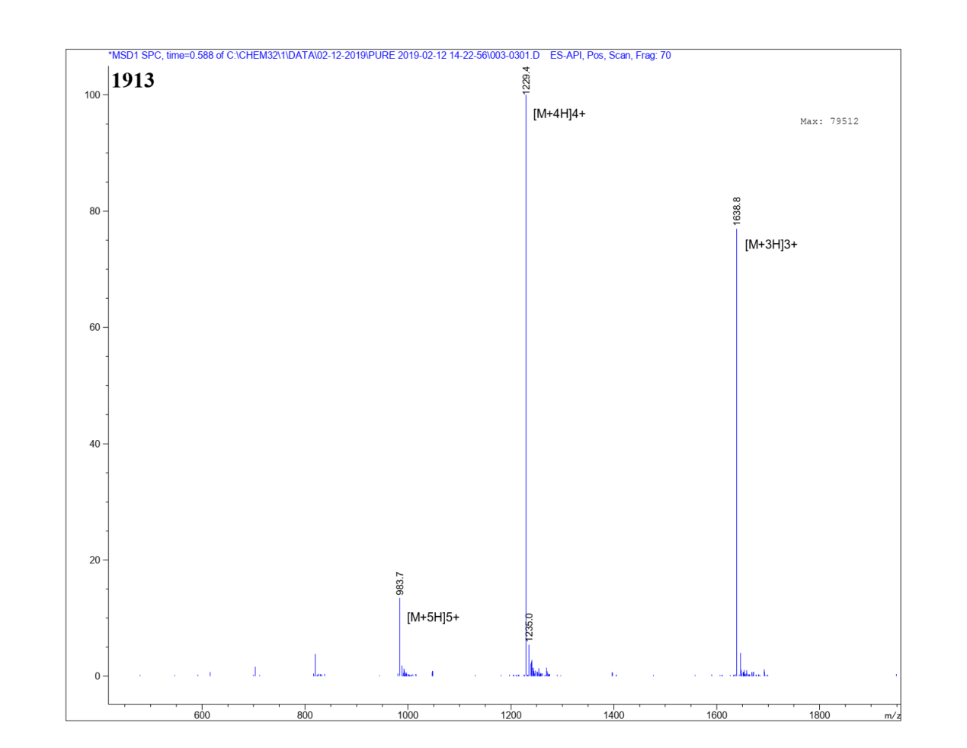
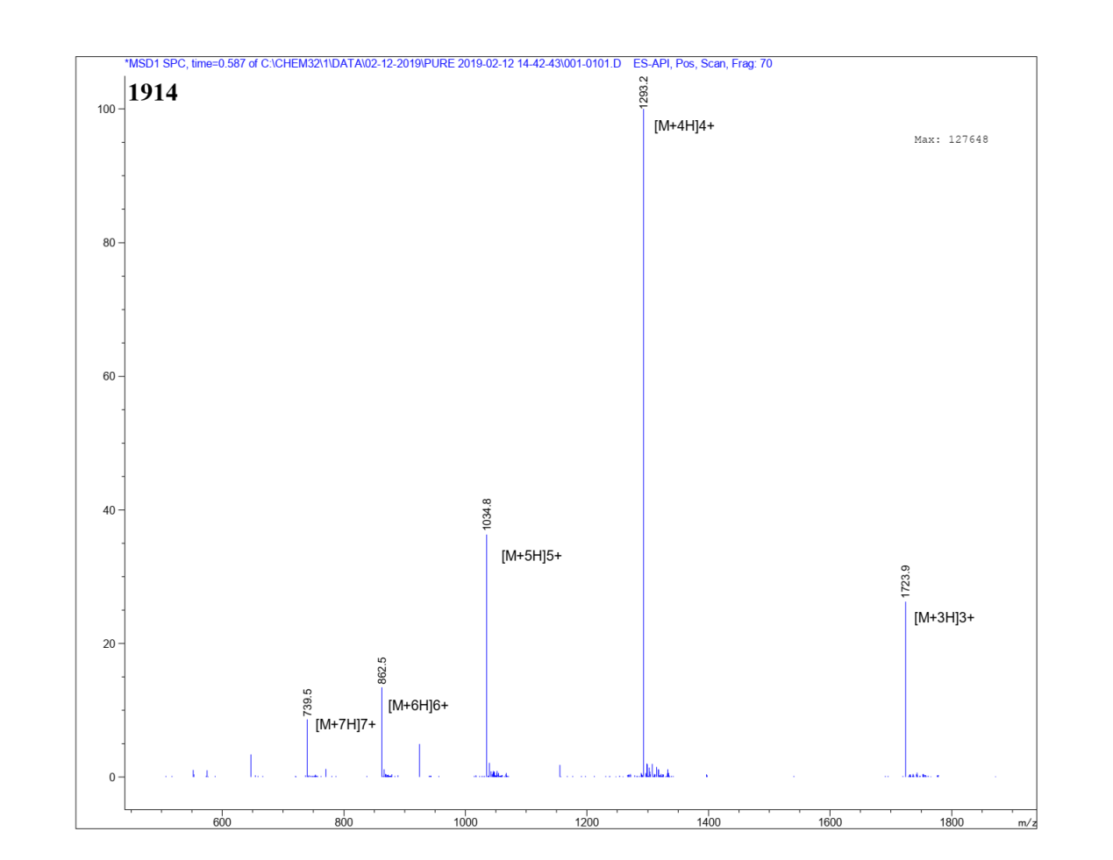
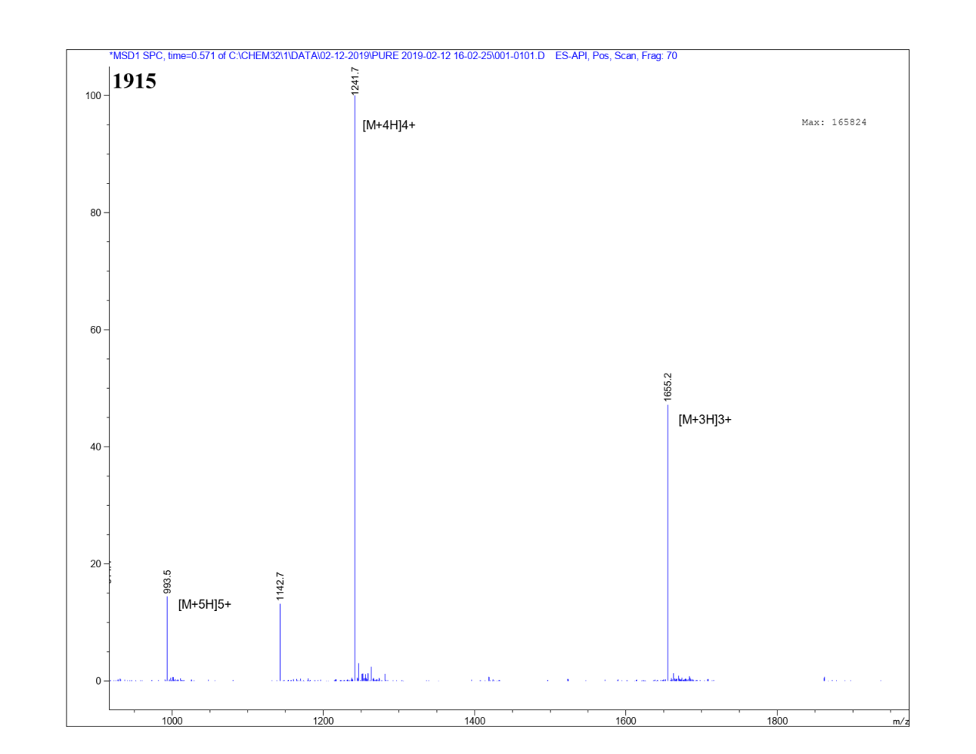
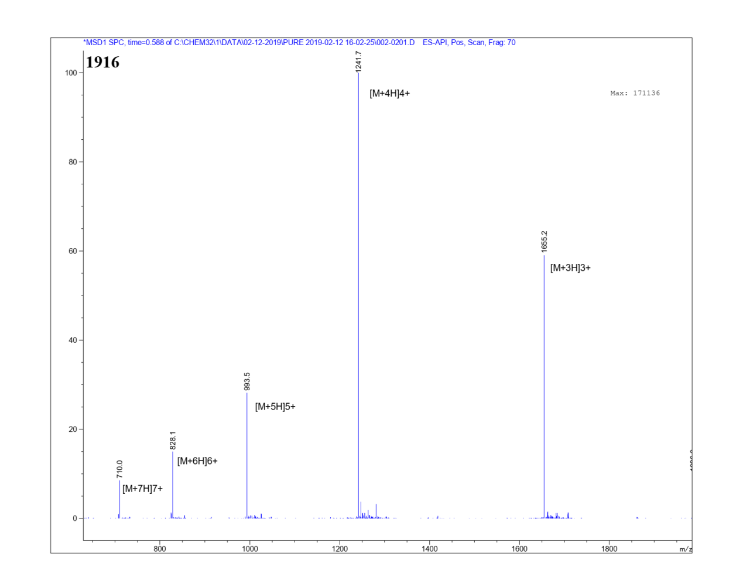
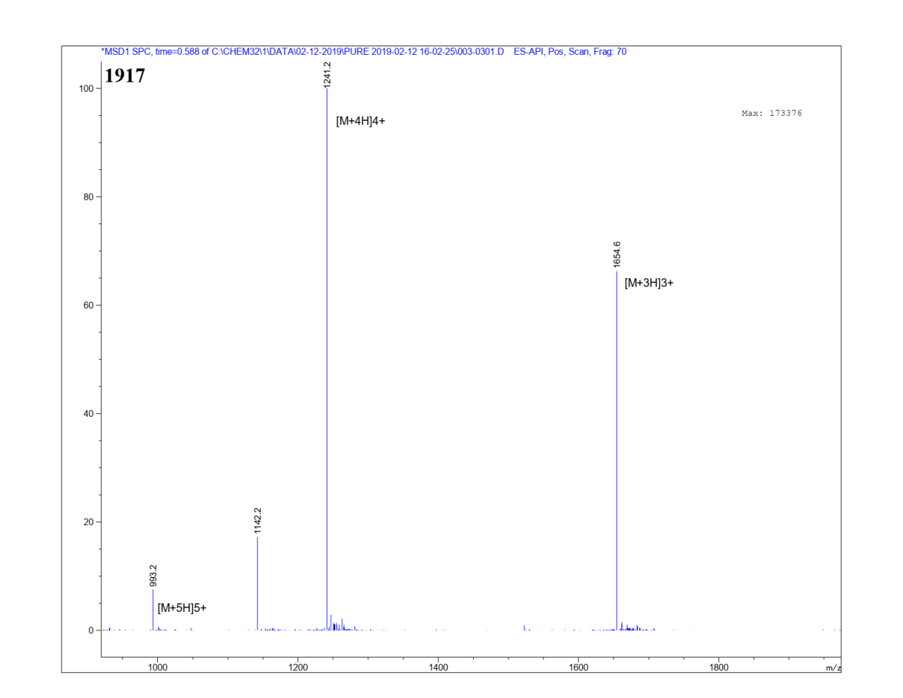
Supplementary Fig.9 | Confirmation of atomic accumulation of candidate peptides with electrospray ionization-mass spectrometry.
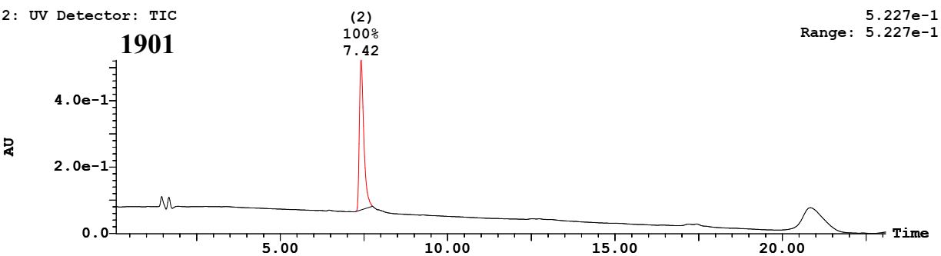
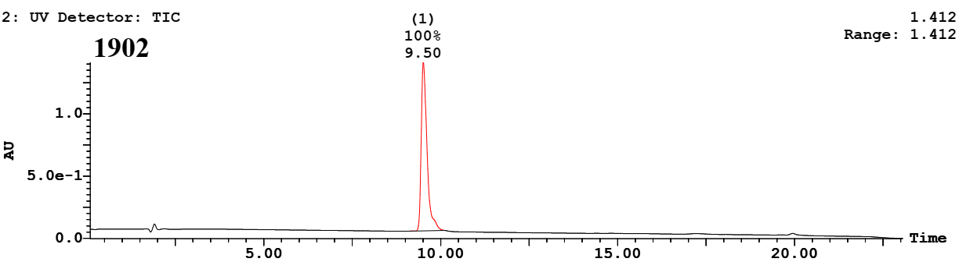
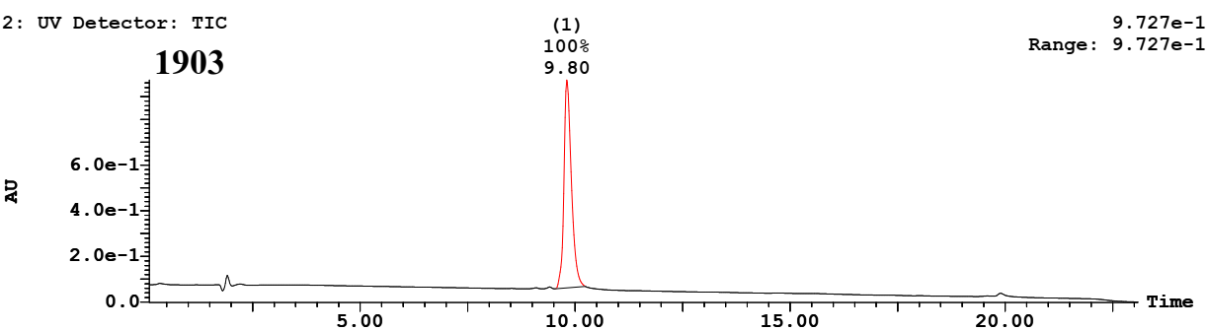
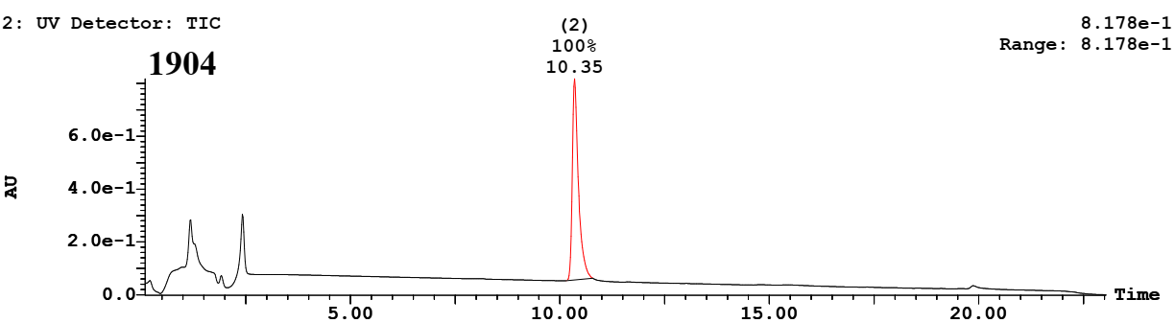
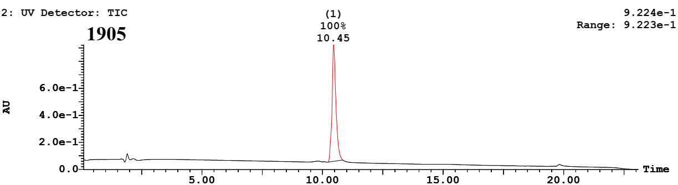
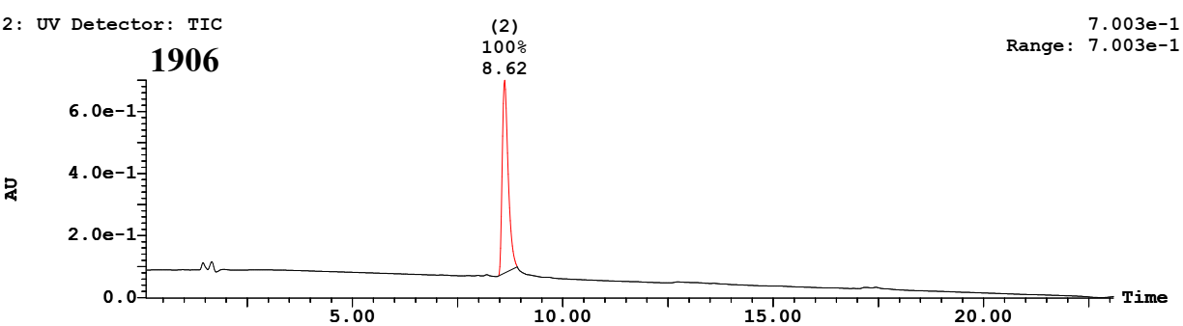
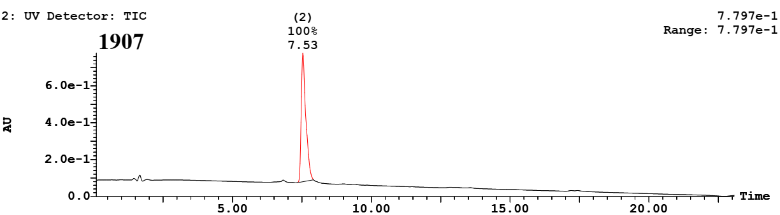
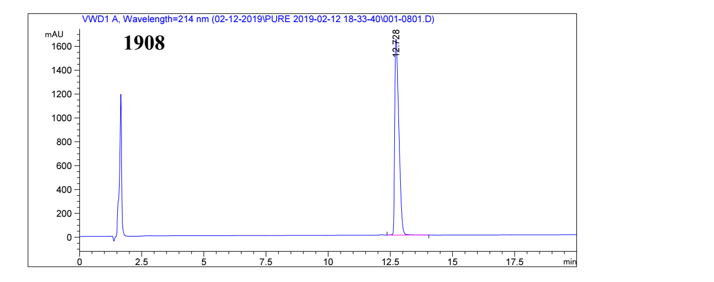
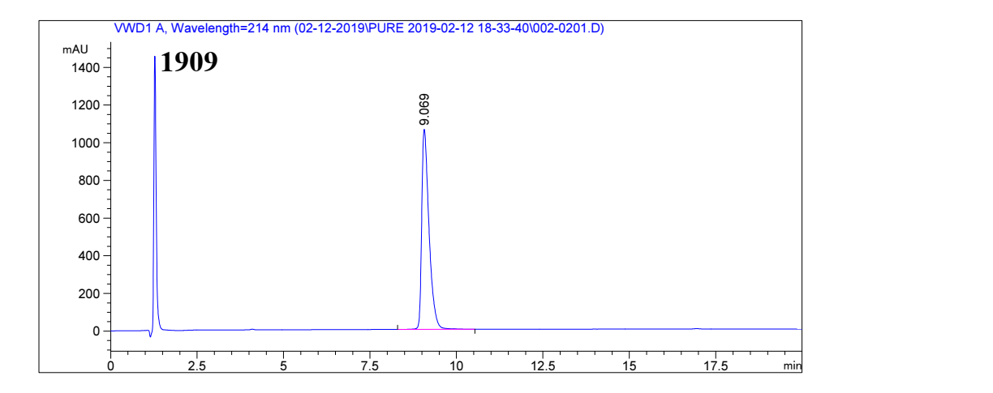
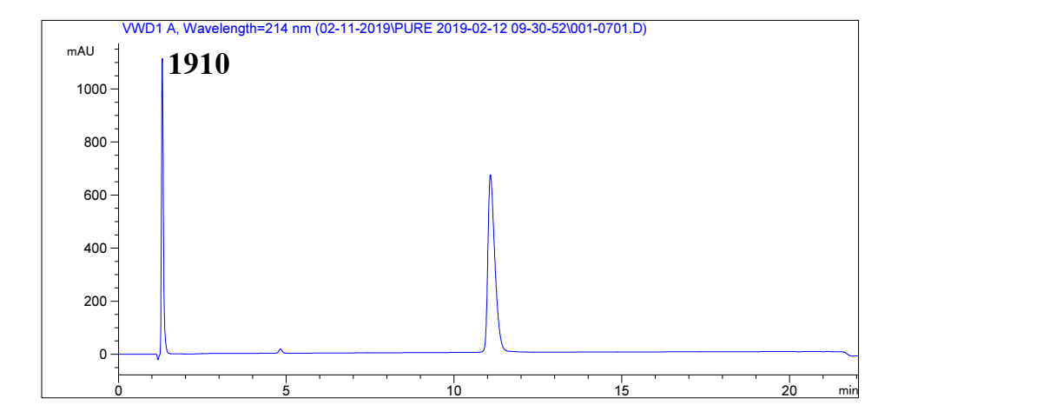
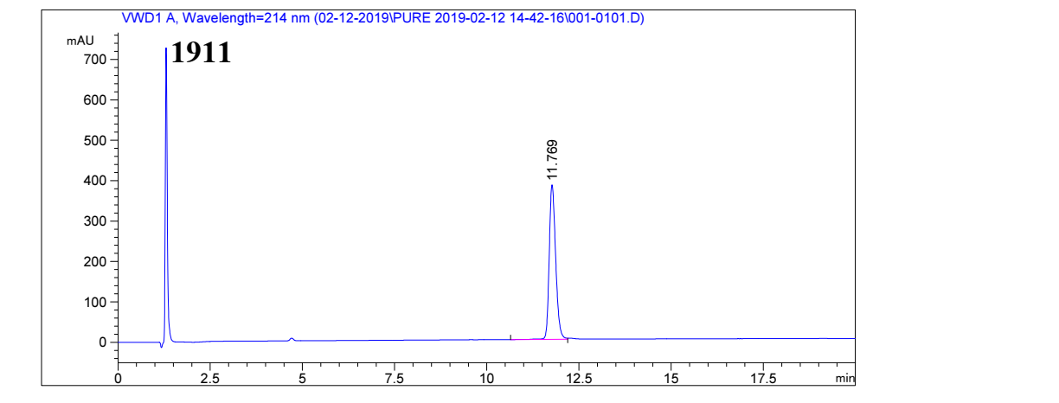
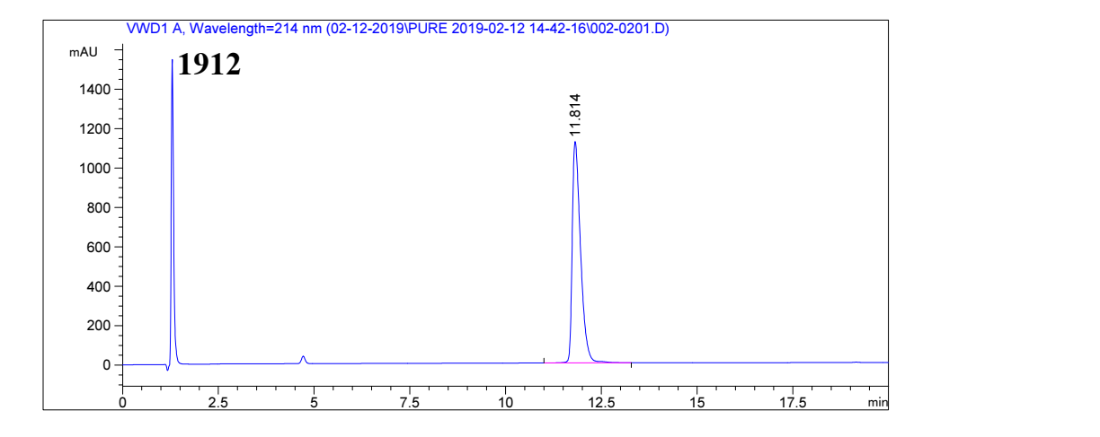
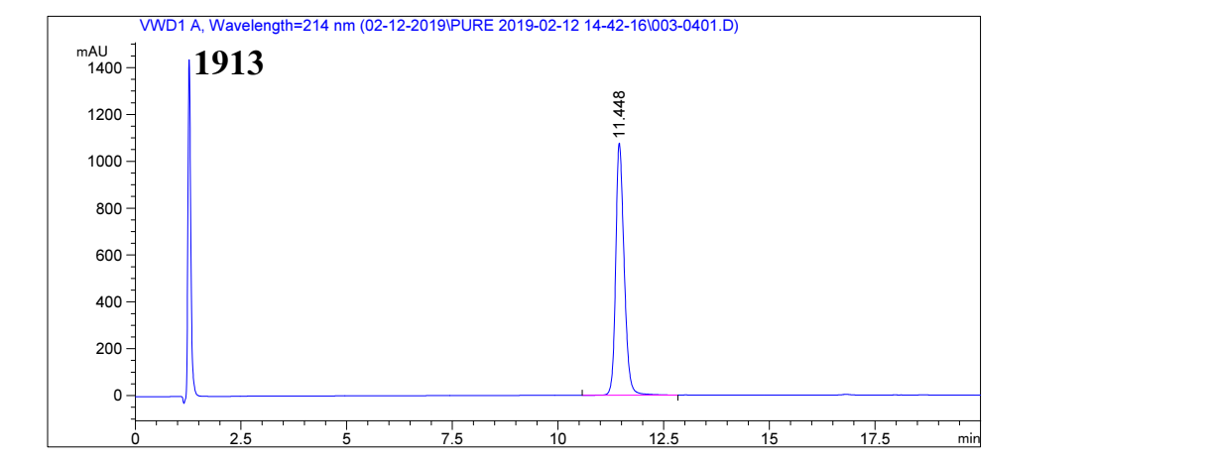
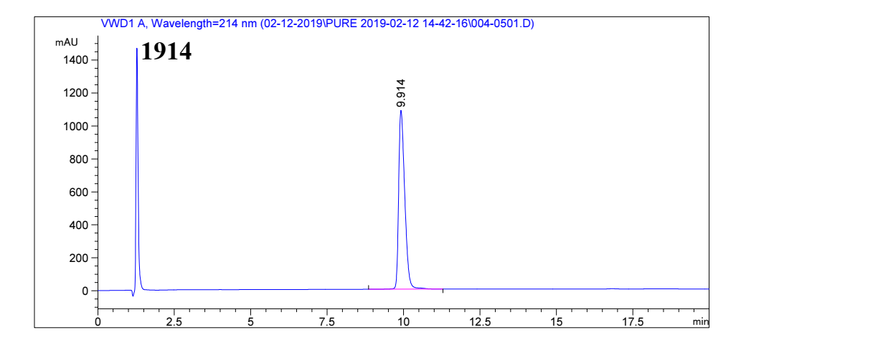
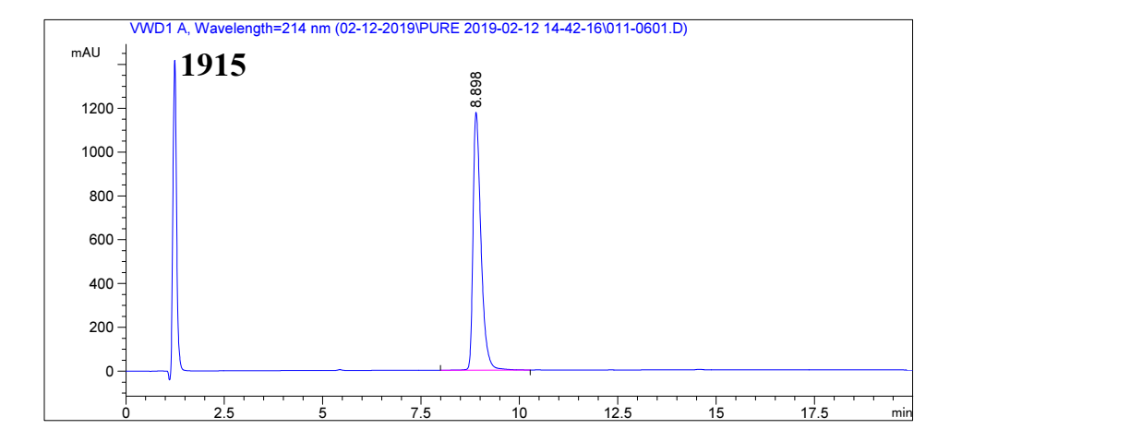
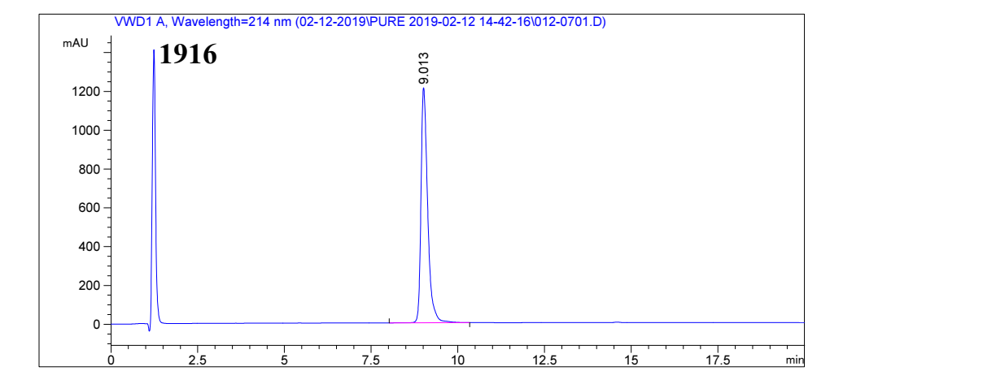
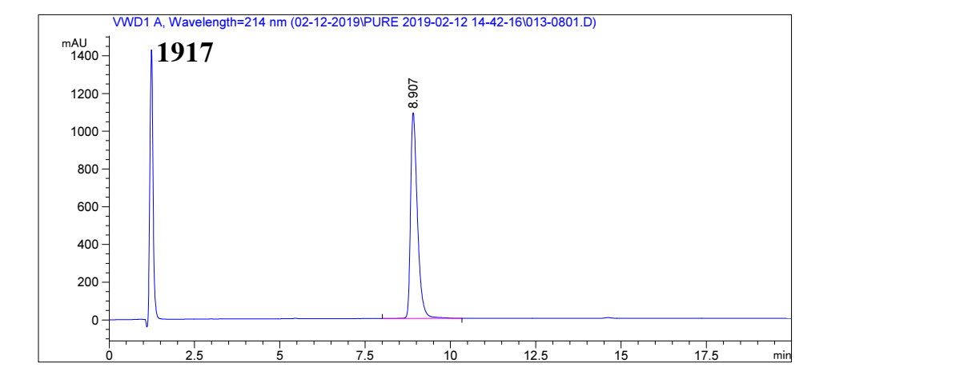
Supplementary Fig.10 | Purification of candidate peptides with reverse phase high performance liquid chromatography mass spectrometric (RP-HPLC-MS).

Supplementary Tables
Supplementary Table 1. Calculated % Helicity in PBS or 50% TFE.
 | PBS (190-260nm) | 50% TFE(190-260nm)
Glucagon | 24.1 | 36.1
Semaglutide | 23.7 | 30.3
Liraglutide | 30.9 | 30.9
1901 | 30.1 | 23.7
1902 | 26.2 | 23.7
1903 | 35.6 | 40.9
1904 | 26.3 | 37
1905 | 22.6 | 25.7
1906 | 25.4 | 34.3
1907 | 29.3 | 35.7
1908 | 29.4 | 43.6
1909 | 31.7 | 48.1
1910 | 31.5 | 40
1911 | 26.8 | 28.7
1912 | 26 | 37
1913 | 30.9 | 45
1914 | 22.1 | 26.6
1915 | 28.3 | 37.1
1916 | 28.8 | 38.6
1917 | 25.4 | 38.6
Supplementary Table 2. Glucagon and GLP-1 receptor-mediated cAMP synthesis by chimeric peptide analogs.
Peptide | GCGR | GLP-1R | GCGR | GLP-1R | Selectivity ratio
Peptide | EC50 (nM) | EC50 (nM) | Relative % | Relative % | GCGR : GLP-1R
Glucagon | 111.45 | >1000 | 100.00 | <0.1 | >1000
Semaglutide | >1000 | 0.764 | <0.01 | 5.23 | <0.001
Liraglutide | >1000 | 0.040 | <0.01 | 100.00 | <0.001
1901 | >1000 | 0.037 | <0.01 | 108.87 | <0.001
1902 | >1000 | 0.134 | <0.01 | 29.77 | <0.001
1903 | 742.99 | 0.031 | 15.00 | 128.42 | 0.12
1904 | 974.66 | 0.022 | 11.43 | 179.82 | 0.06
1905 | >1000 | 0.008 | <0.01 | 481.52 | <0.001
1906 | 971.53 | 0.028 | 11.47 | 143.20 | 0.08
1907 | 569.33 | 0.002 | 19.57 | 2053.39 | 0.01
1908 | >1000 | 0.004 | <0.01 | 890.67 | <0.001
1909 | >1000 | 0.838 | <0.01 | 4.77 | <0.001
1910 | >1000 | 0.041 | <0.01 | 97.04 | <0.001
1911 | >1000 | 0.092 | <0.01 | 43.60 | <0.001
1912 | >1000 | 0.453 | <0.01 | 8.82 | <0.001
1913 | 132.70 | 0.029 | 83.99 | 138.60 | 0.61
1914 | 113.68 | 0.034 | 98.04 | 118.14 | 0.83
1915 | 69.66 | 0.034 | 159.99 | 119.24 | 1.34
1916 | 267.04 | 0.029 | 41.73 | 136.60 | 0.31
1917 | 337.70 | 0.003 | 33.00 | 1393.73 | 0.02
Supplementary Table 3. Study on body weight of male SD rats.
Group | 1907-B (1.5 mg/kg) | 1907-B (0.75 mg/kg) | 1907-B (0.25 mg/kg) | Vehicle
Body Weigh (g)
Initial | 141.6 ± 8.91 | 143.6 ± 6.23 | 146.4 ± 12.38 | 148.8 ± 7.12
1 week | 184.4 ± 11.08* | 196.4 ± 10.64 | 206 ± 16.17 | 209.4 ± 8.11
2 weeks | 228.4 ± 10.41* | 239 ± 10.15* | 257 ± 15.38 | 259 ± 10.98
3 weeks | 263 ± 12.75* | 275.2 ± 14.96* | 303 ± 11.9 | 299.6 ± 10.43
4 weeks | 292.6 ± 11.72* | 314.4 ± 13.33 | 344.2 ± 14.41 | 331.2 ± 16.08
Values shown are mean ± SD, n=5. *P < 0.05 vs. vehicle mice.
Supplementary Table 4. Study on body weight of female SD rats.
Group | 1907-B (1.5 mg/kg) | 1907-B (0.75 mg/kg) | 1907-B (0.25 mg/kg) | Vehicle
Body weight (g)
Initial | 187.6 ± 3.97 | 182.2 ± 11.43 | 186.4 ± 7.44 | 183.6 ± 15.66
1 week | 196.8 ± 15.16* | 206.2 ± 13.59 | 219.2 ± 9.44 | 220.0 ± 14.90
2 weeks | 222.6 ± 10.24 | 230.4 ± 12.93 | 236.6 ± 8.32 | 237.4 ± 15.34
3 weeks | 237.0 ± 8.40 | 237.6 ± 16.04 | 249.6 ± 5.46 | 253.8 ± 18.49
4 weeks | 245.2 ± 13.37 | 250.8 ± 20.17 | 266 ± 10.49 | 269.0 ± 20.09
Values shown are mean ± SD, n=5. *P < 0.05 vs. vehicle mice.
Supplementary Table 5. Study on organ index of male SD rats.
Group | 1907-B (1.5 mg/kg) | 1907-B (0.75 mg/kg) | 1907-B (0.25 mg/kg) | Vehicle
Organ index (mg/g)
Heart | 3.36 ± 0.43 | 3.78 ± 0.17* | 3.51 ± 0.36 | 3.12 ± 0.27
Liver | 35.28 ± 1.87 | 33.29 ± 2* | 35.89 ± 2.28 | 38.2 ± 2.8
Spleen | 2.17 ± 0.52 | 2.02 ± 0.26 | 2.04 ± 0.26 | 2.44 ± 0.3
Lung | 4.53 ± 0.23 | 4.13 ± 0.37 | 4 ± 0.29 | 4.45 ± 0.55
Kidney | 7.87 ± 0.41 | 8.01 ± 0.44 | 7.61 ± 0.76 | 7.34 ± 0.6
Adrenal glands | 0.15 ± 0.03 | 0.14 ± 0.06 | 0.15 ± 0.04 | 0.14 ± 0.01
Thymus | 1.63 ± 0.33 | 1.38 ± 0.36 | 1.55 ± 0.32 | 1.58 ± 0.28
Brain | 6.2 ± 0.62 | 5.83 ± 0.31 | 5.3 ± 0.23 | 5.6 ± 0.36
Epididymis | 2.39 ± 0.26 | 2.35 ± 0.14 | 2.04 ± 0.36 | 2.16 ± 0.08
Testis | 9.91 ± 0.14 | 8.89 ± 0.85 | 8.44 ± 0.37 | 9.11 ± 0.37
Values shown are mean ± SD, n=5. *P < 0.05 vs. vehicle mice.
Supplementary Table 6. Study on organ index of female SD rats.
Group | 1907-B (1.5 mg/kg) | 1907-B (0.75 mg/kg) | 1907-B (0.25 mg/kg) | Vehicle
Organ index (mg/g)
Heart | 3.34 ± 0.24 | 3.74 ± 0.39 | 3.55 ± 0.27 | 3.45 ± 0.32
Liver | 35.32 ± 1.58 | 35.95 ± 1.77 | 34.99 ± 3.86 | 34.3 ± 3.28
Spleen | 2.48 ± 0.29 | 2.37 ± 0.15 | 2.16 ± 0.39 | 2.52 ± 0.25
Lung | 4.79 ± 0.21 | 4.9 ± 0.77 | 4.8 ± 0.53 | 4.74 ± 0.56
Kidney | 7.55 ± 0.43 | 7.96 ± 0.58* | 7.52 ± 0.69 | 7.04 ± 0.21
Adrenal glands | 0.25 ± 0.02 | 0.26 ± 0.03 | 0.23 ± 0.05 | 0.3 ± 0.05
Thymus | 2.3 ± 0.57 | 2.16 ± 0.3 | 2.29 ± 0.52 | 1.93 ± 0.33
Brain | 7.41 ± 0.59 | 7.1 ± 0.62 | 6.81 ± 0.58 | 6.78 ± 0.65
Ovary | 0.61 ± 0.05 | 0.58 ± 0.1 | 0.53 ± 0.08 | 0.55 ± 0.05
Uterus | 1.41 ± 0.16 | 1.42 ± 0.31 | 1.91 ± 0.75 | 1.9 ± 0.64
Values shown are mean ± SD, n=5. *P < 0.05 vs. vehicle mice.
Supplementary Table 7. Study on hematological index of male SD rats.
Group | 1907-B (1.5 mg/kg) | 1907-B (0.75 mg/kg) | 1907-B (0.25 mg/kg) | Vehicle
Hematological index
WBC (10^9/L) | 10.18 ± 1.79* | 7.78 ± 1.82 | 5.39 ± 0.44 | 5.7 ± 1.27
RBC (10^12/L) | 7.38 ± 0.24* | 7.75 ± 0.57 | 7.84 ± 0.25 | 8.03 ± 0.21
HGB (g/L) | 142 ± 4.24* | 148 ± 4.3* | 153.8 ± 5.31 | 156.6 ± 4.93
HCT (%) | 44.94 ± 1.18* | 47.16 ± 1.7 | 48.48 ± 1.75 | 50.04 ± 2.41
MCV (fL) | 60.96 ± 2.06 | 61.02 ± 2.51 | 61.8 ± 0.7 | 62.32 ± 2.84
MCH (pg) | 19.28 ± 0.66 | 19.18 ± 1.01 | 19.6 ± 0.51 | 19.5 ± 0.69
MCHC (g/L) | 316 ± 1.58 | 314 ± 6.82 | 317 ± 5.29 | 313.2 ± 6.26
NEUT (%) | 14.14 ± 4.61* | 16.58 ± 3.68 | 18.4 ± 3.33 | 22.82 ± 4.72
LYMPH (%) | 81.76 ± 4.72* | 78.58 ± 4.94* | 76.2 ± 2.82 | 71.2 ± 3.58
MONO (%) | 2.46 ± 1.71 | 2.76 ± 1.66 | 3.14 ± 1.82 | 3.92 ± 3.27
EO (%) | 1.48 ± 0.32 | 2 ± 0.77 | 2.1 ± 0.54 | 1.84 ± 0.3
BASO (%) | 0.16 ± 0.05 | 0.08 ± 0.08 | 0.16 ± 0.09 | 0.22 ± 0.15
RDW-SD (fL) | 27.18 ± 1.68 | 26.96 ± 1.67 | 26.34 ± 2.39 | 26.78 ± 1.52
RDW-CV (%) | 14.22 ± 1.23 | 14.5 ± 1.32 | 13.84 ± 1.33 | 14.16 ± 0.46
Values shown are mean ± SD, n=5. *P < 0.05 vs. vehicle mice.

Supplementary Table 8. Study on hematological index of female SD rats.
Group | 1907-B (1.5 mg/kg) | 1907-B (0.75 mg/kg) | 1907-B (0.25 mg/kg) | Vehicle
Hematological index
WBC (10^9/L) | 12.31 ± 2.51 | 11.72 ± 3.44 | 13.11 ± 2.67 | 10.36 ± 4.87
RBC (10^12/L) | 7.13 ± 0.28* | 7.4 ± 0.17 | 7.3 ± 0.26* | 7.82 ± 0.45
HGB (g/L) | 138.2 ± 2.28 | 144.2 ± 5.63 | 142.6 ± 4.45 | 147 ± 8.04
HCT (%) | 42.54 ± 0.99* | 44.14 ± 1.53 | 43.8 ± 1.26 | 46.2 ± 2.26
MCV (fL) | 59.7 ± 1 | 59.62 ± 1.28 | 60.06 ± 1.55 | 59.15 ± 1.07
MCH (pg) | 19.42 ± 0.64 | 19.46 ± 0.51 | 19.56 ± 0.44 | 18.83 ± 0.46
MCHC (g/L) | 325 ± 6.89 | 326.6 ± 3.65* | 325.6 ± 3.58 | 318 ± 2.83
NEUT (%) | 9.34 ± 3.56 | 8.58 ± 2.45 | 11 ± 3.75 | 9.5 ± 1.52
LYMPH (%) | 88.1 ± 4.36 | 89.46 ± 2.74 | 85.22 ± 2.88 | 88.38 ± 1.82
MONO (%) | 1.22 ± 0.84 | 0.7 ± 0.23 | 2.3 ± 1.77 | 0.95 ± 0.34
EO (%) | 1.22 ± 0.44 | 1.14 ± 0.42 | 1.38 ± 0.62 | 1.1 ± 0.61
BASO (%) | 0.12 ± 0.04 | 0.12 ± 0.04 | 0.1 ± 0 | 0.08 ± 0.05
RDW-SD (fL) | 23.72 ± 1.07 | 24.08 ± 0.69 | 22.92 ± 0.77 | 23.33 ± 0.62
RDW-CV (%) | 12.1 ± 0.64 | 12.68 ± 0.51 | 11.7 ± 0.39* | 12.88 ± 0.59
Values shown are mean ± SD, n=5. *P < 0.05 vs. vehicle mice.

Supplementary Table 9. Target sequences for AAV9-RNAi mediated GLP-1R and GCGR knockdown.
AAV9-RNAi | Target sequence
AAV9-Control-shRNA | CGCTGAGTACTTCGAAATGTC
AAV9-GLP-1R-shRNA | CAGCGCATCTTCAAGCTGTAT
AAV9-GCGR-shRNA | TCCCAACACCACTGCCAACAT

Supplementary Table 10. Antibodies information for immunohistochemistry staining, immunofluorescent staining or western blotting.
Antibody | Manufacturer | Product code | Dilution
4 Hydroxynonenal | Abcam | ab46545 | IHC: 1:100
GCGR | Abcam | ab75240 | IHC: 1:100
Glucagon | Abcam | ab92517 | IHC: 1:100
IKBα | Abcam | ab32518 | WB: 1:1000
Insulin | Abcam | ab181547 | IHC: 1:100
TGF-β1 | Abcam | ab92486 | IHC: 1:100
PGC-1α | Abcam | ab54481 | WB: 1:1000
GLP-1R (Human) | Affinity | DF7750 | IHC: 1:100
PGC-1β | Bioss | BS-7534R | WB: 1:1000
CD68 | Boster | BA3638 | IHC: 1:100; WB: 1:500
Fibronectin | Boster | BA1772 | IHC: 1:100; WB: 1:500
NOX4 | Boster | A00403 | IHC: 1:100; WB: 1:500
α-SMA | CST | 19245S | IHC: 1:200; WB: 1:1000
Collagen I | CST | 72026 | IHC: 1:100; WB: 1:1000
P65 | CST | 4764S | WB: 1:1000
p-IKBα | CST | 2859S | WB: 1:1000
p-P65 | CST | 3039S | WB: 1:1000
p-Smad 2/3 | CST | 8828S | WB: 1:1000
GLP-1R (Mouse) | Santa Cruz | SC-390774 | IHC: 1:50
IL-1β | Santa Cruz | SC-12742 | WB: 1:500
Smad 2/3 | Santa Cruz | SC-133098 | WB: 1:500
TNF-α | Santa Cruz | SC-52746 | WB: 1:500
β-actin | TransGen Biotech | HC201 | WB: 1:1500
GAPDH | TransGen Biotech | HC301 | WB: 1:1500
HRP-labeled Goat Anti-Rabbit IgG(H+L) | ZSGB-BIO | ZB-2301 | WB: 1:10000
HRP-labeled Goat Anti-Mouse IgG(H+L) | ZSGB-BIO | ZB-2305 | WB: 1:10000

Supplementary Table 11. Primers sequences for qRT-PCR.
Mouse Gene | Forward Primer | Reverse Primer
β-actin | CTGAGAGGGAAATCGTGCGT | TGTTGGCATAGAGGTCTTTACGG
CAT | AGCGACCAGATGAAGCAGTG | TCCGCTCTCTGTCAAAGTGTG
CCL2 | TTAAAAACCTGGATCGGAACCAA | GCATTAGCTTCAGATTTACGGGT
CCL4 | TTCCTGCTGTTTCTCTTACACCT | CTGTCTGCCTCTTTTGGTCAG
Desmin | CTCGGAAGTTGAGAGCAGAGA | GTGAAGATGGCCTTGGATGT
F4/80 | CCCCAGTGTCCTTACAGAGTG | GTGCCCAGAGTGGATGTCT
GCGR | TGGGTGGTGGTCAAGTGTCT | CCAGCCGGAACTTATAGTCAG
GLP-1R | GAAGGATGCAAACAGGTTCAG | CTCTGGCTACATAAGGACAACTC
GPX1 | AGTCCACCGTGTATGCCTTCT | GAGACGCGACATTCTCAATGA
HO-1 | AAGCCGAGAATGCTGAGTTCA | GCCGTGTAGATATGGTACAAGGA
iNOS | TGCGCCTTTGCTCATGACATCGA | ATGGATGCTGCTGAGGGCTCTGTT
IL-1β | GCAACTGTTCCTGAACTCAACT | ATCTTTTGGGGTCCGTCAACT
IL-6 | TAGTCCTTCCTACCCCAATTTCC | TTGGTCCTTAGCCACTCCTTC
MMP3 | AGCCTTGGCTGAGTGGTAGA | CGATGATGAACGATGGACAG
MMP8 | AGACCGGAATTGATTGCTTG | CCCAGTACCTGAACACCTGGA
MMP9 | GCGCCACCACAGCCAACTATG | TGGATGCCGTCTATGTCGTCTTTA
PAI-1 | TTCAGCCCTTGCTTGCCTC | ACACTTTTACTCCGAAGTCGGT
PGC-1α | TATGGAGTGACATAGAGTGTGCT | CCACTTCAATCCACCCAGAAAG
PGC-1β | TCCTGTAAAAGCCCGGAGTAT | GCTCTGGTAGGGGCAGTGA
SOD1 | AACCAGTTGTGTTGTCAGGAC | CCACCATGTTTCTTAGAGTGAGG
SOD2 | CAGACCTGCCTTACGACTATGG | CTCGGTGGCGTTGAGATTGTT
UQCRC1 | AGACCCAGGTCAGCATCTTG | GCCGATTCTTTGTTCCCTTGA

